

Growth Assessment:

2026 Q2

4 September 2026

GROWTH SLOWED IN THE SECOND QUARTER

Seyfettin Gürsel and Saliha Tanrıverdi

Executive Summary
The Turkish economy grew by 2.3% year-on-year and 1.1% quarter-on-quarter in the second quarter of 2026 (Figure 2). As in the first quarter, private consumption made the largest contribution to annual growth. Rising by 3.5% year-on-year, private consumption alone contributed 1.8 percentage points to overall growth. However, private consumption declined by 1.3% compared with the preceding quarter. Government consumption also fell in both annual and quarterly terms. Investment increased by 0.6% year-on-year, contributing 0.2 percentage points to growth, while inventory changes contributed -0.3 percentage points. On a quarterly basis, investment remained unchanged and made no contribution to growth. Inventory changes added 0.3 percentage points relative to the preceding quarter. Foreign trade showed a marked quarter-on-quarter improvement: exports rose by 6.2% while imports declined by 1.8%, bringing the net trade contribution to 1.8 percentage points. In annual terms, exports and imports contracted by 3.4% and 6.4%, respectively, resulting in a positive net trade contribution of 0.9 percentage points. Looking ahead, the course of growth will depend on the CBRT's monetary policy, whether the loss of momentum in private consumption persists, and whether the recovery in foreign trade is sustained.

Private consumption continues to contribute to growth
According to seasonally and calendar-adjusted data, private consumption increased by 3.5% year-on-year in the second quarter of 2026, contributing 1.8 percentage points to annual growth. In the first quarter, private consumption had grown by 5.1% year-on-year (Table 1). Compared with the preceding quarter, private consumption declined by 1.3%, reducing quarterly growth by 0.7 percentage points. It had declined by 0.1% between the fourth quarter of 2025 and the first quarter of 2026 (Table 2).

Figure 1: Contributions of GDP components to annual growth (left) and their growth rates (right), 2026 Q2
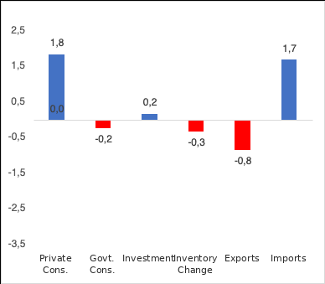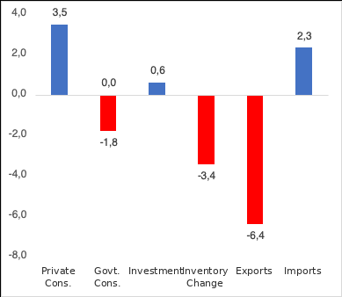
Source: TurkStat, Betam.

Table 1: Annual growth rates and contributions to growth of GDP components, 2026 Q1 and 2026 Q2
 | 2026Q1 |  | 2026Q2
 | Change (%) | Contribution (pp) | Change (%) | Contribution (pp)
Private Consumption | 5,1 | 2,9 | 3,5 | 1,8
Government Consumption | 0,8 | 0,1 | -1,8 | -0,2
Investment | 3,1 | 1,0 | 0,6 | 0,2
Inventory Changes |  | 1,7 |  | -0,3
Exports | -12,7 | -3,3 | -3,4 | -0,8
Imports | -2,0 | 0,3 | -6,4 | 1,7
GDP | 2,6 |  | 2,3
Source: TurkStat, Betam

Table 2: Quarterly growth rates and contributions to growth of GDP components, 2026 Q1 and 2026 Q2 (seasonally and calendar-adjusted)
 | 2026Q1 |  | 2026Q2
 | Change (%) | Contribution (pp) | Change (%) | Contribution (pp)
Private Consumption | -0,1 | -0,1 | -1,3 | -0,7
Government Consumption | 1,3 | 0,2 | -2,0 | -0,3
Investment | -2,0 | -0,7 | 0,0 | 0,0
Inventory Changes |  | 1,6 |  | 0,3
Exports | -7,0 | -1,6 | 6,2 | 1,4
Imports | -3,4 | 0,8 | -1,8 | 0,4
GDP | 0,3 |  | 1,1
Source: TurkStat, Betam
Investment slowdown continues
The strong investment growth observed in the 2024 and 2025 growth assessments continued in 2026, albeit at a slower pace. Investment rose by 0.6% year-on-year in the second quarter of 2026 and contributed 0.2 percentage points to growth (Table 1). On a quarterly basis, investment remained unchanged, and its contribution to growth was zero. In the first quarter of 2026, investment had contracted by 2% relative to the fourth quarter of 2025 (Table 2).

The impact of inventory changes diminished
According to seasonally and calendar-adjusted data, inventory changes contributed 0.3 percentage points to quarterly growth in the second quarter of 2026, compared with 1.6 percentage points in the first quarter (Table 2). This technical adjustment had prevented growth from turning negative in the first quarter. In the second quarter, however, the contribution of inventory changes approached zero. Having been a principal driver of annual growth with a contribution of 1.7 percentage points in the previous quarter, inventory changes reduced annual growth by 0.3 percentage points this quarter (Table 1).

Foreign trade makes a positive contribution
Seasonally and calendar-adjusted data indicate that exports rose by 6.2% and imports declined by 1.8% compared with the previous quarter in the second quarter of 2026. Exports added 1.4 percentage points to quarterly growth (Table 2). On an annual basis, exports fell by 3.4% while imports declined by 6.4%. Consequently, net foreign trade made an important positive contribution to growth in the second quarter, both year-on-year (0.9 percentage points) and quarter-on-quarter (1.8 percentage points) (Table 1).

Government consumption turns negative
According to seasonally and calendar-adjusted data, government consumption fell by 2% quarter-on-quarter in the second quarter of 2026, subtracting 0.3 percentage points from growth (Table 2). Government spending declined by 1.8% year-on-year and reduced growth by 0.2 percentage points (Table 1).

Growth outlook
As Figure 2 shows, quarterly growth momentum recovered significantly in the second quarter, but annual growth slowed from 2.6% to 2.3%. The main reason for the annual slowdown was the decline in the contribution of private consumption, from 2.9 to 1.8 percentage points. Despite its quarterly recovery, the annual contribution of exports remained negative at -0.8 percentage points, while the positive annual contribution of net foreign trade (0.9 percentage points) primarily reflected the sharp contraction in imports. Thus, the annual slowdown points to weakness in domestic demand rather than foreign trade. The quarterly picture is the opposite: the recovery came almost entirely from foreign trade (a net contribution of 1.8 percentage points), while domestic demand components weakened, including private consumption (-0.7 percentage points), government consumption (-0.3 percentage points), and inventory changes (0.3 percentage points, down from 1.6 percentage points in the previous quarter). Growth in the second half of 2026 will depend largely on whether the decline in private consumption persists and whether the sharp increase in exports merely offsets the large decline in the preceding quarter—in other words, whether it is temporary.

Figure 2: GDP growth rates compared with the previous quarter and the same quarter of the previous year

Source: TurkStat, Betam

Betam, seyfettin.gursel@bau.edu.tr
Betam, saliha.tanriverdi@bau.edu.tr
“TÜİK yeni milli gelir serilerini hesaplarken zincirleme hacim endeksi yöntemini kullanıyor. Zincirleme yöntemde hem TurkStat uses the chain-linked volume index method to calculate the new national accounts series. Because this method entails non-additivity and no chain-linked index can be derived for the “changes in inventories” component, the contribution of inventory changes to growth cannot be calculated directly. Our research note discusses in detail how to calculate this contribution under the chain-linked volume index approach (see Betam Research Note 17/217).

