

Growth Assessment:

2026 Q1

21 July 2026

GROWTH STALLED IN THE FIRST QUARTER

Seyfettin Gürsel and Saliha Tanrıverdi

Executive Summary
The Turkish economy grew by 2.5% year-on-year and 0.1% quarter-on-quarter in the first quarter of 2026 (Figure 2). As in the fourth quarter of 2025, private consumption made the largest contribution to economic growth in the first quarter of 2026. Quarterly growth in private consumption slowed from 4.2% to 0.1%. With an annual increase of 4.8%, private consumption alone accounted for 2.7 percentage points of overall growth. Government consumption also increased both year-on-year and quarter-on-quarter. Investment rose by 3% year-on-year, contributing 0.9 percentage points to growth, but declined by 2.2% quarter-on-quarter, reducing growth by 0.7 percentage points. Foreign trade components also weakened on both an annual and a quarterly basis. In particular, a 12.7% year-on-year contraction in exports reduced growth by 3.3 percentage points. Without the 1.1-percentage-point contribution from changes in inventories, quarterly growth would have been negative. Looking ahead, the trajectory of growth will depend on the Central Bank of the Republic of Türkiye (CBRT) monetary policy stance and whether the momentum in private consumption can be sustained.

Private consumption continues to contribute, but loses momentum
According to seasonally and calendar-adjusted figures, private consumption increased by 4.8% year-on-year in the first quarter of 2026, contributing 2.7 percentage points to annual growth. In the fourth quarter, private consumption had grown by 5.2% year-on-year (Table 1). Compared with the previous quarter, private consumption rose by 0.1%, adding 0.1 percentage points to quarterly growth. By contrast, private consumption had increased by 4.2% between the third and fourth quarters (Table 2). Although private consumption growth appears to have slowed in the first quarter of 2026, it continued to make a positive contribution.
Figure 1: Contributions of GDP components to year-on-year growth (left panel) and their growth rates (right panel), 2026 Q1
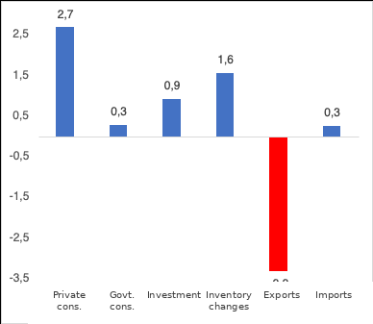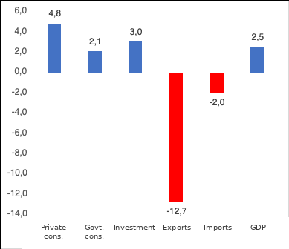
Source: TurkStat, Betam.

Table 1: Year-on-year growth rates and contributions to growth of GDP components, 2025 Q4 and 2026 Q1
 | 2025Q4 |  | 2026Q1
 | Change (%) | Contribution (pp) | Change (%) | Contribution (pp)
Private consumption | 5,2 | 2,9 | 4,8 | 2,7
Government consumption | -0,9 | -0,1 | 2,1 | 0,3
Investment | 5,4 | 1,7 | 3,0 | 0,9
Inventory changes |  | 0,0 |  | 1,6
Exports | -2,3 | -0,5 | -12,7 | -3,3
Imports | 3,8 | -0,6 | -2,0 | 0,3
GDP | 3,4 |  | 2,5
Source: TurkStat, Betam

Table 2: Quarter-on-quarter growth rates and contributions to growth of GDP components, 2025 Q4 and 2026 Q1 (seasonally and calendar-adjusted)
 | 2025Q4 |  | 2026Q1
 | Change (%) | Contribution (pp) | Change (%) | Contribution (pp)
Private consumption | 4,2 | 2,3 | 0,1 | 0,1
Government consumption | -1,7 | -0,2 | 3,3 | 0,5
Investment | -0,3 | -0,1 | -2,2 | -0,7
Inventory changes |  | 0,8 |  | 1,1
Exports | -4,5 | -1,2 | -7,5 | -1,7
Imports | 4,3 | -1,1 | -3,9 | 1,0
GDP | 0,4 |  | 0,1
Source: TurkStat, Betam
Signs of a slowdown in investment
The strong growth in investment highlighted in the growth assessments for 2024 and 2025 continued in 2026, albeit at a slower pace. Investment increased by 3% year-on-year in the first quarter of 2026, contributing 0.9 percentage points to growth (Table 1). On a quarterly basis, however, investment fell by 2.2% relative to the previous quarter, reducing the growth rate by 0.7 percentage points. In the fourth quarter, investment growth relative to the third quarter had been -0.3% (Table 2).

Foreign trade subtracted 3 percentage points from growth
Seasonally and calendar-adjusted figures for the first quarter of 2026 show that exports fell by 7.5% and imports by 3.9% compared with the previous quarter. Exports reduced quarterly growth by 1.7 percentage points (Table 2). On an annual basis, exports declined by 12.7% and imports by 2%. As a result, the annual contribution of net exports (-3 percentage points) almost entirely offset the combined positive contribution of private consumption, government consumption and investment (3.9 percentage points) (Table 1).

Government consumption provides the most stable support to growth
According to seasonally and calendar-adjusted figures, government consumption increased by 3.3% quarter-on-quarter in the first quarter of 2026, contributing 0.5 percentage points to growth (Table 2). Government consumption rose by 2.1% year-on-year in the first quarter of 2026, adding 0.3 percentage points to growth (Table 1).

Without inventory changes, growth would have been negative
According to seasonally and calendar-adjusted data, changes in inventories added 0.8 percentage points to quarterly growth in the fourth quarter of 2025 and 1.1 percentage points in the first quarter of 2026 (Table 2). These technical adjustments prevented growth from turning negative in the last two quarters. While inventory changes had no effect on annual growth in the previous quarter, they added 1.6 percentage points to annual growth this quarter (Table 1).

The outlook for growth
As shown in Figure 2, quarterly growth momentum slowed throughout 2025, while annual growth recovered relative to the preceding year. As 2026 began, the recovery in annual growth observed in 2025 appeared to have faded. Quarterly growth, meanwhile, came close to zero. Although private consumption, government consumption and investment continued to make positive contributions to annual growth in the first quarter of 2026, the contraction in foreign trade weighed substantially on growth. Looking at the quarterly components reveals a striking picture specific to this quarter. The contribution of private consumption declined from 2.3 percentage points in the previous quarter to 0.1 percentage points, while investment, which fell by 2.2% compared with the previous quarter, contributed -0.7 percentage points. Quarterly growth was sustained largely by government consumption, which grew by 3.3% and contributed 0.5 percentage points, and especially by changes in inventories (1.1 percentage points). Without the latter, quarterly growth would have been negative.

The sharp loss of momentum in private consumption in the first quarter of 2026 compared with previous quarters suggests that the revival supported by lower lending rates and promotional financing opportunities may not be lasting. The substantial contraction in exports for two consecutive quarters points to structural factors rather than a purely cyclical movement, such as the real appreciation of the Turkish lira, weaker industrial demand in the EU, or sector-specific and geopolitical effects. The contributions of both private consumption and exports to growth have declined markedly in recent years: the annual contribution of private consumption fell from around 9–10 percentage points in 2022 to 2.7 percentage points in the first quarter of 2026, while exports experienced a similarly large deterioration, turning into a negative contribution. The weakening of these two components has largely been offset by the technical and temporary support of changes in inventories; the sustainability of this support warrants close monitoring. The pace of monetary tightening by the CBRT and developments in credit conditions will remain key determinants of growth performance in 2026.

Figure 2: GDP growth rates relative to the previous quarter and the same quarter of the previous year

Source: TurkStat, Betam

Betam, seyfettin.gursel@bau.edu.tr
Betam, saliha.tanriverdi@bau.edu.tr
TurkStat uses the chain-linked volume index method to calculate its new national accounts series. Under this method, the contribution of changes in inventories to growth cannot be readily calculated because chain-linking creates a non-additivity problem and a chained index cannot be derived for the “changes in inventories” component. We discussed in detail how to calculate the contribution of inventory changes to growth under the chain-linked volume index approach in our research note (see Betam Research Note 17/217).

