Labor Market Outlook:
February 2024

12 Feb 2024

SIGNIFICANT INCREASE IN EMPLOYMENT AND LABOR FORCE, SLIGHT DECREASE IN UNEMPLOYMENT

Seyfettin Gürsel*, Saliha Tanrıverdi**

Executive Summary

The increase of 399,000 in employment, along with a decrease of 12,000 in the number of unemployed, resulted in a total labor force increase of 387,000. The overall unemployment rate has decreased by 0.1 percentage points from November to December, reaching 8.8 percent.

The seasonally adjusted female unemployment rate increased by 0.1 percentage points from November to December, reaching 12 percent, as a result of a 208,000 decrease in employment and a 43,000 decrease in the number of unemployed. On the other hand, the male unemployment rate declined to 7.1 percent in December, following a 191,000 increase in employment and a 56,000 decrease in the number of unemployed males. The female labor force level increased by 250,000, while the male labor force level increased by 135,000. Consequently, the gender gap in unemployment rates increased from 4.5 percentage points to 4.9 percentage points in December.

Figure 1: Seasonally adjusted labor force, employment, and unemployment

Source: Turkstat, Betam

Slight decrease in unemployment rate despite a significant rise in employment

According to seasonally adjusted data, the number of employed individuals increased by 399,000, reaching 32.056 million from November to December. In December, the number of unemployed individuals decreased by 12,000, reaching 3.098 million. The labor force increased by 387,000 and stands at 35.154 million (Figure 1, Table 1). As a result, the unemployment rate decreased by 0.1 percentage points from November to December, reaching 8.8 percent.

Developments in the alternative unemployment rates

Box 1 reports the methods Turkstat uses to calculate the alternative unemployment rates. These measures consider both the time-related underemployment (those who are employed for less than 40 hours a week but would like to increase their working hours and fail to do so) and the potential labor force (the individuals who are neither employed nor looking for a job but wish to work).

According to seasonally adjusted data, the "overall unemployment rate" in December was 8.8 percent, while the unemployment rate considering the potential labor force increased from 17.3 to 17.9 percent, with an increase of 379,000 in the potential labor force. The unemployment rate accounting for time-related underemployment increased by 1.6 percentage points to 16.4 percent. The composite measure of labor underutilization rate, which is a combination of the last two alternative rates, increased by 2.1 percentage points to reach 24.7 percent (Figure 2, Table 2).

Figure 2: Headline Unemployment Rate and Supplementary Indicators for Labor Force

Source: Turkstat, Betam

Visible increase in female employment

Figure 3 shows the seasonally adjusted unemployment rate for females and males. From November to December, the level of female employment increased by 208,000, while the number of unemployed females increased by 43,000, resulting in a net rise of 250,000 in the labor force. The female unemployment rate also increased by 0.1 percentage points, reaching 12 percent from November to December. In November, female employment had decreased by 106,000, and the female unemployment rate had increased from 11.5 percent to 11.9 percent. In December, male employment increased by 191,000, while the number of unemployed males decreased by 56,000, and the male unemployment rate declined to 7.1 percent. In November, male employment had decreased by 124,000. The male unemployment rate faced an increase of 0.3 percentage point, reaching 7.4 percent.

Figure 3: Seasonally adjusted unemployment rate by gender (%)
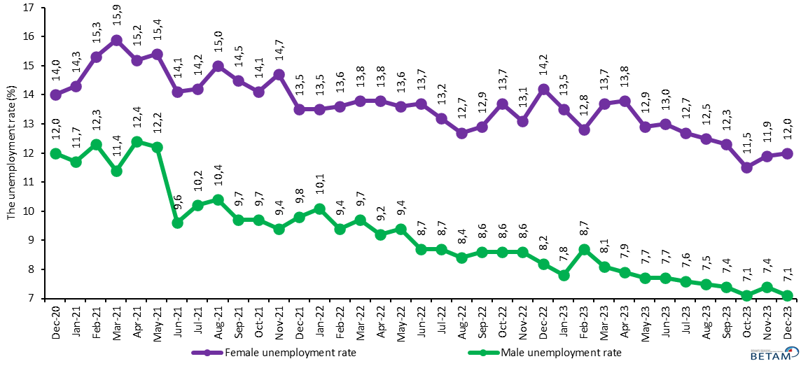
Source: Turkstat, Betam

The female employment rate increased by 0.6 percentage point to 31.9 percent as a result of the 208,000 increase in employment, while the male employment rate reached 66.1 percent (Figure 4).

Figure 4: Seasonally adjusted employment rate by gender (%)
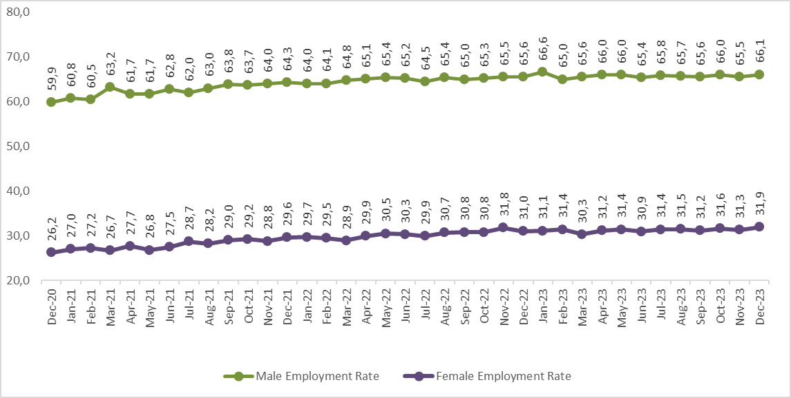
Source: Turkstat, Betam

Table 1: Seasonally adjusted labor force indicators (in thousands)
 | Labor Force | Employment | Unemployment | Unemployment Rate | Monthly Changes
November-20 | 31.068 | 27.016 | 4.052 | 13,0 | Labor Force | Employment | Unemployment
December-20 | 31.003 | 27.089 | 3.913 | 12,6 | -65 | 73 | -139
January-21 | 31.604 | 27.644 | 3.960 | 12,5 | 601 | 555 | 47
February-21 | 31.913 | 27.671 | 4.242 | 13,3 | 309 | 27 | 282
March-21 | 32.567 | 28.393 | 4.174 | 12,8 | 654 | 722 | -68
April-21 | 32.621 | 28.288 | 4.333 | 13,3 | 54 | -105 | 159
May-21 | 32.275 | 28.006 | 4.269 | 13,2 | -346 | -282 | -64
June-21 | 32.183 | 28.629 | 3.554 | 11,0 | -92 | 623 | -715
July-21 | 32.566 | 28.806 | 3.761 | 11,5 | 383 | 177 | 207
August-21 | 32.898 | 28.978 | 3.920 | 11,9 | 332 | 172 | 159
September-21 | 33.325 | 29.564 | 3.761 | 11,3 | 427 | 586 | -159
October-21 | 33.327 | 29.614 | 3.713 | 11,1 | 2 | 50 | -48
November-21 | 33.330 | 29.617 | 3.713 | 11,1 | 3 | 3
December-21 | 33.739 | 30.031 | 3.708 | 11,0 | 409 | 414 | -5
January-22 | 33.780 | 29.985 | 3.795 | 11,2 | 41 | -46 | 87
February-22 | 33.636 | 30.001 | 3.635 | 10,8 | -144 | 16 | -160
March-22 | 33.809 | 30.074 | 3.735 | 11,0 | 173 | 73 | 100
April-22 | 34.186 | 30.508 | 3.679 | 10,8 | 377 | 434 | -56
May-22 | 34.574 | 30.848 | 3.725 | 10,8 | 388 | 340 | 46
June-22 | 34.313 | 30.758 | 3.555 | 10,4 | -261 | -90 | -170
July-22 | 33.906 | 30.449 | 3.458 | 10,2 | -407 | -309 | -97
August-22 | 34.381 | 31.009 | 3.372 | 9,8 | 475 | 560 | -86
September-22 | 34.430 | 30.959 | 3.472 | 10,1 | 49 | -50 | 100
October-22 | 34.674 | 31.096 | 3.578 | 10,3 | 244 | 137 | 106
November-22 | 35.062 | 31.519 | 3.543 | 10,1 | 388 | 423 | -35
December-22 | 34.921 | 31.340 | 3.581 | 10,3 | -141 | -179 | 38
January-23 | 35.106 | 31.689 | 3.417 | 9,7 | 185 | 349 | -164
February-23 | 34.861 | 31.335 | 3.527 | 10,1 | -245 | -354 | 110
March-23 | 34.601 | 31.156 | 3.445 | 10,0 | -260 | -179 | -82
April-23 | 35.127 | 31.635 | 3.492 | 9,9 | 526 | 479 | 47
May-23 | 35.014 | 31.713 | 3.301 | 9,4 | -113 | 78 | -191
June-23 | 34.659 | 31.355 | 3.304 | 9,5 | -355 | -358 | 3
July-23 | 34.962 | 31.702 | 3.259 | 9,3 | 303 | 347 | -45
August-23 | 34.891 | 31.686 | 3.204 | 9,2 | -71 | -16 | -55
September-23 | 34.786 | 31.628 | 3.158 | 9,1 | -105 | -58 | -46
October-23 | 34.889 | 31.888 | 3.002 | 8,6 | 103 | 260 | -156
November-23 | 34.767 | 31.657 | 3.110 | 8,9 | -122 | -231 | 108
December-23 | 35.154 | 32.056 | 3.098 | 8,8 | 387 | 399 | -12
Source: Turkstat, Betam

Table 2: Unemployment, alternative unemployment rates (%) levels (in thousand)
 | Unemployment Rate (%) | Persons in Unemployment (in thousands) | Combined Rate of Time-Related Underemployment and Unemployment (%) | Time-Related Underemployed (in thousands) | Combined Rate of Unemployment and Potential Labor Force (%) | Potential Labor Force (in thousands) | Composite Measure of Labor Underutilization (%) | Total
Sep-20 | 12,6 | 3923 | 15,9 | 1021 | 21,2 | 3387 | 24,1 | 8330
Oct-20 | 13,1 | 4080 | 17,4 | 1329 | 21,9 | 3492 | 25,7 | 8901
Nov-20 | 13,0 | 4052 | 17,1 | 1261 | 23,1 | 4063 | 26,6 | 9376
Dec-20 | 12,6 | 3913 | 17,8 | 1606 | 23,8 | 4548 | 28,3 | 10067
Jan-21 | 12,5 | 3960 | 20,0 | 2361 | 22,8 | 4204 | 29,3 | 10525
Feb-21 | 13,3 | 4242 | 19,7 | 2045 | 22,4 | 3746 | 28,1 | 10032
Mar-21 | 12,8 | 4174 | 17,9 | 1655 | 20,9 | 3328 | 25,4 | 9158
Apr-21 | 13,3 | 4333 | 19,3 | 1963 | 21,4 | 3369 | 26,9 | 9665
May-21 | 13,2 | 4269 | 19,3 | 1960 | 21,7 | 3493 | 27,2 | 9722
Jun-21 | 11,0 | 3554 | 15,0 | 1273 | 19,1 | 3205 | 22,7 | 8033
Jul-21 | 11,5 | 3761 | 15,9 | 1417 | 19,3 | 3128 | 23,3 | 8306
Aug-21 | 11,9 | 3920 | 15,0 | 1015 | 18,9 | 2833 | 21,8 | 7768
Sep-21 | 11,3 | 3761 | 14,9 | 1204 | 18,3 | 2861 | 21,7 | 7826
Oct-21 | 11,1 | 3713 | 15,6 | 1486 | 18,7 | 3099 | 22,8 | 8298
Nov-21 | 11,1 | 3713 | 15,3 | 1386 | 18,2 | 2877 | 22,1 | 7976
Dec-21 | 11,0 | 3708 | 15,2 | 1420 | 18,6 | 3154 | 22,5 | 8282
Jan-22 | 11,2 | 3795 | 15,5 | 1441 | 18,8 | 3147 | 22,7 | 8383
Feb-22 | 10,8 | 3635 | 14,9 | 1377 | 18,2 | 3040 | 21,9 | 8052
Mar-22 | 11,0 | 3735 | 15,3 | 1438 | 18,4 | 3046 | 22,2 | 8219
Apr-22 | 10,8 | 3679 | 14,3 | 1210 | 18,0 | 3018 | 21,3 | 7906
May-22 | 10,8 | 3725 | 15,8 | 1738 | 17,6 | 2864 | 22,3 | 8327
Jun-22 | 10,4 | 3555 | 14,0 | 1249 | 17,2 | 2834 | 20,5 | 7638
Jul-22 | 10,2 | 3458 | 15,2 | 1696 | 18,1 | 3271 | 22,7 | 8425
Aug-22 | 9,8 | 3372 | 13,5 | 1269 | 16,5 | 2756 | 19,9 | 7397
Sep-22 | 10,1 | 3472 | 13,9 | 1314 | 16,7 | 2734 | 20,3 | 7520
Oct-22 | 10,3 | 3578 | 14,4 | 1415 | 16,7 | 2656 | 20,5 | 7649
Nov-22 | 10,1 | 3543 | 14,2 | 1436 | 16,9 | 2867 | 20,7 | 7846
Dec-22 | 10,3 | 3581 | 14,9 | 1622 | 17,2 | 2929 | 21,4 | 8132
Jan-23 | 9,7 | 3417 | 15,3 | 1954 | 16,8 | 2982 | 21,9 | 8353
Feb-23 | 10,1 | 3527 | 16,1 | 2086 | 17,9 | 3305 | 23,4 | 8917
Mar-23 | 10,0 | 3445 | 15,0 | 1745 | 17,3 | 3073 | 22,0 | 8263
Apr-23 | 9,9 | 3492 | 16,8 | 2409 | 17,3 | 3126 | 23,6 | 9027
May-23 | 9,4 | 3301 | 15,8 | 2231 | 16,6 | 3011 | 22,4 | 8543
Jun-23 | 9,5 | 3304 | 16,5 | 2415 | 17,8 | 3486 | 24,1 | 9205
Jul-23 | 9,3 | 3259 | 14,7 | 1880 | 17,7 | 3559 | 22,6 | 8699
Aug-23 | 9,2 | 3204 | 15,2 | 2099 | 17,5 | 3517 | 23,0 | 8821
Sep-23 | 9,1 | 3158 | 14,6 | 1921 | 16,7 | 3183 | 21,8 | 8262
Oct-23 | 8,6 | 3002 | 13,8 | 1813 | 16,6 | 3345 | 21,4 | 8159
Nov-23 | 8,9 | 3110 | 14,8 | 2036 | 17,3 | 3512 | 22,6 | 8658
Dec-23 | 8,8 | 3098 | 16,4 | 2667 | 17,9 | 3891 | 24,7 | 9656
Source: Turkstat, Betam

Table 3: Seasonally adjusted female and male labor market indicators (thousands)
 | Total labor force, Female | Total Employment, Female | Total Unemployed, Female | Total labor force, Male | Total Employment, Male | Total Unemployed, Male | Women LFPR | Women Employment Rate | Men LFPR | Men Employment Rate
Sep-20 | 9812 | 8386 | 1425 | 21282 | 18783 | 2498 | 30,9 | 26,4 | 68,4 | 60,4
Oct-20 | 9703 | 8232 | 1471 | 21382 | 18773 | 2609 | 30,5 | 25,9 | 68,6 | 60,3
Nov-20 | 9563 | 8155 | 1408 | 21505 | 18861 | 2644 | 30,0 | 25,6 | 68,9 | 60,4
Dec-20 | 9710 | 8353 | 1357 | 21293 | 18736 | 2557 | 30,5 | 26,2 | 68,1 | 59,9
Jan-21 | 10042 | 8602 | 1440 | 21562 | 19041 | 2520 | 31,5 | 27,0 | 68,8 | 60,8
Feb-21 | 10275 | 8700 | 1575 | 21638 | 18971 | 2667 | 32,1 | 27,2 | 69,0 | 60,5
Mar-21 | 10171 | 8556 | 1615 | 22396 | 19837 | 2560 | 31,8 | 26,7 | 71,3 | 63,2
Apr-21 | 10484 | 8886 | 1598 | 22137 | 19402 | 2735 | 32,7 | 27,7 | 70,4 | 61,7
May-21 | 10146 | 8587 | 1559 | 22129 | 19419 | 2710 | 31,6 | 26,8 | 70,3 | 61,7
Jun-21 | 10290 | 8836 | 1454 | 21892 | 19793 | 2100 | 32,0 | 27,5 | 69,5 | 62,8
Jul-21 | 10766 | 9233 | 1534 | 21800 | 19573 | 2227 | 33,4 | 28,7 | 69,1 | 62,0
Aug-21 | 10690 | 9090 | 1600 | 22208 | 19888 | 2320 | 33,2 | 28,2 | 70,3 | 63,0
Sep-21 | 10956 | 9370 | 1586 | 22369 | 20194 | 2175 | 33,9 | 29,0 | 70,7 | 63,8
Oct-21 | 10996 | 9447 | 1549 | 22331 | 20167 | 2163 | 34,0 | 29,2 | 70,5 | 63,7
Nov-21 | 10929 | 9327 | 1602 | 22401 | 20290 | 2111 | 33,8 | 28,8 | 70,6 | 64,0
Dec-21 | 11113 | 9614 | 1499 | 22625 | 20417 | 2209 | 34,3 | 29,6 | 71,3 | 64,3
Jan-22 | 11165 | 9656 | 1508 | 22615 | 20329 | 2286 | 34,4 | 29,7 | 71,1 | 64,0
Feb-22 | 11112 | 9597 | 1515 | 22523 | 20404 | 2120 | 34,2 | 29,5 | 70,8 | 64,1
Mar-22 | 10931 | 9419 | 1512 | 22878 | 20655 | 2223 | 33,6 | 28,9 | 71,8 | 64,8
Apr-22 | 11314 | 9749 | 1565 | 22873 | 20759 | 2114 | 34,7 | 29,9 | 71,7 | 65,1
May-22 | 11526 | 9957 | 1569 | 23047 | 20891 | 2156 | 35,3 | 30,5 | 72,1 | 65,4
Jun-22 | 11470 | 9899 | 1570 | 22844 | 20859 | 1985 | 35,1 | 30,3 | 71,4 | 65,2
Jul-22 | 11284 | 9789 | 1494 | 22623 | 20659 | 1964 | 34,5 | 29,9 | 70,6 | 64,5
Aug-22 | 11509 | 10050 | 1459 | 22872 | 20959 | 1913 | 35,2 | 30,7 | 71,3 | 65,4
Sep-22 | 11577 | 10081 | 1496 | 22854 | 20878 | 1976 | 35,3 | 30,8 | 71,2 | 65,0
Oct-22 | 11694 | 10096 | 1598 | 22980 | 21000 | 1980 | 35,6 | 30,8 | 71,5 | 65,3
Nov-22 | 11999 | 10431 | 1568 | 23063 | 21089 | 1974 | 36,5 | 31,8 | 71,7 | 65,5
Dec-22 | 11886 | 10196 | 1690 | 23036 | 21144 | 1892 | 36,2 | 31,0 | 71,5 | 65,6
Jan-23 | 11823 | 10221 | 1602 | 23283 | 21468 | 1816 | 35,9 | 31,1 | 72,2 | 66,6
Feb-23 | 11871 | 10355 | 1517 | 22990 | 20980 | 2010 | 36,0 | 31,4 | 71,2 | 65,0
Mar-23 | 11558 | 9972 | 1585 | 23044 | 21184 | 1859 | 35,1 | 30,3 | 71,3 | 65,6
Apr-23 | 11943 | 10293 | 1651 | 23184 | 21342 | 1842 | 36,2 | 31,2 | 71,7 | 66,0
May-23 | 11891 | 10360 | 1531 | 23123 | 21353 | 1770 | 36,0 | 31,4 | 71,5 | 66,0
Jun-23 | 11724 | 10195 | 1529 | 22935 | 21160 | 1775 | 35,5 | 30,9 | 70,9 | 65,4
Jul-23 | 11896 | 10382 | 1515 | 23065 | 21321 | 1745 | 36,0 | 31,4 | 71,2 | 65,8
Aug-23 | 11887 | 10403 | 1484 | 23004 | 21283 | 1721 | 35,9 | 31,5 | 71,0 | 65,7
Sep-23 | 11779 | 10334 | 1445 | 23007 | 21294 | 1713 | 35,6 | 31,2 | 70,9 | 65,6
Oct-23 | 11843 | 10478 | 1364 | 23047 | 21409 | 1637 | 35,8 | 31,6 | 71,0 | 66,0
Nov-23 | 11777 | 10372 | 1404 | 22991 | 21285 | 1706 | 35,5 | 31,3 | 70,8 | 65,5
Dec-23 | 12027 | 10580 | 1447 | 23126 | 21476 | 1650 | 36,3 | 31,9 | 71,1 | 66,1
Source: Turkstat, Betam

Box 1: Definitions of alternative unemployment rates
The time-related underemployment: Persons employed in the reference week who worked less than 40 hours in total (in main job and additional job/s) were willing to work additional hours and were available to do so but could not find a job for the extra hours.

The potential labor force: Persons not in employment who would like to work, but for whom the existing conditions limit active job search and/or availability.

The unemployed: The unemployed comprises all persons 15 years of age and over who were not employed during the reference period, had used at least one active channel for seeking a job during the last four weeks, and were available to start work within two weeks.
1) Unemployment rate = [persons in unemployment/labor force]x100

2) Combined rate of time-related underemployment and unemployment =
[(persons in time-related underemployment + persons in unemployment) / labor force] * 100

3) Combined rate of unemployment and potential labor force =
[(persons in unemployment + potential labor force)/ (labor force+ potential labor force)] x 100

4) Composite measure of labor underutilization =
[(persons in time-related underemployment + persons in unemployment + potential labor force) / (labor force+ potential labor force)] x 100

* Prof. Dr. Seyfettin Gürsel, Betam, Director, seyfettin.gursel@bau.edu.tr
** Saliha Tanrıverdi, Betam, Research Assistant, saliha.tanriverdi@bau.edu.tr
Detailed information is available in the Metadata section of the link : https://data.tuik.gov.tr/Kategori/GetKategori?p=istihdam-issizlik-ve-ucret-108&dil=1

