Research Brief 259

December 1, 2022

HIGH INFLATION HAS ERODED THE MINIMUM WAGE RISE

Seyfettin Gürsel*, Ozan Bakış** , Hamza Mutluay***

Executive Summary

In this brief, we examine the effect of the minimum wage increase on the purchasing power of individuals by comparing the increase that took place in January 2022 with the increase of January 2016. Although the minimum wage increase enhances consumers' purchasing power and protects consumers from the adverse effect of price increases, the data shows that the increase in the first half of 2022 has significantly melted due to the striking inflation. It is clear that the significant price increases in food, electricity, gas, and other fuels, which take up a large part of the consumption basket of the poor, have eroded the minimum wage increase in the first half of the year.
The government increased the minimum wage from 4,253 TL rose to 5,500 TL on 1 July 2022 by an extra 30 percent to mitigate the devastating effect of inflation. The last observation point of the data we use in the tables and graphs is June since we do not have enough data to extend the observation period. We will investigate the effects of an extra increase in the minimum wage in the following periods and then update the research brief.

Weight of minimum wage earners

Table 1 shows the rate of those earning less than or equal to minimum wage over the years. Although there have been yearly variation, nearly one out of every three employees earns less than or equal to the minimum. The rate is much higher for informal workers (about 60 percent). Notably, this rate has tended to increase for formal employees in recent years. In 2021, the rate of total workers earning less than or equal to the minimum wage was 33.6 percent, 29.9 percent and 61 percent for formal and informal workers, respectively. The majority of wage earners in Turkey are significantly affected by the minimum wage increases.

Table 1: The ratio of the workers earning less than or equal to minimum wage (%, 2004-2021)
 | Total | Formal | Informal
2004 | 41.6 | 28.7 | 69.5
2005 | 33.0 | 21.7 | 57.8
2006 | 33.2 | 22.5 | 57.7
2007 | 29.2 | 20.3 | 52.0
2008 | 28.6 | 19.9 | 54.6
2009 | 25.5 | 17.9 | 48.8
2010 | 28.0 | 19.7 | 54.2
2011 | 26.9 | 19.9 | 49.9
2012 | 29.7 | 23.5 | 53.7
2013 | 27.1 | 21.0 | 54.8
2014 | 28.6 | 23.2 | 54.1
2015 | 33.1 | 27.7 | 60.9
2016 | 35.8 | 31.0 | 61.0
2017 | 31.6 | 26.9 | 56.3
2018 | 33.3 | 27.9 | 62.2
2019 | 39.8 | 34.7 | 67.5
2020 | 34.2 | 30.4 | 61.2
2021 | 33.6 | 29.9 | 61.0
Source: Turkstat, Authors' calculations.
Note: The income question is coded as zero for those who started working in the survey month and those who did not declare their income. Therefore, those who declared their income as "0" were not considered in calculating the rate of those earning at or below the minimum wage. On the other hand, since the income information is based on declarations and the majority of the respondents round up their income when giving their income information, 5 percent more than the minimum wage was used as the threshold when calculating the number of those earning wages less than or equal to minimum wage. Since the Minimum Living Allowance (AGI) application started in 2008, no minimum wage AGI contribution exists prior to that. Before 2008, employees collected value-added tax (VAT) refunds by accumulating spending slips. Although the VAT refund was calculated annually, it is possible to calculate the monthly amount. According to our calculations, a VAT refund corresponds to an increase of approximately 8 percent in the monthly income of a minimum wage worker. In order to make comparisons between years, the minimum wages before 2008 were multiplied by 1.08.

The progress of the minimum wage and inflation over the years
Figure 1 shows the development of the minimum wage and inflation over the years. The minimum wage increased at a very high rate of 40 percent at the beginning of 2004. Since inflation was in single digits in this period, the real minimum wage, 226 TL in June 2003, increased to 297 TL in June 2004 (31 percent increase) and remained around 300 until June 2007. Inflation was also in single digits in this period (Figure 1 and Annex Table 1). In the following period, a steady increase, albeit slowly, is observed in the real minimum wage. As a result, the real minimum increased to 369 TL in June 2014. The real minimum wage increased by 23 percent between 2007 and 2014.
The highest nominal minimum wage increase after 2004 was realized at the beginning of 2016 (30 percent). With a low annual inflation rate (8 percent) in 2016, the real minimum wage increased from 386 TL to 466 TL, by 21 percent from June 2015 to June 2016. The real minimum wage more than doubled between June 2003 and June 2016.
Figure 1: Real minimum wage (TL) ve CPI (2003 June=100)

Source: Turkstat, Authors' calculations.

In the following years, real minimum wage increases stagnated (Figure 1 and Annex Table 1). Also, inflation has resulted in double digits since 2017. As of May 2020, the nominal minimum wage also started to increase with the acceleration of inflation. The real minimum wage, 489 TL in June 2019, increased by 5.7 percent in June 2021 to only 517 TL. Inflation reached a record level of 78.6 percent on an annual basis in June 2022. Despite the 50 percent increase in the minimum wage at the beginning of 2022, the real minimum wage decreased by 15.9 percent in June 2022, decreasing from 517 TL a year ago to 435 TL (Figure 1, Annex Table 1). We have entered a new period in which high inflation rapidly melts minimum wage increases.

Food, housing and transport inflation melted the minimum wage
The food, rent, electricity, gas, and other fuels and transportation price indexes, which constitute approximately 50 percent of the weight in the consumption basket of low and middle-income groups, can be compared with the CPI to understand how the minimum wage increase affects the purchasing power of the consumer. To ease comparison, the indexes in Figure 2 were created by taking the December value of each item in 2015 and 2021 as 100. Figure 2 shows that the price indexes of all sub-items either slightly decreased or increased over time in 2016 (left graph). Food prices even started to decline after February 2016. As mentioned above, the low increases in consumption item prices and the 30 percent nominal increase in the minimum wage led to a significant increase in the real income of the households and increased their purchasing power.
Figure 2: Increases of indexes in consumption expenditure and minimum wage
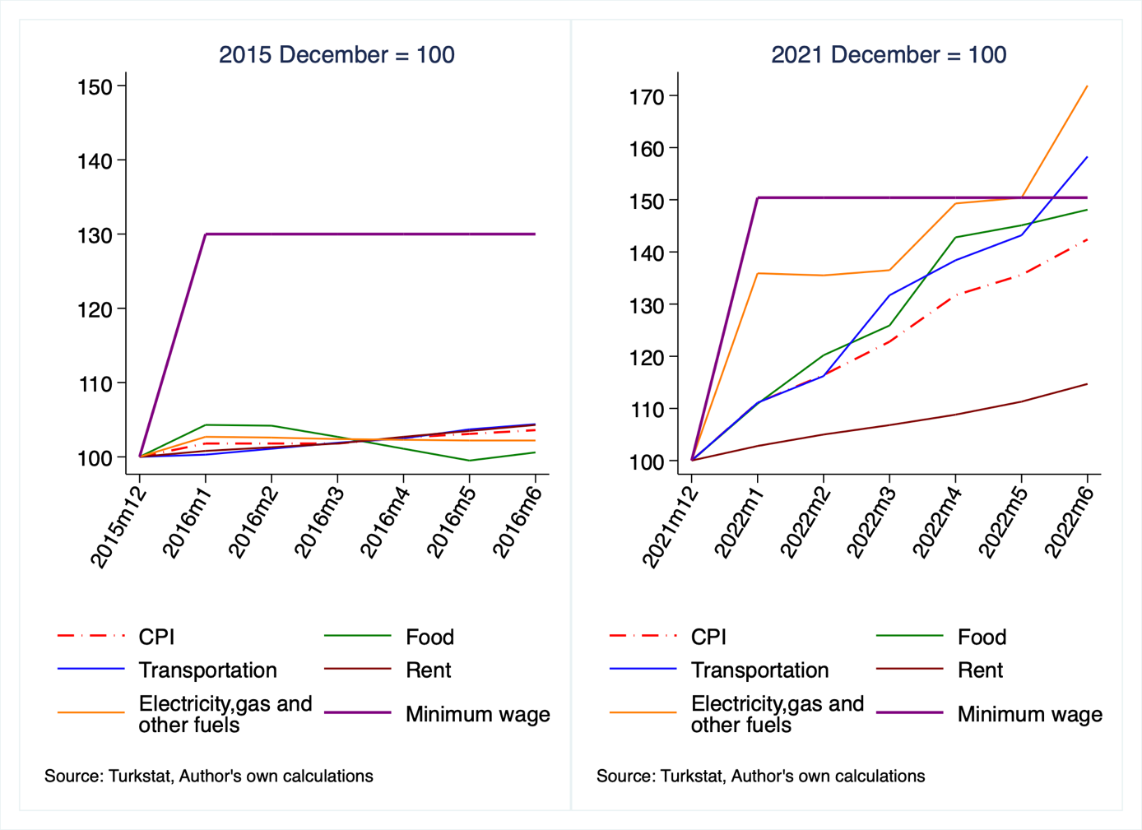

This situation is entirely different for the year 2022. All item prices increased significantly (right graph). Energy, food, and transportation prices have increased considerably above the general price index in the recent period. Although the increase in rent prices was more moderate compared to other items and remained below the CPI increase, the high minimum wage increase at the beginning of 2022 has melted mainly due to the striking price increases in the other three expenditure items. As mentioned above, the real minimum wage decreased from 517 TL in June 2021 to 435 TL in June 2022. This indicates a severe loss in the purchasing power of households.
Conclusion and recommendations
The findings in this research note reveal that the minimum wage increase in 2022 melted in the first six months of the year. Based on the recent global food, energy crisis and exchange rate shock, food and housing expenditures, which take up a significant percentage of the low-income consumption basket, are expected to increase in the future. Therefore, even if the government increases the minimum wage in the year's second half, a one-time increase will likely not prevent a decline in workers' incomes. During such periods of high inflation, however, government social assistance, such as direct income support to the poor and middle classes, will protect the purchasing power of relatively poor households against price increases.
Annex Table1: Minimum wage and Consumer Price Index
Year(June) | CPI (2003 June=100) | Real Minimum Wage(TL) | Nominal Minimum Wage (TL)
2003 | 100.0 | 226 | 226
2004 | 107.1 | 297 | 318
2005 | 116.7 | 300 | 350
2006 | 128.5 | 296 | 380
2007 | 139.5 | 300 | 419
2008 | 154.3 | 326 | 503
2009 | 163.2 | 335 | 546
2010 | 176.8 | 339 | 599
2011 | 187.9 | 351 | 659
2012 | 204.5 | 362 | 740
2013 | 221.5 | 363 | 804
2014 | 241.8 | 369 | 891
2015 | 259.2 | 386 | 1001
2016 | 279.0 | 466 | 1301
2017 | 309.4 | 454 | 1404
2018 | 357.0 | 449 | 1603
2019 | 413.1 | 489 | 2021
2020 | 465.3 | 500 | 2325
2021 | 546.8 | 517 | 2826
2022 | 976.7 | 435 | 4253
Source: Turkstat, Authors' calculations.
Annex Table 2: Consumption Expenditure Indexes (2003=100)
 | General | Food and non-alcoholic beverages | Transportation | Real rent | Electiricty, gas ve other fuels
2015 December | 269.54 | 302.27 | 245.87 | 364.90 | 302.92
2016 January | 274.44 | 315.22 | 246.71 | 367.72 | 311.04
2016 February | 274.38 | 315.10 | 248.61 | 369.70 | 310.65
2016 March | 274.27 | 310.29 | 250.57 | 371.46 | 310.11
2016 April | 276.42 | 305.70 | 252.13 | 374.64 | 309.75
2016 May | 278.02 | 300.69 | 254.90 | 377.52 | 309.65
2016 June | 279.33 | 304.18 | 256.62 | 380.66 | 309.58
2021 December | 686.95 | 874.42 | 791.13 | 643.07 | 738.56
2022 January | 763.23 | 969.71 | 879.32 | 660.79 | 1003.84
2022 February | 799.93 | 1051.29 | 919.45 | 675.49 | 1000.38
2022 March | 843.64 | 1101.00 | 1041.68 | 686.71 | 1008.15
2022 April | 904.79 | 1248.33 | 1094.98 | 699.54 | 1102.57
2022 May | 931.76 | 1268.74 | 1132.57 | 715.50 | 1110.93
2022 June | 977.90 | 1295.25 | 1252.47 | 737.75 | 1269.72
Source: Turkstat, Authors' calculations.
Annex Table 3: Weights by expenditure groups of consumer price index (2003=100, %)
 | Food and non-alcoholic beverages | Transport | Actual rentals for housing | Electricity, gas and other fuels
2016 | 23,68 | 14,31 | 5,15 | 6,62
2021 | 25,94 | 15,49 | 5,47 | 5,85
Source: Turkstat, Authors' calculations.

* Prof. Seyfettin Gürsel, Betam, seyfettin.gursel@eas.bau.edu.tr
** Prof. Ozan Bakış, Betam, ozan.bakis@eas.bau.edu.tr
*** Hamza Mutluay, Betam, hamza.mutluay@eas.bau.edu.tr
Since 2022 has not been completed, the annual inflation rate is unavailable. Therefore, to calculate real minimum wage for June 2022, the price index for June 2003 was taken as a basis. The same method was followed for real minimum wage calculations in other years.

