19 12 2022

Growth Evaluation:

2022 3rd Quarter

INVESTMENT IS DECREASING

Ozan Bakış ve Uğurcan Acar

Executive Summary
The Turkish economy has grown by 3.9 percent in the third quarter of 2022. The biggest contribution to the growth has come from private consumption, with 10.8 percentage points. The contribution of net foreign trade, which was 3.9 percentage points previous quarter, has been 0.7 percentage points. Changes in inventories have pulled the growth down by 8.3 percentage points. According to the seasonally and calendar-adjusted series, the Turkish economy has shrunk after nine quarters. Despite the 2.4 percentage point contribution of private consumption, net foreign trade’s contribution has been minus 2.5 percentage points. Changes in inventories and investments drove quarterly growth down by 0.8 and 0.6 percentage points, respectively.
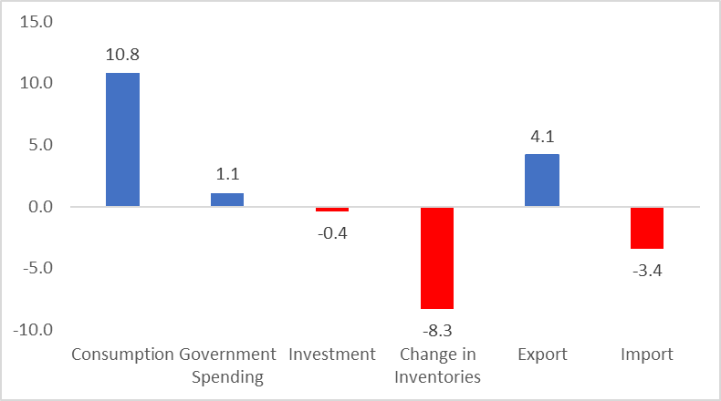

Figure 1: Contributions to growth (left) and year-on-year growth rates (right) of GDP components in 2022 Q3
Source: TurkStat, Betam

The increase in private consumption continues
In the third quarter of 2022, private consumption increased by 19.9 percent yearly, contributing 10.8 percentage points to growth (Table 1). According to the seasonally and calendar-adjusted figures, private consumption increased by 3.9 percent compared to the previous quarter, contributing 2.4 percentage points to quarterly growth (Table 2).

Table 1: Growth rates and contributions to the growth of GDP components in 2022 Q2 and 2022 Q3 compared to the same quarter of the previous year
 | 2022Q2 |  | 2022Q3
 | Change (%) | Contribution (%) | Change (%) | Contribution (%)
Consumption | 22.5 | 12.2 | 19.9 | 10.8
Government Spending | 2.0 | 0.3 | 8.5 | 1.1
Investment | 5.0 | 1.5 | -1.3 | -0.4
Change in Inventories |  | -10.1 |  | -8.3
Export | 16.4 | 5.7 | 12.6 | 4.1
Import | 5.8 | -1.9 | 12.2 | -3.4
GDP | 7.7 |  | 3.9
Source: TurkStat, Betam

Table 2: Growth rates and contributions to the growth of GDP components in 2022 Q2 and 2022 Q3 compared to the previous quarter
 | 2022Q2 |  | 2022Q3
 | Change (%) | Contribution (%) | Change (%) | Contribution (%)
Consumption | 4.3 | 2.5 | 3.9 | 2.4
Government Spending | -0.2 | 0.0 | 11.7 | 1.4
Investment | -1.4 | -0.4 | -2.3 | -0.6
Change in Inventories |  | -1.1 |  | -0.8
Export | 3.9 | 1.4 | -1.1 | -0.4
Import | 1.5 | -0.5 | 6.0 | -2.1
GDP | 1.9 |  | -0.1
Source: TurkStat, Betam

Investment spending has decreased
Investment spending has decreased by 1.3 percent this quarter, contributing minus 0.4 percentage points to growth. It decreased by 2.3 percent quarterly compared to the previous quarter, suppressing growth by 0.6 percentage points (Table 1 and Table 2).

Inventories have continued to decrease
We see that stock changes are continuing to suppress annual growth. The contribution of stock changes to annual and quarterly growth has been minus 8.3 and 0.8 percentage points, respectively (Tables 1 and 2). The contribution of stock change to annual growth is negative because the stocks accumulated during the pandemic continue to melt in 2022, as in 2021. The increase in production lags behind the rise in consumption due to decreasing stocks.

Low Foreign trade contribution due to increasing import
In the third quarter of 2022, exports increased by 12.6 percent, and imports increased by 12.2 percent annually. The acceleration in the increase in imports caused the foreign trade contribution to decline to 0.7 percentage points this quarter, which was 3.9 percentage points in the previous quarter. (Table 1). Looking at the seasonally and calendar-adjusted figures, it is seen that exports decreased by 1.1 percent and imports increased by 6 percent; thus, foreign trade pulled quarterly growth down by 1.7 percentage points (Table 2).
Public spending has increased
In the second quarter of 2022, public spending increased by 8.5 percent, contributing 1.1 percentage points to annual growth (Table 1). Public consumption increased by 11.7 percent in seasonally and calendar-adjusted figures, supporting quarterly growth by 1.4 percentage points (Table 2).

The future of growth
Two components drove growth in the third quarter of 2022 as in the first quarter: private consumption and exports. The contribution of change in inventories and investments have been negative. It is less likely that private consumption and exports will retain same trend in the coming quarters. Because, we can say that we have come to the end of the period of deferred demand due to the pandemic and of pull-forward demand of durable goods due to the high inflation. The stable trend of the dollar exchange rate is expected to increase the import demand in the coming periods. As we mentioned in our previous evaluation note, there are two other factors that negatively affect the course of growth. The first is declining investment spending for a while. The other is melting stocks. The decrease in these two variables can be interpreted as the expectations of the producing sectors for the future periods are not very positive.

Figure 2: GDP growth rates compared to the previous quarter and the same quarter of last year
Source: TurkStat, Betam

Betam, ozan.bakis@eas.bau.edu.tr
Betam, ugurcan.acar@eas.bau.edu.tr
TurkStat uses the chained volume index method when calculating new national income series. The contribution to growth of the inventory change cannot be easily calculated because there is an additivity problem in the chain method and a chain index cannot be derived for the "changes in inventories". We discussed in detail in the research note that we recently published how to account for the contribution of inventory change to growth in the chain-volume index approach (see Betam Research Note 17/217).

