7 June 2021

Growth Evaluation:

2022 1st Quarter

HOUSEHOLDS’ CONSUMPTION AND EXPORT HAS DRIVEN GROWTH

Ozan Bakış ve Uğurcan Acar

Executive Summary
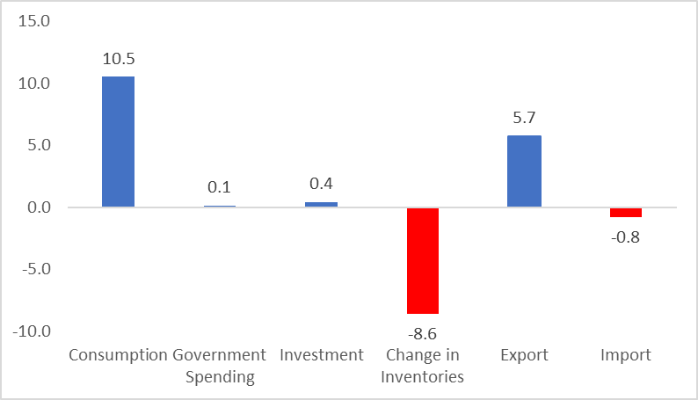
The Turkish economy has grown 7.3 percent in the first quarter of 2022. The biggest contribution to the growth has come from private consumption with 10.5 percentage points. The net foreign trade has contributed to the growth by 4.9 percentage points. According to the seasonally and calendar adjusted series, the GDP has grown by 1.2 percent compared to the previous quarter with the contribution of stock changes and imports. Private consumption reduced quarterly growth by two percentage points.
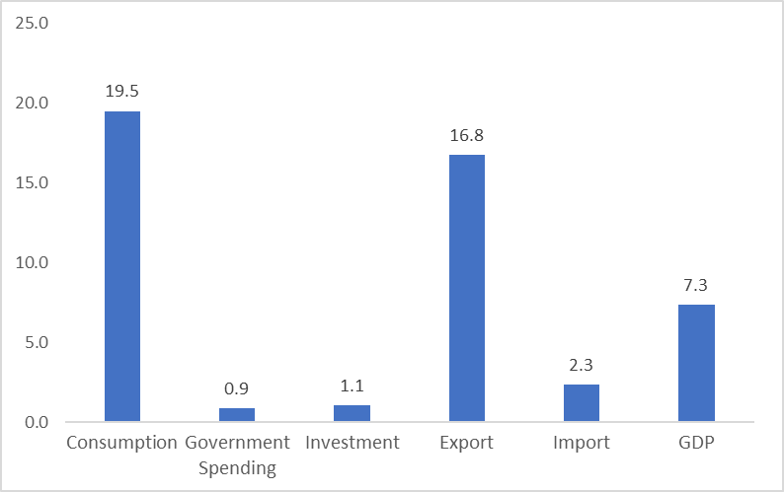

Figure 1: Contributions to growth (left) and year-on-year growth rates (right) of GDP components in 2022 Q1
Source: TurkStat, Betam

A massive increase in private consumption
In the first quarter of 2022, private consumption increased by 19.5 percent year on year, contributing 10.5 percentage points to growth (Table 1). The opposite is observed in the case of figures adjusted for seasonal and calendar effects. Private consumption decreased by 2.8 percent, pulling growth down by two percentage points (Table 2).

Table 1: Growth rates and contributions to the growth of GDP components in 2021 Q4 and 2022 Q1 compared to the same quarter of the previous year
 | 2021Q4 |  | 2022Q1
 | Change (%) | Contribution (%) | Change (%) | Contribution (%)
Consumption | 21.4 | 11.9 | 19.5 | 10.5
Government Spending | -1.9 | -0.3 | 0.9 | 0.1
Investment | -0.8 | -0.2 | 1.1 | 0.4
Change in Inventories |  | -7.8 |  | -8.6
Export | 20.7 | 6.6 | 16.8 | 5.7
Import | 2.6 | -1.0 | 2.3 | -0.8
GDP | 9.1 |  | 7.3
Source: TurkStat, Betam

Table 2: Growth rates and contributions to the growth of GDP components in 2021 Q4 and 2022 Q1 compared to the previous quarter
 | 2021Q4 |  | 2022Q1
 | Change (%) | Contribution (%) | Change (%) | Contribution (%)
Consumption | 9.4 | 5.6 | -2.8 | -2.0
Government Spending | -7.3 | -1.1 | 0.0 | 0.0
Investment | -1.0 | -0.3 | 2.0 | 0.4
Change in Inventories |  | -3.7 |  | 1.9
Export | 11.4 | 3.6 | -3.2 | -1.0
Import | 9.2 | -2.7 | -5.6 | 1.8
GDP | 1.5 |  | 1.2
Source: TurkStat, Betam

Investment spending has slightly increased
Investment spending, which decreased in the second half of 2021, increased this quarter, albeit limited, and supported growth. Investments, which increased by 1.1 percent on an annual basis and by 2% quarterly, contributed 0.4 percentage points to the annual and quarterly growth figures (Table 1 and Table 2).
Inventories have continued to decrease
We see that stock changes are continuing to suppress annual growth. While the contribution of stock changes to annual growth has been minus 8.6 percentage points (Table 1), according to seasonal and calendar adjusted data, its contribution to quarterly growth has been 1.9 percentage points (Table 2). The contribution of stock change to annual growth is negative because the stocks accumulated during the pandemic continue to melt in the first quarter of 2022, as in 2021. It can be said that the increase in production lags behind the rise in consumption due to decreasing stocks.

Foreign trade contribution falls
Since the increase in exports slows down faster than the increase in imports, the foreign trade contribution decreases. In the first quarter of 2022, exports have increased by 16.8 percent compared to the same period of the previous year, contributing 5.7 percentage points to the annual GDP growth. However, the contribution of net foreign trade to growth has decreased to 4.9 percentage points, with a negative contribution of 0.8 percentage points caused by the 2.3 percent increase in imports (Table 1). Considering the seasonally and calendar-adjusted figures, imports, which increased by 9.2 percent in the previous quarter, have decreased by 5.6 percent (Table 2).

Public spending has decreased
In the first quarter of 2022, public spending increased by 0.9 percent, contributing 0.4 percentage points to annual growth (Table 1). In seasonally adjusted figures, public consumption remained stable and did not affect growth (Table 2).

The future of growth
Two components drove growth in the first quarter of 2022: private consumption and exports. We can say that the main reason behind the high increase in private consumption in the first quarter was the forwarded demand in an environment with increasing inflation rates. The reason for the increase in exports was the depreciation in TL, which occurred in the last period. If there are no surprise shocks in inflation and exchange rate, we can say that both effects will be weaker in coming months, and as a result future economic growth. Another factor affecting the growth negatively is the low investment appetite due to the increasing inflation and deteriorating expectations. We do not expect investment behavior to change radically in the near future. For all these reasons, we expect the next period’s growth to be lower than the first quarter’s growth.

Figure 2: GDP growth rates compared to the previous quarter and the same quarter of last year

Source: TurkStat, Betam

Betam, ozan.bakis@eas.bau.edu.tr
Betam, ugurcan.acar@eas.bau.edu.tr
TurkStat uses the chained volume index method when calculating new national income series. The contribution to growth of the inventory change cannot be easily calculated because there is an additivity problem in the chain method and a chain index cannot be derived for the "changes in inventories". We discussed in detail in the research note that we recently published how to account for the contribution of inventory change to growth in the chain-volume index approach (see Betam Research Note 17/217).

