7 March 2021

Growth Evaluation:

2021 4th Quarter

HOUSEHOLDS’ CONSUMPTION DRIVED GROWTH

Ozan Bakış ve Uğurcan Acar

Executive Summary
The Turkish economy has grown 9.1 percent in the last quarter of 2021. The biggest contribution to the growth has come from special consumption this quarter. The 9.3 percentage point in the third quarter and 8.7 percentage point in the second foreign trade contribution which was 9.3 and 8.7 percentage points, respectively, in the second and third quarters of the year, decreased to 5.6 percentage points in this quarter. Using seasonally and calendar-adjusted data, we see that the GDP grows by 1.5 percent compared to the previous quarter by means of special consumption. The foreign trade contribution to the growth was 0.9 percentage points. Decreasing investments and public consumption, especially the stock change, slowed the quarterly growth.
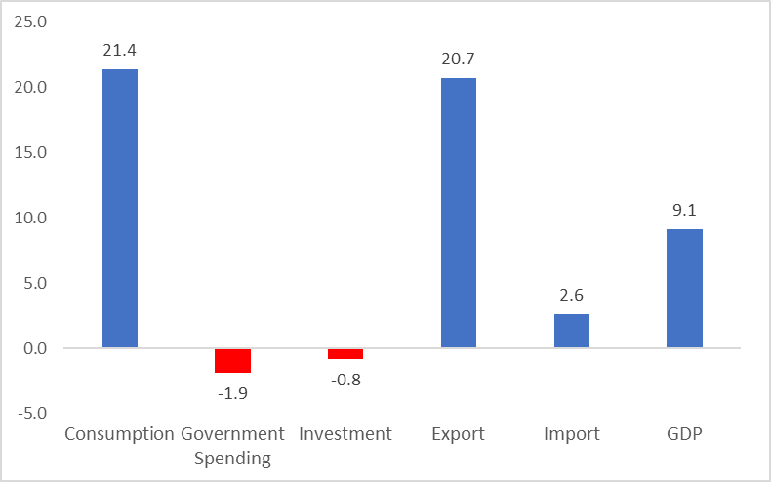
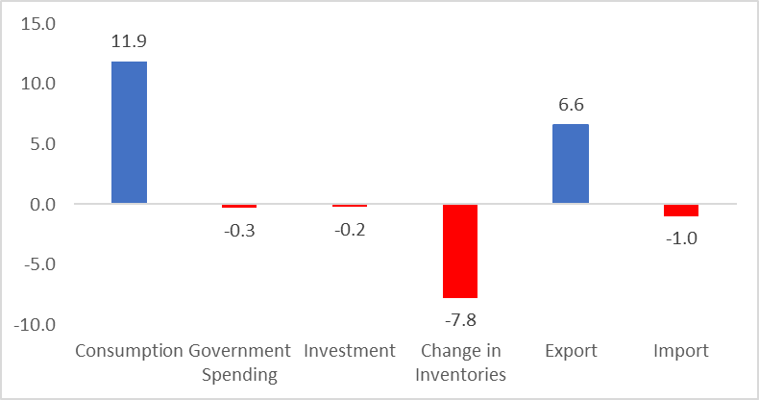
Figure 1: Contributions to growth (left) and year-on-year growth rates (right) of GDP components in 2021 Q3
Source: TurkStat, Betam

A massive increase in private consumption
In the fourth quarter of 2021, private consumption increased by 21.4 percent year on year, contributing 11.9 percentage points to growth (Table 1). When we look at the seasonally and calendar-adjusted figures, we see that private consumption increased by 9.4 percent and supported the growth by 5.6 percentage points (Table 2).

Table 1: Growth rates and contributions to the growth of GDP components in 2021 Q3 and 2021 Q4 compared to the same quarter of the previous year
 | 2021Q3 |  | 2021Q4
 | Change (%) | Contribution (%) | Change (%) | Contribution (%)
Consumption | 9.1 | 5.2 | 21.4 | 11.9
Government Spending | 7.9 | 1.1 | -1.9 | -0.3
Investment | -1.9 | -0.5 | -0.8 | -0.2
Change in Inventories |  | -7.7 |  | -7.8
Export | 25.5 | 6.6 | 20.7 | 6.6
Import | -8.9 | 2.9 | 2.6 | -1.0
GDP | 7.5 |  | 9.1
Source: TurkStat, Betam

Table 2: Growth rates and contributions to the growth of GDP components in 2021 Q3 and 2021 Q4 compared to the previous quarter
 | 2021Q3 |  | 2021Q4
 | Change (%) | Contribution (%) | Change (%) | Contribution (%)
Consumption | 8.3 | 4.6 | 9.4 | 5.6
Government Spending | 6.9 | 1.0 | -7.3 | -1.1
Investment | -1.8 | -0.5 | -1.0 | -0.3
Change in Inventories |  | -2.6 |  | -3.7
Export | 4.5 | 1.4 | 11.4 | 3.6
Import | 4.2 | -1.2 | 9.2 | -2.7
GDP | 2.8 |  | 1.5
Source: TurkStat, Betam

Decrease in investment
The contribution of investments that supported growth during the previous year changed direction in the second half of this year. The decline in investments that started in the previous quarter continued in the last quarter of 2021 (Table 1). Considering the seasonally and calendar-adjusted figures, a similar situation exists: investments decreased by 1 percent on a quarterly basis, bringing quarterly growth down by 0.3 percentage points (Table 2).
Inventories have run out
In the fourth quarter of 2021, just as in the previous quarter, stocks put a lot of pressure on growth. While the contribution of stock changes to annual growth was minus 7.8 percentage points (Table 1), according to seasonal and calendar adjusted data, the contribution of stock changes to quarterly growth was minus 3.7 percentage points (Table 2). We can say that the base effect continues in suppressing annual growth by the stock change. We observe that stocks that swelled with the impact of the pandemic dissolved rapidly in the third quarter, putting a brake on production.

Exports continue to increase, but imports also increase
In the fourth quarter of 2021, exports increased by 20.7 percent compared to the same period of the previous year, contributing 6.6 percentage points to annual GDP growth. However, with the increase in imports, the contribution of net foreign trade to growth decreased to 5.6 percentage points (Table 1). Looking at it quarter-on-quarter, it is seen that there was a substantial increase of 9.2 percent in imports (Table 2).

Public spending has decreased
In the fourth quarter of 2021, public expenditures decreased by 1.9 percent, bringing annual growth down by 0.3 percentage points (Table 1). In seasonally adjusted figures, however, we see that public consumption decreased by 7.3 percent compared to the previous quarter and made a negative contribution to growth by 1.1 percentage points (Table 2).

The future of growth
In our previous growth evaluation note, we had stated that we expect the contribution of net foreign trade to growth to be even stronger in the last quarter, as the exchange rates remained relatively flat throughout the third quarter and the main increases were realized in the fourth quarter. Seasonally and calendar-adjusted data have shown a course in line with this expectation. As long as the exchange rates remain at these levels, we can say that the TL will be incredibly worthless against other currencies, and therefore, net foreign trade will be a factor pushing growth up. Again, in our previous note, we had stated that we expect the deteriorating expectations due to inflation and market interest rates to pull down growth, especially on investments. Seasonally and calendar-adjusted fourth-quarter figures confirm this expectation. We can say that the near-term growth story will be determined by which of these two competing factors will dominate.

Figure 2: GDP growth rates compared to the previous quarter and same quarter of last year

Source: TurkStat, Betam

Betam, ozan.bakis@eas.bau.edu.tr
Betam, ugurcan.acar@eas.bau.edu.tr
TurkStat uses the chained volume index method when calculating new national income series. The contribution to growth of the inventory change cannot be easily calculated because there is an additivity problem in the chain method and a chain index cannot be derived for the "changes in inventories". We discussed in detail in the research note that we recently published how to account for the contribution of inventory change to growth in the chain-volume index approach (see Betam Research Note 17/217).

