27 September 2021

Growth Evaluation:

2021 2nd Quarter

EXPORTS ARE THE MAIN DRIVER OF GROWTH

Ozan Bakış ve Gökhan Dilek

Executive Summary
In the second quarter of 2021, the growth rate of the Turkish economy on an annual basis come out at the record-breaking level, thanks in large part to the base effect. GDP grows by 21.7 percent compared to the same quarter of the previous year, with the biggest contribution coming from exports and private consumption expenditures. When we look at the seasonally and calendar adjusted data, we see that the GDP grows by 0.9 percent compared to the previous quarter, and except for change in inventories, all factors make positive contributions to the growth. Both annual and quarterly growth figures show that the recovery of the Turkish economy from the epidemic still continues despite the lockdown measures implemented in the second quarter. The faster pace of vaccination is likely to be a factor maintaining the recovery process.

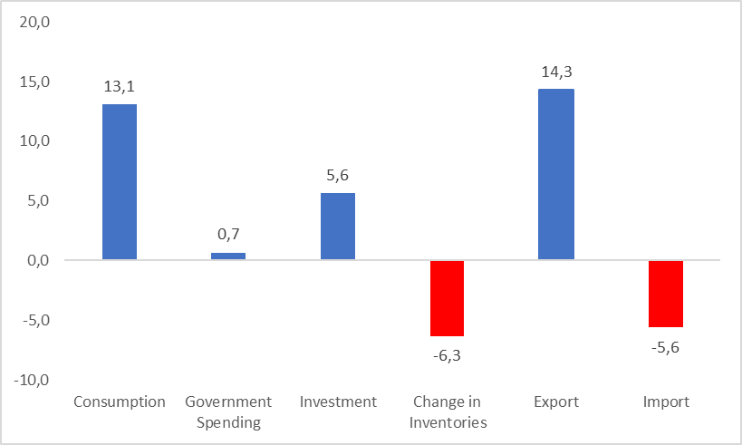
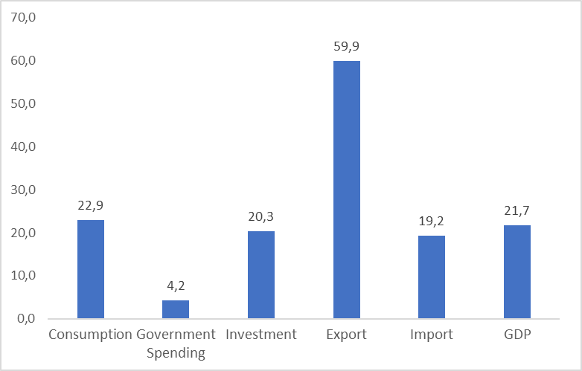
Figure 1: Contributions to growth (left) and year-on-year growth rates (right) of GDP components in 2021 Q2

Source: TurkStat, Betam

Increase in private consumption
In the second quarter of 2021, the growth rate of private consumption by the households on an annual basis is mostly affected by the base effect. In this quarter, private consumption grows at the annual rate of 22.9 percent and supports the yearly GDP growth by 13.1 percentage points in the first quarter of 2021 (Table 1). When we look at the seasonally and calendar adjusted data, we see that private consumption increases by 1.6 percent and contributes positively the quarterly GDP growth by 0.9 percentage points (Table 2). The contraction in imports and expansion of private consumption expenditures are the main drivers of the GDP growth.

Table 1: Growth rates and contributions to the growth of GDP components in 2021 Q1 and 2021 Q2 compared to the same quarter of the previous year
 | 2021Q1 |  | 2021Q2
 | Change (%) | Contribution (%) | Change (%) | Contribution (%)
Consumption | 7,0 | 4,0 | 22,9 | 13,1
Government Spending | 0,7 | 0,1 | 4,2 | 0,7
Investment | 12,4 | 3,2 | 20,3 | 5,6
Change in Inventories |  | -1,8 |  | -6,3
Export | 3,0 | 1,2 | 59,9 | 14,3
Import | -1,8 | 0,6 | 19,2 | -5,6
GDP | 7,2 |  | 21,7

Source: TurkStat, Betam

Table 2: Growth rates and contributions to the growth of GDP components in 2021 Q1 and 2021 Q2 compared to the previous quarter
 | 2021Q1 |  | 2021Q2
 | Change (%) | Contribution (%) | Change (%) | Contribution (%)
Consumption | -0,7 | -0,4 | 1,6 | 0,9
Government Spending | -0,8 | -0,1 | 0,7 | 0,1
Investment | 1,4 | 0,4 | 0,7 | 0,2
Change in Inventories |  | -0,2 |  | -1,9
Export | -2,8 | -0,7 | 2,2 | 0,7
Import | -9,7 | 3,2 | -3,3 | 1,0
GDP | 2,2 |  | 0,9
Source: TurkStat, Betam

Investments continue to grow
Investment expenditures, which have been increasing since the third quarter of 2020, continue to grow in the second quarter of 2021 at an annual rate of 20.3 percent, and contribute the output growth by 5.6 percentage points (Table 1). According to the seasonally and calendar adjusted data, investment expenditures grow by 0.7 percent compared to the previous quarter. Thus, investment expenditures support quarterly growth by 0.2 percentage points in this quarter (Table 2).

Decreases in inventory suppress growth
In the second quarter of 2021, change in inventories weighs down annual GDP growth by minus 6.3 percentage points (Table 1); according to the seasonal and calendar adjusted data, change in inventories contributes to the GDP growth by minus 1.9 percentage points (Table 2). The negative effect of change in inventories to the GDP is also a result of the base effect, as the shutdown in the economic activity caused firms to pile up inventories in the second quarter of 2020.

Imports increase yearly, decrease quarterly
In the second quarter of 2021, exports record a steep increase of 59.9 percent year-on-year, and contribute the GDP growth by 14.3 percentage points. On the other hand, the yearly increase in imports by 19.2 percentage points depresses the growth by 5.6 percentage points. (Table 1). Both changes in imports and exports contributed the quarterly GDP growth, as the contraction in imports by 3.3 percentage points contributed the growth by 1.0 percentage points (Table 2).

Public spending is in its “normal” course
After remaining unchanged in the second quarter of the previous year, the public expenditures increase mildly at an annual rate of 4.2 percent and contributed to the growth by 0.7 percentage points in the second quarter of 2021 (Table 1). According to the seasonally and calendar adjusted data, public expenditures increase by 0.7 percent in this quarter compared to the previous quarter. Its contribution to growth is 0.1 percentage points (Table 2).
The future of growth
Year-on-year GDP comparisons of 2021 will yield unhealthy results because the GDP decreased by more than 10 percent on the same quarter of the last year. For this reason, it would be appropriate to focus on the seasonal and calendar adjusted data that do not include the base effect. This approach is proven to be more grounded as the quarterly GDP growth is moderate with a rate of 0.9 percent. We do not expect the quarterly growth figure to be very high for the coming quarter because of two reasons. The first one is the uncertainty surrounding the monetary policy implemented by the Central Bank of Turkey. The second one is the uncertainty around the pandemic. These two factors may induce the private investors to limit or defer their investments.

Figure 2: GDP growth rates compared to the previous quarter and same quarter of last year
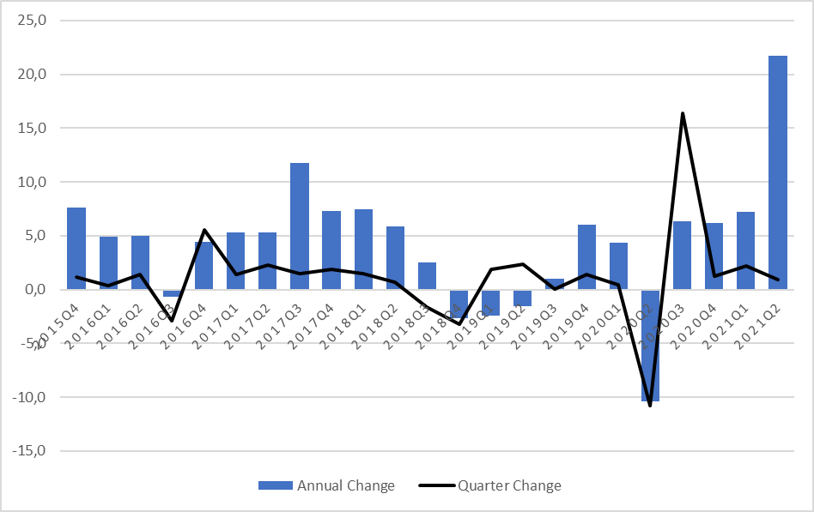
Source: TurkStat, Betam

Betam, ozan.bakis@eas.bau.edu.tr
Betam, gokhan.dilek@eas.bau.edu.tr
TurkStat uses the chained volume index method when calculating new national income series. The contribution to growth of the inventory change cannot be easily calculated because there is an additivity problem in the chain method and a chain index cannot be derived for the "changes in inventories". We discussed in detail in the research note that we recently published how to account for the contribution of inventory change to growth in the chain-volume index approach (see Betam Research Note 17/217).

