Labor Market Outlook:
September 2021

13 September 2021

NUMBER OF UNEMPLOYED PEOPLE INCREASED BY 506K WHILE EMPLOYMENT ROSE BY 125K

Seyfettin Gürsel*, Hamza Mutluay** ,Mehmet Cem Şahin***

Executive Summary

Unemployment level rose at a high rate of 506 thousand as opposed to the increase in employment level by 125 thousand and hence total labor force increased by 631 thousand. Therefore, unemployment rate rose by 1.4% MoM and reached 12%. Labor force increased following the falls in the last three months. On the other hand, the rate of increase in employment level reduced following a big hike (583 thousand) in June. According to the sectorial data, employment level in manufacturing and construction sectors declined while employment level in agricultural and services sectors increased. In July, employment level in services sector rose by 454 thousand whereas agricultural employment level rose by 17 thousand. Employment levels in manufacturing and construction sectors declined by 287 thousand and 60 thousand, respectively.
Seasonally adjusted female unemployment rate rose by 0.2% MoM to 14.4%. On the other hand, seasonally adjusted male unemployment rate rose by 1.9% to 10.8% because of a decline in employment level by 191 thousand and a rise of unemployed people by 432 thousand. Female employment rose and male employment declined while both female and male labor force increased. As a result of the dramatic fall in male employment, gender gap in unemployment rates reduced by 1.7% to 3.6%.
Unemployment soars
According to the seasonally adjusted monthly data, the number of employed people rose by 125 thousand to 28 million 730 thousand, the number of unemployed people increased by 506 thousand to 3 million 902 thousand and hence total labor force rose by 631 thousand to 32 million 632 thousand (Figure 1, Table 1). As a result of these developments, unemployment rate rose by 1.4% to 12% in July.
Figure 1 : Seasonally adjusted labor force, employment, and unemployment

Source: Turkstat, Betam

Developments in the alternative unemployment rates
Box 1 reports the methods how Turkstat calculates the alternative unemployment rates. These measures take both the time-related underemployment (those who are employed less than 40 hours a week, would like to increase their working hours, but fail to find the jobs) and the potential labor force (the individuals who are neither employed nor looking for a job but wish to work) into account.
Box 1: Definitions of alternative unemployment rates
The time-related underemployment: Persons employed in the reference week who actually worked less than 40 hours as total (in main job and additional job/s), were willing to work additional hours and were available to do so but could not find a job for the extra hours.

The potential labor force: Persons not in employment who would like to work, but for whom the existing conditions limit active job search and/or availability.

The unemployed: The unemployed comprises all persons 15 years of age and over who were not employed during the reference period had used at least one active channel for seeking a job during the last four weeks and were available to start work within two weeks.
1) Unemployment rate = [persons in unemployment/labor force]x100

2) Combined rate of time-related underemployment and unemployment =
[(persons in time-related underemployment + persons in unemployment) / labor force] * 100

3) Combined rate of unemployment and potential labor force =
[(persons in unemployment + potential labor force)/ (labor force+ potential labor force)] x 100

4) Composite measure of labor underutilization =
[(persons in time-related underemployment + persons in unemployment + potential labor force) / (labor force+ potential labor force)] x 100

All of three alternative unemployment rates increased by similar rates while unemployment rate rose from 10.6% to 12%. In addition to the soar in unemployment rate, both time-related underemployment and labor underutilization levels increased. The seasonally adjusted data reveals that the combined rate of time-related underemployment and unemployment increased by 1.7 pp to 16.3%, whereas the combined rate of unemployment and the potential labor force rose by 0.8 pp to 19.6%. The composite measure of labor underutilization, which consists of these two alternative unemployment rate measures, rose by 1.2 pp to 23.6% (Figure 2, Table 4).

Figure 2 : Headline Unemployment Rate and Supplementary Indicators for Labor Force

Source: Turkstat, Betam

Unexpected fall of employment in manufacturing, strong growth in non-agricultural unemployment

According to the seasonally adjusted data, non-agricultural employment level rose by 108 thousand to 23 million 800 thousand (Figure 3, Table 2). Non- agricultural unemployment level rose by 519 thousand to 3 million 842 thousand. As a result, non- agricultural unemployment rate rose by 1.6 pp to 13.9%.

Figure 3 : Seasonally adjusted labor force, employment, and unemployment rate

Source: Turkstat, Betam

In July, employment levels in manufacturing and construction sectors fell. Employment level of manufacturing sector decreased by 287 thousand in July after a rise of 295 thousand in June. It is not possible to completely attribute the high volatility of employment level in manufacturing sector in subsequent months to labor market dynamics. On the other hand, employment level in construction sector fell by 60 thousand in July after moderate rises in May and June. Employment levels in agricultural and services sectors rose by 17 thousand and 454 thousand, respectively. It is noteworthy that female employment level in services sector increased by 289 thousand in a very short time span of one month. As a result of this development, employment level in services sector exceeded not only its pre-pandemic level but also its pre-2018 crisis level and reached a record level.
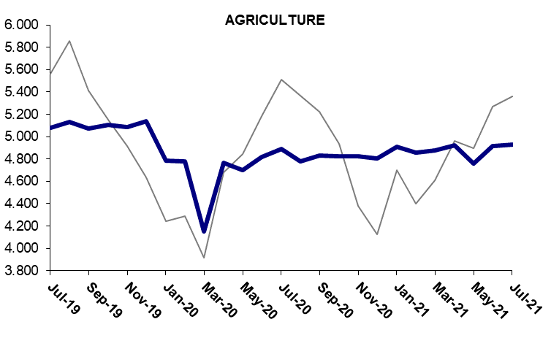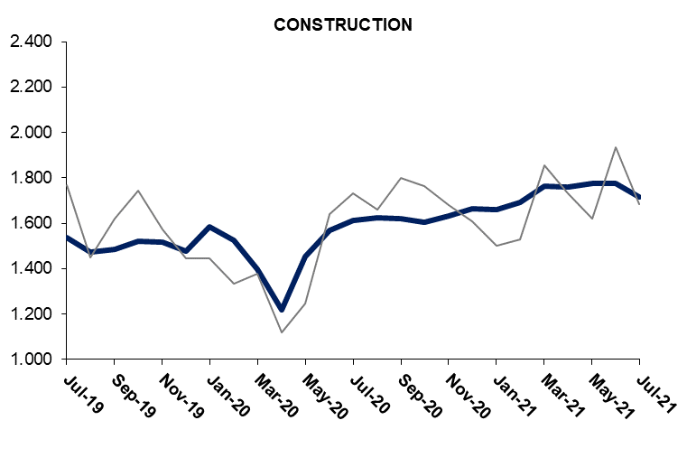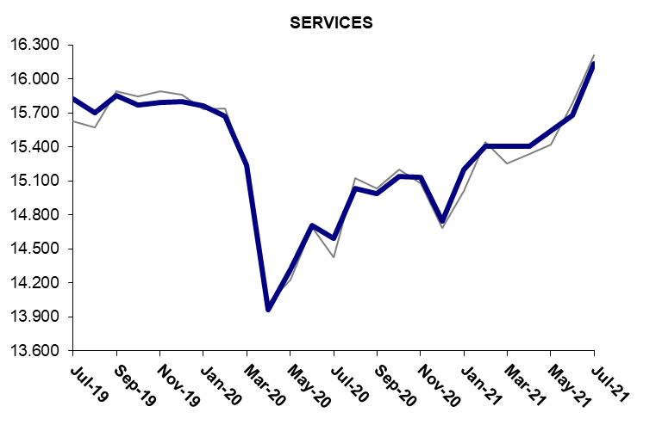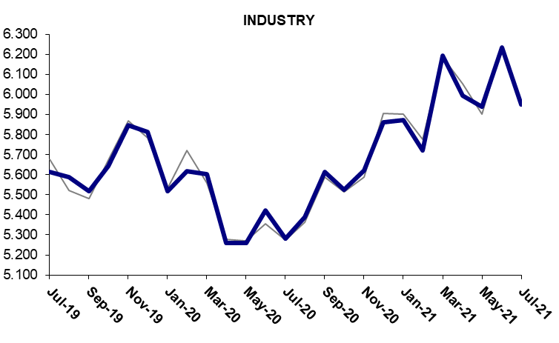
Figure 4 : Employment by sectors (in thousands)

Source: Turkstat, Betam

The fall in male employment reduced the gender gap in unemployment rates

Figure 5 depicts seasonally adjusted unemployment rate for females (purple) and males (green). In July, female labor force and employment level rose by 390 thousand and 316 thousand, respectively. It is worth noting that the rise of 289 thousand of female employment in services is the main constituent of the total rise of 316 thousand in female employment. Female unemployment rate rose by 0.2 pp to 14.4% as the rise of the female labor force is greater than the rise of female employment. Male labor force increased by 241 thousand and male employment fell by 191 thousand (Table 5). As a result, male unemployment rate rose by 1.9 pp to 10.8%.

Figure 5 : Seasonally adjusted unemployment rate by gender (%)

Source: Turkstat, Betam

In line with those developments, female employment rate rose by 0.9 pp but male employment rate reduced by 0.7 pp. In July, female employment rate recovered from 0.9 pp fall in May. Female employment rate also exceeded its pre-pandemic level (January 2020: 27.6%, July 2021: 28.2%). Following 1.1 pp MoM rise in June, male employment rate receded in July.

Figure 6 : Seasonally adjusted employment rate by gender (%)

Source: Turkstat, Betam

Table 1 : Seasonally adjusted labor force indicators (in thousands)

 | Labor force | Employment | Unemployment | Unemployment rate | Monthly changes
July-18 | 32457 | 28955 | 3502 | 10.8% | Labor force | Employment | Unemployment
August-18 | 32325 | 28708 | 3616 | 11.2% | -132 | -247 | 114
September-18 | 32489 | 28760 | 3729 | 11.5% | 164 | 52 | 113
October-18 | 32324 | 28574 | 3749 | 11.6% | -165 | -186 | 20
November-18 | 32357 | 28406 | 3951 | 12.2% | 33 | -168 | 202
December-18 | 32395 | 28258 | 4137 | 12.8% | 38 | -148 | 186
January-19 | 32074 | 27737 | 4337 | 13.5% | -321 | -521 | 200
February-19 | 32456 | 27951 | 4504 | 13.9% | 382 | 214 | 167
March-19 | 32843 | 28284 | 4559 | 13.9% | 387 | 333 | 55
April-19 | 32335 | 27906 | 4429 | 13.7% | -508 | -378 | -130
May-19 | 32662 | 28205 | 4457 | 13.6% | 327 | 299 | 28
June-19 | 32543 | 28088 | 4455 | 13.7% | -119 | -117 | -2
July-19 | 32595 | 28053 | 4542 | 13.9% | 52 | -35 | 87
August-19 | 32482 | 27896 | 4586 | 14.1% | -113 | -157 | 44
September-19 | 32510 | 27928 | 4582 | 14.1% | 28 | 32 | -4
October-19 | 32389 | 28039 | 4350 | 13.4% | -121 | 111 | -232
November-19 | 32588 | 28243 | 4345 | 13.3% | 199 | 204 | -5
December-19 | 32572 | 28228 | 4345 | 13.3% | -16 | -15 | 0
January-20 | 31824 | 27649 | 4175 | 13.1% | -748 | -579 | -170
February-20 | 31616 | 27592 | 4024 | 12.7% | -208 | -57 | -151
March-20 | 30350 | 26388 | 3962 | 13.1% | -1266 | -1204 | -62
April-20 | 29106 | 25209 | 3897 | 13.4% | -1244 | -1179 | -65
May-20 | 29648 | 25729 | 3919 | 13.2% | 542 | 520 | 22
June-20 | 30580 | 26513 | 4067 | 13.3% | 932 | 784 | 148
July-20 | 30828 | 26379 | 4449 | 14.4% | 248 | -134 | 382
August-20 | 30870 | 26830 | 4040 | 13.1% | 42 | 451 | -409
September-20 | 31007 | 27056 | 3951 | 12.7% | 137 | 226 | -89
October-20 | 31127 | 27097 | 4030 | 12.9% | 120 | 41 | 79
November-20 | 31271 | 27210 | 4061 | 13.0% | 144 | 113 | 31
December-20 | 31013 | 27071 | 3942 | 12.7% | -258 | -139 | -119
January-21 | 31644 | 27640 | 4004 | 12.7% | 631 | 569 | 62
February-21 | 31863 | 27671 | 4192 | 13.2% | 219 | 31 | 188
March-21 | 32468 | 28237 | 4231 | 13.0% | 605 | 566 | 39
April-21 | 32454 | 28082 | 4372 | 13.5% | -14 | -155 | 141
May-21 | 32113 | 28022 | 4091 | 12.7% | -341 | -60 | -281
June-21 | 32001 | 28605 | 3396 | 10.6% | -112 | 583 | -695
July-21 | 32632 | 28730 | 3902 | 12.0% | 631 | 125 | 506

Source: Turkstat, Betam

Table 2 : Seasonally adjusted non-agricultural labor force indicators (in thousands)

 | Labor force | Employment | Unemployment | Unemployment rate | Monthly changes
July-18 | 27,120 | 23,676 | 3,444 | 12.7% | Labor force | Employment | Unemployment
August-18 | 27,016 | 23,477 | 3,539 | 13.1% | -104 | -199 | 95
September-18 | 27,145 | 23,535 | 3,610 | 13.3% | 129 | 58 | 71
October-18 | 27,081 | 23,398 | 3,683 | 13.6% | -64 | -137 | 73
November-18 | 27,070 | 23,199 | 3,871 | 14.3% | -11 | -199 | 188
December-18 | 27,138 | 23,122 | 4,016 | 14.8% | 68 | -77 | 145
January-19 | 26,857 | 22,614 | 4,243 | 15.8% | -281 | -508 | 227
February-19 | 27,139 | 22,797 | 4,342 | 16.0% | 282 | 183 | 99
March-19 | 27,618 | 23,199 | 4,419 | 16.0% | 479 | 402 | 77
April-19 | 27,184 | 22,807 | 4,377 | 16.1% | -434 | -392 | -42
May-19 | 27,451 | 23,114 | 4,337 | 15.8% | 268 | 307 | -39
June-19 | 27,395 | 23,012 | 4,383 | 16.0% | -56 | -102 | 46
July-19 | 27,448 | 22,974 | 4,474 | 16.3% | 53 | -38 | 91
August-19 | 27,262 | 22,764 | 4,498 | 16.5% | -186 | -210 | 24
September-19 | 27,371 | 22,855 | 4,516 | 16.5% | 109 | 91 | 18
October-19 | 27,205 | 22,934 | 4,271 | 15.7% | -166 | 79 | -245
November-19 | 27,466 | 23,154 | 4,312 | 15.7% | 261 | 220 | 41
December-19 | 27,358 | 23,090 | 4,268 | 15.6% | -108 | -64 | -44
January-20 | 26,932 | 22,865 | 4,067 | 15.1% | -426 | -225 | -201
February-20 | 26,680 | 22,811 | 3,869 | 14.5% | -252 | -54 | -198
March-20 | 26,102 | 22,239 | 3,863 | 14.8% | -577 | -572 | -5
April-20 | 24,247 | 20,440 | 3,807 | 15.7% | -1855 | -1799 | -56
May-20 | 24,916 | 21,029 | 3,887 | 15.6% | 669 | 589 | 80
June-20 | 25,677 | 21,697 | 3,980 | 15.5% | 761 | 668 | 93
July-20 | 25,888 | 21,487 | 4,401 | 17.0% | 211 | -210 | 421
August-20 | 26,032 | 22,049 | 3,983 | 15.3% | 144 | 562 | -418
September-20 | 26,113 | 22,222 | 3,891 | 14.9% | 81 | 173 | -92
October-20 | 26,231 | 22,270 | 3,961 | 15.1% | 118 | 48 | 70
November-20 | 26,336 | 22,386 | 3,950 | 15.0% | 106 | 116 | -10
December-20 | 26,134 | 22,266 | 3,868 | 14.8% | -203 | -120 | -83
January-21 | 26,616 | 22,730 | 3,886 | 14.6% | 482 | 464 | 18
February-21 | 26,873 | 22,815 | 4,058 | 15.1% | 257 | 85 | 172
March-21 | 27,417 | 23,359 | 4,058 | 14.8% | 544 | 544 | 0
April-21 | 27,443 | 23,162 | 4,281 | 15.6% | 26 | -197 | 223
May-21 | 27,237 | 23,260 | 3,977 | 14.6% | -207 | 98 | -305
June-21 | 27,015 | 23,692 | 3,323 | 12.3% | -222 | 432 | -654
July-21 | 27,642 | 23,800 | 3,842 | 13.9% | 627 | 108 | 519

Source: Turkstat, Betam

Table 3 : Seasonally adjusted employment by sectors (in thousands)

 | Agriculture | Manufacturing | Construction | Service | Monthly changes
July-18 | 5279 | 5842 | 2016 | 15817 | Agriculture | Manufacturing | Construction | Service
August-18 | 5231 | 5751 | 1912 | 15814 | -48 | -91 | -104 | -3
September-18 | 5225 | 5753 | 1950 | 15833 | -6 | 2 | 38 | 19
October-18 | 5176 | 5790 | 1887 | 15721 | -49 | 37 | -63 | -112
November-18 | 5207 | 5659 | 1764 | 15776 | 31 | -131 | -123 | 55
December-18 | 5136 | 5629 | 1787 | 15706 | -71 | -30 | 23 | -70
January-19 | 5123 | 5194 | 1676 | 15743 | -13 | -435 | -111 | 37
February-19 | 5154 | 5369 | 1654 | 15775 | 31 | 175 | -22 | 32
March-19 | 5085 | 5610 | 1719 | 15869 | -69 | 241 | 65 | 94
April-19 | 5099 | 5366 | 1597 | 15844 | 14 | -244 | -122 | -25
May-19 | 5091 | 5618 | 1628 | 15868 | -8 | 252 | 31 | 24
June-19 | 5076 | 5663 | 1546 | 15802 | -15 | 45 | -82 | -66
July-19 | 5079 | 5615 | 1535 | 15824 | 3 | -48 | -11 | 22
August-19 | 5132 | 5589 | 1472 | 15704 | 53 | -26 | -63 | -120
September-19 | 5073 | 5518 | 1486 | 15851 | -59 | -71 | 14 | 147
October-19 | 5105 | 5644 | 1522 | 15768 | 32 | 126 | 36 | -83
November-19 | 5089 | 5847 | 1517 | 15789 | -16 | 203 | -5 | 21
December-19 | 5138 | 5813 | 1476 | 15802 | 49 | -34 | -41 | 13
January-20 | 4784 | 5516 | 1583 | 15766 | -354 | -297 | 107 | -36
February-20 | 4781 | 5616 | 1527 | 15668 | -3 | 100 | -56 | -98
March-20 | 4149 | 5604 | 1399 | 15236 | -632 | -12 | -128 | -432
April-20 | 4769 | 5261 | 1218 | 13961 | 620 | -343 | -181 | -1275
May-20 | 4700 | 5260 | 1452 | 14317 | -69 | -1 | 234 | 356
June-20 | 4816 | 5422 | 1570 | 14706 | 116 | 162 | 118 | 389
July-20 | 4892 | 5283 | 1611 | 14592 | 76 | -139 | 41 | -114
August-20 | 4781 | 5388 | 1625 | 15036 | -111 | 105 | 14 | 444
September-20 | 4834 | 5614 | 1621 | 14987 | 53 | 226 | -4 | -49
October-20 | 4827 | 5524 | 1604 | 15142 | -7 | -90 | -17 | 155
November-20 | 4824 | 5622 | 1634 | 15130 | -3 | 98 | 30 | -12
December-20 | 4805 | 5861 | 1664 | 14741 | -19 | 239 | 30 | -389
January-21 | 4910 | 5871 | 1659 | 15200 | 105 | 10 | -5 | 459
February-21 | 4856 | 5720 | 1692 | 15402 | -54 | -151 | 33 | 202
March-21 | 4878 | 6194 | 1763 | 15402 | 22 | 474 | 71 | 0
April-21 | 4920 | 5994 | 1759 | 15409 | 42 | -200 | -4 | 7
May-21 | 4762 | 5940 | 1776 | 15544 | -158 | -54 | 17 | 135
June-21 | 4913 | 6235 | 1777 | 15681 | 151 | 295 | 1 | 137
July-21 | 4930 | 5948 | 1717 | 16135 | 17 | -287 | -60 | 454

Source: Turkstat, Betam

Table 4 : Unemployment, alternative unemployment rates (%) levels (in thousand)

 | Unemployment Rate (%) | Persons in Unemployment (in thousands) | Combined Rate of Time-Related Underemployment and Unemployment (%) | Time-Related Underemployed (in thousands) | Combined Rate of Unemployment and Potential Labor Force (%) | Potential Labor Force (in thousands) | Composite Measure of Labor Underutilization (%) | Total
Jul-18 | 10.8 | 3502 | 11.8 | 328 | 15.3 | 1728 | 16.3 | 5558
Aug-18 | 11.2 | 3616 | 12.3 | 360 | 15.6 | 1690 | 16.6 | 5666
Sep-18 | 11.5 | 3729 | 12.4 | 300 | 15.3 | 1466 | 16.2 | 5495
Oct-18 | 11.6 | 3749 | 12.9 | 421 | 15.8 | 1613 | 17.0 | 5783
Nov-18 | 12.2 | 3951 | 13.4 | 385 | 16.5 | 1662 | 17.6 | 5998
Dec-18 | 12.8 | 4137 | 14.0 | 398 | 17.1 | 1692 | 18.2 | 6227
Jan-19 | 13.6 | 4337 | 14.7 | 378 | 18.6 | 2001 | 19.7 | 6716
Feb-19 | 13.9 | 4504 | 15.1 | 397 | 18.1 | 1673 | 19.2 | 6574
Mar-19 | 13.9 | 4559 | 15.2 | 433 | 18.4 | 1819 | 19.7 | 6811
Apr-19 | 13.8 | 4429 | 14.8 | 357 | 17.9 | 1655 | 19.0 | 6441
May-19 | 13.7 | 4457 | 14.5 | 279 | 17.7 | 1609 | 18.5 | 6345
Jun-19 | 13.7 | 4455 | 14.6 | 296 | 18.2 | 1794 | 19.1 | 6546
Jul-19 | 13.9 | 4542 | 15.0 | 347 | 18.3 | 1742 | 19.3 | 6631
Aug-19 | 14.1 | 4586 | 14.9 | 254 | 18.5 | 1746 | 19.3 | 6586
Sep-19 | 14.1 | 4582 | 15.2 | 360 | 17.9 | 1507 | 19.0 | 6449
Oct-19 | 13.4 | 4350 | 14.4 | 314 | 17.8 | 1722 | 18.7 | 6386
Nov-19 | 13.3 | 4345 | 14.4 | 348 | 17.5 | 1646 | 18.5 | 6339
Dec-19 | 13.3 | 4345 | 14.5 | 378 | 17.6 | 1684 | 18.6 | 6407
Jan-20 | 13.1 | 4175 | 15.7 | 821 | 19.1 | 2353 | 21.5 | 7349
Feb-20 | 12.7 | 4024 | 15.0 | 718 | 18.7 | 2322 | 20.8 | 7065
Mar-20 | 13.1 | 3962 | 16.1 | 924 | 20.5 | 2842 | 23.2 | 7729
Apr-20 | 13.5 | 3897 | 18.2 | 1400 | 23.4 | 3804 | 27.7 | 9101
May-20 | 13.4 | 3919 | 19.0 | 1714 | 24.1 | 4251 | 29.1 | 9884
Jun-20 | 13.3 | 4067 | 17.0 | 1132 | 22.4 | 3586 | 25.7 | 8785
Jul-20 | 14.4 | 4449 | 18.4 | 1223 | 22.6 | 3253 | 26.2 | 8926
Aug-20 | 13.0 | 4040 | 17.1 | 1239 | 21.7 | 3396 | 25.3 | 8674
Sep-20 | 12.6 | 3951 | 16.0 | 1010 | 21.3 | 3372 | 24.3 | 8333
Oct-20 | 12.8 | 4030 | 17.2 | 1324 | 21.7 | 3480 | 25.6 | 8833
Nov-20 | 13.0 | 4061 | 17.0 | 1255 | 23.0 | 4067 | 26.5 | 9383
Dec-20 | 12.7 | 3942 | 17.9 | 1609 | 23.9 | 4560 | 28.4 | 10111
Jan-21 | 12.6 | 4004 | 20.1 | 2356 | 22.9 | 4206 | 29.4 | 10566
Feb-21 | 13.2 | 4192 | 19.6 | 2053 | 22.3 | 3750 | 28.0 | 9995
Mar-21 | 13.2 | 4231 | 18.1 | 1646 | 21.1 | 3320 | 25.7 | 9197
Apr-21 | 13.8 | 4372 | 19.6 | 1989 | 21.6 | 3365 | 27.1 | 9726
May-21 | 13.1 | 4091 | 18.8 | 1946 | 21.3 | 3493 | 26.8 | 9530
Jun-21 | 10.6 | 3396 | 14.6 | 1276 | 18.8 | 3227 | 22.4 | 7899
Jul-21 | 12.0 | 3902 | 16.3 | 1417 | 19.6 | 3102 | 23.6 | 8421

Source: Turkstat, Betam

Table 5 : Seasonally adjusted female and male labor market indicators (thousands)

 | Total labor force, Female | Total Employment, Female | Total Unemployed, Female | Total labor force, Male | Total Employment, Male | Total Unemployed, Male | Women LFPR | Women Employment Rate | Men LFPR | Men Employment Rate
Jul-18 | 10,484 | 9,038 | 1,446 | 21,973 | 19,917 | 2,056 | 34.2 | 29.5 | 73.2 | 66.4
Aug-18 | 10,471 | 9,007 | 1,464 | 21,854 | 19,702 | 2,152 | 34.1 | 29.3 | 72.8 | 65.6
Sep-18 | 10,547 | 9,049 | 1,498 | 21,942 | 19,711 | 2,231 | 34.3 | 29.4 | 73.0 | 65.6
Oct-18 | 10,444 | 9,007 | 1,437 | 21,879 | 19,567 | 2,312 | 34.0 | 29.3 | 72.7 | 65.0
Nov-18 | 10,493 | 8,987 | 1,506 | 21,863 | 19,419 | 2,444 | 34.1 | 29.2 | 72.6 | 64.5
Dec-18 | 10,555 | 8,984 | 1,571 | 21,840 | 19,274 | 2,566 | 34.2 | 29.1 | 72.5 | 64.0
Jan-19 | 10,648 | 8,953 | 1,695 | 21,425 | 18,783 | 2,642 | 34.5 | 29.0 | 71.1 | 62.3
Feb-19 | 10,718 | 8,951 | 1,767 | 21,739 | 19,001 | 2,738 | 34.7 | 29.0 | 72.0 | 62.9
Mar-19 | 10,795 | 8,976 | 1,819 | 22,049 | 19,308 | 2,741 | 34.9 | 29.0 | 72.9 | 63.9
Apr-19 | 10,732 | 8,986 | 1,746 | 21,603 | 18,920 | 2,683 | 34.6 | 29.0 | 71.4 | 62.5
May-19 | 10,741 | 8,973 | 1,768 | 21,921 | 19,232 | 2,689 | 34.6 | 28.9 | 72.3 | 63.4
Jun-19 | 10,653 | 8,928 | 1,725 | 21,889 | 19,159 | 2,730 | 34.3 | 28.7 | 72.1 | 63.1
Jul-19 | 10,693 | 8,939 | 1,754 | 21,901 | 19,113 | 2,788 | 34.4 | 28.7 | 72.1 | 62.9
Aug-19 | 10,632 | 8,885 | 1,747 | 21,849 | 19,011 | 2,838 | 34.1 | 28.5 | 71.8 | 62.5
Sep-19 | 10,697 | 8,919 | 1,778 | 21,813 | 19,009 | 2,804 | 34.3 | 28.6 | 71.6 | 62.4
Oct-19 | 10,621 | 8,950 | 1,671 | 21,768 | 19,089 | 2,679 | 34.0 | 28.6 | 71.3 | 62.6
Nov-19 | 10,734 | 8,966 | 1,768 | 21,854 | 19,277 | 2,577 | 34.3 | 28.7 | 71.5 | 63.1
Dec-19 | 10,646 | 8,907 | 1,739 | 21,926 | 19,320 | 2,606 | 34.0 | 28.4 | 71.7 | 63.2
Jan-20 | 10,347 | 8,673 | 1,674 | 21,477 | 18,976 | 2,501 | 33.0 | 27.6 | 70.1 | 61.9
Feb-20 | 10,129 | 8,648 | 1,481 | 21,487 | 18,944 | 2,543 | 32.2 | 27.5 | 70.0 | 61.7
Mar-20 | 9,440 | 8,030 | 1,410 | 20,910 | 18,358 | 2,552 | 30.0 | 25.5 | 68.0 | 59.7
Apr-20 | 9,136 | 7,862 | 1,274 | 19,970 | 17,347 | 2,623 | 29.0 | 25.0 | 64.8 | 56.3
May-20 | 9,292 | 7,971 | 1,321 | 20,355 | 17,757 | 2,598 | 29.4 | 25.3 | 65.9 | 57.5
Jun-20 | 9,729 | 8,234 | 1,495 | 20,851 | 18,279 | 2,572 | 30.8 | 26.1 | 67.4 | 59.1
Jul-20 | 9,792 | 8,253 | 1,539 | 21,036 | 18,126 | 2,910 | 30.9 | 26.1 | 67.9 | 58.5
Aug-20 | 9,762 | 8,317 | 1,445 | 21,108 | 18,513 | 2,595 | 30.8 | 26.2 | 68.0 | 59.6
Sep-20 | 9,755 | 8,347 | 1,408 | 21,253 | 18,710 | 2,543 | 30.7 | 26.3 | 68.3 | 60.2
Oct-20 | 9,827 | 8,391 | 1,436 | 21,300 | 18,706 | 2,594 | 30.9 | 26.4 | 68.4 | 60.0
Nov-20 | 9,819 | 8,404 | 1,415 | 21,452 | 18,806 | 2,646 | 30.9 | 26.4 | 68.7 | 60.3
Dec-20 | 9,895 | 8,516 | 1,379 | 21,119 | 18,556 | 2,563 | 31.0 | 26.7 | 67.5 | 59.3
Jan-21 | 10,030 | 8,571 | 1,459 | 21,614 | 19,069 | 2,545 | 31.4 | 26.9 | 69.0 | 60.9
Feb-21 | 10,187 | 8,616 | 1,571 | 21,676 | 19,055 | 2,621 | 31.9 | 27.0 | 69.1 | 60.8
Mar-21 | 10,250 | 8,591 | 1,659 | 22,219 | 19,647 | 2,572 | 32.0 | 26.8 | 70.8 | 62.6
Apr-21 | 10,374 | 8,741 | 1,633 | 22,078 | 19,340 | 2,738 | 32.4 | 27.3 | 70.2 | 61.5
May-21 | 10,112 | 8,564 | 1,548 | 22,001 | 19,458 | 2,543 | 31.5 | 26.7 | 69.9 | 61.8
Jun-21 | 10,226 | 8,773 | 1,453 | 21,775 | 19,832 | 1,943 | 31.8 | 27.3 | 69.1 | 62.9
Jul-21 | 10,616 | 9,089 | 1,527 | 22,016 | 19,641 | 2,375 | 33.0 | 28.2 | 69.8 | 62.3
Source: Turkstat, Betam

* Prof. Dr. Seyfettin Gürsel, Betam, Director, seyfettin.gursel@eas.bau.edu.tr
** Hamza Mutluay, Betam, Research Assistant, hamza.mutluay@eas.bau.edu.tr
***Mehmet Cem Şahin, Betam, Research Assistant, mehmetcem.sahin@eas.bau.edu.tr
Detailed information is available in the Metadata section of the link : https://data.tuik.gov.tr/Kategori/GetKategori?p=istihdam-issizlik-ve-ucret-108&dil=1

