14 June 2021

Growth Evaluation:

2021 1st Quarter

DECLINE IN IMPORTS IS THE MAIN DETERMINANT OF GDP GROWTH

Ozan Bakış ve Gökhan Dilek

Executive Summary
In the first quarter of 2021, the economy is not affected by the pandemic. The separation of economic activities from lockdown measures is effective in this situation. By expenditure method, the GDP grows by 7 percent compared to the same quarter of the previous year, with the biggest contribution coming from investment and private consumption expenditures. When we look at the seasonally and calendar adjusted data, we see that the GDP grows by 1.7 percent compared to the previous quarter and this growth is almost entirely due to the decrease in imports. Both annual and quarterly growth figures show that the Turkish economy is not affected by the pandemic in the first quarter. Undoubtedly, the separation of economic activities from the restrictions on the epidemic plays an important role in this.

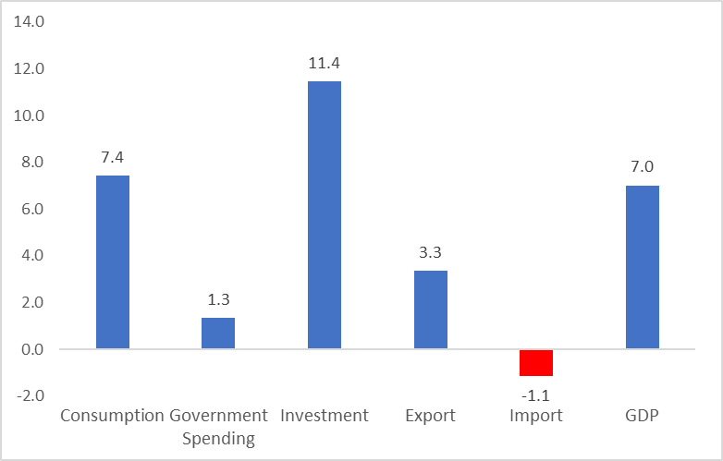
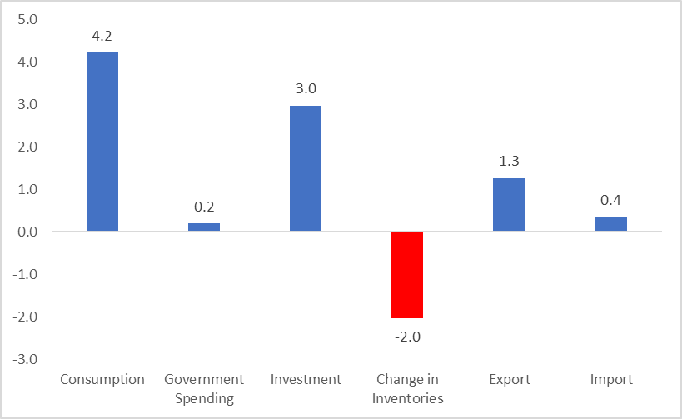
Figure 1: Contributions to growth (left) and year-on-year growth rates (right) of GDP components in 2021 Q1
Source: TurkStat, Betam

Increase in private consumption
Private consumption expenditures, which increased by 8.2 percent on an annual basis in the last quarter of 2020, grow at a high pace by 7.4 percent in the first quarter of 2021. Private consumption supports the yearly GDP growth by 4.2 percentage points in the first quarter of 2021 (Table 1). When we look at the seasonally and calendar adjusted data, we see that private consumption decreases by 1.7 percent and suppresses the quarterly GDP growth by 1.0 percentage points (Table 2). Since the quarterly growth is based on the previous quarter, the indicators that have grown relatively fast in the recent past may show a decrease on a quarterly basis, although they have grown at a high rate on an annual basis. Here, we see an example of this situation.

Table 1: Growth rates and contributions to the growth of GDP components in 2020 Q4 and 2021 Q1 compared to the same quarter of the previous year
 | 2020Q4 |  | 2021Q1
 | Change (%) | Contribution (%) | Change (%) | Contribution (%)
Consumption | 8.2 | 4.6 | 7.4 | 4.2
Government Spending | 6.6 | 1.1 | 1.3 | 0.2
Investment | 10.3 | 2.7 | 11.4 | 3.0
Change in Inventories |  | -1.5 |  | -2.0
Export | 0.0 | 0.0 | 3.3 | 1.3
Import | 2.5 | -1.0 | -1.1 | 0.4
GDP | 5.9 |  | 7.0
Source: TurkStat, Betam
Table 2: Growth rates and contributions to the growth of GDP components in 2020 Q4 and 2021 Q1 compared to the previous quarter
 | 2020Q4 |  | 2021Q1
 | Change (%) | Contribution (%) | Change (%) | Contribution (%)
Consumption | 0.8 | 0.5 | -1.7 | -1.0
Government Spending | 3.6 | 0.5 | -2.1 | -0.3
Investment | -2.7 | -0.8 | 1.6 | 0.4
Change in Inventories |  | -3.4 |  | 0.2
Export | 18.9 | 4.9 | -2.3 | -0.6
Import | 0.2 | -0.1 | -9.1 | 3.0
GDP | 1.7 |  | 1.7
Source: TurkStat, Betam

Investments continue to grow
Investment expenditures, which contracted annually since the second half of 2018, expanded significantly by 21.9 percent annually in the third quarter and 10.3 percent in the fourth quarter of 2020. Recovery in investments continues in the first quarter of 2021, with an annual increase of 11.4 percent. The contribution of this increase to GDP growth is 3.0 percentage points (Table 1). When we look at the seasonally and calendar adjusted data, we see that investment expenditures grew by 1.6 percent compared to the previous quarter. Thus, investment expenditures supported quarterly growth by 0.4 percentage points in this quarter (Table 2).
Signs of recovery in inventories
In the first quarter of 2021, change in inventories suppresses annual GDP growth by minus 2.0 percentage points (Table 1), while according to seasonal and calendar adjusted data, the contribution of change in inventories to the quarterly GDP growth is 0.2 percentage points (Table 2).
Decline in imports supports growth
In the first quarter of 2021, exports increase yearly (3.3 percent), but decline on a quarterly basis (minus 2.3 percent). Imports, on the other hand, decrease both yearly (minus 1.1 percent), and quarterly (9.1 percent) (Tables 1 and 2). While the foreign trade balance supports GDP growth both on annual and quarterly basis, the large contraction experienced in imports compared to the previous quarter is the most important reason for the quarterly GDP growth since imports contribute 3.0 percentage points (Table 2).
The effects of public spending are limited
Compared to the same quarter of the previous year, public expenditures expand by 1.3 percent in the first quarter of 2021 and support annual GDP growth by 0.2 percentage points (Table 1). According to the seasonally and calendar adjusted data, public expenditures decrease by 2.1 percent in this quarter compared to the fourth quarter of 2020. Its contribution to growth is minus 0.3 percentage points (Table 2).
The future of growth
Year-on-year GDP comparisons of 2021 will yield unhealthy results because the GDP decreased by more than 10 percent on an annual basis and by more than 16 percent on a quarterly basis in the second quarter of 2020. For this reason, it would be appropriate to focus on the seasonal and calendar adjusted data that do not include the base effect. We do not expect the quarterly growth figure to be very high for the coming quarter because of two reasons. First, the negative effects of the full closure implemented between April 29 and May 17 will be revealed in the coming macroeconomic data. The second factor is TL, which has depreciated against foreign currencies since the end of March. The US dollar rate, which was around 7.5 TL at the end of 2020, was slightly above 7 TL until 20 March 2021, while the US dollar rate increased almost regularly with the surprise dismissal of the Central Bank president, who took office 4 months ago on 8 November. With this rise, the US dollar exchange rate surpassed 8.5 TL at the beginning of June. This rapid increase in the exchange rate would be expected to slow down imports and trigger exports in the second quarter. However, we do not expect the decrease in imports to be very strong since the decrease in imports was already very strong in the first quarter. As investment goods are directly affected by exchange rate movements and expectations, a strong increase in investment expenditures is not likely.

Figure 2: GDP growth rates compared to the previous quarter and same quarter of last year
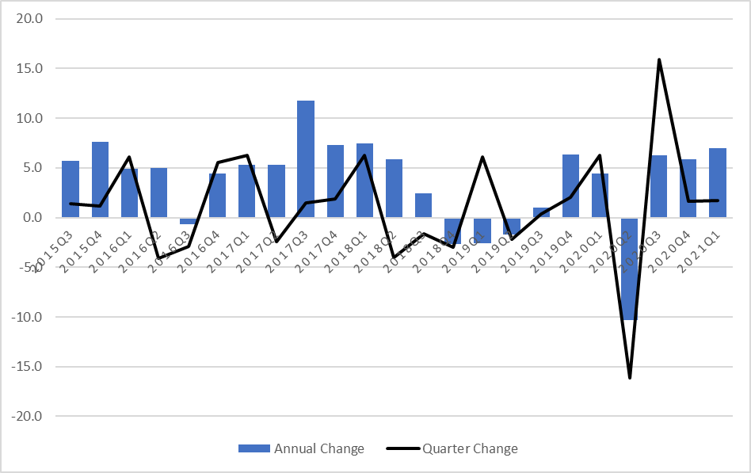
Source: TurkStat, Betam

Betam, ozan.bakis@eas.bau.edu.tr
Betam, gokhan.dilek@eas.bau.edu.tr
TurkStat uses the chained volume index method when calculating new national income series. The contribution to growth of the inventory change cannot be easily calculated because there is an additivity problem in the chain method and a chain index cannot be derived for the "changes in inventories". We discussed in detail in the research note that we recently published how to account for the contribution of inventory change to growth in the chain-volume index approach (see Betam Research Note 17/217).

