11 March 2021

Growth Evaluation:

2020 4th Quarter

HIGH GROWTH DESPITE QUARANTINE MEASURES

Ozan Bakış ve Gökhan Dilek

Executive Summary
In the last month of the fourth quarter of 2020, quarantine measures started to be implemented again. The fact that economic activities were not included in the bans ensured that economic growth was not affected by these measures in this quarter. Except exports, all GDP expenditure components increase considerably. In the fourth quarter of 2020, compared to the same period of the previous year, private consumption increased by 8.2 percent, public expenditures by 6.6 percent and investments by 10.3 percent, while exports remained stable and did not contribute to the GDP growth and 2.5 percent increase in imports suppressed it. Thus, GDP grew by 5.9 percent on an annual basis. According to the seasonally and calendar adjusted data, private consumption (0.8 percent), public expenditures (3.6 percent), exports (18.9 percent) and imports (0.2 percent) record increases compared to the previous quarter, while investments (minus 2.7 percent), on the other hand, decline.
Significant growth was achieved in the fourth quarter because of the absence of any lockdown measures in October and November and the exemption of economic activities from the new measures taken at the beginning of December. Turkey was one of the few countries that recorded economic growth in 2020 (1.8% in 2020 compared to the previous year). We expect the economic recovery to continue in the first quarter of 2021, with the gradual re-normalization process starting in March.
Figure 1: Contributions to growth (left) and year-on-year growth rates (right) of GDP components in 2020 Q4
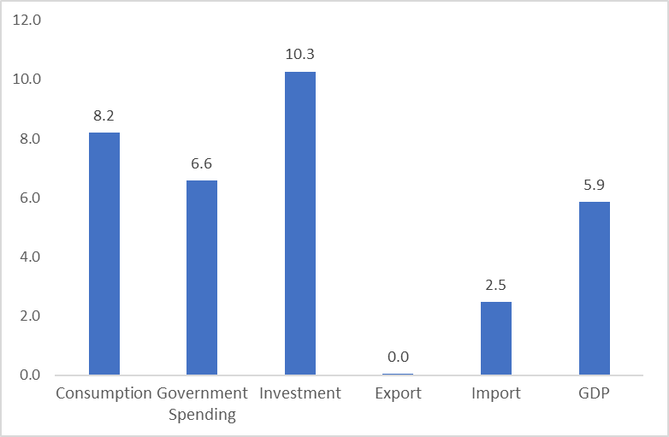
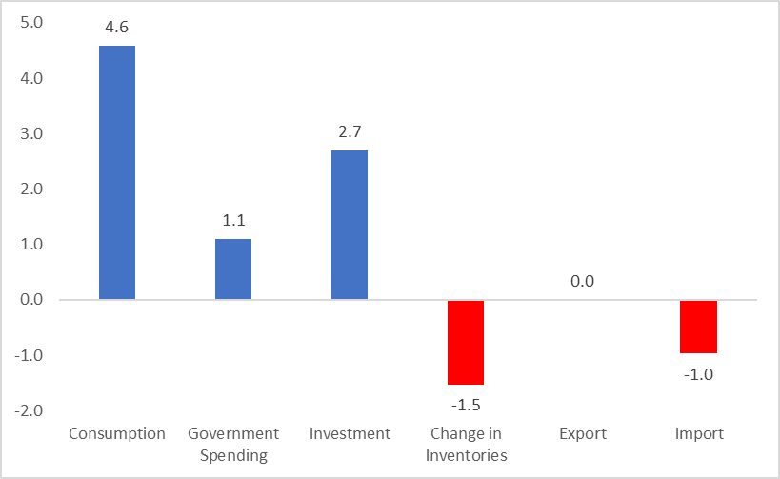
Source: TurkStat, Betam

Increase in private consumption
Private consumption, which grew by 8.5 percent annually in the third quarter of 2020, sustains its pace in the fourth quarter and increases by 8.2 percent in the last quarter. Hence, private consumption supported growth by 4.6 percentage points in this quarter (Table 1). When we look at the seasonally and calendar adjusted figures, we see that private consumption increased by 0.8 percent and contributed 0.5 percentage points to growth (Table 2). The reason for this difference between annual and quarterly growth is the base effect of annual growth. It is reasonable to expect a more moderate increase in private consumption expenditures in the next quarter.
Table 1: Growth rates and contributions to the growth of GDP components in 2020 Q3 and 2020 Q4 compared to the same quarter of the previous year
 | 2020Q3 |  | 2020Q4
 | Change (%) | Contribution (%) | Change (%) | Contribution (%)
Consumption | 8.5 | 4.8 | 8.2 | 4.6
Government Spending | 0.8 | 0.1 | 6.6 | 1.1
Investment | 21.9 | 5.3 | 10.3 | 2.7
Change in Inventories |  | 8.3 |  | -1.5
Export | -22.1 | -7.5 | 0.0 | 0.0
Import | 16.4 | -4.7 | 2.5 | -1.0
GDP | 6.3 |  | 5.9
Source: TurkStat, Betam

Table 2: Growth rates and contributions to the growth of GDP components in 2020 Q3 and 2020 Q4 compared to the previous quarter
 | 2020Q3 |  | 2020Q4
 | Change (%) | Contribution (%) | Change (%) | Contribution (%)
Consumption | 21.9 | 12.3 | 0.8 | 0.5
Government Spending | 3.7 | 0.6 | 3.6 | 0.5
Investment | 20.2 | 5.5 | -2.7 | -0.8
Change in Inventories |  | -1.7 |  | -3.4
Export | 33.3 | 7.5 | 18.9 | 4.9
Import | 28.0 | -8.4 | 0.2 | -0.1
GDP | 15.9 |  | 1.7
Source: TurkStat, Betam

Recovery in investment spending
Investment expenditures, which contracted annually since the second half of 2018, expanded significantly by 21.9 percent annually in the third quarter of 2020. The recovery in investments continues in the fourth quarter and the annual growth rate is 10.3 percent. The contribution of this increase to growth is 2.7 percentage points (Table 1). When we look at the seasonally and calendar adjusted figures, we see that investments decline by 2.7 percent compared to the previous quarter. Thus, investment expenditures suppress the quarterly GDP growth by 0.8 percentage points in this quarter (Table 2).
Negative change in inventories
In the fourth quarter of 2020, the contribution of change in inventories to the GDP growth on an annual basis was minus 1.5 percentage points (Table 1), while according to seasonal and calendar adjusted data, the contribution to the quarterly GDP growth was minus 3.4 percentage points (Table 2). It can be stated that the increase in demand with the economic recovery decreases the stocks.
Mixed outlook for exports and imports
In the fourth quarter of 2020, exports and imports follow different trends on an annual and quarterly basis. While exports remain stable on an annual basis, imports increase moderately by 2.5 percent. Thus, the net contribution of foreign trade to growth is minus 1.0 percentage points (Table 1). In the last quarter of 2020, a strong increase (18.9 percent) is recorded in exports compared to the previous quarter, while imports follow a moderate course with 0.2 percent. The net contribution of foreign trade to quarterly growth was 4.8 percentage points (Table 2).
Public spending supports the GDP growth
Compared to the same quarter of the previous year, public expenditures expand by 6.6 percent in the fourth quarter of 2020 and significantly support the annual GDP growth by 1.1 percentage points (Table 1). According to the seasonally and calendar adjusted data, public expenditures increase by 3.6 percent in the fourth quarter compared to the third quarter. Its contribution to growth is 0.5 percentage points (Table 2).
The future of growth
The GDP growth in the fourth quarter is higher than expectations. The normalization steps, which started in June and continued until December, were effective in this high GDP growth rates. In our previous evaluation, we had predicted that the last quarter growth would be slightly lower than the third quarter growth due to the new lockdown measures introduced in December. Our expectations come true.
In March, the coronavirus risk map entered our lives. Accordingly, the provinces were divided into 4 groups: blue-colored provinces with the lowest risk, yellow-colored provinces with medium risk, orange provinces with high risk, and red provinces with very high risk. The lockdown measures were localized according to the risk structure of provinces. This is a new situation, the results of which are difficult to predict, but it can be expected that economic activities in each province will recover inversely with the risk ratio. We see that the stocks accumulated in the third quarter partially melted in the fourth quarter. Considering that the new normalization measures started in March, the first quarter growth figure of 2021 may remain relatively low.

Figure 2: GDP growth rates compared to the previous quarter and same quarter of last year
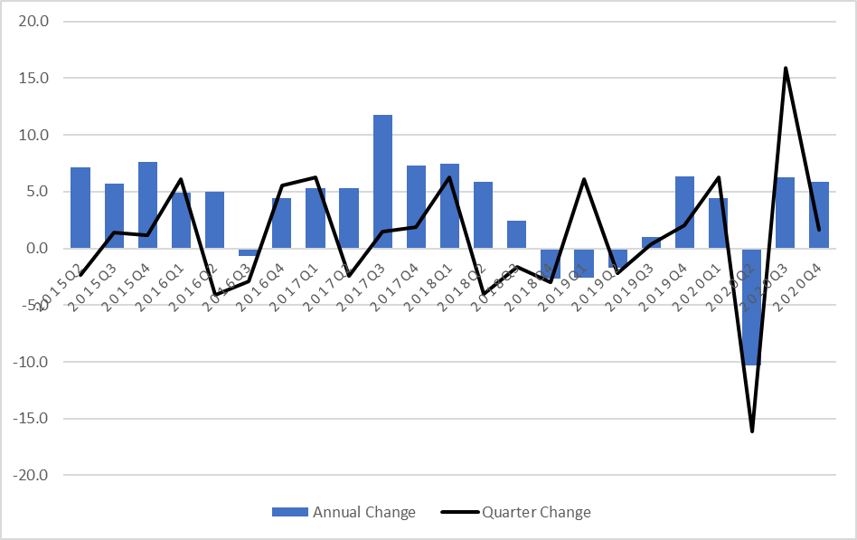 Source: TurkStat, Betam

Betam, ozan.bakis@eas.bau.edu.tr
Betam, gokhan.dilek@eas.bau.edu.tr
TurkStat uses the chained volume index method when calculating new national income series. The contribution to growth of the inventory change cannot be easily calculated because there is an additivity problem in the chain method and a chain index cannot be derived for the "changes in inventories". We discussed in detail in the research note that we recently published how to account for the contribution of inventory change to growth in the chain-volume index approach (see Betam Research Note 17/217).

