Labor Market Outlook:
March 2021

24 March 2021

SUBSTANTIAL REVISIONS IN THE LABOR FORCE STATISTICS

The decrease in the unemployment rate is accompanied by an increase in the composite underutilization rate

Seyfettin Gürsel*, Gökçe Uysal** , Hamza Mutluay***, Mehmet Cem Şahin****

Executive Summary

On 10th March, 2021, Turkstat made a series of revisions in the Household Labor Force Statistics (HLFS) January 2021. We attempt to summarize the measures taken by the Turkstat and discuss why they are important. We decided to modify our “Labor Market Outlook” research notes to keep up with these revisions,. We suggest that our readers read the first part carefully where the HLFS revisions are summarized.

Based on the monthly employment statistics, both the number of employed and the labor force increased from December 2020 to January 2021 in a parallel manner. As a result, the number of unemployed remained unchanged. Even though the number of unemployed didn’t decrease, the unemployment rate decreased from 12.6 percent to 12.2 percent as a result of the increases in the labor force and the employment exceeding 800 thousand. Note that the level of increases in employment is very close to that occurred between May and June 2020. The quarter-on-quarter GDP increases in the fourth quarter of 2020 may have fueled the increases in employment.

The Turkstat’s new labor force indicators suggest that, the number of the potential labor force (defined as the number of persons not in employment, who express an interest in employment, but for whom the existing conditions limit active job search and/or availability) decreased from December 2020 to January 2021. Contrary to that, another labor underutilization indicator that takes into account the number of time-related underemployed (defined as the number of persons employed who worked less than 40 hours in the reference week, but were willing to work additional hours and were available to do so) noted significant increases.

According to the sectoral data, the manufacturing employment increased by 14 thousand while the construction employment decreased by 9 thousand. The employment in agriculture and in the service sector increased by 366 and 451 thousand, respectively. One would need to analyze the sub-sector data in order to understand the sources of the strong increase in the service sector, when it becomes available. According to the seasonally adjusted data, non-agricultural unemployment declined to 14.2 percent in January 2021, following a decrease of 0.5 percentage points.

The seasonally adjusted data shows that the female labor force participation rate (LFPR) increased from 30.8 percent to 32.0 percent between December 2020 and January 2021. During this period, the male LFPR increased from 66.9 percent to 68.2 percent. While the male unemployment rate went down from 11.9 percent to 11.4 percent, the female unemployment rate increased from 13.9 percent to 14.1 percent. The fact that women are returning to the labor market is an opportunity that should not be wasted. Therefore, measures aiming to eliminate the gender gap in unemployment rates should be taken.

The revisions in the Household Labor Force Statistics

The January statistics published by Turkstat on 10th March 2021 incorporate new revisions regarding the Turkish labor market. To adapt to these revisions, we had to update our “Labor Market Outlook” note which was usually published as soon as the Turkstat’s report is published. We have published this note two weeks after Turkstat’s report was published, to implement these changes. We summarize the revisions Turkstat made, and we also introduce the adaptations made in our “Labor Market Outlook” note.

The most important revision that has been made by Turkstat is the addition of three alternative definitions of underutilization to supplement the headline unemployment rate. Based on the International Labor Organization’s (ILO) definition of unemployment, a person without a job, has to actively search for a job to be counted as unemployed. In accordance with the ILO, the Turkstat calculates the unemployment rate as Unemployed / Labor Force, as Labor Force = Unemployed + Employed which can be regarded as the ‘strict’ or ‘narrow’ unemployment rate. As a result, those who are not seeking a job but willing to work are not counted as unemployed.

The labor force statistics were affected in unexpected ways because of the coronavirus pandemic, which started in the spring of the previous year. While the employment levels and the working hours took significant dips, the increases in the number of unemployed persons remained limited. Before the pandemic, the number of those who were not seeking a job but were willing to work was about 2.5 million. After the pandemic, this number climbed to near 5 million. As the result of these unexpected events, even though the ‘narrow’ unemployment rate fell, in reality, the standard unemployment rate became short of explaining how the coronavirus pandemic affected the labor market in Turkey. The ‘broader’ definitions of unemployment were necessary to understand the dynamics of the labor market after the pandemic.

The second most important revision was the transformation of the labor force statistics from 3-month moving averages (due to which we referred to the periods, rather than the months in the notes), to actual monthly statistics, beginning from January 2021. The one before the last press release, which was published on 10th February 2021, contained the statistics of “the period of November”, averaging the statistics of October, November and December. On 10th March 2021, instead of the statistics of “the period of December” that would cover the months of November, December and January 2021, the statistics of “the month of January 2021” were published. We would like to emphasize that the sample size had to be greatly enlarged in order for this transformation to take effect. This transformation also allows the release of the labor market statistics 40 days after the end of the month, instead of the 70 days previously. Therefore, these statistics have a shorter lag, and they are considerably more timely.

The third revision was about the “headline” unemployment rate provided by the Turkstat. Previously, the Turkstat Labor Market Press Releases used to publish the non-seasonally adjusted unemployment rate as the “headline” unemployment rate. It is well-known that the employment in most economic activities reflect seasonal fluctuations, unrelated to the actual economic conditions, albeit in different degrees. Although the Turkstat used to publish the seasonally adjusted figures previously, these figures were not in the headline and were mostly ignored by the media, so, the seasonal fluctuations in the labor market statistics caused important misunderstandings about the unemployment dynamics. The Turkstat press release will focus on the seasonally adjusted unemployment rate as the headline data from this month on, thereby leading the public opinion to a more healthy statistic to follow the unemployment dynamics.

Prior to this note, our headline data was the seasonally adjusted non-agricultural unemployment rate, as the unemployment levels in the agricultural sector had been quite low, and the employment in the agricultural sector had displayed serious seasonal fluctuations. As the seasonally adjusted unemployment rate headline the press releases and the complementary labor force data aslo focus on the overall labor market, we decided to update our headline labor force indicator to be the as the Turkstat’s, i.e. the “seasonally adjusted unemployment rate”, instead of the “seasonally adjusted non-agricultural unemployment rate”.

Striking increases in employment

Seasonally adjusted data shows that, employment increased by 822 thousand to 27 million 706 thousand, labor force increased by 821 thousand to 31 million 567 in January 2021 compared to the previous month. In this month, the number of unemployed decreased by 1 thousand, and the unemployment rate decreased from 12.6 to 12.2 percent.

According to the new monthly employment data, employment reached its highest level of 27 million 57 thousand in November since January 2020, when the unemployment rate was 12.9 percent. In December 2020, the number of employed persons decreased to 26 million 884 thousand, falling by 173 thousand and the unemployment rate dropped to 12.6 percent. The reason for the surprising results is that the number of unemployed persons decreased from 4 million 18 thousand to 3 milliyon 862 thousand, falling by 156 thusand (Table 1). Apparently a considerable number of people who lost their job gave up looking for jobs and exited the labor force. This phenomenon can be clarified by the alternative unemployment rates recently released by TURKSTAT.

Figure 1 : Seasonally adjusted labor force, employment, and unemployment
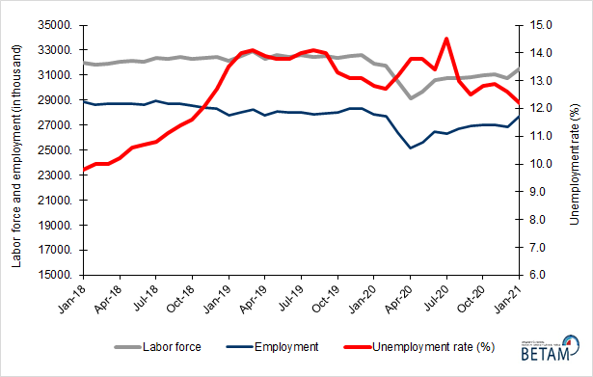
Source: Turkstat, Betam

The developments in the alternative unemployment rates

The methodology for the calculation of the alternative unemployment rates is presented in Box 1. The alternative unemployment rates comprise of the time-related underemployment (those who are employed less than 40 hours a week, would like to increase their working hours, but fail to find the jobs), the potential labor force (the individuals who are neither employed nor unemployed but wish to work), and some composite statistics.

Box 1 : Definitions of alternative unemployment rates
The time-related underemployment : Persons employed in the reference week who actually worked less than 40 hours as total (in main job and additional job/s), were willing to work additional hours and were available to do so, but could not find a job for the extra hours.

The potential labor force: Persons not in employment who would like to work, but for whom the existing conditions limit active job search and/or availability.

The unemployed: The unemployed comprises all persons 15 years of age and over who were not employed during the reference period had used at least one active channel for seeking a job during the last four weeks and were available to start work within two weeks.
1) Unemployment rate = [persons in unemployment/labor force]x100

2) Combined rate of time-related underemployment and unemployment =
[(persons in time-related underemployment + persons in unemployment) / labor force] * 100

3) Combined rate of unemployment and potential labor force =
[(persons in unemployment + potential labor force)/ (labor force+ potential labor force)] x 100

4) Composite measure of labor underutilization =
[(persons in time-related underemployment + persons in unemployment + potential labor force) / (labor force+ potential labor force)] x 100

While the unemployment rate decreased from 16.2 percent to 12.2, primarily due to the high employment growth, two of the three alternative unemployment rates increased and the remaining one decreased in January 2021 compared to December 2020. Compared to December 2020, the seasonally adjusted data shows that while the combined rate of time-related underemployment and unemployment rose to 19.7 with a 1.9 percentage point increase, the combined rate of unemployment and the potential labor force decreased by 1.4 percentage point to 22.5 percent in January 2021. The rate of labor underutilization consisting of time-related underemployment, potential labor force and unemployment rose from 28.4 to 29.1 percent (Figure 2, Table 4).

The increase in potential labor force is in line with these movements. The potential labor force increased by almost 500 thousand from November to December in 2020. As might be expected, the combined rate of unemployment and the potential labor force rose to 23.9 percent, with an increase of 0.9 percentage points.

However, as stated above, the employment growth was high in January 2021 compared to the previous month. As a result, the combined rate of unemployment and the potential labor force decreased to 22.5 percent. The combined rate of time-related underemployment and unemployment, calculated by taking into account the changes in the reduced working hours, increased from 16.9 percent to 17.8 percent between November and December in 2020, and then rose to 19.7 in January 2021. In January 2021, the rate of labor underutilization rose to 29.1 percent with a steady increase since its November 2020 level (26.5 percent).

Figure 2 : Headline Unemployment Rate and Supplementary Indicators for Labor Force
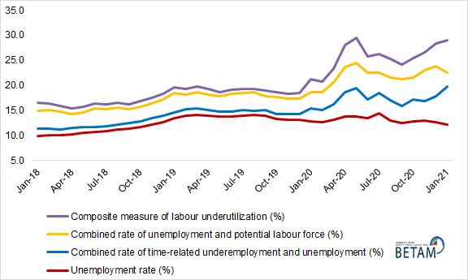
Source: Turkstat, Betam

Sectorial developments and non-agricultural unemployment

According to the seasonally adjusted employment data, in January 2021 compared to December 2020, the number of the non-agricultural employed persons reached 22 million 544 thousand, following the increase of 456 thousand. (Figure 3, Table 2) The level of non-agricultural unemployment decreased by 75 thousand, and the non-agricultural unemployment rate dropped to 14.2 percent with a decrease of 0.5 percentage points. As a result, the level of non-agricultural labor force increased by 381 thousand and reached 26 million 275 thousand. The dynamics of the non-agricultural unemployment rate are in parallel with the dynamics of the unemployment rate. As the headline unemployment rate decreased from 12.9 percent to 12.2 percent, the non-agricultural unemployment rate decreased from 14.9 percent to 14.2 percent in January 2021 compared to November 2020.

Figure 3 : Seasonally adjusted non-agricultural labor force, employment, and unemployment rate
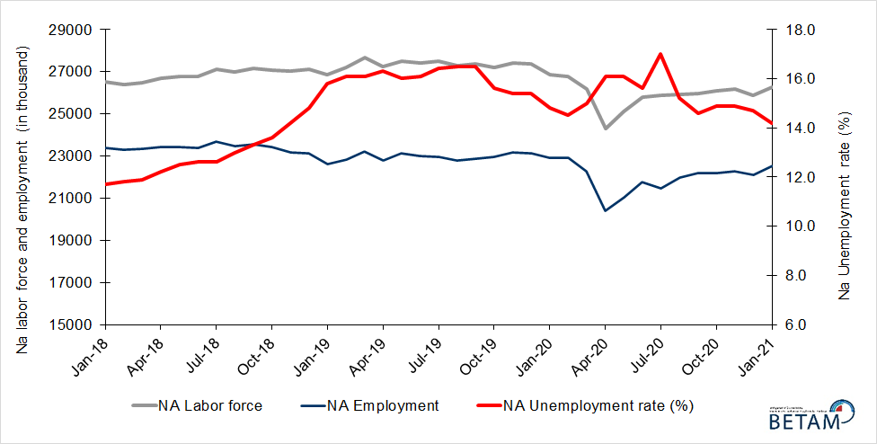
Source: Turkstat, Betam

Nearly all of the surge in employment (822 thousand) originated from increases in the agricultural and the service employment. The employment in the agricultural and in the services sectors increased by 366 and 451 thousands, respectively. The employment increased merely by 14 thousand in the manufacturing sector, and decreased by 9 thousand in the construction sector. The increases in both the agricultural and the service sector are strikingly strong.

The long-run trend in the agricultural employment has been downward. Nevertheless, it is possible for the agricultural employment to display significant fluctuations from month to month. Especially after the COVID pandemic affected the labor market substantially, these fluctuations occurred more frequently. Still, the increase of 366 thousand is the highest upside change in this sector since April 2020. The largest monthly employment increase in this sector was seen in the month of April 2020 (Table 3). As the restrictions that prioritise social distancing unfolded, many economic activities were affected adversely. As a result, the employment losses accumulated especially in the non-agricultural sectors. The number of employed persons increases in the agricultural sector in periods of the pandemic, could thus be attributed to two things : First, the employment losses in the non-agricultural sectors could discourage people that are willing to immigrate to cities to find a job. Second, it could be attributed to the reverse migration, i.e. the return of the people, who were still attached to their villages while living in cities before the pandemic, to their villages as they lost their jobs in cities as the pandemic hit. Both effects may have reemerged after the restrictions have been tightened again in November 2020.

The employment increases in the services sector of comparable sizes, were last seen in the months of May and June 2020. As the employment losses accumulated to 1 million 880 thousand in this sector through March and April 2020, the total employment increase in the services sector in May and June amounted to 867 thousand as the distancing restrictions were eased. The restrictions of economic activities in the end of November 2020 might be responsible for the employment loss of 441 thousand in December 2020. Nevertheless, as there was no easing in the restrictions of economic activities (except for the skiing resorts), the sources of the gain in employment in January 2021 remain unknown. The sub-sectoral movements in employment may provide useful information, however, these data are yet to be published.

Figure 4 : Employment by sectors (in thousand)
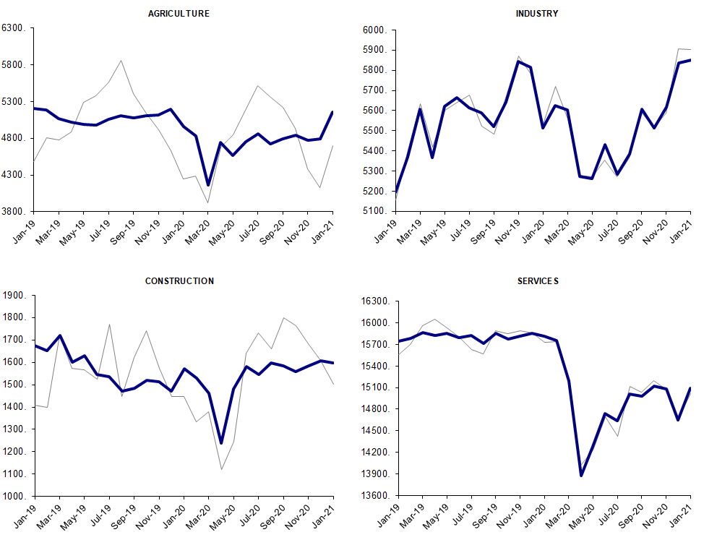
Source: TURKSTAT, Betam

Strong increases in the female labor force

Figure 5 shows seasonally adjusted unemployment rate for males (green) and for females (purple). In accordance with the data revised by Turkstat, we analyze the seasonally adjusted unemployment rate across the gender division.

After the female unemployment fell down from 14.4 percent to 13.9 in December 2020, it increased to 14.1 percent in January 2021. Contrary to the female unemployment rate, the male unemployment rate fell in both those consecutive months, from 12.3 percent to 11.4 percent. After narrowing down in the first periods of the pandemic, the gender gap in the unemployment rate has started to widen again. As the male unemployment rate decreased substantially from December 2020 to January 2021, the gender gap in the unemployment rate widened.

Figure 5 : Seasonally adjusted unemployment rate by gender (%)
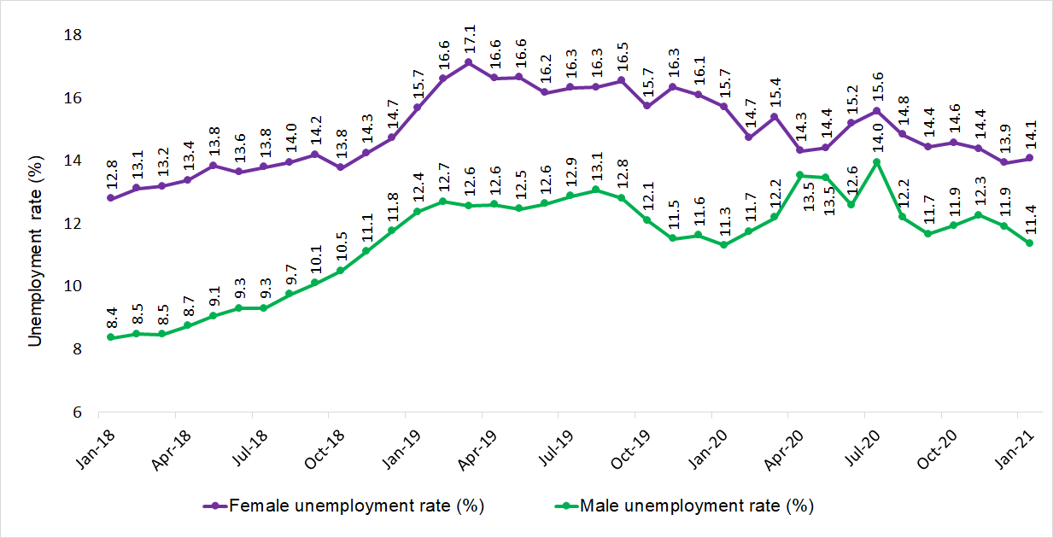Source: Turkstat, Betam

However, the increases in the female unemployment rate in this month seems to stem from the increases in the female labor force participation rate (LFPR). While the female LFPR had been around 30.0 percent since February 2020, it spiked from 30.8 percent to 32.0 percent in January 2021 (Table 5). Such a sizeable increase in the female LFPR is undoubtedly a positive sign. Thanks to this spike in the female LFPR, the female employment rate increased from 26.5 percent to 27.5 percent in January 2021. Between December 2020 and January 2021, the increase in the male LFPR from 66.9 percent to 68.2 percent is accompanied by an increase in the male employment rate from 59.0 percent to 60.5 percent.

From December to January, the number of women in the labor force, in employment and in unemployment increased by 395 thousands, 326 thousands and 69 thousands,respectively. During the same month, while the number of men in the labor force and in employment increased by 426 and 496 thousands, respectively, the number of men in unemployment decreased by 70 thousand.

Figure 6 : Seasonally adjusted employment rate by gender (%)
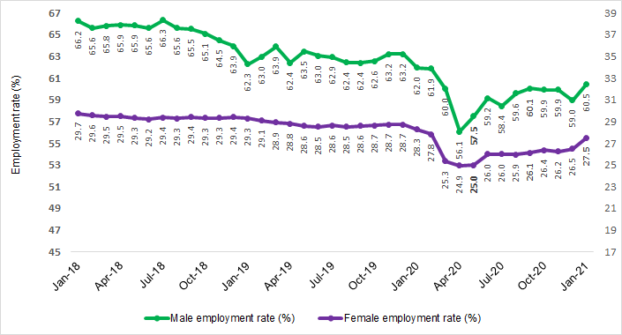
Source: Turkstat, Betam

Table 1: Seasonally adjusted labor market indicators (in thousands)
 | Labor force | Employment | Unemployment | Unemployment rate | Monthly changes
January-18 | 32000 | 28863 | 3137 | 9,8% | Labor force | Employment | Unemployment
February-18 | 31844 | 28658 | 3186 | 10,0% | -156 | -205 | 49
March-18 | 31884 | 28693 | 3191 | 10,0% | 40 | 35 | 5
April-18 | 32036 | 28753 | 3284 | 10,3% | 152 | 60 | 93
May-18 | 32127 | 28718 | 3409 | 10,6% | 91 | -35 | 125
June-18 | 32069 | 28637 | 3432 | 10,7% | -58 | -81 | 23
July-18 | 32404 | 28919 | 3484 | 10,8% | 335 | 282 | 52
August-18 | 32291 | 28704 | 3587 | 11,1% | -113 | -215 | 103
September-18 | 32448 | 28737 | 3711 | 11,4% | 157 | 33 | 124
October-18 | 32329 | 28592 | 3737 | 11,6% | -119 | -145 | 26
November-18 | 32373 | 28443 | 3930 | 12,1% | 44 | -149 | 193
December-18 | 32455 | 28321 | 4133 | 12,7% | 82 | -122 | 203
January-19 | 32152 | 27821 | 4331 | 13,5% | -303 | -500 | 198
February-19 | 32556 | 28001 | 4555 | 14,0% | 404 | 180 | 224
March-19 | 32884 | 28264 | 4620 | 14,0% | 328 | 263 | 65
April-19 | 32310 | 27808 | 4502 | 13,9% | -574 | -456 | -118
May-19 | 32609 | 28100 | 4510 | 13,8% | 299 | 292 | 8
June-19 | 32465 | 27991 | 4474 | 13,8% | -144 | -109 | -36
July-19 | 32600 | 28035 | 4565 | 14,0% | 135 | 44 | 91
August-19 | 32473 | 27883 | 4590 | 14,1% | -127 | -152 | 25
September-19 | 32501 | 27940 | 4561 | 14,0% | 28 | 57 | -29
October-19 | 32347 | 28047 | 4300 | 13,3% | -154 | 107 | -261
November-19 | 32564 | 28294 | 4270 | 13,1% | 217 | 247 | -30
December-19 | 32606 | 28335 | 4271 | 13,1% | 42 | 41 | 1
January-20 | 31933 | 27860 | 4074 | 12,8% | -673 | -475 | -197
February-20 | 31777 | 27737 | 4040 | 12,7% | -156 | -123 | -34
March-20 | 30435 | 26423 | 4012 | 13,2% | -1342 | -1314 | -28
April-20 | 29148 | 25133 | 4015 | 13,8% | -1287 | -1290 | 3
May-20 | 29704 | 25618 | 4086 | 13,8% | 556 | 485 | 71
June-20 | 30610 | 26506 | 4104 | 13,4% | 906 | 888 | 18
July-20 | 30776 | 26324 | 4453 | 14,5% | 166 | -182 | 349
August-20 | 30723 | 26719 | 4003 | 13,0% | -53 | 395 | -450
September-20 | 30830 | 26965 | 3865 | 12,5% | 107 | 246 | -138
October-20 | 31006 | 27046 | 3960 | 12,8% | 176 | 81 | 95
November-20 | 31075 | 27057 | 4018 | 12,9% | 69 | 11 | 58
December-20 | 30746 | 26884 | 3862 | 12,6% | -329 | -173 | -156
January-21 | 31567 | 27706 | 3861 | 12,2% | 821 | 822 | -1

Source: Turkstat, Betam

Table 2: Seasonally adjusted non-agricultural labor market indicators (in thousands)
 | Labor force | Employment | Unemployment | Unemployment rate | Monthly changes
January-18 | 26497 | 23397 | 3100 | 11,7% | Labor force | Employment | Unemployment
February-18 | 26393 | 23279 | 3114 | 11,8% | -104 | -118 | 14
March-18 | 26477 | 23326 | 3151 | 11,9% | 83 | 47 | 36
April-18 | 26694 | 23437 | 3257 | 12,2% | 217 | 111 | 106
May-18 | 26789 | 23440 | 3349 | 12,5% | 95 | 3 | 92
June-18 | 26762 | 23390 | 3372 | 12,6% | -27 | -50 | 23
July-18 | 27096 | 23682 | 3414 | 12,6% | 334 | 292 | 42
August-18 | 26987 | 23479 | 3508 | 13,0% | -109 | -203 | 94
September-18 | 27140 | 23530 | 3610 | 13,3% | 152 | 51 | 101
October-18 | 27089 | 23405 | 3684 | 13,6% | -50 | -125 | 75
November-18 | 27026 | 23188 | 3838 | 14,2% | -63 | -217 | 154
December-18 | 27122 | 23108 | 4014 | 14,8% | 96 | -80 | 176
January-19 | 26859 | 22615 | 4244 | 15,8% | -263 | -493 | 230
February-19 | 27190 | 22812 | 4378 | 16,1% | 331 | 197 | 134
March-19 | 27650 | 23198 | 4452 | 16,1% | 460 | 386 | 74
April-19 | 27225 | 22787 | 4438 | 16,3% | -425 | -411 | -14
May-19 | 27508 | 23107 | 4401 | 16,0% | 284 | 320 | -36
June-19 | 27423 | 23008 | 4415 | 16,1% | -85 | -99 | 14
July-19 | 27478 | 22972 | 4506 | 16,4% | 55 | -36 | 91
August-19 | 27273 | 22773 | 4500 | 16,5% | -205 | -199 | -6
September-19 | 27384 | 22866 | 4518 | 16,5% | 111 | 93 | 18
October-19 | 27182 | 22942 | 4240 | 15,6% | -202 | 76 | -278
November-19 | 27391 | 23173 | 4218 | 15,4% | 209 | 231 | -22
December-19 | 27351 | 23139 | 4212 | 15,4% | -40 | -34 | -6
January-20 | 26874 | 22897 | 3977 | 14,8% | -477 | -242 | -235
February-20 | 26789 | 22905 | 3884 | 14,5% | -85 | 8 | -93
March-20 | 26186 | 22258 | 3928 | 15,0% | -604 | -647 | 43
April-20 | 24297 | 20385 | 3912 | 16,1% | -1889 | -1873 | -16
May-20 | 25088 | 21049 | 4039 | 16,1% | 791 | 664 | 127
June-20 | 25776 | 21755 | 4021 | 15,6% | 688 | 706 | -18
July-20 | 25863 | 21466 | 4397 | 17,0% | 87 | -289 | 376
August-20 | 25938 | 21995 | 3943 | 15,2% | 75 | 529 | -454
September-20 | 25960 | 22170 | 3790 | 14,6% | 23 | 175 | -152
October-20 | 26087 | 22200 | 3887 | 14,9% | 127 | 30 | 97
November-20 | 26188 | 22286 | 3902 | 14,9% | 101 | 86 | 15
December-20 | 25894 | 22088 | 3806 | 14,7% | -294 | -198 | -96
January-21 | 26275 | 22544 | 3731 | 14,2% | 381 | 456 | -75

Source: Turkstat, Betam

Table 3: Seasonally adjusted employment by sectors (in thousands) *
 | Agriculture | Manufacturing | Construction | Service | Monthly changes
January-18 | 5466 | 5681 | 2195 | 15521 | Agriculture | Manufacturing | Construction | Service
February-18 | 5379 | 5555 | 2175 | 15548 | -87 | -126 | -20 | 27
March-18 | 5367 | 5568 | 2130 | 15628 | -12 | 13 | -45 | 80
April-18 | 5316 | 5602 | 2151 | 15684 | -51 | 34 | 21 | 56
May-18 | 5278 | 5693 | 2075 | 15673 | -38 | 91 | -76 | -11
June-18 | 5247 | 5645 | 2011 | 15735 | -31 | -48 | -64 | 62
July-18 | 5237 | 5844 | 2016 | 15822 | -10 | 199 | 5 | 87
August-18 | 5225 | 5752 | 1912 | 15814 | -12 | -92 | -104 | -8
September-18 | 5207 | 5753 | 1950 | 15828 | -18 | 1 | 38 | 14
October-18 | 5187 | 5791 | 1887 | 15727 | -20 | 38 | -63 | -101
November-18 | 5255 | 5659 | 1764 | 15764 | 68 | -132 | -123 | 37
December-18 | 5213 | 5629 | 1787 | 15693 | -42 | -30 | 23 | -71
January-19 | 5206 | 5195 | 1675 | 15745 | -7 | -434 | -112 | 52
February-19 | 5189 | 5371 | 1653 | 15788 | -17 | 176 | -22 | 43
March-19 | 5066 | 5608 | 1719 | 15870 | -123 | 237 | 66 | 82
April-19 | 5021 | 5365 | 1599 | 15822 | -45 | -243 | -120 | -48
May-19 | 4993 | 5620 | 1628 | 15859 | -28 | 255 | 29 | 37
June-19 | 4983 | 5663 | 1546 | 15799 | -10 | 43 | -82 | -60
July-19 | 5063 | 5614 | 1535 | 15823 | 80 | -49 | -11 | 24
August-19 | 5110 | 5590 | 1471 | 15712 | 47 | -24 | -64 | -111
September-19 | 5074 | 5521 | 1485 | 15860 | -36 | -69 | 14 | 148
October-19 | 5105 | 5642 | 1521 | 15778 | 31 | 121 | 36 | -82
November-19 | 5121 | 5844 | 1514 | 15815 | 16 | 202 | -7 | 37
December-19 | 5196 | 5815 | 1470 | 15854 | 75 | -29 | -44 | 39
January-20 | 4963 | 5513 | 1571 | 15814 | -233 | -302 | 101 | -40
February-20 | 4832 | 5623 | 1530 | 15753 | -131 | 110 | -41 | -61
March-20 | 4165 | 5602 | 1460 | 15196 | -667 | -21 | -70 | -557
April-20 | 4748 | 5272 | 1240 | 13873 | 583 | -330 | -220 | -1323
May-20 | 4569 | 5261 | 1482 | 14305 | -179 | -11 | 242 | 432
June-20 | 4751 | 5432 | 1582 | 14740 | 182 | 171 | 100 | 435
July-20 | 4858 | 5283 | 1545 | 14638 | 107 | -149 | -37 | -102
August-20 | 4724 | 5385 | 1596 | 15014 | -134 | 102 | 51 | 376
September-20 | 4795 | 5607 | 1584 | 14979 | 71 | 222 | -12 | -35
October-20 | 4846 | 5515 | 1560 | 15126 | 51 | -92 | -24 | 147
November-20 | 4771 | 5617 | 1583 | 15086 | -75 | 102 | 23 | -40
December-20 | 4796 | 5836 | 1607 | 14645 | 25 | 219 | 24 | -441
January-21 | 5162 | 5850 | 1598 | 15096 | 366 | 14 | -9 | 451
Source: Turkstat

Tablo 4 : Unemployment, alternative unemployment rates (%) levels (in thousand)
 | Unemployment rate (%) | Unemployed (thousand) | Combined rate of time-related underemployment and unemployment | Time-related underemployment (thousand) | Combined rate of unemployment and potential labor force | Potential labor force (thousand) | Composite measure of labor underutilization | Labor underutilization (thousand)
January-18 | 9.8 | 3137 | 11.4 | 511 | 14.9 | 1917 | 16.5 | 5565
February-18 | 10.0 | 3186 | 11.3 | 412 | 15.0 | 1871 | 16.2 | 5470
March-18 | 10.0 | 3191 | 11.2 | 380 | 14.7 | 1754 | 15.9 | 5325
April-18 | 10.2 | 3284 | 11.5 | 400 | 14.3 | 1514 | 15.4 | 5198
May-18 | 10.6 | 3409 | 11.7 | 350 | 14.6 | 1501 | 15.7 | 5259
June-18 | 10.7 | 3432 | 11.6 | 288 | 15.4 | 1781 | 16.3 | 5501
July-18 | 10.8 | 3484 | 11.8 | 340 | 15.2 | 1700 | 16.2 | 5523
August-18 | 11.1 | 3587 | 12.2 | 353 | 15.5 | 1678 | 16.6 | 5618
September-18 | 11.4 | 3711 | 12.4 | 313 | 15.3 | 1480 | 16.2 | 5504
October-18 | 11.6 | 3737 | 12.8 | 401 | 15.7 | 1588 | 16.9 | 5726
November-18 | 12.1 | 3930 | 13.4 | 408 | 16.4 | 1650 | 17.6 | 5988
December-18 | 12.7 | 4133 | 13.9 | 378 | 17.1 | 1709 | 18.2 | 6220
January-19 | 13.5 | 4331 | 14.6 | 363 | 18.5 | 1984 | 19.6 | 6678
February-19 | 14.0 | 4555 | 15.2 | 394 | 18.2 | 1675 | 19.3 | 6624
March-19 | 14.1 | 4620 | 15.4 | 444 | 18.6 | 1838 | 19.8 | 6902
April-19 | 13.9 | 4502 | 15.1 | 377 | 18.1 | 1644 | 19.2 | 6522
May-19 | 13.8 | 4510 | 14.7 | 284 | 17.9 | 1616 | 18.7 | 6410
June-19 | 13.8 | 4474 | 14.7 | 298 | 18.3 | 1796 | 19.2 | 6568
July-19 | 14.0 | 4565 | 15.0 | 325 | 18.4 | 1757 | 19.4 | 6647
August-19 | 14.1 | 4590 | 14.9 | 248 | 18.6 | 1781 | 19.3 | 6620
September-19 | 14.0 | 4561 | 15.1 | 347 | 17.9 | 1531 | 18.9 | 6438
October-19 | 13.3 | 4300 | 14.2 | 293 | 17.7 | 1732 | 18.6 | 6325
November-19 | 13.1 | 4270 | 14.2 | 354 | 17.3 | 1649 | 18.3 | 6273
December-19 | 13.1 | 4271 | 14.2 | 359 | 17.3 | 1656 | 18.4 | 6286
January-20 | 12.8 | 4074 | 15.4 | 844 | 18.7 | 2334 | 21.2 | 7252
February-20 | 12.7 | 4040 | 15.0 | 727 | 18.6 | 2298 | 20.8 | 7064
March-20 | 13.2 | 4012 | 16.2 | 918 | 20.6 | 2843 | 23.3 | 7774
April-20 | 13.8 | 4015 | 18.6 | 1407 | 23.7 | 3792 | 28.0 | 9213
May-20 | 13.8 | 4086 | 19.5 | 1706 | 24.5 | 4227 | 29.5 | 10019
June-20 | 13.4 | 4104 | 17.1 | 1130 | 22.5 | 3591 | 25.8 | 8826
July-20 | 14.5 | 4453 | 18.5 | 1241 | 22.6 | 3233 | 26.3 | 8927
August-20 | 13.0 | 4003 | 17.0 | 1220 | 21.6 | 3359 | 25.3 | 8582
September-20 | 12.5 | 3865 | 15.8 | 1006 | 21.2 | 3390 | 24.1 | 8261
October-20 | 12.8 | 3960 | 17.1 | 1342 | 21.6 | 3491 | 25.5 | 8793
November-20 | 12.9 | 4018 | 16.9 | 1234 | 23.0 | 4064 | 26.5 | 9316
December-20 | 12.6 | 3862 | 17.8 | 1611 | 23.9 | 4581 | 28.4 | 10054
January-21 | 12.2 | 3861 | 19.7 | 2358 | 22.5 | 4183 | 29.1 | 10401
Source: Turkstat, Betam

Table 5 : Seasonally adjusted female and male labor market indicators (thousands)
 | Total labor force, Female | Total Employment, Female | Total Unemployed, Female | Total labor force, Male | Total Employment, Male | Total Unemployed, Male | Women LFPR | Women Employment Rate | Men LFPR | Men Employment Rate
January-18 | 10.390 | 9.060 | 1.330 | 21.611 | 19.804 | 1.807 | 34,1 | 29,7 | 72,3 | 66,2
February-18 | 10.387 | 9.024 | 1.363 | 21.457 | 19.634 | 1.823 | 34,1 | 29,6 | 71,7 | 65,6
March-18 | 10.363 | 8.996 | 1.368 | 21.521 | 19.697 | 1.823 | 33,9 | 29,5 | 71,9 | 65,8
April-18 | 10.405 | 9.013 | 1.393 | 21.631 | 19.740 | 1.891 | 34,0 | 29,5 | 72,2 | 65,9
May-18 | 10.417 | 8.975 | 1.442 | 21.710 | 19.744 | 1.966 | 34,0 | 29,3 | 72,4 | 65,9
June-18 | 10.365 | 8.951 | 1.414 | 21.704 | 19.686 | 2.018 | 33,8 | 29,2 | 72,4 | 65,6
July-18 | 10.445 | 9.004 | 1.441 | 21.959 | 19.915 | 2.043 | 34,1 | 29,4 | 73,1 | 66,3
August-18 | 10.450 | 8.992 | 1.458 | 21.841 | 19.712 | 2.129 | 34,0 | 29,3 | 72,7 | 65,6
September-18 | 10.537 | 9.042 | 1.495 | 21.910 | 19.695 | 2.216 | 34,3 | 29,4 | 72,9 | 65,5
October-18 | 10.456 | 9.016 | 1.440 | 21.873 | 19.576 | 2.297 | 34,0 | 29,3 | 72,7 | 65,1
November-18 | 10.533 | 9.032 | 1.501 | 21.839 | 19.411 | 2.429 | 34,2 | 29,3 | 72,6 | 64,5
December-18 | 10.627 | 9.062 | 1.565 | 21.827 | 19.259 | 2.568 | 34,5 | 29,4 | 72,5 | 63,9
January-19 | 10.719 | 9.039 | 1.679 | 21.434 | 18.782 | 2.652 | 34,7 | 29,3 | 71,1 | 62,3
February-19 | 10.777 | 8.989 | 1.788 | 21.779 | 19.012 | 2.767 | 34,9 | 29,1 | 72,1 | 63,0
March-19 | 10.794 | 8.947 | 1.846 | 22.090 | 19.316 | 2.774 | 34,9 | 28,9 | 73,1 | 63,9
April-19 | 10.699 | 8.920 | 1.779 | 21.611 | 18.888 | 2.723 | 34,5 | 28,8 | 71,4 | 62,4
May-19 | 10.639 | 8.868 | 1.771 | 21.971 | 19.232 | 2.739 | 34,3 | 28,6 | 72,5 | 63,5
June-19 | 10.563 | 8.856 | 1.707 | 21.902 | 19.135 | 2.767 | 34,0 | 28,5 | 72,2 | 63,0
July-19 | 10.649 | 8.910 | 1.739 | 21.951 | 19.125 | 2.826 | 34,2 | 28,6 | 72,2 | 62,9
August-19 | 10.622 | 8.886 | 1.736 | 21.851 | 18.997 | 2.854 | 34,1 | 28,5 | 71,8 | 62,4
September-19 | 10.694 | 8.925 | 1.769 | 21.807 | 19.015 | 2.792 | 34,3 | 28,6 | 71,6 | 62,4
October-19 | 10.623 | 8.953 | 1.670 | 21.724 | 19.094 | 2.630 | 34,0 | 28,7 | 71,2 | 62,6
November-19 | 10.741 | 8.986 | 1.755 | 21.823 | 19.308 | 2.516 | 34,3 | 28,7 | 71,4 | 63,2
December-19 | 10.727 | 9.000 | 1.726 | 21.879 | 19.334 | 2.545 | 34,2 | 28,7 | 71,5 | 63,2
January-20 | 10.524 | 8.871 | 1.653 | 21.410 | 18.989 | 2.421 | 33,5 | 28,3 | 69,9 | 62,0
February-20 | 10.258 | 8.746 | 1.512 | 21.519 | 18.991 | 2.528 | 32,6 | 27,8 | 70,1 | 61,9
March-20 | 9.418 | 7.969 | 1.448 | 21.018 | 18.454 | 2.564 | 29,9 | 25,3 | 68,3 | 60,0
April-20 | 9.166 | 7.854 | 1.312 | 19.982 | 17.279 | 2.703 | 29,1 | 24,9 | 64,9 | 56,1
May-20 | 9.206 | 7.879 | 1.327 | 20.497 | 17.739 | 2.758 | 29,2 | 25,0 | 66,4 | 57,5
June-20 | 9.682 | 8.212 | 1.470 | 20.928 | 18.293 | 2.634 | 30,6 | 26,0 | 67,7 | 59,2
July-20 | 9.738 | 8.221 | 1.516 | 21.039 | 18.103 | 2.936 | 30,8 | 26,0 | 67,9 | 58,4
August-20 | 9.653 | 8.221 | 1.432 | 21.069 | 18.498 | 2.571 | 30,5 | 25,9 | 67,9 | 59,6
September-20 | 9.685 | 8.287 | 1.398 | 21.145 | 18.678 | 2.467 | 30,5 | 26,1 | 68,0 | 60,1
October-20 | 9.812 | 8.382 | 1.430 | 21.194 | 18.665 | 2.530 | 30,9 | 26,4 | 68,0 | 59,9
November-20 | 9.750 | 8.348 | 1.403 | 21.324 | 18.709 | 2.615 | 30,6 | 26,2 | 68,3 | 59,9
December-20 | 9.812 | 8.445 | 1.367 | 20.934 | 18.439 | 2.495 | 30,8 | 26,5 | 66,9 | 59,0
January-21 | 10.207 | 8.771 | 1.436 | 21.360 | 18.935 | 2.426 | 32,0 | 27,5 | 68,2 | 60,5

Source: Turkstat, Betam

* Prof. Dr. Seyfettin Gürsel, Betam, Director, seyfettin.gursel@eas.bau.edu.tr
** Doç. Dr. Gökçe Uysal, Betam, Deputy Director, gokce.uysal@eas.bau.edu.tr
*** Hamza Mutluay, Betam, Research Assistant, hamza.mutluay@eas.bau.edu.tr
**** Mehmet Cem Şahin, Betam, Research Assistant, mehmetcem.sahin@eas.bau.edu.tr
With the purpose of specifying the reasons for not actively searching for a job, in the year of 2020, Turkstat included another question to its questionnaire specifying the reasons for not searching for work actively, which is answered by those who is out of the labor force and confirmed that she/he would be willing to work if an available job exists
Detailed information is available in the Metadata section of the link : https://data.tuik.gov.tr/Kategori/GetKategori?p=istihdam-issizlik-ve-ucret-108&dil=1

