Labor Market Outlook:
February 2021

25 February 2021

THE LABOR MARKET TAKES A HIT AS THE PANDEMIC INTENSIFIES

Seyfettin Gürsel*, Gökçe Uysal** , Mehmet Cem Şahin***

Executive Summary

Seasonally adjusted labor market data show that in the period of November 2020, compared to the period of October 2020, non-agricultural unemployment rate remained at 14.9 percent. In this period, while the non-agricultural employment increased by 38 thousand, the labor force increased by 45 thousand. According to the sectoral data, employment decreased in all sectors except for manufacturing. While employment in the manufacturing sector increased by 83 thousand, employment in the construction and services sectors decreased by 6 thousand and 38 thousand respectively. According to seasonally adjusted data, while female non-agricultural employment and labor force increased by 41 thousand and 23 thousand respectively, male non-agricultural employment and labor force decreased by 5 thousand and 13 thousand respectively. As a result, the non-agricultural female unemployment rate went down to 18.0 percent, and the non-agricultural male unemployment rate remained constant at 13.5 percent. The gender gap in non-agricultural unemployment rate is currently 4.5 percent.

Non-agricultural labor force and employment are still below the January 2020 levels

Seasonally adjusted data show that the non-agricultural labor force rose to 26 million 411 thousand, increasing by 45 thousand in the period between November 2020 (September-October-November) and October 2020 (September-October-November). In the period of November 2020, the non-agricultural labor force remained below the level of the period of January 2020 (27 million 163 thousand) by 752 thousand. The non-agricultural employment increased to 22 million 476 thousand, following an increase by 38 thousand, compared to the previous period (Figure1, Table1). In this period, non-agricultural employment is still below its January 2020 levels by 667 thousand.

In this period, increases in the labor force and employment remain very limited. Compared to the period of January 2020, non-agricultural unemployment is lower by 85 thousand (January 2020 : 4 million 20 thousand, November 2020 : 3 million 935 thousand), and unemployment rate is higher by 0.1 percentage points (January 2020 : 14.8 percent, November 2020 : 14.9 percent). As of the period of November 2020, labor market data shows that deceleration in the labor market continued as the pandemic intensifies in autumn.

In this brief, to correct for the possibly misleading effects of the decreasing labor force on unemployment, we also discuss the ratio of total unemployed to non-institutional working age population along with the LFPR and the employment rate, as presented in Figure 2. In the period of November 2020, compared to October 2020, the ratio of total unemployed to non-institutional working age population remained unchanged at 6.4 percent. The labor force participation rate decreased to 49.4 percent following the decrease of 0.1 percentage points, and the employment rate decreased from 43.2 to 43.1 percent. The labor force participation rate and the employment rate were lower by 3.3 and 2.6 percentage points, respectively, compared to the period of November 2019. Let us further note that labor force participation and employment rates were still lower by 2.4 and 2.1 percentage points respectively compared to pre-COVID levels.(Figure 2).

Figure 1. Seasonally adjusted non-agricultural labor force, employment, and unemployment
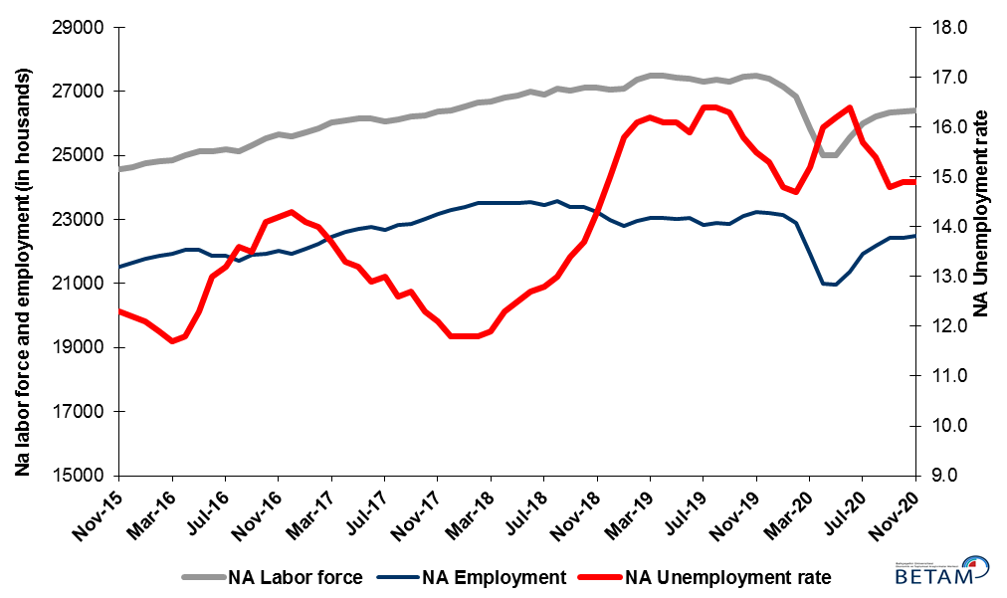
Source: Turkstat, Betam

Figure 2. Seasonally adjusted LFPR, employment rate and non-agricultural unemployment rate
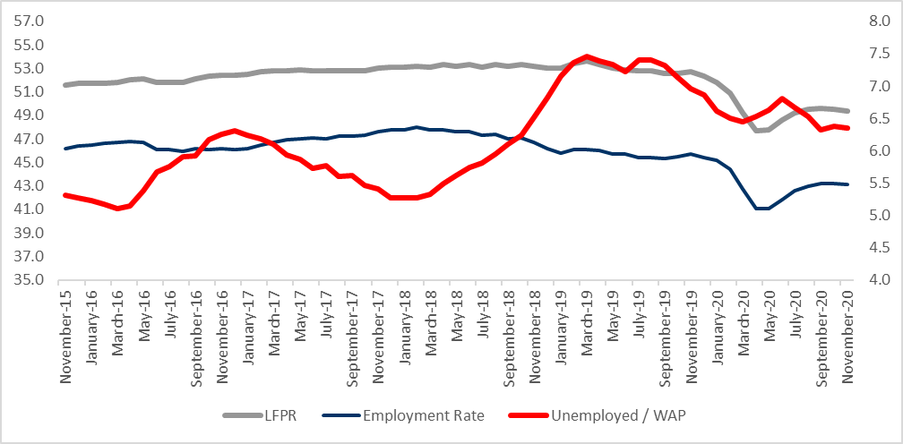
Source: Turkstat, Betam

The unemployed and those “not searching but available to start” sum up to almost 9 million

The level of labor force, by definition, is the summation of the level of employed people and the level of job seekers (unemployed). During the periods of massive employment losses, we may observe striking increases among individuals who wish to work but are not actively seeking a job as they think that they would not be able to find a job. Those individuals that stop searching for jobs and hence drop out of the labor force due to loss of confidence and other reasons are referred as ‘Discouraged workers’ and ‘Other’ by TurkStat. The sustained increases in the number of discouraged workers started in January 2019 and accelerated during the pandemic. Even though this trend was reversed in the period of June 2020, the decreases in the number of discouraged workers started to slow down in the period of September 2020. The number of inactive non-seekers who are available to start working increased by 302 thousand in the period of November 2020. Finally, adding these categories to the number of unemployed, the sum reached 8 million 975 thousand with an increase of 293 thousand.

Figure 3. The number of unemployed people, non-seekers who are available, and summation of both (SA)
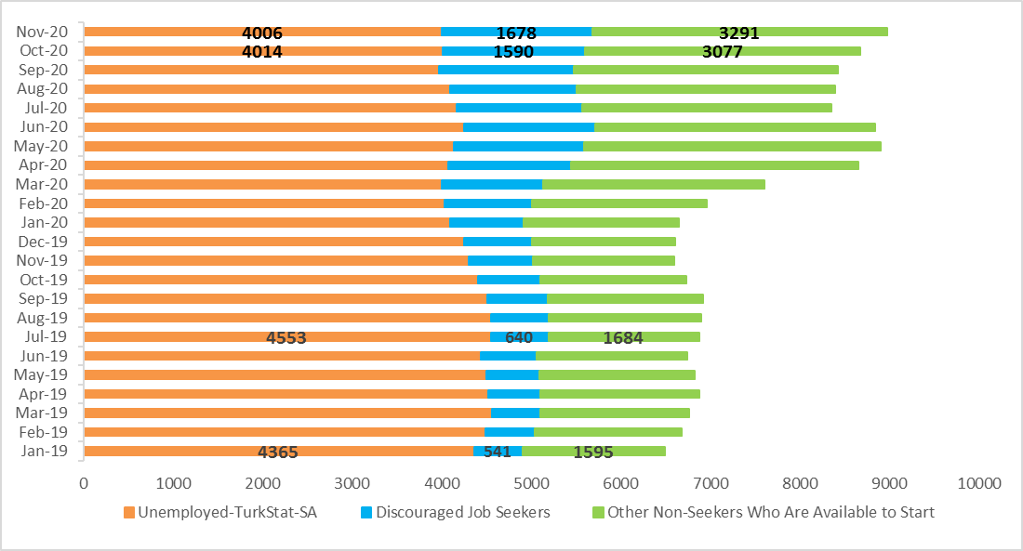
Source: Turkstat, Betam

Decreases in construction and services sectors

According to seasonally adjusted employment data, in the period of November 2020 compared to October 2020, employment increased in the manufacturing sector, and decreased in all other sectors. The employment in construction decreased by 6 thousand. The manufacturing employment surpassed its January 2020 level for the first time following an increase of 83 thousand,. After a decrease of 72 thousand in the period of October 2020, the services employment decreased again by 38 thousand in the period of November 2020. Compared to its January 2020 levels, the employment in the services sector is lower by 4.7 percent. The decreases in services employment imply that the adverse effects of the pandemic are coming back. The employment in agriculture decreased by 62 thousand compared to the previous period.

Figure 4: Employment by sectors (in thousand)
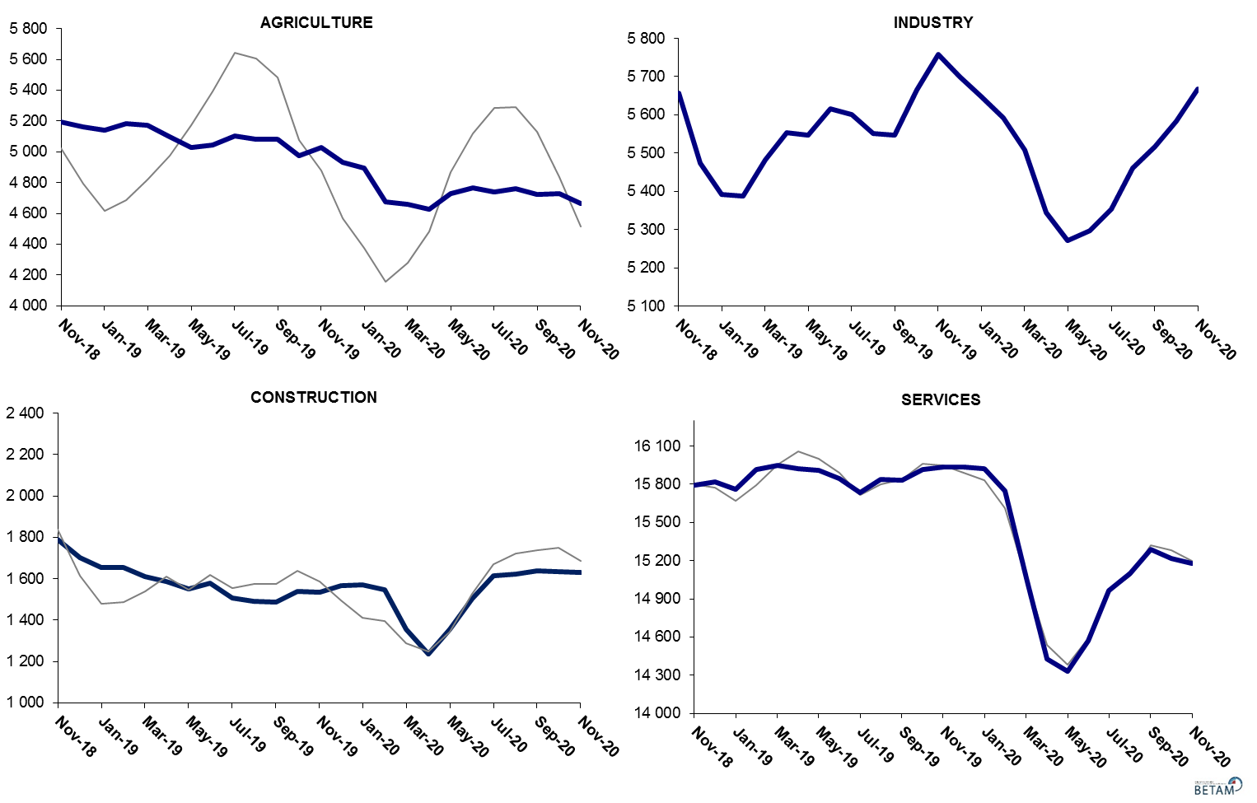
Source: TURKSTAT, Betam
Decreases in yearly non-agricultural labor force and employment continue

Compared to November 2019, the non-agricultural employment decreased by 741 thousand (2.8 percent) in November 2020 while non-agricultural labor force declined by 1 million 64 thousand. It can be concluded that the decreases in the non-agricultural unemployment are actually the result of the flows of individuals out of the labor force (Figure 5).

Figure 5 Year-on-year changes in non-agricultural labor force, employment, and unemployment
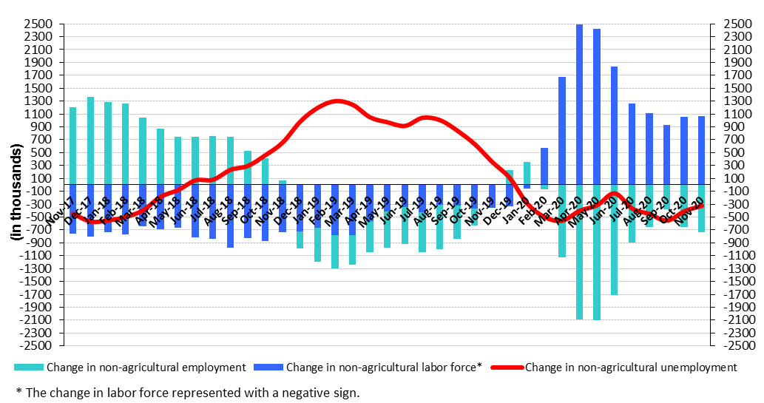
Source: TURKSTAT, Betam

Decreases in male labor force and employment, increases in female labor force and employment

Figure 6 shows seasonally adjusted non-agricultural unemployment rate for males (green) and for females (purple). In the period of November 2020 compared to the previous period, female non-agricultural unemployment rate fell down to 18.0 percent. Compared to October 2020, male non-agricultural unemployment rate remained unchanged at 13.5 percent. While female labor force and employment increased by 23 and 41 thousand respectively, male labor force and employment decreased by 5 and 13 thousand. As a result, the gender gap in the non-agricultural unemployment rate turned out to be 4.5 percent following the decrease by 0.3 percent.

Figure 6: Seasonally adjusted non-agricultural unemployment rate by gender (%)
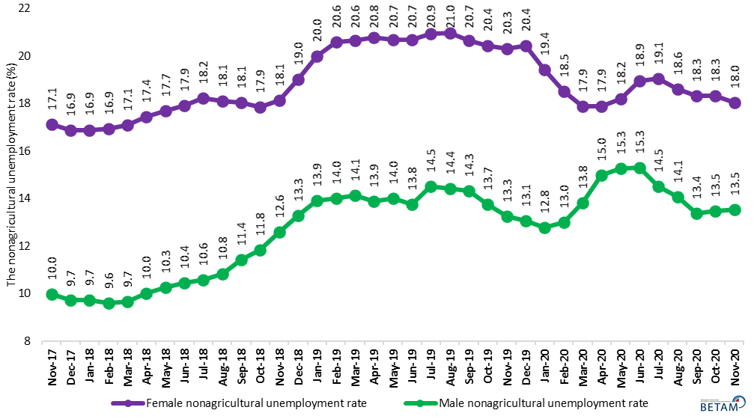
Source: Turkstat, Betam

Figure 7 and Figure 8 shows the recent developments in the participation rate and employment rate of men and women. As can be seen in Figure 7, men’s long-run LFPR which has been steady over the last three years has been badly affected by the pandemic. Over three periods, it had dropped by 5 percentage points until it started to recover in the period of May. However, the labor market data shows that male LFPR went down again in the period of November. Male LFPR, which turned out to be 68.4 percent in the period of November, is 3.6 percentage points lower than its long-term average, 72.0 percent.
Female LFPR has also been affected severely by the pandemic. Over those periods between January and April 2020, female LFPR decreased by 3.6 percentage points to merely 29.6 percent. The limited improvement in female LFPR between periods of May and August reversed and female LFPR has been on a declining course over the last three periods. As of November 2020, the female LFPR fell back to 30.5 percent, which is 4.7 percentage points lower than its maximum.
As for the employment rates (Figure 8), the male employment rate which had been going up since the period of May reversed its course in the period of November, and fell down to 60.4 percent. Employment rate among men is 2.5 percentage points lower than its January 2020 level. Even though there was a recovery beginning in May, in the female employment rate, it has been affected adversely in autumn. As a result, the total decreases in the female employment rate over September, October and November periods became 0.4 percentage points. As of November 2020, female employment rate is 2.0 percentage points lower than its January 2020 level.

Figure 7 : Seasonally adjusted female and male LFPR (%)
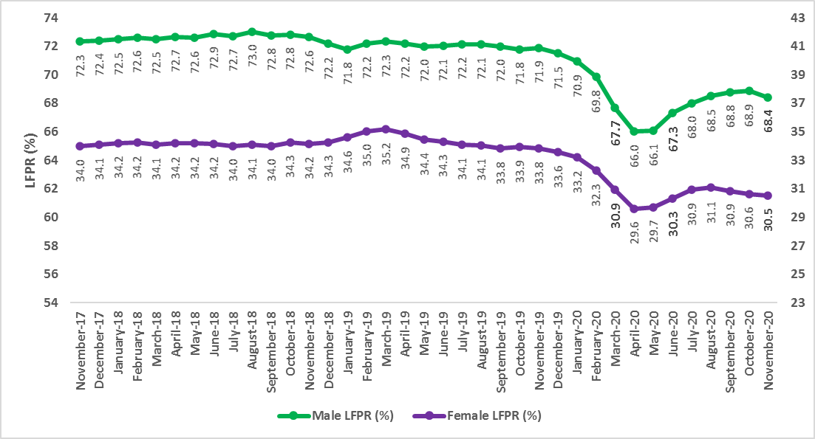
Source : Turkstat, Betam

Figure 8 : Seasonally adjusted female and male employment rate (%)
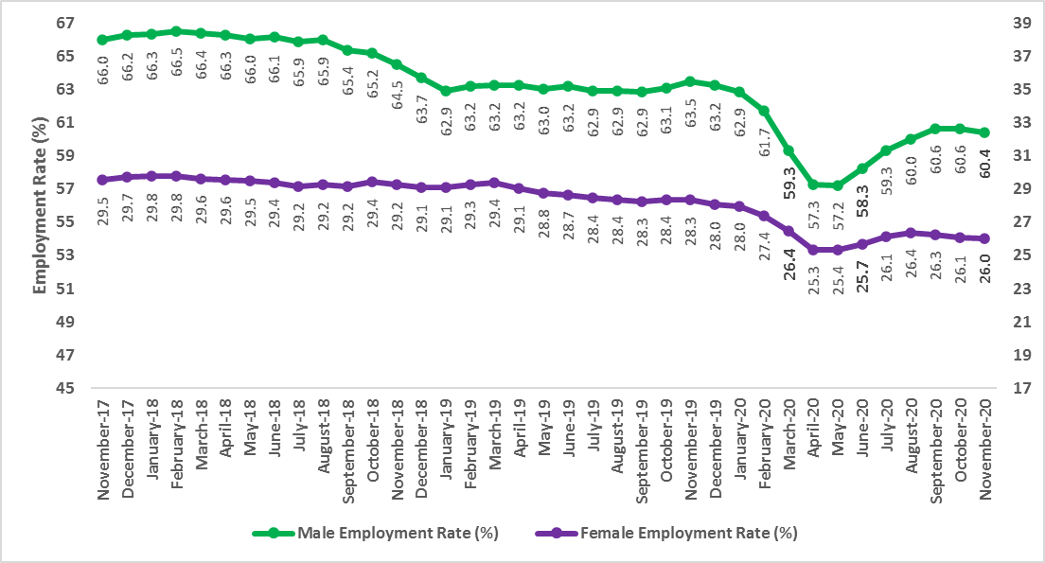
Source : Turkstat, Betam

Table 1: Seasonally adjusted non-agricultural labor market indicators (in thousands)
 | Labor force | Employment | Unemployment | Unemployment rate | Monthly changes
November-17 | 26372 | 23181 | 3191 | 12.1% | Labor force | Employment | Unemployment
December-17 | 26405 | 23289 | 3116 | 11.8% | 33 | 108 | -75
January-18 | 26523 | 23393 | 3130 | 11.8% | 118 | 104 | 14
February-18 | 26658 | 23512 | 3146 | 11.8% | 135 | 119 | 16
March-18 | 26684 | 23509 | 3175 | 11.9% | 27 | -3 | 30
April-18 | 26802 | 23505 | 3297 | 12.3% | 117 | -4 | 121
May-18 | 26866 | 23508 | 3358 | 12.5% | 65 | 3 | 62
June-18 | 26986 | 23559 | 3427 | 12.7% | 120 | 51 | 69
July-18 | 26889 | 23447 | 3442 | 12.8% | -97 | -112 | 15
August-18 | 27094 | 23572 | 3522 | 13.0% | 205 | 125 | 80
September-18 | 27013 | 23393 | 3620 | 13.4% | -82 | -179 | 97
October-18 | 27109 | 23395 | 3714 | 13.7% | 96 | 2 | 94
November-18 | 27120 | 23242 | 3878 | 14.3% | 11 | -153 | 164
December-18 | 27054 | 22996 | 4058 | 15.0% | -66 | -246 | 180
January-19 | 27090 | 22810 | 4280 | 15.8% | 36 | -186 | 222
February-19 | 27362 | 22957 | 4405 | 16.1% | 272 | 147 | 125
March-19 | 27494 | 23040 | 4454 | 16.2% | 132 | 83 | 49
April-19 | 27486 | 23061 | 4425 | 16.1% | -8 | 21 | -29
May-19 | 27420 | 23005 | 4415 | 16.1% | -67 | -56 | -11
June-19 | 27395 | 23039 | 4356 | 15.9% | -25 | 34 | -59
July-19 | 27321 | 22840 | 4481 | 16.4% | -74 | -199 | 125
August-19 | 27371 | 22882 | 4489 | 16.4% | 50 | 42 | 8
September-19 | 27321 | 22868 | 4453 | 16.3% | -49 | -14 | -35
October-19 | 27458 | 23120 | 4338 | 15.8% | 137 | 252 | -115
November-19 | 27490 | 23229 | 4261 | 15.5% | 32 | 109 | -77
December-19 | 27390 | 23199 | 4191 | 15.3% | -100 | -30 | -70
January-20 | 27163 | 23143 | 4020 | 14.8% | -226 | -56 | -170
February-20 | 26830 | 22886 | 3944 | 14.7% | -333 | -257 | -76
March-20 | 25853 | 21923 | 3930 | 15.2% | -977 | -963 | -14
April-20 | 25013 | 21011 | 4002 | 16.0% | -839 | -912 | 73
May-20 | 25007 | 20956 | 4051 | 16.2% | -6 | -55 | 49
June-20 | 25559 | 21367 | 4192 | 16.4% | 551 | 411 | 140
July-20 | 26017 | 21932 | 4085 | 15.7% | 458 | 565 | -107
August-20 | 26227 | 22188 | 4039 | 15.4% | 210 | 256 | -46
September-20 | 26343 | 22444 | 3899 | 14.8% | 116 | 256 | -140
October-20 | 26367 | 22438 | 3929 | 14.9% | 24 | -6 | 30
November-20 | 26411 | 22476 | 3935 | 14.9% | 45 | 38 | 7

Source: Turkstat, Betam

Table 2: Seasonally adjusted employment by sectors (in thousands) *
 | Agriculture | Manufacturing | Construction | Service | Monthly changes
November-17 | 5484 | 5470 | 2123 | 15588 | Agriculture | Manufacturing | Construction | Service
December-17 | 5542 | 5514 | 2173 | 15603 | 58 | 44 | 50 | 15
January-18 | 5488 | 5567 | 2199 | 15628 | -54 | 53 | 26 | 25
February-18 | 5459 | 5627 | 2193 | 15692 | -29 | 60 | -6 | 64
March-18 | 5396 | 5618 | 2160 | 15731 | -63 | -9 | -33 | 39
April-18 | 5397 | 5650 | 2109 | 15745 | 1 | 32 | -51 | 14
May-18 | 5322 | 5669 | 2063 | 15776 | -75 | 19 | -46 | 31
June-18 | 5275 | 5737 | 2043 | 15780 | -47 | 68 | -20 | 4
July-18 | 5247 | 5703 | 1957 | 15787 | -28 | -34 | -86 | 7
August-18 | 5196 | 5730 | 1958 | 15883 | -51 | 27 | 1 | 96
September-18 | 5207 | 5698 | 1897 | 15798 | 11 | -32 | -61 | -85
October-18 | 5261 | 5696 | 1838 | 15862 | 54 | -2 | -59 | 64
November-18 | 5192 | 5656 | 1791 | 15795 | -69 | -40 | -47 | -67
December-18 | 5162 | 5474 | 1700 | 15822 | -30 | -182 | -91 | 27
January-19 | 5141 | 5392 | 1656 | 15763 | -21 | -82 | -44 | -59
February-19 | 5184 | 5388 | 1655 | 15914 | 43 | -4 | -1 | 151
March-19 | 5175 | 5482 | 1611 | 15946 | -9 | 94 | -44 | 32
April-19 | 5096 | 5553 | 1588 | 15920 | -79 | 71 | -23 | -26
May-19 | 5030 | 5546 | 1550 | 15909 | -66 | -7 | -38 | -11
June-19 | 5043 | 5616 | 1578 | 15845 | 13 | 70 | 28 | -64
July-19 | 5105 | 5600 | 1508 | 15732 | 62 | -16 | -70 | -113
August-19 | 5083 | 5551 | 1490 | 15841 | -22 | -49 | -18 | 109
September-19 | 5080 | 5546 | 1487 | 15835 | -3 | -5 | -3 | -6
October-19 | 4976 | 5666 | 1539 | 15915 | -104 | 120 | 52 | 80
November-19 | 5029 | 5758 | 1536 | 15935 | 53 | 92 | -3 | 20
December-19 | 4931 | 5699 | 1565 | 15935 | -98 | -59 | 29 | 0
January-20 | 4896 | 5649 | 1571 | 15924 | -35 | -50 | 6 | -11
February-20 | 4677 | 5593 | 1548 | 15745 | -219 | -56 | -23 | -179
March-20 | 4660 | 5508 | 1354 | 15061 | -17 | -85 | -194 | -684
April-20 | 4629 | 5344 | 1238 | 14428 | -31 | -164 | -116 | -633
May-20 | 4729 | 5272 | 1356 | 14328 | 100 | -72 | 118 | -100
June-20 | 4766 | 5297 | 1502 | 14569 | 37 | 25 | 146 | 241
July-20 | 4739 | 5354 | 1614 | 14963 | -27 | 57 | 112 | 394
August-20 | 4760 | 5460 | 1624 | 15104 | 21 | 106 | 10 | 141
September-20 | 4722 | 5517 | 1638 | 15289 | -38 | 57 | 14 | 185
October-20 | 4726 | 5584 | 1636 | 15217 | 4 | 67 | -2 | -72
November-20 | 4664 | 5667 | 1630 | 15179 | -62 | 83 | -6 | -38
Source: Turkstat

Table 3: Seasonally adjusted non-agricultural labor force by gender (thousands)
 | Female Labor Force | Female Employment | Female Unemployed | Male Labor Force | Male Employment | Male Unemployed
November-17 | 7840 | 6498 | 1343 | 18530 | 16680 | 1850
December-17 | 7866 | 6539 | 1327 | 18541 | 16738 | 1803
January-18 | 7953 | 6609 | 1343 | 18593 | 16781 | 1812
February-18 | 7983 | 6632 | 1351 | 18667 | 16872 | 1794
March-18 | 7984 | 6618 | 1366 | 18694 | 16885 | 1809
April-18 | 8034 | 6632 | 1402 | 18743 | 16866 | 1877
May-18 | 8070 | 6641 | 1429 | 18780 | 16854 | 1926
June-18 | 8091 | 6641 | 1450 | 18896 | 16921 | 1975
July-18 | 8063 | 6594 | 1469 | 18867 | 16868 | 1999
August-18 | 8130 | 6658 | 1472 | 18997 | 16936 | 2061
September-18 | 8113 | 6649 | 1465 | 18924 | 16763 | 2162
October-18 | 8218 | 6750 | 1468 | 18888 | 16651 | 2237
November-18 | 8241 | 6746 | 1495 | 18867 | 16490 | 2377
December-18 | 8314 | 6734 | 1580 | 18738 | 16249 | 2488
January-19 | 8395 | 6715 | 1680 | 18686 | 16087 | 2599
February-19 | 8489 | 6742 | 1747 | 18845 | 16202 | 2643
March-19 | 8559 | 6792 | 1767 | 18916 | 16240 | 2675
April-19 | 8513 | 6743 | 1770 | 18942 | 16312 | 2630
May-19 | 8451 | 6702 | 1749 | 18937 | 16284 | 2653
June-19 | 8425 | 6682 | 1744 | 18963 | 16353 | 2610
July-19 | 8365 | 6615 | 1751 | 18995 | 16237 | 2758
August-19 | 8380 | 6622 | 1757 | 19022 | 16281 | 2742
September-19 | 8339 | 6616 | 1723 | 19000 | 16276 | 2724
October-19 | 8437 | 6713 | 1723 | 19037 | 16420 | 2617
November-19 | 8391 | 6688 | 1704 | 19072 | 16543 | 2529
December-19 | 8374 | 6663 | 1712 | 19016 | 16533 | 2483
January-20 | 8315 | 6698 | 1616 | 18853 | 16445 | 2408
February-20 | 8166 | 6653 | 1513 | 18646 | 16219 | 2427
March-20 | 7807 | 6411 | 1396 | 17993 | 15503 | 2489
April-20 | 7459 | 6125 | 1335 | 17502 | 14877 | 2625
May-20 | 7475 | 6116 | 1360 | 17481 | 14812 | 2669
June-20 | 7689 | 6233 | 1457 | 17861 | 15125 | 2736
July-20 | 7898 | 6393 | 1505 | 18145 | 15513 | 2632
August-20 | 7966 | 6483 | 1484 | 18308 | 15729 | 2579
September-20 | 7928 | 6476 | 1452 | 18469 | 15997 | 2472
October-20 | 7850 | 6412 | 1438 | 18542 | 16041 | 2502
November-20 | 7873 | 6453 | 1420 | 18537 | 16028 | 2509

Source: Turkstat, Betam

Table 4 : Seasonally adjusted female and male labor market indicators (thousands)
 | 15+ WAP, Female | Total Employment, Female | Total Unemployed, Female | 15+ WAP, Male | Total Employment, Male | Total Unemployed, Male
November-17 | 30399 | 8976 | 1354 | 29824 | 19683 | 1890
December-17 | 30433 | 9047 | 1336 | 29863 | 19780 | 1839
January-18 | 30467 | 9067 | 1353 | 29893 | 19817 | 1847
February-18 | 30500 | 9077 | 1362 | 29914 | 19895 | 1830
March-18 | 30530 | 9038 | 1375 | 29934 | 19862 | 1845
April-18 | 30564 | 9038 | 1412 | 29955 | 19855 | 1908
May-18 | 30596 | 9019 | 1440 | 29975 | 19797 | 1962
June-18 | 30630 | 8998 | 1463 | 29996 | 19836 | 2021
July-18 | 30662 | 8940 | 1483 | 30017 | 19770 | 2057
August-18 | 30695 | 8977 | 1496 | 30038 | 19810 | 2124
September-18 | 30729 | 8965 | 1485 | 30059 | 19649 | 2224
October-18 | 30761 | 9053 | 1486 | 30080 | 19605 | 2301
November-18 | 30795 | 9007 | 1511 | 30101 | 19421 | 2443
December-18 | 30827 | 8970 | 1594 | 30121 | 19184 | 2553
January-19 | 30865 | 8973 | 1707 | 30152 | 18974 | 2671
February-19 | 30908 | 9048 | 1782 | 30193 | 19081 | 2716
March-19 | 30947 | 9092 | 1795 | 30230 | 19113 | 2753
April-19 | 30990 | 9007 | 1794 | 30270 | 19143 | 2709
May-19 | 31032 | 8926 | 1761 | 30310 | 19092 | 2730
June-19 | 31075 | 8907 | 1759 | 30351 | 19171 | 2697
July-19 | 31117 | 8852 | 1764 | 30390 | 19108 | 2822
August-19 | 31160 | 8842 | 1772 | 30431 | 19146 | 2806
September-19 | 31203 | 8819 | 1736 | 30472 | 19153 | 2787
October-19 | 31245 | 8865 | 1734 | 30511 | 19237 | 2663
November-19 | 31288 | 8865 | 1718 | 30552 | 19389 | 2573
December-19 | 31330 | 8786 | 1727 | 30591 | 19341 | 2531
January-20 | 31374 | 8779 | 1638 | 30641 | 19258 | 2479
February-20 | 31420 | 8606 | 1532 | 30699 | 18938 | 2501
March-20 | 31463 | 8322 | 1410 | 30753 | 18248 | 2567
April-20 | 31509 | 7982 | 1345 | 30811 | 17651 | 2686
May-20 | 31554 | 8001 | 1376 | 30867 | 17663 | 2735
June-20 | 31600 | 8117 | 1469 | 30926 | 18015 | 2799
July-20 | 31644 | 8271 | 1518 | 30982 | 18382 | 2689
August-20 | 31690 | 8357 | 1492 | 31040 | 18619 | 2640
September-20 | 31736 | 8335 | 1457 | 31098 | 18859 | 2535
October-20 | 31781 | 8286 | 1454 | 31154 | 18886 | 2570
November-20 | 31827 | 8290 | 1420 | 31213 | 18846 | 2509

Source: Turkstat, Betam

Table 5 : Seasonally adjusted female and male LFPR and ER (%)

 | Women LFPR | Women Employment Rate | Women LFPR | Men Employment Rate
November-18 | 34.2 | 29.2 | 72.6 | 64.5
December-18 | 34.3 | 29.1 | 72.2 | 63.7
January-19 | 34.6 | 29.1 | 71.8 | 62.9
February-19 | 35.0 | 29.3 | 72.2 | 63.2
March-19 | 35.2 | 29.4 | 72.3 | 63.2
April-19 | 34.9 | 29.1 | 72.2 | 63.2
May-19 | 34.4 | 28.8 | 72.0 | 63.0
June-19 | 34.3 | 28.7 | 72.1 | 63.2
July-19 | 34.1 | 28.4 | 72.2 | 62.9
August-19 | 34.1 | 28.4 | 72.1 | 62.9
September-19 | 33.8 | 28.3 | 72.0 | 62.9
October-19 | 33.9 | 28.4 | 71.8 | 63.1
November-19 | 33.8 | 28.3 | 71.9 | 63.5
December-19 | 33.6 | 28.0 | 71.5 | 63.2
January-20 | 33.2 | 28.0 | 70.9 | 62.9
February-20 | 32.3 | 27.4 | 69.8 | 61.7
March-20 | 30.9 | 26.4 | 67.7 | 59.3
April-20 | 29.6 | 25.3 | 66.0 | 57.3
May-20 | 29.7 | 25.4 | 66.1 | 57.2
June-20 | 30.3 | 25.7 | 67.3 | 58.3
July-20 | 30.9 | 26.1 | 68.0 | 59.3
August-20 | 31.1 | 26.4 | 68.5 | 60.0
September-20 | 30.9 | 26.3 | 68.8 | 60.6
October-20 | 30.6 | 26.1 | 68.9 | 60.6
November-20 | 30.5 | 26.0 | 68.4 | 60.4

Source: Turkstat, Betam

Table 6 : Seasonally adjusted LFPR, ER and Unemployed / WAP (%)
 | 15+ WAP | Labor Force | Employment | LFPR | ER | Unemployed / WAP
Nov-17 | 60223 | 31917 | 28665 | 53.0 | 47.6 | 5.4
Dec-17 | 60295 | 32007 | 28831 | 53.1 | 47.8 | 5.3
Jan-18 | 60360 | 32064 | 28881 | 53.1 | 47.8 | 5.3
Feb-18 | 60415 | 32155 | 28971 | 53.2 | 48.0 | 5.3
Mar-18 | 60464 | 32126 | 28905 | 53.1 | 47.8 | 5.3
Apr-18 | 60519 | 32228 | 28902 | 53.3 | 47.8 | 5.5
May-18 | 60571 | 32234 | 28830 | 53.2 | 47.6 | 5.6
Jun-18 | 60626 | 32313 | 28834 | 53.3 | 47.6 | 5.7
Jul-18 | 60679 | 32220 | 28694 | 53.1 | 47.3 | 5.8
Aug-18 | 60733 | 32383 | 28768 | 53.3 | 47.4 | 6.0
Sep-18 | 60788 | 32310 | 28600 | 53.2 | 47.0 | 6.1
Oct-18 | 60841 | 32451 | 28656 | 53.3 | 47.1 | 6.2
Nov-18 | 60896 | 32403 | 28434 | 53.2 | 46.7 | 6.5
Dec-18 | 60948 | 32311 | 28158 | 53.0 | 46.2 | 6.8
Jan-19 | 61017 | 32317 | 27951 | 53.0 | 45.8 | 7.2
Feb-19 | 61101 | 32634 | 28141 | 53.4 | 46.1 | 7.4
Mar-19 | 61177 | 32774 | 28215 | 53.6 | 46.1 | 7.5
Apr-19 | 61261 | 32680 | 28157 | 53.3 | 46.0 | 7.4
May-19 | 61342 | 32532 | 28035 | 53.0 | 45.7 | 7.3
Jun-19 | 61426 | 32521 | 28082 | 52.9 | 45.7 | 7.2
Jul-19 | 61507 | 32499 | 27945 | 52.8 | 45.4 | 7.4
Aug-19 | 61591 | 32518 | 27965 | 52.8 | 45.4 | 7.4
Sep-19 | 61675 | 32463 | 27948 | 52.6 | 45.3 | 7.3
Oct-19 | 61756 | 32501 | 28096 | 52.6 | 45.5 | 7.1
Nov-19 | 61840 | 32564 | 28258 | 52.7 | 45.7 | 7.0
Dec-19 | 61921 | 32381 | 28130 | 52.3 | 45.4 | 6.9
Jan-20 | 62015 | 32140 | 28039 | 51.8 | 45.2 | 6.6
Feb-20 | 62119 | 31599 | 27563 | 50.9 | 44.4 | 6.5
Mar-20 | 62216 | 30589 | 26583 | 49.2 | 42.7 | 6.4
Apr-20 | 62320 | 29711 | 25640 | 47.7 | 41.1 | 6.5
May-20 | 62421 | 29823 | 25685 | 47.8 | 41.1 | 6.6
Jun-20 | 62525 | 30386 | 26133 | 48.6 | 41.8 | 6.8
Jul-20 | 62626 | 30843 | 26671 | 49.2 | 42.6 | 6.7
Aug-20 | 62730 | 31041 | 26948 | 49.5 | 43.0 | 6.5
Sep-20 | 62834 | 31140 | 27166 | 49.6 | 43.2 | 6.3
Oct-20 | 62935 | 31178 | 27164 | 49.5 | 43.2 | 6.4
Nov-20 | 63040 | 31146 | 27140 | 49.4 | 43.1 | 6.4

Source: Turkstat, Betam

Table 7 : Seasonally adjusted non-seekers that are available to start, unemployed and sum of both

 | Discouraged Job Seekers-SA | Unemployed-TurkStat-SA | Other Non-Seekers Who are Available To Start | Total
Mar-19 | 545 | 4560 | 1661 | 6767
Apr-19 | 584 | 4523 | 1773 | 6880
May-19 | 602 | 4497 | 1727 | 6826
Jun-19 | 622 | 4439 | 1686 | 6747
Jul-19 | 640 | 4553 | 1684 | 6876
Aug-19 | 645 | 4554 | 1697 | 6897
Sep-19 | 670 | 4515 | 1736 | 6920
Oct-19 | 702 | 4405 | 1629 | 6735
Nov-19 | 719 | 4305 | 1576 | 6600
Dec-19 | 762 | 4252 | 1602 | 6615
Jan-20 | 820 | 4101 | 1728 | 6648
Feb-20 | 978 | 4037 | 1949 | 6964
Mar-20 | 1133 | 4006 | 2474 | 7613
Apr-20 | 1378 | 4072 | 3210 | 8660
May-20 | 1454 | 4138 | 3318 | 8910
Jun-20 | 1465 | 4253 | 3123 | 8841
Jul-20 | 1404 | 4172 | 2782 | 8358
Aug-20 | 1420 | 4093 | 2879 | 8393
Sep-20 | 1502 | 3975 | 2954 | 8431
Oct-20 | 1590 | 4014 | 3077 | 8681
Nov-20 | 1678 | 4006 | 3291 | 8975

Source: Turkstat, Betam

* Prof. Dr. Seyfettin Gürsel, Betam, Director, seyfettin.gursel@eas.bau.edu.tr
** Doç. Dr. Gökçe Uysal, Betam, Deputy Director, gokce.uysal@eas.bau.edu.tr
*** Mehmet Cem Şahin, Betam, Research Assistant, hamza.mutluay@eas.bau.edu.tr
Turkstat revised the labor market statistics drastically in February 2014. Within this framework, they back casted various labor market indicators and they also continued to announce seasonally adjusted series. However, Turkstat is not providing back-casted series by gender. Therefore, female and male labor market statistics are not sufficiently long for the seasonal adjustment procedures (There should be minimum 36 observations). With the announcement of the period of February 2017 data, the number of observations required for the seasonal decontamination process was provided. From this period Betam generated seasonal adjustment series in terms of gender. Nevertheless, it should not be forgotten that seasonal adjustment may cause extra volatility in the series for at least a while.

