Labor Market Outlook:
January 2021

14 January 2021

MILD INCREASE IN UNEMPLOYMENT AS EMPLOYMENT DROPS IN SERVICES

Seyfettin Gürsel*, Gökçe Uysal** , Hamza Mutluay***

Executive Summary

Seasonally adjusted labor market data show that in the period of October 2020, non-agricultural unemployment rate is 14.9 percent following a 0.1 percentage point increase from September 2020. In this period, while non-agricultural employment decreased by 5 thousand, labor force increased by 25 thousand. According to sectoral data, employment decreased in the construction and services sectors. While employment in the construction and services sectors decreased by 2 thousand and 70 thousand respectively, employment in the agriculture and manufacturing sectors increased by 6 thousand and 67 thousand, respectively. According to seasonally adjusted data, the female non-agricultural employment decreased by 63 thousand and female labor force by 77 thousand. As a result, the non-agricultural female unemployment rate remained unchanged at 18.3 percent. As for the male labor force and employment, they increased by 73 thousand and 44 thousand, respectively. Thus, the non-agricultural male unemployment rate increased from 13.4 to 13.5 percent. The existing gender gap in non-agricultural unemployment rate is 4.8 percent.

Limited decreases in non-agricultural employment

Seasonally adjusted data show that the non-agricultural labor force rose to 26 million 385 thousand, increasing by 25 thousand in the period between October 2020 (September-October-November) and September 2020 (August-September-October). In the period of October 2020, the non-agricultural labor force remained lower than that in the period of January 2020 (27 million 154 thousand) by 768 thousand. The non-agricultural employment decreased to 22 million 454 thousand, falling by 5 thousand, compared to the previous period (Figure1, Table1). In the period of October 2020, while the increases in labor force continued to decelerate, employment began to decrease after sustained increases during the last four periods. In this period, the number of unemployed in the non-agricultural sectors increased by 30 thousand, and the non-agricultural unemployment rate rose to 14.9 percent with an increase of 0.1 percentage point.

In this brief, to correct for the possibly misleading effects of the decreasing labor force on unemployment, we also discuss the ratio of total unemployed to non-institutional working age population along with the LFPR and the Employment Rate, as presented in Figure 2. In the period of October 2020, compared to September 2020, the ratio of total unemployed to non-institutional working age population increased from 6.3 to 6.4 percent. The labor force participation rate remained unchanged at 49.6 percent, and employment rate decreased from 43.3 to 43.2 percent. The labor force participation rate and the employment rate were lower by 3.1 and 2.3 percentage points, respectively, compared to the period of October 2019. Let us further note that labor force participation and employment rates were still lower by 2.2 and 2.0 percentage points respectively compared to pre-COVID levels.(Figure 2).

Figure 1. Seasonally adjusted non-agricultural labor force, employment, and unemployment
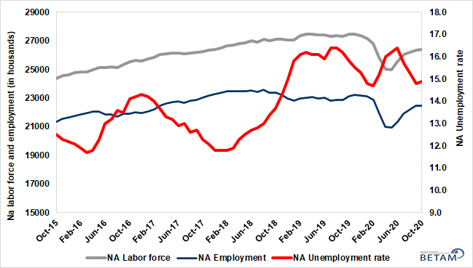
Source: Turkstat, Betam

Figure 2. Seasonally adjusted LFPR, employment rate and non-agricultural unemployment rate
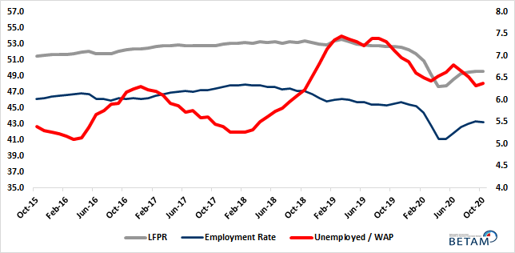
Source: Turkstat, Betam

Increase in the number of those who are “not seeking a job but available to start”

The level of labor force, by definition, is the summation of the level of employed people and the level of job seekers (unemployed). During the periods of massive employment losses, we may observe striking increases among individuals who wish to work but are not actively seeking a job as they think that they would not be able to find a job. Those individuals that stop searching for jobs and hence drop out of the labor force due to loss of confidence and other reasons are referred as ‘Discouraged workers’ and ‘Other’ by TurkStat. The sustained increases in the number of discouraged workers started in January 2019 and accelerated during the pandemic. Even though this trend was reversed in the period of June 2020, the number of discouraged workers increased by 90 thousand in the period of October 2020. In addition, the number of inactive non-seekers who are available to start working increased by 122 thousand. Finally, adding these categories to the number of unemployed, the sum reached 8 million 630 thousand with an increase of 251 thousand.

Figure 3. The number of unemployed people, non-seekers who are available, and summation of both (SA)
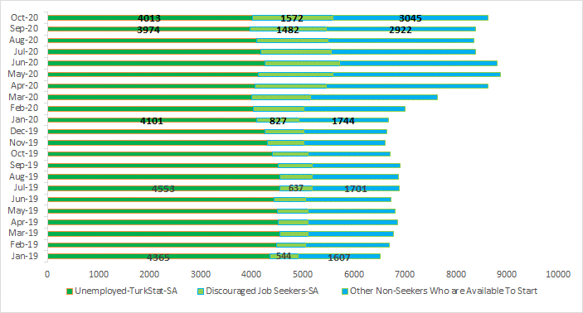
Source: Turkstat, Betam

Decreases in construction and services sectors

According to seasonally adjusted employment data, in the period of October 2020 compared to September 2020, while employment increased in the agriculture and manufacturing sectors, the employment in the construction and services sectors decreased. Employment in the construction and services sectors decreased by 2 thousand and 70 thousand, respectively. After the rise in employment in the construction and services sectors during all of the last four periods, employment in both sectors declined in the period of October 2020. In the manufacturing sector, while employment increased by 67 thousand, the level of employment was still lower by 65 thousand than that in the period of January 2020. The employment in agriculture increased by 6 thousand compared to the previous period.

Figure 4: Employment by sectors (in thousand)
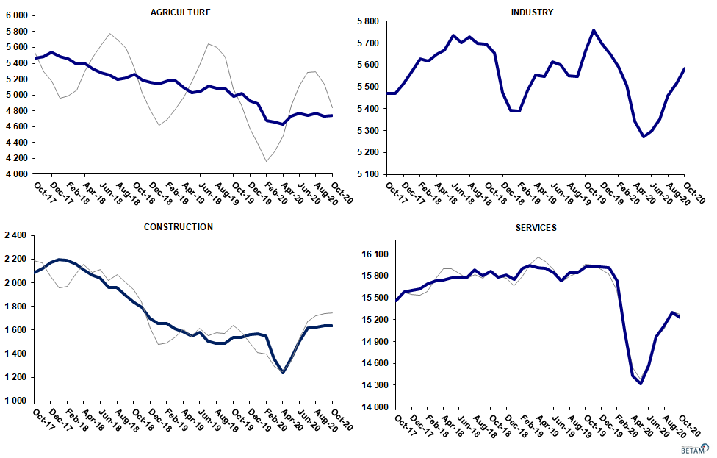
Source: TURKSTAT, Betam

Strong decreases in yearly non-agricultural labor force and employment

Compared to October 2019, the non-agricultural employment decreased by 654 thousand (2.8 percent) in October 2020 while non-agricultural labor force declined by 1 million 59 thousand, resulting in a decrease of 405 thousand in the number of unemployed people (Figure 5).

Figure 5 Year-on-year changes in non-agricultural labor force, employment, and unemployment
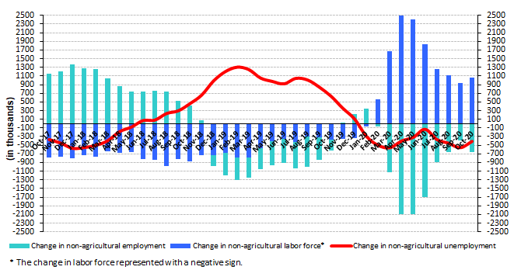
Source: TURKSTAT, Betam

Female labor force and employment continue to decline

Figure 6 shows seasonally adjusted non-agricultural unemployment rate for males (green) and for females (purple). In the period of October 2020 compared to the previous period, female non-agricultural unemployment rate remained unchanged at 18.3 percent. Male non-agricultural unemployment rate was 13.5 percent, with an increase of 0.1 percentage point compared to September 2020. While female labor force and employment decreased by 77 and 63 thousand respectively, male labor force and employment increased by 73 and 44 thousand. As a result, the gender gap in the non-agricultural unemployment rate remained unchanged at 4.9 percent.

Figure 6: Seasonally adjusted non-agricultural unemployment rate by gender (%)
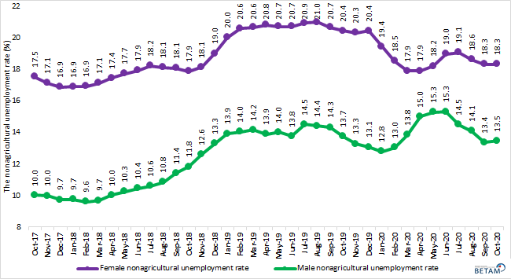
Source: Turkstat, Betam

In addition to non-agricultural male and female unemployment rates, we track the developments in the labor market along the gender divide. The female labor force participation rate (LFPR) and the male LFPR are presented in Figure 7, along with the female employment rate (ER) and the male employment rate in Figure 8. As can be seen in Figure 7, when the pandemic started in March 2020, the male LFPR decreased sharply by 5 percentage points over the next three periods. The decreasing trend was reversed after the period of May 2020. As a result, in the period of October 2020, male LFPR was 68.9 percent. However,the male LFPR is still lower by 3.0 percentage points compared to its long run average of 72.0 percent.
While the female LFPR had been rising steadily over years, the increase stopped after the period of March 2019 and entered a period of slow decline. After it peaked in the period of March 2019 (at 35.2 percent), it fell by 2 percentage points from March 2019 to January 2020. Following the pandemic, the female LFPR declined to 29.6 percent in April 2020, falling by 3.6 percentage points between January and April 2020. While the female LFPR recovered after May 2020, this recovery stopped in the period of September 2020 and the female LFPR decreased by 0.2 percentage points to 30.7 percent in the period of October 2020.
It is worthwhile to note two things about female and male LFPR : 1) the fall in the female LFPR started earlier than the fall in the male LFPR and this corresponds to the increase in female unemployment (Figure 6). 2) While the coronavirus pandemic hit the male LFPR harder than the female LFPR, the trend is stronger for the male LFPR than for the female LFPR. The decrease in the female LFPR in this period suggests that it will take a while before the female LFPR reaches its pre-pandemic levels.

Figure 7 : Seasonally adjusted female and male LFPR (%)
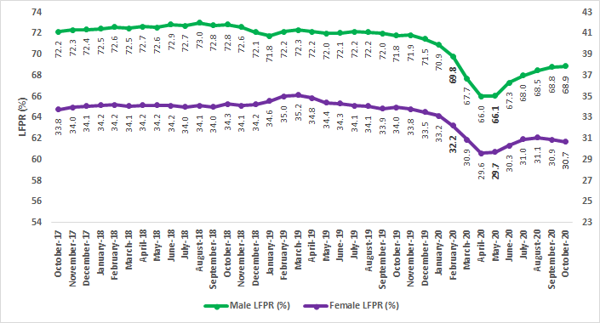
Source : Turkstat, Betam

As the strong increases in the GDP and the employment pulled up the male the ER to over 66 percent in the second half of 2017, the male ER went down to 62.9 percent in the period of January 2020. The pandemic caused the male ER to decrease further to 57.3 percent in the period of April 2020. As a result of the increasing trend that is observed after May 2020, the male ER reached 60.7 percent in the period of October 2020. Still, this rate is lower by 2.2 percentage point than its January 2020 levels. When we examine the female LFPR, we see that while it remained in the 29-29.5 band until March 2019, it started to decline afterwards and dropped to 28.0 percent in January 2020, along with the increases in female unemployment. After the pandemic, the female ER fell further down by 2.6 percentange points to 25.3 percent in April 2020. Again, the increase that started in May 2020 has stalled in the period of September 2020 and decreased to 26.1 percent in the period of October 2020.
Regarding the effects of the pandemic on the female and the male ER, we observe that while the female ER took a smaller hit than the male ER, its recovery has also been weaker. In addition, the recovery in female employment has been weaker and the female ER has started falling again in the last two periods.
Figure 8 : Seasonally adjusted female and male employment rate (%)
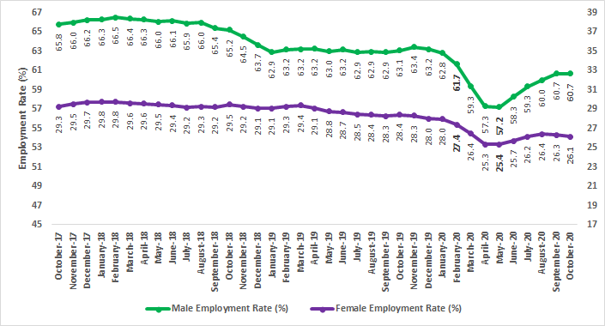
Source : Turkstat, Betam

Table 1: Seasonally adjusted non-agricultural labor market indicators (in thousands)
 | Labor force | Employment | Unemployment | Unemployment rate | Monthly changes
October-17 | 26241 | 23013 | 3228 | 12.3% | Labor force | Employment | Unemployment
November-17 | 26366 | 23176 | 3190 | 12.1% | 126 | 163 | -37
December-17 | 26400 | 23285 | 3115 | 11.8% | 34 | 109 | -75
January-18 | 26518 | 23389 | 3129 | 11.8% | 118 | 104 | 14
February-18 | 26655 | 23510 | 3145 | 11.8% | 137 | 121 | 16
March-18 | 26683 | 23508 | 3175 | 11.9% | 28 | -2 | 30
April-18 | 26800 | 23504 | 3296 | 12.3% | 117 | -4 | 121
May-18 | 26865 | 23507 | 3358 | 12.5% | 65 | 3 | 62
June-18 | 26987 | 23560 | 3427 | 12.7% | 122 | 53 | 69
July-18 | 26891 | 23449 | 3442 | 12.8% | -96 | -111 | 15
August-18 | 27100 | 23577 | 3523 | 13.0% | 209 | 128 | 81
September-18 | 27021 | 23400 | 3621 | 13.4% | -79 | -177 | 98
October-18 | 27119 | 23404 | 3715 | 13.7% | 99 | 4 | 95
November-18 | 27112 | 23235 | 3877 | 14.3% | -7 | -169 | 162
December-18 | 27046 | 22989 | 4057 | 15.0% | -66 | -246 | 180
January-19 | 27083 | 22804 | 4279 | 15.8% | 37 | -185 | 222
February-19 | 27358 | 22953 | 4405 | 16.1% | 274 | 149 | 125
March-19 | 27490 | 23037 | 4453 | 16.2% | 133 | 84 | 49
April-19 | 27485 | 23060 | 4425 | 16.1% | -5 | 23 | -28
May-19 | 27416 | 23002 | 4414 | 16.1% | -69 | -58 | -11
June-19 | 27396 | 23040 | 4356 | 15.9% | -20 | 38 | -58
July-19 | 27327 | 22845 | 4482 | 16.4% | -69 | -195 | 126
August-19 | 27382 | 22891 | 4491 | 16.4% | 55 | 46 | 9
September-19 | 27302 | 22879 | 4423 | 16.2% | -80 | -12 | -68
October-19 | 27474 | 23133 | 4341 | 15.8% | 172 | 254 | -82
November-19 | 27478 | 23219 | 4259 | 15.5% | 4 | 86 | -82
December-19 | 27379 | 23190 | 4189 | 15.3% | -99 | -29 | -70
January-20 | 27154 | 23135 | 4019 | 14.8% | -225 | -55 | -170
February-20 | 26822 | 22879 | 3943 | 14.7% | -332 | -256 | -76
March-20 | 25848 | 21919 | 3929 | 15.2% | -974 | -960 | -14
April-20 | 25010 | 21008 | 4002 | 16.0% | -838 | -911 | 73
May-20 | 25001 | 20951 | 4050 | 16.2% | -8 | -57 | 49
June-20 | 25559 | 21367 | 4192 | 16.4% | 557 | 416 | 141
July-20 | 26024 | 21938 | 4086 | 15.7% | 465 | 571 | -106
August-20 | 26210 | 22200 | 4010 | 15.3% | 186 | 262 | -76
September-20 | 26360 | 22459 | 3901 | 14.8% | 150 | 259 | -109
October-20 | 26385 | 22454 | 3931 | 14.9% | 25 | -5 | 30

Source: Turkstat, Betam

Table 2: Seasonally adjusted employment by sectors (in thousands) *
 | Agriculture | Manufacturing | Construction | Service | Monthly changes
October-17 | 5468 | 5470 | 2082 | 15462 | Agriculture | Manufacturing | Construction | Service
November-17 | 5480 | 5470 | 2122 | 15583 | 12 | 0 | 40 | 121
December-17 | 5538 | 5514 | 2172 | 15598 | 58 | 44 | 50 | 15
January-18 | 5485 | 5567 | 2199 | 15624 | -53 | 53 | 27 | 26
February-18 | 5457 | 5627 | 2193 | 15690 | -28 | 60 | -6 | 66
March-18 | 5395 | 5618 | 2160 | 15730 | -62 | -9 | -33 | 40
April-18 | 5397 | 5650 | 2109 | 15745 | 2 | 32 | -51 | 15
May-18 | 5323 | 5669 | 2063 | 15775 | -74 | 19 | -46 | 30
June-18 | 5277 | 5737 | 2043 | 15780 | -46 | 68 | -20 | 5
July-18 | 5250 | 5703 | 1957 | 15790 | -27 | -34 | -86 | 10
August-18 | 5199 | 5730 | 1958 | 15888 | -51 | 27 | 1 | 98
September-18 | 5211 | 5698 | 1897 | 15805 | 12 | -32 | -61 | -83
October-18 | 5265 | 5696 | 1838 | 15870 | 54 | -2 | -59 | 65
November-18 | 5187 | 5656 | 1790 | 15788 | -78 | -40 | -48 | -82
December-18 | 5157 | 5474 | 1700 | 15815 | -30 | -182 | -90 | 27
January-19 | 5137 | 5392 | 1656 | 15757 | -20 | -82 | -44 | -58
February-19 | 5181 | 5388 | 1655 | 15910 | 44 | -4 | -1 | 153
March-19 | 5174 | 5482 | 1611 | 15944 | -7 | 94 | -44 | 34
April-19 | 5096 | 5553 | 1588 | 15919 | -78 | 71 | -23 | -25
May-19 | 5031 | 5546 | 1550 | 15906 | -65 | -7 | -38 | -13
June-19 | 5045 | 5616 | 1578 | 15846 | 14 | 70 | 28 | -60
July-19 | 5108 | 5600 | 1508 | 15737 | 63 | -16 | -70 | -109
August-19 | 5087 | 5551 | 1490 | 15849 | -21 | -49 | -18 | 112
September-19 | 5086 | 5546 | 1487 | 15845 | -1 | -5 | -3 | -4
October-19 | 4983 | 5666 | 1540 | 15928 | -103 | 120 | 53 | 83
November-19 | 5021 | 5758 | 1536 | 15925 | 38 | 92 | -4 | -3
December-19 | 4923 | 5699 | 1564 | 15927 | -98 | -59 | 28 | 2
January-20 | 4890 | 5649 | 1570 | 15916 | -33 | -50 | 6 | -11
February-20 | 4673 | 5593 | 1548 | 15739 | -217 | -56 | -22 | -177
March-20 | 4658 | 5508 | 1354 | 15057 | -15 | -85 | -194 | -682
April-20 | 4629 | 5344 | 1238 | 14426 | -29 | -164 | -116 | -631
May-20 | 4731 | 5272 | 1356 | 14324 | 102 | -72 | 118 | -102
June-20 | 4769 | 5297 | 1502 | 14569 | 38 | 25 | 146 | 245
July-20 | 4744 | 5354 | 1615 | 14969 | -25 | 57 | 113 | 400
August-20 | 4766 | 5460 | 1624 | 15116 | 22 | 106 | 9 | 147
September-20 | 4731 | 5517 | 1639 | 15304 | -35 | 57 | 15 | 188
October-20 | 4737 | 5584 | 1637 | 15234 | 6 | 67 | -2 | -70
Source: Turkstat

Table 3: Seasonally adjusted non-agricultural labor force by gender (thousands)
 | Female Labor Force | Female Employment | Female Unemployed | Male Labor Force | Male Employment | Male Unemployed
October-17 | 7764 | 6404 | 1360 | 18466 | 16616 | 1850
November-17 | 7839 | 6497 | 1342 | 18526 | 16675 | 1850
December-17 | 7865 | 6538 | 1326 | 18538 | 16734 | 1804
January-18 | 7951 | 6608 | 1343 | 18591 | 16778 | 1813
February-18 | 7982 | 6631 | 1351 | 18666 | 16871 | 1795
March-18 | 7982 | 6617 | 1366 | 18694 | 16885 | 1810
April-18 | 8033 | 6631 | 1401 | 18744 | 16866 | 1878
May-18 | 8069 | 6640 | 1429 | 18779 | 16853 | 1926
June-18 | 8091 | 6640 | 1450 | 18896 | 16922 | 1974
July-18 | 8064 | 6595 | 1469 | 18869 | 16870 | 1999
August-18 | 8133 | 6660 | 1473 | 19000 | 16940 | 2060
September-18 | 8117 | 6652 | 1466 | 18927 | 16767 | 2160
October-18 | 8224 | 6755 | 1469 | 18891 | 16656 | 2235
November-18 | 8239 | 6745 | 1494 | 18863 | 16485 | 2378
December-18 | 8311 | 6732 | 1579 | 18734 | 16245 | 2489
January-19 | 8392 | 6714 | 1679 | 18684 | 16083 | 2600
February-19 | 8487 | 6740 | 1746 | 18844 | 16199 | 2645
March-19 | 8557 | 6790 | 1767 | 18916 | 16239 | 2677
April-19 | 8511 | 6741 | 1770 | 18942 | 16311 | 2631
May-19 | 8449 | 6700 | 1750 | 18936 | 16283 | 2653
June-19 | 8425 | 6681 | 1744 | 18964 | 16354 | 2610
July-19 | 8368 | 6616 | 1751 | 18996 | 16240 | 2756
August-19 | 8385 | 6626 | 1758 | 19025 | 16286 | 2740
September-19 | 8346 | 6621 | 1724 | 19003 | 16282 | 2721
October-19 | 8445 | 6720 | 1725 | 19040 | 16427 | 2614
November-19 | 8387 | 6685 | 1702 | 19066 | 16537 | 2530
December-19 | 8370 | 6660 | 1710 | 19013 | 16527 | 2485
January-20 | 8311 | 6696 | 1615 | 18850 | 16440 | 2410
February-20 | 8162 | 6650 | 1512 | 18645 | 16216 | 2429
March-20 | 7804 | 6408 | 1396 | 17993 | 15502 | 2491
April-20 | 7457 | 6122 | 1335 | 17502 | 14877 | 2626
May-20 | 7473 | 6113 | 1360 | 17480 | 14811 | 2669
June-20 | 7690 | 6233 | 1457 | 17861 | 15126 | 2735
July-20 | 7902 | 6396 | 1506 | 18147 | 15517 | 2630
August-20 | 7973 | 6489 | 1485 | 18311 | 15735 | 2577
September-20 | 7936 | 6483 | 1453 | 18473 | 16005 | 2468
October-20 | 7859 | 6420 | 1439 | 18546 | 16049 | 2497

Source: Turkstat, Betam

Table 4 : Seasonally adjusted female and male labor market indicators (thousands)
 | 15+ WAP, Female | Total Employment, Female | Total Unemployed, Female | 15+ WAP, Male | Total Employment, Male | Total Unemployed, Male
September-17 | 30330 | 8778 | 1440 | 29746 | 19600 | 1927
October-17 | 30364 | 8888 | 1373 | 29785 | 19595 | 1897
November-17 | 30399 | 8974 | 1353 | 29824 | 19677 | 1890
December-17 | 30433 | 9044 | 1335 | 29863 | 19774 | 1840
January-18 | 30467 | 9065 | 1352 | 29893 | 19813 | 1848
February-18 | 30500 | 9075 | 1362 | 29914 | 19892 | 1831
March-18 | 30530 | 9036 | 1375 | 29934 | 19861 | 1845
April-18 | 30564 | 9037 | 1412 | 29955 | 19855 | 1908
May-18 | 30596 | 9018 | 1440 | 29975 | 19797 | 1962
June-18 | 30630 | 8998 | 1464 | 29996 | 19837 | 2020
July-18 | 30662 | 8941 | 1483 | 30017 | 19773 | 2056
August-18 | 30695 | 8981 | 1497 | 30038 | 19814 | 2123
September-18 | 30729 | 8970 | 1486 | 30059 | 19655 | 2223
October-18 | 30761 | 9060 | 1487 | 30080 | 19612 | 2299
November-18 | 30795 | 9003 | 1510 | 30101 | 19414 | 2444
December-18 | 30827 | 8965 | 1593 | 30121 | 19178 | 2554
January-19 | 30865 | 8969 | 1706 | 30152 | 18969 | 2673
February-19 | 30908 | 9044 | 1781 | 30193 | 19077 | 2718
March-19 | 30947 | 9089 | 1794 | 30230 | 19112 | 2755
April-19 | 30990 | 9005 | 1794 | 30270 | 19142 | 2710
May-19 | 31032 | 8925 | 1761 | 30310 | 19091 | 2731
June-19 | 31075 | 8908 | 1759 | 30351 | 19172 | 2697
July-19 | 31117 | 8856 | 1765 | 30390 | 19112 | 2820
August-19 | 31160 | 8849 | 1773 | 30431 | 19152 | 2804
September-19 | 31203 | 8827 | 1737 | 30472 | 19161 | 2784
October-19 | 31245 | 8876 | 1736 | 30511 | 19247 | 2659
November-19 | 31288 | 8857 | 1717 | 30552 | 19381 | 2574
December-19 | 31330 | 8777 | 1725 | 30591 | 19333 | 2533
January-20 | 31374 | 8771 | 1636 | 30641 | 19252 | 2481
February-20 | 31420 | 8600 | 1531 | 30699 | 18933 | 2503
March-20 | 31463 | 8317 | 1410 | 30753 | 18246 | 2569
April-20 | 31509 | 7979 | 1345 | 30811 | 17651 | 2688
May-20 | 31554 | 8000 | 1376 | 30867 | 17662 | 2735
June-20 | 31600 | 8120 | 1470 | 30926 | 18016 | 2799
July-20 | 31644 | 8278 | 1518 | 30982 | 18386 | 2688
August-20 | 31690 | 8369 | 1493 | 31040 | 18627 | 2638
September-20 | 31736 | 8349 | 1458 | 31098 | 18870 | 2531
October-20 | 31781 | 8301 | 1455 | 31154 | 18897 | 2565

Source: Turkstat, Betam

Table 5 : Seasonally adjusted female and male LFPR and ER (%)

 | Women LFPR | Women Employment Rate | Women LFPR | Men Employment Rate
October-18 | 34.3 | 29.5 | 72.8 | 65.2
November-18 | 34.1 | 29.2 | 72.6 | 64.5
December-18 | 34.2 | 29.1 | 72.1 | 63.7
January-19 | 34.6 | 29.1 | 71.8 | 62.9
February-19 | 35.0 | 29.3 | 72.2 | 63.2
March-19 | 35.2 | 29.4 | 72.3 | 63.2
April-19 | 34.8 | 29.1 | 72.2 | 63.2
May-19 | 34.4 | 28.8 | 72.0 | 63.0
June-19 | 34.3 | 28.7 | 72.1 | 63.2
July-19 | 34.1 | 28.5 | 72.2 | 62.9
August-19 | 34.1 | 28.4 | 72.2 | 62.9
September-19 | 33.9 | 28.3 | 72.0 | 62.9
October-19 | 34.0 | 28.4 | 71.8 | 63.1
November-19 | 33.8 | 28.3 | 71.9 | 63.4
December-19 | 33.5 | 28.0 | 71.5 | 63.2
January-20 | 33.2 | 28.0 | 70.9 | 62.8
February-20 | 32.2 | 27.4 | 69.8 | 61.7
March-20 | 30.9 | 26.4 | 67.7 | 59.3
April-20 | 29.6 | 25.3 | 66.0 | 57.3
May-20 | 29.7 | 25.4 | 66.1 | 57.2
June-20 | 30.3 | 25.7 | 67.3 | 58.3
July-20 | 31.0 | 26.2 | 68.0 | 59.3
August-20 | 31.1 | 26.4 | 68.5 | 60.0
September-20 | 30.9 | 26.3 | 68.8 | 60.7
October-20 | 30.7 | 26.1 | 68.9 | 60.7

Source: Turkstat, Betam

Table 6 : Seasonally adjusted LFPR, ER and Unemployed / WAP (%)

 | 15+ WAP | Labor Force | Employment | LFPR | ER | Unemployed / WAP
September-17 | 60076 | 31 749 | 28 373 | 52.8 | 47.2 | 5.6
October-17 | 60148 | 31 764 | 28 481 | 52.8 | 47.4 | 5.5
November-17 | 60223 | 31 908 | 28 656 | 53.0 | 47.6 | 5.4
December-17 | 60295 | 31 998 | 28 823 | 53.1 | 47.8 | 5.3
January-18 | 60360 | 32 058 | 28 874 | 53.1 | 47.8 | 5.3
February-18 | 60415 | 32 152 | 28 967 | 53.2 | 47.9 | 5.3
March-18 | 60464 | 32 124 | 28 903 | 53.1 | 47.8 | 5.3
April-18 | 60519 | 32 228 | 28 901 | 53.3 | 47.8 | 5.5
May-18 | 60571 | 32 234 | 28 830 | 53.2 | 47.6 | 5.6
June-18 | 60626 | 32 316 | 28 837 | 53.3 | 47.6 | 5.7
July-18 | 60679 | 32 225 | 28 699 | 53.1 | 47.3 | 5.8
August-18 | 60733 | 32 391 | 28 776 | 53.3 | 47.4 | 6.0
September-18 | 60788 | 32 320 | 28 611 | 53.2 | 47.1 | 6.1
October-18 | 60841 | 32 464 | 28 669 | 53.4 | 47.1 | 6.2
November-18 | 60896 | 32 390 | 28 422 | 53.2 | 46.7 | 6.5
December-18 | 60948 | 32 299 | 28 146 | 53.0 | 46.2 | 6.8
January-19 | 61017 | 32 307 | 27 941 | 52.9 | 45.8 | 7.2
February-19 | 61101 | 32 627 | 28 134 | 53.4 | 46.0 | 7.4
March-19 | 61177 | 32 771 | 28 211 | 53.6 | 46.1 | 7.5
April-19 | 61261 | 32 679 | 28 156 | 53.3 | 46.0 | 7.4
May-19 | 61342 | 32 531 | 28 033 | 53.0 | 45.7 | 7.3
June-19 | 61426 | 32 524 | 28 085 | 52.9 | 45.7 | 7.2
July-19 | 61507 | 32 506 | 27 953 | 52.8 | 45.4 | 7.4
August-19 | 61591 | 32 531 | 27 978 | 52.8 | 45.4 | 7.4
September-19 | 61675 | 32 479 | 27 965 | 52.7 | 45.3 | 7.3
October-19 | 61756 | 32 521 | 28 116 | 52.7 | 45.5 | 7.1
November-19 | 61840 | 32 546 | 28 240 | 52.6 | 45.7 | 7.0
December-19 | 61921 | 32 365 | 28 113 | 52.3 | 45.4 | 6.9
January-20 | 62015 | 32 127 | 28 025 | 51.8 | 45.2 | 6.6
February-20 | 62119 | 31 590 | 27 552 | 50.9 | 44.4 | 6.5
March-20 | 62216 | 30 583 | 26 577 | 49.2 | 42.7 | 6.4
April-20 | 62320 | 29 709 | 25 637 | 47.7 | 41.1 | 6.5
May-20 | 62421 | 29 821 | 25 682 | 47.8 | 41.1 | 6.6
June-20 | 62525 | 30 390 | 26 136 | 48.6 | 41.8 | 6.8
July-20 | 62626 | 30 853 | 26 682 | 49.3 | 42.6 | 6.7
August-20 | 62730 | 31 059 | 26 966 | 49.5 | 43.0 | 6.5
September-20 | 62834 | 31 164 | 27 190 | 49.6 | 43.3 | 6.3
October-20 | 62935 | 31204 | 27191 | 49.6 | 43.2 | 6.4

Source: Turkstat, Betam

Table 7 : Seasonally adjusted non-seekers that are available to start, unemployed and sum of both

 | Discouraged Job Seekers-SA | Unemployed-TurkStat-SA | Other Non-Seekers Who are Available To Start | Total
March-19 | 547 | 4560 | 1673 | 6780
April-19 | 586 | 4523 | 1753 | 6862
May-19 | 602 | 4497 | 1708 | 6807
June-19 | 621 | 4439 | 1670 | 6730
July-19 | 637 | 4553 | 1701 | 6891
August-19 | 640 | 4553 | 1685 | 6877
September-19 | 663 | 4514 | 1722 | 6899
October-19 | 695 | 4404 | 1616 | 6716
November-19 | 721 | 4305 | 1591 | 6617
December-19 | 768 | 4252 | 1619 | 6639
January-20 | 827 | 4101 | 1744 | 6673
February-20 | 987 | 4037 | 1973 | 6998
March-20 | 1138 | 4007 | 2496 | 7641
April-20 | 1384 | 4072 | 3163 | 8619
May-20 | 1458 | 4138 | 3267 | 8863
June-20 | 1463 | 4253 | 3086 | 8802
July-20 | 1393 | 4171 | 2821 | 8385
August-20 | 1401 | 4093 | 2854 | 8348
September-20 | 1482 | 3974 | 2922 | 8379
October-20 | 1572 | 4013 | 3045 | 8630

Source: Turkstat, Betam

* Prof. Dr. Seyfettin Gürsel, Betam, Director, seyfettin.gursel@eas.bau.edu.tr
** Doç. Dr. Gökçe Uysal, Betam, Deputy Director, gokce.uysal@eas.bau.edu.tr
*** Hamza Mutluay, Betam, Research Assistant, hamza.mutluay@eas.bau.edu.tr
Turkstat revised the labor market statistics drastically in February 2014. Within this framework, they back casted various labor market indicators and they also continued to announce seasonally adjusted series. However, Turkstat is not providing back-casted series by gender. Therefore, female and male labor market statistics are not sufficiently long for the seasonal adjustment procedures (There should be minimum 36 observations). With the announcement of the period of February 2017 data, the number of observations required for the seasonal decontamination process was provided. From this period Betam generated seasonal adjustment series in terms of gender. Nevertheless, it should not be forgotten that seasonal adjustment may cause extra volatility in the series for at least a while.

