Labor Market Outlook:
December 2020

15 December 2020

UNEMPLOYMENT DECREASED, INCREASES IN EMPLOYMENT AND LABOR FORCE DECELERATED

Seyfettin Gürsel*, Gökçe Uysal** , Mehmet Cem Şahin***

Executive Summary

Seasonally adjusted labor market data shows that in the period of September 2020, non-agricultural unemployment rate is 14.7 percent following a 0.6 percentage point decrease from August 2020. In this period, non-agricultural employment and labor force increased by 263 thousand and by 124 thousand respectively. According to sectoral data, employment increased in all sectors except for agriculture. While employment in the construction sector increased by 15 thousand, employment in the manufacturing and services sectors increased by 57 thousand and 191 thousand, respectively. According to seasonally adjusted data, female non-agricultural employment decreased by 3 thousand and female labor force by 34 thousand. As a result, non-agricultural female unemployment rate decreased by 0.3 percentage points to 18.3 percent. As for male labor force and employment, they increased by 159 thousand and 272 thousand respectively. Thus, non-agricultural male unemployment rate decreased remarkably from 14.0 to 13.3 percent. The existing gender gap in non-agricultural unemployment rate increased by 0.4 percentage points to reach 5.0 percent.

Increases in non-agricultural labor force and employment

Seasonally adjusted data shows that, non-agricultural labor force increased to 26 million 349 thousand after the increase of 124 thousand in the period of September 2020 (August-September-October) compared to the period of August 2020 (July-August-September). In the period of September 2020, the level of non-agricultural labor force remains lower than that during the period of January 2020 (27 million 147 thousand) by an amount of 797 thousand. Non-agricultural employment increased to 22 million 476 thousand following an increase of 263 thousand (Figure1, Table1). Nevertheless, the employment level in the period of September 2020 is still lower than that during the period of January 2020 by 653 thousand. In this period, while increases in labor force continued to decelerate, increases in employment kept its pace. Compared to the period of January 2020, the number of unemployed in the non-agricultural sectors is lower by 144 thousand, and the non-agricultural unemployment rate is lower by 0.1 percentage points.

In this brief, to correct for the possibly misleading effects of the decreasing labor force on unemployment, we also discuss the ratio of total unemployed to non-institutional working age population along with the LFPR and the Employment Rate, as presented in Figure 2. The increases in both the labor force and the employment rates since the period of May 2020 have continued in the period of September. In the period of September 2020, compared to August 2020, the labor force participation rate reached 49.6 percent with an increase of 0.1 percentage points, and employment rate rose to 43.3 percent with an increase of 0.3 percentage points. Nevertheless, the labor force participation rate and the employment rate are still lower respectively by 3.0 and 2.1 percentage points, compared to the period of September 2019. Let us further note that labor force participation and employment rates are still lower by 2.2 and 1.9 percentage points respectively compared to January 2020 (Figure 2).

Figure 1. Seasonally adjusted non-agricultural labor force, employment, and unemployment
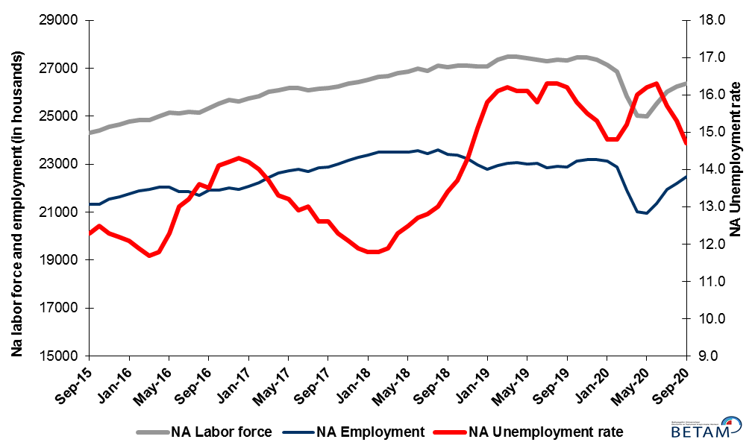
Source: Turkstat, Betam

Figure 2. Seasonally adjusted LFPR, employment rate and non-agricultural unemployment rate
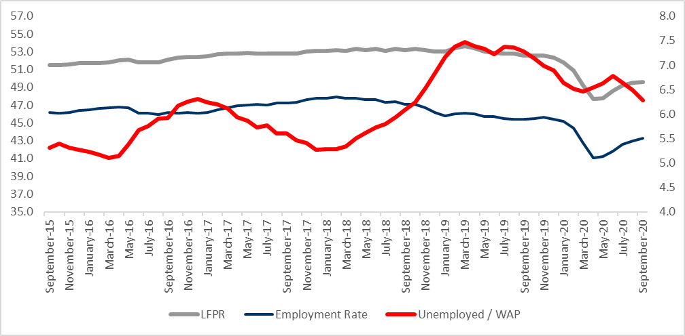
Source: Turkstat, Betam

Increase in the number of those who are “not seeking a job but available to start”

The level of labor force, by definition, is the summation of the level of employed people and the level of job seekers (unemployed). During the periods of massive employment losses, we may observe striking increases among individuals who wish to work but are not actively seeking a job as they think that they would not be able to find any. Those individuals that stop searching for jobs and hence drop out of the labor force due to loss of confidence and other reasons are referred as ‘Discouraged workers’ and ‘Other’ by TurkStat. The sustained increases in the number of discouraged workers started in January 2019 and accelerated during the pandemic. Even though this trend was reversed in the period of June, the number of discouraged workers increased by 82 thousand in the period of September. In addition, the number of inactive non-seekers who are available to start working increased by 45 thousand. Finally, adding these categories to the number of unemployed, the sum increased by a thousand to 8 million 309 thousand.

Figure 3. The number of unemployed people, non-seekers who are available and summation of both, SA
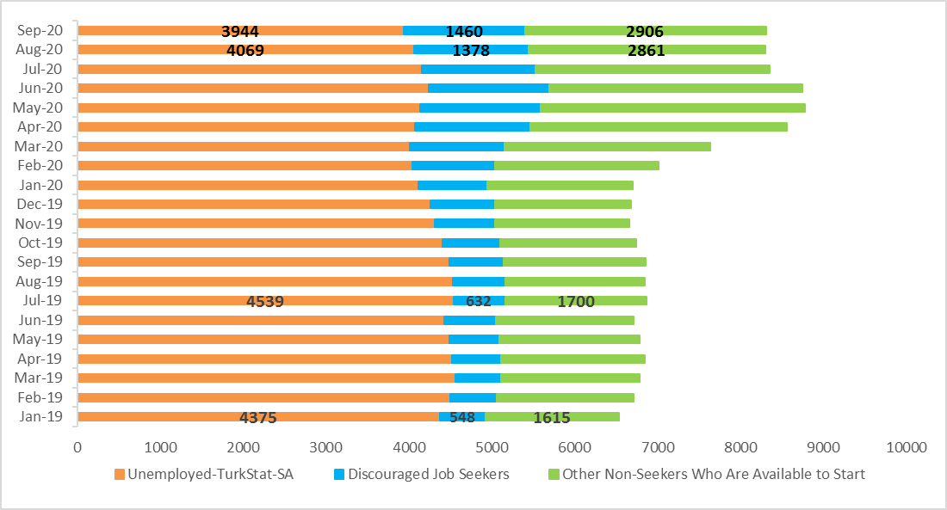
Source: Turkstat, Betam

Employment increases in non-agricultural sectors continued

According to seasonally adjusted employment data, in the period of September 2020 compared to August 2020, employment increased in all of the non-agricultural sectors. Employment in the construction sector increased by 15 thousand. Note that the employment in this sector is now greater by 69 thousand than that in the period of January 2020. In the manufacturing sector, while employment increased by 57 thousand, the level of employment (5 million 517 thousand) is still lower by 132 thousand, compared to that of the period of January 2020 (5 million 649 thousand). The employment in the service sector increased by 191 thousand compared to the previous period. A deceleration is observed in the increase in the service employment since August 2020. Note that the total increase over the last two periods (340 thousand) is significantly lower than the total increase over the periods of June and July (650 thousand). The level of services employment in September is 3.7 percent lower than the level in the period of January 2020 (January 2020: 15 million 909 thousand, September 2020: 15 million 320 thousand). Compared to the period of August, agricultural employment decreased by 37 thousand.

Figure 4: Employment by sectors (in thousand)
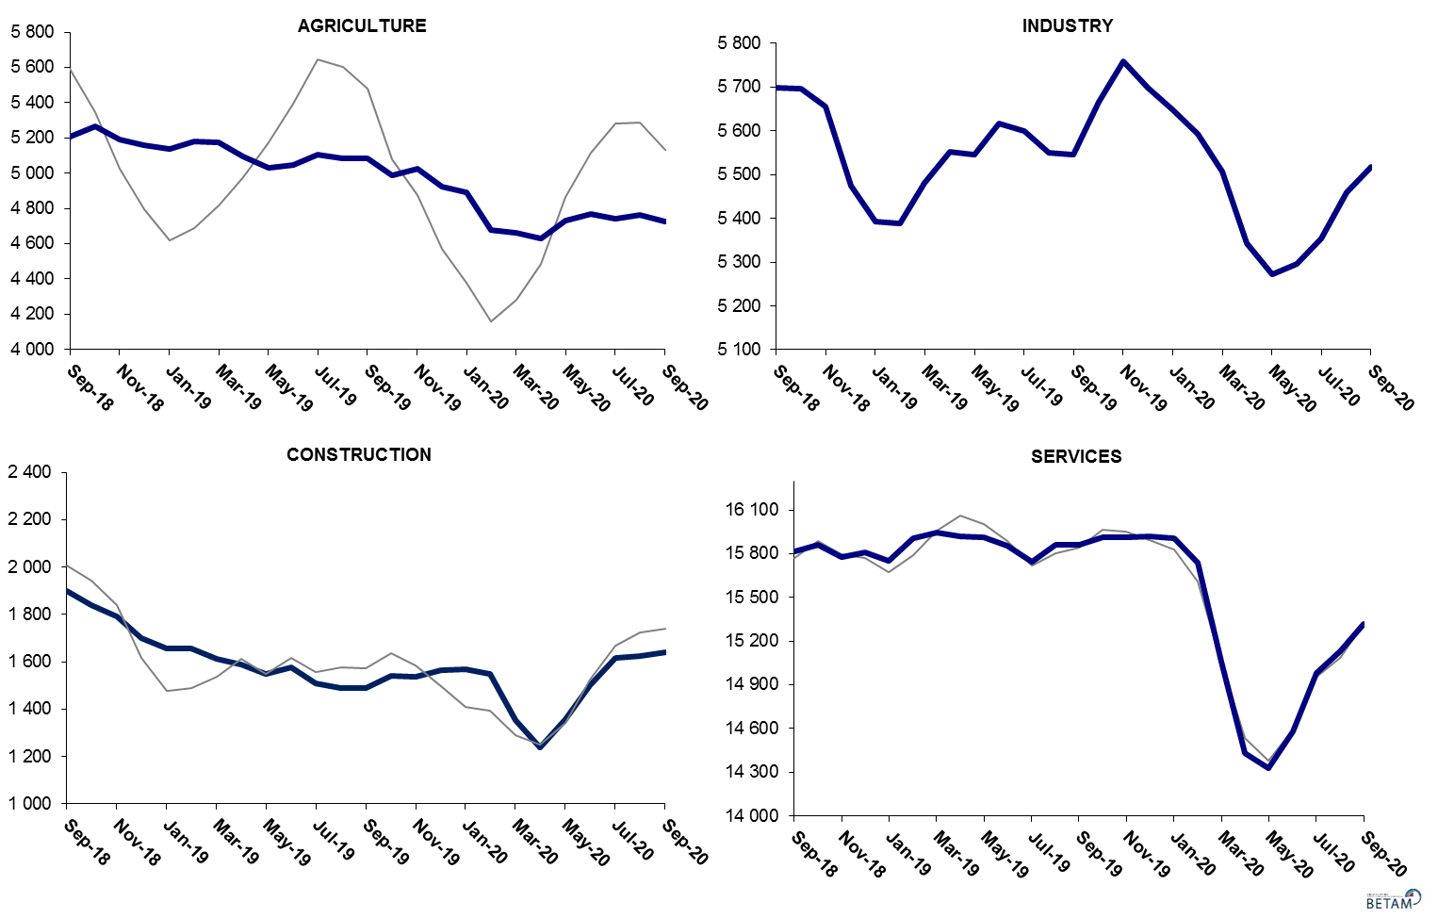
Source: TURKSTAT, Betam

Non-agricultural labor force and employment is still lower than its September 2019 levels

Compared to September 2019, non-agricultural employment decreased by 383 thousand (1.7 percent) in September 2020 while the non-agricultural labor force declined by 934 thousand, causing a decrease of 551 thousand in the number of unemployed people (Figure 5).

Figure 5 Year-on-year changes in non-agricultural labor force, employment, and unemployment
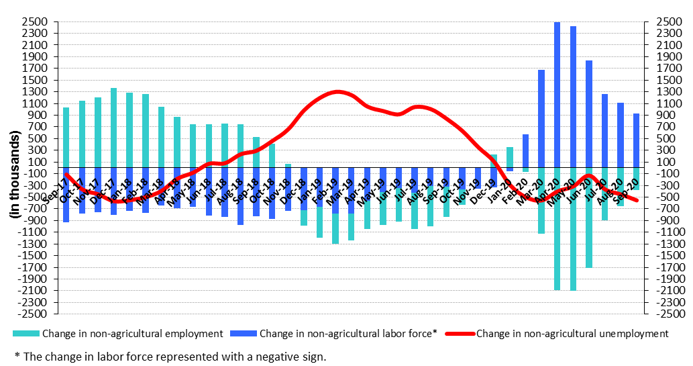
Source: TURKSTAT, Betam

Increases in total employment stem from increases in male employment

Figure 6 shows seasonally adjusted non-agricultural unemployment rate for males (green) and for females (purple). In the period of September 2020 compared to the previous period, female non-agricultural unemployment rate decreased by 0.3 percentage point to 18.3 percent. Male non-agricultural unemployment turned out to be 13.3 percent, with a strong decrease of 0.7 percentage point, compared to July 2020. While female labor force and employment decreased by 34 and 3 thousand respectively, increases in male labor force and employment reached 159 and 272 thousand. A strong increase in male labor force and employment along with a decrease in female labor force and employment is a rare event (Table 3). As a result of this decrease in male unemployment, the gender gap in non-agricultural unemployment increased by 0.4 percentage points to 5.0 percent in September 2020.

Figure 6: Seasonally adjusted non-agricultural unemployment rate by gender (%)
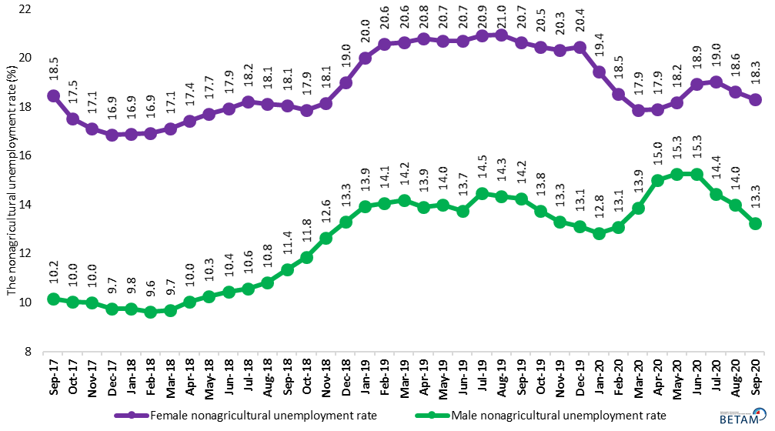
Source: Turkstat, Betam

In addition to the update in Figure 2, in this report, we tried to observe the developments in female labor force participation rate (LFPR) and male LFPR in Figure 7, along with female employment rate (ER) and male employment rate in Figure 8. As can be seen in Figure 7, steady levels in male LFPR took a sharp hit and trended down after the period of December 2019. As the pandemic further hit male LFPR, in the period of April 2020, male LFPR decreased significantly by 5 percent over three periods. The decreasing trend reversed up in the period of May 2020. As a result, in the period of September 2020, male LFPR turned out to be 68.8 percent. However, male LFPR is still lower by 3.2 percent compared to its long run average, 72.0 percent. While female LFPR had been trending up over years, the increases stopped after the period of March 2019 and reversed mildly down. After female LFPR had peaked in the period of March 2019 (35.2 percent), it went down from March 2019 to January 2020 by 2 percentage points. Due to the pandemic, female LFPR declined further by 3.6 percentage points between January and April 2020 and turned out to be 29.6 percent. While female LFPR had been trending up since May 2020, increasing trend stopped again in the period of September 2020 and female LFPR decreased by 0.2 percentage points to 30.9 percent. Female LFPR is 4.3 percent lower by its all-time high levels.
It is worthwhile to note two things about female and male LFPR : 1) female LFPR trended down earlier than male LFPR and that corresponds increases in female unemployment (Figure 6). 2) While coronavirus pandemic hit male LFPR harder than female LFPR, the ongoing trend is stronger for male LFPR than for female LFPR. The decrease in female LFPR in this period signals that female LFPR may reach its all-time highs much later than thought.

Figure 7 : Seasonally adjusted female and male LFPR (%)
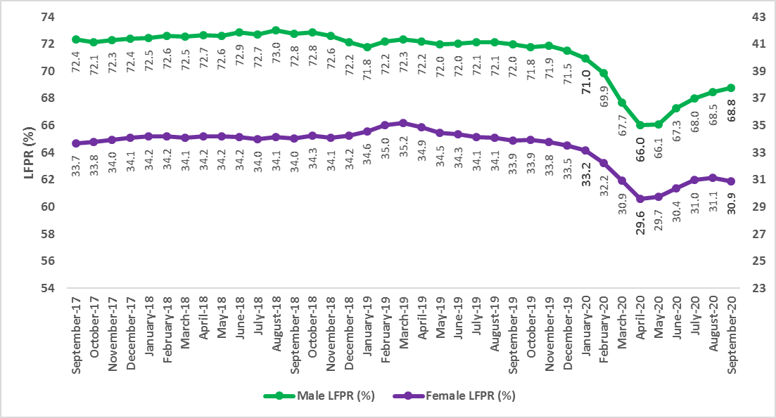

Source : Turkstat, Betam

As for the employment rate (ER) of females and males (Figure 8), the overall decreasing trend of male ER stands out. As the strong increases in the GDP and the employment lifted up male ER to over 66 percent in the second half of 2017, the male ER went down to 62.8 percent in the period of January 2020. The pandemic caused male ER to decrease further to 57.3 percent in the period of April 2020. An increasing trend has started since May 2020 and continued as male ER reached 60.7 percent in the period of September 2020. Still, this rate is lower by 2.1 percentage points than its January 2020 levels. As for the female ER, it peaked in the period of March 2019 and since then, along with the increases in female unemployment, it decreased to 27.9 percent between March 2019 and January 2020. The pandemic caused female ER to go down significantly by 2.6 percent to 25.3 percent. Again, the increase that started in May 2020 has stalled in the period of September 2020. The female ER is lower than its January 2020 levels by 1.6 percentage points.

Regarding the effects of the pandemic on the female and male ER, we observe that while the male ER took a harder hit than the female ER, its recovery has also been stronger than that of the female ER.

Figure 8 : Seasonally adjusted female and male employment rate (%)
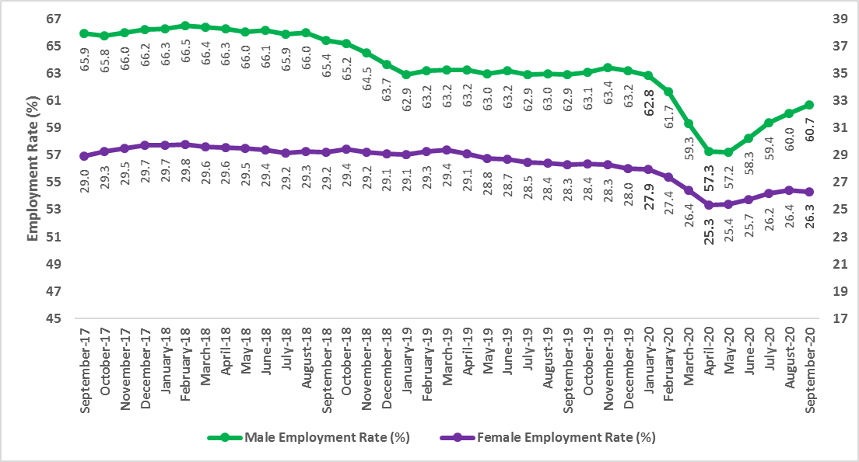

Source : Turkstat, Betam

Table 1: Seasonally adjusted non-agricultural labor market indicators (in thousands)
 | Labor force | Employment | Unemployment | Unemployment rate | Monthly changes
September-17 | 26190 | 22890 | 3300 | 12.6% | Labor force | Employment | Unemployment
October-17 | 26233 | 23006 | 3227 | 12.3% | 43 | 116 | -73
November-17 | 26357 | 23168 | 3189 | 12.1% | 125 | 162 | -37
December-17 | 26423 | 23279 | 3144 | 11.9% | 66 | 111 | -45
January-18 | 26515 | 23386 | 3129 | 11.8% | 91 | 107 | -16
February-18 | 26652 | 23507 | 3145 | 11.8% | 137 | 121 | 16
March-18 | 26682 | 23507 | 3175 | 11.9% | 30 | 0 | 30
April-18 | 26803 | 23506 | 3297 | 12.3% | 121 | -1 | 122
May-18 | 26869 | 23510 | 3359 | 12.5% | 66 | 4 | 62
June-18 | 26994 | 23566 | 3428 | 12.7% | 126 | 56 | 70
July-18 | 26899 | 23456 | 3443 | 12.8% | -95 | -110 | 15
August-18 | 27109 | 23585 | 3524 | 13.0% | 210 | 129 | 81
September-18 | 27032 | 23410 | 3622 | 13.4% | -77 | -175 | 98
October-18 | 27107 | 23393 | 3714 | 13.7% | 74 | -17 | 91
November-18 | 27100 | 23225 | 3875 | 14.3% | -6 | -168 | 162
December-18 | 27069 | 22982 | 4087 | 15.1% | -31 | -243 | 212
January-19 | 27077 | 22799 | 4278 | 15.8% | 8 | -183 | 191
February-19 | 27354 | 22950 | 4404 | 16.1% | 277 | 151 | 126
March-19 | 27489 | 23036 | 4453 | 16.2% | 135 | 86 | 49
April-19 | 27486 | 23061 | 4425 | 16.1% | -3 | 25 | -28
May-19 | 27422 | 23007 | 4415 | 16.1% | -64 | -54 | -10
June-19 | 27372 | 23047 | 4325 | 15.8% | -50 | 40 | -90
July-19 | 27303 | 22853 | 4450 | 16.3% | -68 | -194 | 126
August-19 | 27361 | 22901 | 4460 | 16.3% | 57 | 48 | 9
September-19 | 27317 | 22892 | 4425 | 16.2% | -43 | -9 | -34
October-19 | 27455 | 23117 | 4338 | 15.8% | 137 | 225 | -88
November-19 | 27463 | 23206 | 4257 | 15.5% | 8 | 89 | -81
December-19 | 27367 | 23180 | 4187 | 15.3% | -96 | -26 | -70
January-20 | 27147 | 23129 | 4018 | 14.8% | -220 | -51 | -169
February-20 | 26850 | 22876 | 3974 | 14.8% | -297 | -253 | -44
March-20 | 25847 | 21918 | 3929 | 15.2% | -1003 | -958 | -45
April-20 | 25012 | 21010 | 4002 | 16.0% | -835 | -908 | 73
May-20 | 25010 | 20958 | 4052 | 16.2% | -2 | -52 | 50
June-20 | 25539 | 21376 | 4163 | 16.3% | 529 | 418 | 111
July-20 | 26037 | 21949 | 4088 | 15.7% | 498 | 573 | -75
August-20 | 26226 | 22213 | 4013 | 15.3% | 189 | 264 | -75
September-20 | 26349 | 22476 | 3873 | 14.7% | 124 | 263 | -139

Source: Turkstat, Betam

Table 2: Seasonally adjusted employment by sectors (in thousands) *
 | Agriculture | Manufacturing | Construction | Service | Monthly changes
September-17 | 5489 | 5421 | 2111 | 15358 | Agriculture | Manufacturing | Construction | Service
October-17 | 5469 | 5470 | 2082 | 15454 | -20 | 49 | -29 | 96
November-17 | 5482 | 5470 | 2122 | 15576 | 13 | 0 | 40 | 122
December-17 | 5539 | 5514 | 2172 | 15593 | 57 | 44 | 50 | 17
January-18 | 5485 | 5567 | 2199 | 15620 | -54 | 53 | 27 | 27
February-18 | 5457 | 5627 | 2193 | 15688 | -28 | 60 | -6 | 68
March-18 | 5395 | 5618 | 2160 | 15729 | -62 | -9 | -33 | 41
April-18 | 5397 | 5650 | 2109 | 15746 | 2 | 32 | -51 | 17
May-18 | 5323 | 5669 | 2063 | 15778 | -74 | 19 | -46 | 32
June-18 | 5276 | 5737 | 2043 | 15785 | -47 | 68 | -20 | 7
July-18 | 5248 | 5703 | 1957 | 15796 | -28 | -34 | -86 | 11
August-18 | 5197 | 5730 | 1958 | 15897 | -51 | 27 | 1 | 101
September-18 | 5208 | 5698 | 1897 | 15815 | 11 | -32 | -61 | -82
October-18 | 5267 | 5696 | 1838 | 15858 | 59 | -2 | -59 | 43
November-18 | 5189 | 5656 | 1790 | 15778 | -78 | -40 | -48 | -80
December-18 | 5158 | 5474 | 1700 | 15808 | -31 | -182 | -90 | 30
January-19 | 5138 | 5392 | 1655 | 15752 | -20 | -82 | -45 | -56
February-19 | 5182 | 5388 | 1655 | 15907 | 44 | -4 | 0 | 155
March-19 | 5175 | 5482 | 1611 | 15943 | -7 | 94 | -44 | 36
April-19 | 5097 | 5553 | 1588 | 15920 | -78 | 71 | -23 | -23
May-19 | 5031 | 5546 | 1550 | 15911 | -66 | -7 | -38 | -9
June-19 | 5044 | 5616 | 1578 | 15853 | 13 | 70 | 28 | -58
July-19 | 5106 | 5600 | 1508 | 15745 | 62 | -16 | -70 | -108
August-19 | 5084 | 5551 | 1490 | 15860 | -22 | -49 | -18 | 115
September-19 | 5081 | 5546 | 1487 | 15859 | -3 | -5 | -3 | -1
October-19 | 4986 | 5666 | 1540 | 15911 | -95 | 120 | 53 | 52
November-19 | 5024 | 5758 | 1536 | 15912 | 38 | 92 | -4 | 1
December-19 | 4925 | 5699 | 1564 | 15917 | -99 | -59 | 28 | 5
January-20 | 4891 | 5649 | 1570 | 15909 | -34 | -50 | 6 | -8
February-20 | 4675 | 5593 | 1547 | 15735 | -216 | -56 | -23 | -174
March-20 | 4660 | 5508 | 1354 | 15056 | -15 | -85 | -193 | -679
April-20 | 4631 | 5344 | 1238 | 14428 | -29 | -164 | -116 | -628
May-20 | 4730 | 5272 | 1356 | 14330 | 99 | -72 | 118 | -98
June-20 | 4767 | 5297 | 1502 | 14577 | 37 | 25 | 146 | 247
July-20 | 4740 | 5354 | 1615 | 14980 | -27 | 57 | 113 | 403
August-20 | 4761 | 5460 | 1624 | 15129 | 21 | 106 | 9 | 149
September-20 | 4724 | 5517 | 1639 | 15320 | -37 | 57 | 15 | 191

Source: Turkstat

Table 3: Seasonally adjusted non-agricultural labor force by gender (thousands)
 | Female Labor Force | Female Employment | Female Unemployed | Male Labor Force | Male Employment | Male Unemployed
September-17 | 7731 | 6303 | 1428 | 18478 | 16601 | 1877
October-17 | 7757 | 6397 | 1360 | 18464 | 16613 | 1851
November-17 | 7833 | 6491 | 1342 | 18525 | 16673 | 1852
December-17 | 7860 | 6534 | 1326 | 18538 | 16732 | 1806
January-18 | 7948 | 6605 | 1342 | 18592 | 16777 | 1815
February-18 | 7980 | 6630 | 1351 | 18668 | 16870 | 1798
March-18 | 7982 | 6617 | 1366 | 18697 | 16885 | 1812
April-18 | 8035 | 6633 | 1401 | 18746 | 16866 | 1880
May-18 | 8073 | 6644 | 1429 | 18779 | 16853 | 1926
June-18 | 8096 | 6645 | 1451 | 18895 | 16923 | 1972
July-18 | 8070 | 6600 | 1470 | 18867 | 16873 | 1994
August-18 | 8139 | 6665 | 1474 | 18997 | 16943 | 2054
September-18 | 8124 | 6658 | 1467 | 18922 | 16771 | 2151
October-18 | 8212 | 6744 | 1469 | 18890 | 16653 | 2237
November-18 | 8229 | 6736 | 1494 | 18865 | 16482 | 2383
December-18 | 8304 | 6726 | 1578 | 18738 | 16242 | 2495
January-19 | 8388 | 6710 | 1678 | 18689 | 16082 | 2607
February-19 | 8484 | 6739 | 1746 | 18850 | 16199 | 2651
March-19 | 8558 | 6791 | 1767 | 18921 | 16239 | 2682
April-19 | 8515 | 6745 | 1770 | 18945 | 16312 | 2633
May-19 | 8456 | 6706 | 1750 | 18933 | 16282 | 2651
June-19 | 8432 | 6688 | 1744 | 18959 | 16354 | 2604
July-19 | 8375 | 6623 | 1752 | 18989 | 16243 | 2746
August-19 | 8393 | 6633 | 1760 | 19017 | 16290 | 2727
September-19 | 8355 | 6630 | 1725 | 18992 | 16288 | 2704
October-19 | 8429 | 6704 | 1724 | 19042 | 16423 | 2619
November-19 | 8374 | 6673 | 1702 | 19072 | 16534 | 2539
December-19 | 8360 | 6651 | 1709 | 19020 | 16525 | 2495
January-20 | 8304 | 6690 | 1614 | 18859 | 16438 | 2420
February-20 | 8160 | 6648 | 1511 | 18653 | 16214 | 2439
March-20 | 7805 | 6409 | 1396 | 18000 | 15501 | 2498
April-20 | 7461 | 6127 | 1334 | 17505 | 14877 | 2629
May-20 | 7481 | 6121 | 1360 | 17476 | 14809 | 2667
June-20 | 7699 | 6241 | 1458 | 17853 | 15126 | 2726
July-20 | 7911 | 6404 | 1507 | 18136 | 15520 | 2617
August-20 | 7983 | 6498 | 1486 | 18298 | 15739 | 2559
September-20 | 7949 | 6495 | 1454 | 18458 | 16011 | 2447

Source: Turkstat, Betam

Table 4 : Seasonally adjusted female and male labor market indicators (thousands)
 | 15+ WAP, Female | Total Employment, Female | Total Unemployed, Female | 15+ WAP, Male | Total Employment, Male | Total Unemployed, Male
September-17 | 30330 | 8781 | 1441 | 29746 | 19604 | 1922
October-17 | 30364 | 8883 | 1373 | 29785 | 19591 | 1898
November-17 | 30399 | 8970 | 1353 | 29824 | 19674 | 1892
December-17 | 30433 | 9041 | 1334 | 29863 | 19772 | 1842
January-18 | 30467 | 9063 | 1352 | 29893 | 19812 | 1851
February-18 | 30500 | 9074 | 1362 | 29914 | 19892 | 1833
March-18 | 30530 | 9037 | 1375 | 29934 | 19862 | 1848
April-18 | 30564 | 9039 | 1411 | 29955 | 19856 | 1910
May-18 | 30596 | 9021 | 1440 | 29975 | 19797 | 1962
June-18 | 30630 | 9002 | 1464 | 29996 | 19838 | 2018
July-18 | 30662 | 8945 | 1484 | 30017 | 19776 | 2051
August-18 | 30695 | 8984 | 1497 | 30038 | 19819 | 2117
September-18 | 30729 | 8973 | 1486 | 30059 | 19660 | 2214
October-18 | 30761 | 9052 | 1487 | 30080 | 19607 | 2302
November-18 | 30795 | 8997 | 1509 | 30101 | 19410 | 2449
December-18 | 30827 | 8961 | 1593 | 30121 | 19175 | 2560
January-19 | 30865 | 8967 | 1706 | 30152 | 18967 | 2679
February-19 | 30908 | 9043 | 1780 | 30193 | 19076 | 2724
March-19 | 30947 | 9090 | 1794 | 30230 | 19111 | 2760
April-19 | 30990 | 9008 | 1794 | 30270 | 19142 | 2712
May-19 | 31032 | 8930 | 1761 | 30310 | 19090 | 2729
June-19 | 31075 | 8913 | 1759 | 30351 | 19173 | 2691
July-19 | 31117 | 8859 | 1766 | 30390 | 19115 | 2810
August-19 | 31160 | 8851 | 1774 | 30431 | 19158 | 2791
September-19 | 31203 | 8830 | 1738 | 30472 | 19168 | 2767
October-19 | 31245 | 8865 | 1736 | 30511 | 19242 | 2665
November-19 | 31288 | 8850 | 1716 | 30552 | 19377 | 2583
December-19 | 31330 | 8773 | 1725 | 30591 | 19330 | 2543
January-20 | 31374 | 8769 | 1636 | 30641 | 19250 | 2491
February-20 | 31420 | 8601 | 1530 | 30699 | 18931 | 2513
March-20 | 31463 | 8320 | 1410 | 30753 | 18245 | 2576
April-20 | 31509 | 7985 | 1345 | 30811 | 17650 | 2690
May-20 | 31554 | 8006 | 1376 | 30867 | 17661 | 2732
June-20 | 31600 | 8125 | 1470 | 30926 | 18017 | 2790
July-20 | 31644 | 8280 | 1519 | 30982 | 18391 | 2674
August-20 | 31690 | 8369 | 1494 | 31040 | 18633 | 2620
September-20 | 31736 | 8351 | 1459 | 31098 | 18878 | 2509

Source: Turkstat, Betam

Table 5 : Seasonally adjusted female and male LFPR and ER (%)

 | Women LFPR | Women Employment Rate | Women LFPR | Men Employment Rate
September-18 | 34.0 | 29.2 | 72.8 | 65.4
October-18 | 34.3 | 29.4 | 72.8 | 65.2
November-18 | 34.1 | 29.2 | 72.6 | 64.5
December-18 | 34.2 | 29.1 | 72.2 | 63.7
January-19 | 34.6 | 29.1 | 71.8 | 62.9
February-19 | 35.0 | 29.3 | 72.2 | 63.2
March-19 | 35.2 | 29.4 | 72.3 | 63.2
April-19 | 34.9 | 29.1 | 72.2 | 63.2
May-19 | 34.5 | 28.8 | 72.0 | 63.0
June-19 | 34.3 | 28.7 | 72.0 | 63.2
July-19 | 34.1 | 28.5 | 72.1 | 62.9
August-19 | 34.1 | 28.4 | 72.1 | 63.0
September-19 | 33.9 | 28.3 | 72.0 | 62.9
October-19 | 33.9 | 28.4 | 71.8 | 63.1
November-19 | 33.8 | 28.3 | 71.9 | 63.4
December-19 | 33.5 | 28.0 | 71.5 | 63.2
January-20 | 33.2 | 27.9 | 71.0 | 62.8
February-20 | 32.2 | 27.4 | 69.9 | 61.7
March-20 | 30.9 | 26.4 | 67.7 | 59.3
April-20 | 29.6 | 25.3 | 66.0 | 57.3
May-20 | 29.7 | 25.4 | 66.1 | 57.2
June-20 | 30.4 | 25.7 | 67.3 | 58.3
July-20 | 31.0 | 26.2 | 68.0 | 59.4
August-20 | 31.1 | 26.4 | 68.5 | 60.0
September-20 | 30.9 | 26.3 | 68.8 | 60.7

Source: Turkstat, Betam

Table 6 : Seasonally adjusted LFPR, ER and Unemployed / WAP (%)

 | 15+ WAP | Labor Force | Employment | LFPR | ER | Unemployed / WAP
Sep-17 | 60076 | 31746 | 28379 | 52.8 | 47.2 | 5.6
Oct-17 | 60148 | 31760 | 28475 | 52.8 | 47.3 | 5.5
Nov-17 | 60223 | 31906 | 28650 | 53.0 | 47.6 | 5.4
Dec-17 | 60295 | 31999 | 28818 | 53.1 | 47.8 | 5.3
Jan-18 | 60360 | 32059 | 28871 | 53.1 | 47.8 | 5.3
Feb-18 | 60415 | 32153 | 28964 | 53.2 | 47.9 | 5.3
Mar-18 | 60464 | 32127 | 28902 | 53.1 | 47.8 | 5.3
Apr-18 | 60519 | 32231 | 28903 | 53.3 | 47.8 | 5.5
May-18 | 60571 | 32236 | 28833 | 53.2 | 47.6 | 5.6
Jun-18 | 60626 | 32317 | 28842 | 53.3 | 47.6 | 5.7
Jul-18 | 60679 | 32223 | 28704 | 53.1 | 47.3 | 5.8
Aug-18 | 60733 | 32387 | 28782 | 53.3 | 47.4 | 5.9
Sep-18 | 60788 | 32314 | 28618 | 53.2 | 47.1 | 6.1
Oct-18 | 60841 | 32458 | 28660 | 53.3 | 47.1 | 6.2
Nov-18 | 60896 | 32390 | 28414 | 53.2 | 46.7 | 6.5
Dec-18 | 60948 | 32304 | 28140 | 53.0 | 46.2 | 6.8
Jan-19 | 61017 | 32313 | 27937 | 53.0 | 45.8 | 7.2
Feb-19 | 61101 | 32634 | 28132 | 53.4 | 46.0 | 7.4
Mar-19 | 61177 | 32777 | 28211 | 53.6 | 46.1 | 7.5
Apr-19 | 61261 | 32685 | 28158 | 53.4 | 46.0 | 7.4
May-19 | 61342 | 32533 | 28038 | 53.0 | 45.7 | 7.3
Jun-19 | 61426 | 32523 | 28091 | 52.9 | 45.7 | 7.2
Jul-19 | 61507 | 32498 | 27959 | 52.8 | 45.5 | 7.4
Aug-19 | 61591 | 32519 | 27985 | 52.8 | 45.4 | 7.4
Sep-19 | 61675 | 32464 | 27973 | 52.6 | 45.4 | 7.3
Oct-19 | 61756 | 32513 | 28103 | 52.6 | 45.5 | 7.1
Nov-19 | 61840 | 32547 | 28230 | 52.6 | 45.7 | 7.0
Dec-19 | 61921 | 32372 | 28105 | 52.3 | 45.4 | 6.9
Jan-20 | 62015 | 32136 | 28020 | 51.8 | 45.2 | 6.6
Feb-20 | 62119 | 31600 | 27551 | 50.9 | 44.4 | 6.5
Mar-20 | 62216 | 30593 | 26578 | 49.2 | 42.7 | 6.5
Apr-20 | 62320 | 29717 | 25641 | 47.7 | 41.1 | 6.5
May-20 | 62421 | 29824 | 25688 | 47.8 | 41.2 | 6.6
Jun-20 | 62525 | 30386 | 26143 | 48.6 | 41.8 | 6.8
Jul-20 | 62626 | 30843 | 26689 | 49.2 | 42.6 | 6.6
Aug-20 | 62730 | 31043 | 26974 | 49.5 | 43.0 | 6.5
Sep-20 | 62834 | 31144 | 27200 | 49.6 | 43.3 | 6.3

Source: Turkstat, Betam

Table 7 : Seasonally adjusted non-seekers that are available to start, unemployed and sum of both

 | Discouraged Job Seekers-SA | Unemployed-TurkStat-SA | Other Non-Seekers Who are Available To Start | Total
Mar-19 | 549 | 4566 | 1671 | 6786
Apr-19 | 587 | 4526 | 1731 | 6844
May-19 | 603 | 4495 | 1686 | 6783
Jun-19 | 619 | 4432 | 1661 | 6713
Jul-19 | 632 | 4539 | 1700 | 6871
Aug-19 | 632 | 4535 | 1685 | 6851
Sep-19 | 655 | 4491 | 1713 | 6859
Oct-19 | 695 | 4410 | 1638 | 6743
Nov-19 | 725 | 4317 | 1617 | 6659
Dec-19 | 775 | 4267 | 1639 | 6680
Jan-20 | 835 | 4116 | 1753 | 6704
Feb-20 | 997 | 4049 | 1974 | 7021
Mar-20 | 1142 | 4015 | 2485 | 7642
Apr-20 | 1388 | 4076 | 3099 | 8563
May-20 | 1461 | 4135 | 3187 | 8784
Jun-20 | 1459 | 4242 | 3052 | 8753
Jul-20 | 1378 | 4154 | 2828 | 8361
Aug-20 | 1378 | 4069 | 2861 | 8308
Sep-20 | 1460 | 3944 | 2906 | 8309

Source: Turkstat, Betam

* Prof. Dr. Seyfettin Gürsel, Betam, Director, seyfettin.gursel@eas.bau.edu.tr
** Doç. Dr. Gökçe Uysal, Betam, Deputy Director, gokce.uysal@eas.bau.edu.tr
*** Mehmet Cem Şahin, Betam, Research Assistant, mehmetcem.sahin@eas.bau.edu.tr
Turkstat revised the labor market statistics drastically in February 2014. Within this framework, they back casted various labor market indicators and they also continued to announce seasonally adjusted series. However, Turkstat is not providing back-casted series by gender. Therefore, female and male labor market statistics are not sufficiently long for the seasonal adjustment procedures (There should be minimum 36 observations). With the announcement of the period of February 2017 data, the number of observations required for the seasonal decontamination process was provided. From this period Betam generated seasonal adjustment series in terms of gender. Nevertheless, it should not be forgotten that seasonal adjustment may cause extra volatility in the series for at least a while.

