Labor Market Outlook:
October 2020

15 October 2020

DECREASES IN UNEMPLOYMENT AS A RESULT OF HIGHER INCREASES IN EMPLOYMENT THAN IN LABOR FORCE

Seyfettin Gürsel*, Hamza Mutluay**

Executive Summary

Seasonally adjusted labor market data shows that in the period of July 2020, non-agricultural unemployment rate turned out to be 15.9 percent, with 0.6 percentage point decreases compared to June 2020. In this period, both non-agricultural employment and labor force increased by 568 thousand and by 493 thousand respectively. According to sectoral data, employment increased in all sectors except agriculture. In addition to the increase of employment in construction by 111 thousand, employment gains in manufacturing and services employment amounted to 57 thousand and 399 thousand while employment in agriculture decreased by 28 thousand. Based on the seasonally adjusted data, while female non-agricultural employment increased by 165 thousand non-agricultural female labor force increased by 216 thousand. As a result, non-agricultural female unemployment rate increased by 0.1 percentage points to 19.1 percent. On the other hand, male labor force and employment increased by 323 thousand and 423 thousand respectively taking down non-agricultural male unemployment rate from 15.4 to 14.6 percent. The existing gender gap in non-agricultural unemployment rate has been enlarged by 0.9 percentage points.

Increases in all non-agricultural labor market indicators

Seasonally adjusted data shows that, non-agricultural labor force increased to 26 million 55 thousand after the increase of 493 thousand in July 2020 period (June-July-August) compared to June 2020 period (May-June-July). Still, the level of non-agricultural labor force is lower in the period of July 2020 than February 2020 by the amount of 761 thousand (26 million 816 thousand). Non-agricultural employment increased to 21 million 912 thousand along with an increase of 568 thousand (Figure 1, Table 1). Nevertheless, employment level in the period of July 2020 is still lower than that in the period of February 2020 by 962 thousand. The number of non-agricultural unemployed decreased by 75 thousand to 4 million 143 thousand, and the non-agricultural unemployment rate dropped to 15.9.

The increases in both the labor force and the employment rates in the recent period have continued in the period of July. As a result, in the period of July 2020 compared to June 2020, labor force participation rate reached 49.3 percent with an increase of 0.7 percentage points, and employment rate rose to 42.6 percent with an increase of 0.8 percentage points. Let us note that in July 2020 labor force participation and employment rates are still lower by 3.6 and 2.8 percentage points respectively comparing to July 2019 (Figure 2).

Figure 1. Seasonally adjusted non-agricultural labor force, employment, and unemployment
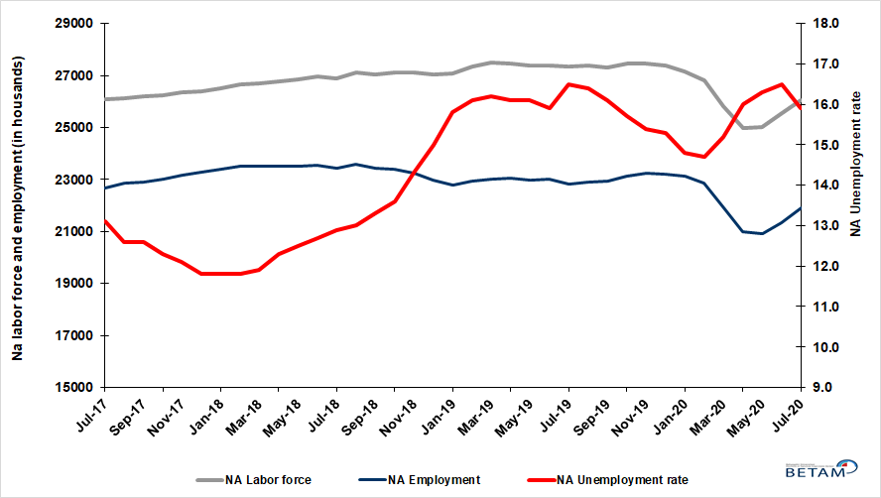
Source: Turkstat, Betam

Figure 2. Seasonally adjusted LFPR, employment rate and non-agricultural unemployment rate
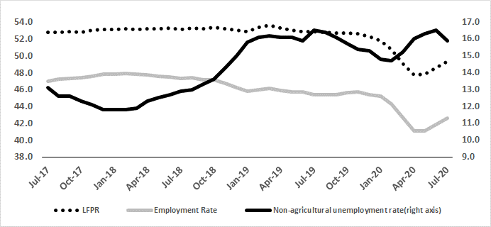
Source: Turkstat, Betam

Decrease in the number of “not seeking a job but available to start”

The level of labor force, by definition, is the summation of the level of employed people and the level of job seekers (unemployed). During the periods of massive employment losses one witnesses striking increase among individuals who desire to work but they are not actively seeking a job as they think that they could not find any. Those individuals that quit seeking for jobs and labor force due to loss of confidence and other reasons are referred as ‘Discouraged workers’ and ‘Other’ by TurkStat. The number of discouraged workers continuously increased since January 2019, decelerated in the period of June and decreased by 300 thousand in the period of July. Decreases in the number of inactive non-seekers that are available to start continued in July. The summation of seasonally adjusted ‘non-seekers but available to start’ and seasonally adjusted ‘unemployed’ population decreased by 380 thousand to 8 million 253 thousand.

Figure 3. The number of unemployed people, non-seekers who are available and summation of both, SA
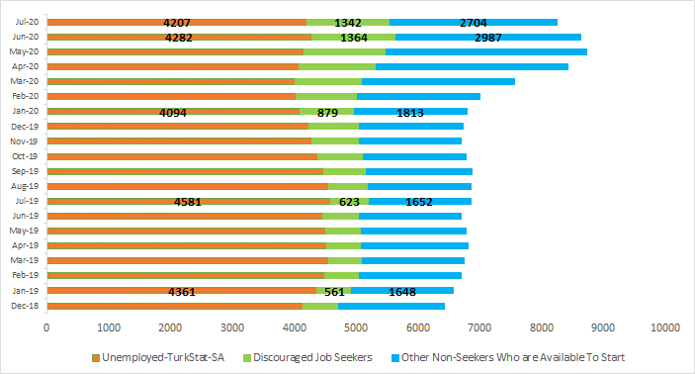
Source: Turkstat, Betam

Employment increases in all sectors except agriculture

According to seasonally adjusted employment data, in the period of July 2020 compared to June 2020, employment increased in all sectors except agriculture. With the increase of 111 thousand in the construction employment, for the last three periods, employment gains in this sector reached 373 thousand. Employment in manufacturing increased by 57 thousand. After increases in services employment in June, employment in services continued its upward trend in the period of July (399 thousand). On the other hand, employment in agriculture decreased by 28 thousand in the period of July 2020 compared to June 2020.

Figure 4: Employment by sectors (in thousand)
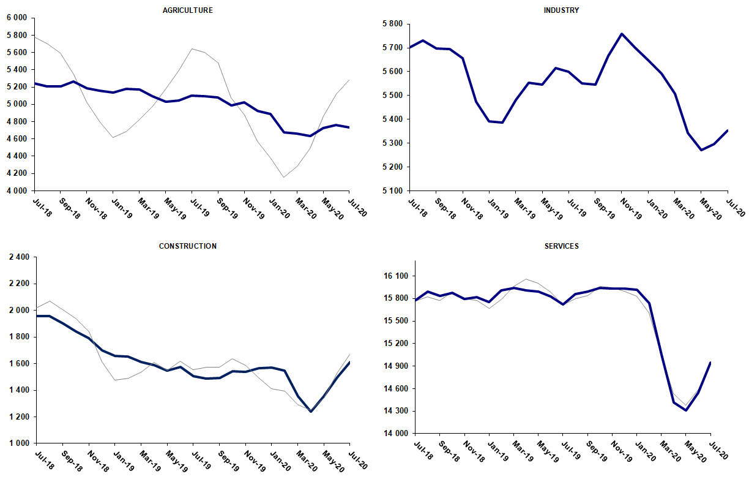
Source: TURKSTAT, Betam

Strong decreases in yearly non-agricultural labor force and employment

Compared to July 2019, non-agricultural employment decreased by 893 thousand (3.9 percent) in July 2020 while the non-agricultural labor force declined by 1 million 257 thousand, causing a decrease of 364 thousand in the number of unemployed people (Figure 5).

Figure 5Year-on-year changes in non-agricultural labor force, employment, and unemployment
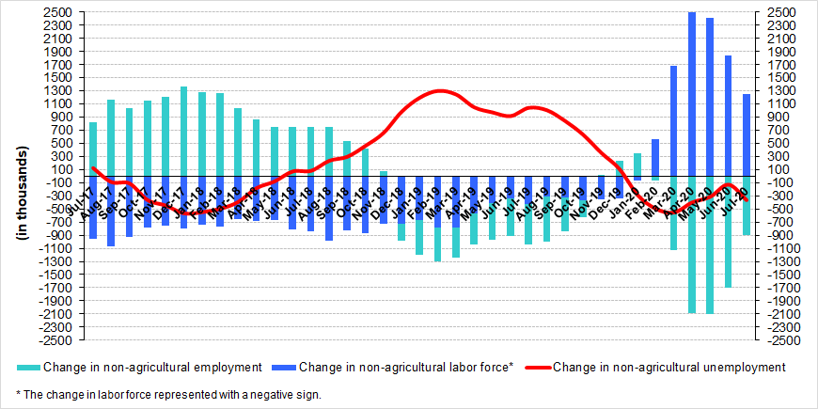
Source: TURKSTAT, Betam

Increases in female unemployment rate

Figure 6 shows seasonally adjusted non-agricultural unemployment rate for males (green) and for females (purple). In the period of July 2020 compared to the previous period, female non-agricultural unemployment rate increased by 0.1 percentage point to 19.1 percent. Male non-agricultural unemployment turned out to be 14.6 percent, with 0.8 percentage point decreases compared to June 2020. While female and male labor force increased by 217 thousand and 323 thousand, respectively, female and male employment increased by 165 thousand and 423 thousand. As increase in male employment compared to labor force was higher, male unemployment rate decreased in the period of July. Since increases in female employment compared to labor force was lower, female unemployment rate increased in the period of July. As a result, the gender gap in non-agricultural unemployment rates increased from 3.6 percent to 4.5 percent points in June 2020 (Table 3).

Figure 6: Seasonally adjusted non-agricultural unemployment rate by gender (%)
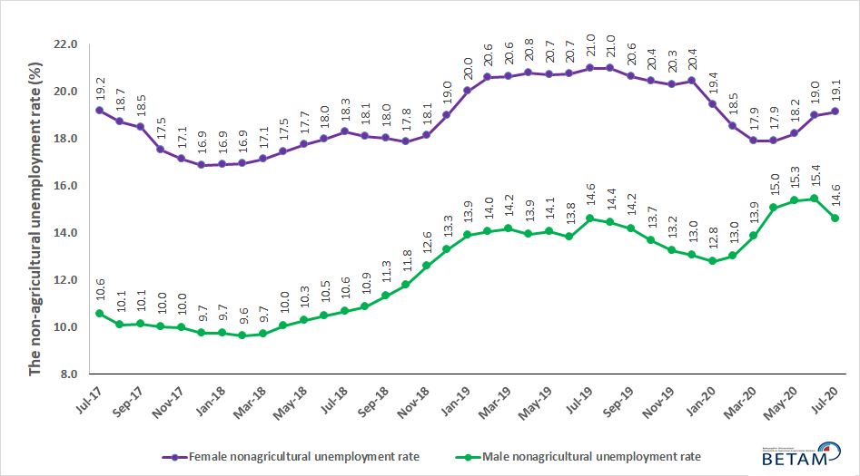
Source: Turkstat, Betam

Table 1: Seasonally adjusted non-agricultural labor market indicators (in thousands) **
 | Labor force | Employment | Unemployment | Unemployment rate | Monthly changes
Jul-17 | 26092 | 22674 | 3418 | 13.1% | Labor force | Employment | Unemployment
Aug-17 | 26137 | 22844 | 3293 | 12.6% | 45 | 170 | -125
Sep-17 | 26209 | 22907 | 3302 | 12.6% | 72 | 63 | 9
Oct-17 | 26247 | 23019 | 3228 | 12.3% | 38 | 112 | -74
Nov-17 | 26371 | 23180 | 3191 | 12.1% | 123 | 161 | -38
Dec-17 | 26401 | 23286 | 3115 | 11.8% | 30 | 106 | -76
Jan-18 | 26519 | 23390 | 3129 | 11.8% | 118 | 104 | 14
Feb-18 | 26653 | 23508 | 3145 | 11.8% | 134 | 118 | 16
Mar-18 | 26679 | 23504 | 3175 | 11.9% | 26 | -4 | 30
Apr-18 | 26792 | 23497 | 3295 | 12.3% | 114 | -7 | 121
May-18 | 26853 | 23496 | 3357 | 12.5% | 60 | -1 | 61
Jun-18 | 26973 | 23547 | 3426 | 12.7% | 120 | 51 | 69
Jul-18 | 26906 | 23435 | 3471 | 12.9% | -67 | -112 | 45
Aug-18 | 27105 | 23581 | 3524 | 13.0% | 199 | 146 | 53
Sep-18 | 27030 | 23435 | 3595 | 13.3% | -75 | -146 | 71
Oct-18 | 27100 | 23414 | 3686 | 13.6% | 70 | -21 | 91
Nov-18 | 27119 | 23241 | 3878 | 14.3% | 19 | -173 | 192
Dec-18 | 27049 | 22992 | 4057 | 15.0% | -70 | -249 | 179
Jan-19 | 27083 | 22804 | 4279 | 15.8% | 34 | -188 | 222
Feb-19 | 27353 | 22949 | 4404 | 16.1% | 270 | 145 | 125
Mar-19 | 27483 | 23031 | 4452 | 16.2% | 130 | 82 | 48
Apr-19 | 27472 | 23049 | 4423 | 16.1% | -11 | 18 | -29
May-19 | 27398 | 22987 | 4411 | 16.1% | -74 | -62 | -12
Jun-19 | 27375 | 23022 | 4353 | 15.9% | -24 | 35 | -59
Jul-19 | 27334 | 22824 | 4510 | 16.5% | -40 | -198 | 158
Aug-19 | 27389 | 22897 | 4492 | 16.4% | 55 | 73 | -18
Sep-19 | 27325 | 22926 | 4399 | 16.1% | -63 | 29 | -92
Oct-19 | 27458 | 23147 | 4311 | 15.7% | 133 | 221 | -88
Nov-19 | 27456 | 23228 | 4228 | 15.4% | -2 | 81 | -83
Dec-19 | 27385 | 23195 | 4190 | 15.3% | -71 | -33 | -38
Jan-20 | 27154 | 23135 | 4019 | 14.8% | -231 | -60 | -171
Feb-20 | 26816 | 22874 | 3942 | 14.7% | -338 | -261 | -77
Mar-20 | 25837 | 21910 | 3927 | 15.2% | -979 | -964 | -15
Apr-20 | 24994 | 20995 | 3999 | 16.0% | -843 | -915 | 72
May-20 | 25010 | 20933 | 4077 | 16.3% | 16 | -62 | 78
Jun-20 | 25562 | 21344 | 4218 | 16.5% | 552 | 411 | 141
Jul-20 | 26055 | 21912 | 4143 | 15.9% | 493 | 568 | -75

Source: Turkstat, Betam

Table 2: Seasonally adjusted employment by sectors (in thousands) *
 | Agriculture | Manufacturing | Construction | Service | Monthly changes
Jul-17 | 5502 | 5363 | 2111 | 15200 | Agriculture | Manufacturing | Construction | Service
Aug-17 | 5467 | 5437 | 2159 | 15249 | -35 | 74 | 48 | 49
Sep-17 | 5489 | 5421 | 2113 | 15373 | 22 | -16 | -46 | 124
Oct-17 | 5470 | 5470 | 2083 | 15466 | -19 | 49 | -30 | 93
Nov-17 | 5482 | 5470 | 2124 | 15586 | 12 | 0 | 41 | 120
Dec-17 | 5539 | 5514 | 2173 | 15599 | 57 | 44 | 49 | 13
Jan-18 | 5484 | 5567 | 2199 | 15623 | -55 | 53 | 26 | 24
Feb-18 | 5456 | 5627 | 2193 | 15688 | -28 | 60 | -6 | 65
Mar-18 | 5394 | 5618 | 2160 | 15726 | -62 | -9 | -33 | 38
Apr-18 | 5397 | 5650 | 2108 | 15739 | 3 | 32 | -52 | 13
May-18 | 5322 | 5669 | 2062 | 15765 | -75 | 19 | -46 | 26
Jun-18 | 5276 | 5737 | 2041 | 15769 | -46 | 68 | -21 | 4
Jul-18 | 5246 | 5703 | 1955 | 15777 | -30 | -34 | -86 | 8
Aug-18 | 5204 | 5730 | 1957 | 15895 | -42 | 27 | 2 | 118
Sep-18 | 5209 | 5698 | 1900 | 15837 | 5 | -32 | -57 | -58
Oct-18 | 5267 | 5696 | 1840 | 15877 | 58 | -2 | -60 | 40
Nov-18 | 5189 | 5656 | 1792 | 15793 | -78 | -40 | -48 | -84
Dec-18 | 5158 | 5474 | 1701 | 15817 | -31 | -182 | -91 | 24
Jan-19 | 5137 | 5392 | 1656 | 15756 | -21 | -82 | -45 | -61
Feb-19 | 5182 | 5388 | 1655 | 15907 | 45 | -4 | -1 | 151
Mar-19 | 5174 | 5482 | 1611 | 15938 | -8 | 94 | -44 | 31
Apr-19 | 5097 | 5553 | 1587 | 15909 | -77 | 71 | -24 | -29
May-19 | 5030 | 5546 | 1548 | 15892 | -67 | -7 | -39 | -17
Jun-19 | 5042 | 5616 | 1576 | 15830 | 12 | 70 | 28 | -62
Jul-19 | 5103 | 5600 | 1505 | 15720 | 61 | -16 | -71 | -110
Aug-19 | 5093 | 5551 | 1488 | 15858 | -10 | -49 | -17 | 138
Sep-19 | 5082 | 5546 | 1491 | 15890 | -11 | -5 | 3 | 32
Oct-19 | 4985 | 5666 | 1543 | 15938 | -97 | 120 | 52 | 48
Nov-19 | 5023 | 5758 | 1538 | 15932 | 38 | 92 | -5 | -6
Dec-19 | 4924 | 5699 | 1566 | 15930 | -99 | -59 | 28 | -2
Jan-20 | 4890 | 5649 | 1571 | 15915 | -34 | -50 | 5 | -15
Feb-20 | 4675 | 5593 | 1548 | 15734 | -215 | -56 | -23 | -181
Mar-20 | 4659 | 5508 | 1353 | 15049 | -16 | -85 | -195 | -685
Apr-20 | 4630 | 5344 | 1237 | 14414 | -29 | -164 | -116 | -635
May-20 | 4728 | 5272 | 1354 | 14306 | 98 | -72 | 117 | -108
Jun-20 | 4764 | 5297 | 1499 | 14549 | 36 | 25 | 145 | 243
Jul-20 | 4736 | 5354 | 1610 | 14948 | -28 | 57 | 111 | 399

Source: Turkstat, Betam

Table 3: Seasonally adjusted non-agricultural labor force by gender (thousands)
 | Female Labor Force | Female Employment | Female Unemployed | Male Labor Force | Male Employment | Male Unemployed
Jul-17 | 7657 | 6189 | 1467 | 18446 | 16498 | 1948
Aug-17 | 7668 | 6235 | 1433 | 18492 | 16629 | 1863
Sep-17 | 7728 | 6302 | 1426 | 18491 | 16617 | 1874
Oct-17 | 7754 | 6396 | 1358 | 18475 | 16628 | 1847
Nov-17 | 7830 | 6490 | 1340 | 18533 | 16685 | 1848
Dec-17 | 7858 | 6533 | 1325 | 18543 | 16741 | 1802
Jan-18 | 7947 | 6606 | 1342 | 18593 | 16782 | 1812
Feb-18 | 7978 | 6628 | 1350 | 18664 | 16869 | 1795
Mar-18 | 7982 | 6616 | 1366 | 18689 | 16879 | 1810
Apr-18 | 8032 | 6631 | 1402 | 18737 | 16858 | 1879
May-18 | 8073 | 6642 | 1431 | 18772 | 16842 | 1930
Jun-18 | 8096 | 6642 | 1454 | 18886 | 16906 | 1980
Jul-18 | 8073 | 6598 | 1474 | 18858 | 16852 | 2007
Aug-18 | 8147 | 6672 | 1475 | 18999 | 16936 | 2063
Sep-18 | 8124 | 6660 | 1464 | 18940 | 16794 | 2146
Oct-18 | 8211 | 6745 | 1465 | 18899 | 16670 | 2229
Nov-18 | 8228 | 6737 | 1491 | 18870 | 16496 | 2374
Dec-18 | 8303 | 6726 | 1576 | 18737 | 16251 | 2486
Jan-19 | 8388 | 6711 | 1677 | 18683 | 16085 | 2598
Feb-19 | 8484 | 6738 | 1745 | 18842 | 16198 | 2644
Mar-19 | 8557 | 6790 | 1767 | 18912 | 16234 | 2678
Apr-19 | 8513 | 6743 | 1771 | 18937 | 16302 | 2635
May-19 | 8455 | 6703 | 1752 | 18929 | 16269 | 2661
Jun-19 | 8436 | 6687 | 1748 | 18958 | 16337 | 2621
Jul-19 | 8380 | 6622 | 1759 | 18994 | 16220 | 2773
Aug-19 | 8404 | 6643 | 1761 | 19029 | 16283 | 2746
Sep-19 | 8353 | 6631 | 1722 | 19009 | 16313 | 2695
Oct-19 | 8426 | 6706 | 1720 | 19051 | 16447 | 2604
Nov-19 | 8373 | 6674 | 1699 | 19074 | 16551 | 2523
Dec-19 | 8357 | 6650 | 1708 | 19018 | 16538 | 2480
Jan-20 | 8303 | 6690 | 1614 | 18850 | 16444 | 2406
Feb-20 | 8157 | 6647 | 1511 | 18642 | 16214 | 2427
Mar-20 | 7802 | 6407 | 1396 | 17988 | 15496 | 2493
Apr-20 | 7458 | 6123 | 1335 | 17498 | 14866 | 2632
May-20 | 7479 | 6118 | 1362 | 17476 | 14795 | 2681
Jun-20 | 7699 | 6238 | 1461 | 17857 | 15105 | 2753
Jul-20 | 7916 | 6403 | 1513 | 18180 | 15528 | 2652

Source: Turkstat, Betam

Table 4: Seasonally adjusted LFPR, employment rate and non-agricultural unemployment rate (%)

 | LFPR | Employment Rate | Unemployment rate
Jul-17 | 52.8 | 47.0 | 13.1
Aug-17 | 52.8 | 47.2 | 12.6
Sep-17 | 52.9 | 47.3 | 12.6
Oct-17 | 52.8 | 47.4 | 12.3
Nov-17 | 53.0 | 47.6 | 12.1
Dec-17 | 53.1 | 47.8 | 11.8
Jan-18 | 53.1 | 47.8 | 11.8
Feb-18 | 53.2 | 47.9 | 11.8
Mar-18 | 53.1 | 47.8 | 11.9
Apr-18 | 53.2 | 47.7 | 12.3
May-18 | 53.2 | 47.6 | 12.5
Jun-18 | 53.3 | 47.5 | 12.7
Jul-18 | 53.1 | 47.3 | 12.9
Aug-18 | 53.3 | 47.4 | 13.0
Sep-18 | 53.2 | 47.1 | 13.3
Oct-18 | 53.4 | 47.1 | 13.6
Nov-18 | 53.2 | 46.7 | 14.3
Dec-18 | 53.0 | 46.2 | 15.0
Jan-19 | 52.9 | 45.8 | 15.8
Feb-19 | 53.4 | 46.0 | 16.1
Mar-19 | 53.6 | 46.1 | 16.2
Apr-19 | 53.3 | 45.9 | 16.1
May-19 | 53.0 | 45.7 | 16.1
Jun-19 | 52.9 | 45.7 | 15.9
Jul-19 | 52.9 | 45.4 | 16.5
Aug-19 | 52.8 | 45.4 | 16.4
Sep-19 | 52.7 | 45.4 | 16.1
Oct-19 | 52.7 | 45.6 | 15.7
Nov-19 | 52.6 | 45.7 | 15.4
Dec-19 | 52.3 | 45.4 | 15.3
Jan-20 | 51.8 | 45.2 | 14.8
Feb-20 | 50.8 | 44.3 | 14.7
Mar-20 | 49.1 | 42.7 | 15.2
Apr-20 | 47.7 | 41.1 | 16
May-20 | 47.8 | 41.1 | 16.3
Jun-20 | 48.6 | 41.8 | 16.5
Jul-20 | 49.3 | 42.6 | 15.9

Source: Turkstat

Table 5: Seasonally adjusted non-seekers that are available to start, unemployed and sum of both

 | Discouraged Job Seekers-SA | Unemployed-TurkStat-SA | Other Non-Seekers Who are Available To Start | Total
Jan-19 | 561 | 4361 | 1648 | 6570
Feb-19 | 554 | 4492 | 1650 | 6696
Mar-19 | 534 | 4562 | 1657 | 6753
Apr-19 | 550 | 4531 | 1724 | 6805
May-19 | 571 | 4512 | 1700 | 6783
Jun-19 | 598 | 4460 | 1637 | 6695
Jul-19 | 623 | 4581 | 1652 | 6856
Aug-19 | 645 | 4557 | 1661 | 6862
Sep-19 | 684 | 4481 | 1713 | 6878
Oct-19 | 731 | 4388 | 1651 | 6770
Nov-19 | 763 | 4290 | 1643 | 6696
Dec-19 | 813 | 4243 | 1680 | 6736
Jan-20 | 879 | 4094 | 1813 | 6786
Feb-20 | 990 | 4034 | 1970 | 6994
Mar-20 | 1098 | 4008 | 2459 | 7566
Apr-20 | 1249 | 4082 | 3090 | 8422
May-20 | 1329 | 4157 | 3237 | 8723
Jun-20 | 1364 | 4282 | 2987 | 8633
Jul-20 | 1342 | 4207 | 2704 | 8253

Source: Turkstat, Betam

*Prof. Dr. Seyfettin Gürsel, Betam, Director, seyfettin.gursel@eas.bau.edu.tr **Hamza Mutluay, Betam, Research Assistant, hamza.mutluay@eas.bau.edu.tr
Turkstat revised the labor market statistics drastically in February 2014. Within this framework, they back casted various labor market indicators and they also continued to announce seasonally adjusted series. However, Turkstat is not providing back-casted series by gender. Therefore, female and male labor market statistics are not sufficiently long for the seasonal adjustment procedures (There should be minimum 36 observations). With the announcement of the period of February 2017 data, the number of observations required for the seasonal decontamination process was provided. From this period Betam generated seasonal adjustment series in terms of gender. Nevertheless, it should not be forgotten that seasonal adjustment may cause extra volatility in the series for at least a while.

