Labor Market Outlook:
September 2020

11 September 2020

STRONG REVERSAL IN LABOR FORCE PARTICIPATION AND EMPLOYMENT

Seyfettin Gürsel*,Mehmet Cem Şahin**

Executive Summary

Seasonally adjusted labor market data shows that in the period of June 2020, non-agricultural unemployment rate turned out to be 16.7 percent, with 0.2 percentage point increases compared to May 2020. In this period, both non-agricultural employment and labor force increased by 395 thousand and by 534 thousand respectively. According to sectorial data, employment increased in all sectors. In addition to the increase of employment in agriculture and construction by 36 thousand and 141 thousand respectively, employment gains in manufacturing and services employment amounted to 25 thousand and 230 thousand. Services employment reversed its consecutive decreases which lasted for 7 periods. Based on the seasonally adjusted data, while female non-agricultural employment increased by 151 thousand non-agricultural female labor force increased by 251 thousand. As a result, non-agricultural female unemployment rate increased by 0.7 percentage points to 19.0 percent. On the other hand, male labor force and employment increased by 414 thousand and 330 thousand respectively taking up non-agricultural male unemployment rate from 15.5 to 15.6 percent. The existing gender gap in non-agricultural unemployment rate has been enlarged by 0.6 percentage points.

Increases in all non-agricultural labor market indicators

Seasonally adjusted data shows that, non-agricultural labor force increased to 25 million 531 thousand after the increase of 534 thousand in June 2020 period (May-June-July) compared to May 2020 period (April-May-June). Still, the level of non-agricultural labor force is lower in the period of June 2020 than February 2020 by the amount of 1 million 289 thousand. Non-agricultural employment increased to 21 million 267 thousand along with an increase of 395 thousand. Nevertheless, employment level in the period of June 2020 is still lower than that in the period of February 2020 by 1 million 583 thousand. The number of non-agricultural unemployed increased by 139 thousand to 4 million 264 thousand, and the non-agricultural unemployment rate rose to 16.7.

The strong decreases in both the labor force and the employment rates in the recent period have reversed in the period of June. As a result, in the period of June 2020 compared to May 2020, labor force participation rate reached 48.6 percent with an increase of 0.9 percentage points, and employment rate reversed its 6-month consecutive slide with an increase of 0.6 percentage points. Let us note that in June 2020 labor force participation and employment rates are still lower by 4.3 and 4.0 percentage points respectively comparing to June 2019 (Figure 2).

Figure 1. Seasonally adjusted non-agricultural labor force, employment, and unemployment
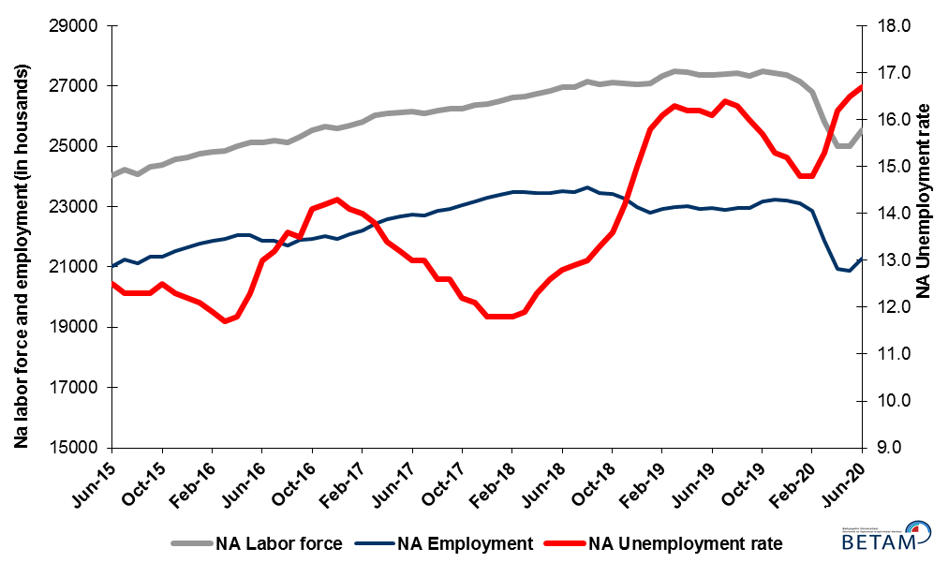
Source: Turkstat, Betam

Figure 2. Seasonally adjusted LFPR, employment rate and non-agricultural unemployment rate
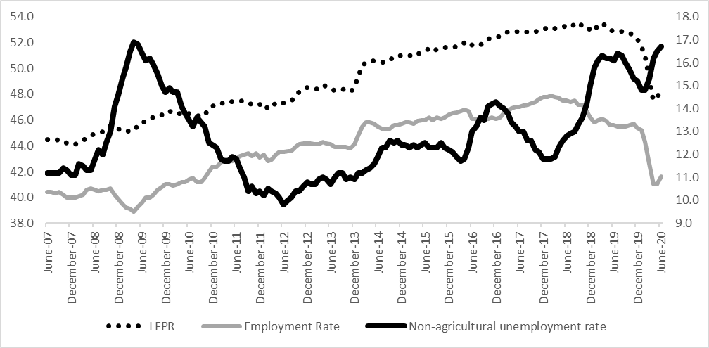
Source: Turkstat, Betam

Decrease in the number of “not seeking a job but available to start”

The level of labor force, by definition, is the summation of the level of employed people and the level of job seekers (unemployed). During the periods of massive employment losses one witnesses strange increase among individuals who desire to work but they are not actively seeking a job as they think that they could not find any. Those individuals that quit seeking for jobs and labor force due to loss of confidence and other reasons are referred as ‘Discouraged workers’ and ‘Other’ by TurkStat. The number of discouraged workers continuously increased since January 2019 and the increases accelerated in February, March and April. After deceleration in the period of May, the number of inactive non-seekers that are available to start decreased for the first time since the period of October 2019. In addition, the summation of seasonally adjusted ‘non-seekers but available to start’ and seasonally adjusted ‘unemployed’ population decreased for the first time since the period of November 2019. We estimate that this total figure decreased to 8 million 765 thousand in the period of June 2020, from 8 million 848 thousand in the period of May 2020.

Figure 3. The number of unemployed people, non-seekers who are available and summation of both, SA
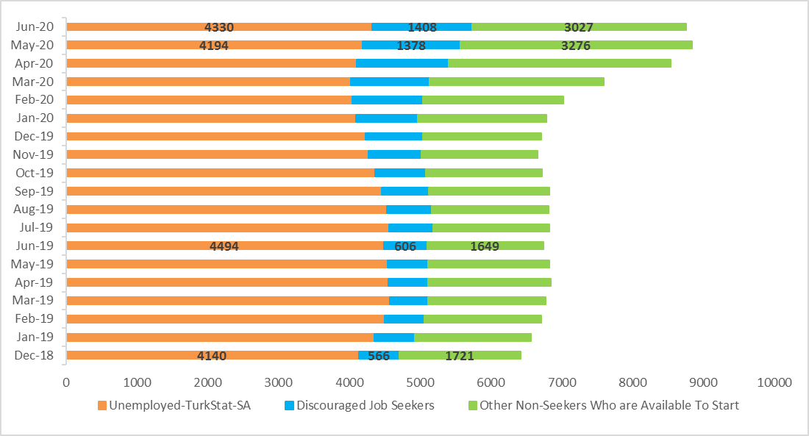
Source: Turkstat, Betam

Employment increases in all sectors

According to seasonally adjusted employment data, in the period of June 2020 compared to May 2020, employment increased in all four sectors. With the increase of 141 thousand in the construction employment, for the last two periods, employment gains in this sector totaled 251 thousand. As a result, employment in the construction sector recovered almost all its loss due to the pandemic. Employment in manufacturing increased by 25 thousand and by 230 thousand in services which has been going through employment losses even before the pandemic and suffered the most severe losses during the pandemic. Nevertheless, level of employment in manufacturing and services sector is far from their pre-pandemic levels.

Figure 4: Employment by sectors (in thousand)
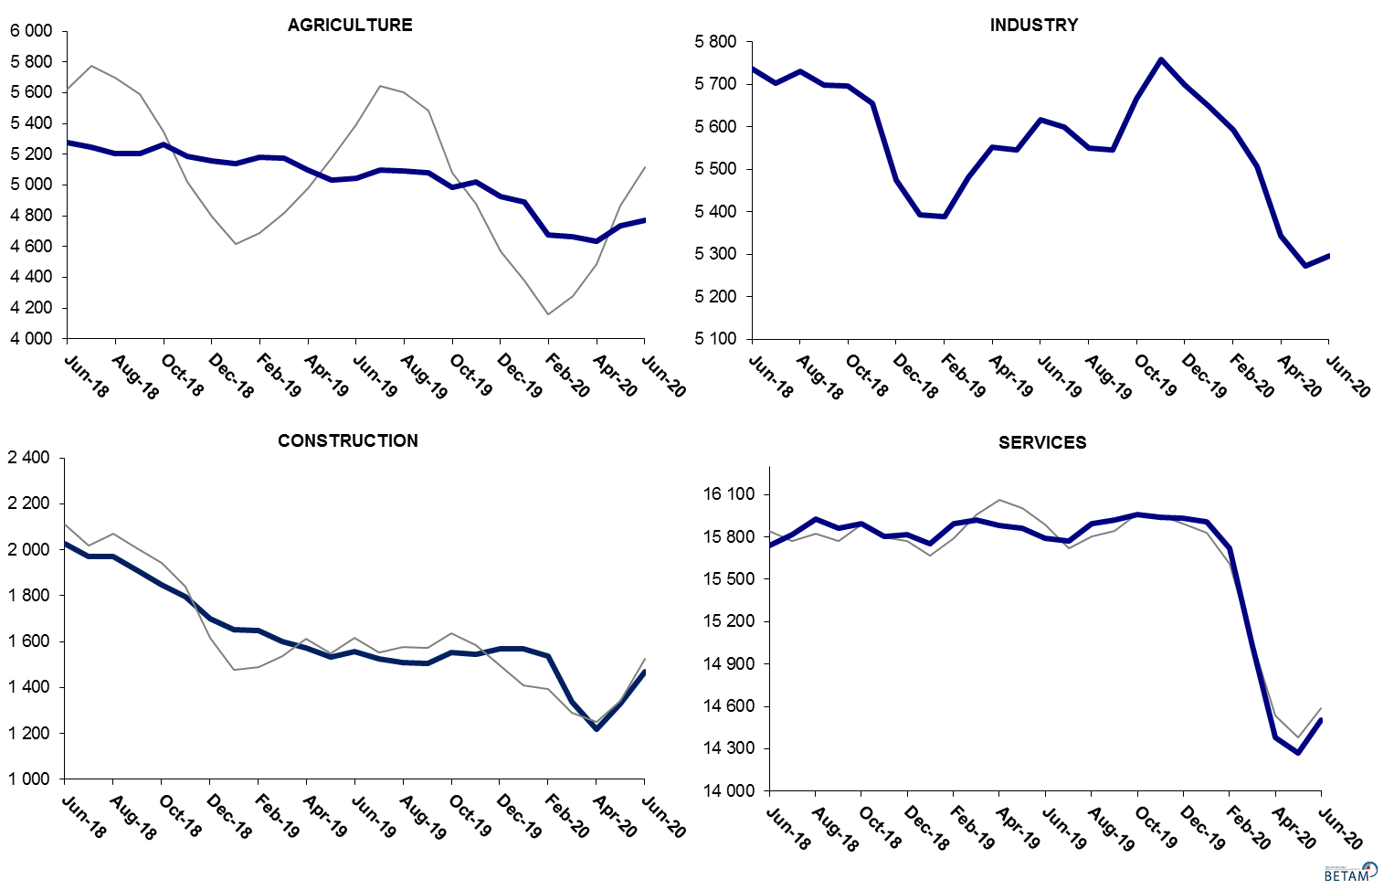
Source: TURKSTAT, Betam

Strong decreases in yearly non-agricultural labor force and employment

Compared to June 2019, non-agricultural employment decreased by 1 million 708 thousand (7.4 percent) in June 2020 while the non-agricultural labor force declined by 1 million 836 thousand, causing a decrease of 128 thousand in the number of unemployed people (Figure 5).

Figure 5Year-on-year changes in non-agricultural labor force, employment, and unemployment
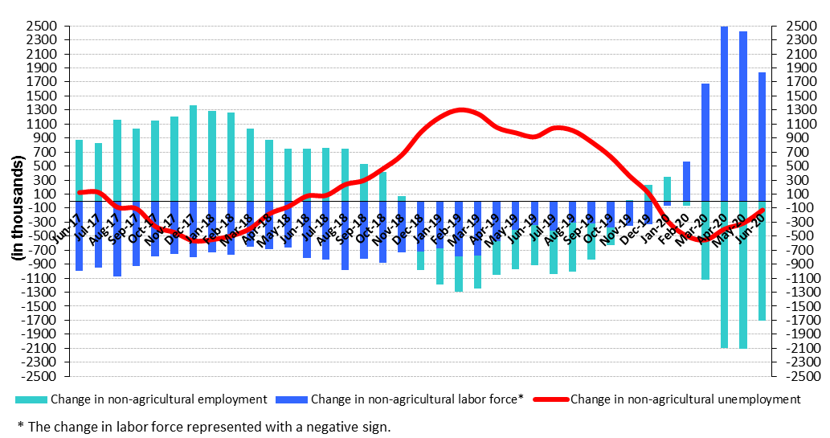
Source: TURKSTAT, Betam

Increases in male and female unemployment rates

Figure 6 shows seasonally adjusted non-agricultural unemployment rate for males (green) and for females (purple). In the period of June 2020 compared to the previous period, female non-agricultural unemployment rate increased by 0.7 percentage point to 19.0 percent. Male non-agricultural unemployment turned out to be 15.6 percent, with 0.1 percentage point increases compared to May 2020.While female and male labor force increased by 252 thousand and 413 thousand, respectively, female and male employment increased by 151 thousand and 330 thousand. As increase in female labor force compared to employment increase was quite higher female unemployment rate jumped by 0.7 percentage points that enlarged the unemployment gender gap by 0.6 percentage points; the gender gap attained 3.3 percentage points in June 2020 (Table 3).

Figure 6: Seasonally adjusted non-agricultural unemployment rate by gender
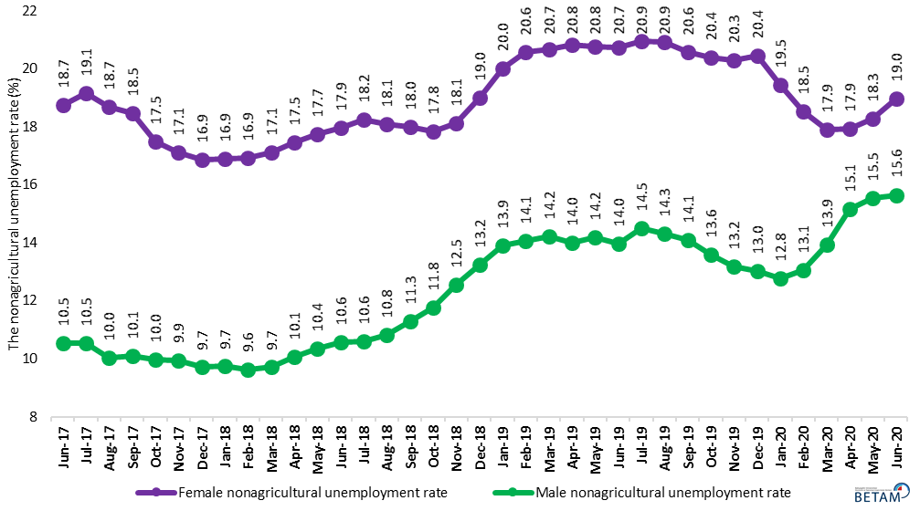
Source: Turkstat, Betam

Table 1Seasonally adjusted non-agricultural labor market indicators (in thousands) **
 | Labor force | Employment | Unemployment | Unemployment rate | Monthly changes
June-17 | 26146 | 22747 | 3399 | 13.0% | Labor force | Employment | Unemployment
July-17 | 26105 | 22711 | 3394 | 13.0% | -41 | -36 | -5
August-17 | 26176 | 22878 | 3298 | 12.6% | 72 | 167 | -95
September-17 | 26238 | 22932 | 3306 | 12.6% | 62 | 54 | 8
October-17 | 26239 | 23038 | 3201 | 12.2% | 1 | 106 | -105
November-17 | 26381 | 23189 | 3192 | 12.1% | 142 | 151 | -9
December-17 | 26405 | 23289 | 3116 | 11.8% | 24 | 100 | -76
January-18 | 26511 | 23383 | 3128 | 11.8% | 107 | 94 | 13
February-18 | 26634 | 23491 | 3143 | 11.8% | 122 | 108 | 14
March-18 | 26649 | 23478 | 3171 | 11.9% | 15 | -13 | 28
April-18 | 26754 | 23463 | 3291 | 12.3% | 104 | -15 | 119
May-18 | 26840 | 23458 | 3382 | 12.6% | 86 | -5 | 91
June-18 | 26952 | 23502 | 3450 | 12.8% | 112 | 44 | 68
July-18 | 26968 | 23489 | 3479 | 12.9% | 16 | -13 | 29
August-18 | 27155 | 23625 | 3530 | 13.0% | 187 | 136 | 51
September-18 | 27069 | 23469 | 3600 | 13.3% | -86 | -156 | 70
October-18 | 27125 | 23436 | 3689 | 13.6% | 56 | -33 | 89
November-18 | 27101 | 23253 | 3848 | 14.2% | -24 | -183 | 159
December-18 | 27053 | 22995 | 4058 | 15.0% | -48 | -258 | 210
January-19 | 27075 | 22797 | 4278 | 15.8% | 22 | -198 | 220
February-19 | 27330 | 22930 | 4400 | 16.1% | 255 | 133 | 122
March-19 | 27479 | 23000 | 4479 | 16.3% | 149 | 70 | 79
April-19 | 27456 | 23008 | 4448 | 16.2% | -23 | 8 | -31
May-19 | 27374 | 22939 | 4435 | 16.2% | -82 | -69 | -13
June-19 | 27368 | 22962 | 4406 | 16.1% | -5 | 23 | -28
July-19 | 27386 | 22895 | 4491 | 16.4% | 18 | -67 | 85
August-19 | 27424 | 22954 | 4470 | 16.3% | 38 | 59 | -21
September-19 | 27348 | 22972 | 4376 | 16.0% | -77 | 18 | -95
October-19 | 27493 | 23177 | 4316 | 15.7% | 146 | 205 | -59
November-19 | 27443 | 23244 | 4199 | 15.3% | -51 | 67 | -118
December-19 | 27356 | 23198 | 4158 | 15.2% | -87 | -46 | -41
January-20 | 27141 | 23124 | 4017 | 14.8% | -215 | -74 | -141
February-20 | 26819 | 22850 | 3969 | 14.8% | -322 | -274 | -48
March-20 | 25822 | 21871 | 3951 | 15.3% | -998 | -979 | -19
April-20 | 24994 | 20945 | 4049 | 16.2% | -828 | -926 | 98
May-20 | 24996 | 20872 | 4124 | 16.5% | 2 | -73 | 75
June-20 | 25531 | 21267 | 4264 | 16.7% | 534 | 395 | 139

Source: Turkstat, Betam

Table 2seasonally adjusted employment by sectors (in thousands) *
 | Agriculture | Manufacturing | Construction | Service | Monthly changes
June-17 | 5403 | 5383 | 2082 | 15282 | Agriculture | Manufacturing | Construction | Service
July-17 | 5501 | 5363 | 2123 | 15226 | 98 | -20 | 41 | -56
August-17 | 5465 | 5437 | 2169 | 15271 | -36 | 74 | 46 | 45
September-17 | 5488 | 5421 | 2121 | 15390 | 23 | -16 | -48 | 119
October-17 | 5469 | 5470 | 2090 | 15478 | -19 | 49 | -31 | 88
November-17 | 5482 | 5470 | 2127 | 15592 | 13 | 0 | 37 | 114
December-17 | 5538 | 5514 | 2174 | 15601 | 56 | 44 | 47 | 9
January-18 | 5484 | 5567 | 2197 | 15619 | -54 | 53 | 23 | 18
February-18 | 5456 | 5627 | 2187 | 15678 | -28 | 60 | -10 | 59
March-18 | 5395 | 5618 | 2149 | 15710 | -61 | -9 | -38 | 32
April-18 | 5399 | 5650 | 2095 | 15718 | 4 | 32 | -54 | 8
May-18 | 5325 | 5669 | 2048 | 15742 | -74 | 19 | -47 | 24
June-18 | 5278 | 5737 | 2026 | 15738 | -47 | 68 | -22 | -4
July-18 | 5244 | 5703 | 1972 | 15813 | -34 | -34 | -54 | 75
August-18 | 5202 | 5730 | 1972 | 15923 | -42 | 27 | 0 | 110
September-18 | 5207 | 5698 | 1912 | 15859 | 5 | -32 | -60 | -64
October-18 | 5266 | 5696 | 1849 | 15892 | 59 | -2 | -63 | 33
November-18 | 5188 | 5656 | 1797 | 15800 | -78 | -40 | -52 | -92
December-18 | 5157 | 5474 | 1702 | 15819 | -31 | -182 | -95 | 19
January-19 | 5136 | 5392 | 1654 | 15751 | -21 | -82 | -48 | -68
February-19 | 5183 | 5388 | 1648 | 15894 | 47 | -4 | -6 | 143
March-19 | 5176 | 5482 | 1600 | 15918 | -7 | 94 | -48 | 24
April-19 | 5100 | 5553 | 1573 | 15882 | -76 | 71 | -27 | -36
May-19 | 5034 | 5546 | 1532 | 15862 | -66 | -7 | -41 | -20
June-19 | 5046 | 5616 | 1557 | 15789 | 12 | 70 | 25 | -73
July-19 | 5099 | 5600 | 1527 | 15768 | 53 | -16 | -30 | -21
August-19 | 5090 | 5551 | 1508 | 15896 | -9 | -49 | -19 | 128
September-19 | 5078 | 5546 | 1507 | 15919 | -12 | -5 | -1 | 23
October-19 | 4983 | 5666 | 1554 | 15957 | -95 | 120 | 47 | 38
November-19 | 5021 | 5758 | 1544 | 15942 | 38 | 92 | -10 | -15
December-19 | 4923 | 5699 | 1567 | 15931 | -98 | -59 | 23 | -11
January-20 | 4890 | 5649 | 1567 | 15908 | -33 | -50 | 0 | -23
February-20 | 4677 | 5593 | 1538 | 15718 | -213 | -56 | -29 | -190
March-20 | 4663 | 5508 | 1340 | 15024 | -14 | -85 | -198 | -694
April-20 | 4635 | 5344 | 1220 | 14382 | -28 | -164 | -120 | -642
May-20 | 4733 | 5272 | 1330 | 14270 | 98 | -72 | 110 | -112
June-20 | 4769 | 5297 | 1471 | 14500 | 36 | 25 | 141 | 230

Source: Turkstat, Betam

Table 3: Seasonally adjusted non-agricultural labor force by gender (thousands)
 | Female Labor Force | Female Employment | Female Unemployed | Male Labor Force | Male Employment | Male Unemployed
June-17 | 7675 | 6237 | 1438 | 18466 | 16521 | 1945
July-17 | 7670 | 6202 | 1469 | 18472 | 16528 | 1944
August-17 | 7680 | 6246 | 1435 | 18507 | 16648 | 1859
September-17 | 7738 | 6310 | 1428 | 18495 | 16626 | 1869
October-17 | 7761 | 6402 | 1359 | 18474 | 16631 | 1842
November-17 | 7833 | 6493 | 1340 | 18532 | 16689 | 1843
December-17 | 7859 | 6534 | 1325 | 18535 | 16736 | 1799
January-18 | 7945 | 6603 | 1342 | 18591 | 16781 | 1810
February-18 | 7969 | 6619 | 1349 | 18666 | 16870 | 1796
March-18 | 7971 | 6607 | 1364 | 18695 | 16880 | 1815
April-18 | 8015 | 6615 | 1400 | 18740 | 16852 | 1888
May-18 | 8049 | 6621 | 1429 | 18730 | 16790 | 1940
June-18 | 8091 | 6638 | 1452 | 18869 | 16875 | 1994
July-18 | 8094 | 6617 | 1476 | 18890 | 16890 | 2000
August-18 | 8166 | 6688 | 1477 | 19023 | 16967 | 2055
September-18 | 8139 | 6674 | 1466 | 18949 | 16812 | 2138
October-18 | 8223 | 6757 | 1466 | 18900 | 16679 | 2221
November-18 | 8237 | 6745 | 1492 | 18868 | 16501 | 2366
December-18 | 8304 | 6727 | 1577 | 18728 | 16247 | 2481
January-19 | 8384 | 6707 | 1677 | 18679 | 16083 | 2597
February-19 | 8474 | 6729 | 1744 | 18843 | 16195 | 2648
March-19 | 8538 | 6773 | 1764 | 18920 | 16232 | 2688
April-19 | 8490 | 6723 | 1767 | 18941 | 16292 | 2649
May-19 | 8422 | 6674 | 1749 | 18884 | 16205 | 2679
June-19 | 8426 | 6680 | 1746 | 18944 | 16296 | 2649
July-19 | 8411 | 6650 | 1761 | 19025 | 16266 | 2758
August-19 | 8432 | 6668 | 1764 | 19053 | 16324 | 2729
September-19 | 8375 | 6650 | 1724 | 19018 | 16340 | 2678
October-19 | 8442 | 6720 | 1722 | 19054 | 16464 | 2590
November-19 | 8379 | 6679 | 1700 | 19073 | 16561 | 2512
December-19 | 8358 | 6649 | 1709 | 19011 | 16538 | 2473
January-20 | 8297 | 6683 | 1614 | 18847 | 16441 | 2406
February-20 | 8143 | 6633 | 1510 | 18638 | 16205 | 2433
March-20 | 7780 | 6387 | 1394 | 17992 | 15487 | 2505
April-20 | 7428 | 6096 | 1332 | 17501 | 14849 | 2651
May-20 | 7438 | 6079 | 1359 | 17432 | 14723 | 2709
June-20 | 7690 | 6230 | 1459 | 17845 | 15053 | 2793

Source: Turkstat, Betam

Table 4: Seasonally adjusted LFPR, employment rate and non-agricultural unemployment rate (%)

 | Non-Agricultural Labor Force | Non-Agricultural Employment | Non-Agricultural Unemployed
Jun-17 | 52.8 | 47.0 | 13.0
Jul-17 | 52.9 | 47.1 | 13.0
Aug-17 | 52.8 | 47.2 | 12.6
Sep-17 | 52.9 | 47.3 | 12.6
Oct-17 | 52.8 | 47.4 | 12.2
Nov-17 | 53.0 | 47.6 | 12.1
Dec-17 | 53.1 | 47.8 | 11.8
Jan-18 | 53.1 | 47.8 | 11.8
Feb-18 | 53.2 | 47.9 | 11.8
Mar-18 | 53.1 | 47.8 | 11.9
Apr-18 | 53.2 | 47.7 | 12.3
May-18 | 53.2 | 47.5 | 12.6
Jun-18 | 53.3 | 47.5 | 12.8
Jul-18 | 53.2 | 47.4 | 12.9
Aug-18 | 53.4 | 47.5 | 13.0
Sep-18 | 53.2 | 47.2 | 13.3
Oct-18 | 53.4 | 47.2 | 13.6
Nov-18 | 53.2 | 46.7 | 14.2
Dec-18 | 53.0 | 46.2 | 15.0
Jan-19 | 52.9 | 45.8 | 15.8
Feb-19 | 53.4 | 46.0 | 16.1
Mar-19 | 53.5 | 46.1 | 16.3
Apr-19 | 53.3 | 45.9 | 16.2
May-19 | 53.0 | 45.6 | 16.2
Jun-19 | 52.9 | 45.6 | 16.1
Jul-19 | 52.9 | 45.5 | 16.4
Aug-19 | 52.9 | 45.5 | 16.3
Sep-19 | 52.7 | 45.5 | 16.0
Oct-19 | 52.7 | 45.6 | 15.7
Nov-19 | 52.6 | 45.7 | 15.3
Dec-19 | 52.2 | 45.4 | 15.2
Jan-20 | 51.8 | 45.2 | 14.8
Feb-20 | 50.8 | 44.3 | 14.8
Mar-20 | 49.1 | 42.6 | 15.3
Apr-20 | 47.6 | 41.0 | 16.2
May-20 | 47.7 | 41.0 | 16.5
Jun-20 | 48.6 | 41.6 | 16.7

Source: Turkstat

Table 5: Seasonally adjusted non-seekers that are available to start, unemployed and sum of both

 | Discouraged Job Seekers-SA | Unemployed-TurkStat-SA | Other Non-Seekers Who are Available To Start | Total
Jan-19 | 564 | 4359 | 1648 | 6572
Feb-19 | 561 | 4498 | 1654 | 6712
Mar-19 | 535 | 4576 | 1661 | 6772
Apr-19 | 560 | 4552 | 1739 | 6851
May-19 | 580 | 4539 | 1712 | 6831
Jun-19 | 606 | 4494 | 1649 | 6749
Jul-19 | 618 | 4569 | 1643 | 6830
Aug-19 | 630 | 4537 | 1648 | 6815
Sep-19 | 670 | 4455 | 1703 | 6828
Oct-19 | 719 | 4364 | 1641 | 6724
Nov-19 | 754 | 4271 | 1634 | 6659
Dec-19 | 809 | 4230 | 1674 | 6712
Jan-20 | 879 | 4092 | 1812 | 6782
Feb-20 | 1002 | 4042 | 1978 | 7022
Mar-20 | 1104 | 4027 | 2472 | 7602
Apr-20 | 1298 | 4111 | 3131 | 8540
May-20 | 1378 | 4194 | 3276 | 8848
Jun-20 | 1408 | 4330 | 3027 | 8765

Source: Turkstat, Betam

*Prof. Dr. Seyfettin Gürsel, Betam, Director, seyfettin.gursel@eas.bau.edu.tr **Mehmet Cem Şahin, Betam, Research Assistant, mehmetcem.sahin@eas.bau.edu.tr
Turkstat revised the labor market statistics drastically in February 2014. Within this framework, they back casted various labor market indicators and they also continued to announce seasonally adjusted series. However, Turkstat is not providing back-casted series by gender. Therefore, female and male labor market statistics are not sufficiently long for the seasonal adjustment procedures (There should be minimum 36 observations). With the announcement of the period of February 2017 data, the number of observations required for the seasonal decontamination process was provided. From this period Betam generated seasonal adjustment series in terms of gender. Nevertheless, it should not be forgotten that seasonal adjustment may cause extra volatility in the series for at least a while.

