Labor Market Outlook:
August 2020

12 August 2020

SLOW DOWN IN EMPLOYMENT AND LABOR FORCE LOSSES
WHILE UNEMPLOYMENT CONTINUES TO INCREASE

Seyfettin Gürsel*, Hamza Mutluay **

Executive Summary

Seasonally adjusted labor market data shows that in the period of May 2020, non-agricultural unemployment rate turned out to be 16.4 percent, with 0.3 percentage point increases compared to April 2020. In this period, non-agricultural employment decreased by 139 thousand while non-agricultural labor force decreased by 77 thousand. According to sectorial data, employment in manufacturing and services sector continued to decrease while agricultural and construction employment increased. Agriculture and construction employment increased by 96 thousand and 107 thousand respectively, manufacturing and services employment decreased by 72 thousand and 174 thousand respectively. Over the last three periods, employment losses in services sector amounted to 1 million 515 thousand. Based on the seasonally adjusted data, while female non-agricultural employment decreased by 15 thousand, non-agricultural female labor force increased by 12 thousand. As the result of this decreases in female employment, non-agricultural female unemployment rate increased by 0.4 percentage points to 18.2 percent. Male labor force and employment decreased by 77 thousand and 131 thousand respectively. Since the decline in male employment was higher than the male labor force, male non-agricultural unemployment rate increased by 0.4 percentage points to 15.5 percent.

Decreases in all non-agricultural labor market indicators

Seasonally adjusted data shows that, non-agricultural labor force decreased to 24 million 883 thousand after a loss of 77 thousand in May 2020 period (April-May-June) compared to April 2020 period (March-April-May). Over the last three periods, decreases in labor force amounted to 1 million 913 thousand. Non-agricultural employment declined to 20 million 802 thousand along with a decrease of 139 thousand. So, decreases in employment amounted to 2 million 55 thousand over the last three periods. As a result of this striking decline in employment and labor force, the number of non-agricultural unemployed increased only by 62 thousand to 4 million 81 thousand, and the non-agricultural unemployment rate rose to 16.4 from 16.1 percent.

The strong decreases in both the labor force and the employment rate in the recent period have started to lose acceleration in the period of May. As a result, in the period of May 2020 compared to April 2020, labor force participation rate stood unchanged at 47.6, employment rate decreased by 0.1 percentage point to 40.9 percent. In the recent year, labor force participation and employment rate decreased by 5.3 percentage points and 4.6 percentage points respectively (Figure 2).

Figure 1. Seasonally adjusted non-agricultural labor force, employment, and unemployment
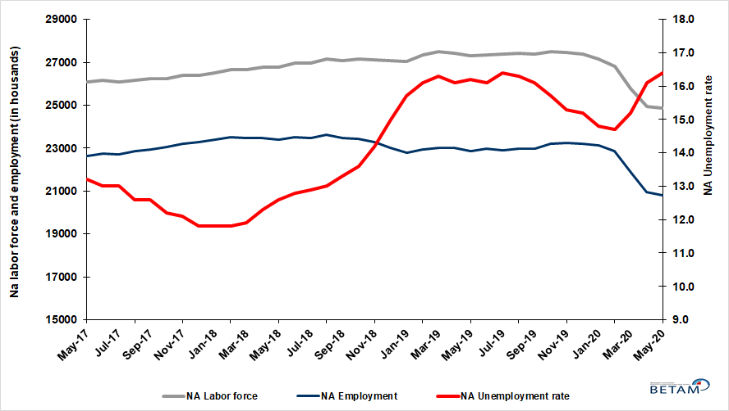
Source: Turkstat, Betam

Figure 2. Seasonally adjusted LFPR, employment rate and non-agricultural unemployment rate
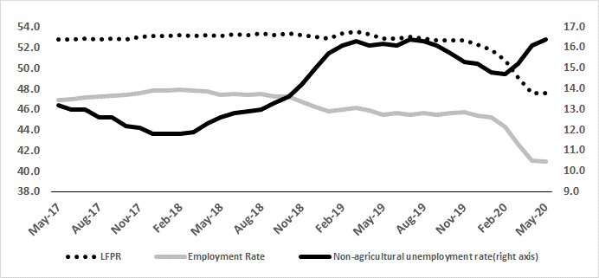
Source: Turkstat, Betam

Significant increase in the number of discouraged workers

The level of labor force, by definition, is the summation of the level of employed people and the level of job seekers (unemployed). The unusual developments in the labor market, cause loss of confidence among individuals who desire to work but they are not actively seeking a job as they think that they could not find any one. Those individuals that quit seeking for jobs and labor force due to loss of confidence are referred as ‘Discouraged workers’ by TurkStat. The number of discouraged workers continuously increased since January 2019 and the increases accelerated in February, March and April. As for May 2020, even though the decreases in the number of discouraged workers decelerate, the number of discouraged workers continuous to increase. As can be seen from the Figure 3 that features discouraged workers, unemployed people and summation of both, the number of discouraged workers nearly tripled from the period of January 2019 and reached 1 million 359 thousand within a year.

Figure 3. The number of unemployed people, discouraged workers and summation of both, SA
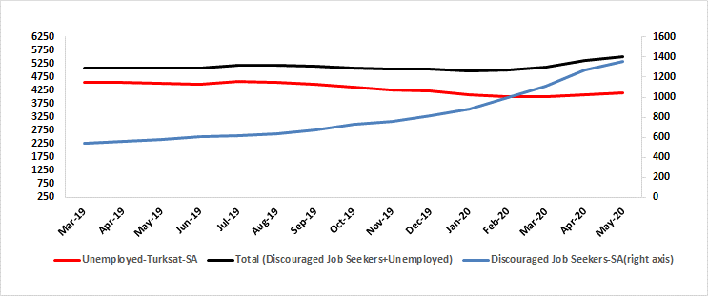
Source: Turkstat, Betam

Warning regarding the forecast of unemployment rate

In order to restrict the adverse impact of the corona pandemic on employment, instead of short-time working allowance and layoff measures, furloughs considerably invalidate the relationship between the economic activity level and employment. Additionally, the relatively high correlation between the employment losses and the number of unemployed also lost its function. We believe that these developments significantly increased the standard error interval of the Betam unemployment forecast model. As in the case of previous research brief, we prefer not to publish our June 2020 forecast in our Labor Market Outlook report for the period of May 2020. However, we would like to share with our readers that Betam’s forecasting model predicted that non-agricultural unemployment rate would rise up to 16.1 percent in June 2020.

Increases in agriculture and construction sector

According to seasonally adjusted sectorial labor market data, in the period of May 2020 compared to April 2020, while employment increased in agricultural and construction sector, employment decreased in manufacturing and services sector. In the period of May 2020 employment in agriculture increased by 96 thousand and by 107 thousand in construction. On the other hand, employment in manufacturing decreased by 72 thousand and employment in services sector by 174 thousand following a decrease of 647 thousand in April. Thus employment losses reached 1 million 515 thousand over the last three periods. As expected, the services sector is the most affected by the measures taken against the spread of the Coronavirus pandemic.
Figure 4: Employment by sectors (in thousand)
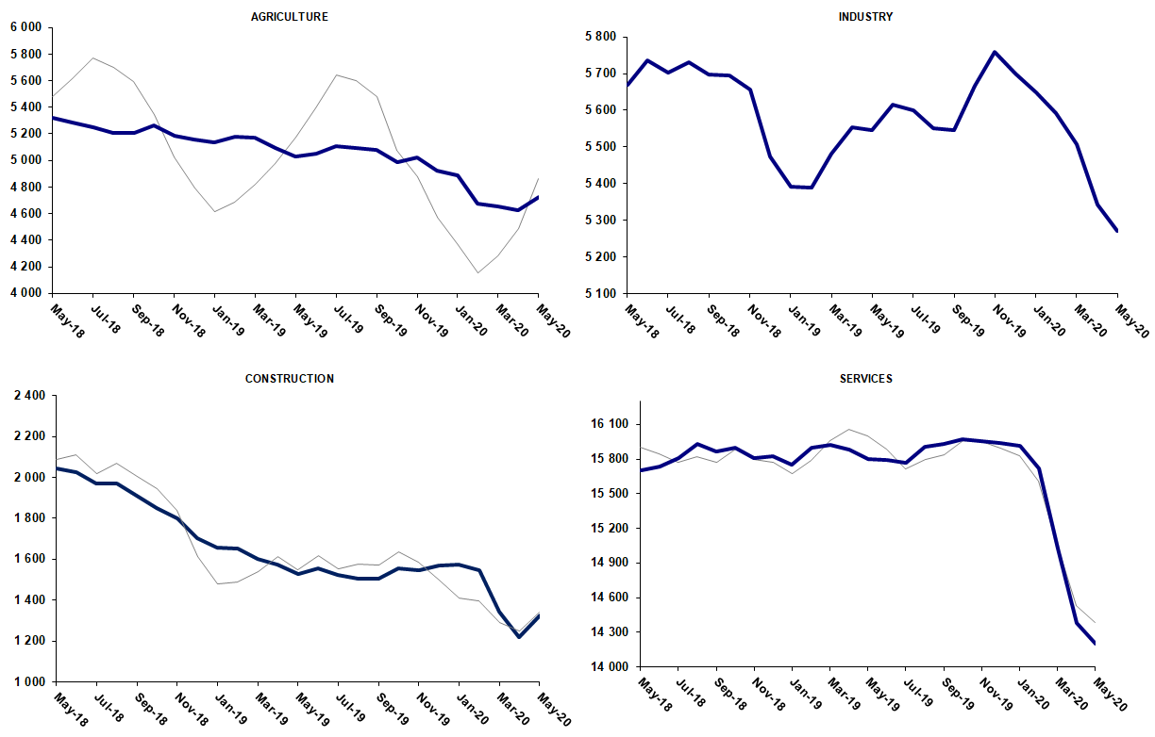
Source: TURKSTAT, Betam

Strong decreases in yearly non-agricultural labor force participation and employment

Compared to May 2019, non-agricultural employment decreased by 2 million 103 thousand (9.1 percent) in May 2020. Compared to the same period of the previous year, the number of non-agricultural unemployed decreased instead of increasing. In the recent year, the number of non-agricultural labor force decreased by 2 million 416 thousand and the number of unemployed decreased by 313 thousand (Figure 5).

Figure 5 Year-on-year changes in non-agricultural labor force, employment, and unemployment
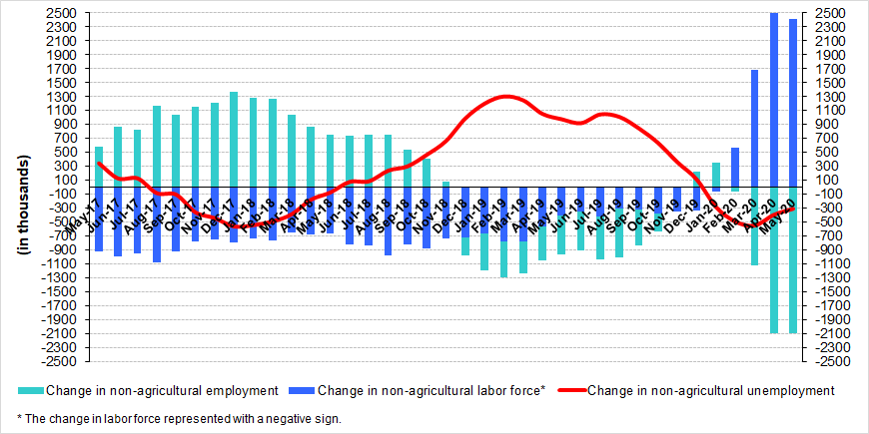
Source: TURKSTAT, Betam

Increases in male and female unemployment rate

Figure 6 shows seasonally adjusted non-agricultural unemployment rate for males (green) and for females (purple). In the period of May 2020 compared to the previous period, female non-agricultural unemployment rate increased by 0.4 percentage point to 18.2 percent. Male non-agricultural unemployment turned out to be 15.5 percent, with 0.4 percentage point increases compared to April 2020. After severe decreases in female labor force over the last three periods, female laborforce increased (12 thousand) in the period of May 2020. Increase in male unemployment resulted from decreases in employment (131 thousand) and lower decreases in labor force (77 thousand) (Table 3). As a result, the gender gap in non-agricultural unemployment rates remained unchanged at 2.7 percent points.

Figure 6: Seasonally adjusted non-agricultural unemployment rate by gender
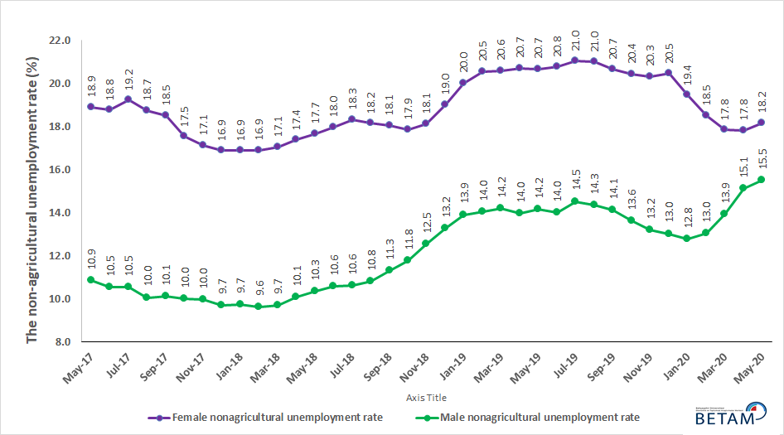
Source: Turkstat, Betam

Table 1 Seasonally adjusted non-agricultural labor market indicators (in thousands) **
 | Labor force | Employment | Unemployment | Unemployment rate | Monthly changes
May-17 | 26091 | 22647 | 3444 | 13.2% | Labor force | Employment | Unemployment
Jun-17 | 26145 | 22746 | 3399 | 13.0% | 54 | 99 | -45
Jul-17 | 26102 | 22709 | 3393 | 13.0% | -43 | -37 | -6
Aug-17 | 26172 | 22874 | 3298 | 12.6% | 69 | 165 | -96
Sep-17 | 26237 | 22931 | 3306 | 12.6% | 65 | 57 | 8
Oct-17 | 26241 | 23040 | 3201 | 12.2% | 5 | 109 | -104
Nov-17 | 26390 | 23197 | 3193 | 12.1% | 149 | 157 | -8
Dec-17 | 26410 | 23294 | 3116 | 11.8% | 20 | 97 | -77
Jan-18 | 26517 | 23388 | 3129 | 11.8% | 107 | 94 | 13
Feb-18 | 26647 | 23503 | 3144 | 11.8% | 130 | 115 | 15
Mar-18 | 26658 | 23486 | 3172 | 11.9% | 11 | -17 | 28
Apr-18 | 26757 | 23466 | 3291 | 12.3% | 99 | -20 | 119
May-18 | 26788 | 23413 | 3375 | 12.6% | 31 | -53 | 84
Jun-18 | 26948 | 23499 | 3449 | 12.8% | 160 | 86 | 74
Jul-18 | 26962 | 23484 | 3478 | 12.9% | 14 | -15 | 29
Aug-18 | 27159 | 23628 | 3531 | 13.0% | 197 | 144 | 53
Sep-18 | 27074 | 23473 | 3601 | 13.3% | -85 | -155 | 70
Oct-18 | 27137 | 23446 | 3691 | 13.6% | 63 | -27 | 90
Nov-18 | 27115 | 23265 | 3850 | 14.2% | -21 | -181 | 160
Dec-18 | 27062 | 23003 | 4059 | 15.0% | -53 | -262 | 209
Jan-19 | 27049 | 22802 | 4247 | 15.7% | -14 | -201 | 187
Feb-19 | 27341 | 22939 | 4402 | 16.1% | 292 | 137 | 155
Mar-19 | 27486 | 23006 | 4480 | 16.3% | 145 | 67 | 78
Apr-19 | 27422 | 23007 | 4415 | 16.1% | -64 | 1 | -65
May-19 | 27300 | 22877 | 4423 | 16.2% | -122 | -130 | 8
Jun-19 | 27364 | 22958 | 4406 | 16.1% | 64 | 81 | -17
Jul-19 | 27380 | 22890 | 4490 | 16.4% | 17 | -68 | 85
Aug-19 | 27432 | 22961 | 4471 | 16.3% | 52 | 71 | -19
Sep-19 | 27390 | 22980 | 4410 | 16.1% | -43 | 19 | -62
Oct-19 | 27512 | 23193 | 4319 | 15.7% | 123 | 213 | -90
Nov-19 | 27463 | 23261 | 4202 | 15.3% | -50 | 68 | -118
Dec-19 | 27373 | 23212 | 4161 | 15.2% | -90 | -49 | -41
Jan-20 | 27153 | 23134 | 4019 | 14.8% | -220 | -78 | -142
Feb-20 | 26796 | 22857 | 3939 | 14.7% | -357 | -277 | -80
Mar-20 | 25796 | 21875 | 3921 | 15.2% | -1000 | -982 | -18
Apr-20 | 24959 | 20941 | 4018 | 16.1% | -837 | -934 | 97
May-20 | 24883 | 20802 | 4081 | 16.4% | -77 | -139 | 62
Source: Turkstat, Betam

Table 2 seasonally adjusted employment by sectors (in thousands) *
 | Agriculture | Manufacturing | Construction | Service | Monthly changes
May-17 | 5397 | 5386 | 2086 | 15174 | Agriculture | Manufacturing | Construction | Service
Jun-17 | 5405 | 5383 | 2080 | 15283 | 8 | -3 | -6 | 109
Jul-17 | 5503 | 5363 | 2121 | 15225 | 98 | -20 | 41 | -58
Aug-17 | 5467 | 5437 | 2169 | 15268 | -36 | 74 | 48 | 43
Sep-17 | 5489 | 5421 | 2121 | 15388 | 22 | -16 | -48 | 120
Oct-17 | 5470 | 5470 | 2090 | 15480 | -19 | 49 | -31 | 92
Nov-17 | 5482 | 5470 | 2128 | 15599 | 12 | 0 | 38 | 119
Dec-17 | 5538 | 5514 | 2176 | 15605 | 56 | 44 | 48 | 6
Jan-18 | 5483 | 5567 | 2199 | 15622 | -55 | 53 | 23 | 17
Feb-18 | 5454 | 5627 | 2190 | 15686 | -29 | 60 | -9 | 64
Mar-18 | 5393 | 5618 | 2151 | 15717 | -61 | -9 | -39 | 31
Apr-18 | 5395 | 5650 | 2095 | 15721 | 2 | 32 | -56 | 4
May-18 | 5320 | 5669 | 2045 | 15699 | -75 | 19 | -50 | -22
Jun-18 | 5282 | 5737 | 2023 | 15738 | -38 | 68 | -22 | 39
Jul-18 | 5249 | 5703 | 1970 | 15811 | -33 | -34 | -53 | 73
Aug-18 | 5205 | 5730 | 1971 | 15927 | -44 | 27 | 1 | 116
Sep-18 | 5209 | 5698 | 1912 | 15863 | 4 | -32 | -59 | -64
Oct-18 | 5267 | 5696 | 1849 | 15901 | 58 | -2 | -63 | 38
Nov-18 | 5188 | 5656 | 1798 | 15811 | -79 | -40 | -51 | -90
Dec-18 | 5157 | 5474 | 1704 | 15825 | -31 | -182 | -94 | 14
Jan-19 | 5135 | 5392 | 1657 | 15754 | -22 | -82 | -47 | -71
Feb-19 | 5180 | 5388 | 1652 | 15899 | 45 | -4 | -5 | 145
Mar-19 | 5172 | 5482 | 1602 | 15922 | -8 | 94 | -50 | 23
Apr-19 | 5095 | 5553 | 1572 | 15883 | -77 | 71 | -30 | -39
May-19 | 5027 | 5546 | 1528 | 15803 | -68 | -7 | -44 | -80
Jun-19 | 5052 | 5616 | 1553 | 15789 | 25 | 70 | 25 | -14
Jul-19 | 5106 | 5600 | 1524 | 15766 | 54 | -16 | -29 | -23
Aug-19 | 5095 | 5551 | 1506 | 15904 | -11 | -49 | -18 | 138
Sep-19 | 5082 | 5546 | 1506 | 15928 | -13 | -5 | 0 | 24
Oct-19 | 4985 | 5666 | 1555 | 15972 | -97 | 120 | 49 | 44
Nov-19 | 5022 | 5758 | 1546 | 15957 | 37 | 92 | -9 | -15
Dec-19 | 4922 | 5699 | 1571 | 15942 | -100 | -59 | 25 | -15
Jan-20 | 4887 | 5649 | 1572 | 15913 | -35 | -50 | 1 | -29
Feb-20 | 4673 | 5593 | 1544 | 15719 | -214 | -56 | -28 | -194
Mar-20 | 4657 | 5508 | 1342 | 15025 | -16 | -85 | -202 | -694
Apr-20 | 4627 | 5344 | 1219 | 14378 | -30 | -164 | -123 | -647
May-20 | 4723 | 5272 | 1326 | 14204 | 96 | -72 | 107 | -174
Source: Turkstat, Betam

Table 3: Seasonally adjusted non-agricultural labor force by gender (thousands)
 | Female Labor Force | Female Employment | Female Unemployed | Male Labor Force | Male Employment | Male Unemployed
May-17 | 7670 | 6221 | 1449 | 18419 | 16420 | 1999
Jun-17 | 7679 | 6239 | 1440 | 18464 | 16518 | 1946
Jul-17 | 7678 | 6203 | 1475 | 18469 | 16524 | 1945
Aug-17 | 7687 | 6247 | 1440 | 18505 | 16645 | 1860
Sep-17 | 7743 | 6310 | 1433 | 18495 | 16624 | 1870
Oct-17 | 7764 | 6403 | 1361 | 18473 | 16629 | 1843
Nov-17 | 7835 | 6493 | 1342 | 18533 | 16689 | 1844
Dec-17 | 7858 | 6533 | 1325 | 18538 | 16739 | 1799
Jan-18 | 7942 | 6602 | 1340 | 18593 | 16783 | 1810
Feb-18 | 7964 | 6618 | 1346 | 18670 | 16875 | 1796
Mar-18 | 7964 | 6606 | 1359 | 18700 | 16886 | 1814
Apr-18 | 8008 | 6617 | 1392 | 18738 | 16852 | 1886
May-18 | 8043 | 6622 | 1421 | 18724 | 16787 | 1937
Jun-18 | 8095 | 6641 | 1455 | 18864 | 16869 | 1995
Jul-18 | 8103 | 6619 | 1484 | 18887 | 16886 | 2001
Aug-18 | 8172 | 6688 | 1483 | 19021 | 16965 | 2057
Sep-18 | 8145 | 6674 | 1471 | 18949 | 16810 | 2139
Oct-18 | 8227 | 6757 | 1469 | 18902 | 16679 | 2223
Nov-18 | 8238 | 6744 | 1494 | 18870 | 16503 | 2368
Dec-18 | 8304 | 6726 | 1578 | 18733 | 16251 | 2482
Jan-19 | 8380 | 6704 | 1676 | 18683 | 16087 | 2597
Feb-19 | 8467 | 6727 | 1740 | 18848 | 16201 | 2647
Mar-19 | 8528 | 6771 | 1756 | 18922 | 16237 | 2685
Apr-19 | 8479 | 6723 | 1756 | 18937 | 16292 | 2645
May-19 | 8412 | 6675 | 1738 | 18874 | 16200 | 2673
Jun-19 | 8432 | 6682 | 1750 | 18938 | 16289 | 2649
Jul-19 | 8423 | 6652 | 1771 | 19020 | 16260 | 2760
Aug-19 | 8442 | 6669 | 1772 | 19051 | 16319 | 2732
Sep-19 | 8382 | 6651 | 1731 | 19019 | 16338 | 2681
Oct-19 | 8446 | 6721 | 1726 | 19056 | 16463 | 2593
Nov-19 | 8380 | 6678 | 1702 | 19078 | 16563 | 2514
Dec-19 | 8358 | 6648 | 1710 | 19017 | 16543 | 2475
Jan-20 | 8293 | 6680 | 1613 | 18855 | 16449 | 2406
Feb-20 | 8135 | 6630 | 1506 | 18647 | 16215 | 2432
Mar-20 | 7771 | 6385 | 1386 | 17995 | 15493 | 2502
Apr-20 | 7419 | 6096 | 1322 | 17495 | 14850 | 2645
May-20 | 7431 | 6081 | 1350 | 17418 | 14718 | 2700

Source: Turkstat, Betam

Table 4: Seasonally adjusted LFPR, employment rate and non-agricultural unemployment rate (%)

 | LFPR | Employment Rate | Non-agricultural unemployment rate
May-17 | 52.8 | 46.9 | 13.2
Jun-17 | 52.8 | 47.0 | 13.0
Jul-17 | 52.9 | 47.1 | 13.0
Aug-17 | 52.8 | 47.2 | 12.6
Sep-17 | 52.9 | 47.3 | 12.6
Oct-17 | 52.8 | 47.4 | 12.2
Nov-17 | 53.0 | 47.6 | 12.1
Dec-17 | 53.1 | 47.8 | 11.8
Jan-18 | 53.1 | 47.8 | 11.8
Feb-18 | 53.2 | 47.9 | 11.8
Mar-18 | 53.1 | 47.8 | 11.9
Apr-18 | 53.2 | 47.7 | 12.3
May-18 | 53.1 | 47.4 | 12.6
Jun-18 | 53.3 | 47.5 | 12.8
Jul-18 | 53.2 | 47.4 | 12.9
Aug-18 | 53.4 | 47.5 | 13.0
Sep-18 | 53.2 | 47.2 | 13.3
Oct-18 | 53.4 | 47.2 | 13.6
Nov-18 | 53.2 | 46.7 | 14.2
Dec-18 | 53.0 | 46.2 | 15.0
Jan-19 | 52.9 | 45.8 | 15.7
Feb-19 | 53.4 | 46.0 | 16.1
Mar-19 | 53.5 | 46.1 | 16.3
Apr-19 | 53.3 | 45.9 | 16.1
May-19 | 52.9 | 45.5 | 16.2
Jun-19 | 52.9 | 45.6 | 16.1
Jul-19 | 53.0 | 45.5 | 16.4
Aug-19 | 52.9 | 45.6 | 16.3
Sep-19 | 52.7 | 45.5 | 16.1
Oct-19 | 52.7 | 45.6 | 15.7
Nov-19 | 52.7 | 45.7 | 15.3
Dec-19 | 52.3 | 45.4 | 15.2
Jan-20 | 51.8 | 45.2 | 14.8
Feb-20 | 50.8 | 44.3 | 14.7
Mar-20 | 49.1 | 42.6 | 15.2
Apr-20 | 47.6 | 41.0 | 16.1
May-20 | 47.6 | 40.9 | 16.4

Source: Turkstat

Table 5: Seasonally adjusted discouraged workers, unemployed and sum of both

 | Discouraged Workers-SA | Unemployed-TurkStat-SA | Total (Discouraged Workers + Unemployed)
Jan-19 | 562 | 4358 | 4920
Feb-19 | 557 | 4492 | 5049
Mar-19 | 537 | 4565 | 5102
Apr-19 | 555 | 4537 | 5092
May-19 | 578 | 4519 | 5097
Jun-19 | 605 | 4496 | 5101
Jul-19 | 617 | 4578 | 5195
Aug-19 | 635 | 4550 | 5185
Sep-19 | 676 | 4469 | 5145
Oct-19 | 725 | 4376 | 5101
Nov-19 | 759 | 4279 | 5038
Dec-19 | 812 | 4234 | 5046
Jan-20 | 882 | 4090 | 4972
Feb-20 | 998 | 4034 | 5032
Mar-20 | 1112 | 4014 | 5126
Apr-20 | 1271 | 4091 | 5362
May-20 | 1359 | 4166 | 5525

Source: Turkstat, Betam

*Prof. Dr. Seyfettin Gürsel, Betam, Director, seyfettin.gursel@eas.bau.edu.tr **Hamza Mutluay, Betam, Research Assistant, hamza.mutluay@eas.bau.edu.tr
Turkstat revised the labor market statistics drastically in February 2014. Within this framework, they back casted various labor market indicators and they also continued to announce seasonally adjusted series. However, Turkstat is not providing back-casted series by gender. Therefore, female and male labor market statistics are not sufficiently long for the seasonal adjustment procedures (There should be minimum 36 observations). With the announcement of the period of February 2017 data, the number of observations required for the seasonal decontamination process was provided. From this period Betam generated seasonal adjustment series in terms of gender. Nevertheless, it should not be forgotten that seasonal adjustment may cause extra volatility in the series for at least a while.

