Labor Market Outlook:
July 2020

13 July 2020

SEVERE LOSSES IN LABOR FORCE AND EMPLOYMENT

Seyfettin Gürsel*, Mehmet Cem Şahin **

Executive Summary

Seasonally adjusted labor market data shows that in the period of April 2020, non-agricultural unemployment rate turned out to be 16.1 percent, with 0.9 percentage point increases compared to March 2020. In this period, non-agricultural employment decreased by 934 thousand while non-agricultural labor force decreased by 837 thousand. According to sectorial data, employment losses occurred in all sectors. While agriculture employment decreased by 34 thousand, manufacturing employment and construction employment decreased by 164 thousand and by 123 thousand respectively. The most significant decreases in employment occurred in services that attained 647 thousand. Over the last two periods, employment losses in this sector amounted to 1 million 341 thousand. Based on the seasonally adjusted data, while female non-agricultural employment decreased by 289 thousand, non-agricultural labor force decreased by 353 thousand. As the result of this decreases in female labor force and employment, non-agricultural female unemployment rate stood unchanged at 17.8 percent. Male labor force and employment decreased by 499 thousand and 643 thousand respectively. Since the decline in male employment was higher than the male labor force, male non-agricultural unemployment rate increased by 1.2 percentage points to 15.1 percent.

Decreases in all non-agricultural labor market indicators

Seasonally adjusted data shows that, non-agricultural labor force decreased to 24 million 959 thousand after a loss of 837 thousand in April 2020 period (March-April-May) compared to March 2020 period (February-March-April). Over the last two periods, decreases in labor force amounted to 1 million 835 thousand. Non-agricultural employment declined to 20 million 941 thousand along with a decrease of 934 thousand. So, decreases in employment amounted to 1 million 915 thousand over the last two periods As a result of this striking decline in employment and labor force, the number of non-agricultural unemployed increased only by 97 thousand to 4 million 18 thousand, and the non-agricultural unemployment rate rose to 16.1 from 15.2 percent.

To better capture the extraordinary decrease in non-agricultural labor force, we added a new figure that features seasonally adjusted LFPR, employment rate and non-agricultural unemployment rate into our Labor Market Outlook reports. Decreases in both the labor force and the employment rates that occurred in the periods of February and March, continued in April as well. Combining with the steady increases in the non-institutional population, decreases in labor force and employment caused LFPR to decrease to 47.5 percent, a level not seen since August 2012. As for employment rate, it declined to 41.0 percent, taking it back to its March 2010 level. It is worthy to note that those striking losses is a new phenomenon in Turkish labor market; The employment rate had reached 47.9 percent in February 2018 and the labor force participation rate 53,5 percent in March 2019 (Table 4).

Figure 1. Seasonally adjusted non-agricultural labor force, employment, and unemployment
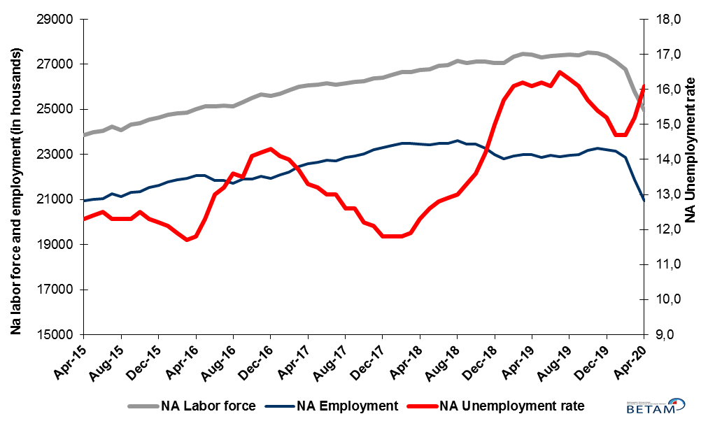
Source: Turkstat, Betam

Figure 2. Seasonally adjusted LFPR, employment rate and non-agricultural unemployment rate
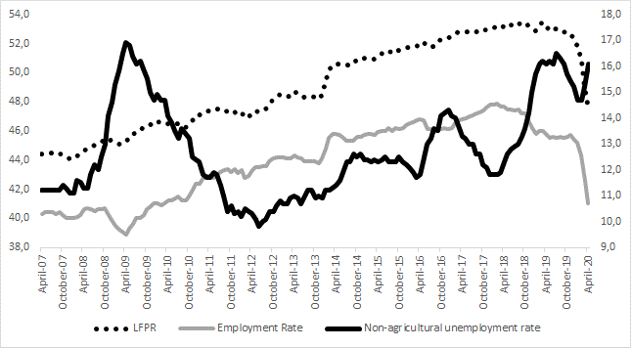
Source: Turkstat, Betam

Significant increase in the number of discouraged workers

The level of labor force, by definition, is the summation of the level of employed people and the level of job seekers (unemployed). The unusual developments in the labor market, cause loss of confidence among individuals who desire to work but they are not actively seeking a job as they think that they could not find any one. Those individuals that quit seeking for jobs and labor force due to loss of confidence are referred as ‘Discouraged workers’ by TurkStat. As can be seen from Figure 3 that features discouraged workers, the number of discouraged workers nearly doubles from the period of January 2019 and exceeded 1 million 300 thousand within a year.

Figure 3. The number of unemployed people, discouraged workers and summation of both, SA
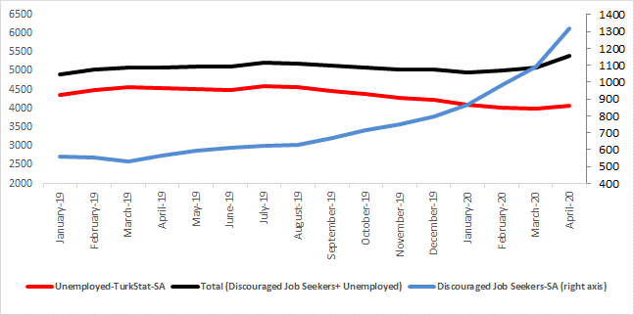
Source: Turkstat, Betam

Warning regarding the forecast of unemployment rate

In order to restrict the adverse impact of the corona pandemic on employment, instead of short-time working allowance and layoff measures, furloughs considerably invalidate the relationship between the economic activity level and employment. Additionally, the relatively high correlation between the employment losses and the number of unemployed also lost its function. We believe that these developments significantly increased the standard error interval of the Betam unemployment forecast model. As in the case of previous research brief, we prefer not to publish our May 2020 forecast in our Labor Market Outlook report for the period of April 2020. However, we would like to share with our readers that Betam’s forecasting model predicted that non-agricultural unemployment rate would remain unchanged at 16.2 percent in May 2020.

Sharp decreases in services sector

According to seasonally adjusted sectorial labor market data, in the period of April 2020 compared to March 2020, employment losses occurred in all sectors (Figure 4, Table 2). In the period of April 2020, while employment decreases in manufacturing sector accelerated, employment decreases in construction sector decelerated. Manufacturing employment decreased by 164 thousand in the period of April 2020 after the decrease of 85 thousand in the previous period. Employment in construction sector decreased further by 123 thousand in April after a decrease of 202 thousand in March. Agricultural employment decreased by 34 thousand. Following the decrease of 694 thousand in March 2020, the number of employed in services sector decreased strongly again by 647 thousand in April 2020. Since February 2020, employment in services decreased by 1 million 341 thousand (8.5% of services employment in February 2020). As expected, the services sector is the most affected by the measures taken against the spread of the Coronavirus pandemic.
.
Figure 4: Employment by sectors (in thousand)
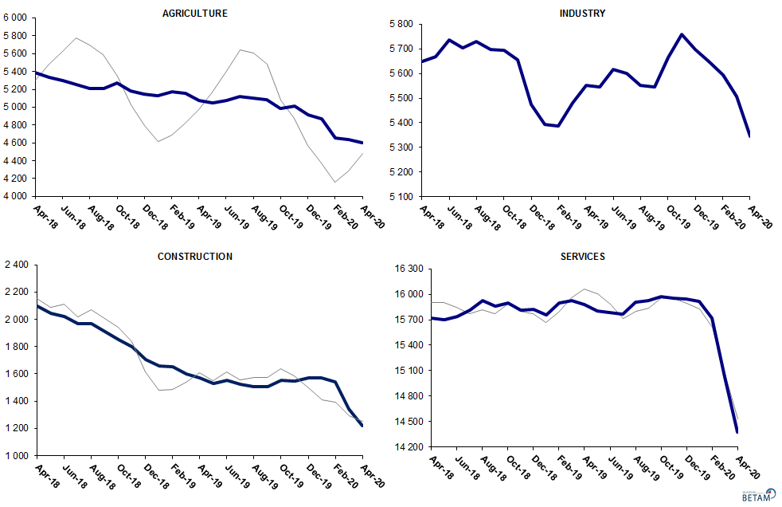
Source: TURKSTAT, Betam

Yearly strong decreases in non-agricultural labor force participation and employment

Compared to April 2019, non-agricultural employment decreased by 2 million 94 thousand in April 2020. Compared to the same period of the previous year, instead of increasing the number of non-agricultural unemployed decreased by 399 thousand. We think that a significant part of this big difference resulted from the increase in the number of discouraged workers. As a result, the number of non-agricultural labor force decreased by 2 million 493 thousand (9.7 percentage point) in April 2020 (Figure 5).

Figure 5 Year-on-year changes in non-agricultural labor force, employment, and unemployment
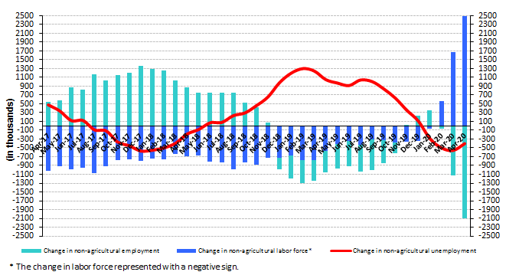
Source: TURKSTAT, Betam

Significant decreases in male employment

Figure 6 shows seasonally adjusted non-agricultural unemployment rate for males (green) and for females (purple). In the period of April 2020 compared to the previous period, female non-agricultural unemployment rate remained unchanged at 17.8 percent. However, this resulted from a decrease of 353 thousand in the female labor force and a decrease of 289 thousand in employment. Male unemployment rate spiked significantly by 1.2 percent, and reached 15.1 percent. Increase in male unemployment resulted from significant decreases in employment (643 thousand) and lower decreases in labor force (499 thousand). As a result, the gender gap in non-agricultural unemployment rates decreased from 3.9 percent to 2.7 percent points.

Figure 6: Seasonally adjusted non-agricultural unemployment rate by gender
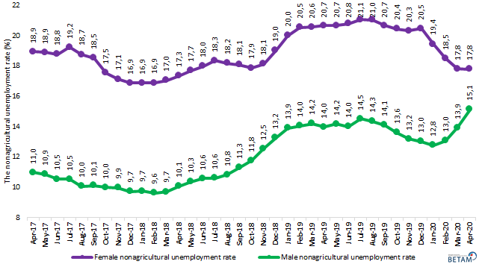
Source: Turkstat, Betam

Table 1 Seasonally adjusted non-agricultural labor market indicators (in thousands) **
 | Labor force | Employment | Unemployment | Unemployment rate | Monthly changes
April-17 | 26065 | 22598 | 3467 | 13,3% | Labor force | Employment | Unemployment
May-17 | 26091 | 22647 | 3444 | 13,2% | 26 | 49 | -23
June-17 | 26145 | 22746 | 3399 | 13,0% | 54 | 99 | -45
July-17 | 26103 | 22710 | 3393 | 13,0% | -41 | -36 | -5
August-17 | 26172 | 22874 | 3298 | 12,6% | 68 | 164 | -96
September-17 | 26237 | 22931 | 3306 | 12,6% | 65 | 57 | 8
October-17 | 26240 | 23039 | 3201 | 12,2% | 3 | 108 | -105
November-17 | 26390 | 23197 | 3193 | 12,1% | 150 | 158 | -8
December-17 | 26412 | 23295 | 3117 | 11,8% | 21 | 98 | -77
January-18 | 26517 | 23388 | 3129 | 11,8% | 105 | 93 | 12
February-18 | 26647 | 23503 | 3144 | 11,8% | 130 | 115 | 15
March-18 | 26658 | 23486 | 3172 | 11,9% | 11 | -17 | 28
April-18 | 26757 | 23466 | 3291 | 12,3% | 99 | -20 | 119
May-18 | 26788 | 23413 | 3375 | 12,6% | 31 | -53 | 84
June-18 | 26947 | 23498 | 3449 | 12,8% | 159 | 85 | 74
July-18 | 26963 | 23485 | 3478 | 12,9% | 16 | -13 | 29
August-18 | 27159 | 23628 | 3531 | 13,0% | 195 | 143 | 52
September-18 | 27074 | 23473 | 3601 | 13,3% | -85 | -155 | 70
October-18 | 27137 | 23446 | 3691 | 13,6% | 63 | -27 | 90
November-18 | 27114 | 23264 | 3850 | 14,2% | -22 | -182 | 160
December-18 | 27064 | 23004 | 4060 | 15,0% | -51 | -260 | 209
January-19 | 27049 | 22802 | 4247 | 15,7% | -15 | -202 | 187
February-19 | 27340 | 22938 | 4402 | 16,1% | 291 | 136 | 155
March-19 | 27452 | 23005 | 4447 | 16,2% | 113 | 67 | 46
April-19 | 27422 | 23007 | 4415 | 16,1% | -30 | 2 | -32
May-19 | 27301 | 22878 | 4423 | 16,2% | -121 | -129 | 8
June-19 | 27364 | 22958 | 4406 | 16,1% | 63 | 80 | -17
July-19 | 27413 | 22890 | 4523 | 16,5% | 50 | -68 | 118
August-19 | 27434 | 22962 | 4472 | 16,3% | 21 | 72 | -51
September-19 | 27390 | 22980 | 4410 | 16,1% | -44 | 18 | -62
October-19 | 27512 | 23193 | 4319 | 15,7% | 123 | 213 | -90
November-19 | 27496 | 23262 | 4234 | 15,4% | -16 | 69 | -85
December-19 | 27371 | 23211 | 4160 | 15,2% | -125 | -51 | -74
January-20 | 27121 | 23134 | 3987 | 14,7% | -251 | -77 | -174
February-20 | 26795 | 22856 | 3939 | 14,7% | -326 | -278 | -48
March-20 | 25796 | 21875 | 3921 | 15,2% | -999 | -981 | -18
April-20 | 24959 | 20941 | 4018 | 16,1% | -837 | -934 | 97

Source: Turkstat, Betam

Table 2 seasonally adjusted employment by sectors (in thousands) *
 | Agriculture | Manufacturing | Construction | Service | Monthly changes
April-17 | 5375 | 5372 | 2123 | 15103 | Agriculture | Manufacturing | Construction | Service
May-17 | 5405 | 5386 | 2086 | 15175 | 30 | 14 | -37 | 72
June-17 | 5414 | 5383 | 2080 | 15283 | 9 | -3 | -6 | 108
July-17 | 5509 | 5363 | 2121 | 15225 | 95 | -20 | 41 | -58
August-17 | 5472 | 5437 | 2169 | 15269 | -37 | 74 | 48 | 44
September-17 | 5491 | 5421 | 2121 | 15389 | 19 | -16 | -48 | 120
October-17 | 5471 | 5470 | 2090 | 15480 | -20 | 49 | -31 | 91
November-17 | 5481 | 5470 | 2128 | 15599 | 10 | 0 | 38 | 119
December-17 | 5534 | 5514 | 2176 | 15605 | 53 | 44 | 48 | 6
January-18 | 5477 | 5567 | 2199 | 15622 | -57 | 53 | 23 | 17
February-18 | 5446 | 5627 | 2190 | 15686 | -31 | 60 | -9 | 64
March-18 | 5383 | 5618 | 2151 | 15717 | -63 | -9 | -39 | 31
April-18 | 5384 | 5650 | 2095 | 15721 | 1 | 32 | -56 | 4
May-18 | 5333 | 5669 | 2045 | 15700 | -51 | 19 | -50 | -21
June-18 | 5296 | 5737 | 2023 | 15738 | -37 | 68 | -22 | 38
July-18 | 5258 | 5703 | 1970 | 15812 | -38 | -34 | -53 | 74
August-18 | 5212 | 5730 | 1971 | 15928 | -46 | 27 | 1 | 116
September-18 | 5212 | 5698 | 1912 | 15864 | 0 | -32 | -59 | -64
October-18 | 5268 | 5696 | 1849 | 15901 | 56 | -2 | -63 | 37
November-18 | 5186 | 5656 | 1798 | 15811 | -82 | -40 | -51 | -90
December-18 | 5151 | 5474 | 1704 | 15825 | -35 | -182 | -94 | 14
January-19 | 5126 | 5392 | 1657 | 15754 | -25 | -82 | -47 | -71
February-19 | 5169 | 5388 | 1652 | 15898 | 43 | -4 | -5 | 144
March-19 | 5158 | 5482 | 1602 | 15922 | -11 | 94 | -50 | 24
April-19 | 5077 | 5553 | 1572 | 15882 | -81 | 71 | -30 | -40
May-19 | 5047 | 5546 | 1528 | 15803 | -30 | -7 | -44 | -79
June-19 | 5072 | 5616 | 1553 | 15789 | 25 | 70 | 25 | -14
July-19 | 5120 | 5600 | 1524 | 15767 | 48 | -16 | -29 | -22
August-19 | 5105 | 5551 | 1506 | 15905 | -15 | -49 | -18 | 138
September-19 | 5087 | 5546 | 1506 | 15928 | -18 | -5 | 0 | 23
October-19 | 4986 | 5666 | 1555 | 15972 | -101 | 120 | 49 | 44
November-19 | 5017 | 5758 | 1546 | 15957 | 31 | 92 | -9 | -15
December-19 | 4914 | 5699 | 1571 | 15942 | -103 | -59 | 25 | -15
January-20 | 4873 | 5649 | 1572 | 15913 | -41 | -50 | 1 | -29
February-20 | 4656 | 5593 | 1544 | 15719 | -217 | -56 | -28 | -194
March-20 | 4634 | 5508 | 1342 | 15025 | -22 | -85 | -202 | -694
April-20 | 4600 | 5344 | 1219 | 14378 | -34 | -164 | -123 | -647

Source: Turkstat, Betam

Table 3: Seasonally adjusted non-agricultural labor force by gender (thousands)
 | Female Labor Force | Female Employment | Female Unemployed | Male Labor Force | Male Employment | Male Unemployed
April-17 | 7625 | 6181 | 1444 | 18440 | 16418 | 2022
May-17 | 7671 | 6222 | 1449 | 18419 | 16420 | 1999
June-17 | 7680 | 6239 | 1442 | 18463 | 16518 | 1945
July-17 | 7681 | 6203 | 1478 | 18469 | 16524 | 1944
August-17 | 7689 | 6247 | 1442 | 18505 | 16645 | 1859
September-17 | 7744 | 6310 | 1434 | 18494 | 16624 | 1870
October-17 | 7764 | 6403 | 1361 | 18473 | 16629 | 1843
November-17 | 7835 | 6493 | 1342 | 18533 | 16689 | 1844
December-17 | 7858 | 6533 | 1325 | 18538 | 16739 | 1799
January-18 | 7941 | 6602 | 1340 | 18593 | 16783 | 1810
February-18 | 7963 | 6619 | 1344 | 18670 | 16875 | 1796
March-18 | 7962 | 6606 | 1356 | 18700 | 16886 | 1814
April-18 | 8005 | 6617 | 1389 | 18739 | 16852 | 1887
May-18 | 8044 | 6622 | 1421 | 18724 | 16787 | 1937
June-18 | 8097 | 6641 | 1456 | 18864 | 16869 | 1994
July-18 | 8105 | 6619 | 1486 | 18886 | 16886 | 2000
August-18 | 8173 | 6688 | 1485 | 19021 | 16965 | 2056
September-18 | 8146 | 6674 | 1472 | 18949 | 16810 | 2139
October-18 | 8227 | 6757 | 1470 | 18902 | 16679 | 2223
November-18 | 8238 | 6744 | 1494 | 18870 | 16503 | 2368
December-18 | 8303 | 6726 | 1578 | 18733 | 16251 | 2482
January-19 | 8379 | 6704 | 1675 | 18684 | 16087 | 2597
February-19 | 8465 | 6727 | 1738 | 18848 | 16201 | 2648
March-19 | 8524 | 6772 | 1753 | 18923 | 16237 | 2686
April-19 | 8475 | 6723 | 1752 | 18938 | 16292 | 2647
May-19 | 8413 | 6675 | 1738 | 18873 | 16200 | 2673
June-19 | 8434 | 6682 | 1752 | 18937 | 16289 | 2649
July-19 | 8426 | 6652 | 1774 | 19019 | 16260 | 2759
August-19 | 8444 | 6669 | 1775 | 19050 | 16319 | 2731
September-19 | 8384 | 6651 | 1733 | 19018 | 16338 | 2680
October-19 | 8447 | 6720 | 1726 | 19056 | 16463 | 2593
November-19 | 8380 | 6678 | 1702 | 19078 | 16564 | 2514
December-19 | 8357 | 6646 | 1710 | 19018 | 16543 | 2475
January-20 | 8292 | 6680 | 1612 | 18855 | 16449 | 2407
February-20 | 8133 | 6630 | 1504 | 18648 | 16214 | 2433
March-20 | 7768 | 6385 | 1383 | 17996 | 15492 | 2503
April-20 | 7415 | 6096 | 1319 | 17497 | 14849 | 2647

Source: Turkstat, Betam

Table 4: Seasonally adjusted LFPR, employment rate and non-agricultural unemployment rate (%)

 | LFPR | Employment Rate | Non-Agricultural Unemployment  Rate
Apr-17 | 52,8 | 46,8 | 13,3
May-17 | 52,8 | 46,9 | 13,2
Jun-17 | 52,8 | 47,0 | 13,0
Jul-17 | 52,9 | 47,1 | 13,0
Aug-17 | 52,8 | 47,2 | 12,6
Sep-17 | 52,9 | 47,3 | 12,6
Oct-17 | 52,8 | 47,4 | 12,2
Nov-17 | 53,0 | 47,6 | 12,1
Dec-17 | 53,1 | 47,8 | 11,8
Jan-18 | 53,1 | 47,8 | 11,8
Feb-18 | 53,2 | 47,9 | 11,8
Mar-18 | 53,1 | 47,7 | 11,9
Apr-18 | 53,2 | 47,7 | 12,3
May-18 | 53,1 | 47,5 | 12,6
Jun-18 | 53,3 | 47,5 | 12,8
Jul-18 | 53,2 | 47,4 | 12,9
Aug-18 | 53,4 | 47,5 | 13,0
Sep-18 | 53,3 | 47,2 | 13,3
Oct-18 | 53,4 | 47,2 | 13,6
Nov-18 | 53,2 | 46,7 | 14,2
Dec-18 | 53,0 | 46,2 | 15,0
Jan-19 | 52,9 | 45,8 | 15,7
Feb-19 | 53,3 | 46,0 | 16,1
Mar-19 | 53,5 | 46,0 | 16,2
Apr-19 | 53,2 | 45,8 | 16,1
May-19 | 52,9 | 45,5 | 16,2
Jun-19 | 53,0 | 45,6 | 16,1
Jul-19 | 53,0 | 45,5 | 16,5
Aug-19 | 53,0 | 45,6 | 16,3
Sep-19 | 52,8 | 45,5 | 16,1
Oct-19 | 52,7 | 45,6 | 15,7
Nov-19 | 52,7 | 45,7 | 15,4
Dec-19 | 52,3 | 45,4 | 15,2
Jan-20 | 51,8 | 45,2 | 14,7
Feb-20 | 50,8 | 44,3 | 14,7
Mar-20 | 49,0 | 42,6 | 15,2
Apr-20 | 47,5 | 41,0 | 16,1

Source: Turkstat

Table 5: Seasonally adjusted discouraged workers, unemployed and sum of both

 | Discouraged Workers-SA | Unemployed-TurkStat-SA | Total (Discouraged Workers + Unemployed)
Jan-19 | 560 | 4355 | 4915
Feb-19 | 555 | 4487 | 5042
Mar-19 | 532 | 4558 | 5090
Apr-19 | 565 | 4528 | 5093
May-19 | 592 | 4522 | 5114
Jun-19 | 614 | 4501 | 5115
Jul-19 | 622 | 4585 | 5207
Aug-19 | 632 | 4556 | 5188
Sep-19 | 669 | 4473 | 5142
Oct-19 | 716 | 4379 | 5095
Nov-19 | 748 | 4280 | 5028
Dec-19 | 799 | 4233 | 5032
Jan-20 | 865 | 4086 | 4951
Feb-20 | 984 | 4028 | 5012
Mar-20 | 1095 | 4004 | 5099
Apr-20 | 1315 | 4080 | 5395

Source: Turkstat, Betam

*Prof. Dr. Seyfettin Gürsel, Betam, Director, seyfettin.gursel@eas.bau.edu.tr **Mehmet Cem Şahin, Betam, Research Assistant, mehmetcem.sahin@eas.bau.edu.tr
Employment in each sector is seasonally adjusted separately. Hence the sum of these series may differ from the seasonally adjusted series of total employment. The difference stems from the non-linearity of the seasonal adjustment process.
Turkstat revised the labor market statistics drastically in February 2014. Within this framework, they back casted various labor market indicators and they also continued to announce seasonally adjusted series. However, Turkstat is not providing back-casted series by gender. Therefore, female and male labor market statistics are not sufficiently long for the seasonal adjustment procedures (There should be minimum 36 observations). With the announcement of the period of February 2017 data, the number of observations required for the seasonal decontamination process was provided. From this period Betam generated seasonal adjustment series in terms of gender. Nevertheless, it should not be forgotten that seasonal adjustment may cause extra volatility in the series for at least a while.

