Labor Market Outlook:
June 2020

18 June 2020

IMPACT OF CORONAVIRUS PANDEMIC SHOCK ON LABOR MARKET:
INCREASES IN UNEMPLOYMENT
ALONG WITH DROP IN EMPLOYMENT AND LABOR FORCE

Seyfettin Gürsel*, Hamza Mutluay **

Executive Summary

Seasonally adjusted labor market data shows that in the period of March 2020, non-agricultural unemployment rate turned out to be 15.1 percent, with 0.5 percentage point increases compared to February 2020. In this period, non-agricultural employment decreased by 982 thousand while non-agricultural labor force decreased by 999 thousand. According to sectorial data, employment losses occurred in all sectors. The most significant decreases in employment occurred in services (by 694 thousand). While agriculture employment decreased by 21 thousand, manufacturing employment decreased by 85 thousand and construction employment decreased by 202 thousand. Based on the seasonally adjusted data, while female non-agricultural employment decreased by 245 thousand, non-agricultural labor force decreased by 361 thousand. As the decrease in female labor force was higher than that in employment, female non-agricultural unemployment rate decreased by 0.6 percentage points to 17.9 percent. Male labor force and employment decreased by 657 thousand and 722 thousand respectively. Since the decline in male employment was higher than the labor force, male non-agricultural unemployment rate increased by 0.8 percentage points to 13.7 percent.

Decreases in all non-agricultural labor market indicators

Seasonally adjusted data shows that, non-agricultural labor force reached 25 million 766 thousand after the decrease of 999 thousand in March 2020 period (February-March-April) compared to February 2020 period (January-February-March). Year-over-year decrease in labor force occurred for the first time. As a result of this striking decline in employment and labor force, the number of non-agricultural unemployed decreased by 17 thousand to 3 million 891 thousand, and the non-agricultural unemployment rate rose to 15.1 percent.

To better capture the extraordinary decrease in non-agricultural labor force, we added a new figure that features seasonally adjusted LFPR, employment rate and non-agricultural unemployment rate into our Labor Market Outlook reports. Decreases in both the labor force and the employment rate continued in March as well. While non-institutional population over 15-year-old keeps increasing, LFPR decreased by 4.4 percent in March 2020 compared to the same month of the previous year and reached 49.0 percent. Employment rate decreased by 3.4 percent point in February 2020 compared to the same month of the previous year and reached 46.6 percent.

Figure 1. Seasonally adjusted non-agricultural labor force, employment, and unemployment
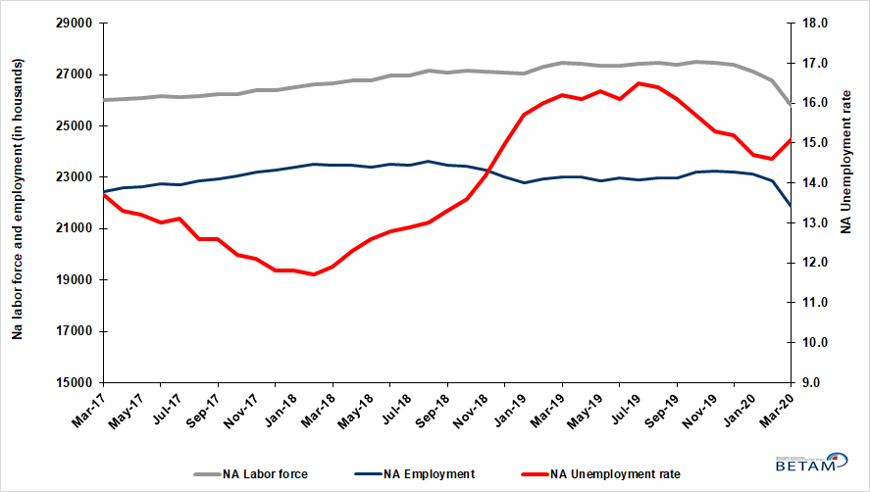
Source: Turkstat, Betam

Figure 2. Seasonally adjusted LFPR, employment rate and non-agricultural unemployment rate
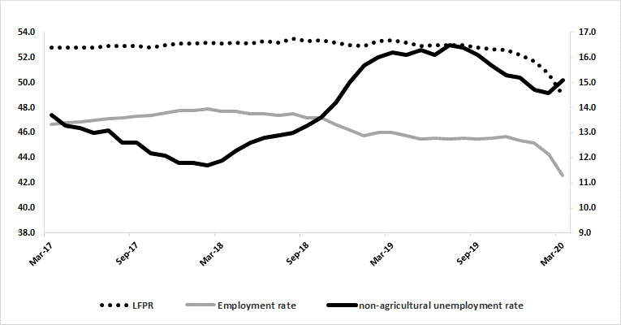
Source: Turkstat, Betam

Significant increase in discouraged workers

The level of labor force, by definition, is the summation of the level of employed people and the level of job seekers (unemployed). The unusual developments in the labor market, cause loss of confidence among individuals who desire to work but they are not actively seeking a job as they think that they could not find any job. Those individuals that quit seeking for jobs and labor force due to loss of confidence are referred as ‘Discouraged workers’ by TurkStat. As can be seen from another new Figure 3 that features discouraged workers, unemployed people and summation of both, the number of discouraged workers nearly doubles from the period of January 2019 and reached 1 million 100 thousand within a year.

Figure 3. The number of unemployed people, discouraged workers and summation of both, SA
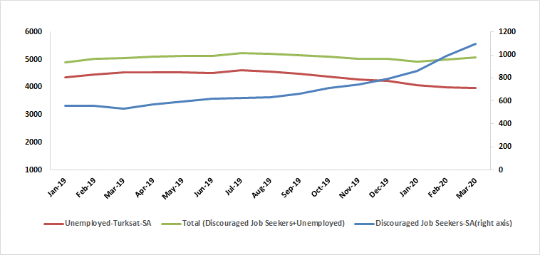
Source: Turkstat, Betam

Warning regarding the forecast of unemployment rate

In order to restrict the adverse impact of the corona pandemic on employment, instead of short-time working allowance and layoff measures, furloughs considerably invalidate the relationship between the economic activity level and employment. Additionally, the relatively high correlation between the employment losses and the number of unemployed also lost its function. We believe that these developments significantly increased the standard error interval of the Betam unemployment forecast model. As in the case of previous research brief, we prefer not to publish our April 2020 forecast in our Labor Market Outlook report for the period of March 2020. However, we would like to share with our readers that Betam’s forecasting model predicted that non-agricultural unemployment rate would remain unchanged at 15.1 percent in April 2020.

Sharp decreases in services sector

According to seasonally adjusted sectorial labor market data, in the period of March 2020 compared to February 2020, employment losses occurred in all sectors (Figure 4, Table 2). After the decrease of 218 thousand in February 2020, employment in agriculture sector decreased by 21 thousand. Following the decrease of 194 thousand in February 2020, the number of employed in services sector decreased dramatically (694 thousand) in March 2020. As expected, the services is the most affected by the measures taken against the spread of the Coronavirus pandemic. Employment in manufacturing and construction sectors decreased by 85 and 202 thousand respectively in the period of March 2020.
.
Figure 4: Employment by sectors (in thousand)
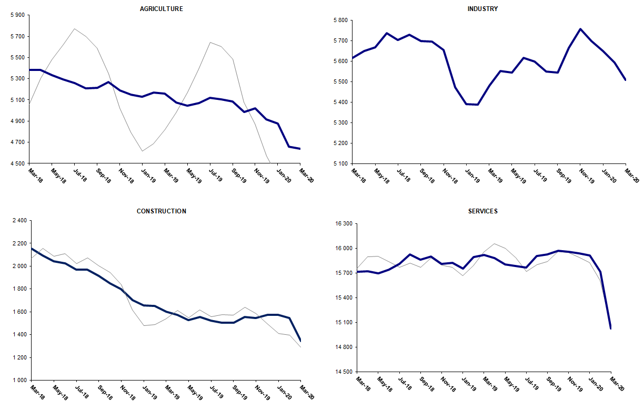
Source: TURKSTAT, Betam

Yearly strong decreases in non-agricultural labor force participation and employment

Compared to March 2019, non-agricultural employment decreased by 1 million 124 thousand in March 2020. Compared to the same period of the previous year, the decrease in the number of non-agricultural unemployed was limited to 553 thousand. We think that a significant part of this big difference resulted from the increase in the number of discouraged workers. As a result, the number of non-agricultural labor force decreased by 1 million 677 thousand (1 million + 533 thousand) in March 2020 (Figure 5).

Figure 5 Year-on-year changes in non-agricultural labor force, employment, and unemployment
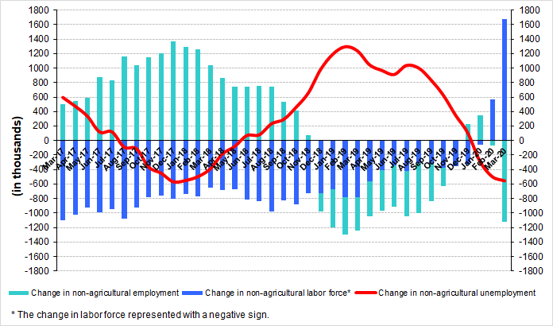
Source: TURKSTAT, Betam

Decrease in male employment along with increase in male unemployment rate

Figure 6 shows seasonally adjusted non-agricultural unemployment rate for males (green) and for females (purple). In the period of March 2020 compared to the previous period, female non-agricultural unemployment rate decreased by 0.6 percentage point to 17.9 percent. This significant decrease in female unemployment rate resulted from the decrease (361 thousand) in the female labor force while the decrease in employment has been limited to 245 thousand. Male unemployment rate turned out to be 13.7 with 0.8 percentage point increase. Even though male employment decreased by 722 thousand, male labor force decreased by 657 thousand. As a result, the gender gap in non-agricultural unemployment rates decreased from 5.6 percent to 4.1 percent points.

Figure 6: Seasonally adjusted non-agricultural unemployment rate by gender
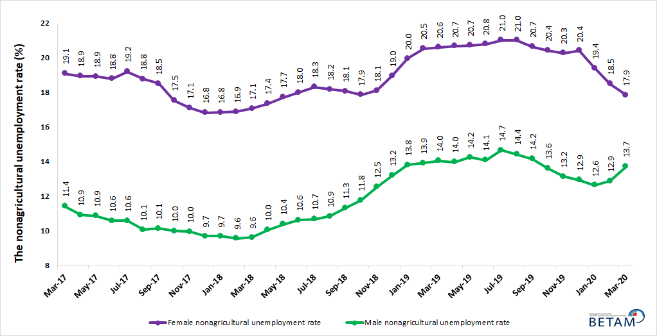
Source: Turkstat, Betam

Table 1 Seasonally adjusted non-agricultural labor market indicators (in thousands) **
 | Labor force | Employment | Unemployment | Unemployment rate | Monthly changes
Mar-17 | 26015 | 22451 | 3564 | 13.7% | Labor force | Employment | Unemployment
Apr-17 | 26065 | 22598 | 3467 | 13.3% | 50 | 147 | -97
May-17 | 26091 | 22647 | 3444 | 13.2% | 26 | 49 | -23
Jun-17 | 26145 | 22746 | 3399 | 13.0% | 54 | 99 | -45
Jul-17 | 26132 | 22709 | 3423 | 13.1% | -12 | -37 | 25
Aug-17 | 26173 | 22875 | 3298 | 12.6% | 40 | 166 | -126
Sep-17 | 26237 | 22931 | 3306 | 12.6% | 64 | 56 | 8
Oct-17 | 26241 | 23040 | 3201 | 12.2% | 5 | 109 | -104
Nov-17 | 26390 | 23197 | 3193 | 12.1% | 149 | 157 | -8
Dec-17 | 26410 | 23294 | 3116 | 11.8% | 20 | 97 | -77
Jan-18 | 26517 | 23388 | 3129 | 11.8% | 107 | 94 | 13
Feb-18 | 26617 | 23503 | 3114 | 11.7% | 100 | 115 | -15
Mar-18 | 26658 | 23486 | 3172 | 11.9% | 41 | -17 | 58
Apr-18 | 26757 | 23466 | 3291 | 12.3% | 99 | -20 | 119
May-18 | 26789 | 23414 | 3375 | 12.6% | 32 | -52 | 84
Jun-18 | 26948 | 23499 | 3449 | 12.8% | 159 | 85 | 74
Jul-18 | 26963 | 23485 | 3478 | 12.9% | 15 | -14 | 29
Aug-18 | 27160 | 23629 | 3531 | 13.0% | 197 | 144 | 53
Sep-18 | 27074 | 23473 | 3601 | 13.3% | -86 | -156 | 70
Oct-18 | 27137 | 23446 | 3691 | 13.6% | 63 | -27 | 90
Nov-18 | 27114 | 23264 | 3850 | 14.2% | -22 | -182 | 160
Dec-18 | 27064 | 23004 | 4060 | 15.0% | -51 | -260 | 209
Jan-19 | 27049 | 22802 | 4247 | 15.7% | -15 | -202 | 187
Feb-19 | 27308 | 22939 | 4369 | 16.0% | 260 | 137 | 123
Mar-19 | 27452 | 23005 | 4447 | 16.2% | 144 | 66 | 78
Apr-19 | 27422 | 23007 | 4415 | 16.1% | -30 | 2 | -32
May-19 | 27333 | 22878 | 4455 | 16.3% | -89 | -129 | 40
Jun-19 | 27364 | 22958 | 4406 | 16.1% | 30 | 80 | -50
Jul-19 | 27414 | 22891 | 4523 | 16.5% | 51 | -67 | 118
Aug-19 | 27467 | 22962 | 4505 | 16.4% | 52 | 71 | -19
Sep-19 | 27390 | 22980 | 4410 | 16.1% | -77 | 18 | -95
Oct-19 | 27511 | 23192 | 4319 | 15.7% | 122 | 212 | -90
Nov-19 | 27463 | 23261 | 4202 | 15.3% | -48 | 69 | -117
Dec-19 | 27371 | 23211 | 4160 | 15.2% | -91 | -50 | -41
Jan-20 | 27121 | 23134 | 3987 | 14.7% | -251 | -77 | -174
Feb-20 | 26765 | 22857 | 3908 | 14.6% | -356 | -277 | -79
Mar-20 | 25766 | 21875 | 3891 | 15.1% | -999 | -982 | -17
Source: Turkstat, Betam

Table 2 seasonally adjusted employment by sectors (in thousands) *
 | Agriculture | Manufacturing | Construction | Service | Monthly changes
Mar-17 | 5396 | 5346 | 2089 | 15016 | Agriculture | Manufacturing | Construction | Service
Apr-17 | 5374 | 5372 | 2123 | 15103 | -22 | 26 | 34 | 87
May-17 | 5404 | 5386 | 2086 | 15175 | 30 | 14 | -37 | 72
Jun-17 | 5413 | 5383 | 2080 | 15283 | 9 | -3 | -6 | 108
Jul-17 | 5509 | 5363 | 2121 | 15225 | 96 | -20 | 41 | -58
Aug-17 | 5471 | 5437 | 2169 | 15269 | -38 | 74 | 48 | 44
Sep-17 | 5491 | 5421 | 2121 | 15389 | 20 | -16 | -48 | 120
Oct-17 | 5471 | 5470 | 2090 | 15480 | -20 | 49 | -31 | 91
Nov-17 | 5481 | 5470 | 2128 | 15599 | 10 | 0 | 38 | 119
Dec-17 | 5535 | 5514 | 2176 | 15605 | 54 | 44 | 48 | 6
Jan-18 | 5478 | 5567 | 2199 | 15622 | -57 | 53 | 23 | 17
Feb-18 | 5447 | 5627 | 2190 | 15686 | -31 | 60 | -9 | 64
Mar-18 | 5385 | 5618 | 2151 | 15717 | -62 | -9 | -39 | 31
Apr-18 | 5382 | 5650 | 2095 | 15721 | -3 | 32 | -56 | 4
May-18 | 5331 | 5669 | 2045 | 15700 | -51 | 19 | -50 | -21
Jun-18 | 5294 | 5737 | 2023 | 15739 | -37 | 68 | -22 | 39
Jul-18 | 5257 | 5703 | 1970 | 15812 | -37 | -34 | -53 | 73
Aug-18 | 5211 | 5730 | 1971 | 15928 | -46 | 27 | 1 | 116
Sep-18 | 5212 | 5698 | 1912 | 15864 | 1 | -32 | -59 | -64
Oct-18 | 5268 | 5696 | 1849 | 15901 | 56 | -2 | -63 | 37
Nov-18 | 5187 | 5656 | 1798 | 15810 | -81 | -40 | -51 | -91
Dec-18 | 5152 | 5474 | 1704 | 15825 | -35 | -182 | -94 | 15
Jan-19 | 5128 | 5392 | 1657 | 15754 | -24 | -82 | -47 | -71
Feb-19 | 5170 | 5388 | 1652 | 15898 | 42 | -4 | -5 | 144
Mar-19 | 5160 | 5482 | 1602 | 15922 | -10 | 94 | -50 | 24
Apr-19 | 5074 | 5553 | 1572 | 15882 | -86 | 71 | -30 | -40
May-19 | 5044 | 5546 | 1528 | 15804 | -30 | -7 | -44 | -78
Jun-19 | 5070 | 5616 | 1553 | 15789 | 26 | 70 | 25 | -15
Jul-19 | 5119 | 5600 | 1524 | 15767 | 49 | -16 | -29 | -22
Aug-19 | 5104 | 5551 | 1506 | 15905 | -15 | -49 | -18 | 138
Sep-19 | 5087 | 5546 | 1506 | 15928 | -17 | -5 | 0 | 23
Oct-19 | 4987 | 5666 | 1555 | 15972 | -100 | 120 | 49 | 44
Nov-19 | 5019 | 5758 | 1546 | 15957 | 32 | 92 | -9 | -15
Dec-19 | 4916 | 5699 | 1571 | 15942 | -103 | -59 | 25 | -15
Jan-20 | 4876 | 5649 | 1572 | 15913 | -40 | -50 | 1 | -29
Feb-20 | 4658 | 5593 | 1544 | 15719 | -218 | -56 | -28 | -194
Mar-20 | 4637 | 5508 | 1342 | 15025 | -21 | -85 | -202 | -694
Source: Turkstat, Betam

Table 3: Seasonally adjusted non-agricultural labor force by gender (thousands)
 | Female Labor Force | Female Employment | Female Unemployed | Male Labor Force | Male Employment | Male Unemployed
Mar-17 | 7635 | 6177 | 1458 | 18369 | 16272 | 2098
Apr-17 | 7628 | 6183 | 1445 | 18424 | 16412 | 2012
May-17 | 7673 | 6220 | 1453 | 18421 | 16418 | 2002
Jun-17 | 7681 | 6238 | 1443 | 18469 | 16515 | 1955
Jul-17 | 7676 | 6201 | 1475 | 18480 | 16523 | 1956
Aug-17 | 7670 | 6230 | 1441 | 18511 | 16647 | 1864
Sep-17 | 7742 | 6309 | 1433 | 18504 | 16627 | 1876
Oct-17 | 7764 | 6403 | 1361 | 18480 | 16634 | 1846
Nov-17 | 7831 | 6491 | 1340 | 18537 | 16692 | 1845
Dec-17 | 7864 | 6540 | 1324 | 18539 | 16742 | 1797
Jan-18 | 7951 | 6612 | 1339 | 18599 | 16794 | 1805
Feb-18 | 7965 | 6619 | 1345 | 18652 | 16868 | 1784
Mar-18 | 7965 | 6606 | 1359 | 18674 | 16878 | 1796
Apr-18 | 8006 | 6617 | 1389 | 18728 | 16847 | 1882
May-18 | 8043 | 6618 | 1425 | 18730 | 16785 | 1945
Jun-18 | 8093 | 6636 | 1457 | 18873 | 16867 | 2006
Jul-18 | 8098 | 6615 | 1483 | 18903 | 16885 | 2018
Aug-18 | 8163 | 6679 | 1484 | 19030 | 16965 | 2065
Sep-18 | 8145 | 6674 | 1471 | 18961 | 16813 | 2148
Oct-18 | 8228 | 6759 | 1470 | 18907 | 16683 | 2224
Nov-18 | 8237 | 6745 | 1492 | 18872 | 16506 | 2366
Dec-18 | 8309 | 6733 | 1576 | 18728 | 16255 | 2473
Jan-19 | 8388 | 6714 | 1674 | 18678 | 16098 | 2580
Feb-19 | 8466 | 6728 | 1739 | 18813 | 16193 | 2620
Mar-19 | 8531 | 6773 | 1758 | 18880 | 16228 | 2652
Apr-19 | 8478 | 6725 | 1753 | 18930 | 16285 | 2645
May-19 | 8412 | 6669 | 1743 | 18890 | 16199 | 2691
Jun-19 | 8430 | 6676 | 1753 | 18957 | 16287 | 2670
Jul-19 | 8418 | 6648 | 1770 | 19055 | 16260 | 2795
Aug-19 | 8437 | 6664 | 1773 | 19072 | 16320 | 2751
Sep-19 | 8383 | 6652 | 1731 | 19039 | 16341 | 2698
Oct-19 | 8449 | 6723 | 1726 | 19063 | 16468 | 2595
Nov-19 | 8379 | 6679 | 1700 | 19076 | 16567 | 2509
Dec-19 | 8360 | 6653 | 1707 | 19008 | 16548 | 2460
Jan-20 | 8299 | 6688 | 1611 | 18841 | 16460 | 2380
Feb-20 | 8134 | 6629 | 1505 | 18603 | 16207 | 2397
Mar-20 | 7773 | 6385 | 1388 | 17946 | 15484 | 2462
Source: Turkstat, Betam

Table 4: Seasonally adjusted LFPR, employment rate and non-agricultural unemployment rate (%)

 | LFPR | Employment rate | non-agricultural unemployment rate
Mar-17 | 52.8 | 46.7 | 13.7
Apr-17 | 52.8 | 46.8 | 13.3
May-17 | 52.8 | 46.9 | 13.2
Jun-17 | 52.8 | 47.0 | 13.0
Jul-17 | 52.9 | 47.1 | 13.1
Aug-17 | 52.9 | 47.2 | 12.6
Sep-17 | 52.9 | 47.3 | 12.6
Oct-17 | 52.8 | 47.4 | 12.2
Nov-17 | 53.0 | 47.6 | 12.1
Dec-17 | 53.1 | 47.8 | 11.8
Jan-18 | 53.1 | 47.8 | 11.8
Feb-18 | 53.2 | 47.9 | 11.7
Mar-18 | 53.1 | 47.7 | 11.9
Apr-18 | 53.2 | 47.7 | 12.3
May-18 | 53.1 | 47.5 | 12.6
Jun-18 | 53.3 | 47.5 | 12.8
Jul-18 | 53.2 | 47.4 | 12.9
Aug-18 | 53.5 | 47.5 | 13.0
Sep-18 | 53.3 | 47.2 | 13.3
Oct-18 | 53.4 | 47.2 | 13.6
Nov-18 | 53.2 | 46.7 | 14.2
Dec-18 | 53.0 | 46.2 | 15.0
Jan-19 | 52.9 | 45.8 | 15.7
Feb-19 | 53.3 | 46.0 | 16.0
Mar-19 | 53.4 | 46.0 | 16.2
Apr-19 | 53.2 | 45.8 | 16.1
May-19 | 52.9 | 45.5 | 16.3
Jun-19 | 53.0 | 45.6 | 16.1
Jul-19 | 53.0 | 45.5 | 16.5
Aug-19 | 53.0 | 45.6 | 16.4
Sep-19 | 52.8 | 45.5 | 16.1
Oct-19 | 52.7 | 45.6 | 15.7
Nov-19 | 52.6 | 45.7 | 15.3
Dec-19 | 52.2 | 45.4 | 15.2
Jan-20 | 51.7 | 45.2 | 14.7
Feb-20 | 50.7 | 44.3 | 14.6
Mar-20 | 49.0 | 42.6 | 15.1

Source: Turkstat

Table 5: Seasonally adjusted discouraged workers, unemployed and sum of both

 | Discouraged Workers-SA | Unemployed-TurkStat-SA | Total (Discouraged Workers + Unemployed)
Jan-19 | 559 | 4343 | 4902
Feb-19 | 557 | 4469 | 5026
Mar-19 | 532 | 4533 | 5065
Apr-19 | 569 | 4530 | 5099
May-19 | 596 | 4532 | 5128
Jun-19 | 617 | 4517 | 5134
Jul-19 | 623 | 4602 | 5225
Aug-19 | 629 | 4571 | 5200
Sep-19 | 665 | 4484 | 5149
Oct-19 | 711 | 4383 | 5094
Nov-19 | 743 | 4278 | 5021
Dec-19 | 795 | 4223 | 5018
Jan-20 | 861 | 4069 | 4930
Feb-20 | 988 | 4005 | 4993
Mar-20 | 1095 | 3972 | 5067

Source: Turkstat, Betam

*Prof. Dr. Seyfettin Gürsel, Betam, Director, seyfettin.gursel@eas.bau.edu.tr **Hamza Mutluay, Betam, Research Assistant, hamza.mutluay@eas.bau.edu.tr
Employment in each sector is seasonally adjusted separately. Hence the sum of these series may differ from the seasonally adjusted series of total employment. The difference stems from the non-linearity of the seasonal adjustment process.
Turkstat revised the labor market statistics drastically in February 2014. Within this framework, they back casted various labor market indicators and they also continued to announce seasonally adjusted series. However, Turkstat is not providing back-casted series by gender. Therefore, female and male labor market statistics are not sufficiently long for the seasonal adjustment procedures (There should be minimum 36 observations). With the announcement of the period of February 2017 data, the number of observations required for the seasonal decontamination process was provided. From this period Betam generated seasonal adjustment series in terms of gender. Nevertheless, it should not be forgotten that seasonal adjustment may cause extra volatility in the series for at least a while.

