

# **Research Brief 20/251**

**14 May 2020**

**Total Factor Productivity in Agriculture, Manufacturing, Construction and Services: 1980-2018[1]#**

**Ozan Bakış[2]*, Uğurcan Acar[3]** ve Gökhan Dilek[4]\*\***

**Executive Summary**

In this research brief, we examine Total Factor Productivity (TFP) dynamics in Turkish economy for the four main sectors (agriculture, industry, construction and services). In the years between 1980 and 2018, all sectors record TFP increases except services. The cumulative increase in TFP is the highest in the industry sector with 123.2% growth rate followed by the agriculture with 58.3% in this 38-year period. TFP growth in construction slightly falls behind the agriculture with a figure of 56.4 percent while in services, TFP decreases by 41.3 percent.

According to broad periodization we reach the following conclusions:

* There are TFP increases in agriculture except in 80s. In the 1990-2002 and 2003-2013 periods, TFP increases at 1.5% rate on annual average while in the 2014-2018 period, TFP increases 3.1% annually.
* In the 1981-1989 period, TFP in industry rises at a considerably high rate by 4.5% annual average. TFP increases at 4.6% on annual average in the 2011-2013 subperiod. TFP in industry sector increases in all the periods except the years of Global Financial Crisis, yet the growth rate of TFP is weak in the 90s. An interesting point is that the growth rate of TFP in industry in the years between 2014 and 2018 converges to the growth rates in the 90s.
* In construction, TFP increases 3.2% on annual average while the 1990-2002 period witnesses 1.9% contraction. In the 2003-2013 period TFP grows by 4.8%. The 2014-2018 period records 2.5% decrease in construction TFP.
* TFP in services declines in every period.

**Introduction**

This document is the second research brief based on the Betam TFP Working Paper. In the first research brief, we examine the growth, employment and productivity dynamics of the Turkish economy at the aggregate level by periodizing the years between 1980 and 2018 into four broad categories[5]. In this second research brief, the growth, employment and productivity dynamics are presented for agriculture, industry, construction and services. We analyze these sectors according to the periodization used in the working paper: 1980-1989, 1990-2002, 2003-2013 and 2014-2018.

**Sectoral Growth**

**Figure 1: The Growth Rate of Sectoral Output (%)**

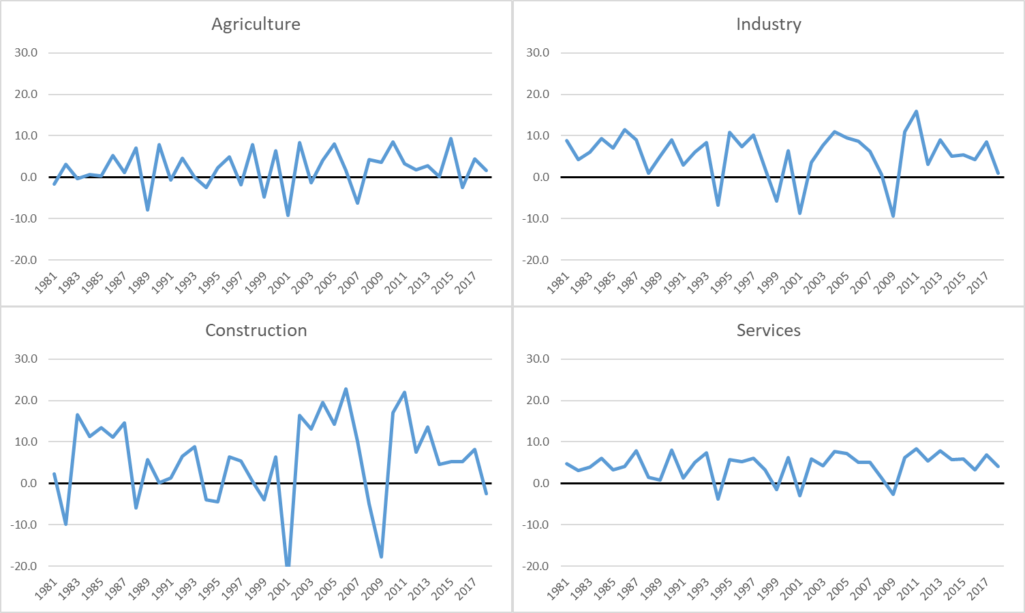

**Source:** Betam

Figure 1 presents annual growth rate of the output in the four main sectors from 1980 to 2018. Agricultural sector shows more volatility among others and contracts 11 times during the entire time span. This volatility is not be surprising when considering the structure of the sector. Although the construction sector does not contract as many times as agriculture does, it has the biggest wavelength and, in this sense, it is the most volatile sector. The construction sector records phenomenal growth rates and then sharp declines. The industry and the services present more stable outlook in these years.

Between 1980 and 2018, the agricultural sector grows at 2.1% annual average rate while the industrial output increases 5.7% and the services sector expanded 4.4% yearly. The construction sector is the most rapidly growing sector with an average growth rate of 6.3%.

There are strong growth rates for the industry and the construction in the 1981-1989 and 2003-2013 periods. All sectors record weak growth rates in the economic stagnation years of 1990-2002 except the agricultural sector. In the 2014-2018 period, the industry and the services become the driving forces of the economy while the construction steps aside.

**Table 1: The Growth Rates of Sectoral Output in the Time Periods (Annual Average %)**

|  |  |  |  |  |
| --- | --- | --- | --- | --- |
|  | Agriculture | Industry | Construction | Services |
| **Growth Rate (%)** |  |  |  |  |
| 1981-1989 | 0.8 | 6.9 | 6.6 | 3.9 |
| 1990-2002 | 1.8 | 3.5 | 1.3 | 3.5 |
| 2003-2013 | 2.7 | 6.7 | 10.7 | 5.0 |
| *2003-2007* | *1.2* | *8.6* | *16.0* | *5.8* |
| *2008-2010* | *5.5* | *0.7* | *-1.9* | *1.6* |
| *2011-2013* | *2.6* | *9.3* | *14.4* | *7.2* |
| 2014-2018 | 2.6 | 4.8 | 4.2 | 5.2 |

**Source:** Betam

**The Course of Employment in the Sectors**

According to sectoral employment series constructed by Betam, employment in all sectors increases for the years between 1980 and 2018 except in the agriculture[6]. In the 1980-2018 period, the highest cumulative increase in employment happens in the services (296%) while in the industry this figure is 152% and in the construction 137%. In the agriculture, the employment decreases by 20% in these years.

**Table 2: Change in Sectoral Employment (Annual Average %)**

|  |  |  |  |  |
| --- | --- | --- | --- | --- |
|  | Agriculture | Industry | Construction | Services |
| **Growth Rate (%)** |  |  |  |  |
| 1981-1989 | 0.4 | 2.4 | 0.5 | 3.7 |
| 1990-2002 | -1.1 | 2.5 | 0.1 | 3.4 |
| 2003-2013 | 0.4 | 2.2 | 6.2 | 3.5 |
| *2003-2007* | *-3.4* | *2.1* | *6.3* | *3.5* |
| *2008-2010* | *5.2* | *1.4* | *5.0* | *2.1* |
| *2011-2013* | *1.9* | *3.2* | *7.3* | *5.0* |
| 2014-2018 | -2.5 | 2.7 | 2.2 | 4.2 |

**Kaynak:** Betam

Agricultural employment contracts in the 1990-2002 and 2014-2018 periods while increases in the other periods. The year 2013 is a cornerstone for the agricultural employment. After 2013, agricultural employment starts to decrease at a fast rate. In Table 2, the increases in the construction employment after 2002 are eye-catching. Employment in the construction contracts by 5% in 2018 due to the economic recession, as a result the 2014-2018 period records only 2.2% annual average increase in the construction employment. The growth rates of employment in the industry and the services are more stable.

The employment shares of the sectors changed over the years with the transition of the Turkish economy. The share of the agricultural employment decreases to 18% in 2018 from 48% in 1980 as urbanization increases. On the contrary, the employment share of the services continually increases from 29% to 55%. The share of the industry has a more stable course and increases from 17% in 1980 to 20% in 2018. The employment share of the construction remains at 6-7% for the entire 1980-2018 period.

**Figure 2: Changes in the Sectoral Employment Shares from 1980 to 2018**

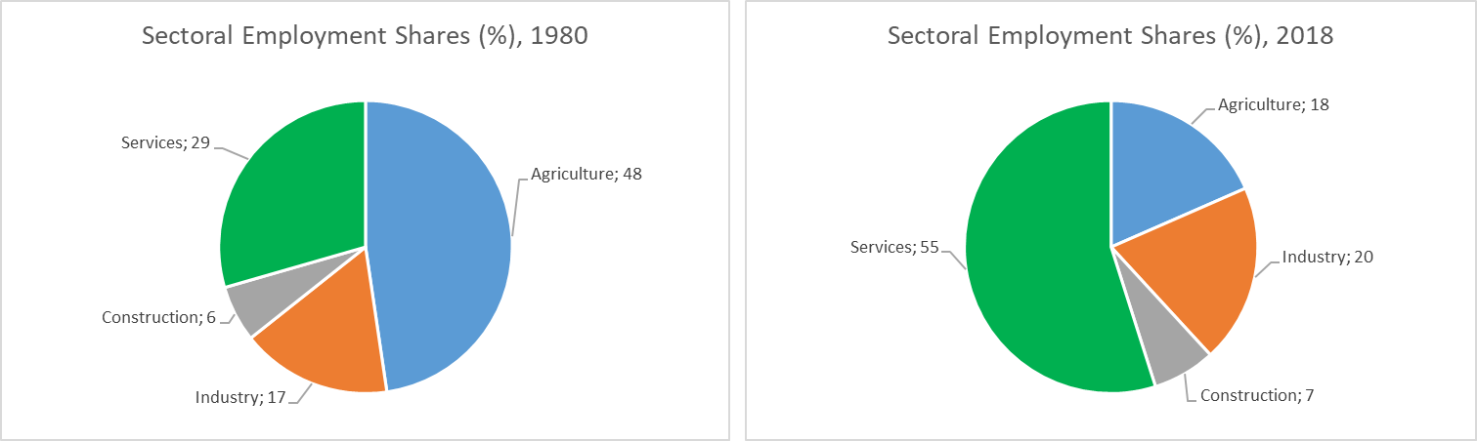

**Source:** Betam

**Sectoral Labor Productivities**

The labor productivities of the sectors are calculated by dividing real sectoral outputs to sectoral employment. Real sectoral output series are constructed by Betam[7]. In Table 3, each sectors’ labor productivity is equalized to 100 and the following years are normalized accordingly.

**Figure 3: The Course of Sectoral Labor Productivity (1980=100)**

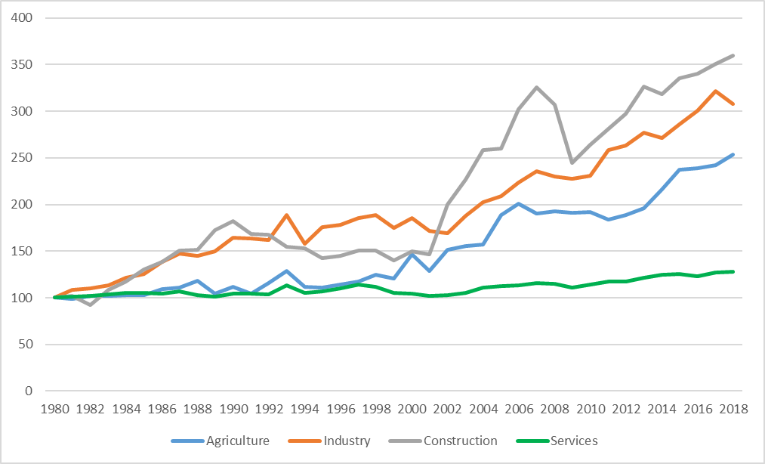

**Source:** Betam

The most rapid increase in labor productivity is recorded in the construction sector with a cumulative rate of 260% growth from 1980 to 2018. In the same period, the labor productivity in the industry grows by 208% and in the agriculture by 154% while in the services, labor productivity increases at a much milder cumulative rate of 28%. The main reason behind the increases in agricultural labor productivity is that the sectoral output remains stable over these years despite the decreases in agricultural employment. In other sectors, outputs increase more than employment gains. However, labor productivity in the services is somewhat stagnated.

**Table 3: Increases in Sectoral Labor Productivities (Annual Average %)**

|  |  |  |  |  |
| --- | --- | --- | --- | --- |
|  | Agriculture | Industry | Construction | Services |
| **Growth Rate (%)** |  |  |  |  |
| 1981-1989 | 0.6 | 4.7 | 6.5 | 0.2 |
| 1990-2002 | 3.4 | 1.3 | 1.7 | 0.2 |
| 2003-2013 | 2.6 | 4.6 | 5.1 | 1.5 |
| *2003-2007* | *5.0* | *6.8* | *10.3* | *2.3* |
| *2008-2010* | *0.3* | *-0.7* | *-5.9* | *-0.4* |
| *2011-2013* | *0.8* | *6.4* | *7.3* | *2.2* |
| 2014-2018 | 5.3 | 2.2 | 2.0 | 1.0 |

**Source:** Betam

The most fascinating increase in labor productivity happens in the 1981-1989 period in the construction sector with 6.5% annual average growth rate. The 2003-2013 period witnesses solid growth rates in the construction while the industrial labor productivity growth is also favorable in these years. Service labor productivity increases at mild rates in the 1981-1989 and the 1990-2002 periods. The services sector is the slowest sector in terms of labor productivity gains. In the 2014-2018 period, agricultural labor productivity rapidly grows due to the employment declines and output rises.

**The Course of TFP in Sectors**

There is not any difference between calculation of TFP for an aggregate economy and for a sector. A production function should be assumed for a sector in order to calculate the TFP of that sector. Employment, capital stock, and real output series of the sector are gathered[8]. The part of the sectoral output that cannot be explained by increases in employment and fixed capital stock is defined as Total Factor Productivity (TFP) in that sector. This unexplained part (sometimes referred as residual, or Solow residual as well) accounts for advances in technology, knowledge level or a more efficient reallocation of existing factors of production in that sector. TFP growth is vital for a sustained economic expansion.

Capital stock is calculated by *perpetual inventory* method. Each year’s capital depreciation is subtracted from each year’s investments, and by so doing we calculate the capital stock for every year. To be able to employ this method two things should be known: Capital stock in the base year and the depreciation rate. Unfortunately, TurkStat does not provide a depreciation rate data. Bakış and Acar (2020) assumed 6% depreciation rate for the aggregate economy in line with the TFP literature. There are studies discussing that the depreciation rate for the construction sector is greater than the average and the depreciation rate for the agricultural sector is less than it (Jorgenson, 1996; Hulten and Wykoff, 1981); hence, Bakış and Acar (2020) assumed the depreciation rate as 8% for the construction, 4% for the agriculture, and 6% for the industry and services[9].

Two factor (labor and capital) Cobb-Douglas production function is the most widely used production function in the TFP literature. For the aggregate Turkish economy, Betam TFP Working Paper calculates the capital share parameter $α$ as 0.51, and labor share parameter as 0.49. For the sectoral TFP calculation, capital shares are computed for each sector. For the agricultural sector capital share is set as 0.39, for the industry 0.6, for the construction 0.67, and for the services 0.47. TurkStat reports also GDP series calculated by income approach. When calculating sectoral income shares, Bakış and Acar (2020) use this series. In this GDP series, capital payments are presented as a residual of the value added once wage bill and (net) taxes are subtracted. This series should be adjusted for unpaid family workers, self-employees and employers. Bakış and Acar (2020) adjusted the series for each sector. After the adjustments, the capital shares are found as expressed above[10].

**Figure 4: The Course of Sectoral TFPs (1980=100)**

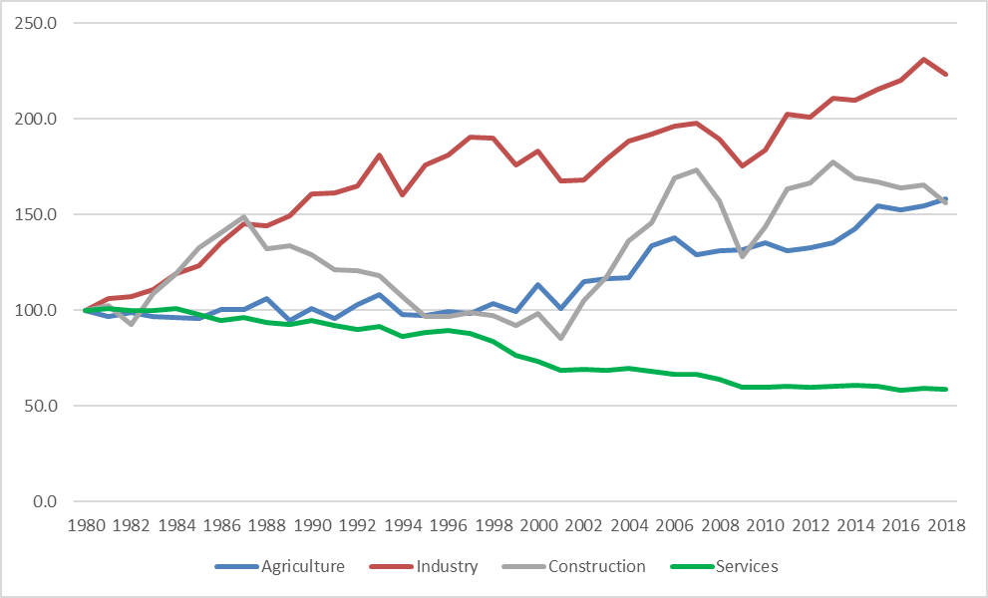

**Source:** Betam

In the 1980-2018 period, all sectors experience TFP increases except services. Over these years, the highest cumulative increase is recorded in the industry sector with 123.2% while the agriculture comes as second with 58.3%. In the construction sector, TFP grows by 56.4% cumulatively and TFP in the service sector contracts by 41.3%. TFP growth in the industry sector has a more stable pattern. Although TFP growth rate of the construction and the agriculture are close to each other, the construction sector is more volatile. This is the main reason that the TFP growth in the construction falls the same rate of the agriculture despite the rapid growth rates of construction TFP in some periods. This situation is closely related to the construction investments’ quality and the sector’s potential to create value added. Low or negative TFP growth in the service sector is not specific to Turkey alone. OECD average and the US economy displays similar patterns on the services TFP (see Kets and Lejour, 2003; Foerster et al., 2019).

**Table 4: Sectoral TFP Growth Rates (Annual Average, %)**

|  |  |  |  |  |
| --- | --- | --- | --- | --- |
|  | Agriculture TFP | Industry TFP | Construction TFP | Services TFP |
| **Growth Rate (%)** |  |  |  |  |
| 1981-1989 | -0.6 | 4.5 | 3.2 | -0.8 |
| 1990-2002 | 1.5 | 0.9 | -1.9 | -2.3 |
| 2003-2013 | 1.5 | 2.1 | 4.8 | -1.2 |
| *2003-2007* | *2.2* | *3.3* | *10.0* | *-0.8* |
| *2008-2010* | *1.7* | *-2.5* | *-6.3* | *-3.4* |
| *2011-2013* | *0.0* | *4.6* | *7.1* | *0.2* |
| 2014-2018 | 3.1 | 1.1 | -2.5 | -0.5 |

**Source:** Betam

When we analyze the TFP growth rates of the sectors according to broad periodization, we see that agricultural TFP increases in every period except the 1981-1989 period. In the 1990-2002 and 2003-2013 periods, TFP grows by 1.5% on annual average in the agriculture sector while the 2014-2018 period witnesses more rapid growth rate of 3.1%. In the 2003-2007 subperiod and the 2014-2018 period, declines in agricultural employment drives the TFP increases (Agricultural employment falls 3.4% and 3.5% on annual average in these periods respectively). This situation points to the fact that there is a hidden unemployment in the agricultural sector. Employment loses in the agriculture do not cause output declines, and the labor shifted from rural areas to urban centers become more active in the economy. Another surprising observation is that, during the crisis years of 2008-2010 agricultural employment increases by 5.2%, and this increase is reflected as an output increase of 5.5%.

TFP growth in the industry is considerably high during the 1981-1989 period with a 4.5% annual average increase. The 2011-2013 subperiod records a rapid growth rate of industrial TFP with 4.6%. Except the years of Global Financial Crisis, industrial TFP increases in every period while its performance is quite low in the 90s. A curious point is that industrial TFP growth rates converges to the 90s sluggish figures. This situation is a sign that a technological advancement is needed immediately in the industry sector.

The construction is the most volatile sector in terms of both sectoral GDP and TFP growth rates. Economic crisis hit hard the construction sector while it achieves phenomenal growth rates during the economic booms. The volatility in the sectoral GDP is mainly caused by the volatility of the sectoral TFP because employment and capital stock gains are more stable. The construction TFP increases by 3.2% on annual average in the 1981-1989 period and declines by 1.9% in the 1990-2002 period. The years between 2003-2013 record 4.8% annual growth rate and the sector contracts at 2.5% annual average rate in the 2014-2018 period.

Services TFP contracts in all the periods. This situation is partly caused by the measurement problems of the value added in the education and health services because of the non-market characteristics of these sectors, and partly caused by aggregation of many different trades (from transportation to catering) into one item. However, the service sector is crucially important for the rest of the economy because its value-added share is 63% and its employment share is 55%. Thus, shall Turkey escape from the middle-income trap there must be TFP increases in the service sector.

**Contribution of TFP to Sectoral GDP Growths**

Table 5 presents annual average sectoral GDP contributions of capital stock, employment and TFP by sectors and by time periods. The contribution of the employment in the agriculture is generally negative because of the employment loses in the sector. Capital stock makes mild but stable contributions to the agricultural GDP growth while the contribution of the TFP surpasses contributions of the investments. The strongest TFP contribution happens in the 2014-2018 period with 3.1 percentage point. In the 1990-2002 and 2003-2013 periods, TFP supports sectoral growth by 1.5 percentage points. In the 1981-1989 period, TFP weighs down the sectoral growth by 0.6 percentage point.

The highest TFP contributions are recorded in the industry sector compared to the other sectors. The 1981-1989 and 2003-2013 periods are the considerably favorable years for the industrial sector. In these two periods the contributions of TFP to the growth are 4.5 percentage point and 2.1 percentage point respectively. The sectoral GDP growths are close to each other in these periods while there is a prominent difference between them: The TFP contribution is higher than capital stock’s contribution in the former period and vice versa for the latter. In the 2014-2018 period, both sectoral growth and sectoral TFP increases slow down and TFP contributed only 1.1 percentage point. In the years between 1990 and 2002 the annual average TFP contribution is quite low with 0.9 percentage point.

In the construction sector, employment and capital stock gains contribute to the sectoral growth in a stable manner. TFP contribution to the growth is volatile in line with the fluctuating TFP growth rates. According to broad periodization, in the 2003-2013 period TFP contributes to the sectoral GDP by 4.8 percentage point. This is the highest contribution rate of the TFP compared to other time periods. The 1981-1989 period is the second according to TFP contribution (3.2 percentage point). In the 2014-2018 period, sectoral growth slows down considerably (4.2%) and the main reason is that the TFP weighs down the growth by 2.5 percentage point. In the 2003-2007 subperiod, TFP contribution is record high with 10 percentage point and for the years between 2011 and 2013 this figure is 7.1 percentage point.

Although employment and capital stock make positive contributions to the services GDP growth, TFP contribution is negative. Only in the 2011-2013 subperiod TFP contributes positively (0.2 percentage point). The lowest TFP contribution is recorded in the 1990-2002 period with minus 2.3 percentage point. In the 1981-1989 period this figure is minus 0.8 percentage point while in the 2003-2013 period TFP weighs down the sectoral growth by 1.2 percentage point. In the years between 2014 and 2018, the effect of TFP on the services sector remains limited with minus 0.5 percentage point contribution.

**Table 5: Contributions to Sectoral Growth Rates (Percentage Points)**



**Source:** Betam

**References:**

* Bakış, O. and Acar, U. (2020): Türkiye Ekonomisinde Toplam Faktör Verimliliğinin Seyri: Sektörel Bakış, Betam Çalışma Tebliği No. 19 *(yakında yayınlacak)*
* Foerster, A., Hornstein, A., Sarte, P.D., and Watson, M.W. (2019). Aggregate Implications of Changing Sectoral Trends (No. w25867). National Bureau of Economic Research.
* Hulten, C. R., and Wykoff, F.C. (1981). The measurement of economic depreciation. In Hulten, C. R. (Ed.). *Depreciation, inflation & the taxation of income from capital* (pp. 81-125. Urban Institute Press.
* Jorgenson, D. W. (1996). Empirical studies of depreciation. *Economic inquiry*, 34(1), 24-42.
* Kets, W. and Lejour, A. (2003). Sectoral TFP developments in the OECD (No. 58). CPB Netherlands Bureau for Economic Policy Analysis.

1. # We are thankful to Prof. Dr. Seyfettin Gürsel for his suggestions and directions in the preparation of this research brief.
2. * Ozan Bakış, Betam, Senior Researcher, [ozan.bakis@eas.bau.edu.tr](mailto:ozan.bakis@eas.bau.edu.tr)
3. ** Uğurcan Acar, Betam, Research Assistant, [ugurcan.acars@eas.bau.edu.tr](mailto:ugurcan.acars@eas.bau.edu.tr)
4. ** Gökhan Dilek, Betam, Research Assistant, [gokhan.dilek@eas.bau.edu.tr](mailto:gokhan.dilek@eas.bau.edu.tr)
5. These periods are: 1980-1989, 1990-2002, 2003-2013, and 2014-2018. More detailed information could be found in the forthcoming Betam TFP Working Paper (Bakış and Acar, 2020).
6. For more detailed information on the derivation of sectoral employment data see Bakış and Acar (2020).
7. For more detailed information see Bakış and Acar (2020).
8. Detailed information on the calculation of each series for each sector is presented in the forthcoming Betam TFP Working Paper (Bakış and Acar, 2020).
9. For more detailed information see Bakış and Acar (2020).
10. For more detailed information see Bakış and Acar (2020).