Research Brief 20/250

14 May 2020

IMPACT OF CORONAVIRUS PANDEMIC ON LABOR MARKET:
WHAT THE LEADING INDICATORS SAY

Seyfettin Gürsel*, Mehmet Cem Şahin **

Executive Summary

The Covid-19 Pandemic started to affect Turkey by the mid of March. While the measures aiming to confine the outbreak suspended many economic branches, income losses both at the global and country level inflicted a heavy blow to the demand of many goods and services. Under these circumstances, high employment losses and a spike in the unemployment rate are inevitable. Unfortunately, we will learn the full scope of these effects when the Household Labor Force Survey (HLFS) for March will be released on the 10th of June. Instead of waiting the HLFS, in this research brief, we share our first impressions on the developments in the Turkish labor market in April by using vacant jobs, job placements and labor demand series obtained from Turkish Employment Agency (İŞKUR) and Kariyer.net. Not surprisingly, these leading indicators suggest a great collapse both in the aggregate and in the sectorial level.

Introduction
This new research brief aims to provide the best possible opinion on the effects of the Covid-19 Pandemic on the labor market. We list our reasons to conduct this study below.

Betam follows the developments in the labor market by publishing the monthly “Labor Market Outlook” research briefs on the release day of HLFS for about 9.5 years. The first research brief was released on 15th October 2010. As very well known, TurkStat releases HLFS every month. However, these statistics reflects the developments during a period of three months. This is the reason that TurkStat uses the “period” term instead of “month” for these statistics. For instance, the last HLFS was published on 10th of April named as “January period” covering December, January and February months. Hence, the HLFS data is coming with a lag: If we look at the middle month of the period, then we could see the developments in the labor market with 70 days lag. If we use the last month of the period, then we reach the partial information on the current period with a 40 days lag at best. This compulsory delay is not a problem in the “normal” times where the number of the employed, unemployed and labor force (labor force is the total of the former two by definition) are in line with the structural dynamics. Also, in times of rapid changes in the unemployment rate, the delay of the data is not an important concern in practice since the employment is affected by the economic developments with a lag.

This time the situation is different. The economic effects of Covid-19 are different than the crisis of the recent years in terms of economic processes. These differences are not the subject of this research brief; hence, we shall confine ourselves with a quick reminder: While the quarantine measures halted many economic activities especially in the service sector, on the other hand, there is a rapid decline in demand for the operating manufacturing branches. Thus, the impacts of the Covid-19 on the labor market are severe as well as sudden. On the other hand, these effects turn the structural dynamics of the Turkish labor market upside down and created new statutes; for example, high number of applications to “Short-Term Employment Allowance” and compulsory leave without pay which created an unprecedented status that we would like to call “unemployed who counts as employed”.

Figure 1: Year-on-year changes in vacant jobs: January 2015-March 2020
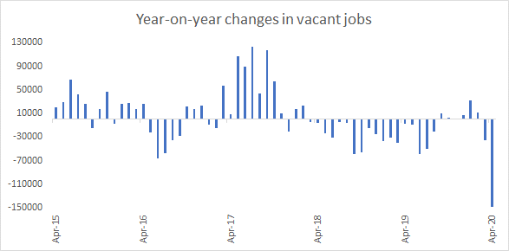
Source:İŞKUR, Monthly statistics bulletin, Betam’s own calculations

In March, the yearly changes in vacant jobs has already gone to the negative side. The figures released today (8th of May) shows a total collapse. In April 2020, the number of vacant jobs has been reduced to 52 thousand from 200 thousand in April 2019 corresponding to a decline of 148 thousand. Such a great decrease did not happen even in the periods of economic recession years of the considered period. Sectorial vacant jobs series (Appendix Figure 1, 2, and 3) are also mostly in line with HLFS employment statistics. In the industry sector, this alignment is close to the alignment between the aggregate series presented in Figure 1. In the construction sector, the yearly changes of the number of vacant jobs become negative in an early phase and after large employment losses, in the fall of 2019 it records mild increases. The course of vacant jobs in the service sector is interesting. The yearly changes in vacant jobs which had been in line with the course of employment gains until 2018 then started to stagnate in 2018 and recorded apparent increases in 2019. On the other hand, the vacant jobs in the service sector started to decline in the fall of 2019.

The April data reflects the collapse in the three sectors. Vacant jobs in the services decreased by 84 thousand, 50 thousand in the industry and 12 thousand in the construction. The yearly rate of contraction reaches to 70-80% in every sector.

Another data on the labor demand of the firms is total job vacancies and new job vacancies series which are gathered by Kariyer.net and shared with Betam. Figure 2 presents the monthly observations of the data from January 2014 to April 2020. New vacancy postings show the number of vacancies that are posted between start and end of the reference period (month), while total job vacancies consist of all posted vacancies that are active in that month. In the high growth and high employment year of 2017, total job vacancies increased remarkably. Subsequently, in 2018, both new and total job vacancies converged to their long-run averages with slowing GDP growth rates and rising unemployment. Job vacancies series increased mildly after the second half of 2019 following the economic recovery.

In the middle of March, Covid-19 showed up in Turkey and there is an unprecedented fall in job vacancies following the pandemic. Total job vacancies declined to 33.441 in April 2020 (Figure 2) compared to the February figure of 60.015 while the new job vacancies dropped to 3.096 from 19.000 within two months. (Figure 3).

Figure 2: Total and New Job Vacancies (Seasonally and calender adjusted data): January 2014 – April 2020
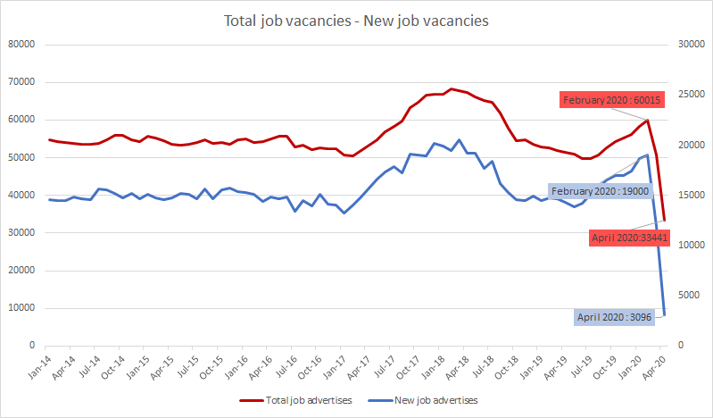
Source: Kariyer.net

The number of staff wanted in the job vacancies that Kariyer.net has recorded for the last three years also confirms the severity of the impact of the Covid-19 pandemic shock on labor force and labor demand. It indicates the total number of workers sought by firms that post advertising on Kariyer.net. This number dropped by 30 percent around in April. In the first approach, such a decrease can be seen as the best of bad lot. However, it is important to note that Kariyer.net mainly mediates the white-collar professional staff.

Figure 3: Labor demand (Seasonally and calendar adjusted data): January 2017 – April 2020

Source: Kariyer.net

Impact of Covid-19 on Job Placement

İşkurs’s monthly bulletin of statistics also provides the number of “job placements” of unemployed registered in the institution. Fluctuations in this series are related to the level of activity exhibited by İŞKUR, as well as changes in the labor force and labor demand. Therefore, we would like to share the developments in the number of job placements as well.

Annual changes in the number of job placements shown in Figure 4 also support the collapse in labor demand. The drop in job placement performance that emerged in the first months of the year continued declining severely in April. In April 2019, İŞKUR succeeded in placing 122 thousand unemployed in a job while in April 2020 this number dropped to 30 thousand.

Figure 4: Year-on-year Changes in Job Placement: January 2015-March 2020
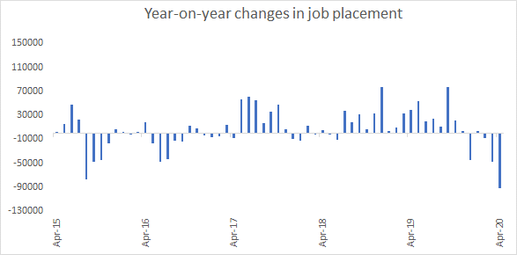
Source:İŞKUR, Monthly statistics bulletin, Betam’s own calculations

Significant reduction in labor supply
Before moving to the effects of the Covid-19 pandemic, we'd like to remind a new phenomenon emerged in Turkey’s labor market in the last two years. It was observed that the significant decrease in employment in the period of 2018-19 did not reflect completely on the number of unemployed. This is a remarkable situation. It is understood that some of those who lost their job avoid from seeking a job. As a result, a stagnation emerged in labor force (employed + unemployed) that has never been experienced before. Some of those who lost their job and gave up on seeking for a job were included in the “discouraged” group of HLFS since they think that they could not find a job. The impressive increase observed in this group is the result of this behaviour. But it is ambiguous where exactly the other part appears. The causes of this new phenomenon are waiting to be explored.
In this context, it is highly probable that the Coronavirus shock creates a similar and even more severe effect. As the leading indicator of such an impact, we can look at the number of applications per job vacancies on Kariyer.net. Figure 5 shows seasonally and calendar adjusted the number of applications on job vacancies. There is a clear upward trend in the total number of applications in the last 6 years. This tendency may be related to the increasing use of the online recruitment website Kariyer.net by jobseekers.
We also remind that employed job-seekers seeking for a job to have better conditions are also included in the application process. it is possible to observe fluctuations in the total application curve that are compatible with the labor market conjuncture. As a matter of fact, it is clearly seen that while the increase in total application accelerated in 2017 and then followed a moderate decline and and finally a plateau has been reached in 2018.
When the Covid-19 epidemic started in Turkey, it is observed that this upward trend changed suddenly direction and the number of applications went down like a free fall in March. The number of applications, which was 10 million 756 thousand in February, dropped to 4 million 400 thousand in April. Under the present circumstances, the hope of finding a job has decreased so much that masses of people think it is not worthwhile to look for a job. But it is uncertain how many of them would be registered as unemployed in the HLFS.

Figure 5: Number of applications on job vacancies (Seasonally and calendar adjusted data): January 2014-Apil 2020

Source: Kariyer.net, Betam’s own calculations

General Evaluation
It is expected that the corona epidemic will cause large-scale reduction in employment and sharp increase in unemployment. Unfortunately, İŞKUR and Kariyer.net leading indicators confirm this expectation. The February period of HLFS (January-February-March), which will be published on May 11, will not reflect this effect, as we noted in the introductory section. With the March period of HLFS data, we will be able to have more complete idea about the extent of tsunami caused by the corona pandemic in the Turkish labor market.

Appendix Figure 1: Year-on-year changes in vacant jobs in industry

Source: İŞKUR, Betam’s own calculations

Appendix Figure 2: Year-on-year changes in vacant jobs in construction
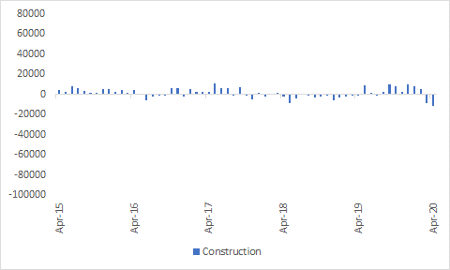
Source: İŞKUR, Betam’s own calculations

Appendix Figure 3: Year-on-year changes in vacant jobs in services

Source: İŞKUR, Betam’s own calculations

Appendix Figure 4: Year-on-year changes in job placement in industry
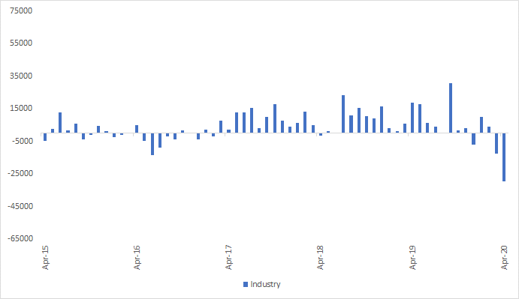
Source: İŞKUR, Betam’s own calculations

Appendix Figure 5: Year-on-year changes in job placement in construction
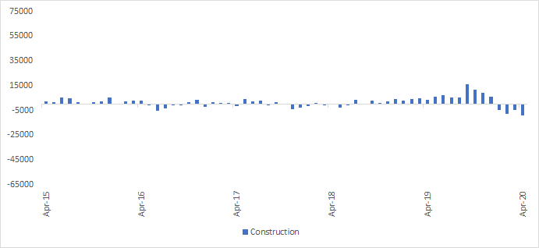
Source: İŞKUR, Betam’s own calculations

Appendix Figure 6: Year-on-year changes in job placement in services
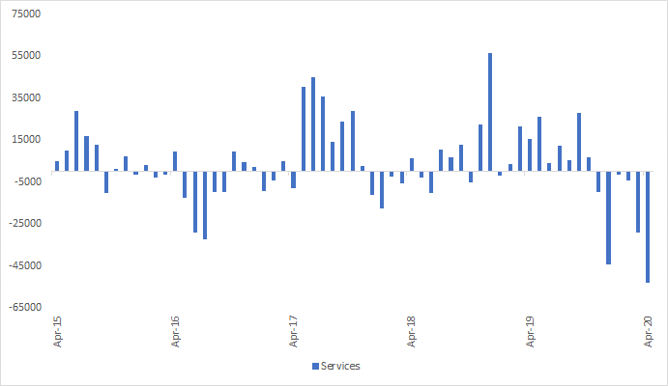
Source: İŞKUR, Betam’s own calculations

*Prof. Dr. Seyfettin Gürsel, Betam, Director, seyfettin.gursel@eas.bau.edu.tr **Mehmet Cem Şahin, Betam, Research Assistant, mehmetcem.sahin@eas.bau.edu.tr

