Labor Market Outlook:
May 2020

12 May 2020

LABOR MARKET OUTLOOK BEFORE THE CORONA PANDEMIC:
DECREASE IN UNEMPLOYMENT
ALONG WITH DROP IN EMPLOYMENT AND LABOR FORCE

Seyfettin Gürsel*, Mehmet Cem Şahin **

Executive Summary

Seasonally adjusted labor market data shows that in the period of February 2020, non-agricultural unemployment rate turned out to be 14.6 percent, with 0.1 percentage point decrease compared to January 2020. In this period, non-agricultural employment decreased by 277 thousand while non-agricultural labor force decreased by 356 thousand. Consequently, the number of unemployed in non-agricultural sector decreased by 79 thousand. As a result of the extraordinary decrease in labor force and employment, seasonally adjusted LFPR and employment rate decreased by 1 percent and 0.9 percent, respectively, compared to the period of January 2020. The decrease in LFPR and employment rate has been the biggest in magnitude since the period of January 2005. According to sectorial data, employment losses occurred in all sectors. The most significant decreases in employment occurred in agriculture (by 218 thousand) and services (by 194 thousand). While construction employment decreased by 28 thousand, manufacturing employment decreased by 56 thousand. Seasonally adjusted data shows that the level of labor force and employed people decreased especially among men, which resulted by an increase in non-agricultural male unemployment rate, whereas female non-agricultural unemployment rate decreased. The decrease in female unemployment was the result of the limited decrease in female employment (by 42 thousand), along with relatively significant decrease in female labor force (by 132 thousand)

Decreases in all non-agricultural labor market indicators

Seasonally adjusted data shows that, non-agricultural labor force reached 26 million 763 thousand after the decrease of 356 thousand in February 2020 period (January-February-March) compared to January 2020 period (December-January-February). In the period of February 2020, the level of non-agricultural labor force decreased (by 2.6 percentage points) compared to the same month of the previous year. Year-over-year decrease in labor force occurred for the first time since January 2005, the beginning of the seasonally adjusted non-agricultural labor force series. Slow growth rate in labor force before the outbreak of COVID19 evolved into year-over-year decrease in labor force. Non-agricultural employment reached 22 million 856 thousand following a decrease of 277 thousand (Figure 1, Table 1). Despite declining employment, the number of non-agricultural unemployed decreased by 79 thousand and reached 3 million 907 thousand. Thus, non-agricultural unemployment rate dropped to 14.6 percent.

To better capture the extraordinary decrease in non-agricultural labor force, we added a new figure that features seasonally adjusted LFPR, employment rate and non-agricultural unemployment rate into our Labor Market Outlook reports. As can be seen from the figure, unemployment shock that occurred in the years of 2008-2009 resulted in the decrease in the employment rate and growth rate in the labor force participation rate (LFPR) along the trend line. This time, LFPR has been decreasing and the pace of the decrease is higher than that occurring in employment rate. While non-institutional population over 15-year-old keeps increasing, LFPR decreased by 2.6 percent in February 2020 compared to the same month of the previous year and reached 50.7 percent. Employment rate decreased by 1.7 percent in February 2020 compared to the same month of the previous year and reached 44.3 percent

Figure 1. Seasonally adjusted non-agricultural labor force, employment, and unemployment
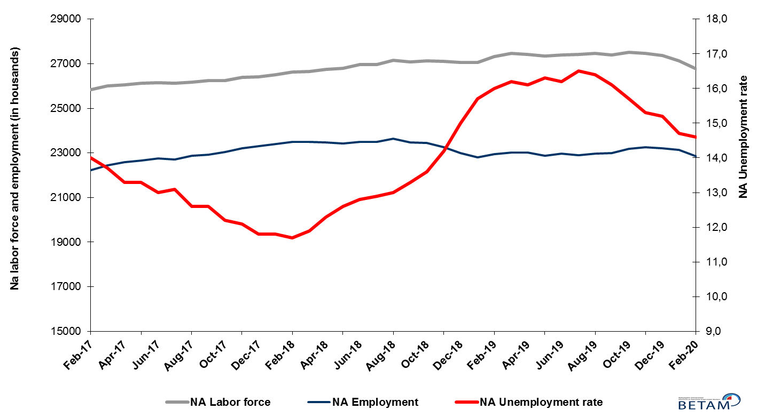
Source: Turkstat, Betam

Figure 2 Seasonally adjusted LFPR, employment rate and non-agricultural unemployment rate
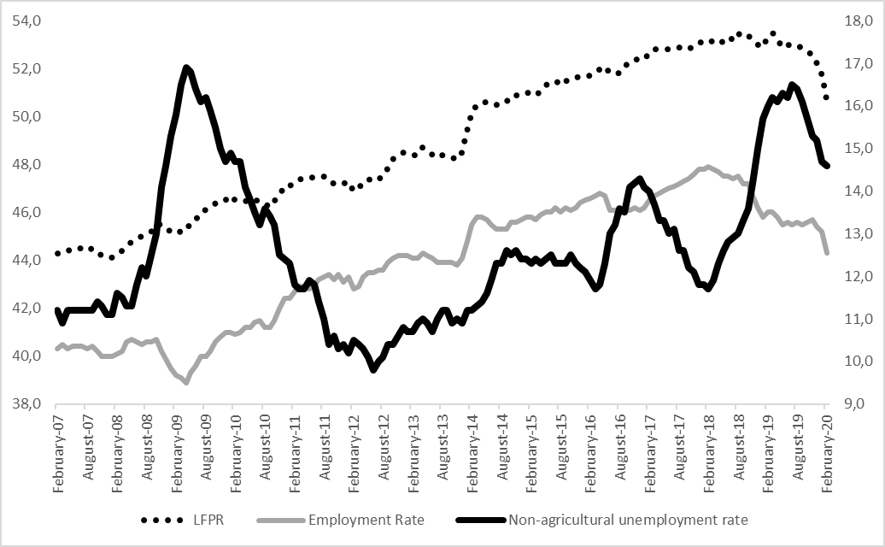
Source: Turkstat, Betam

Significant increase in discouraged job seekers

The level of labor force, by definition, is the summation of the level of employed people and the level of job seekers (unemployed). The unusual developments in the labor market, cause loss of confidence among individuals who desire to work but they are not actively seeking a job as they think that they could not find any job. Those individuals that quit seeking for jobs and labor force due to loss of confidence are referred as ‘Discouraged Job Seekers’ by TurkStat. As can be seen from another new Figure 3 that features discouraged job seekers, unemployed people and summation of both, the number of discouraged job seekers nearly doubles from the period of January 2019 while number of unemployed people has been decreasing for a while.

Figure 3 The number of unemployed people, discouraged job seekers and summation of both, SA
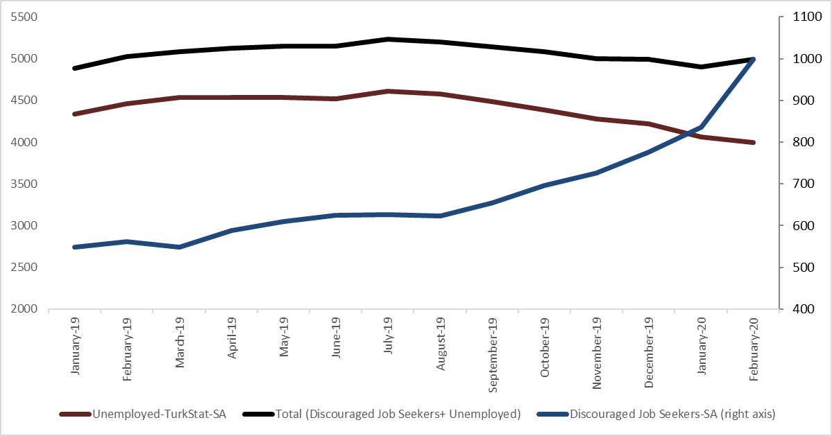
Source: Turkstat, Betam

Warning regarding the forecast of unemployment rate

Betam’s forecasting model predicted that non-agricultural unemployment rate would be 14.4 for March 2020 if ever were COVID19 outbreak were non-existent. As the effects of the pandemic in April 2020 weren’t reflected in the variables that are used in the forecast model, we prefer not to publish our March 2020 forecast in our Labor Market Outlook report for the period of February 2020.

Employment losses in all sectors

According to seasonally adjusted sectorial labor market data, in the period of February 2020 compared to January 2020, employment losses occurred in all sectors (Figure 3, Table 2). After the decrease of 40 thousand in January 2020, employment in agriculture sector decreased by 218 thousand in February 2020. Following the decrease of 29 thousand in December 2019, the number of employed in services sector decreased by 194 thousand. Employment in manufacturing and construction sectors decreased by 56 and 28 thousand respectively in the period of February 2020.
.
Figure 4: Employment by sectors (in thousand)
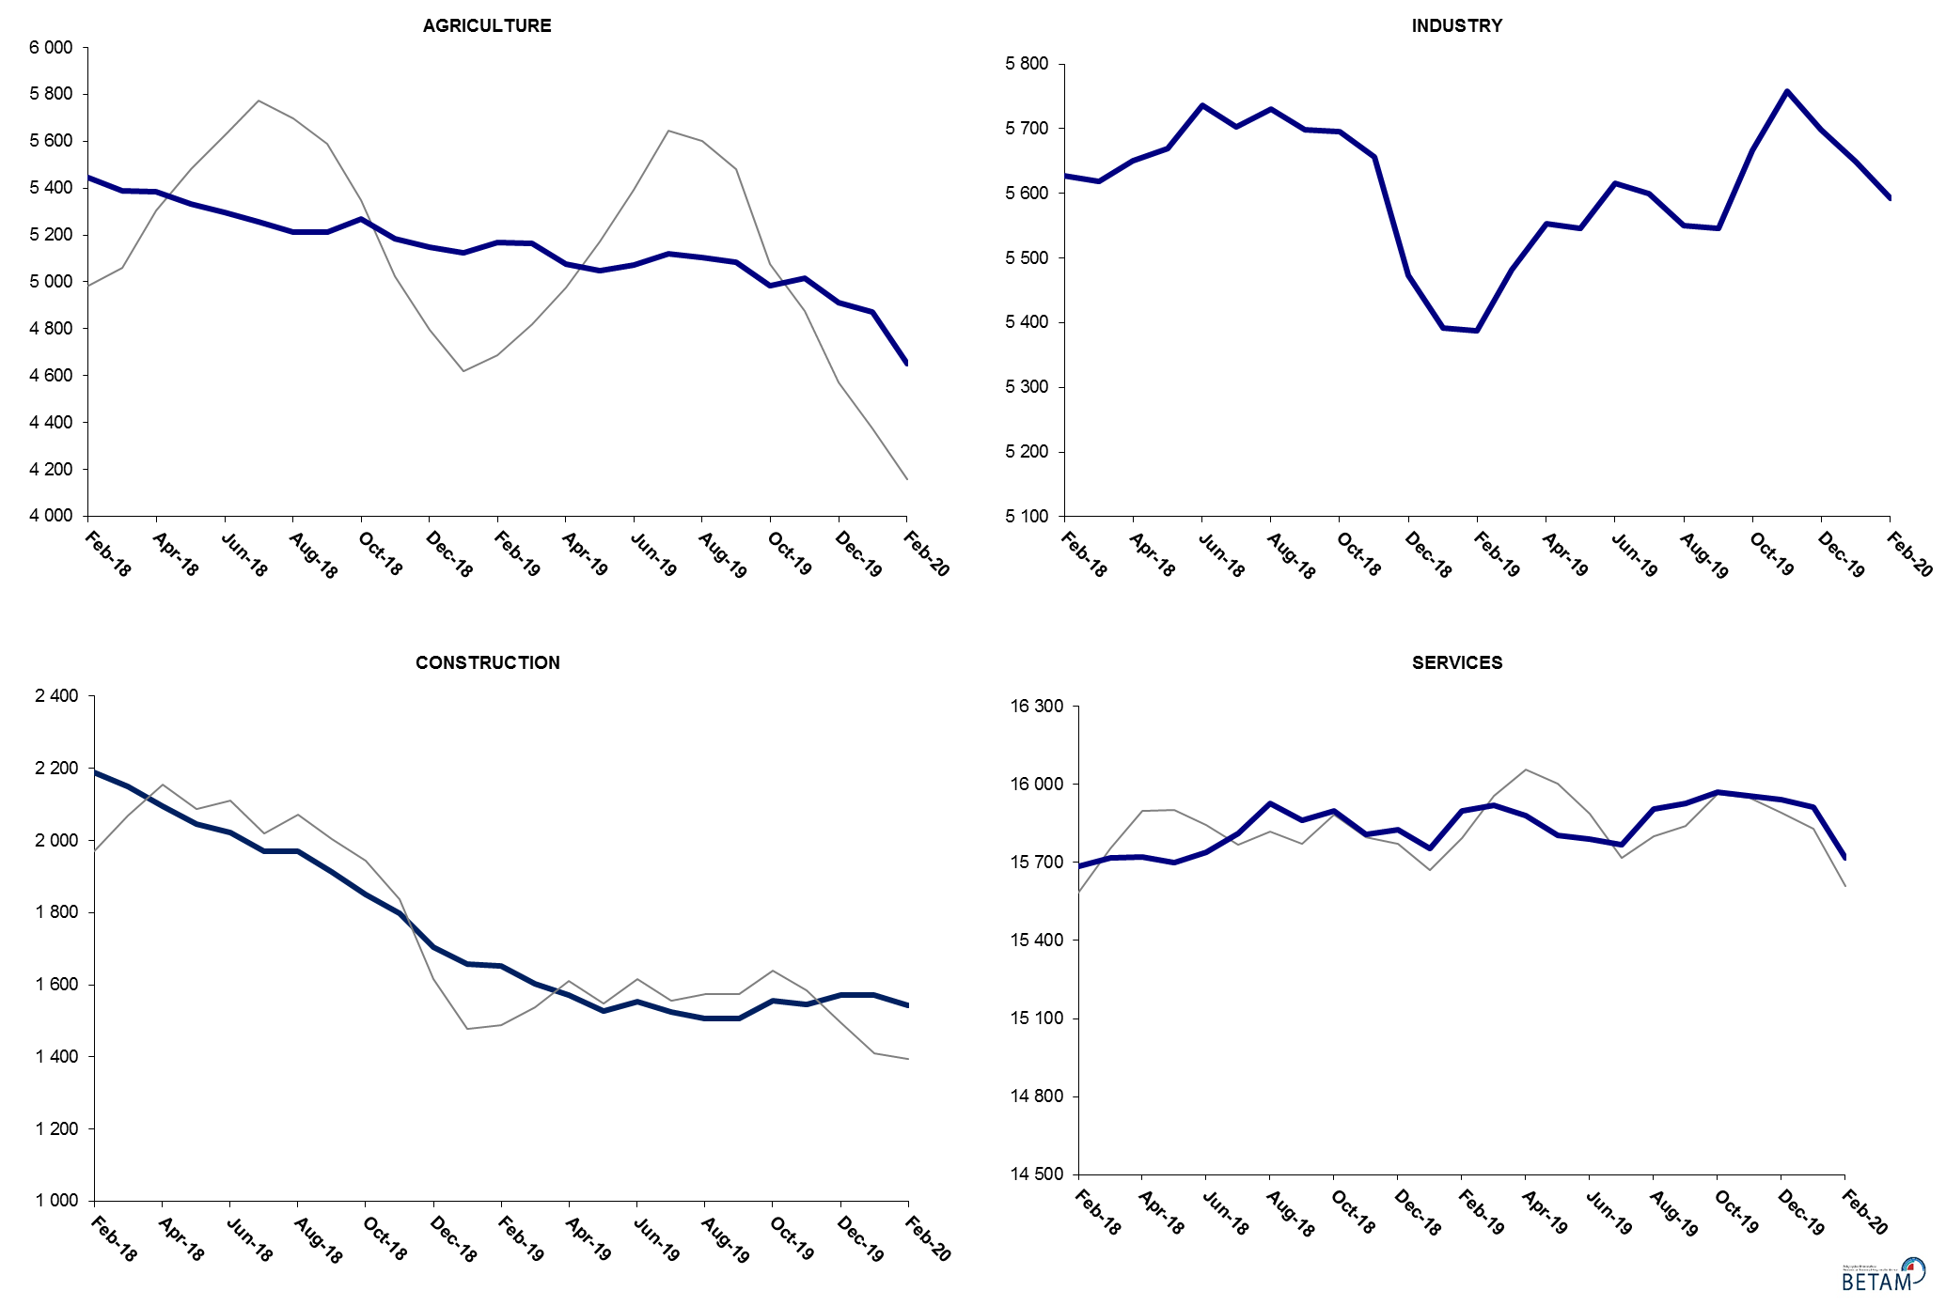
Source: TURKSTAT, Betam

Slowdown in non-agricultural labor force participation, limited increase in employment

Compared to February 2019, non-agricultural labor force decreased by 568 thousand (2.1 percent) in February 2020 (Figure 5, Table 3). Year-on-year level of change in non-agricultural labor force turned negative for the first time in February 2020, since January 2006. The decrease in year-on-year non-agricultural employment level was 71 thousand (0.3 percent). As a result, in the period of February 2020 compared to February 2019, the number of non-agricultural unemployed decreased by 497 thousand.

Figure 5 Year-on-year changes in non-agricultural labor force, employment, and unemployment
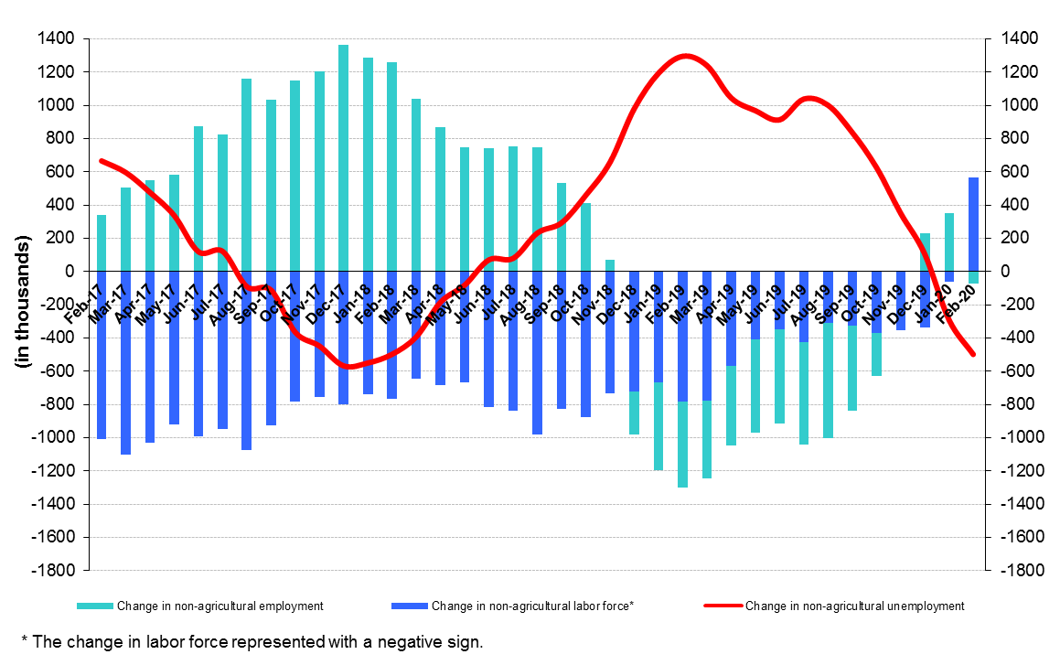
Source: TURKSTAT, Betam

Decrease in female unemployment along with increase in male unemployment

Figure 6 shows seasonally adjusted non-agricultural unemployment rate for males (green) and for females (purple). In the period of February 2020 compared to the previous period, female non-agricultural unemployment rate decreased by 0.8 percentage point to 18.7 percent. This significant decrease in female unemployment rate resulted from the decrease (132 thousand) in the female labor force while the decrease in employment has been limited to 42 thousand. Male unemployment rate turned out to be 12.9 with 0.4 percentage point increase. Even though male employment decreased by 312 thousand, male labor force decreased by 290 thousand. As a result, the gender gap in non-agricultural unemployment rates decreased from 7.0 percent to 5.9 percent points.

Figure 6: Seasonally adjusted non-agricultural unemployment rate by gender

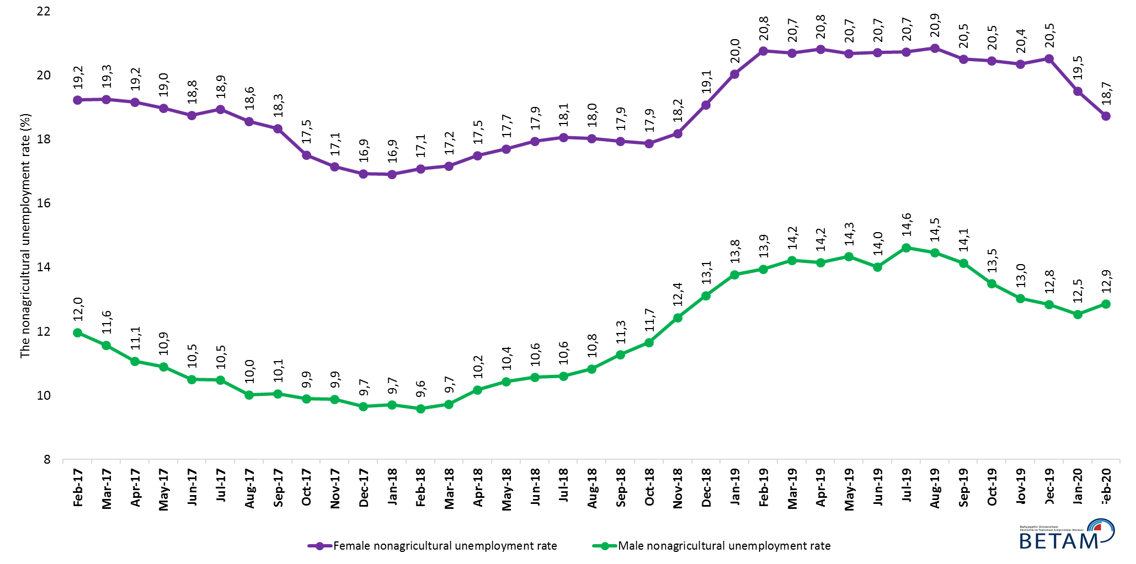

Source: Turkstat, Betam

Table 1 Seasonally adjusted non-agricultural labor market indicators (in thousands) **

 | Labor force | Employment | Unemployment | Unemployment rate | Monthly changes
February-17 | 25844 | 22226 | 3618 | 14,0% | Labor force | Employment | Unemployment
March-17 | 26015 | 22451 | 3564 | 13,7% | 171 | 225 | -54
April-17 | 26063 | 22597 | 3466 | 13,3% | 48 | 146 | -98
May-17 | 26121 | 22647 | 3474 | 13,3% | 58 | 50 | 8
June-17 | 26145 | 22746 | 3399 | 13,0% | 24 | 99 | -75
July-17 | 26133 | 22710 | 3423 | 13,1% | -11 | -36 | 25
August-17 | 26172 | 22874 | 3298 | 12,6% | 38 | 164 | -126
September-17 | 26237 | 22931 | 3306 | 12,6% | 65 | 57 | 8
October-17 | 26241 | 23040 | 3201 | 12,2% | 5 | 109 | -104
November-17 | 26390 | 23197 | 3193 | 12,1% | 149 | 157 | -8
December-17 | 26412 | 23295 | 3117 | 11,8% | 21 | 98 | -77
January-18 | 26517 | 23388 | 3129 | 11,8% | 105 | 93 | 12
February-18 | 26616 | 23502 | 3114 | 11,7% | 99 | 114 | -15
March-18 | 26658 | 23486 | 3172 | 11,9% | 42 | -16 | 58
April-18 | 26756 | 23465 | 3291 | 12,3% | 98 | -21 | 119
May-18 | 26788 | 23413 | 3375 | 12,6% | 32 | -52 | 84
June-18 | 26948 | 23499 | 3449 | 12,8% | 160 | 86 | 74
July-18 | 26963 | 23485 | 3478 | 12,9% | 15 | -14 | 29
August-18 | 27160 | 23629 | 3531 | 13,0% | 197 | 144 | 53
September-18 | 27074 | 23473 | 3601 | 13,3% | -86 | -156 | 70
October-18 | 27137 | 23446 | 3691 | 13,6% | 63 | -27 | 90
November-18 | 27114 | 23264 | 3850 | 14,2% | -22 | -182 | 160
December-18 | 27062 | 23003 | 4059 | 15,0% | -52 | -261 | 209
January-19 | 27049 | 22802 | 4247 | 15,7% | -14 | -201 | 187
February-19 | 27307 | 22938 | 4369 | 16,0% | 259 | 136 | 123
March-19 | 27452 | 23005 | 4447 | 16,2% | 145 | 67 | 78
April-19 | 27422 | 23007 | 4415 | 16,1% | -30 | 2 | -32
May-19 | 27333 | 22878 | 4455 | 16,3% | -89 | -129 | 40
June-19 | 27396 | 22958 | 4438 | 16,2% | 63 | 80 | -17
July-19 | 27414 | 22891 | 4523 | 16,5% | 18 | -67 | 85
August-19 | 27467 | 22962 | 4505 | 16,4% | 52 | 71 | -19
September-19 | 27390 | 22980 | 4410 | 16,1% | -77 | 18 | -95
October-19 | 27511 | 23192 | 4319 | 15,7% | 122 | 212 | -90
November-19 | 27462 | 23260 | 4202 | 15,3% | -50 | 68 | -118
December-19 | 27373 | 23212 | 4161 | 15,2% | -89 | -48 | -41
January-20 | 27120 | 23133 | 3987 | 14,7% | -253 | -79 | -174
February-20 | 26763 | 22856 | 3907 | 14,6% | -356 | -277 | -79

Source: Turkstat, Betam

Table 2 seasonally adjusted employment by sectors (in thousands) *
 | Agriculture | Manufacturing | Construction | Service | Monthly changes
February-17 | 5488 | 5251 | 2010 | 14965 | Agriculture | Manufacturing | Construction | Service
March-17 | 5397 | 5346 | 2089 | 15016 | -91 | 95 | 79 | 51
April-17 | 5376 | 5372 | 2123 | 15102 | -21 | 26 | 34 | 86
May-17 | 5405 | 5386 | 2086 | 15175 | 29 | 14 | -37 | 73
June-17 | 5414 | 5383 | 2080 | 15284 | 9 | -3 | -6 | 109
July-17 | 5509 | 5363 | 2121 | 15225 | 95 | -20 | 41 | -59
August-17 | 5472 | 5437 | 2169 | 15269 | -37 | 74 | 48 | 44
September-17 | 5491 | 5421 | 2121 | 15389 | 19 | -16 | -48 | 120
October-17 | 5470 | 5470 | 2090 | 15480 | -21 | 49 | -31 | 91
November-17 | 5480 | 5470 | 2128 | 15598 | 10 | 0 | 38 | 118
December-17 | 5533 | 5514 | 2176 | 15605 | 53 | 44 | 48 | 7
January-18 | 5476 | 5567 | 2199 | 15622 | -57 | 53 | 23 | 17
February-18 | 5445 | 5627 | 2190 | 15685 | -31 | 60 | -9 | 63
March-18 | 5387 | 5618 | 2151 | 15717 | -58 | -9 | -39 | 32
April-18 | 5385 | 5650 | 2095 | 15721 | -2 | 32 | -56 | 4
May-18 | 5334 | 5669 | 2045 | 15700 | -51 | 19 | -50 | -21
June-18 | 5296 | 5737 | 2023 | 15739 | -38 | 68 | -22 | 39
July-18 | 5258 | 5703 | 1970 | 15812 | -38 | -34 | -53 | 73
August-18 | 5211 | 5730 | 1971 | 15928 | -47 | 27 | 1 | 116
September-18 | 5212 | 5698 | 1912 | 15864 | 1 | -32 | -59 | -64
October-18 | 5267 | 5696 | 1849 | 15900 | 55 | -2 | -63 | 36
November-18 | 5185 | 5656 | 1798 | 15810 | -82 | -40 | -51 | -90
December-18 | 5150 | 5474 | 1704 | 15825 | -35 | -182 | -94 | 15
January-19 | 5124 | 5392 | 1657 | 15754 | -26 | -82 | -47 | -71
February-19 | 5167 | 5388 | 1652 | 15898 | 43 | -4 | -5 | 144
March-19 | 5164 | 5482 | 1602 | 15922 | -3 | 94 | -50 | 24
April-19 | 5078 | 5553 | 1572 | 15882 | -86 | 71 | -30 | -40
May-19 | 5048 | 5546 | 1528 | 15804 | -30 | -7 | -44 | -78
June-19 | 5073 | 5616 | 1553 | 15789 | 25 | 70 | 25 | -15
July-19 | 5120 | 5600 | 1524 | 15767 | 47 | -16 | -29 | -22
August-19 | 5104 | 5551 | 1506 | 15905 | -16 | -49 | -18 | 138
September-19 | 5086 | 5546 | 1506 | 15928 | -18 | -5 | 0 | 23
October-19 | 4985 | 5666 | 1555 | 15971 | -101 | 120 | 49 | 43
November-19 | 5016 | 5758 | 1546 | 15956 | 31 | 92 | -9 | -15
December-19 | 4911 | 5699 | 1571 | 15942 | -105 | -59 | 25 | -14
January-20 | 4871 | 5649 | 1572 | 15913 | -40 | -50 | 1 | -29
February-20 | 4653 | 5593 | 1544 | 15719 | -218 | -56 | -28 | -194

Source: Turkstat, Betam

Table 3 Seasonally unadjusted non-agricultural labor market indicators (in thousands) **

 | Non-Agricultural Labor Force | Non-Agricultural Employment | Non-Agricultural Unemployed
Feb-17 | 25728 | 21920 | 3808
Mar-17 | 25959 | 22403 | 3556
Apr-17 | 26068 | 22836 | 3232
May-17 | 26095 | 22911 | 3184
Jun-17 | 26134 | 22946 | 3188
Jul-17 | 26133 | 22736 | 3397
Aug-17 | 26234 | 22876 | 3358
Sep-17 | 26311 | 22943 | 3368
Oct-17 | 26351 | 23110 | 3241
Nov-17 | 26444 | 23218 | 3226
Dec-17 | 26360 | 23118 | 3242
Jan-18 | 26422 | 23066 | 3356
Feb-18 | 26494 | 23182 | 3312
Mar-18 | 26607 | 23441 | 3166
Apr-18 | 26754 | 23704 | 3050
May-18 | 26762 | 23658 | 3104
Jun-18 | 26951 | 23690 | 3261
Jul-18 | 26970 | 23491 | 3479
Aug-18 | 27213 | 23621 | 3592
Sep-18 | 27138 | 23474 | 3664
Oct-18 | 27227 | 23524 | 3703
Nov-18 | 27176 | 23290 | 3886
Dec-18 | 27085 | 22860 | 4225
Jan-19 | 27091 | 22540 | 4551
Feb-19 | 27278 | 22668 | 4610
Mar-19 | 27386 | 22977 | 4409
Apr-19 | 27321 | 23223 | 4098
May-19 | 27172 | 23096 | 4076
Jun-19 | 27298 | 23121 | 4177
Jul-19 | 27393 | 22873 | 4520
Aug-19 | 27522 | 22926 | 4596
Sep-19 | 27462 | 22958 | 4504
Oct-19 | 27599 | 23266 | 4333
Nov-19 | 27532 | 23292 | 4240
Dec-19 | 27420 | 23088 | 4332
Jan-20 | 27153 | 22890 | 4263
Feb-20 | 26710 | 22597 | 4113

Table 4: Seasonally adjusted non-agricultural labor force by gender (thousands)

 | Female Labor Force | Female Employment | Female Unemployed | Male Labor Force | Male Employment | Male Unemployed
February-17 | 7535 | 6086 | 1449 | 18252 | 16068 | 2184
March-17 | 7645 | 6173 | 1472 | 18351 | 16227 | 2124
April-17 | 7644 | 6179 | 1465 | 18423 | 16383 | 2039
May-17 | 7691 | 6231 | 1460 | 18434 | 16425 | 2009
June-17 | 7691 | 6249 | 1443 | 18456 | 16516 | 1940
July-17 | 7665 | 6214 | 1452 | 18447 | 16514 | 1934
August-17 | 7671 | 6246 | 1425 | 18505 | 16651 | 1855
September-17 | 7716 | 6300 | 1415 | 18508 | 16646 | 1862
October-17 | 7742 | 6386 | 1356 | 18488 | 16658 | 1831
November-17 | 7818 | 6477 | 1341 | 18542 | 16709 | 1833
December-17 | 7861 | 6530 | 1331 | 18558 | 16767 | 1791
January-18 | 7944 | 6600 | 1344 | 18605 | 16799 | 1806
February-18 | 7983 | 6619 | 1364 | 18624 | 16836 | 1787
March-18 | 7989 | 6617 | 1372 | 18642 | 16827 | 1815
April-18 | 8042 | 6635 | 1407 | 18716 | 16811 | 1905
May-18 | 8080 | 6648 | 1431 | 18739 | 16783 | 1956
June-18 | 8111 | 6655 | 1456 | 18869 | 16875 | 1994
July-18 | 8083 | 6623 | 1460 | 18887 | 16884 | 2003
August-18 | 8139 | 6671 | 1467 | 19003 | 16944 | 2058
September-18 | 8110 | 6655 | 1455 | 18944 | 16809 | 2135
October-18 | 8193 | 6727 | 1465 | 18906 | 16703 | 2203
November-18 | 8214 | 6720 | 1494 | 18886 | 16537 | 2348
December-18 | 8300 | 6716 | 1584 | 18757 | 16294 | 2463
January-19 | 8382 | 6702 | 1681 | 18708 | 16131 | 2577
February-19 | 8491 | 6728 | 1763 | 18792 | 16170 | 2621
March-19 | 8563 | 6789 | 1773 | 18852 | 16171 | 2681
April-19 | 8520 | 6747 | 1774 | 18920 | 16240 | 2680
May-19 | 8458 | 6708 | 1750 | 18902 | 16192 | 2710
June-19 | 8452 | 6702 | 1751 | 18959 | 16301 | 2657
July-19 | 8400 | 6658 | 1742 | 19057 | 16271 | 2787
August-19 | 8403 | 6650 | 1752 | 19043 | 16289 | 2753
September-19 | 8345 | 6633 | 1712 | 19015 | 16326 | 2689
October-19 | 8409 | 6688 | 1721 | 19048 | 16477 | 2570
November-19 | 8360 | 6658 | 1702 | 19079 | 16593 | 2486
December-19 | 8353 | 6638 | 1715 | 19024 | 16582 | 2443
January-20 | 8292 | 6674 | 1618 | 18868 | 16501 | 2367
February-20 | 8160 | 6632 | 1529 | 18578 | 16189 | 2389

Source: Turkstat, Betam

Table 5: Seasonally adjusted LFPR, employment rate and non-agricultural unemployment rate (%)

 | LFPR | Employment Rate | Non-agricultural unemployment rate
Feb-17 | 52,7 | 46,5 | 14,0
Mar-17 | 52,8 | 46,7 | 13,7
Apr-17 | 52,8 | 46,8 | 13,3
May-17 | 52,8 | 46,9 | 13,3
Jun-17 | 52,8 | 47,0 | 13,0
Jul-17 | 52,9 | 47,1 | 13,1
Aug-17 | 52,9 | 47,2 | 12,6
Sep-17 | 52,9 | 47,3 | 12,6
Oct-17 | 52,8 | 47,4 | 12,2
Nov-17 | 53,0 | 47,6 | 12,1
Dec-17 | 53,1 | 47,8 | 11,8
Jan-18 | 53,1 | 47,8 | 11,8
Feb-18 | 53,2 | 47,9 | 11,7
Mar-18 | 53,1 | 47,8 | 11,9
Apr-18 | 53,2 | 47,7 | 12,3
May-18 | 53,1 | 47,5 | 12,6
Jun-18 | 53,3 | 47,5 | 12,8
Jul-18 | 53,2 | 47,4 | 12,9
Aug-18 | 53,5 | 47,5 | 13,0
Sep-18 | 53,3 | 47,2 | 13,3
Oct-18 | 53,4 | 47,2 | 13,6
Nov-18 | 53,2 | 46,7 | 14,2
Dec-18 | 53,0 | 46,2 | 15,0
Jan-19 | 52,9 | 45,8 | 15,7
Feb-19 | 53,3 | 46,0 | 16,0
Mar-19 | 53,5 | 46,0 | 16,2
Apr-19 | 53,2 | 45,8 | 16,1
May-19 | 52,9 | 45,5 | 16,3
Jun-19 | 53,0 | 45,6 | 16,2
Jul-19 | 53,0 | 45,5 | 16,5
Aug-19 | 53,0 | 45,6 | 16,4
Sep-19 | 52,8 | 45,5 | 16,1
Oct-19 | 52,7 | 45,6 | 15,7
Nov-19 | 52,6 | 45,7 | 15,3
Dec-19 | 52,2 | 45,4 | 15,2
Jan-20 | 51,7 | 45,2 | 14,7
Feb-20 | 50,7 | 44,3 | 14,6

Source: Turkstat

Table 6: Seasonally adjusted discouraged job-seekers, unemployed and sum of both

 | Discouraged Job Seekers-SA | Unemployed-TurkStat-SA | Total (Discouraged Job Seekers + Unemployed)
Jan-19 | 548 | 4338 | 4886
Feb-19 | 562 | 4462 | 5024
Mar-19 | 548 | 4534 | 5082
Apr-19 | 588 | 4534 | 5122
May-19 | 610 | 4536 | 5146
Jun-19 | 624 | 4522 | 5146
Jul-19 | 626 | 4606 | 5232
Aug-19 | 623 | 4574 | 5197
Sep-19 | 654 | 4485 | 5139
Oct-19 | 696 | 4383 | 5079
Nov-19 | 726 | 4275 | 5001
Dec-19 | 776 | 4218 | 4994
Jan-20 | 836 | 4063 | 4899
Feb-20 | 998 | 3996 | 4994

Source: Turkstat, Betam

*Prof. Dr. Seyfettin Gürsel, Betam, Director, seyfettin.gursel@eas.bau.edu.tr **Mehmet Cem Şahin, Betam, Research Assistant, mehmetcem.sahin@eas.bau.edu.tr
Employment in each sector is seasonally adjusted separately. Hence the sum of these series may differ from the seasonally adjusted series of total employment. The difference stems from the non-linearity of the seasonal adjustment process.
Turkstat revised the labor market statistics drastically in February 2014. Within this framework, they back casted various labor market indicators and they also continued to announce seasonally adjusted series. However, Turkstat is not providing back-casted series by gender. Therefore, female and male labor market statistics are not sufficiently long for the seasonal adjustment procedures (There should be minimum 36 observations). With the announcement of the period of February 2017 data, the number of observations required for the seasonal decontamination process was provided. From this period Betam generated seasonal adjustment series in terms of gender. Nevertheless, it should not be forgotten that seasonal adjustment may cause extra volatility in the series for at least a while.

