Labor Market Outlook:
April 2020

13 April 2020

LABOR MARKET OUTLOOK BEFORE THE CORONA PANDEMIC:
DECREASE IN UNEMPLOYMENT
ALONG WITH DROP IN EMPLOYMENT AND LABOR FORCE

Seyfettin Gürsel*, Hamza Mutluay **

Executive Summary

Seasonally adjusted labor market data shows that in the period of January 2020, non-agricultural unemployment rate turned out to be 14.6 percent, with 5.0 percentage point decrease compared to December 2019. In this period, non-agricultural employment decreased by 69 thousand while non-agricultural labor force decreased by 241 thousand. Despite decreases in employment, the number of unemployed decreased by 172 thousand as a result of the unprecedented decline in the labor force. According to sectorial data, employment losses occurred in all sectors except construction. While construction employment increased by 2 thousand, manufacturing employment and services employment decreased by 50 thousand and 20 thousand, respectively. Based on the seasonally adjusted data, while female employment increased by 39 thousand, female labor force decreased by 58 thousand. Thus, female non-agricultural unemployment rate turned out to be 19.6, with 1.0 percentage point decrease compared to December 2019.

Decreases in all non-agricultural labor market indicators

Seasonally adjusted data shows that, non-agricultural labor force reached 27 million 419 thousand after the decrease of 241 thousand in January 2020 (December-January-February) compared to December 2019 (November-December-January). The labor force increased by 48 thousand (0.2 percent) throughout the last year. Such a slowdown in the labor force was observed for the first time. Non-agricultural employment reached 23 million 168 thousand following a decrease of 69 thousand (Figure 1, Table 1). Despite declining employment, the number of non-agricultural unemployed decreased by 172 thousand and reached 3 million 961 due to the severe decline in labor force. Thus, non-agricultural unemployment rate dropped to 14.6 percent.

Figure 1. Seasonally adjusted non-agricultural labor force, employment, and unemployment
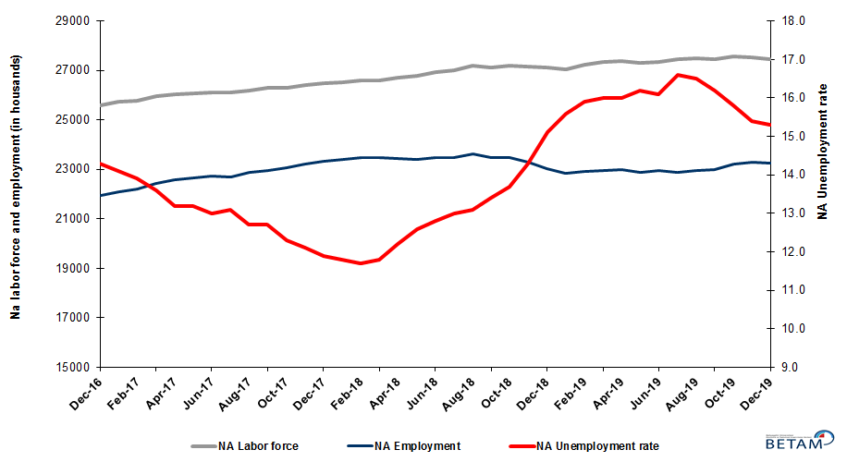
Source: Turk stat, Beta
Unemployment rate is expected to decrease in February 2020

Betam’s forecasting model had predicted that non-agricultural unemployment rate would be 15.0 for January 2020, and non-agricultural unemployment rate occurred as 14.6 percent. We think that the sizable difference between the forecasted rate and the occurrence is due to the unexpected drop in labor force. Our forecasting model predicts a decrease of 0.2 percentage point in non-agricultural unemployment to 14.4 percent in February 2020. Forecasting model details are available on Betam’s website. Kariyer.net application per vacancy series used in the Beta forecasting model is depicted in Figure 3. Kariyer.net series is only one of the inputs of Betam forecast model. Indeed, several variables such as employment agency (İŞKUR) data, reel sector confidence index, capacity utilization rate are used in forecasting.

Figure 2 Seasonally adjusted non-agricultural unemployment rate and application per vacancy
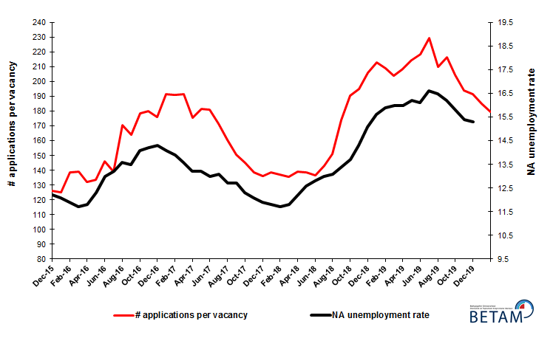
Source: Kariyer.net, Turkstat, Betam

Employment losses in manufacturing and services sectors

According to seasonally adjusted sectorial labor market data, in the period of January 2020 compared to December 2019, employment losses occurred in all sectors except construction (Figure 3, Table 2). After the decrease of 97 thousand in December 2019, employment in agriculture sector decreased by 32 thousand in January 2020. Following the decrease of 7 thousand in December 2019, the number of employed in services sector decreased by 20 thousand. After the decrease of 59 thousand in December 2019, employment in manufacturing sector decreased by 50 thousand in the period of January 2020. Construction is the only sector with the increase of 2 thousandemployed.
Figure 3: Employment by sectors (in thousand)
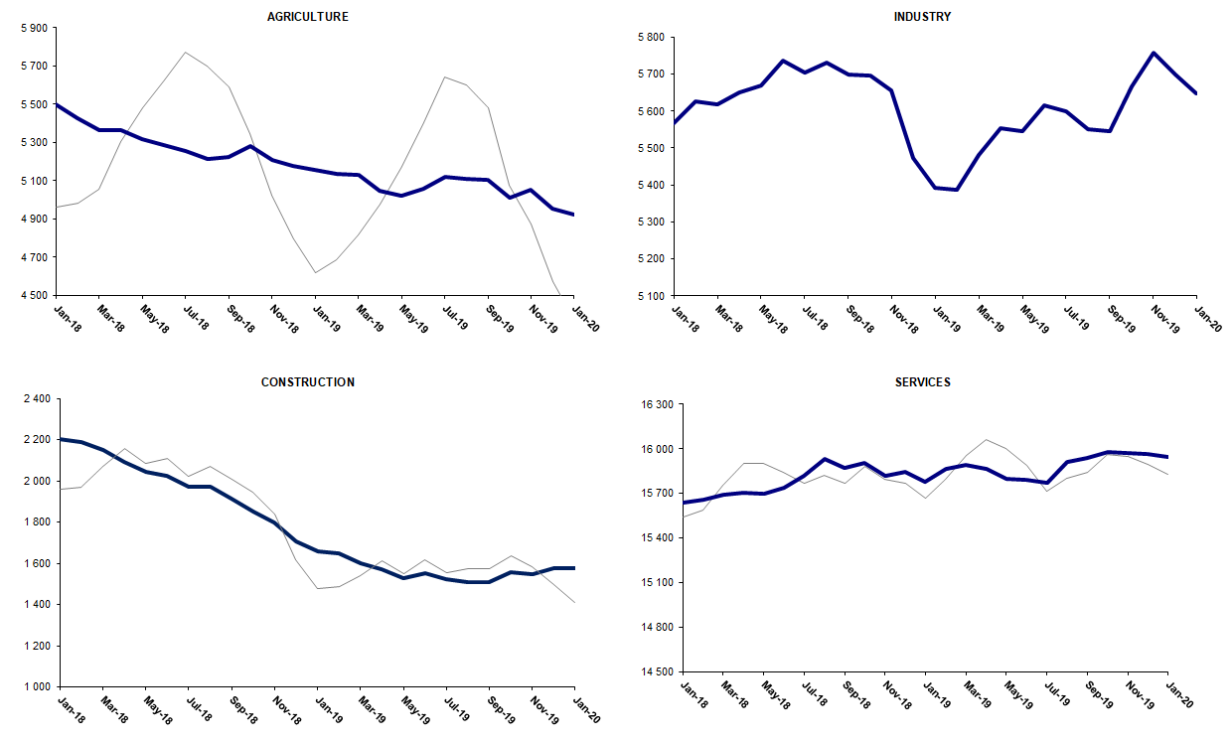
Source: TURKSTAT, Betam

Slowdown in non-agricultural labor force participation, limited increase in employment

Compared to January 2019, non-agricultural labor force increased by 62 thousand (0.2 percent) in January 2020 (Figure 4). The annual growth rate of labor force marked its lowest level in January 2020. While non-institutional working age population continued to increase, labor force participation rate decreases since January 2018. A year after the labor force participation rate recorded at 53.0 percent in January 2019, it dropped to 51.8 percent in January 2020. Year-on-year non-agricultural employment increased by 350 thousand (1.6 percent) and accordingly employment rate fell from 45.9 percent to 45.3 percent. As a result of that, in the period of January 2020 compared to January 2019, the number of non-agricultural unemployed decreased by 288 thousand.

Figure 4 Year-on-year changes in non-agricultural labor force, employment, and unemployment
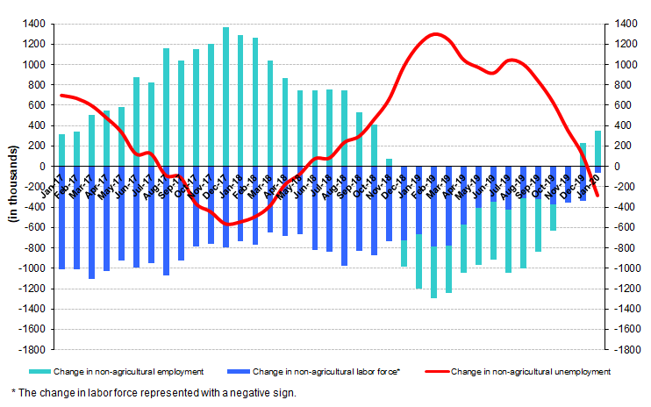
Source: TURKSTAT, Betam

Unemployment decreased for males and females due to lower labor force participation

Figure 5 shows seasonally adjusted non-agricultural unemployment rate for males (green) and for females (purple). In the period of January 2020 compared to the previous month, female non-agricultural unemployment rate decreased by 1.0 percentage point to 19.6 percent. This significant decrease in female unemployment rate resulted from the decrease (58 thousand) in the female labor force and the increase (39 thousand) in the employment. Male unemployment rate turned out to be 12.5 with 0.3 percentage point decrease. Even though male employment decreased by 80 thousand, this improvement in male unemployment rate arises from a decrease of 162 thousand in the male labor force participation. As a result, the gender gap in non-agricultural unemployment rates increased from 7.8 percent to 7.1 percent.

Figure 5: Seasonally adjusted non-agricultural unemployment rate by gender

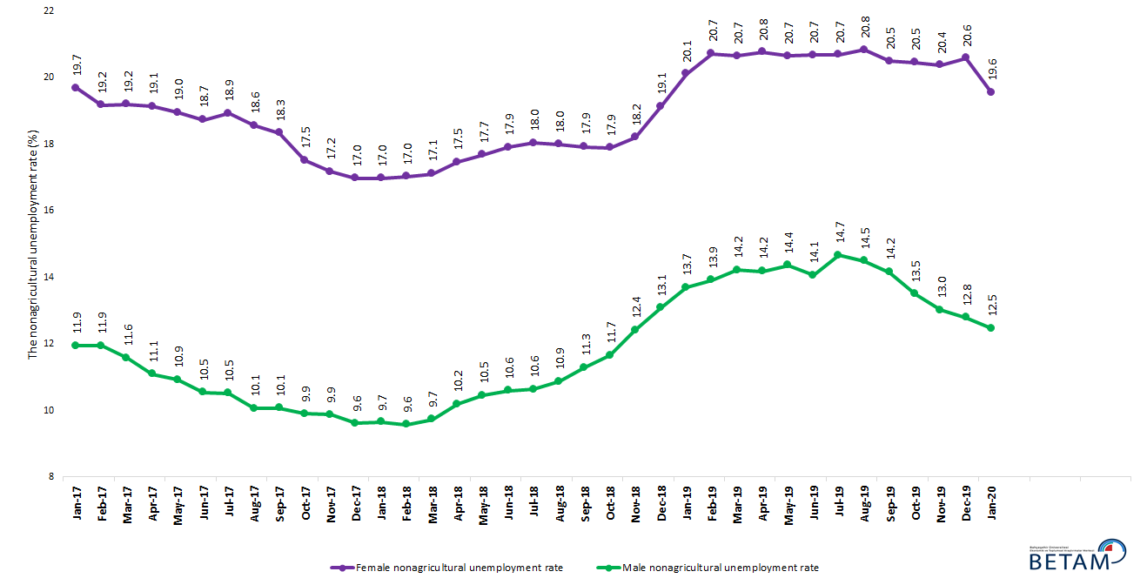

Source: Turk stat, Beta

Table 1 Seasonally adjusted non-agricultural labor market indicators (in thousands) **

 | Labor force | Employment | Unemployment | Unemployment rate | Monthly changes
January-17 | 25718 | 22092 | 3626 | 14.1% | Labor force | Employment | Unemployment
February-17 | 25815 | 22201 | 3614 | 14.0% | 97 | 109 | -12
March-17 | 25990 | 22429 | 3561 | 13.7% | 174 | 228 | -54
April-17 | 26074 | 22580 | 3494 | 13.4% | 84 | 151 | -67
May-17 | 26116 | 22643 | 3473 | 13.3% | 43 | 63 | -20
June-17 | 26144 | 22745 | 3399 | 13.0% | 27 | 102 | -75
July-17 | 26137 | 22713 | 3424 | 13.1% | -7 | -32 | 25
August-17 | 26181 | 22882 | 3299 | 12.6% | 44 | 169 | -125
September-17 | 26247 | 22940 | 3307 | 12.6% | 66 | 58 | 8
October-17 | 26253 | 23050 | 3203 | 12.2% | 6 | 110 | -104
November-17 | 26402 | 23207 | 3195 | 12.1% | 149 | 157 | -8
December-17 | 26427 | 23309 | 3118 | 11.8% | 26 | 102 | -76
January-18 | 26540 | 23408 | 3132 | 11.8% | 112 | 99 | 13
February-18 | 26582 | 23472 | 3110 | 11.7% | 42 | 64 | -22
March-18 | 26628 | 23459 | 3169 | 11.9% | 46 | -13 | 59
April-18 | 26735 | 23447 | 3288 | 12.3% | 108 | -12 | 120
May-18 | 26784 | 23409 | 3375 | 12.6% | 48 | -38 | 86
June-18 | 26948 | 23499 | 3449 | 12.8% | 165 | 90 | 75
July-18 | 26969 | 23490 | 3479 | 12.9% | 21 | -9 | 30
August-18 | 27166 | 23634 | 3532 | 13.0% | 197 | 144 | 53
September-18 | 27084 | 23482 | 3602 | 13.3% | -81 | -152 | 71
October-18 | 27147 | 23455 | 3692 | 13.6% | 63 | -27 | 90
November-18 | 27129 | 23277 | 3852 | 14.2% | -18 | -178 | 160
December-18 | 27053 | 23022 | 4031 | 14.9% | -76 | -255 | 179
January-19 | 27081 | 22829 | 4252 | 15.7% | 28 | -193 | 221
February-19 | 27264 | 22902 | 4362 | 16.0% | 184 | 73 | 111
March-19 | 27416 | 22975 | 4441 | 16.2% | 152 | 73 | 79
April-19 | 27427 | 22984 | 4443 | 16.2% | 11 | 9 | 2
May-19 | 27326 | 22872 | 4454 | 16.3% | -101 | -112 | 11
June-19 | 27397 | 22959 | 4438 | 16.2% | 71 | 87 | -16
July-19 | 27422 | 22897 | 4525 | 16.5% | 24 | -62 | 86
August-19 | 27471 | 22966 | 4505 | 16.4% | 50 | 69 | -19
September-19 | 27402 | 22990 | 4412 | 16.1% | -70 | 24 | -94
October-19 | 27524 | 23203 | 4321 | 15.7% | 123 | 213 | -90
November-19 | 27482 | 23277 | 4205 | 15.3% | -43 | 74 | -117
December-19 | 27370 | 23237 | 4133 | 15.1% | -112 | -40 | -72
January-20 | 27129 | 23168 | 3961 | 14.6% | -241 | -69 | -172

Source: Turk stat, Beta

Table 2 seasonally adjusted employment by sectors (in thousands) *

 | Agriculture | Manufacturing | Construction | Service | Monthly changes
January-17 | 5436 | 5274 | 1956 | 14862 | Agriculture | Manufacturing | Construction | Service
February-17 | 5477 | 5251 | 2008 | 14942 | 41 | -23 | 52 | 80
March-17 | 5385 | 5346 | 2087 | 14997 | -92 | 95 | 79 | 55
April-17 | 5365 | 5372 | 2121 | 15087 | -20 | 26 | 34 | 90
May-17 | 5396 | 5386 | 2085 | 15171 | 31 | 14 | -36 | 84
June-17 | 5406 | 5383 | 2079 | 15283 | 10 | -3 | -6 | 112
July-17 | 5508 | 5363 | 2121 | 15229 | 102 | -20 | 42 | -54
August-17 | 5474 | 5437 | 2169 | 15276 | -34 | 74 | 48 | 47
September-17 | 5499 | 5421 | 2122 | 15398 | 25 | -16 | -47 | 122
October-17 | 5479 | 5470 | 2091 | 15489 | -20 | 49 | -31 | 91
November-17 | 5493 | 5470 | 2130 | 15606 | 14 | 0 | 39 | 117
December-17 | 5552 | 5514 | 2178 | 15617 | 59 | 44 | 48 | 11
January-18 | 5500 | 5567 | 2202 | 15639 | -52 | 53 | 24 | 22
February-18 | 5426 | 5627 | 2187 | 15658 | -74 | 60 | -15 | 19
March-18 | 5366 | 5618 | 2148 | 15694 | -60 | -9 | -39 | 36
April-18 | 5365 | 5650 | 2093 | 15704 | -1 | 32 | -55 | 10
May-18 | 5318 | 5669 | 2043 | 15697 | -47 | 19 | -50 | -7
June-18 | 5284 | 5737 | 2022 | 15740 | -34 | 68 | -21 | 43
July-18 | 5256 | 5703 | 1970 | 15817 | -28 | -34 | -52 | 77
August-18 | 5215 | 5730 | 1971 | 15932 | -41 | 27 | 1 | 115
September-18 | 5223 | 5698 | 1913 | 15871 | 8 | -32 | -58 | -61
October-18 | 5283 | 5696 | 1851 | 15908 | 60 | -2 | -62 | 37
November-18 | 5207 | 5656 | 1800 | 15821 | -76 | -40 | -51 | -87
December-18 | 5178 | 5474 | 1707 | 15842 | -29 | -182 | -93 | 21
January-19 | 5159 | 5392 | 1660 | 15777 | -19 | -82 | -47 | -65
February-19 | 5135 | 5388 | 1648 | 15866 | -24 | -4 | -12 | 89
March-19 | 5129 | 5482 | 1598 | 15894 | -6 | 94 | -50 | 28
April-19 | 5048 | 5553 | 1569 | 15862 | -81 | 71 | -29 | -32
May-19 | 5024 | 5546 | 1526 | 15800 | -24 | -7 | -43 | -62
June-19 | 5057 | 5616 | 1552 | 15791 | 33 | 70 | 26 | -9
July-19 | 5119 | 5600 | 1523 | 15774 | 62 | -16 | -29 | -17
August-19 | 5112 | 5551 | 1507 | 15909 | -7 | -49 | -16 | 135
September-19 | 5104 | 5546 | 1507 | 15936 | -8 | -5 | 0 | 27
October-19 | 5010 | 5666 | 1557 | 15980 | -94 | 120 | 50 | 44
November-19 | 5051 | 5758 | 1549 | 15970 | 41 | 92 | -8 | -10
December-19 | 4954 | 5699 | 1575 | 15963 | -97 | -59 | 26 | -7
January-20 | 4922 | 5649 | 1577 | 15943 | -32 | -50 | 2 | -20

Source: Turk stat, Beta

Table 3: Seasonally adjusted non-agricultural labor force by gender (thousands)

 | Female Labor Force | Female Employment | Female Unemployed | Male Labor Force | Male Employment | Male Unemployed
January-17 | 7493 | 6018 | 1475 | 18240 | 16061 | 2179
February-17 | 7535 | 6090 | 1445 | 18249 | 16070 | 2179
March-17 | 7634 | 6168 | 1466 | 18353 | 16228 | 2125
April-17 | 7634 | 6173 | 1461 | 18427 | 16384 | 2043
May-17 | 7682 | 6226 | 1456 | 18442 | 16428 | 2014
June-17 | 7689 | 6248 | 1441 | 18448 | 16503 | 1945
July-17 | 7667 | 6216 | 1451 | 18444 | 16504 | 1940
August-17 | 7677 | 6252 | 1425 | 18492 | 16633 | 1859
September-17 | 7726 | 6309 | 1417 | 18516 | 16651 | 1865
October-17 | 7752 | 6394 | 1358 | 18496 | 16664 | 1832
November-17 | 7827 | 6482 | 1345 | 18547 | 16715 | 1832
December-17 | 7872 | 6535 | 1337 | 18559 | 16774 | 1785
January-18 | 7957 | 6606 | 1351 | 18601 | 16806 | 1795
February-18 | 7977 | 6618 | 1359 | 18620 | 16837 | 1783
March-18 | 7974 | 6609 | 1365 | 18643 | 16828 | 1815
April-18 | 8028 | 6626 | 1402 | 18720 | 16812 | 1908
May-18 | 8069 | 6642 | 1427 | 18748 | 16788 | 1960
June-18 | 8110 | 6657 | 1453 | 18862 | 16863 | 1999
July-18 | 8092 | 6632 | 1460 | 18885 | 16876 | 2009
August-18 | 8153 | 6685 | 1468 | 18993 | 16929 | 2064
September-18 | 8121 | 6665 | 1456 | 18952 | 16813 | 2139
October-18 | 8202 | 6734 | 1468 | 18911 | 16707 | 2204
November-18 | 8224 | 6726 | 1498 | 18888 | 16542 | 2346
December-18 | 8315 | 6724 | 1591 | 18753 | 16299 | 2454
January-19 | 8402 | 6711 | 1691 | 18699 | 16137 | 2562
February-19 | 8476 | 6719 | 1757 | 18785 | 16170 | 2615
March-19 | 8539 | 6775 | 1764 | 18853 | 16172 | 2681
April-19 | 8499 | 6733 | 1766 | 18926 | 16241 | 2685
May-19 | 8444 | 6700 | 1744 | 18913 | 16197 | 2716
June-19 | 8448 | 6701 | 1747 | 18957 | 16292 | 2665
July-19 | 8405 | 6665 | 1740 | 19060 | 16266 | 2794
August-19 | 8416 | 6662 | 1754 | 19040 | 16280 | 2760
September-19 | 8359 | 6645 | 1714 | 19024 | 16330 | 2694
October-19 | 8423 | 6699 | 1724 | 19052 | 16480 | 2572
November-19 | 8378 | 6670 | 1708 | 19081 | 16598 | 2483
December-19 | 8379 | 6654 | 1725 | 19020 | 16586 | 2434
January-20 | 8321 | 6693 | 1628 | 18858 | 16506 | 2352

Source: Turk stat, Beta

*Prof. Dr. Seyfettin Gürsel, Betam, Director, seyfettin.gursel@eas.bau.edu.tr **Hamza Mutluay, Betam, Research Assistant, hamza.mutluay@eas.bau.edu.tr
For detailed information on Betam's forecasting model, please see Betam Research Brief 168 titled as "Kariyer.net Verisiyle Kısa Vadeli Tarım Dışı İşsizlik Tahmini" . For the innovations in the model please see Betam Research Brief 14 titled as "Mevsim Etkilerinden Arındırılmış İşsizlik Tahmini" Soybilgen, B., "Kariyer.net Verisiyle Kısa Vadeli Tarım Dışı İşsizlik Tahmini", Betam Research Brief 168. http://betam.bahcesehir.edu.tr/tr/2014/06/kariyer-net-verisiyle-kisa-vadeli-tarim-disi-issizlik-tahmini/ Soybilgen, B., "Mevsim Etkilerinden Arındırılmış İşsizlik Tahmini", Betam Research Brief 14 http://betam.bahcesehir.edu.tr/2015/08/mevsim-etkilerinden-arindirilmis-tarim-disi-issizlik-tahmini/
Betam has been calculating application per vacancy using series released by Kariyer.net for a while. Seasonal and calendar adjustment procedure is applied to application per vacancy series. A decrease in applications per vacancy may be caused by an increase in vacancies or by a decrease in the number of applications. An increase in vacancies signals economic growth while decreasing number of applications indicates a decrease in number of people looking for a job. Monthly labor market series released by TurkStat is the average of three months. Therefore, application per vacancy statistics calculated using Kariyer.net series is the average of three months as well.
Employment in each sector is seasonally adjusted separately. Hence the sum of these series may differ from the seasonally adjusted series of total employment. The difference stems from the non-linearity of the seasonal adjustment process.
Turkstat revised the labor market statistics drastically in February 2014. Within this framework, they back casted various labor market indicators and they also continued to announce seasonally adjusted series. However, Turkstat is not providing back-casted series by gender. Therefore, female and male labor market statistics are not sufficiently long for the seasonal adjustment procedures (There should be minimum 36 observations). With the announcement of the period of February 2017 data, the number of observations required for the seasonal decontamination process was provided. From this period Betam generated seasonal adjustment series in terms of gender. Nevertheless, it should not be forgotten that seasonal adjustment may cause extra volatility in the series for at least a while.

