Labor Market Outlook:
March 2020

11 March 2020

DROP IN EMPLOYMENT AND LABOR FORCE RESULTED IN LIMITED DECREASE IN UNEMPLOYMENT

Seyfettin Gürsel*, Mehmet Cem Şahin **

Executive Summary

Seasonally adjusted labor market data shows that in the period of December 2019, non-agricultural unemployment rate turned out to be 15.3 percent, with 0.1 percentage point decrease compared to November 2019. In this period, non-agricultural employment decreased by 40 thousand while non-agricultural labor force decreased by 80 thousand. According to sectorial data, employment losses occurred in all sectors except construction. While construction employment increased by 25 thousand, manufacturing employment and services employment decreased by 59 thousand and 6 thousand, respectively. Based on the seasonally adjusted data, while male non-agricultural unemployment rate continued to decrease, female non-agricultural unemployment rate remained unchanged.

Decreases in all non-agricultural labor market indicators

Seasonally adjusted data shows that, non-agricultural labor force reached 27 million 443 thousand after the decrease of 80 thousand in November 2019, while non-agricultural employment reached 23 million 244 thousand following an increase of 40 thousand (Figure 1, Table 1). Thus, labor force decreased for the tenth time over the last thirty six period (December 2016- December 2019), and employment decreased for the thirteenth time over the same period. As a result of the developments in labor force and employment, non-agricultural unemployment decreased by 40 thousand and reached 4 million 199 thousand, and non-agricultural unemployment rate dropped to 15.3 percent.

Figure 1. Seasonally adjusted non-agricultural labor force, employment, and unemployment
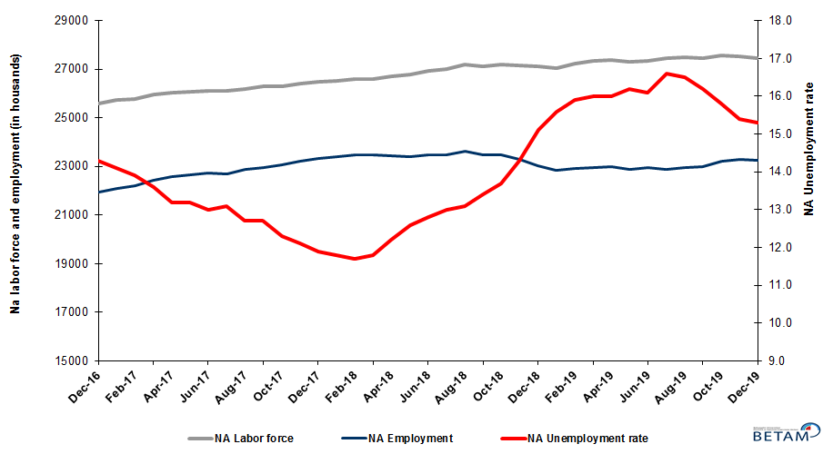
Source: Turkstat, Betam
Unemployment rate is expected to decrease in January 2020

Betam’s forecasting model had predicted that non-agricultural unemployment rate would be 15.3 for December 2019, and non-agricultural unemployment rate occurred as 15.3 percent, in line with the forecast. Our forecasting model predicts a decrease of 0.3 percentage point in non-agricultural unemployment to 15.0 percent in January 2020. Forecasting model details are available on Betam's website. Kariyer.net application per vacancy series used in the Betam forecasting model is depicted in Figure 3. Kariyer.net series is only one of the inputs of Betam forecast model. Indeed, several variables such as employment agency (İŞKUR) data, reel sector confidence index, capacity utilization rate are used in forecasting.

Figure 2 Seasonally adjusted non-agricultural unemployment rate and application per vacancy
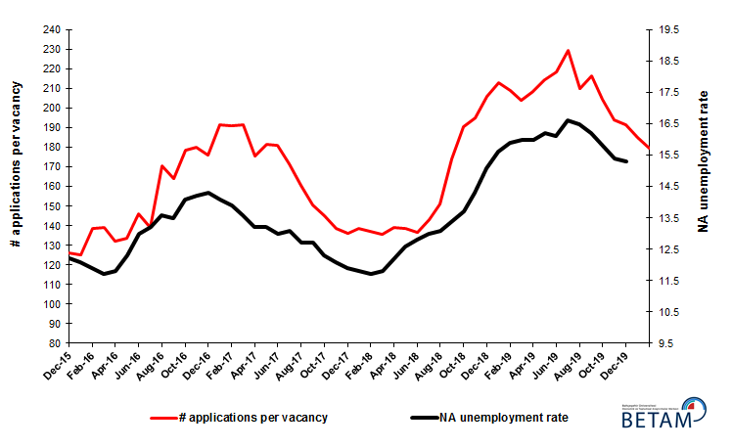
Source: Kariyer.net, Turkstat, Betam

Employment losses in all sectors except construction

According to seasonally adjusted sectorial labor market data, in the period of December 2019 compared to November 2019, employment losses occurred in all sectors except construction (Figure 3, Table 2). After the increase of 41 thousand in November 2019, employment in agriculture sector decreased by 96 thousand. Following the decrease of 8 thousand in November 2019, the number of employed in services sector decreased by 6 thousand. Employment in construction sector increased by 25 thousand. It is worth to note that the employment increase reached 72 thousand in the last 4 months. This might signal that the sizable employment losses in this sector is over. On the other hand, the number of employed people in manufacturing sector decreased by 59 thousand in the period of December 2019 while the increase had reached 212 thousand in the previous two months.
Figure 3: Employment by sectors (in thousand)
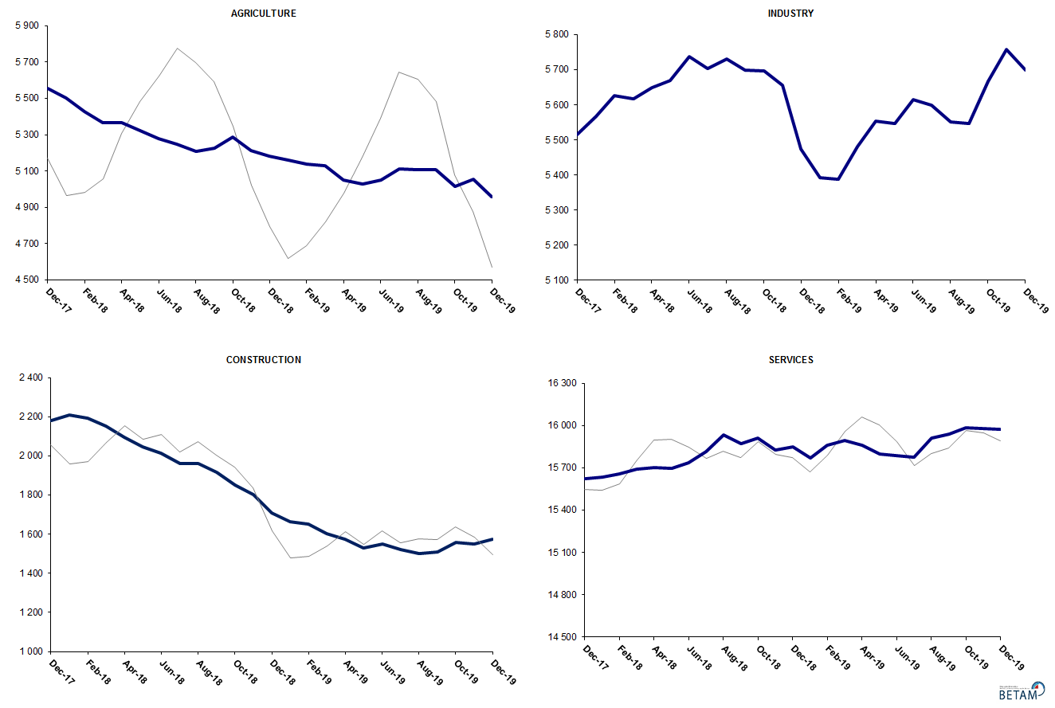
Source: TURKSTAT, Betam

Limited year-on-year increases in labor force and employment

Compared to December 2018, non-agricultural labor force increased by 335 thousand (1.2 percent) and non-agricultural employment increased by 228 thousand (1 percent) (Figure 4). The annual growth rate of labor force marked its third lowest level over the period of January 2006-December 2019. The two previous cases were observed in November 2007 (0.9 percent) and August 2019 (1.1 percent). Year-on-year non-agricultural employment increased (228 thousand) markedly for the first time since November 2018. As a result of that, the number of non-agricultural unemployed increased by 107 thousand.

Figure 4 Year-on-year changes in non-agricultural labor force, employment, and unemployment
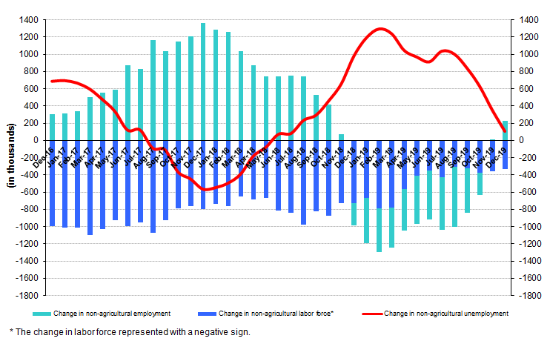
Source: TURKSTAT, Betam

Unemployment decreased for males but remained unchanged for females

Figure 5 shows seasonally adjusted non-agricultural unemployment rate for males (green) and for females (purple). In the period of December 2019, compared to the previous month, female non-agricultural unemployment rate remained unchanged and stood at 20.7 percent, while male non-agricultural unemployment rate decreased by 0.2 percentage points to 13.0 percent. As a result, the gender gap in non-agricultural unemployment rates increased from 7.5 percent to 7.7 percent.

Along with the decrease of 16 thousand in female non-agricultural employment, female non-agricultural labor force decreased by 16 thousand. Male employment increased by 72 thousand and male labor force increased by 45 thousand (Table 3). Since December 2018, male labor force and female labor force increased by 259 thousand and 63 thousand respectively. It is noteworthy that growth rate of overall labor force is positive but below its structural trend and female labor force nearly stopped to grow.

Figure 5: Seasonally adjusted non-agricultural unemployment rate by gender

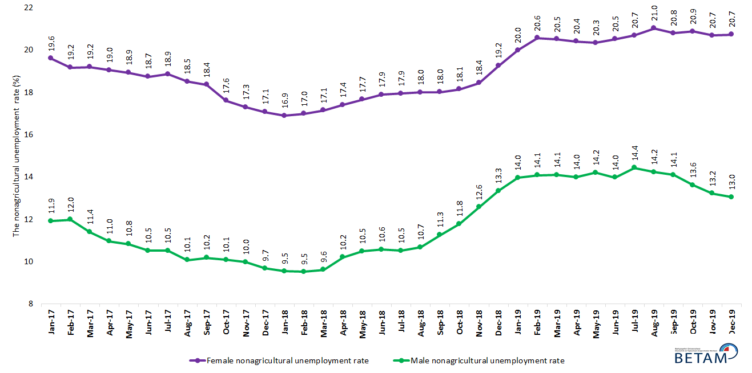

Source: Turkstat, Betam

Table 1 Seasonally adjusted non-agricultural labor market indicators (in thousands) **

 | Labor force | Employment | Unemployment | Unemployment rate | Monthly changes
December-16 | 25606 | 21944 | 3662 | 14.3% | Labor force | Employment | Unemployment
January-17 | 25722 | 22095 | 3627 | 14.1% | 116 | 151 | -35
February-17 | 25790 | 22205 | 3585 | 13.9% | 68 | 110 | -42
March-17 | 25965 | 22434 | 3531 | 13.6% | 175 | 229 | -54
April-17 | 26020 | 22585 | 3435 | 13.2% | 54 | 151 | -97
May-17 | 26091 | 22647 | 3444 | 13.2% | 71 | 62 | 9
June-17 | 26128 | 22731 | 3397 | 13.0% | 37 | 84 | -47
July-17 | 26121 | 22699 | 3422 | 13.1% | -7 | -32 | 25
August-17 | 26194 | 22867 | 3327 | 12.7% | 73 | 168 | -95
September-17 | 26284 | 22946 | 3338 | 12.7% | 90 | 79 | 11
October-17 | 26290 | 23056 | 3234 | 12.3% | 6 | 110 | -104
November-17 | 26410 | 23214 | 3196 | 12.1% | 120 | 158 | -38
December-17 | 26467 | 23317 | 3150 | 11.9% | 57 | 103 | -46
January-18 | 26540 | 23408 | 3132 | 11.8% | 73 | 91 | -18
February-18 | 26583 | 23473 | 3110 | 11.7% | 44 | 65 | -21
March-18 | 26600 | 23461 | 3139 | 11.8% | 17 | -12 | 29
April-18 | 26706 | 23448 | 3258 | 12.2% | 106 | -13 | 119
May-18 | 26786 | 23411 | 3375 | 12.6% | 80 | -37 | 117
June-18 | 26937 | 23489 | 3448 | 12.8% | 151 | 78 | 73
July-18 | 26990 | 23481 | 3509 | 13.0% | 53 | -8 | 61
August-18 | 27186 | 23625 | 3561 | 13.1% | 197 | 144 | 53
September-18 | 27121 | 23487 | 3634 | 13.4% | -65 | -138 | 73
October-18 | 27185 | 23461 | 3724 | 13.7% | 64 | -26 | 90
November-18 | 27168 | 23283 | 3885 | 14.3% | -17 | -178 | 161
December-18 | 27125 | 23029 | 4096 | 15.1% | -43 | -254 | 211
January-19 | 27045 | 22826 | 4219 | 15.6% | -80 | -203 | 123
February-19 | 27231 | 22901 | 4330 | 15.9% | 186 | 75 | 111
March-19 | 27350 | 22974 | 4376 | 16.0% | 119 | 73 | 46
April-19 | 27363 | 22985 | 4378 | 16.0% | 13 | 11 | 2
May-19 | 27295 | 22873 | 4422 | 16.2% | -68 | -112 | 44
June-19 | 27356 | 22952 | 4404 | 16.1% | 62 | 79 | -17
July-19 | 27448 | 22892 | 4556 | 16.6% | 92 | -60 | 152
August-19 | 27501 | 22963 | 4538 | 16.5% | 52 | 71 | -19
September-19 | 27439 | 22994 | 4445 | 16.2% | -61 | 31 | -92
October-19 | 27564 | 23209 | 4355 | 15.8% | 125 | 215 | -90
November-19 | 27522 | 23284 | 4238 | 15.4% | -42 | 75 | -117
December-19 | 27443 | 23244 | 4199 | 15.3% | -80 | -40 | -40

Source: Turkstat, Betam

Table 2 Seasonally adjusted employment by sectors (in thousands) *

 | Agriculture | Manufacturing | Construction | Service | Monthly changes
December-16 | 5313 | 5265 | 1954 | 14724 | Agriculture | Manufacturing | Construction | Service
January-17 | 5440 | 5274 | 1963 | 14858 | 127 | 9 | 9 | 134
February-17 | 5481 | 5251 | 2014 | 14940 | 41 | -23 | 51 | 82
March-17 | 5388 | 5346 | 2092 | 14996 | -93 | 95 | 78 | 56
April-17 | 5368 | 5372 | 2126 | 15087 | -20 | 26 | 34 | 91
May-17 | 5400 | 5386 | 2091 | 15170 | 32 | 14 | -35 | 83
June-17 | 5395 | 5383 | 2067 | 15282 | -5 | -3 | -24 | 112
July-17 | 5497 | 5363 | 2108 | 15228 | 102 | -20 | 41 | -54
August-17 | 5463 | 5437 | 2154 | 15276 | -34 | 74 | 46 | 48
September-17 | 5503 | 5421 | 2126 | 15399 | 40 | -16 | -28 | 123
October-17 | 5484 | 5470 | 2095 | 15491 | -19 | 49 | -31 | 92
November-17 | 5497 | 5470 | 2133 | 15611 | 13 | 0 | 38 | 120
December-17 | 5556 | 5514 | 2181 | 15622 | 59 | 44 | 48 | 11
January-18 | 5502 | 5567 | 2207 | 15633 | -54 | 53 | 26 | 11
February-18 | 5428 | 5627 | 2191 | 15655 | -74 | 60 | -16 | 22
March-18 | 5368 | 5618 | 2152 | 15692 | -60 | -9 | -39 | 37
April-18 | 5368 | 5650 | 2096 | 15702 | 0 | 32 | -56 | 10
May-18 | 5321 | 5669 | 2048 | 15694 | -47 | 19 | -48 | -8
June-18 | 5276 | 5737 | 2014 | 15738 | -45 | 68 | -34 | 44
July-18 | 5248 | 5703 | 1962 | 15816 | -28 | -34 | -52 | 78
August-18 | 5207 | 5730 | 1962 | 15934 | -41 | 27 | 0 | 118
September-18 | 5227 | 5698 | 1915 | 15874 | 20 | -32 | -47 | -60
October-18 | 5287 | 5696 | 1852 | 15913 | 60 | -2 | -63 | 39
November-18 | 5211 | 5656 | 1801 | 15826 | -76 | -40 | -51 | -87
December-18 | 5182 | 5474 | 1707 | 15848 | -29 | -182 | -94 | 22
January-19 | 5160 | 5392 | 1664 | 15769 | -22 | -82 | -43 | -79
February-19 | 5136 | 5388 | 1651 | 15861 | -24 | -4 | -13 | 92
March-19 | 5131 | 5482 | 1601 | 15891 | -5 | 94 | -50 | 30
April-19 | 5049 | 5553 | 1572 | 15860 | -82 | 71 | -29 | -31
May-19 | 5026 | 5546 | 1530 | 15797 | -23 | -7 | -42 | -63
June-19 | 5050 | 5616 | 1548 | 15788 | 24 | 70 | 18 | -9
July-19 | 5112 | 5600 | 1519 | 15773 | 62 | -16 | -29 | -15
August-19 | 5105 | 5551 | 1501 | 15911 | -7 | -49 | -18 | 138
September-19 | 5108 | 5546 | 1509 | 15940 | 3 | -5 | 8 | 29
October-19 | 5014 | 5666 | 1557 | 15986 | -94 | 120 | 48 | 46
November-19 | 5055 | 5758 | 1548 | 15978 | 41 | 92 | -9 | -8
December-19 | 4959 | 5699 | 1573 | 15972 | -96 | -59 | 25 | -6

Source: Turkstat, Betam

Table 3: Seasonally adjusted non-agricultural labor force by gender (thousands)

 | Female Labor Force | Female Employment | Female Unemployed | Male Labor Force | Male Employment | Male Unemployed
January-17 | 7452 | 5992 | 1460 | 18296 | 16116 | 2180
February-17 | 7498 | 6060 | 1438 | 18289 | 16098 | 2191
March-17 | 7598 | 6139 | 1459 | 18340 | 16251 | 2089
April-17 | 7603 | 6155 | 1448 | 18385 | 16371 | 2014
May-17 | 7667 | 6215 | 1451 | 18395 | 16404 | 1992
June-17 | 7677 | 6238 | 1439 | 18442 | 16503 | 1939
July-17 | 7695 | 6244 | 1451 | 18439 | 16499 | 1940
August-17 | 7715 | 6286 | 1428 | 18496 | 16633 | 1863
September-17 | 7777 | 6349 | 1428 | 18509 | 16625 | 1884
October-17 | 7774 | 6405 | 1369 | 18507 | 16641 | 1866
November-17 | 7842 | 6485 | 1357 | 18556 | 16704 | 1852
December-17 | 7888 | 6541 | 1347 | 18587 | 16789 | 1798
January-18 | 7924 | 6584 | 1339 | 18600 | 16825 | 1775
February-18 | 7937 | 6589 | 1348 | 18616 | 16845 | 1772
March-18 | 7928 | 6569 | 1359 | 18656 | 16862 | 1794
April-18 | 7990 | 6599 | 1391 | 18721 | 16811 | 1910
May-18 | 8043 | 6623 | 1420 | 18746 | 16780 | 1966
June-18 | 8085 | 6638 | 1447 | 18842 | 16850 | 1992
July-18 | 8105 | 6651 | 1454 | 18835 | 16854 | 1982
August-18 | 8188 | 6714 | 1474 | 18942 | 16918 | 2023
September-18 | 8178 | 6705 | 1473 | 18912 | 16782 | 2130
October-18 | 8249 | 6753 | 1496 | 18894 | 16668 | 2226
November-18 | 8261 | 6737 | 1524 | 18873 | 16500 | 2373
December-18 | 8342 | 6737 | 1606 | 18843 | 16330 | 2513
January-19 | 8366 | 6693 | 1672 | 18842 | 16213 | 2630
February-19 | 8427 | 6694 | 1733 | 18901 | 16240 | 2661
March-19 | 8470 | 6733 | 1738 | 18905 | 16240 | 2665
April-19 | 8421 | 6702 | 1719 | 18882 | 16241 | 2642
May-19 | 8379 | 6674 | 1705 | 18878 | 16196 | 2682
June-19 | 8405 | 6681 | 1725 | 18893 | 16254 | 2639
July-19 | 8426 | 6683 | 1743 | 18962 | 16226 | 2736
August-19 | 8477 | 6694 | 1782 | 18950 | 16254 | 2696
September-19 | 8443 | 6687 | 1756 | 18972 | 16299 | 2673
October-19 | 8491 | 6717 | 1773 | 19021 | 16431 | 2590
November-19 | 8421 | 6679 | 1742 | 19058 | 16539 | 2518
December-19 | 8405 | 6663 | 1743 | 19102 | 16611 | 2492

Source: Turkstat, Betam

*Prof. Dr. Seyfettin Gürsel, Betam, Director, seyfettin.gursel@eas.bau.edu.tr **Mehmet Cem Şahin, Betam, Research Assistant, mehmetcem.sahin@eas.bau.edu.tr
For detailed information on Betam's forecasting model, please see Betam Research Brief 168 titled as "Kariyer.net Verisiyle Kısa Vadeli Tarım Dışı İşsizlik Tahmini" . For the innovations in the model please see Betam Research Brief 14 titled as "Mevsim Etkilerinden Arındırılmış İşsizlik Tahmini" Soybilgen, B., "Kariyer.net Verisiyle Kısa Vadeli Tarım Dışı İşsizlik Tahmini", Betam Research Brief 168. http://betam.bahcesehir.edu.tr/tr/2014/06/kariyer-net-verisiyle-kisa-vadeli-tarim-disi-issizlik-tahmini/ Soybilgen, B., "Mevsim Etkilerinden Arındırılmış İşsizlik Tahmini", Betam Research Brief 14 http://betam.bahcesehir.edu.tr/2015/08/mevsim-etkilerinden-arindirilmis-tarim-disi-issizlik-tahmini/
Betam has been calculating application per vacancy using series released by Kariyer.net for a while. Seasonal and calendar adjustment procedure is applied to application per vacancy series. A decrease in applications per vacancy may be caused by an increase in vacancies or by a decrease in the number of applications. An increase in vacancies signals economic growth while decreasing number of applications indicates a decrease in number of people looking for a job. Monthly labor market series released by TurkStat is the average of three months. Therefore, application per vacancy statistics calculated using Kariyer.net series is the average of three months as well.
Employment in each sector is seasonally adjusted separately. Hence the sum of these series may differ from the seasonally adjusted series of total employment. The difference stems from the non-linearity of the seasonal adjustment process.
Turkstat revised the labor market statistics drastically in February 2014. Within this framework, they back casted various labor market indicators and they also continued to announce seasonally adjusted series. However, Turkstat is not providing back-casted series by gender. Therefore, female and male labor market statistics are not sufficiently long for the seasonal adjustment procedures (There should be minimum 36 observations). With the announcement of the period of February 2017 data, the number of observations required for the seasonal decontamination process was provided. From this period Betam generated seasonal adjustment series in terms of gender. Nevertheless, it should not be forgotten that seasonal adjustment may cause extra volatility in the series for at least a while.

