Labor Market Outlook:
February 2020

11 February 2020

INCREASE IN MANUFACTURING EMPLOYMENT COMBINED WITH DECREASE IN LABOR FORCE PARTICIPATION CAUSED SIZABLE DROP IN UNEMPLOYMENT

Seyfettin Gürsel*, Mehmet Cem Şahin **

Executive Summary

Seasonally adjusted labor market data shows that in the period of November 2019, non-agricultural unemployment rate turned out to be 15.5 percent, with 0.3 percentage point decrease compared to October 2019. In this period, non-agricultural employment increased by 75 thousand while non-agricultural labor force decreased by 9 thousand. According to sectorial data, while agriculture and manufacturing employment increased, losses occurred in construction and services. Manufacturing employment increased by 92 thousand, while construction and services employment decreased by 10 thousand and 8 thousand, respectively. Based on the seasonally adjusted data, male non-agricultural employment increased by 101 thousand and female non-agricultural employment decreased by 38 thousand.

Increase in employment and decrease in labor force participation

Seasonally adjusted data shows that non-agricultural labor force reached 27 million 551 thousand after the decrease of 9 thousand in November 2019, while non-agricultural employment reached 23 million 281 thousand following an increase of 75 thousand (Figure 1, Table 1). As a result, non-agricultural unemployment decreased by 84 thousand and reached 4 million 270 thousand, and non-agricultural unemployment rate dropped to 15.5 percent.

Figure 1. Seasonally adjusted non-agricultural labor force, employment, and unemployment
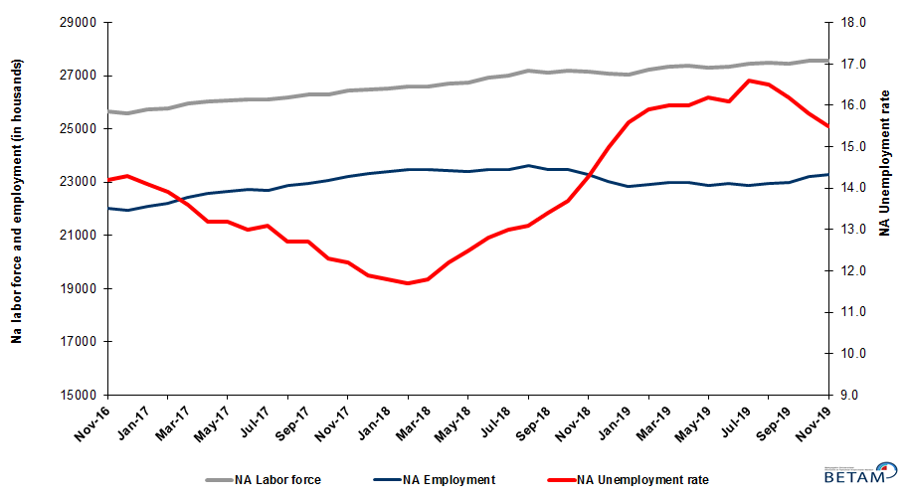

Source: Turkstat, Betam

Unemployment rate is expected to decrease in December 2019

Betam’s forecasting model had predicted that non-agricultural unemployment rate would be 15.7 for November 2019 while the decrease attained 15.5 percent. Our forecasting model predicts a decrease of 0.2 percentage point in non-agricultural unemployment to 15.3 percent in December 2019. Forecasting model details are available on Betam's website. Kariyer.net application per vacancy series used in the Betam forecasting model is depicted in Figure 3. Kariyer.net series is only one of the inputs of Betam forecast model. Indeed, several variables such as employment agency (İŞKUR) data, reel sector confidence index, capacity utilization rate are used in forecasting.

Figure 2 Seasonally adjusted non-agricultural unemployment rate and application per vacancy
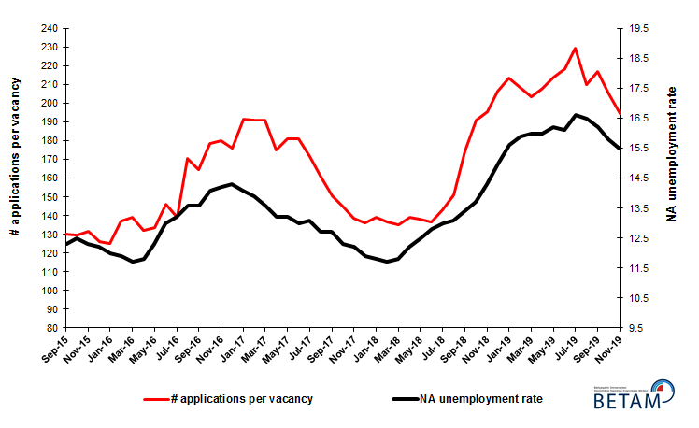
Source: Kariyer.net, Turkstat, Betam

Gains in agriculture and manufacturing, losses in services and construction employment

According to seasonally adjusted sectorial labor market data, employment increased in the period of November 2019 compared to October 2019 in agriculture and manufacturing sector (Figure 3, Table 2). After the decrease of 89 thousand in September 2019, employment in agriculture sector increased by 45 thousand. After the increase of 48 thousand in October 2019, the number of employed in services sector decreased by 8 thousand. Most significant change in the number of employed people occurred in manufacturing sector, with a sizable gain of 92 thousand in November 2019
Figure 3: Employment by sectors (in thousand)
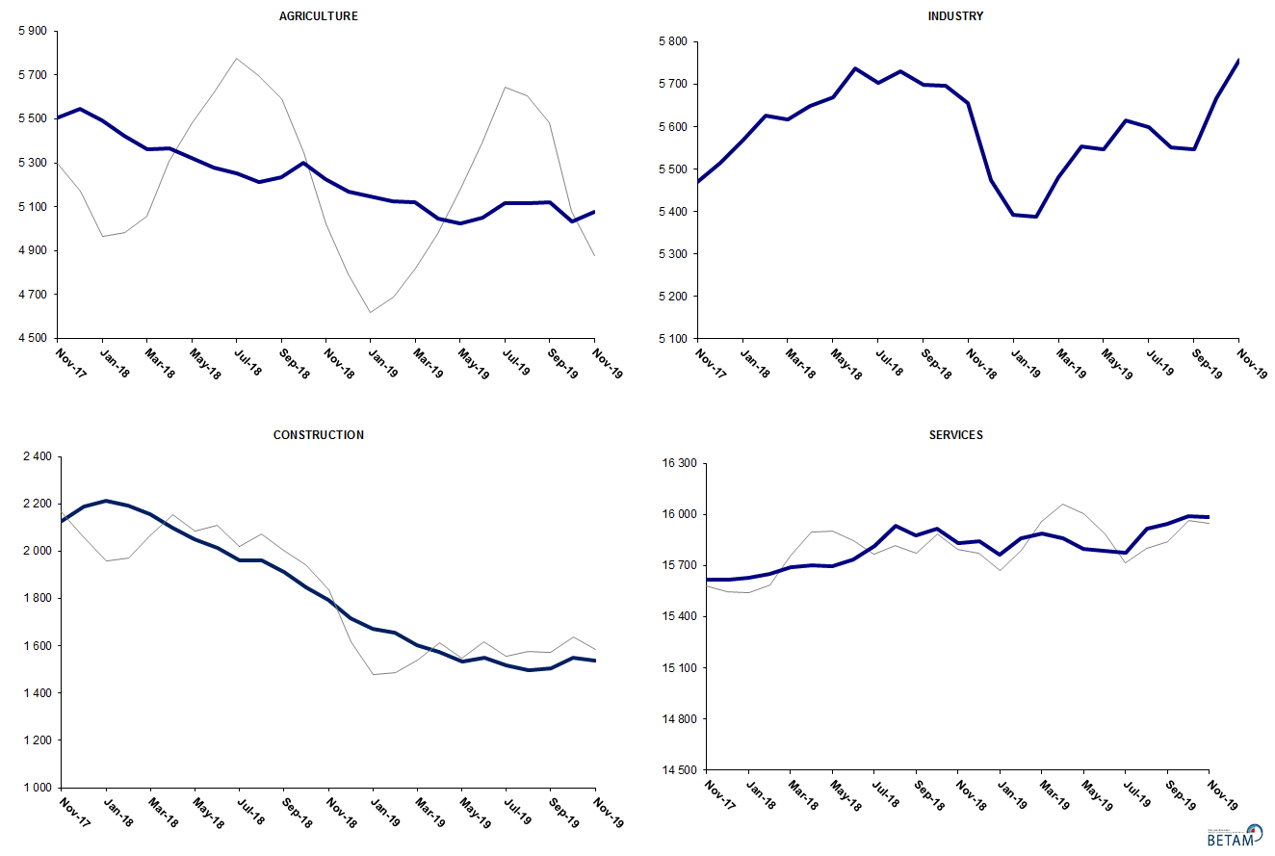
Source: TURKSTAT, Betam

Non-agricultural employment reversed its year-on-year decrease after 11 months

Compared to November 2018, non-agricultural labor force increased by 356 thousand (1.3 percent) and non-agricultural employment increased by 2 thousand (0.01 percent) (Figure 4). The annual growth rate of labor force remained well below its normal tendency. Year-on-year decrease in employment came to a halt after 11 consecutive months; compared to November 2018, the number of non-agricultural unemployed increased by 354 thousand.

Figure 4 Year-on-year changes in non-agricultural labor force, employment, and unemployment
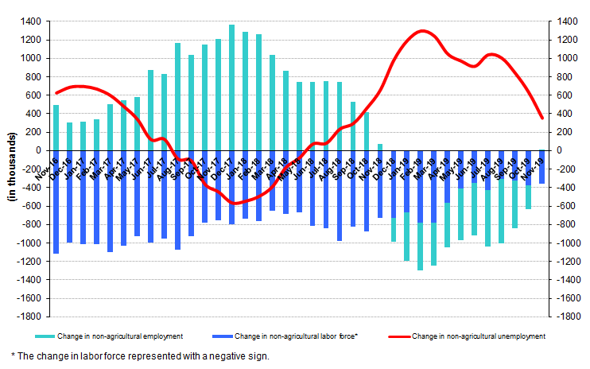
Source: TURKSTAT, Betam

Strong increase in male employment

Figure 5 shows seasonally adjusted non-agricultural unemployment rate for males (green) and for females (purple). In the period of November 2019, compared to the previous month, female non-agricultural unemployment rate decreased by 0.1 percentage point and reached 20.8 percent, while male non-agricultural unemployment rate decreased by 0.4 percentage points to 13.3 percent. As a result, the gender gap in non-agricultural unemployment rates increased from 7.2 percent to 7.5 percent.

Along with the decrease of 38 thousand in female non-agricultural employment, female non-agricultural labor force decreased by 55 thousand. The decline in female unemployment resulted from the decrease in female labor force. Male employment increased by 101 thousand and male labor force increased by 36 thousand (Table 3). Since November 2018, male labor force and female labor force increased by 184 thousand and 167 thousand respectively. Level of year-on-year increase in male labor force exceeded level of year-on-year increase in female labor force for the first time in 2019.

Figure 5: Seasonally adjusted non-agricultural unemployment rate by gender

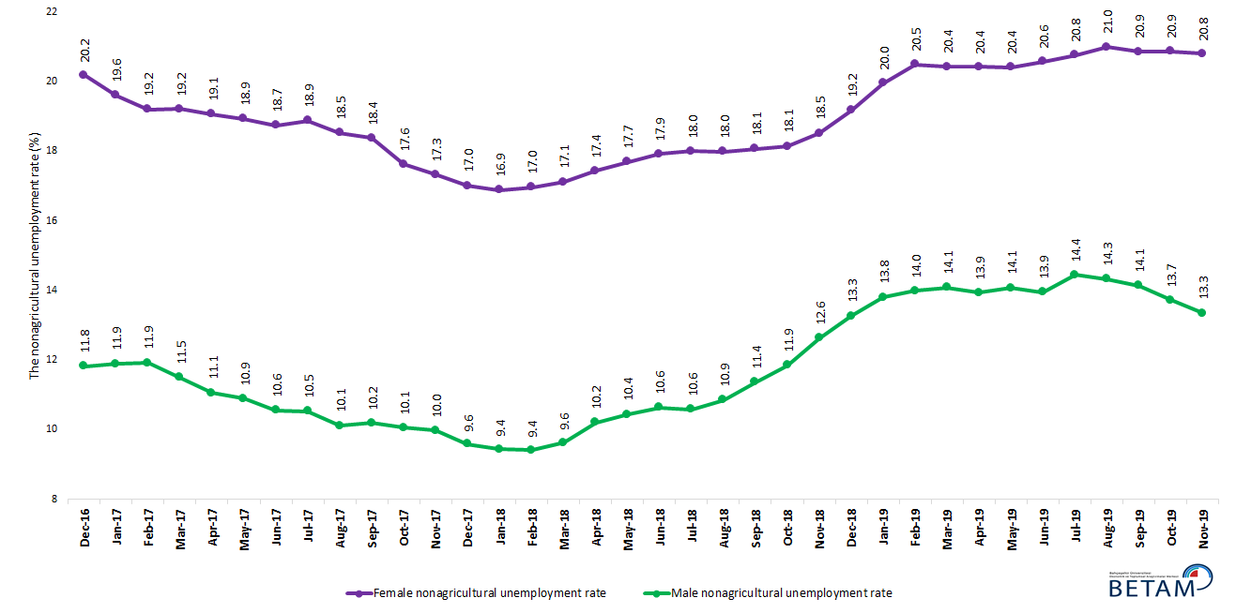

Source: Turkstat, Betam

Table 1 Seasonally adjusted non-agricultural labor market indicators (in thousands) **

 | Labor force | Employment | Unemployment | Unemployment rate | Monthly changes
November-16 | 25667 | 22022 | 3645 | 14.2% | Labor force | Employment | Unemployment
December-16 | 25607 | 21945 | 3662 | 14.3% | -60 | -77 | 17
January-17 | 25722 | 22095 | 3627 | 14.1% | 115 | 150 | -35
February-17 | 25791 | 22206 | 3585 | 13.9% | 69 | 111 | -42
March-17 | 25964 | 22433 | 3531 | 13.6% | 173 | 227 | -54
April-17 | 26020 | 22585 | 3435 | 13.2% | 55 | 152 | -97
May-17 | 26091 | 22647 | 3444 | 13.2% | 71 | 62 | 9
June-17 | 26129 | 22732 | 3397 | 13.0% | 38 | 85 | -47
July-17 | 26122 | 22700 | 3422 | 13.1% | -7 | -32 | 25
August-17 | 26192 | 22866 | 3326 | 12.7% | 70 | 166 | -96
September-17 | 26284 | 22946 | 3338 | 12.7% | 92 | 80 | 12
October-17 | 26291 | 23057 | 3234 | 12.3% | 7 | 111 | -104
November-17 | 26440 | 23214 | 3226 | 12.2% | 149 | 157 | -8
December-17 | 26469 | 23319 | 3150 | 11.9% | 29 | 105 | -76
January-18 | 26541 | 23409 | 3132 | 11.8% | 72 | 90 | -18
February-18 | 26584 | 23474 | 3110 | 11.7% | 44 | 65 | -21
March-18 | 26601 | 23462 | 3139 | 11.8% | 17 | -12 | 29
April-18 | 26707 | 23449 | 3258 | 12.2% | 106 | -13 | 119
May-18 | 26757 | 23412 | 3345 | 12.5% | 49 | -37 | 86
June-18 | 26937 | 23489 | 3448 | 12.8% | 180 | 77 | 103
July-18 | 26990 | 23481 | 3509 | 13.0% | 53 | -8 | 61
August-18 | 27186 | 23625 | 3561 | 13.1% | 197 | 144 | 53
September-18 | 27120 | 23486 | 3634 | 13.4% | -66 | -139 | 73
October-18 | 27184 | 23460 | 3724 | 13.7% | 64 | -26 | 90
November-18 | 27167 | 23282 | 3885 | 14.3% | -17 | -178 | 161
December-18 | 27095 | 23031 | 4064 | 15.0% | -72 | -251 | 179
January-19 | 27046 | 22827 | 4219 | 15.6% | -49 | -204 | 155
February-19 | 27231 | 22901 | 4330 | 15.9% | 184 | 74 | 110
March-19 | 27352 | 22976 | 4376 | 16.0% | 122 | 75 | 47
April-19 | 27364 | 22986 | 4378 | 16.0% | 12 | 10 | 2
May-19 | 27296 | 22874 | 4422 | 16.2% | -68 | -112 | 44
June-19 | 27356 | 22952 | 4404 | 16.1% | 60 | 78 | -18
July-19 | 27447 | 22891 | 4556 | 16.6% | 91 | -61 | 152
August-19 | 27499 | 22962 | 4537 | 16.5% | 52 | 71 | -19
September-19 | 27439 | 22994 | 4445 | 16.2% | -60 | 32 | -92
October-19 | 27561 | 23206 | 4355 | 15.8% | 121 | 212 | -91
November-19 | 27551 | 23281 | 4270 | 15.5% | -9 | 75 | -84

Source: Turkstat, Betam

Table 2 Seasonally adjusted employment by sectors (in thousands) *

 | Agriculture | Manufacturing | Construction | Service | Monthly changes
November-16 | 5277 | 5316 | 1986 | 14720 | Agriculture | Manufacturing | Construction | Service
December-16 | 5307 | 5265 | 1958 | 14721 | 30 | -51 | -28 | 1
January-17 | 5434 | 5274 | 1966 | 14856 | 127 | 9 | 8 | 135
February-17 | 5476 | 5251 | 2016 | 14939 | 42 | -23 | 50 | 83
March-17 | 5385 | 5346 | 2092 | 14995 | -91 | 95 | 76 | 56
April-17 | 5366 | 5372 | 2126 | 15086 | -19 | 26 | 34 | 91
May-17 | 5399 | 5386 | 2092 | 15169 | 33 | 14 | -34 | 83
June-17 | 5396 | 5383 | 2067 | 15282 | -3 | -3 | -25 | 113
July-17 | 5499 | 5363 | 2108 | 15229 | 103 | -20 | 41 | -53
August-17 | 5467 | 5437 | 2152 | 15277 | -32 | 74 | 44 | 48
September-17 | 5508 | 5421 | 2124 | 15401 | 41 | -16 | -28 | 124
October-17 | 5491 | 5470 | 2093 | 15494 | -17 | 49 | -31 | 93
November-17 | 5507 | 5470 | 2129 | 15615 | 16 | 0 | 36 | 121
December-17 | 5547 | 5514 | 2187 | 15618 | 40 | 44 | 58 | 3
January-18 | 5492 | 5567 | 2212 | 15630 | -55 | 53 | 25 | 12
February-18 | 5421 | 5627 | 2194 | 15653 | -71 | 60 | -18 | 23
March-18 | 5362 | 5618 | 2154 | 15691 | -59 | -9 | -40 | 38
April-18 | 5365 | 5650 | 2098 | 15702 | 3 | 32 | -56 | 11
May-18 | 5320 | 5669 | 2050 | 15694 | -45 | 19 | -48 | -8
June-18 | 5278 | 5737 | 2015 | 15738 | -42 | 68 | -35 | 44
July-18 | 5252 | 5703 | 1961 | 15817 | -26 | -34 | -54 | 79
August-18 | 5213 | 5730 | 1959 | 15936 | -39 | 27 | -2 | 119
September-18 | 5236 | 5698 | 1911 | 15877 | 23 | -32 | -48 | -59
October-18 | 5298 | 5696 | 1847 | 15917 | 62 | -2 | -64 | 40
November-18 | 5225 | 5656 | 1794 | 15832 | -73 | -40 | -53 | -85
December-18 | 5168 | 5474 | 1715 | 15843 | -57 | -182 | -79 | 11
January-19 | 5145 | 5392 | 1670 | 15765 | -23 | -82 | -45 | -78
February-19 | 5125 | 5388 | 1656 | 15858 | -20 | -4 | -14 | 93
March-19 | 5122 | 5482 | 1604 | 15889 | -3 | 94 | -52 | 31
April-19 | 5045 | 5553 | 1574 | 15859 | -77 | 71 | -30 | -30
May-19 | 5025 | 5546 | 1532 | 15796 | -20 | -7 | -42 | -63
June-19 | 5052 | 5616 | 1548 | 15788 | 27 | 70 | 16 | -8
July-19 | 5118 | 5600 | 1518 | 15774 | 66 | -16 | -30 | -14
August-19 | 5115 | 5551 | 1498 | 15914 | -3 | -49 | -20 | 140
September-19 | 5121 | 5546 | 1503 | 15944 | 6 | -5 | 5 | 30
October-19 | 5032 | 5666 | 1549 | 15992 | -89 | 120 | 46 | 48
November-19 | 5077 | 5758 | 1539 | 15984 | 45 | 92 | -10 | -8

Source: Turkstat, Betam

Table 3: Seasonally adjusted non-agricultural labor force by gender (thousands)

 | Female Labor Force | Female Employment | Female Unemployed | Male Labor Force | Male Employment | Male Unemployed
December-16 | 7454 | 5950 | 1504 | 18180 | 16031 | 2149
January-17 | 7451 | 5991 | 1460 | 18297 | 16121 | 2176
February-17 | 7499 | 6060 | 1439 | 18283 | 16104 | 2179
March-17 | 7598 | 6139 | 1459 | 18363 | 16251 | 2112
April-17 | 7604 | 6155 | 1449 | 18403 | 16369 | 2035
May-17 | 7666 | 6215 | 1451 | 18407 | 16403 | 2004
June-17 | 7676 | 6238 | 1438 | 18449 | 16501 | 1948
July-17 | 7697 | 6244 | 1453 | 18438 | 16496 | 1942
August-17 | 7716 | 6287 | 1429 | 18497 | 16626 | 1872
September-17 | 7779 | 6350 | 1429 | 18504 | 16618 | 1886
October-17 | 7777 | 6406 | 1370 | 18496 | 16637 | 1859
November-17 | 7846 | 6487 | 1359 | 18547 | 16697 | 1850
December-17 | 7879 | 6539 | 1340 | 18580 | 16799 | 1781
January-18 | 7920 | 6583 | 1337 | 18592 | 16837 | 1755
February-18 | 7933 | 6587 | 1345 | 18606 | 16855 | 1751
March-18 | 7924 | 6568 | 1356 | 18662 | 16866 | 1797
April-18 | 7991 | 6599 | 1393 | 18725 | 16814 | 1911
May-18 | 8046 | 6622 | 1424 | 18743 | 16786 | 1957
June-18 | 8088 | 6638 | 1449 | 18850 | 16846 | 2004
July-18 | 8111 | 6651 | 1460 | 18843 | 16848 | 1995
August-18 | 8188 | 6715 | 1473 | 18961 | 16902 | 2059
September-18 | 8185 | 6707 | 1478 | 18919 | 16769 | 2150
October-18 | 8251 | 6755 | 1496 | 18892 | 16653 | 2239
November-18 | 8272 | 6740 | 1532 | 18866 | 16483 | 2383
December-18 | 8331 | 6734 | 1597 | 18845 | 16344 | 2500
January-19 | 8359 | 6691 | 1668 | 18834 | 16234 | 2600
February-19 | 8417 | 6692 | 1725 | 18900 | 16257 | 2644
March-19 | 8459 | 6731 | 1728 | 18913 | 16250 | 2663
April-19 | 8420 | 6701 | 1719 | 18879 | 16249 | 2630
May-19 | 8385 | 6674 | 1711 | 18862 | 16208 | 2654
June-19 | 8410 | 6681 | 1730 | 18887 | 16253 | 2634
July-19 | 8434 | 6684 | 1750 | 18963 | 16224 | 2739
August-19 | 8475 | 6696 | 1779 | 18956 | 16241 | 2716
September-19 | 8452 | 6689 | 1763 | 18966 | 16285 | 2681
October-19 | 8493 | 6721 | 1772 | 19014 | 16407 | 2608
November-19 | 8438 | 6683 | 1755 | 19050 | 16508 | 2543

Source: Turkstat, Betam

*Prof. Dr. Seyfettin Gürsel, Betam, Director, seyfettin.gursel@eas.bau.edu.tr **Mehmet Cem Şahin, Betam, Research Assistant, mehmetcem.sahin@eas.bau.edu.tr
For detailed information on Betam's forecasting model, please see Betam Research Brief 168 titled as "Kariyer.net Verisiyle Kısa Vadeli Tarım Dışı İşsizlik Tahmini" . For the innovations in the model please see Betam Research Brief 14 titled as "Mevsim Etkilerinden Arındırılmış İşsizlik Tahmini" Soybilgen, B., "Kariyer.net Verisiyle Kısa Vadeli Tarım Dışı İşsizlik Tahmini", Betam Research Brief 168. http://betam.bahcesehir.edu.tr/tr/2014/06/kariyer-net-verisiyle-kisa-vadeli-tarim-disi-issizlik-tahmini/ Soybilgen, B., "Mevsim Etkilerinden Arındırılmış İşsizlik Tahmini", Betam Research Brief 14 http://betam.bahcesehir.edu.tr/2015/08/mevsim-etkilerinden-arindirilmis-tarim-disi-issizlik-tahmini/
Betam has been calculating application per vacancy using series released by Kariyer.net for a while. Seasonal and calendar adjustment procedure is applied to application per vacancy series. A decrease in applications per vacancy may be caused by an increase in vacancies or by a decrease in the number of applications. An increase in vacancies signals economic growth while decreasing number of applications indicates a decrease in number of people looking for a job. Monthly labor market series released by TurkStat is the average of three months. Therefore, application per vacancy statistics calculated using Kariyer.net series is the average of three months as well.
Employment in each sector is seasonally adjusted separately. Hence the sum of these series may differ from the seasonally adjusted series of total employment. The difference stems from the non-linearity of the seasonal adjustment process.
Turkstat revised the labor market statistics drastically in February 2014. Within this framework, they back casted various labor market indicators and they also continued to announce seasonally adjusted series. However, Turkstat is not providing back-casted series by gender. Therefore, female and male labor market statistics are not sufficiently long for the seasonal adjustment procedures (There should be minimum 36 observations). With the announcement of the period of February 2017 data, the number of observations required for the seasonal decontamination process was provided. From this period Betam generated seasonal adjustment series in terms of gender. Nevertheless, it should not be forgotten that seasonal adjustment may cause extra volatility in the series for at least a while.

