Labor Market Outlook:
January 2020

10 January 2020

DECREASE IN UNEMPLOYMENT WITH RECOVERY IN MANUFACTURING AND CONSTRUCTION

Seyfettin Gürsel*, Hamza Mutluay **

Executive Summary

Seasonally adjusted labor market data shows that in the period of October 2019, non-agricultural unemployment rate turned out to be 15.9 percent, with 0.3 percentage point decrease compared to September 2019. In this period, non-agricultural employment increased by 214 thousand and non-agricultural labor force increased by 157 thousand. According to sectorial data, the only sector showing decrease in employment is agriculture, decreasing by 92 thousand. Construction employment increased by 45 thousand and service employment increased by 49 thousand. The only sector showing the most significant increase (120 thousand) in employment is manufacturing. Based on the seasonally adjusted data, male non-agricultural employment increased by 130 thousand and female non-agricultural employment increased by 39 thousand.

Decrease in non-agricultural unemployment

Seasonally adjusted data shows that non-agricultural labor force reached 27 million 602 thousand by an increase of 157 thousand in October 2019, while non-agricultural employment reached 23 million 213 thousand following an increase of 214 thousand (Figure 1, Table 1). As a result, non-agricultural unemployment decreased by 57 thousand and reached 4 million 389 thousand, and non-agricultural unemployment rate dropped to 15.9 percent.

Figure 1. Seasonally adjusted non-agricultural labor force, employment, and unemployment
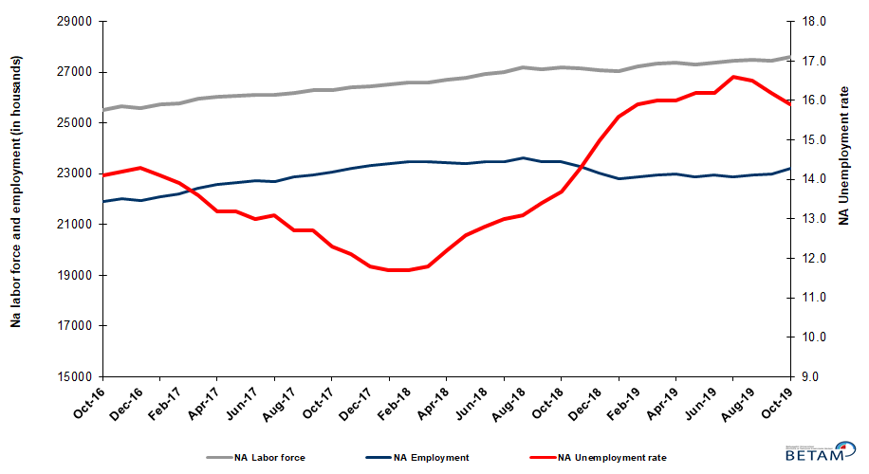

Source: Turkstat, Betam

Unemployment rate is expected to decrease in November 2019

Betam’s forecasting model had predicted that non-agricultural unemployment rate would be 16.0 for October 2019 but it decreased indeed to 15.9 percent. Our forecasting model predicts a decrease of 0.2 percentage point in non-agricultural unemployment rate to 15.7 percent in November 2019. Forecasting model details are available on Betam's website. Kariyer.net application per vacancy series used in the Betam forecasting model is depicted in Figure 3. Kariyer.net series is only one of the inputs of Betam forecast model. Indeed, several variables such as employment agency (İŞKUR) data, reel sector confidence index, capacity utilization rate are used in forecasting.

Figure 2 Seasonally adjusted non-agricultural unemployment rate and application per vacancy
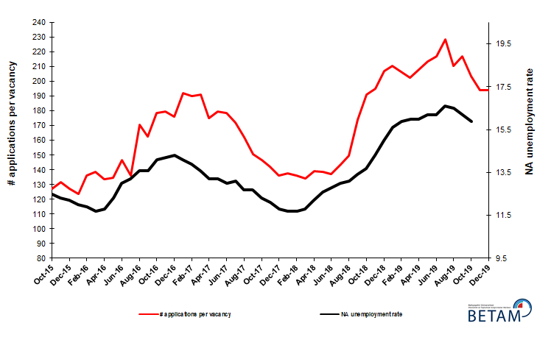
Source: Kariyer.net, Turkstat, Betam

Employment gains in all sectors except agriculture

According to seasonally adjusted sectorial labor market data, employment increased in the period of October 2019 compared to September 2019 in all sectors except agriculture (Figure 3, Table 2). After the increase of 3 thousand in September 2019, employment in agriculture sector decreased by 92 thousand in October 2019. With the increase of 32 thousand in September 2019, the number of employed in services sector increased by 49 thousand in October 2019. On the other hand, employment in manufacturing and in construction increased by 120 thousand and by 45 thousand respectively in October 2019.
Figure 3: Employment by sectors (in thousand)
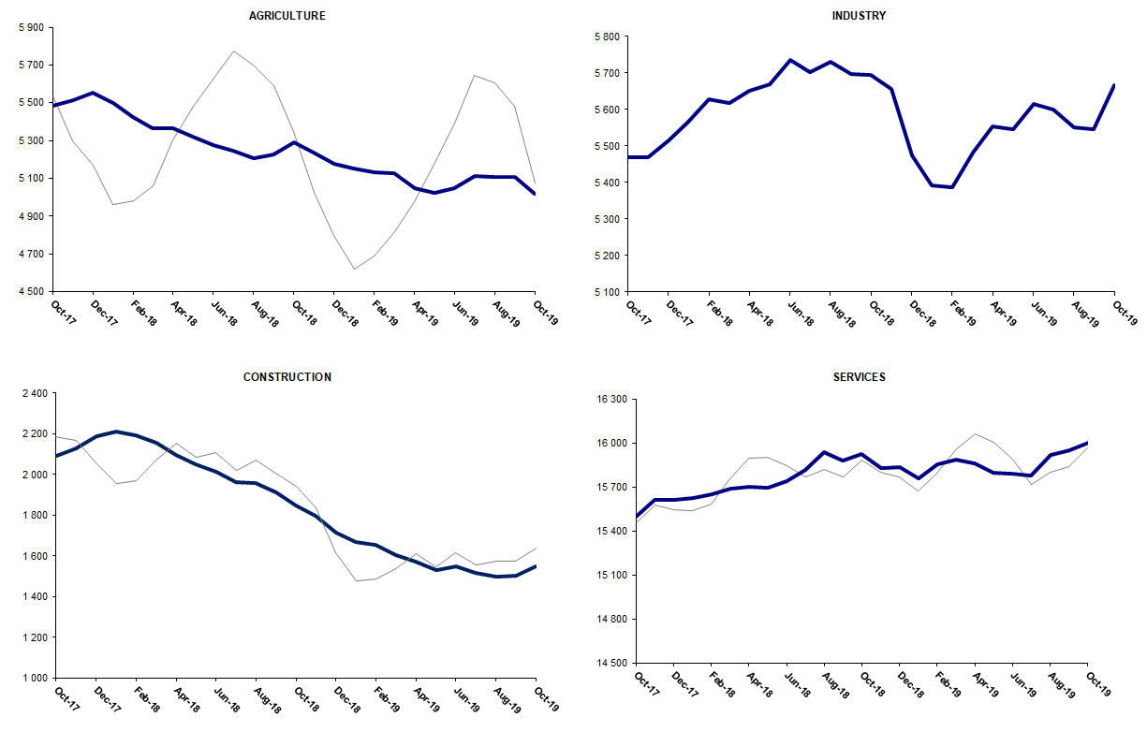
Source: TURKSTAT, Betam

Non-agricultural employment continues to decline year-on-year

Compared to October 2018, non-agricultural labor force increased by 372 thousand (1.4 percent) and non-agricultural employment decreased by 258 thousand (-1.1 percent) (Figure 4). Although periodical labor force growth recorded a remarkable increase from September to October, the annual growth rate remained well below its normal tendency. However, year-on-year decrease in employment continued for the 11th consecutive month. Thus, compared to October 2018, the number of non-agricultural unemployed increased by 630 thousand.

Figure 4 Year-on-year changes in non-agricultural labor force, employment, and unemployment
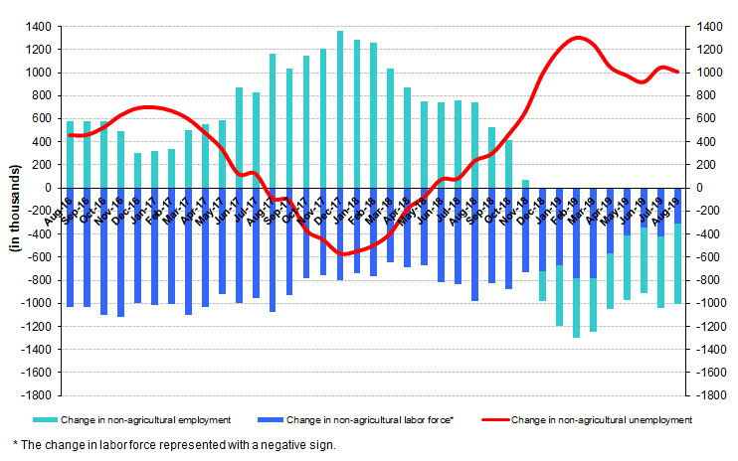
Source: TURKSTAT, Betam

Sharp decrease in male unemployment while female unemployment remains unchanged

Figure 5 shows seasonally adjusted non-agricultural unemployment rate for males (green) and for females (purple). In the period of October 2019, compared to the previous month, female non-agricultural unemployment remained unchanged at 20.8 percent while male non-agricultural unemployment rate decreased by 0.5 percent to 13.5 percent. As a result, the gender gap in non-agricultural unemployment rates increased from 6.8 percent to 7.3 percent.

Along with the increase of 55 thousand in female non-agricultural labor force, female non-agricultural employment increased by 39 thousand, while male employment increased by 130 thousand and male labor force increase remained at 37 thousand (Table 3). Since October 2018, male labor force and female labor force increased by 102 thousand and 322 thousand respectively.

Figure 5: Seasonally adjusted non-agricultural unemployment rate by gender

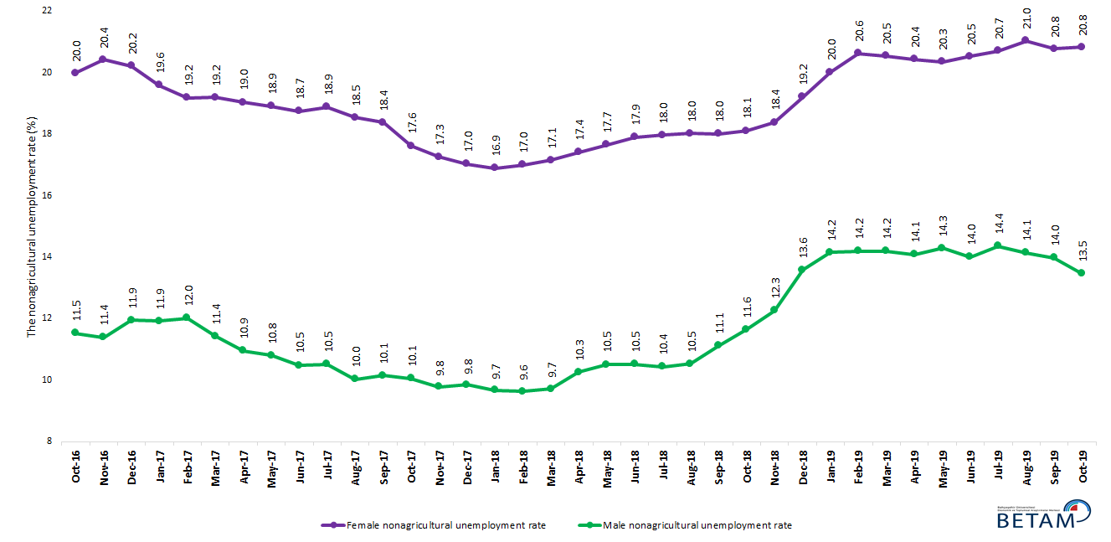

Source: Turkstat, Betam

Table 1 Seasonally adjusted non-agricultural labor market indicators (in thousands) **

 | Labor force | Employment | Unemployment | Unemployment rate | Monthly changes
October-16 | 25525 | 21926 | 3599 | 14.1% | Labor force | Employment | Unemployment
November-16 | 25663 | 22019 | 3644 | 14.2% | 138 | 93 | 45
December-16 | 25603 | 21942 | 3661 | 14.3% | -60 | -77 | 17
January-17 | 25719 | 22093 | 3626 | 14.1% | 116 | 151 | -35
February-17 | 25789 | 22204 | 3585 | 13.9% | 69 | 111 | -42
March-17 | 25964 | 22433 | 3531 | 13.6% | 176 | 229 | -53
April-17 | 26018 | 22584 | 3434 | 13.2% | 54 | 151 | -97
May-17 | 26092 | 22648 | 3444 | 13.2% | 74 | 64 | 10
June-17 | 26130 | 22733 | 3397 | 13.0% | 38 | 85 | -47
July-17 | 26122 | 22700 | 3422 | 13.1% | -8 | -33 | 25
August-17 | 26195 | 22868 | 3327 | 12.7% | 73 | 168 | -95
September-17 | 26286 | 22948 | 3338 | 12.7% | 92 | 80 | 12
October-17 | 26295 | 23061 | 3234 | 12.3% | 9 | 113 | -104
November-17 | 26404 | 23209 | 3195 | 12.1% | 109 | 148 | -39
December-17 | 26435 | 23316 | 3119 | 11.8% | 32 | 107 | -75
January-18 | 26507 | 23406 | 3101 | 11.7% | 72 | 90 | -18
February-18 | 26582 | 23472 | 3110 | 11.7% | 75 | 66 | 9
March-18 | 26600 | 23461 | 3139 | 11.8% | 18 | -11 | 29
April-18 | 26707 | 23449 | 3258 | 12.2% | 108 | -12 | 120
May-18 | 26787 | 23412 | 3375 | 12.6% | 80 | -37 | 117
June-18 | 26939 | 23491 | 3448 | 12.8% | 152 | 79 | 73
July-18 | 26993 | 23484 | 3509 | 13.0% | 54 | -7 | 61
August-18 | 27190 | 23628 | 3562 | 13.1% | 197 | 144 | 53
September-18 | 27125 | 23490 | 3635 | 13.4% | -65 | -138 | 73
October-18 | 27189 | 23464 | 3725 | 13.7% | 64 | -26 | 90
November-18 | 27160 | 23276 | 3884 | 14.3% | -29 | -188 | 159
December-18 | 27091 | 23027 | 4064 | 15.0% | -69 | -249 | 180
January-19 | 27041 | 22823 | 4218 | 15.6% | -49 | -204 | 155
February-19 | 27228 | 22899 | 4329 | 15.9% | 187 | 76 | 111
March-19 | 27350 | 22974 | 4376 | 16.0% | 122 | 75 | 47
April-19 | 27363 | 22985 | 4378 | 16.0% | 13 | 11 | 2
May-19 | 27297 | 22875 | 4422 | 16.2% | -66 | -110 | 44
June-19 | 27391 | 22954 | 4437 | 16.2% | 94 | 79 | 15
July-19 | 27452 | 22895 | 4557 | 16.6% | 61 | -59 | 120
August-19 | 27504 | 22966 | 4538 | 16.5% | 52 | 71 | -19
September-19 | 27445 | 22999 | 4446 | 16.2% | -59 | 33 | -92
October-19 | 27602 | 23213 | 4389 | 15.9% | 157 | 214 | -57

Source: Turkstat, Betam

Table 2 Seasonally adjusted employment by sectors (in thousands) *

 | Agriculture | Manufacturing | Construction | Service | Monthly changes
October-16 | 5269 | 5282 | 1985 | 14659 | Agriculture | Manufacturing | Construction | Service
November-16 | 5282 | 5316 | 1986 | 14717 | 13 | 34 | 1 | 58
December-16 | 5312 | 5265 | 1958 | 14719 | 30 | -51 | -28 | 2
January-17 | 5437 | 5274 | 1966 | 14854 | 125 | 9 | 8 | 135
February-17 | 5478 | 5251 | 2016 | 14937 | 41 | -23 | 50 | 83
March-17 | 5386 | 5346 | 2092 | 14994 | -92 | 95 | 76 | 57
April-17 | 5367 | 5372 | 2126 | 15086 | -19 | 26 | 34 | 92
May-17 | 5399 | 5386 | 2092 | 15169 | 32 | 14 | -34 | 83
June-17 | 5395 | 5383 | 2067 | 15283 | -4 | -3 | -25 | 114
July-17 | 5497 | 5363 | 2107 | 15230 | 102 | -20 | 40 | -53
August-17 | 5463 | 5437 | 2152 | 15280 | -34 | 74 | 45 | 50
September-17 | 5503 | 5421 | 2124 | 15404 | 40 | -16 | -28 | 124
October-17 | 5484 | 5470 | 2092 | 15498 | -19 | 49 | -32 | 94
November-17 | 5514 | 5470 | 2129 | 15610 | 30 | 0 | 37 | 112
December-17 | 5553 | 5514 | 2187 | 15614 | 39 | 44 | 58 | 4
January-18 | 5497 | 5567 | 2212 | 15627 | -56 | 53 | 25 | 13
February-18 | 5424 | 5627 | 2195 | 15651 | -73 | 60 | -17 | 24
March-18 | 5365 | 5618 | 2154 | 15689 | -59 | -9 | -41 | 38
April-18 | 5366 | 5650 | 2098 | 15701 | 1 | 32 | -56 | 12
May-18 | 5320 | 5669 | 2050 | 15694 | -46 | 19 | -48 | -7
June-18 | 5276 | 5737 | 2014 | 15739 | -44 | 68 | -36 | 45
July-18 | 5247 | 5703 | 1961 | 15819 | -29 | -34 | -53 | 80
August-18 | 5207 | 5730 | 1959 | 15939 | -40 | 27 | -2 | 120
September-18 | 5227 | 5698 | 1911 | 15881 | 20 | -32 | -48 | -58
October-18 | 5288 | 5696 | 1846 | 15922 | 61 | -2 | -65 | 41
November-18 | 5235 | 5656 | 1795 | 15826 | -53 | -40 | -51 | -96
December-18 | 5178 | 5474 | 1715 | 15838 | -57 | -182 | -80 | 12
January-19 | 5153 | 5392 | 1670 | 15761 | -25 | -82 | -45 | -77
February-19 | 5130 | 5388 | 1656 | 15855 | -23 | -4 | -14 | 94
March-19 | 5126 | 5482 | 1604 | 15888 | -4 | 94 | -52 | 33
April-19 | 5047 | 5553 | 1574 | 15858 | -79 | 71 | -30 | -30
May-19 | 5024 | 5546 | 1532 | 15796 | -23 | -7 | -42 | -62
June-19 | 5049 | 5616 | 1548 | 15790 | 25 | 70 | 16 | -6
July-19 | 5110 | 5600 | 1517 | 15777 | 61 | -16 | -31 | -13
August-19 | 5105 | 5551 | 1498 | 15918 | -5 | -49 | -19 | 141
September-19 | 5108 | 5546 | 1503 | 15950 | 3 | -5 | 5 | 32
October-19 | 5016 | 5666 | 1548 | 15999 | -92 | 120 | 45 | 49

Source: Turkstat, Betam

Table 3: Seasonally adjusted non-agricultural labor force by gender (thousands)

 | Female Labor Force | Female Employment | Female Unemployed | Male Labor Force | Male Employment | Male Unemployed
November-16 | 7466 | 5942 | 1524 | 18155 | 16088 | 2067
December-16 | 7451 | 5945 | 1506 | 18185 | 16013 | 2172
January-17 | 7446 | 5987 | 1459 | 18286 | 16106 | 2180
February-17 | 7495 | 6058 | 1437 | 18290 | 16092 | 2199
March-17 | 7596 | 6138 | 1458 | 18339 | 16244 | 2095
April-17 | 7602 | 6155 | 1447 | 18378 | 16365 | 2012
May-17 | 7667 | 6217 | 1450 | 18388 | 16401 | 1986
June-17 | 7679 | 6240 | 1439 | 18435 | 16502 | 1933
July-17 | 7698 | 6245 | 1453 | 18439 | 16500 | 1938
August-17 | 7720 | 6289 | 1431 | 18490 | 16634 | 1855
September-17 | 7784 | 6353 | 1430 | 18507 | 16629 | 1878
October-17 | 7784 | 6412 | 1371 | 18511 | 16649 | 1862
November-17 | 7835 | 6483 | 1352 | 18561 | 16745 | 1816
December-17 | 7878 | 6536 | 1342 | 18602 | 16771 | 1831
January-18 | 7917 | 6580 | 1337 | 18613 | 16812 | 1800
February-18 | 7934 | 6585 | 1349 | 18631 | 16835 | 1796
March-18 | 7927 | 6567 | 1359 | 18667 | 16852 | 1814
April-18 | 7988 | 6597 | 1391 | 18725 | 16805 | 1920
May-18 | 8042 | 6622 | 1420 | 18750 | 16779 | 1971
June-18 | 8086 | 6639 | 1448 | 18830 | 16848 | 1982
July-18 | 8108 | 6651 | 1457 | 18821 | 16856 | 1965
August-18 | 8197 | 6719 | 1477 | 18910 | 16919 | 1991
September-18 | 8187 | 6712 | 1474 | 18889 | 16789 | 2100
October-18 | 8263 | 6767 | 1496 | 18875 | 16677 | 2198
November-18 | 8252 | 6735 | 1517 | 18875 | 16562 | 2313
December-18 | 8330 | 6730 | 1600 | 18869 | 16308 | 2562
January-19 | 8358 | 6685 | 1673 | 18869 | 16198 | 2671
February-19 | 8425 | 6687 | 1737 | 18913 | 16228 | 2685
March-19 | 8470 | 6730 | 1739 | 18915 | 16229 | 2686
April-19 | 8419 | 6699 | 1720 | 18895 | 16233 | 2662
May-19 | 8377 | 6672 | 1705 | 18893 | 16194 | 2699
June-19 | 8407 | 6681 | 1726 | 18893 | 16248 | 2645
July-19 | 8430 | 6684 | 1746 | 18944 | 16223 | 2721
August-19 | 8488 | 6703 | 1785 | 18921 | 16247 | 2674
September-19 | 8454 | 6698 | 1756 | 18940 | 16294 | 2647
November-19 | 8509 | 6737 | 1772 | 18977 | 16424 | 2553

Source: Turkstat, Betam

*Prof. Dr. Seyfettin Gürsel, Betam, Director, seyfettin.gursel@eas.bau.edu.tr **Hamza Mutluay, Betam, Research Assistant, mehmetcem.sahin@eas.bau.edu.tr
For detailed information on Betam's forecasting model, please see Betam Research Brief 168 titled as "Kariyer.net Verisiyle Kısa Vadeli Tarım Dışı İşsizlik Tahmini" . For the innovations in the model please see Betam Research Brief 14 titled as "Mevsim Etkilerinden Arındırılmış İşsizlik Tahmini" Soybilgen, B., "Kariyer.net Verisiyle Kısa Vadeli Tarım Dışı İşsizlik Tahmini", Betam Research Brief 168. http://betam.bahcesehir.edu.tr/tr/2014/06/kariyer-net-verisiyle-kisa-vadeli-tarim-disi-issizlik-tahmini/ Soybilgen, B., "Mevsim Etkilerinden Arındırılmış İşsizlik Tahmini", Betam Research Brief 14 http://betam.bahcesehir.edu.tr/2015/08/mevsim-etkilerinden-arindirilmis-tarim-disi-issizlik-tahmini/
Betam has been calculating application per vacancy using series released by Kariyer.net for a while. Seasonal and calendar adjustment procedure is applied to application per vacancy series. A decrease in applications per vacancy may be caused by an increase in vacancies or by a decrease in the number of applications. An increase in vacancies signals economic growth while decreasing number of applications indicates a decrease in number of people looking for a job. Monthly labor market series released by TurkStat is the average of three months. Therefore, application per vacancy statistics calculated using Kariyer.net series is the average of three months as well.
Employment in each sector is seasonally adjusted separately. Hence the sum of these series may differ from the seasonally adjusted series of total employment. The difference stems from the non-linearity of the seasonal adjustment process.
Turkstat revised the labor market statistics drastically in February 2014. Within this framework, they back casted various labor market indicators and they also continued to announce seasonally adjusted series. However, Turkstat is not providing back-casted series by gender. Therefore, female and male labor market statistics are not sufficiently long for the seasonal adjustment procedures (There should be minimum 36 observations). With the announcement of the period of February 2017 data, the number of observations required for the seasonal decontamination process was provided. From this period Betam generated seasonal adjustment series in terms of gender. Nevertheless, it should not be forgotten that seasonal adjustment may cause extra volatility in the series for at least a while.

