Labor Market Outlook:
December 2019

16 December 2019

DECREASE IN UNEMPLOYMENT AND LABOR FORCE

Seyfettin Gürsel*, Mehmet Cem Şahin**

Executive Summary

Seasonally adjusted labor market data shows that, in the period of September 2019, non-agricultural unemployment rate turned out to be 16.3 percent, with 0.2 percentage point decrease compared to August 2019. In this period, non-agricultural employment increased by 29 thousand and non-agricultural labor force decreased by 31 thousand. According to sectorial data, the only sector showing decrease in employment is manufacturing, and the sector showing the most significant (31 thousand) increase in employment is services. In this period, agricultural employment increased by 7 thousand and construction employment by 2 thousand. The amount of employment loss in manufacturing sector turned out to be 5 thousand. Based on the seasonally adjusted data, male non-agricultural employment reversed its continuous decline since August 2018, by an increase of 28 thousand, and female non-agricultural employment decreased slightly by 7 thousand.

Decrease in non-agricultural unemployment

Seasonally adjusted data shows that non-agricultural labor force reached 27 million 458 thousand by the decrease of 31 thousand in September 2019, while non-agricultural employment reached 22 million 982 thousand following the increase of 29 thousand (Figure 1, Table 1). As a result, non-agricultural unemployment decreased by 60 thousand and reached 4 million 476 thousand, and non-agricultural unemployment rate dropped to 16.3 percent.

Figure 1. Seasonally adjusted non-agricultural labor force, employment, and unemployment
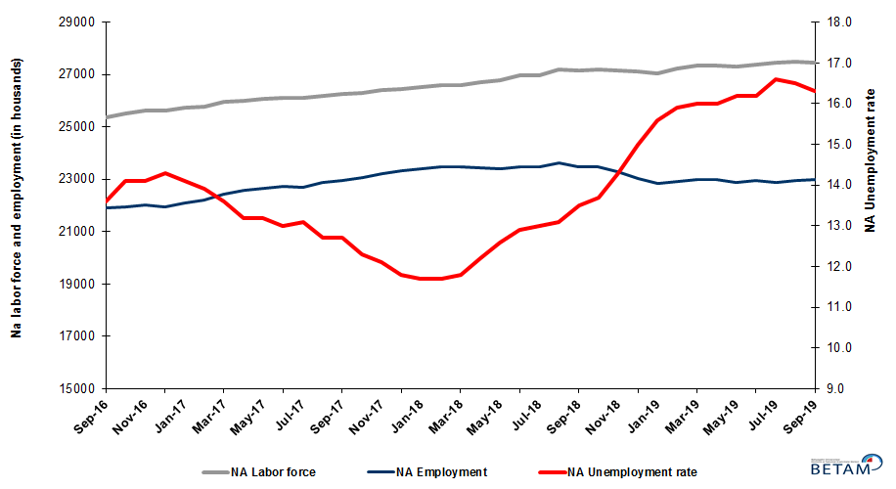

Source: Turkstat, Betam

Unemployment rate is expected to decrease in October 2019

Betam’s forecasting model had predicted an increase of 0.1 percentage point in non-agricultural unemployment rate for September 2019 but it decreased by 0.2 percentage point, after the 0.1 percentage point revision of the nonagricultural unemployment rate for August 2019. Our forecasting model predicts a decrease of 0.3 percentage point in non-agricultural unemployment rate, from 16.3 to 16.0 percent, in October 2019. Forecasting model details are available on Betam's website. Kariyer.net application per vacancy series used in the Betam forecasting model is depicted in Figure 3. Kariyer.net series is only one of the inputs of Betam forecast model. Indeed, several variables such as employment agency (İŞKUR) data, reel sector confidence index, capacity utilization rate are used in forecasting.

Figure 2 Seasonally adjusted non-agricultural unemployment rate and application per vacancy
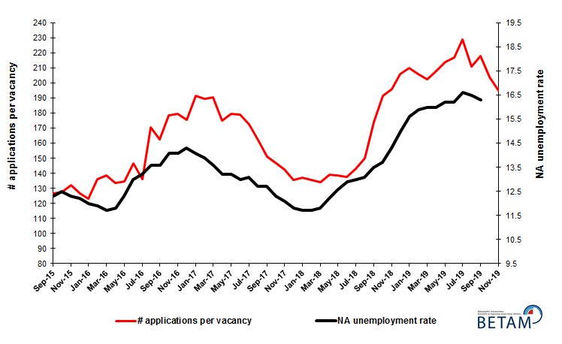
Source: Kariyer.net, Turkstat, Betam

Employment gains in all sectors except manufacturing

According to seasonally adjusted sectorial labor market data, employment increased in the period of September 2019 compared to August 2019 in all sectors except manufacturing (Figure 3, Table 2). After the decrease of 49 thousand in August 2019, employment in manufacturing sector decreased by 5 thousand in September 2019. After the increase of 141 thousand in August 2019, the number of employed in services sector increased by 31 thousand. Employment losses in July and August 2019 are followed by the 2 thousand increase in construction sector.
.
Figure 3: Employment by sectors (in thousand)
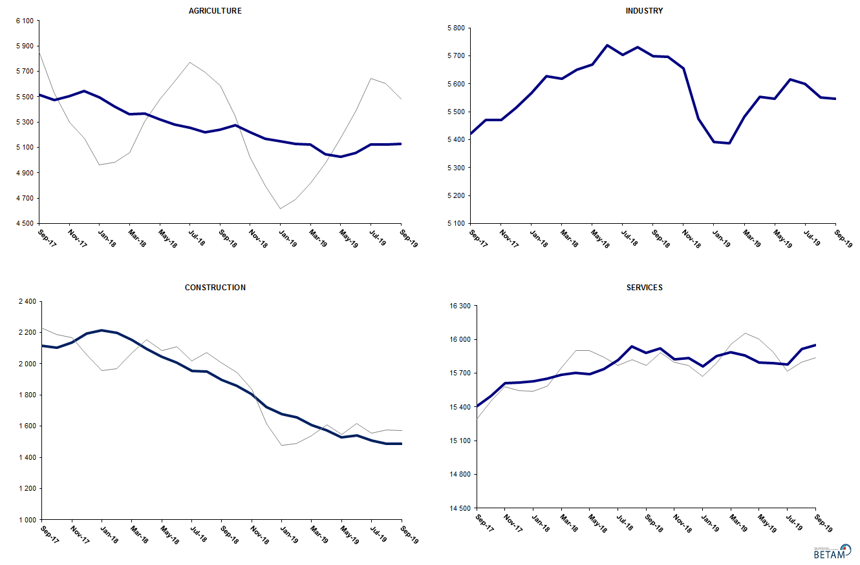
Source: TURKSTAT, Betam

Non-agricultural employment continues to decline year-on-year

Compared to September 2018, non-agricultural labor force increased only by 324 thousand (1.2 percent) and non-agricultural employment decreased by 516 thousand (-2.2 percent) (Figure 4). Annual labor force growth slowed down along with employment losses and deviated from its structural trend. However, year-on-year decrease in employment continued for the 10th consecutive month. Thus, compared to September 2018, the number of non-agricultural unemployed increased by 840 thousand.

Figure 4 Year-on-year changes in non-agricultural labor force, employment, and unemployment
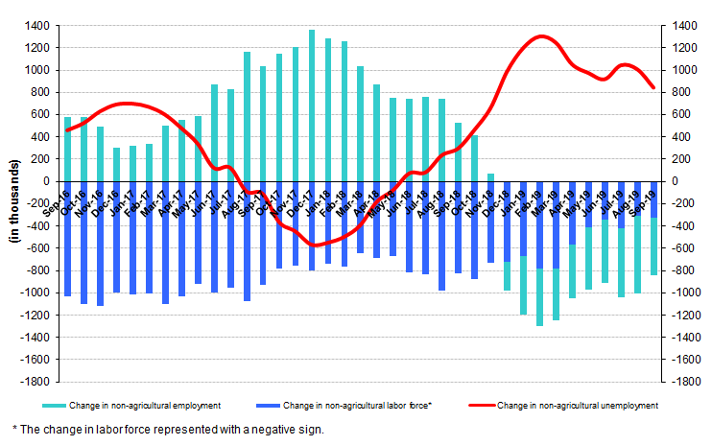
Source: TURKSTAT, Betam

Male employment reversed its decreasing trend, lasting 12 months

Figure 5 shows seasonally adjusted non-agricultural unemployment rate for males (green) and for females (purple). In the period of September 2019, compared to the previous month, female non-agricultural unemployment rate decreased by 0.3 points and reached 20.8 percent, with the 37 thousand decrease in the female non-agricultural labor force. Male non-agricultural unemployment rate decreased by 0.1 percent to 14.4 percent. As a result, the gender gap in non-agricultural unemployment rates narrowed to 6.4 percent.

Along with the decrease of 37 thousand in female non-agricultural labor force, female non-agricultural employment decreased by 7 thousand, while male employment increased by 28 thousand and consecutive decreases in male employment came to a halt (Table 3). The cumulative loss in male non-agricultural employment since August 2018 became 659 thousand.

Figure 5: Seasonally adjusted non-agricultural unemployment rate by gender

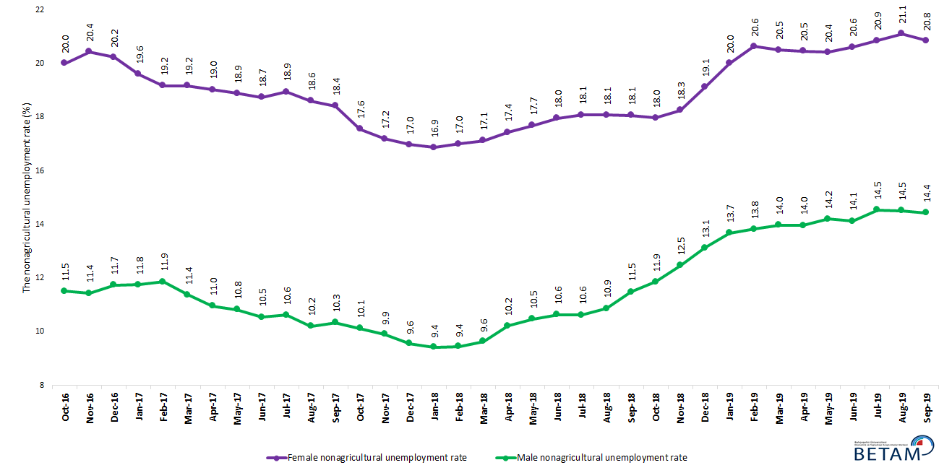

Source: Turkstat, Betam

Table 1 Seasonally adjusted non-agricultural labor market indicators (in thousands) **

 | Labor force | Employment | Unemployment | Unemployment rate | Monthly changes
September-16 | 25360 | 21911 | 3449 | 13.6% | Labor force | Employment | Unemployment
October-16 | 25532 | 21932 | 3600 | 14.1% | 172 | 21 | 151
November-16 | 25638 | 22023 | 3615 | 14.1% | 106 | 91 | 15
December-16 | 25608 | 21946 | 3662 | 14.3% | -30 | -77 | 47
January-17 | 25723 | 22096 | 3627 | 14.1% | 115 | 150 | -35
February-17 | 25791 | 22206 | 3585 | 13.9% | 68 | 110 | -42
March-17 | 25962 | 22431 | 3531 | 13.6% | 171 | 225 | -54
April-17 | 26017 | 22583 | 3434 | 13.2% | 55 | 152 | -97
May-17 | 26090 | 22646 | 3444 | 13.2% | 73 | 63 | 10
June-17 | 26126 | 22730 | 3396 | 13.0% | 37 | 84 | -47
July-17 | 26117 | 22696 | 3421 | 13.1% | -9 | -34 | 25
August-17 | 26188 | 22862 | 3326 | 12.7% | 70 | 166 | -96
September-17 | 26278 | 22941 | 3337 | 12.7% | 90 | 79 | 11
October-17 | 26308 | 23072 | 3236 | 12.3% | 30 | 131 | -101
November-17 | 26413 | 23217 | 3196 | 12.1% | 105 | 145 | -40
December-17 | 26442 | 23322 | 3120 | 11.8% | 29 | 105 | -76
January-18 | 26512 | 23410 | 3102 | 11.7% | 70 | 88 | -18
February-18 | 26583 | 23473 | 3110 | 11.7% | 71 | 63 | 8
March-18 | 26599 | 23460 | 3139 | 11.8% | 15 | -13 | 28
April-18 | 26704 | 23446 | 3258 | 12.2% | 105 | -14 | 119
May-18 | 26785 | 23410 | 3375 | 12.6% | 81 | -36 | 117
June-18 | 26963 | 23485 | 3478 | 12.9% | 178 | 75 | 103
July-18 | 26984 | 23476 | 3508 | 13.0% | 21 | -9 | 30
August-18 | 27177 | 23617 | 3560 | 13.1% | 193 | 141 | 52
September-18 | 27141 | 23477 | 3664 | 13.5% | -36 | -140 | 104
October-18 | 27206 | 23479 | 3727 | 13.7% | 65 | 2 | 63
November-18 | 27174 | 23288 | 3886 | 14.3% | -32 | -191 | 159
December-18 | 27102 | 23037 | 4065 | 15.0% | -72 | -251 | 179
January-19 | 27049 | 22829 | 4220 | 15.6% | -54 | -208 | 154
February-19 | 27232 | 22902 | 4330 | 15.9% | 183 | 73 | 110
March-19 | 27351 | 22975 | 4376 | 16.0% | 119 | 73 | 46
April-19 | 27361 | 22983 | 4378 | 16.0% | 10 | 8 | 2
May-19 | 27292 | 22871 | 4421 | 16.2% | -68 | -112 | 44
June-19 | 27382 | 22946 | 4436 | 16.2% | 89 | 75 | 14
July-19 | 27440 | 22885 | 4555 | 16.6% | 58 | -61 | 119
August-19 | 27489 | 22953 | 4536 | 16.5% | 49 | 68 | -19
September-19 | 27458 | 22982 | 4476 | 16.3% | -31 | 29 | -60

Source: Turkstat, Betam

Table 2 Seasonally adjusted employment by sectors (in thousands) *

 | Agriculture | Manufacturing | Construction | Service | Monthly changes
September-16 | 5327 | 5260 | 2026 | 14625 | Agriculture | Manufacturing | Construction | Service
October-16 | 5263 | 5282 | 1991 | 14659 | -64 | 22 | -35 | 34
November-16 | 5276 | 5316 | 1991 | 14717 | 13 | 34 | 0 | 58
December-16 | 5307 | 5265 | 1962 | 14719 | 31 | -51 | -29 | 2
January-17 | 5434 | 5274 | 1968 | 14854 | 127 | 9 | 6 | 135
February-17 | 5476 | 5251 | 2017 | 14937 | 42 | -23 | 49 | 83
March-17 | 5386 | 5346 | 2091 | 14994 | -90 | 95 | 74 | 57
April-17 | 5367 | 5372 | 2124 | 15086 | -19 | 26 | 33 | 92
May-17 | 5401 | 5386 | 2090 | 15169 | 34 | 14 | -34 | 83
June-17 | 5398 | 5383 | 2065 | 15283 | -3 | -3 | -25 | 114
July-17 | 5502 | 5363 | 2103 | 15230 | 104 | -20 | 38 | -53
August-17 | 5470 | 5437 | 2146 | 15280 | -32 | 74 | 43 | 50
September-17 | 5512 | 5421 | 2116 | 15404 | 42 | -16 | -30 | 124
October-17 | 5476 | 5470 | 2103 | 15499 | -36 | 49 | -13 | 95
November-17 | 5505 | 5470 | 2137 | 15611 | 29 | 0 | 34 | 112
December-17 | 5547 | 5514 | 2194 | 15615 | 42 | 44 | 57 | 4
January-18 | 5493 | 5567 | 2216 | 15627 | -54 | 53 | 22 | 12
February-18 | 5422 | 5627 | 2196 | 15651 | -71 | 60 | -20 | 24
March-18 | 5364 | 5618 | 2153 | 15689 | -58 | -9 | -43 | 38
April-18 | 5367 | 5650 | 2095 | 15701 | 3 | 32 | -58 | 12
May-18 | 5322 | 5669 | 2047 | 15694 | -45 | 19 | -48 | -7
June-18 | 5281 | 5737 | 2009 | 15739 | -41 | 68 | -38 | 45
July-18 | 5256 | 5703 | 1954 | 15819 | -25 | -34 | -55 | 80
August-18 | 5218 | 5730 | 1949 | 15939 | -38 | 27 | -5 | 120
September-18 | 5241 | 5698 | 1898 | 15881 | 23 | -32 | -51 | -58
October-18 | 5276 | 5696 | 1861 | 15923 | 35 | -2 | -37 | 42
November-18 | 5221 | 5656 | 1806 | 15826 | -55 | -40 | -55 | -97
December-18 | 5167 | 5474 | 1724 | 15838 | -54 | -182 | -82 | 12
January-19 | 5146 | 5392 | 1676 | 15761 | -21 | -82 | -48 | -77
February-19 | 5126 | 5388 | 1658 | 15855 | -20 | -4 | -18 | 94
March-19 | 5124 | 5482 | 1605 | 15887 | -2 | 94 | -53 | 32
April-19 | 5048 | 5553 | 1572 | 15858 | -76 | 71 | -33 | -29
May-19 | 5028 | 5546 | 1529 | 15796 | -20 | -7 | -43 | -62
June-19 | 5057 | 5616 | 1541 | 15790 | 29 | 70 | 12 | -6
July-19 | 5123 | 5600 | 1508 | 15777 | 66 | -16 | -33 | -13
August-19 | 5122 | 5551 | 1485 | 15918 | -1 | -49 | -23 | 141
September-19 | 5129 | 5546 | 1487 | 15949 | 7 | -5 | 2 | 31

Source: Turkstat, Betam

Table 3: Seasonally adjusted non-agricultural labor force by gender (thousands)

 | Female Labor Force | Female Employment | Female Unemployed | Male Labor Force | Male Employment | Male Unemployed
October-16 | 7438 | 5950 | 1488 | 18079 | 15998 | 2081
November-16 | 7467 | 5941 | 1526 | 18153 | 16078 | 2076
December-16 | 7452 | 5944 | 1508 | 18182 | 16048 | 2134
January-17 | 7447 | 5987 | 1460 | 18278 | 16131 | 2148
February-17 | 7495 | 6058 | 1437 | 18287 | 16117 | 2170
March-17 | 7596 | 6140 | 1456 | 18335 | 16250 | 2085
April-17 | 7602 | 6156 | 1446 | 18372 | 16359 | 2013
May-17 | 7667 | 6219 | 1448 | 18384 | 16394 | 1989
June-17 | 7679 | 6240 | 1439 | 18432 | 16488 | 1944
July-17 | 7696 | 6238 | 1458 | 18440 | 16481 | 1959
August-17 | 7719 | 6283 | 1436 | 18489 | 16601 | 1888
September-17 | 7782 | 6348 | 1434 | 18508 | 16593 | 1915
October-17 | 7787 | 6420 | 1367 | 18519 | 16644 | 1875
November-17 | 7837 | 6490 | 1347 | 18564 | 16724 | 1841
December-17 | 7880 | 6542 | 1337 | 18606 | 16828 | 1779
January-18 | 7918 | 6582 | 1335 | 18617 | 16863 | 1754
February-18 | 7935 | 6586 | 1349 | 18636 | 16875 | 1761
March-18 | 7927 | 6570 | 1358 | 18670 | 16871 | 1800
April-18 | 7987 | 6594 | 1393 | 18725 | 16813 | 1913
May-18 | 8040 | 6618 | 1422 | 18750 | 16785 | 1965
June-18 | 8085 | 6633 | 1452 | 18822 | 16820 | 2002
July-18 | 8105 | 6640 | 1466 | 18813 | 16813 | 2000
August-18 | 8195 | 6714 | 1482 | 18894 | 16841 | 2053
September-18 | 8184 | 6706 | 1478 | 18874 | 16706 | 2168
October-18 | 8267 | 6782 | 1486 | 18888 | 16647 | 2240
November-18 | 8254 | 6747 | 1507 | 18883 | 16529 | 2355
December-18 | 8332 | 6739 | 1593 | 18879 | 16402 | 2477
January-19 | 8359 | 6687 | 1672 | 18879 | 16296 | 2583
February-19 | 8426 | 6688 | 1738 | 18916 | 16301 | 2615
March-19 | 8471 | 6734 | 1737 | 18915 | 16272 | 2643
April-19 | 8418 | 6695 | 1723 | 18895 | 16256 | 2639
May-19 | 8374 | 6665 | 1710 | 18892 | 16209 | 2683
June-19 | 8404 | 6672 | 1733 | 18884 | 16217 | 2667
July-19 | 8427 | 6670 | 1757 | 18925 | 16174 | 2751
August-19 | 8487 | 6696 | 1791 | 18896 | 16154 | 2742
September-19 | 8450 | 6688 | 1762 | 18913 | 16182 | 2731

Source: Turkstat, Betam

*Prof. Dr. Seyfettin Gürsel, Betam, Director, seyfettin.gursel@eas.bau.edu.tr **Mehmet Cem Şahin, Betam, Research Assistant, mehmetcem.sahin@eas.bau.edu.tr
For detailed information on Betam's forecasting model, please see Betam Research Brief 168 titled as "Kariyer.net Verisiyle Kısa Vadeli Tarım Dışı İşsizlik Tahmini" . For the innovations in the model please see Betam Research Brief 14 titled as "Mevsim Etkilerinden Arındırılmış İşsizlik Tahmini" Soybilgen, B., "Kariyer.net Verisiyle Kısa Vadeli Tarım Dışı İşsizlik Tahmini", Betam Research Brief 168. http://betam.bahcesehir.edu.tr/tr/2014/06/kariyer-net-verisiyle-kisa-vadeli-tarim-disi-issizlik-tahmini/ Soybilgen, B., "Mevsim Etkilerinden Arındırılmış İşsizlik Tahmini", Betam Research Brief 14 http://betam.bahcesehir.edu.tr/2015/08/mevsim-etkilerinden-arindirilmis-tarim-disi-issizlik-tahmini/
Betam has been calculating application per vacancy using series released by Kariyer.net for a while. Seasonal and calendar adjustment procedure is applied to application per vacancy series. A decrease in applications per vacancy may be caused by an increase in vacancies or by a decrease in the number of applications. An increase in vacancies signals economic growth while decreasing number of applications indicates a decrease in number of people looking for a job. Monthly labor market series released by TurkStat is the average of three months. Therefore, application per vacancy statistics calculated using Kariyer.net series is the average of three months as well.
Employment in each sector is seasonally adjusted separately. Hence the sum of these series may differ from the seasonally adjusted series of total employment. The difference stems from the non-linearity of the seasonal adjustment process.
Turkstat revised the labor market statistics drastically in February 2014. Within this framework, they back casted various labor market indicators and they also continued to announce seasonally adjusted series. However, Turkstat is not providing back-casted series by gender. Therefore, female and male labor market statistics are not sufficiently long for the seasonal adjustment procedures (There should be minimum 36 observations). With the announcement of the period of February 2017 data, the number of observations required for the seasonal decontamination process was provided. From this period Betam generated seasonal adjustment series in terms of gender. Nevertheless, it should not be forgotten that seasonal adjustment may cause extra volatility in the series for at least a while.

