Labor Market Outlook:
November 2019

15 November 2019

PAUSE IN UNEMPLOYMENT INCREASE, EMPLOYMENT LOSSES IN INDUSTRY AND CONSTRUCTION

Seyfettin Gürsel*, Hamza Mutluay**

Executive Summary

Seasonally adjusted labor market data shows that, in the period of August 2019, non-agricultural unemployment rate turned out to be 16.6 percent, with 0.1 point decrease compared to July 2019. In this period, non-agricultural employment increased by 69 thousand and non-agricultural labor force increased by 50 thousand. According to sectorial data, the only sector showing increase in employment with 141 thousand is services, and the sector showing the most significant decrease with 49 thousand is industry. While agricultural employment decreased by 3 thousand, construction lost 24 thousand workers. Based on the seasonally adjusted data, male employment had a net loss in employment for the 12th consecutive period and female employment increased by 25 thousand. Apparently, the decreases in male employment is affected by the losses in construction employment.

Limited decrease in the number of non-agricultural unemployed

Seasonally adjusted data shows that non-agricultural labor force reached 27 million 518 thousand by an increase of 50 thousand in August 2019, while non-agricultural employment went up to 22 million 950 thousand after an increase of 69 thousand in August 2019 (Figure 1, Table 1). As a result, the number of unemployed decreased by 19 thousand and went down 4 million 568 thousand, and non-agricultural unemployment rate declined to 16.6 percent.

Figure 1. Seasonally adjusted non-agricultural labor force, employment, and unemployment
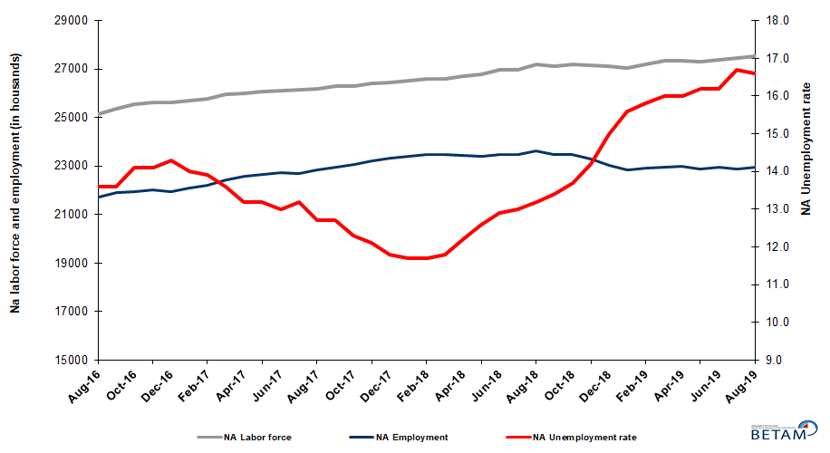

Source: Turkstat, Betam

Unemployment rate is expected to increase in September 2019

Betam’s forecasting model had predicted that non-agricultural unemployment rate would be 16.6 percent for August 2019 and the unemployment rate decreased indeed to 16.6 percent. Our forecasting model predicts an increase of 0.2 percentage points in non-agricultural unemployment rate for September 2019 that would reach 16.8 percent. Forecasting model details are available on Betam's website. Kariyer.net application per vacancy series used in the Betam forecasting model is depicted in Figure 3. Kariyer.net series is only one of the inputs of Betam forecast model. Indeed, several variables such as employment agency (İŞKUR) data, reel sector confidence index, capacity utilization rate are used in forecasting.

Figure 2 Seasonally adjusted non-agricultural unemployment rate and application per vacancy
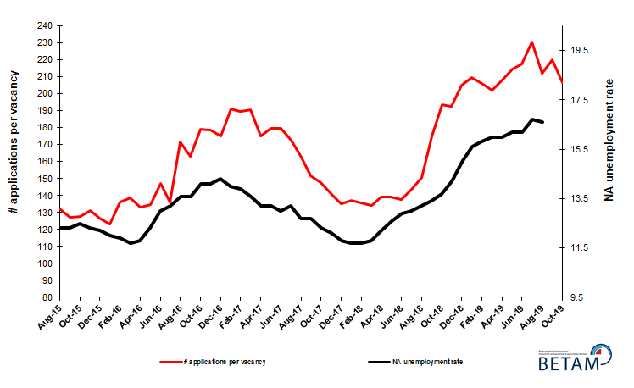
Source: Kariyer.net, Turkstat, Betam

Employment increases in services, declines in industry and construction

According to seasonally adjusted sectorial labor market data, employment decreased in the period of August 2019 compared to July 2019 in all sectors except services (Figure 3, Table 2). After showing an decrease of 16 thousand in July 2019, employment in industry sector decreased by 49 thousand in August 2019. With the decrease of 13 thousand in July 2019, employment loss in services sector increased by 141 thousand in August 2019.As for the construction, the employment increase observed in the period of June after continuous decreases since February 2018, reversed in July and August 2019 to decreases; During these two consecutive periods employment losses attained 57 thousand.

Figure 3: Employment by sectors (in thousand)
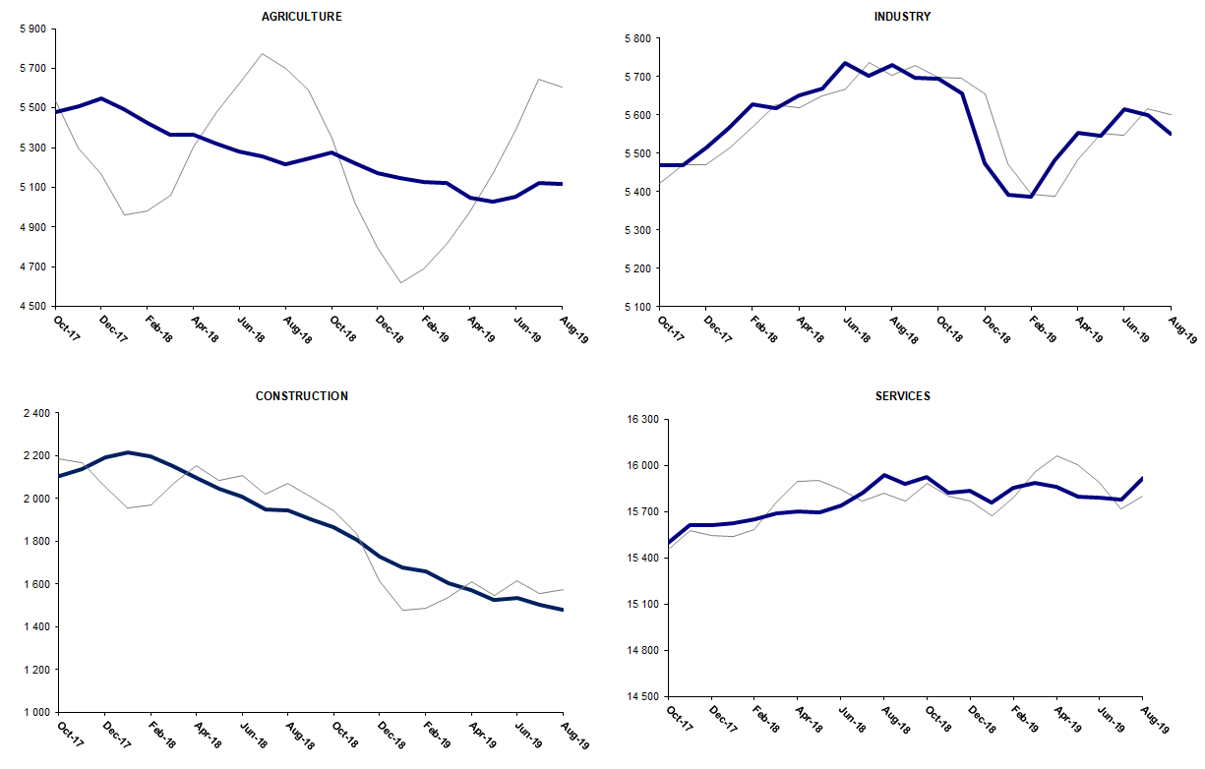
Source: TURKSTAT, Betam

Year-on-year decline in non-agricultural employment continues

From August 2018 to August 2019 non-agricultural labor force increased by 309 thousand (1.1 percent) and non-agricultural employment decreased by 695 thousand (-2.9 percent) (Figure 4). Annual labor force growth slowed down along with employment losses and deviated from its structural trend. On the other hand, non-agricultural employment has been declining for ninth consecutive month. Thus, compared to August 2018, the number of non-agricultural unemployed increased by 1 million 4 thousand.

Figure 4 Year-on-year changes in non-agricultural labor force, employment, and unemployment
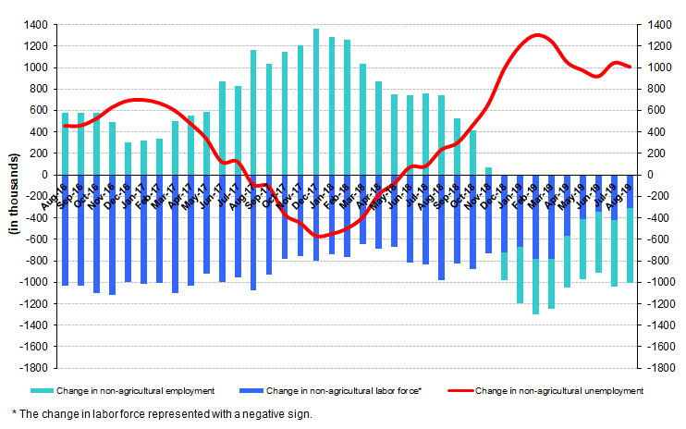
Source: TURKSTAT, Betam

Male employment has been consecutively decreasing for twelve months

Figure 5 shows seasonally adjusted non-agricultural unemployment rate for males (green) and for females (purple). In the period of August 2019, compared to the previous period, female non-agricultural unemployment rate increased by 0.3 points and reached 21.1 percent. The male unemployment rate remained unchanged at 14.7 percent. As a result, the gender gap in non-agricultural unemployment rates went up to 6.4 percent.

In this period, while female labor force increased by 66 thousand, female employment increased by 25 thousand. This development may imply that the “additional workers effect” could have come into play again as it was observed during the past episodes of high unemployment. On the other hand, male labor force decreased by 30 thousand and male employment decreased by 36 thousand (Table 3). It is worthy to note that over the last 12 months male employment decreased by 705 thousand while male labor force decreased by 2 thousand. That is said female labor force increased by 292 thousand in the same period.

Figure 5: Seasonally adjusted non-agricultural unemployment rate by gender

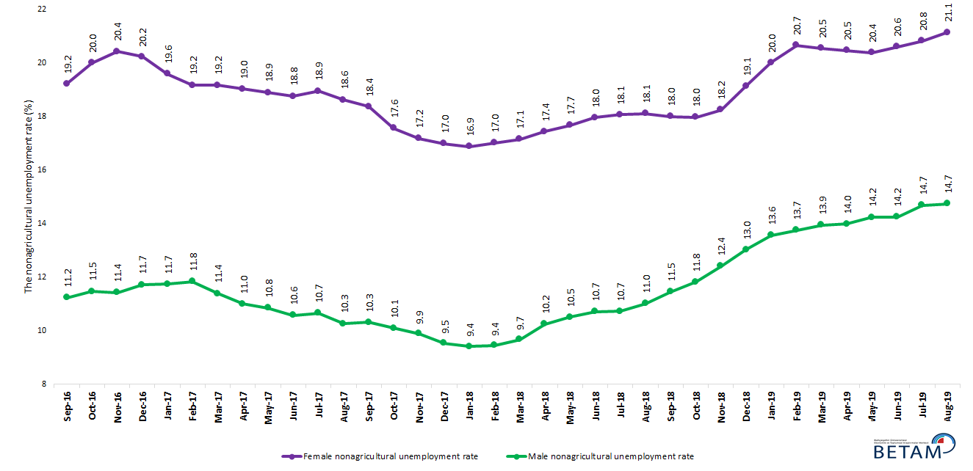

Source: Turkstat, Betam

Table 1 Seasonally adjusted non-agricultural labor market indicators (in thousands) **

 | Labor force | Employment | Unemployment | Unemployment rate | Monthly changes
August-16 | 25134 | 21716 | 3418 | 13.6% | Labor force | Employment | Unemployment
September-16 | 25361 | 21912 | 3449 | 13.6% | 227 | 196 | 31
October-16 | 25533 | 21933 | 3600 | 14.1% | 172 | 21 | 151
November-16 | 25640 | 22025 | 3615 | 14.1% | 107 | 92 | 15
December-16 | 25608 | 21946 | 3662 | 14.3% | -32 | -79 | 47
January-17 | 25694 | 22097 | 3597 | 14.0% | 86 | 151 | -65
February-17 | 25790 | 22205 | 3585 | 13.9% | 96 | 108 | -12
March-17 | 25962 | 22431 | 3531 | 13.6% | 172 | 226 | -54
April-17 | 26016 | 22582 | 3434 | 13.2% | 54 | 151 | -97
May-17 | 26089 | 22645 | 3444 | 13.2% | 73 | 63 | 10
June-17 | 26126 | 22730 | 3396 | 13.0% | 38 | 85 | -47
July-17 | 26146 | 22695 | 3451 | 13.2% | 20 | -35 | 55
August-17 | 26186 | 22860 | 3326 | 12.7% | 39 | 165 | -126
September-17 | 26281 | 22943 | 3338 | 12.7% | 95 | 83 | 12
October-17 | 26309 | 23073 | 3236 | 12.3% | 28 | 130 | -102
November-17 | 26415 | 23219 | 3196 | 12.1% | 106 | 146 | -40
December-17 | 26443 | 23323 | 3120 | 11.8% | 28 | 104 | -76
January-18 | 26512 | 23410 | 3102 | 11.7% | 69 | 87 | -18
February-18 | 26583 | 23473 | 3110 | 11.7% | 71 | 63 | 8
March-18 | 26599 | 23460 | 3139 | 11.8% | 15 | -13 | 28
April-18 | 26703 | 23445 | 3258 | 12.2% | 104 | -15 | 119
May-18 | 26784 | 23409 | 3375 | 12.6% | 81 | -36 | 117
June-18 | 26962 | 23484 | 3478 | 12.9% | 178 | 75 | 103
July-18 | 26982 | 23474 | 3508 | 13.0% | 19 | -10 | 29
August-18 | 27206 | 23615 | 3591 | 13.2% | 225 | 141 | 84
September-18 | 27113 | 23480 | 3633 | 13.4% | -93 | -135 | 42
October-18 | 27211 | 23483 | 3728 | 13.7% | 98 | 3 | 95
November-18 | 27145 | 23290 | 3855 | 14.2% | -66 | -193 | 127
December-18 | 27104 | 23038 | 4066 | 15.0% | -41 | -252 | 211
January-19 | 27050 | 22830 | 4220 | 15.6% | -54 | -208 | 154
February-19 | 27200 | 22902 | 4298 | 15.8% | 150 | 72 | 78
March-19 | 27350 | 22974 | 4376 | 16.0% | 150 | 72 | 78
April-19 | 27361 | 22983 | 4378 | 16.0% | 11 | 9 | 2
May-19 | 27291 | 22870 | 4421 | 16.2% | -70 | -113 | 43
June-19 | 27379 | 22944 | 4435 | 16.2% | 88 | 74 | 14
July-19 | 27468 | 22881 | 4587 | 16.7% | 89 | -63 | 152
August-19 | 27518 | 22950 | 4568 | 16.6% | 50 | 69 | -19

Source: Turkstat, Betam

Table 2 Seasonally adjusted employment by sectors (in thousands) *

 | Agriculture | Industry | Construction | Service | Monthly changes
August-16 | 5274 | 5224 | 1919 | 14573 | Agriculture | Industry | Construction | Service
September-16 | 5328 | 5260 | 2028 | 14624 | 54 | 36 | 109 | 51
October-16 | 5264 | 5282 | 1992 | 14659 | -64 | 22 | -36 | 35
November-16 | 5276 | 5316 | 1992 | 14716 | 12 | 34 | 0 | 57
December-16 | 5308 | 5265 | 1963 | 14719 | 32 | -51 | -29 | 3
January-17 | 5434 | 5274 | 1969 | 14854 | 126 | 9 | 6 | 135
February-17 | 5477 | 5251 | 2017 | 14937 | 43 | -23 | 48 | 83
March-17 | 5386 | 5346 | 2091 | 14994 | -91 | 95 | 74 | 57
April-17 | 5367 | 5372 | 2123 | 15086 | -19 | 26 | 32 | 92
May-17 | 5400 | 5386 | 2089 | 15170 | 33 | 14 | -34 | 84
June-17 | 5396 | 5383 | 2063 | 15284 | -4 | -3 | -26 | 114
July-17 | 5501 | 5363 | 2101 | 15231 | 105 | -20 | 38 | -53
August-17 | 5468 | 5437 | 2143 | 15281 | -33 | 74 | 42 | 50
September-17 | 5514 | 5421 | 2119 | 15403 | 46 | -16 | -24 | 122
October-17 | 5478 | 5470 | 2105 | 15498 | -36 | 49 | -14 | 95
November-17 | 5506 | 5470 | 2139 | 15610 | 28 | 0 | 34 | 112
December-17 | 5548 | 5514 | 2195 | 15614 | 42 | 44 | 56 | 4
January-18 | 5494 | 5567 | 2217 | 15627 | -54 | 53 | 22 | 13
February-18 | 5422 | 5627 | 2196 | 15651 | -72 | 60 | -21 | 24
March-18 | 5363 | 5618 | 2152 | 15689 | -59 | -9 | -44 | 38
April-18 | 5366 | 5650 | 2094 | 15701 | 3 | 32 | -58 | 12
May-18 | 5321 | 5669 | 2045 | 15695 | -45 | 19 | -49 | -6
June-18 | 5279 | 5737 | 2007 | 15740 | -42 | 68 | -38 | 45
July-18 | 5254 | 5703 | 1951 | 15820 | -25 | -34 | -56 | 80
August-18 | 5215 | 5730 | 1945 | 15940 | -39 | 27 | -6 | 120
September-18 | 5244 | 5698 | 1903 | 15880 | 29 | -32 | -42 | -60
October-18 | 5278 | 5696 | 1865 | 15922 | 34 | -2 | -38 | 42
November-18 | 5223 | 5656 | 1808 | 15825 | -55 | -40 | -57 | -97
December-18 | 5169 | 5474 | 1726 | 15837 | -54 | -182 | -82 | 12
January-19 | 5147 | 5392 | 1677 | 15761 | -22 | -82 | -49 | -76
February-19 | 5126 | 5388 | 1659 | 15855 | -21 | -4 | -18 | 94
March-19 | 5124 | 5482 | 1604 | 15888 | -2 | 94 | -55 | 33
April-19 | 5046 | 5553 | 1571 | 15859 | -78 | 71 | -33 | -29
May-19 | 5026 | 5546 | 1527 | 15797 | -20 | -7 | -44 | -62
June-19 | 5054 | 5616 | 1537 | 15791 | 28 | 70 | 10 | -6
July-19 | 5121 | 5600 | 1504 | 15778 | 67 | -16 | -33 | -13
August-19 | 5118 | 5551 | 1480 | 15919 | -3 | -49 | -24 | 141

Source: Turkstat, Betam

Table 3: Seasonally adjusted non-agricultural labor force by gender (thousands)

 | Female Labor Force | Female Employment | Female Unemployed | Male Labor Force | Male Employment | Male Unemployed
September-16 | 7385 | 5966 | 1419 | 18010 | 15988 | 2021
October-16 | 7436 | 5949 | 1487 | 18080 | 16007 | 2073
November-16 | 7466 | 5941 | 1525 | 18152 | 16081 | 2072
December-16 | 7451 | 5944 | 1507 | 18181 | 16052 | 2129
January-17 | 7446 | 5987 | 1459 | 18275 | 16132 | 2143
February-17 | 7494 | 6058 | 1436 | 18285 | 16122 | 2163
March-17 | 7596 | 6140 | 1456 | 18333 | 16247 | 2086
April-17 | 7602 | 6156 | 1446 | 18370 | 16352 | 2019
May-17 | 7668 | 6219 | 1449 | 18382 | 16389 | 1993
June-17 | 7681 | 6240 | 1441 | 18431 | 16483 | 1948
July-17 | 7699 | 6240 | 1459 | 18441 | 16476 | 1964
August-17 | 7722 | 6284 | 1438 | 18488 | 16591 | 1897
September-17 | 7775 | 6347 | 1428 | 18510 | 16602 | 1908
October-17 | 7785 | 6419 | 1367 | 18521 | 16653 | 1868
November-17 | 7835 | 6489 | 1346 | 18566 | 16730 | 1836
December-17 | 7880 | 6541 | 1338 | 18607 | 16834 | 1774
January-18 | 7918 | 6582 | 1336 | 18618 | 16867 | 1751
February-18 | 7936 | 6586 | 1350 | 18638 | 16879 | 1759
March-18 | 7929 | 6570 | 1360 | 18672 | 16868 | 1804
April-18 | 7987 | 6595 | 1392 | 18725 | 16809 | 1917
May-18 | 8040 | 6619 | 1421 | 18750 | 16783 | 1968
June-18 | 8086 | 6634 | 1452 | 18819 | 16805 | 2014
July-18 | 8106 | 6642 | 1465 | 18810 | 16795 | 2016
August-18 | 8201 | 6716 | 1485 | 18888 | 16808 | 2080
September-18 | 8176 | 6705 | 1471 | 18877 | 16715 | 2161
October-18 | 8266 | 6780 | 1486 | 18889 | 16657 | 2232
November-18 | 8251 | 6745 | 1505 | 18885 | 16543 | 2342
December-18 | 8332 | 6738 | 1594 | 18882 | 16423 | 2459
January-19 | 8360 | 6687 | 1673 | 18882 | 16321 | 2561
February-19 | 8430 | 6688 | 1742 | 18916 | 16315 | 2601
March-19 | 8476 | 6734 | 1742 | 18914 | 16276 | 2638
April-19 | 8418 | 6696 | 1723 | 18894 | 16253 | 2641
May-19 | 8373 | 6666 | 1707 | 18890 | 16201 | 2689
June-19 | 8405 | 6673 | 1732 | 18880 | 16190 | 2690
July-19 | 8427 | 6672 | 1755 | 18916 | 16139 | 2778
August-19 | 8493 | 6697 | 1796 | 18886 | 16103 | 2783

Source: Turkstat, Betam

*Prof. Dr. Seyfettin Gürsel, Betam, Director, seyfettin.gursel@eas.bau.edu.tr **Hamza Mutluay, Betam, Research Assistant, hamza.mutluay@eas.bau.edu.tr
For detailed information on Betam's forecasting model, please see Betam Research Brief 168 titled as "Kariyer.net Verisiyle Kısa Vadeli Tarım Dışı İşsizlik Tahmini" . For the innovations in the model please see Betam Research Brief 14 titled as "Mevsim Etkilerinden Arındırılmış İşsizlik Tahmini" Soybilgen, B., "Kariyer.net Verisiyle Kısa Vadeli Tarım Dışı İşsizlik Tahmini", Betam Research Brief 168. http://betam.bahcesehir.edu.tr/tr/2014/06/kariyer-net-verisiyle-kisa-vadeli-tarim-disi-issizlik-tahmini/ Soybilgen, B., "Mevsim Etkilerinden Arındırılmış İşsizlik Tahmini", Betam Research Brief 14 http://betam.bahcesehir.edu.tr/2015/08/mevsim-etkilerinden-arindirilmis-tarim-disi-issizlik-tahmini/
Betam has been calculating application per vacancy using series released by Kariyer.net for a while. Seasonal and calendar adjustment procedure is applied to application per vacancy series. A decrease in applications per vacancy may be caused by an increase in vacancies or by a decrease in the number of applications. An increase in vacancies signals economic growth while decreasing number of applications indicates a decrease in number of people looking for a job. Monthly labor market series released by TurkStat is the average of three months. Therefore, application per vacancy statistics calculated using Kariyer.net series is the average of three months as well.
Employment in each sector is seasonally adjusted separately. Hence the sum of these series may differ from the seasonally adjusted series of total employment. The difference stems from the non-linearity of the seasonal adjustment process.
Turkstat revised the labor market statistics drastically in February 2014. Within this framework, they back casted various labor market indicators and they also continued to announce seasonally adjusted series. However, Turkstat is not providing back-casted series by gender. Therefore, female and male labor market statistics are not sufficiently long for the seasonal adjustment procedures (There should be minimum 36 observations). With the announcement of the period of February 2017 data, the number of observations required for the seasonal decontamination process was provided. From this period Betam generated seasonal adjustment series in terms of gender. Nevertheless, it should not be forgotten that seasonal adjustment may cause extra volatility in the series for at least a while.

