Labor Market Outlook:
October 2019

16 October 2019

UNEXPECTED INCREASE IN UNEMPLOYMENT

Seyfettin Gürsel*, Mehmet Cem Şahin**

Executive Summary

Seasonally adjusted labor market data shows that, in the period of July 2019, non-agricultural unemployment rate turned out to be 16.7 percent, with a remarkable increase compared to June 2019. In this period, non-agricultural employment decreased by 65 thousand and non-agricultural labor force increased by 54 thousand. According to sectorial data, the only sector showing increase in employment is agriculture, and the sector showing the most significant decrease in employment is construction. After reversal of the decreasing trend in June 2019, construction employment decreased by 34 thousand. Manufacturing and services sectors had a net employment loss of 16 thousand and 15 thousands, respectively. Based on the seasonally adjusted data, male employment had a net loss in employment for the 11th consecutive period and female employment decreased slightly by 5 thousand. Apparently, the decreases in male employment is affected by the losses in construction employment.

The number of unemployed people in non-agricultural sector exceeded 4.5 million

Seasonally adjusted data shows that non-agricultural labor force reached 27 million 456 thousand by an increase of 54 thousand in June 2019, while non-agricultural employment went down to 22 million 871 thousand after the decrease of 65 thousand in July 2019 (Figure 1, Table 1). As a result, non-agricultural unemployment increased by 119 thousand and reached 4 million 585 thousand, and non-agricultural unemployment rate rose to 16.7 percent.

Figure 1. Seasonally adjusted non-agricultural labor force, employment, and unemployment
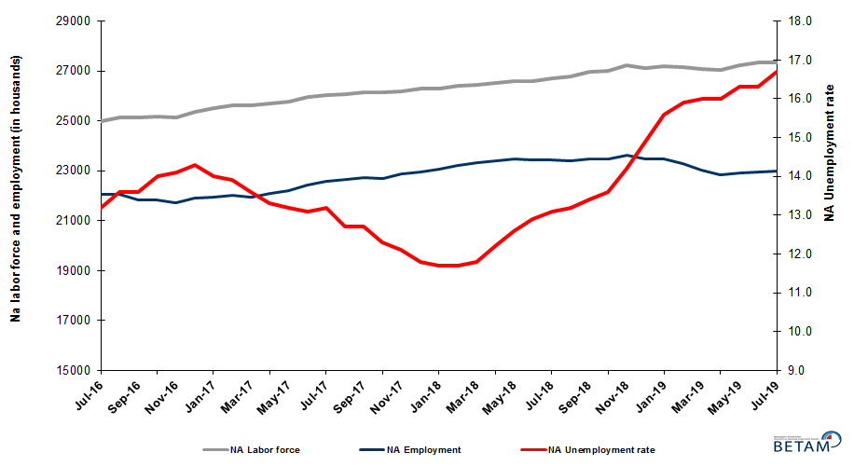

Source: Turkstat, Betam

Unemployment rate is expected to decrease slightly in August 2019

Betam’s forecasting model had predicted an increase of 0.1 percentage point in non-agricultural unemployment rate for July 2019 but it increased by more than expected, 0.4 percentage point. Our forecasting model predicts a decrease of 0.1 percentage point in non-agricultural unemployment rate, resulting in 16.6 percent in August 2019. Forecasting model details are available on Betam's website. Kariyer.net application per vacancy series used in the Betam forecasting model is depicted in Figure 3. Kariyer.net series is only one of the inputs of Betam forecast model. Indeed, several variables such as employment agency (İŞKUR) data, reel sector confidence index, capacity utilization rate are used in forecasting.

Figure 2 Seasonally adjusted non-agricultural unemployment rate and application per vacancy
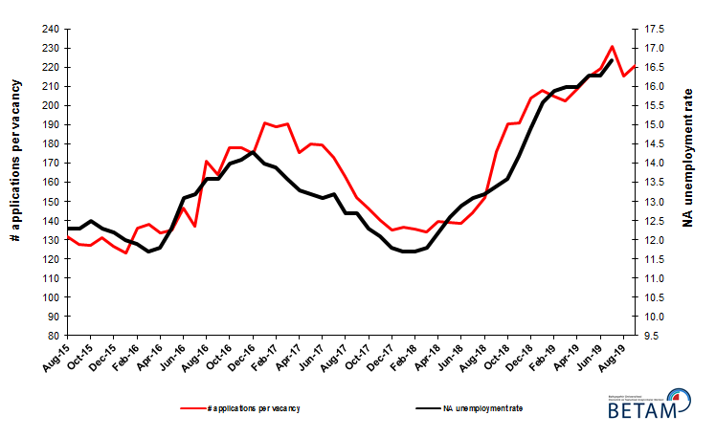
Source: Kariyer.net, Turkstat, Betam

Employment loss in all non-agricultural sectors

According to seasonally adjusted sectorial labor market data, employment decreased in the period of July 2019 compared to June 2019 in all sectors except agriculture (Figure 3, Table 2). After showing an increase of 70 thousand in June 2019, employment in manufacturing sector decreased by 16 thousand in July 2019. With the decrease of 15 thousand in July 2019, employment loss in services sector continued for the 4th consecutive month, totaling 119 thousand. Following the reversal of the decreasing trend in employment in June 2019, employment in construction sector decreased by 34 thousand.
.
Figure 3: Employment by sectors (in thousand)
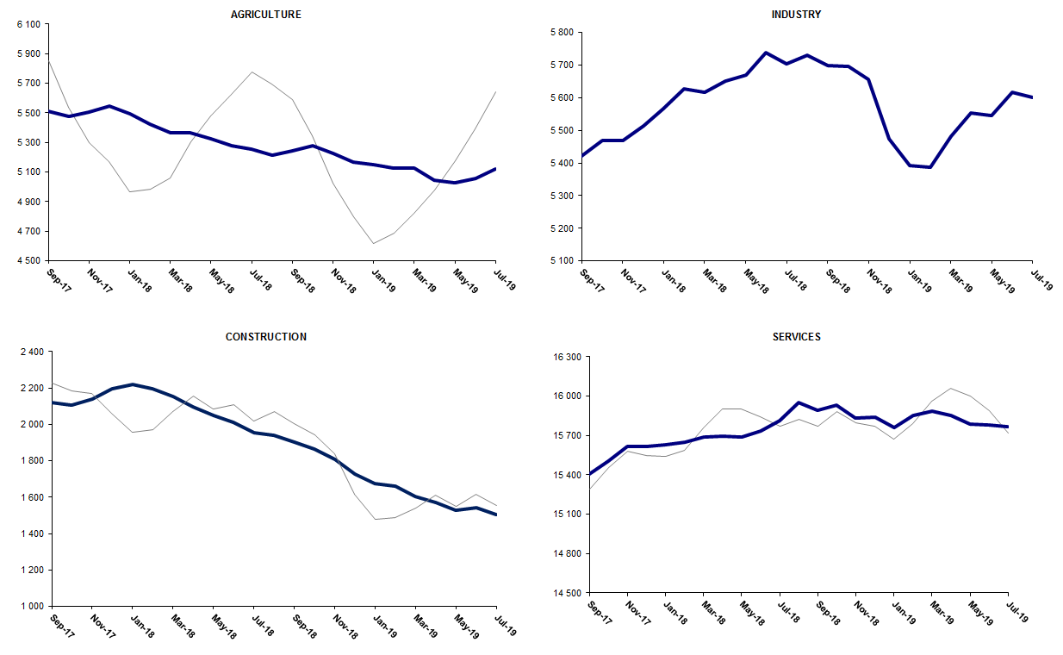
Source: TURKSTAT, Betam

Non-agricultural employment continues to decline year-on-year

From July 2018 to July 2019 non-agricultural labor force increased by 423 thousand (1.6 percent) and non-agricultural employment decreased by 618 thousand (-2.6 percent) (Figure 4). Annual labor force growth slowed down along with
employment losses and deviated from its structural trend. However, non-agricultural employment suffered from heavy
losses during the past year. Thus, compared to July 2018, the number of non-agricultural unemployed increased by
1 million 41 thousand.

Figure 4 Year-on-year changes in non-agricultural labor force, employment, and unemployment
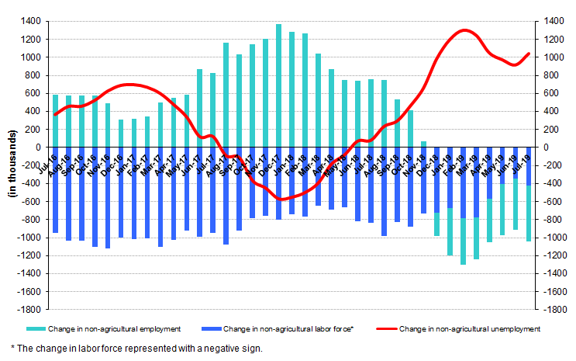
Source: TURKSTAT, Betam

Male employment has been consecutively decreasing for eleven months

Figure 5 shows seasonally adjusted non-agricultural unemployment rate for males (green) and for females (purple). In the period of July 2019, compared to the previous month, female non-agricultural unemployment rate increased by 0.3 points and reached 20.9 percent, while male non-agricultural unemployment rate increased also by 0.3 percent to 14.8 percent. As a result, the gender gap in non-agricultural unemployment rates narrowed to 6.1 percent.

In contrast to increase in both male and female labor force, male and female employment decreased in July 2019 (Table 3). Female employment decreased slightly by 5 thousand, male employment decreased by 51 thousand. Over the last 12 months, female employment increased by 29 thousand and male employment decreased by 658 thousand, and female and male labor force increased by 320 thousand and 139 thousand, respectively. Consequently, the gender gap in non-agricultural unemployment rates narrowed from 7.4 percent to 6.1 percent.

Figure 5: Seasonally adjusted non-agricultural unemployment rate by gender

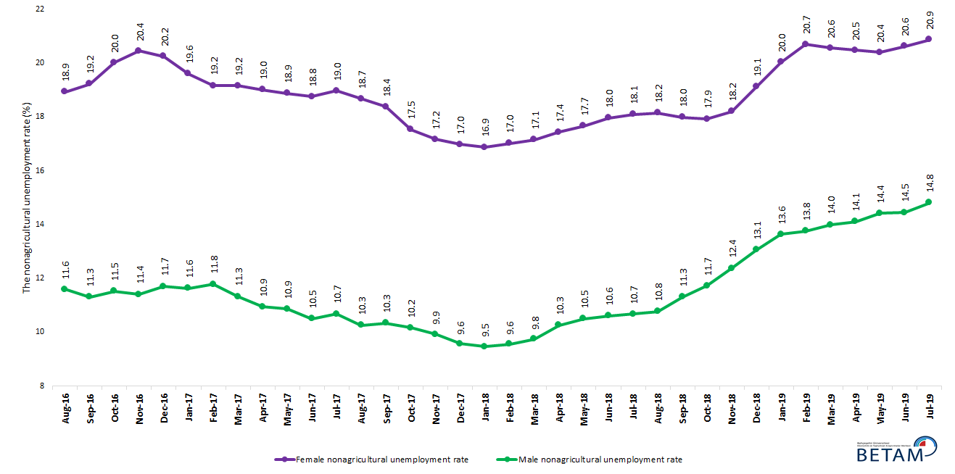

Source: Turkstat, Betam

Table 1 Seasonally adjusted non-agricultural labor market indicators (in thousands) **

 | Labor force | Employment | Unemployment | Unemployment rate | Monthly changes
July-16 | 25172 | 21849 | 3323 | 13.2% | Labor force | Employment | Unemployment
August-16 | 25140 | 21721 | 3419 | 13.6% | -32 | -128 | 96
September-16 | 25366 | 21916 | 3450 | 13.6% | 226 | 195 | 31
October-16 | 25507 | 21936 | 3571 | 14.0% | 141 | 20 | 121
November-16 | 25643 | 22027 | 3616 | 14.1% | 136 | 91 | 45
December-16 | 25610 | 21948 | 3662 | 14.3% | -32 | -79 | 47
January-17 | 25694 | 22097 | 3597 | 14.0% | 84 | 149 | -65
February-17 | 25790 | 22205 | 3585 | 13.9% | 96 | 108 | -12
March-17 | 25959 | 22429 | 3530 | 13.6% | 170 | 224 | -54
April-17 | 26043 | 22579 | 3464 | 13.3% | 83 | 150 | -67
May-17 | 26084 | 22641 | 3443 | 13.2% | 41 | 62 | -21
June-17 | 26150 | 22724 | 3426 | 13.1% | 65 | 83 | -18
July-17 | 26139 | 22689 | 3450 | 13.2% | -10 | -35 | 25
August-17 | 26192 | 22866 | 3326 | 12.7% | 53 | 177 | -124
September-17 | 26286 | 22948 | 3338 | 12.7% | 94 | 82 | 12
October-17 | 26314 | 23077 | 3237 | 12.3% | 27 | 129 | -102
November-17 | 26419 | 23222 | 3197 | 12.1% | 105 | 145 | -40
December-17 | 26446 | 23325 | 3121 | 11.8% | 27 | 103 | -76
January-18 | 26514 | 23412 | 3102 | 11.7% | 69 | 87 | -18
February-18 | 26583 | 23473 | 3110 | 11.7% | 69 | 61 | 8
March-18 | 26595 | 23457 | 3138 | 11.8% | 12 | -16 | 28
April-18 | 26699 | 23442 | 3257 | 12.2% | 104 | -15 | 119
May-18 | 26777 | 23403 | 3374 | 12.6% | 78 | -39 | 117
June-18 | 26955 | 23478 | 3477 | 12.9% | 178 | 75 | 103
July-18 | 27003 | 23466 | 3537 | 13.1% | 48 | -12 | 60
August-18 | 27215 | 23623 | 3592 | 13.2% | 212 | 157 | 55
September-18 | 27121 | 23487 | 3634 | 13.4% | -94 | -136 | 42
October-18 | 27185 | 23488 | 3697 | 13.6% | 64 | 1 | 63
November-18 | 27149 | 23294 | 3855 | 14.2% | -36 | -194 | 158
December-18 | 27074 | 23040 | 4034 | 14.9% | -75 | -254 | 179
January-19 | 27051 | 22831 | 4220 | 15.6% | -23 | -209 | 186
February-19 | 27231 | 22901 | 4330 | 15.9% | 180 | 70 | 110
March-19 | 27346 | 22971 | 4375 | 16.0% | 116 | 70 | 46
April-19 | 27355 | 22978 | 4377 | 16.0% | 8 | 7 | 1
May-19 | 27315 | 22863 | 4452 | 16.3% | -39 | -115 | 76
June-19 | 27403 | 22936 | 4467 | 16.3% | 87 | 73 | 14
July-19 | 27456 | 22871 | 4585 | 16.7% | 54 | -65 | 119

Source: Turkstat, Betam

Table 2 Seasonally adjusted employment by sectors (in thousands) *

 | Agriculture | Manufacturing | Construction | Service | Monthly changes
July-16 | 5210 | 5254 | 1957 | 14638 | Agriculture | Manufacturing | Construction | Service
August-16 | 5274 | 5224 | 1918 | 14578 | 64 | -30 | -39 | -60
September-16 | 5328 | 5260 | 2027 | 14629 | 54 | 36 | 109 | 51
October-16 | 5264 | 5282 | 1992 | 14662 | -64 | 22 | -35 | 33
November-16 | 5276 | 5316 | 1992 | 14719 | 12 | 34 | 0 | 57
December-16 | 5308 | 5265 | 1963 | 14720 | 32 | -51 | -29 | 1
January-17 | 5434 | 5274 | 1969 | 14854 | 126 | 9 | 6 | 134
February-17 | 5477 | 5251 | 2017 | 14937 | 43 | -23 | 48 | 83
March-17 | 5386 | 5346 | 2091 | 14993 | -91 | 95 | 74 | 56
April-17 | 5367 | 5372 | 2124 | 15083 | -19 | 26 | 33 | 90
May-17 | 5401 | 5386 | 2090 | 15165 | 34 | 14 | -34 | 82
June-17 | 5397 | 5383 | 2064 | 15277 | -4 | -3 | -26 | 112
July-17 | 5501 | 5363 | 2103 | 15223 | 104 | -20 | 39 | -54
August-17 | 5468 | 5437 | 2141 | 15289 | -33 | 74 | 38 | 66
September-17 | 5513 | 5421 | 2118 | 15409 | 45 | -16 | -23 | 120
October-17 | 5478 | 5470 | 2104 | 15503 | -35 | 49 | -14 | 94
November-17 | 5506 | 5470 | 2139 | 15614 | 28 | 0 | 35 | 111
December-17 | 5548 | 5514 | 2195 | 15616 | 42 | 44 | 56 | 2
January-18 | 5493 | 5567 | 2217 | 15627 | -55 | 53 | 22 | 11
February-18 | 5422 | 5627 | 2196 | 15650 | -71 | 60 | -21 | 23
March-18 | 5364 | 5618 | 2153 | 15687 | -58 | -9 | -43 | 37
April-18 | 5366 | 5650 | 2095 | 15697 | 2 | 32 | -58 | 10
May-18 | 5322 | 5669 | 2047 | 15688 | -44 | 19 | -48 | -9
June-18 | 5279 | 5737 | 2009 | 15732 | -43 | 68 | -38 | 44
July-18 | 5255 | 5703 | 1953 | 15810 | -24 | -34 | -56 | 78
August-18 | 5215 | 5730 | 1942 | 15951 | -40 | 27 | -11 | 141
September-18 | 5243 | 5698 | 1901 | 15889 | 28 | -32 | -41 | -62
October-18 | 5278 | 5696 | 1863 | 15929 | 35 | -2 | -38 | 40
November-18 | 5223 | 5656 | 1807 | 15830 | -55 | -40 | -56 | -99
December-18 | 5169 | 5474 | 1726 | 15840 | -54 | -182 | -81 | 10
January-19 | 5147 | 5392 | 1677 | 15761 | -22 | -82 | -49 | -79
February-19 | 5126 | 5388 | 1659 | 15854 | -21 | -4 | -18 | 93
March-19 | 5124 | 5482 | 1605 | 15884 | -2 | 94 | -54 | 30
April-19 | 5047 | 5553 | 1572 | 15853 | -77 | 71 | -33 | -31
May-19 | 5027 | 5546 | 1529 | 15788 | -20 | -7 | -43 | -65
June-19 | 5055 | 5616 | 1540 | 15780 | 28 | 70 | 11 | -8
July-19 | 5122 | 5600 | 1506 | 15765 | 67 | -16 | -34 | -15

Source: Turkstat, Betam

Table 3: Seasonally adjusted non-agricultural labor force by gender (thousands)

 | Female Labor Force | Female Employment | Female Unemployed | Male Labor Force | Male Employment | Male Unemployed
August-16 | 7322 | 5936 | 1386 | 17960 | 15878 | 2082
September-16 | 7387 | 5967 | 1420 | 18028 | 15989 | 2039
October-16 | 7438 | 5949 | 1489 | 18092 | 16007 | 2085
November-16 | 7468 | 5941 | 1527 | 18152 | 16081 | 2071
December-16 | 7452 | 5943 | 1509 | 18180 | 16052 | 2128
January-17 | 7446 | 5986 | 1459 | 18254 | 16132 | 2122
February-17 | 7494 | 6058 | 1436 | 18276 | 16122 | 2153
March-17 | 7595 | 6140 | 1455 | 18322 | 16246 | 2075
April-17 | 7600 | 6155 | 1445 | 18360 | 16352 | 2009
May-17 | 7666 | 6219 | 1447 | 18386 | 16389 | 1998
June-17 | 7678 | 6239 | 1440 | 18416 | 16482 | 1933
July-17 | 7694 | 6235 | 1459 | 18446 | 16476 | 1971
August-17 | 7728 | 6286 | 1443 | 18488 | 16592 | 1896
September-17 | 7777 | 6349 | 1429 | 18518 | 16602 | 1915
October-17 | 7788 | 6422 | 1365 | 18537 | 16653 | 1884
November-17 | 7836 | 6491 | 1345 | 18574 | 16730 | 1844
December-17 | 7881 | 6544 | 1338 | 18616 | 16834 | 1782
January-18 | 7918 | 6583 | 1336 | 18632 | 16867 | 1765
February-18 | 7937 | 6586 | 1351 | 18662 | 16878 | 1783
March-18 | 7930 | 6570 | 1360 | 18690 | 16867 | 1823
April-18 | 7985 | 6593 | 1392 | 18730 | 16808 | 1923
May-18 | 8036 | 6616 | 1420 | 18751 | 16781 | 1969
June-18 | 8082 | 6630 | 1452 | 18799 | 16804 | 1995
July-18 | 8100 | 6634 | 1466 | 18800 | 16793 | 2007
August-18 | 8207 | 6718 | 1490 | 18839 | 16811 | 2028
September-18 | 8177 | 6707 | 1470 | 18849 | 16717 | 2131
October-18 | 8268 | 6786 | 1482 | 18871 | 16658 | 2213
November-18 | 8251 | 6750 | 1501 | 18881 | 16544 | 2337
December-18 | 8335 | 6742 | 1593 | 18890 | 16424 | 2466
January-19 | 8361 | 6687 | 1674 | 18899 | 16321 | 2578
February-19 | 8432 | 6687 | 1745 | 18918 | 16314 | 2604
March-19 | 8478 | 6735 | 1743 | 18923 | 16275 | 2648
April-19 | 8416 | 6693 | 1723 | 18920 | 16251 | 2669
May-19 | 8367 | 6661 | 1706 | 18928 | 16199 | 2729
June-19 | 8400 | 6668 | 1732 | 18921 | 16186 | 2734
July-19 | 8420 | 6663 | 1757 | 18940 | 16135 | 2805

Source: Turkstat, Betam

*Prof. Dr. Seyfettin Gürsel, Betam, Director, seyfettin.gursel@eas.bau.edu.tr **Mehmet Cem Şahin, Betam, Research Assistant, mehmetcem.sahin@eas.bau.edu.tr
For detailed information on Betam's forecasting model, please see Betam Research Brief 168 titled as "Kariyer.net Verisiyle Kısa Vadeli Tarım Dışı İşsizlik Tahmini" . For the innovations in the model please see Betam Research Brief 14 titled as "Mevsim Etkilerinden Arındırılmış İşsizlik Tahmini" Soybilgen, B., "Kariyer.net Verisiyle Kısa Vadeli Tarım Dışı İşsizlik Tahmini", Betam Research Brief 168. http://betam.bahcesehir.edu.tr/tr/2014/06/kariyer-net-verisiyle-kisa-vadeli-tarim-disi-issizlik-tahmini/ Soybilgen, B., "Mevsim Etkilerinden Arındırılmış İşsizlik Tahmini", Betam Research Brief 14 http://betam.bahcesehir.edu.tr/2015/08/mevsim-etkilerinden-arindirilmis-tarim-disi-issizlik-tahmini/
Betam has been calculating application per vacancy using series released by Kariyer.net for a while. Seasonal and calendar adjustment procedure is applied to application per vacancy series. A decrease in applications per vacancy may be caused by an increase in vacancies or by a decrease in the number of applications. An increase in vacancies signals economic growth while decreasing number of applications indicates a decrease in number of people looking for a job. Monthly labor market series released by TurkStat is the average of three months. Therefore, application per vacancy statistics calculated using Kariyer.net series is the average of three months as well.
Employment in each sector is seasonally adjusted separately. Hence the sum of these series may differ from the seasonally adjusted series of total employment. The difference stems from the non-linearity of the seasonal adjustment process.
Turkstat revised the labor market statistics drastically in February 2014. Within this framework, they back casted various labor market indicators and they also continued to announce seasonally adjusted series. However, Turkstat is not providing back-casted series by gender. Therefore, female and male labor market statistics are not sufficiently long for the seasonal adjustment procedures (There should be minimum 36 observations). With the announcement of the period of February 2017 data, the number of observations required for the seasonal decontamination process was provided. From this period Betam generated seasonal adjustment series in terms of gender. Nevertheless, it should not be forgotten that seasonal adjustment may cause extra volatility in the series for at least a while.

