Labor Market Outlook:
September 2019

17 September 2019

STOP IN INCREASE OF NON-AGRICULTURAL UNEMPLOYMENT

Seyfettin Gürsel*, Gökçe Uysal∗∗ , Mehmet Cem Şahin***

Executive Summary

Seasonally adjusted labor market data shows that, in the period of June 2019, non-agricultural unemployment rate remained unchanged and stood at 16.2 percent. In this period, increases in non-agricultural employment attained 75 thousand and non-agricultural labor force increased by 89 thousand. According to sectorial data, the only sector showing decrease in employment is services, and the sector showing the most significant increase in employment is manufacturing, with 70 thousand. Consecutive decreases in construction employment since February 2018 came to a halt in July 2019 with net increase in employment of 12 thousand people. Based on the seasonally adjusted data, decreases in male employment continued while female employment increased slightly. Apparently, the decreases in male employment is affected by the losses in construction employment.

The number of unemployed people in non-agricultural sector is close to 4.5 million

Seasonally adjusted data shows that non-agricultural labor force reached 27 million 384 thousand by an increase of 89 thousand in June 2019, while non-agricultural employment reached 22 million 948 thousand after an increase of 75 thousand in June 2019 (Figure 1, Table 1). As a result, non-agricultural unemployment increased by 14 thousand and reached 4 million 436 thousand, and non-agricultural unemployment rate stood at 16.2 percent.

Figure 1. Seasonally adjusted non-agricultural labor force, employment, and unemployment
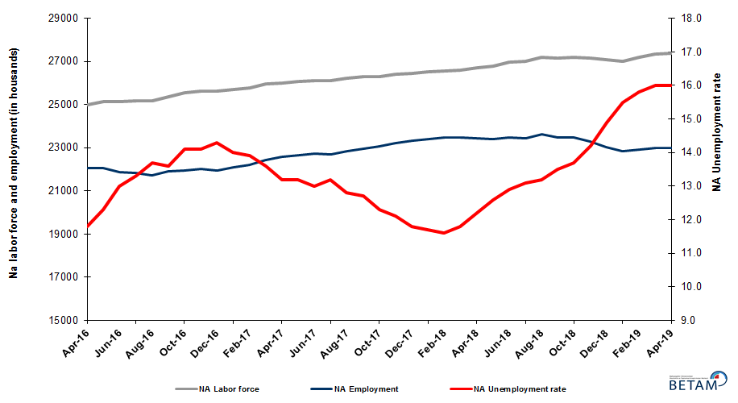

Source: Turkstat, Betam

Unemployment rate is expected to increase in July 2019

Betam’s forecasting model had predicted an increase of 0.1 percentage point in non-agricultural unemployment rate for June 2019 but there has been non-increase. Our forecasting model predicts a 0.1 percentage point, increasing the unemployment rate to 16.3 percent in July 2019. Forecasting model details are available on Betam's website. Kariyer.net application per vacancy series used in the Betam forecasting model is depicted in Figure 3. Kariyer.net series is only one of the inputs of Betam forecast model. Indeed, several variables such as employment agency (İŞKUR) data, reel sector confidence index, capacity utilization rate are used in forecasting.

Figure 2 Seasonally adjusted non-agricultural unemployment rate and application per vacancy
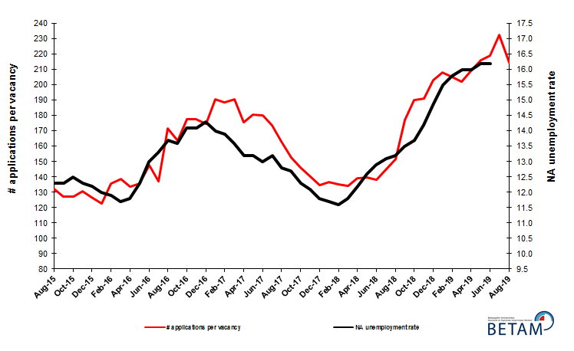
Source: Kariyer.net, Turkstat, Betam

Increase in construction employment after consecutive decreases of 16 months

According to seasonally adjusted sectorial labor market data, employment increased in the period of June 2019 compared to May 2019 in all sectors except services (Figure 3, Table 2). After a decrease of 7 thousand in May 2019, employment in manufacturing sector increased by 70 thousand in June 2019. With an increase of 12 thousand in June 2019, employment in construction sector reversed its persistent decreases in employment during 16 months. On the other hand, employment in services sector has been declining for three consecutive, totaling 100 thousand.

.
Figure 3: Employment by sectors (in thousand)
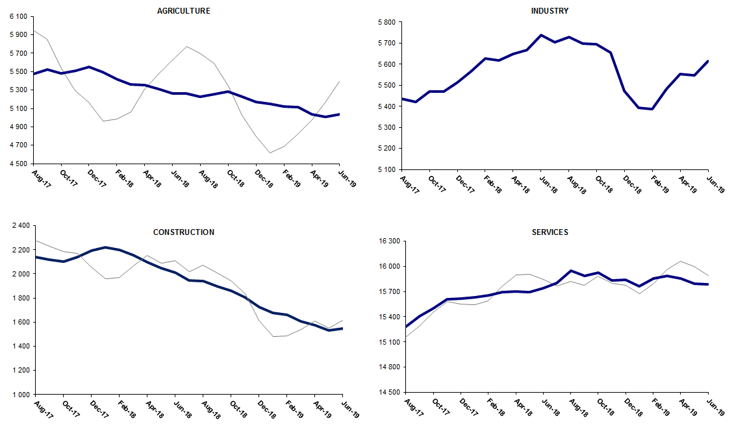
Source: TURKSTAT, Betam

Non-agricultural employment continues to decline year-on-year

From June 2018 to June 2019 non-agricultural labor force increased by 346 thousand (1.3 percent) and non-agricultural employment decreased by 569 thousand (-2.4 percent) (Figure 4). Annual labor force growth slowed down along with
employment losses and deviated from its structural trend. However, non-agricultural employment suffered from heavy
losses during the past year. Thus, compared to June 2018, the number of non-agricultural unemployed increased by
915 thousand

Figure 4 Year-on-year changes in non-agricultural labor force, employment, and unemployment
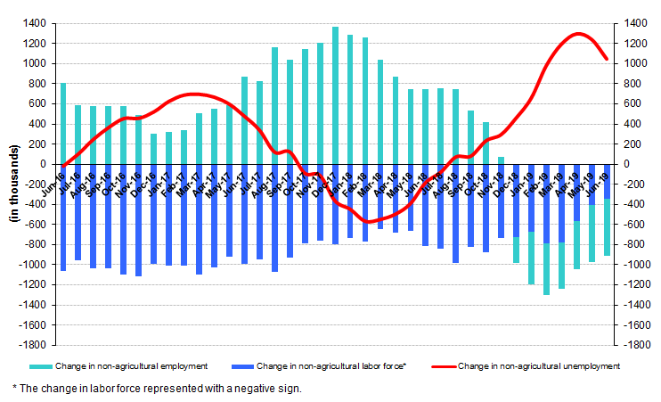
Source: TURKSTAT, Betam

Increase in female employment

Figure 5 shows seasonally adjusted non-agricultural unemployment rate for males (green) and for females (purple). In the period of June 2019, compared to the previous month, female non-agricultural unemployment rate increased by 0.2 percent and reached 20.6 percent, while male non-agricultural unemployment rate remained unchanged at 14.2 percent. As a result, the gender gap in non-agricultural unemployment rates reached 6.4 percent.

In this period, while female labor force increased, the decreases in male labor force observed in the last months continued (Table 3). In contrast to the losses in male non-agricultural employment, female non-agricultural employment increased slightly in this period. Over the last 12 months, female employment increased by 38 thousand and male employment decreased by 612 thousand, and female and male labor force increased by 318 thousand and 65 thousand, respectively. Consequently, the gender gap in non-agricultural unemployment rates narrowed from 7.3 percent to 6.4 percent.

Figure 5: Seasonally adjusted non-agricultural unemployment rate by gender

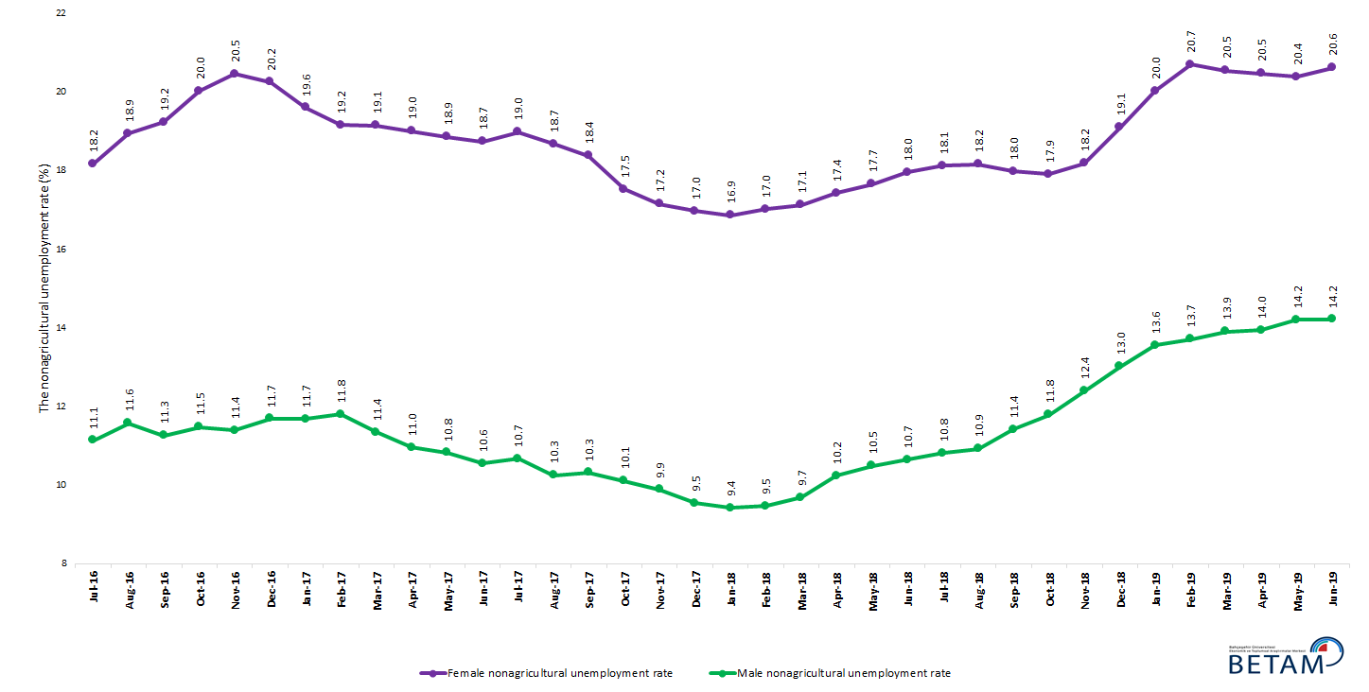

Source: Turkstat, Betam

Table 1 Seasonally adjusted non-agricultural labor market indicators (in thousands) **

 | Labor force | Employment | Unemployment | Unemployment rate | Monthly changes
April-16 | 25003 | 22053 | 2950 | 11.8% | Labor force | Employment | Unemployment
May-16 | 25141 | 22049 | 3092 | 12.3% | 138 | -4 | 142
June-16 | 25122 | 21856 | 3266 | 13.0% | -20 | -193 | 173
July-16 | 25194 | 21843 | 3351 | 13.3% | 72 | -13 | 85
August-16 | 25165 | 21717 | 3448 | 13.7% | -29 | -126 | 97
September-16 | 25362 | 21913 | 3449 | 13.6% | 198 | 196 | 2
October-16 | 25534 | 21934 | 3600 | 14.1% | 172 | 21 | 151
November-16 | 25641 | 22026 | 3615 | 14.1% | 107 | 92 | 15
December-16 | 25610 | 21948 | 3662 | 14.3% | -31 | -78 | 47
January-17 | 25695 | 22098 | 3597 | 14.0% | 85 | 150 | -65
February-17 | 25792 | 22207 | 3585 | 13.9% | 97 | 109 | -12
March-17 | 25964 | 22433 | 3531 | 13.6% | 172 | 226 | -54
April-17 | 26017 | 22583 | 3434 | 13.2% | 53 | 150 | -97
May-17 | 26091 | 22647 | 3444 | 13.2% | 74 | 64 | 10
June-17 | 26128 | 22731 | 3397 | 13.0% | 37 | 84 | -47
July-17 | 26130 | 22681 | 3449 | 13.2% | 3 | -50 | 53
August-17 | 26216 | 22860 | 3356 | 12.8% | 85 | 179 | -94
September-17 | 26281 | 22943 | 3338 | 12.7% | 65 | 83 | -18
October-17 | 26310 | 23074 | 3236 | 12.3% | 30 | 131 | -101
November-17 | 26416 | 23220 | 3196 | 12.1% | 106 | 146 | -40
December-17 | 26446 | 23325 | 3121 | 11.8% | 29 | 105 | -76
January-18 | 26514 | 23412 | 3102 | 11.7% | 69 | 87 | -18
February-18 | 26557 | 23476 | 3081 | 11.6% | 42 | 64 | -22
March-18 | 26601 | 23462 | 3139 | 11.8% | 44 | -14 | 58
April-18 | 26707 | 23449 | 3258 | 12.2% | 106 | -13 | 119
May-18 | 26787 | 23412 | 3375 | 12.6% | 80 | -37 | 117
June-18 | 26967 | 23488 | 3479 | 12.9% | 180 | 76 | 104
July-18 | 26990 | 23454 | 3536 | 13.1% | 23 | -34 | 57
August-18 | 27205 | 23614 | 3591 | 13.2% | 215 | 160 | 55
September-18 | 27145 | 23480 | 3665 | 13.5% | -61 | -134 | 73
October-18 | 27211 | 23483 | 3728 | 13.7% | 66 | 3 | 63
November-18 | 27146 | 23291 | 3855 | 14.2% | -65 | -192 | 127
December-18 | 27074 | 23040 | 4034 | 14.9% | -72 | -251 | 179
January-19 | 27020 | 22832 | 4188 | 15.5% | -54 | -208 | 154
February-19 | 27203 | 22905 | 4298 | 15.8% | 183 | 73 | 110
March-19 | 27354 | 22977 | 4377 | 16.0% | 150 | 72 | 78
April-19 | 27364 | 22986 | 4378 | 16.0% | 11 | 9 | 2
May-19 | 27295 | 22873 | 4422 | 16.2% | -70 | -113 | 43
June-19 | 27384 | 22948 | 4436 | 16.2% | 89 | 75 | 14

Source: Turkstat, Betam

Table 2 Seasonally adjusted employment by sectors (in thousands) *

 | Agriculture | Manufacturing | Construction | Service | Monthly changes
April-16 | 5377 | 5381 | 2035 | 14636 | Agriculture | Manufacturing | Construction | Service
May-16 | 5337 | 5386 | 2064 | 14600 | -40 | 5 | 29 | -36
June-16 | 5187 | 5330 | 1955 | 14570 | -150 | -56 | -109 | -30
July-16 | 5214 | 5254 | 1955 | 14634 | 27 | -76 | 0 | 64
August-16 | 5279 | 5224 | 1917 | 14576 | 65 | -30 | -38 | -58
September-16 | 5333 | 5260 | 2026 | 14626 | 54 | 36 | 109 | 50
October-16 | 5265 | 5282 | 1991 | 14661 | -68 | 22 | -35 | 35
November-16 | 5276 | 5316 | 1991 | 14718 | 11 | 34 | 0 | 57
December-16 | 5308 | 5265 | 1963 | 14720 | 32 | -51 | -28 | 2
January-17 | 5435 | 5274 | 1969 | 14855 | 127 | 9 | 6 | 135
February-17 | 5477 | 5251 | 2018 | 14938 | 42 | -23 | 49 | 83
March-17 | 5383 | 5346 | 2092 | 14995 | -94 | 95 | 74 | 57
April-17 | 5362 | 5372 | 2126 | 15086 | -21 | 26 | 34 | 91
May-17 | 5393 | 5386 | 2092 | 15169 | 31 | 14 | -34 | 83
June-17 | 5386 | 5383 | 2066 | 15282 | -7 | -3 | -26 | 113
July-17 | 5508 | 5363 | 2099 | 15218 | 122 | -20 | 33 | -64
August-17 | 5475 | 5437 | 2139 | 15284 | -33 | 74 | 40 | 66
September-17 | 5521 | 5421 | 2116 | 15406 | 46 | -16 | -23 | 122
October-17 | 5482 | 5470 | 2103 | 15501 | -39 | 49 | -13 | 95
November-17 | 5508 | 5470 | 2138 | 15612 | 26 | 0 | 35 | 111
December-17 | 5550 | 5514 | 2195 | 15616 | 42 | 44 | 57 | 4
January-18 | 5495 | 5567 | 2218 | 15628 | -55 | 53 | 23 | 12
February-18 | 5421 | 5627 | 2198 | 15652 | -74 | 60 | -20 | 24
March-18 | 5359 | 5618 | 2155 | 15690 | -62 | -9 | -43 | 38
April-18 | 5357 | 5650 | 2098 | 15701 | -2 | 32 | -57 | 11
May-18 | 5310 | 5669 | 2050 | 15693 | -47 | 19 | -48 | -8
June-18 | 5264 | 5737 | 2013 | 15737 | -46 | 68 | -37 | 44
July-18 | 5264 | 5703 | 1948 | 15803 | 0 | -34 | -65 | 66
August-18 | 5225 | 5730 | 1938 | 15946 | -39 | 27 | -10 | 143
September-18 | 5254 | 5698 | 1898 | 15884 | 29 | -32 | -40 | -62
October-18 | 5286 | 5696 | 1861 | 15926 | 32 | -2 | -37 | 42
November-18 | 5228 | 5656 | 1806 | 15829 | -58 | -40 | -55 | -97
December-18 | 5171 | 5474 | 1726 | 15840 | -57 | -182 | -80 | 11
January-19 | 5148 | 5392 | 1678 | 15762 | -23 | -82 | -48 | -78
February-19 | 5124 | 5388 | 1661 | 15857 | -24 | -4 | -17 | 95
March-19 | 5117 | 5482 | 1607 | 15888 | -7 | 94 | -54 | 31
April-19 | 5034 | 5553 | 1576 | 15858 | -83 | 71 | -31 | -30
May-19 | 5010 | 5546 | 1533 | 15795 | -24 | -7 | -43 | -63
June-19 | 5035 | 5616 | 1545 | 15788 | 25 | 70 | 12 | -7

Source: Turkstat, Betam

Table 3: Seasonally adjusted non-agricultural labor force by gender (thousands)

 | Female Labor Force | Female Employment | Female Unemployed | Male Labor Force | Male Employment | Male Unemployed
July-16 | 7283 | 5959 | 1324 | 17945 | 15947 | 1999
August-16 | 7322 | 5935 | 1387 | 17957 | 15878 | 2079
September-16 | 7387 | 5967 | 1421 | 18018 | 15988 | 2030
October-16 | 7438 | 5948 | 1489 | 18084 | 16007 | 2076
November-16 | 7468 | 5940 | 1527 | 18150 | 16081 | 2069
December-16 | 7452 | 5943 | 1509 | 18178 | 16052 | 2125
January-17 | 7446 | 5986 | 1459 | 18265 | 16132 | 2133
February-17 | 7494 | 6058 | 1436 | 18280 | 16123 | 2157
March-17 | 7595 | 6141 | 1454 | 18327 | 16247 | 2080
April-17 | 7600 | 6156 | 1444 | 18365 | 16352 | 2013
May-17 | 7666 | 6220 | 1446 | 18379 | 16389 | 1990
June-17 | 7679 | 6240 | 1439 | 18429 | 16483 | 1946
July-17 | 7694 | 6234 | 1460 | 18444 | 16475 | 1969
August-17 | 7728 | 6284 | 1444 | 18488 | 16592 | 1896
September-17 | 7777 | 6348 | 1429 | 18512 | 16602 | 1911
October-17 | 7788 | 6423 | 1365 | 18526 | 16653 | 1873
November-17 | 7836 | 6492 | 1344 | 18568 | 16730 | 1838
December-17 | 7881 | 6544 | 1337 | 18610 | 16834 | 1776
January-18 | 7918 | 6583 | 1336 | 18622 | 16868 | 1754
February-18 | 7937 | 6586 | 1351 | 18645 | 16879 | 1766
March-18 | 7930 | 6571 | 1359 | 18677 | 16868 | 1809
April-18 | 7985 | 6593 | 1392 | 18727 | 16809 | 1918
May-18 | 8036 | 6617 | 1419 | 18751 | 16783 | 1968
June-18 | 8082 | 6631 | 1452 | 18810 | 16806 | 2004
July-18 | 8100 | 6632 | 1468 | 18827 | 16790 | 2036
August-18 | 8207 | 6716 | 1491 | 18870 | 16808 | 2062
September-18 | 8177 | 6706 | 1471 | 18869 | 16715 | 2154
October-18 | 8268 | 6787 | 1481 | 18884 | 16657 | 2227
November-18 | 8251 | 6751 | 1501 | 18883 | 16543 | 2340
December-18 | 8335 | 6742 | 1592 | 18883 | 16424 | 2459
January-19 | 8361 | 6687 | 1674 | 18883 | 16322 | 2561
February-19 | 8432 | 6687 | 1745 | 18909 | 16316 | 2594
March-19 | 8478 | 6737 | 1742 | 18907 | 16277 | 2630
April-19 | 8416 | 6693 | 1723 | 18889 | 16254 | 2635
May-19 | 8368 | 6662 | 1706 | 18886 | 16203 | 2683
June-19 | 8400 | 6668 | 1732 | 18874 | 16191 | 2683

Source: Turkstat, Betam

*Prof. Dr. Seyfettin Gürsel, Betam, Director, seyfettin.gursel@eas.bau.edu.tr
∗∗Doç. Dr. Gökçe Uysal, Betam, Deputy Director, gokce.uysal@eas.bau.edu.tr ***Mehmet Cem Şahin, Betam, Research Assistant, mehmetcem.sahin@eas.bau.edu.tr
For detailed information on Betam's forecasting model, please see Betam Research Brief 168 titled as "Kariyer.net Verisiyle Kısa Vadeli Tarım Dışı İşsizlik Tahmini" . For the innovations in the model please see Betam Research Brief 14 titled as "Mevsim Etkilerinden Arındırılmış İşsizlik Tahmini" Soybilgen, B., "Kariyer.net Verisiyle Kısa Vadeli Tarım Dışı İşsizlik Tahmini", Betam Research Brief 168. http://betam.bahcesehir.edu.tr/tr/2014/06/kariyer-net-verisiyle-kisa-vadeli-tarim-disi-issizlik-tahmini/ Soybilgen, B., "Mevsim Etkilerinden Arındırılmış İşsizlik Tahmini", Betam Research Brief 14 http://betam.bahcesehir.edu.tr/2015/08/mevsim-etkilerinden-arindirilmis-tarim-disi-issizlik-tahmini/
Betam has been calculating application per vacancy using series released by Kariyer.net for a while. Seasonal and calendar adjustment procedure is applied to application per vacancy series. A decrease in applications per vacancy may be caused by an increase in vacancies or by a decrease in the number of applications. An increase in vacancies signals economic growth while decreasing number of applications indicates a decrease in number of people looking for a job. Monthly labor market series released by TurkStat is the average of three months. Therefore, application per vacancy statistics calculated using Kariyer.net series is the average of three months as well.
Employment in each sector is seasonally adjusted separately. Hence the sum of these series may differ from the seasonally adjusted series of total employment. The difference stems from the non-linearity of the seasonal adjustment process.
Turkstat revised the labor market statistics drastically in February 2014. Within this framework, they back casted various labor market indicators and they also continued to announce seasonally adjusted series. However, Turkstat is not providing back-casted series by gender. Therefore, female and male labor market statistics are not sufficiently long for the seasonal adjustment procedures (There should be minimum 36 observations). With the announcement of the period of February 2017 data, the number of observations required for the seasonal decontamination process was provided. From this period Betam generated seasonal adjustment series in terms of gender. Nevertheless, it should not be forgotten that seasonal adjustment may cause extra volatility in the series for at least a while.

