Labor Market Outlook:
August 2019

15 August 2019

LOSSES IN EMPLOYMENT RESTARTED

Seyfettin Gürsel*, Hamza Mutluay∗∗

Executive Summary

Seasonally adjusted labor market data shows that, in the period of May 2019, non-agricultural unemployment increased by 0.2 points to 16.2 percent. In this period, non-agricultural employment decreased by 112 thousand and non-agricultural labor force decreased by 68 thousand. Reductions in both employment and labor force are remarkable. Sectoral data indicate that employment is decreasing in all sectors, but the most striking decrease is in services. While employment in services decreased by 62 thousand, employment loss in industry was 7 thousand. Employment losses in construction continued and since February 2018, the level of employment loss in construction reached 691 thousand. According to seasonally adjusted labor market data, both labor and employment of women decreased.

Number of unemployed in non-agricultural sector reached 4 million 422 thousand

According to seasonally adjusted labor market data, in the period of May 2019 compared to April 2019, the non-agricultural labor force decreased by 68 thousand to 27 million 295 thousand, and the number of employed in non-agricultural sectors decreased by 112 thousand to 22 million 873 thousand. Thereby, the number of unemployed in non-agricultural sectors increased by 44 thousand and reached 4 million 422 thousand and consequently the non-agricultural unemployment rate reached 16.2 percent (Figure 1, Table 1). Despite the decrease in the labor force in non-agricultural sectors, it is observed that non-agricultural unemployment rate increased as a result of greater losses in employment.

Figure 1 : Seasonally adjusted non-agricultural labor force, employment, and unemployment

Source: Turkstat, Betam

Unemployment rate is expected to increase in Jun 2019

Betam's forecasting model had predicted that, in May 2019, the seasonally adjusted non-agricultural unemployment rate would increase by 0.1 percentage point to 16.1 percent. As noted above non-agricultural unemployment rate increased by 0.2 percentage points to 16.2 percent. Betam’s forecasting model predicts that the seasonally adjusted non-agricultural unemployment rate will tick up to 16.3 percent in the period of June 2019. Forecasting model details are available on Betam's website. Kariyer.net application per vacancy series used in the Betam forecasting model is depicted in Figure 2. Kariyer.net series is only one of the inputs of Betam forecast model. Indeed, several variables such as employment agency (İŞKUR) data, reel sector confidence index, capacity utilization rate are used in forecasting.

Figure 2 : Seasonally adjusted non-agricultural unemployment rate and application per vacancy

Source: Kariyer.net, Turkstat, Betam

Employment decreases in all sectors

According to seasonally adjusted sectoral labor market data, employment decreased in the period of May 2019 compared to April 2019 in all sectors (Figure 3, Table 2). While employment in industry had increased by 71 thousand in April 2019, it decreased by 7 thousand in May 2019. In this period, employment in service decreased by 62 thousand (Table 2). Employment in construction has been decreasing for more than a year (since the period of February 2018). Total employment loss has reached 691 thousand. Having 2 million 216 thousand employees in January 2018, this sector lost 31 percent of its employment witnin 16 months.

Figure 3: Employment by Sectors (in thousand)

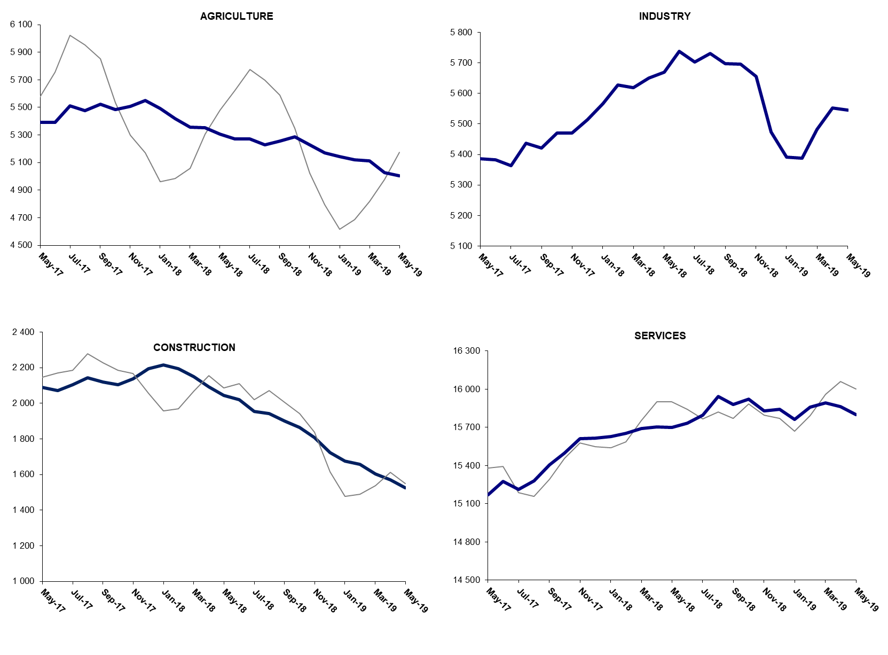

Source: TURKSTAT, Betam

The number of non-agricultural employed continues to decrease year on year

From May 2018 to May 2019 non-agricultural labor force increased by 409 thousand (1.5 percent) and non-agricultural employment decreased by 562 thousand (-2.4 percent) (Figure 3). Annual labor force growth slowed down along with employment losses and deviated from its structural trend. However, non-agricultural employment suffered from heavy losses during the past year. Thus, compared to May 2018, the number of non-agricultural unemployed increased by 971 thousand.

Figure 3 : Year-on-year changes in non-agricultural labor force, employment, and unemployment

Source: Turkstat, Betam

The unemployment gender gap narrowed

Figure 5 shows seasonally adjusted non-agricultural unemployment rate for males (green) and for females (purple). In the period of May 2019, compared to the period of April 2019, the non-agricultural female unemployment rate remained unchanged at 20.5 percent while the non-agricultural male unemployment rate increased by 0.3 percentage points from 14.2 to 14.5. The decline in seasonally adjusted female labor force by 44 thousand, compared to April 2019, is striking, as decline in seasonally adjusted female labor force occurs rarely. The female employment decreased by 32 thousand in the same period 2019 (Table 3), As for male labor force, it increased by 5 thousand and male employment decreased by 53 thousand. Consequently, the gender gap in non-agricultural unemployment rates narrowed to 6.0 percentage point.

Figure 5: Seasonally adjusted non-agricultural unemployment rate by gender

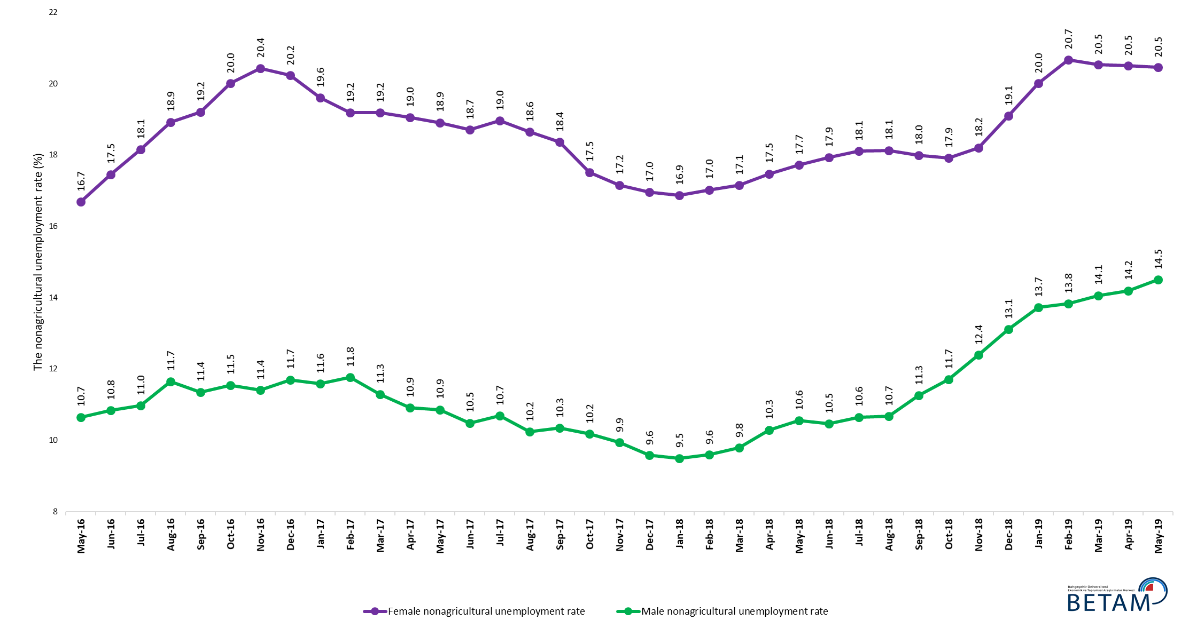

Source: Turkstat, Betam

Table 1: Seasonally adjusted non-agricultural labor market indicators (in thousands) *

 | Labor force | Employment | Unemployment | Unemployment rate | Monthly changes
May-16 | 25143 | 22050 | 3093 | 12.3% | Labor force | Employment | Unemployment
June-16 | 25121 | 21855 | 3266 | 13.0% | -22 | -195 | 173
July-16 | 25195 | 21844 | 3351 | 13.3% | 74 | -11 | 85
August-16 | 25135 | 21717 | 3418 | 13.6% | -60 | -127 | 67
September-16 | 25361 | 21912 | 3449 | 13.6% | 226 | 195 | 31
October-16 | 25534 | 21934 | 3600 | 14.1% | 173 | 22 | 151
November-16 | 25640 | 22025 | 3615 | 14.1% | 106 | 91 | 15
December-16 | 25609 | 21947 | 3662 | 14.3% | -31 | -78 | 47
January-17 | 25694 | 22097 | 3597 | 14.0% | 85 | 150 | -65
February-17 | 25792 | 22207 | 3585 | 13.9% | 98 | 110 | -12
March-17 | 25964 | 22433 | 3531 | 13.6% | 172 | 226 | -54
April-17 | 26017 | 22583 | 3434 | 13.2% | 53 | 150 | -97
May-17 | 26090 | 22646 | 3444 | 13.2% | 73 | 63 | 10
June-17 | 26129 | 22732 | 3397 | 13.0% | 39 | 86 | -47
July-17 | 26130 | 22681 | 3449 | 13.2% | 1 | -51 | 52
August-17 | 26187 | 22861 | 3326 | 12.7% | 57 | 180 | -123
September-17 | 26281 | 22943 | 3338 | 12.7% | 94 | 82 | 12
October-17 | 26310 | 23074 | 3236 | 12.3% | 30 | 131 | -101
November-17 | 26416 | 23220 | 3196 | 12.1% | 106 | 146 | -40
December-17 | 26444 | 23324 | 3120 | 11.8% | 28 | 104 | -76
January-18 | 26514 | 23412 | 3102 | 11.7% | 70 | 88 | -18
February-18 | 26555 | 23475 | 3080 | 11.6% | 41 | 63 | -22
March-18 | 26601 | 23462 | 3139 | 11.8% | 45 | -13 | 58
April-18 | 26706 | 23448 | 3258 | 12.2% | 105 | -14 | 119
May-18 | 26786 | 23411 | 3375 | 12.6% | 80 | -37 | 117
June-18 | 26968 | 23489 | 3479 | 12.9% | 182 | 78 | 104
July-18 | 26992 | 23456 | 3536 | 13.1% | 24 | -33 | 57
August-18 | 27206 | 23615 | 3591 | 13.2% | 214 | 159 | 55
September-18 | 27114 | 23481 | 3633 | 13.4% | -92 | -134 | 42
October-18 | 27211 | 23483 | 3728 | 13.7% | 97 | 2 | 95
November-18 | 27146 | 23291 | 3855 | 14.2% | -65 | -192 | 127
December-18 | 27073 | 23039 | 4034 | 14.9% | -73 | -252 | 179
January-19 | 27051 | 22831 | 4220 | 15.6% | -22 | -208 | 186
February-19 | 27203 | 22905 | 4298 | 15.8% | 152 | 74 | 78
March-19 | 27352 | 22976 | 4376 | 16.0% | 149 | 71 | 78
April-19 | 27363 | 22985 | 4378 | 16.0% | 11 | 9 | 2
May-19 | 27295 | 22873 | 4422 | 16.2% | -68 | -112 | 44

Source: Turkstat, Betam

Table 2: Seasonally adjusted employment by sectors (in thousands) *

 | Agriculture | Manufacturing | Construction | Service | Monthly changes
May-16 | 5334 | 5386 | 2062 | 14602 | Agriculture | Manufacturing | Construction | Service
June-16 | 5191 | 5330 | 1958 | 14567 | -143 | -56 | -104 | -35
July-16 | 5217 | 5254 | 1958 | 14632 | 26 | -76 | 0 | 65
August-16 | 5281 | 5224 | 1919 | 14574 | 64 | -30 | -39 | -58
September-16 | 5334 | 5260 | 2027 | 14625 | 53 | 36 | 108 | 51
October-16 | 5266 | 5282 | 1992 | 14660 | -68 | 22 | -35 | 35
November-16 | 5277 | 5316 | 1991 | 14718 | 11 | 34 | -1 | 58
December-16 | 5308 | 5265 | 1962 | 14720 | 31 | -51 | -29 | 2
January-17 | 5434 | 5274 | 1968 | 14856 | 126 | 9 | 6 | 136
February-17 | 5475 | 5251 | 2016 | 14940 | 41 | -23 | 48 | 84
March-17 | 5380 | 5346 | 2089 | 14997 | -95 | 95 | 73 | 57
April-17 | 5359 | 5372 | 2122 | 15089 | -21 | 26 | 33 | 92
May-17 | 5390 | 5386 | 2088 | 15172 | 31 | 14 | -34 | 83
June-17 | 5391 | 5383 | 2071 | 15278 | 1 | -3 | -17 | 106
July-17 | 5512 | 5363 | 2104 | 15215 | 121 | -20 | 33 | -63
August-17 | 5478 | 5437 | 2142 | 15282 | -34 | 74 | 38 | 67
September-17 | 5522 | 5421 | 2118 | 15404 | 44 | -16 | -24 | 122
October-17 | 5483 | 5470 | 2104 | 15500 | -39 | 49 | -14 | 96
November-17 | 5508 | 5470 | 2138 | 15612 | 25 | 0 | 34 | 112
December-17 | 5549 | 5514 | 2194 | 15617 | 41 | 44 | 56 | 5
January-18 | 5493 | 5567 | 2216 | 15629 | -56 | 53 | 22 | 12
February-18 | 5418 | 5627 | 2194 | 15654 | -75 | 60 | -22 | 25
March-18 | 5355 | 5618 | 2150 | 15693 | -63 | -9 | -44 | 39
April-18 | 5353 | 5650 | 2092 | 15705 | -2 | 32 | -58 | 12
May-18 | 5305 | 5669 | 2044 | 15698 | -48 | 19 | -48 | -7
June-18 | 5271 | 5737 | 2021 | 15732 | -34 | 68 | -23 | 34
July-18 | 5270 | 5703 | 1954 | 15798 | -1 | -34 | -67 | 66
August-18 | 5230 | 5730 | 1943 | 15942 | -40 | 27 | -11 | 144
September-18 | 5256 | 5698 | 1901 | 15882 | 26 | -32 | -42 | -60
October-18 | 5287 | 5696 | 1863 | 15924 | 31 | -2 | -38 | 42
November-18 | 5228 | 5656 | 1806 | 15828 | -59 | -40 | -57 | -96
December-18 | 5170 | 5474 | 1724 | 15841 | -58 | -182 | -82 | 13
January-19 | 5145 | 5392 | 1675 | 15764 | -25 | -82 | -49 | -77
February-19 | 5119 | 5388 | 1656 | 15860 | -26 | -4 | -19 | 96
March-19 | 5112 | 5482 | 1602 | 15892 | -7 | 94 | -54 | 32
April-19 | 5028 | 5553 | 1569 | 15864 | -84 | 71 | -33 | -28
May-19 | 5003 | 5546 | 1525 | 15802 | -25 | -7 | -44 | -62
Source: Turkstat, Betam

Table 3: Seasonally adjusted non-agricultural labor force by gender (thousands)

 | Female Labor Force | Female Employment | Female Unemployed | Male Labor Force | Male Employment | Male Unemployed
May-16 | 7191 | 5991 | 1200 | 17913 | 16005 | 1908
June-16 | 7267 | 5998 | 1268 | 17823 | 15891 | 1932
July-16 | 7281 | 5959 | 1321 | 17912 | 15946 | 1966
August-16 | 7320 | 5935 | 1385 | 17968 | 15875 | 2094
September-16 | 7385 | 5967 | 1418 | 18035 | 15987 | 2047
October-16 | 7436 | 5949 | 1488 | 18095 | 16005 | 2089
November-16 | 7466 | 5941 | 1525 | 18150 | 16080 | 2070
December-16 | 7451 | 5943 | 1508 | 18177 | 16051 | 2127
January-17 | 7446 | 5986 | 1460 | 18246 | 16131 | 2115
February-17 | 7496 | 6058 | 1438 | 18269 | 16119 | 2150
March-17 | 7597 | 6140 | 1457 | 18315 | 16246 | 2069
April-17 | 7604 | 6155 | 1448 | 18355 | 16352 | 2003
May-17 | 7669 | 6219 | 1450 | 18384 | 16387 | 1997
June-17 | 7676 | 6240 | 1436 | 18419 | 16487 | 1932
July-17 | 7693 | 6235 | 1459 | 18449 | 16477 | 1971
August-17 | 7726 | 6285 | 1441 | 18489 | 16595 | 1894
September-17 | 7776 | 6348 | 1428 | 18519 | 16603 | 1916
October-17 | 7786 | 6422 | 1364 | 18541 | 16653 | 1888
November-17 | 7835 | 6491 | 1344 | 18576 | 16730 | 1846
December-17 | 7879 | 6543 | 1336 | 18617 | 16832 | 1784
January-18 | 7918 | 6583 | 1335 | 18636 | 16865 | 1771
February-18 | 7937 | 6586 | 1351 | 18668 | 16875 | 1793
March-18 | 7930 | 6570 | 1360 | 18696 | 16864 | 1831
April-18 | 7989 | 6593 | 1396 | 18732 | 16804 | 1928
May-18 | 8042 | 6617 | 1425 | 18754 | 16774 | 1980
June-18 | 8081 | 6632 | 1449 | 18784 | 16818 | 1966
July-18 | 8101 | 6634 | 1467 | 18803 | 16801 | 2002
August-18 | 8204 | 6717 | 1487 | 18833 | 16822 | 2011
September-18 | 8177 | 6706 | 1471 | 18846 | 16724 | 2122
October-18 | 8266 | 6785 | 1481 | 18870 | 16662 | 2208
November-18 | 8251 | 6749 | 1502 | 18883 | 16543 | 2340
December-18 | 8332 | 6741 | 1591 | 18894 | 16417 | 2477
January-19 | 8359 | 6687 | 1673 | 18904 | 16310 | 2594
February-19 | 8430 | 6687 | 1743 | 18919 | 16303 | 2616
March-19 | 8476 | 6735 | 1740 | 18925 | 16264 | 2661
April-19 | 8420 | 6694 | 1727 | 18924 | 16238 | 2686
May-19 | 8376 | 6662 | 1713 | 18929 | 16185 | 2745

Source: Turkstat, Betam

* Prof. Seyfettin Gürsel, Betam, Director, seyfettin.gursel@eas.bau.edu.tr
**Hamza Mutluay, Betam, Research Assistant, hamza.mutluay@eas.bau.edu.tr
For detailed information on Betam's forecasting model, please see Betam Research Brief 168 titled as "Kariyer.net Verisiyle Kısa Vadeli Tarım Dışı İşsizlik Tahmini" . For the innovations in the model please see Betam Research Brief 14 titled as "Mevsim Etkilerinden Arındırılmış İşsizlik Tahmini" Soybilgen, B., "Kariyer.net Verisiyle Kısa Vadeli Tarım Dışı İşsizlik Tahmini", Betam Research Brief 168. http://betam.bahcesehir.edu.tr/tr/2014/06/kariyer-net-verisiyle-kisa-vadeli-tarim-disi-issizlik-tahmini/ Soybilgen, B., "Mevsim Etkilerinden Arındırılmış İşsizlik Tahmini", Betam Research Brief 14 http://betam.bahcesehir.edu.tr/2015/08/mevsim-etkilerinden-arindirilmis-tarim-disi-issizlik-tahmini/
Betam has been calculating application per vacancy using series released by Kariyer.net for a while. Seasonal and calendar adjustment procedure is applied to application per vacancy series. A decrease in applications per vacancy may be caused by an increase in vacancies or by a decrease in the number of applications. An increase in vacancies signals economic growth while decreasing number of applications indicates a decrease in number of people looking for a job. Monthly labor market series released by TurkStat is the average of three months. Therefore, application per vacancy statistics calculated using Kariyer.net series is the average of three months as well.
Employment in each sector is seasonally adjusted separately. Hence the sum of these series may differ from the seasonally adjusted series of total employment. The difference stems from the non-linearity of the seasonal adjustment process.
Turkstat revised the labor market statistics drastically in February 2014. Within this framework, they back casted various labor market indicators and they also continued to announce seasonally adjusted series. However, Turkstat is not providing back-casted series by gender. Therefore, female and male labor market statistics are not sufficiently long for the seasonal adjustment procedures (There should be minimum 36 observations). With the announcement of the period of February 2017 data, the number of observations required for the seasonal decontamination process was provided. From this period Betam generated seasonal adjustment series in terms of gender. Nevertheless, it should not be forgotten that seasonal adjustment may cause extra volatility in the series for at least a while.

