Labor Market Outlook:
July 2019

16 July 2019

LOSSES IN CONSTRUCTION EMPLOYMENT REACHED 640 THOUSAND

Seyfettin Gürsel*, Gokce Uysal∗∗ and Mehmet Cem Sahin***

Executive Summary

Seasonally adjusted labor market data shows that, in the period of April 2019, non-agricultural unemployment rate remained unchanged and stood at 16.0 percent. In this period, increases in non-agricultural employment reached 10 thousand and non-agricultural labor force increased by 12 thousand. The number of unemployed increased by 2 thousand to 4 million 383 thousand. In manufacturing, employment gains were 71 thousand, while employment in services decreased by 30 thousand. Employment losses in construction continued and since February 2018, the level of employment loss in construction reached 640 thousand. With the marked decrease in female labor force participation, the gender gap in non-agricultural unemployment narrowed.

Number of unemployed in non-agricultural sector reached 4 million 383 thousand

According to seasonally adjusted labor market data, in the period of April 2019 compared to March 2019, the non-agricultural labor force increased by 12 thousand to 27 million 394 thousand, and the number of employed in non-agricultural sectors increased by 10 thousand to 23 million 11 thousand. Thereby, the number of unemployed in non-agricultural sectors increased by 2 thousand and reached 4 million 383 thousand and consequently the non-agricultural unemployment rate remained at 16.0 percent (Figure 1, Table 1). Compared to the previous two periods, both net employment gains and net labor force gains were very limited in April 2019.

Figure 1 : Seasonally adjusted non-agricultural labor force, employment, and unemployment

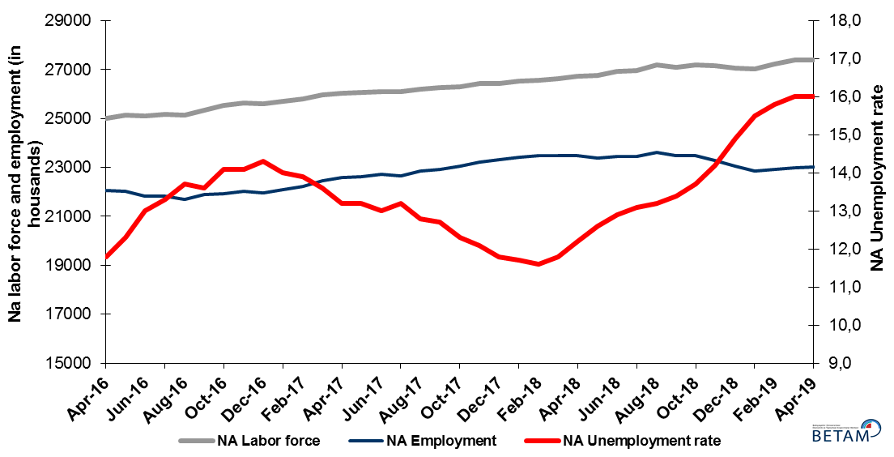

Source: Turkstat, Betam

Unemployment rate is expected to increase in May 2019

Betam's forecasting model had predicted that, in April 2019, the seasonally adjusted non-agricultural unemployment rate would remain unchanged at 16,0 percent compared to March 2019, which is in line with the rate TurkStat announced for April 2019. Betam’s forecasting model predicts that the seasonally adjusted non-agricultural unemployment rate will uptick to 16.1 percent in the period of May 2019. Forecasting model details are available on Betam's website. Kariyer.net application per vacancy series used in the Betam forecasting model is depicted in Figure 2. Kariyer.net series is only one of the inputs of Betam forecast model. Indeed, several variables such as employment agency (İŞKUR) data, reel sector confidence index, capacity utilization rate are used in forecasting.

Figure 2 : Seasonally adjusted non-agricultural unemployment rate and application per vacancy

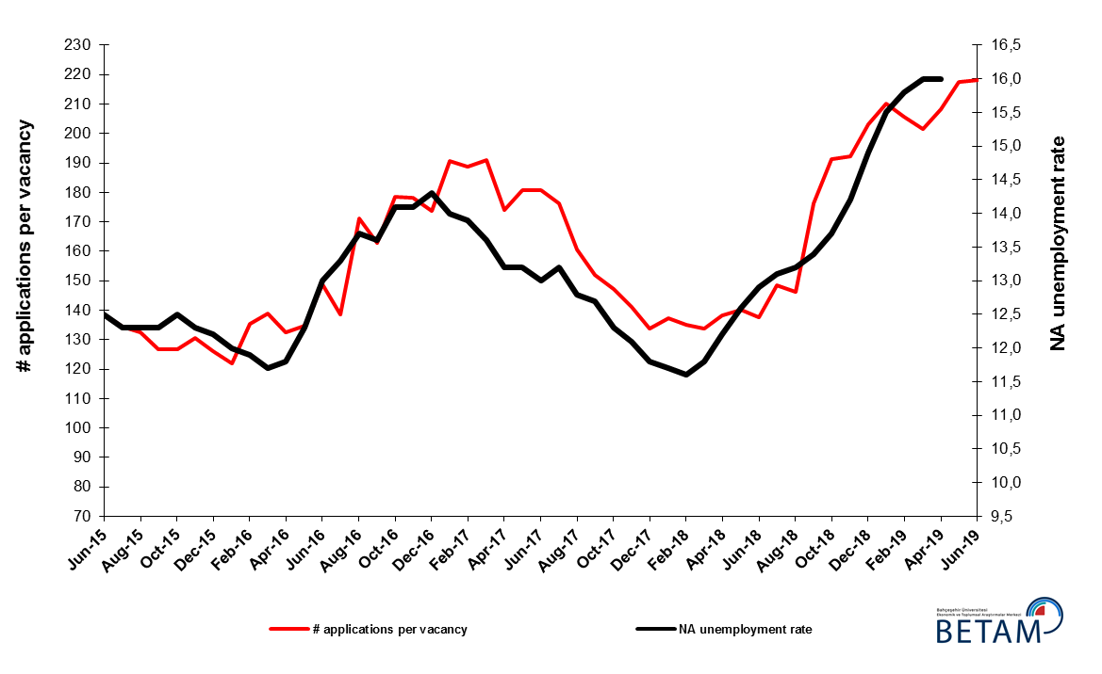
Source: Kariyer.net, Turkstat, Betam

Employment increased in industry sector while fell down in the services sector

According to seasonally adjusted sectoral labor market data, employment decreased in the period of April 2019 compared to March 2019 in all sectors except manufacturing (Figure 3, Table 2). While employment in construction decreased by 32 thousand, employment losses in agriculture and services amounted to 84 thousand and 30 thousand, respectively. On the other hand, the employment in manufacturing increased by 71 thousand (Table 2). Employment in construction has been decreasing for more than a year (since the period of February 2018). Total employment loss has reached 640 thousand.

Figure 3: Employment by Sectors (in thousand)

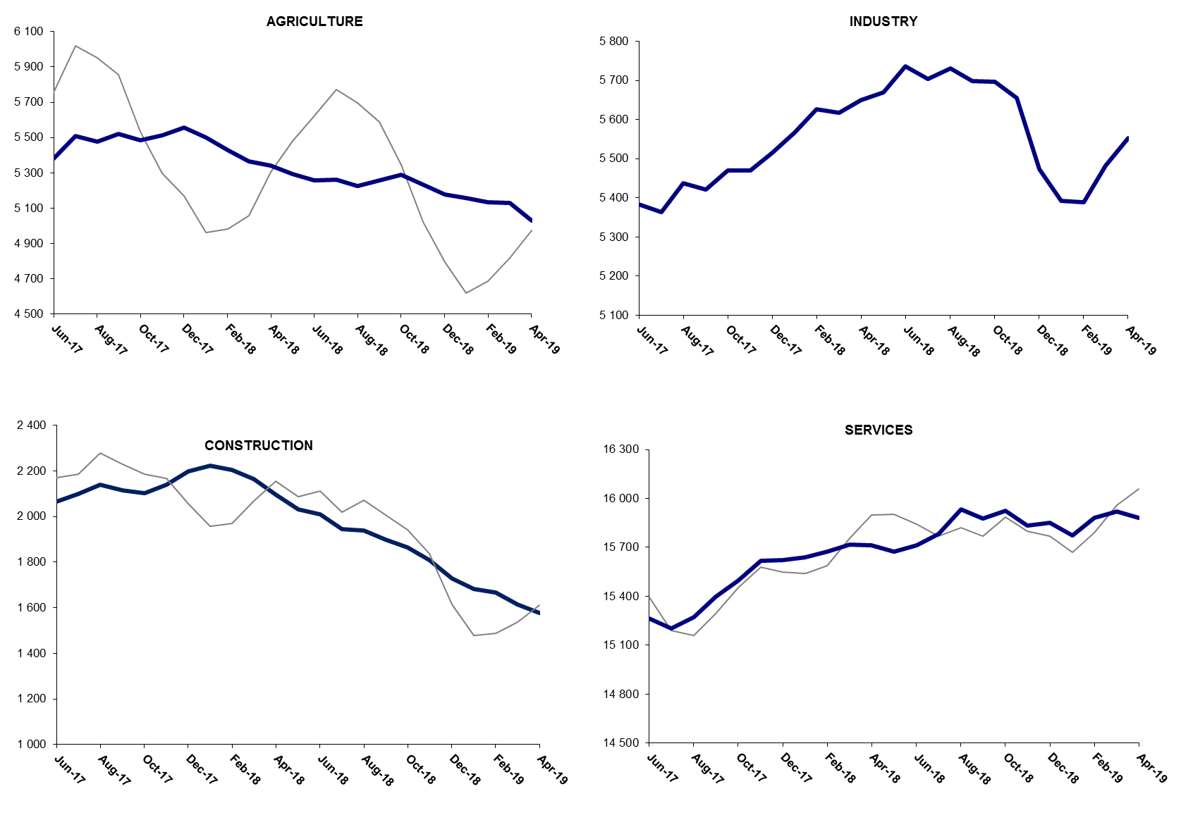

Source: TURKSTAT, Betam

The number of non-agricultural employed continues to decrease year on year

From April 2018 to April 2019 non-agricultural labor force increased by 567 thousand (2.1 percent) and non-agricultural employment decreased by 481 thousand (-2.0 percent) (Figure 3). A slowdown in year on year increase of the labor force caused by the decrease of employment due to the recession is observed. On the other hand, year-on-year non-agricultural employment decreased for the fifth consecutive month. Thus, compared to April 2018, non-agricultural unemployed increased by 1 million 48 thousand and reached 4 million 98 thousand.

Figure 3 : Year-on-year changes in non-agricultural labor force, employment, and unemployment

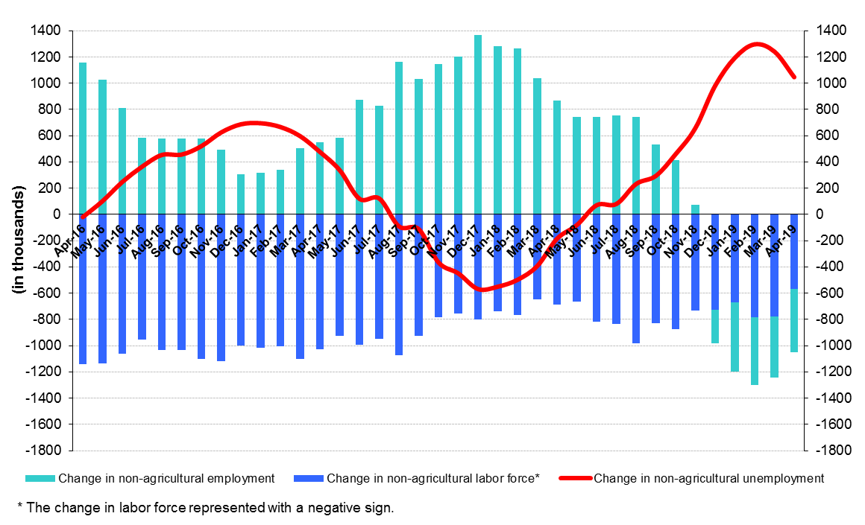
Source: Turkstat, Betam

The gender disparity with regards to unemployment rate narrowed

Figure 5 shows seasonally adjusted non-agricultural unemployment rate for males (green) and for females (purple). In the period of April 2019, compared to the period of March 2019, the non-agricultural female unemployment rate increased by 0.04 percentage points from 20.53 to 20.57 percent while the non-agricultural male unemployment rate increased by 0.09 percentage points from 14.06 to 14.15. The limited increase in female unemployment resulted from a twin decrease both in labor force (44 thousand) and in employment (38 thousand). The decline in seasonally adjusted female labor force by 44 thousand, compared to March 2019, is striking, as decline in seasonally adjusted female labor force occurs rarely. On the other hand, male employment decreased by 25 thousand and male labor force decreased by 10 thousand.in April 2019 compared to March 2019 (Table 3), The gender gap in non-agricultural unemployment rates decreased by 0.05 percentage points only in the period of April.

Figure 5: Seasonally adjusted non-agricultural unemployment rate by gender

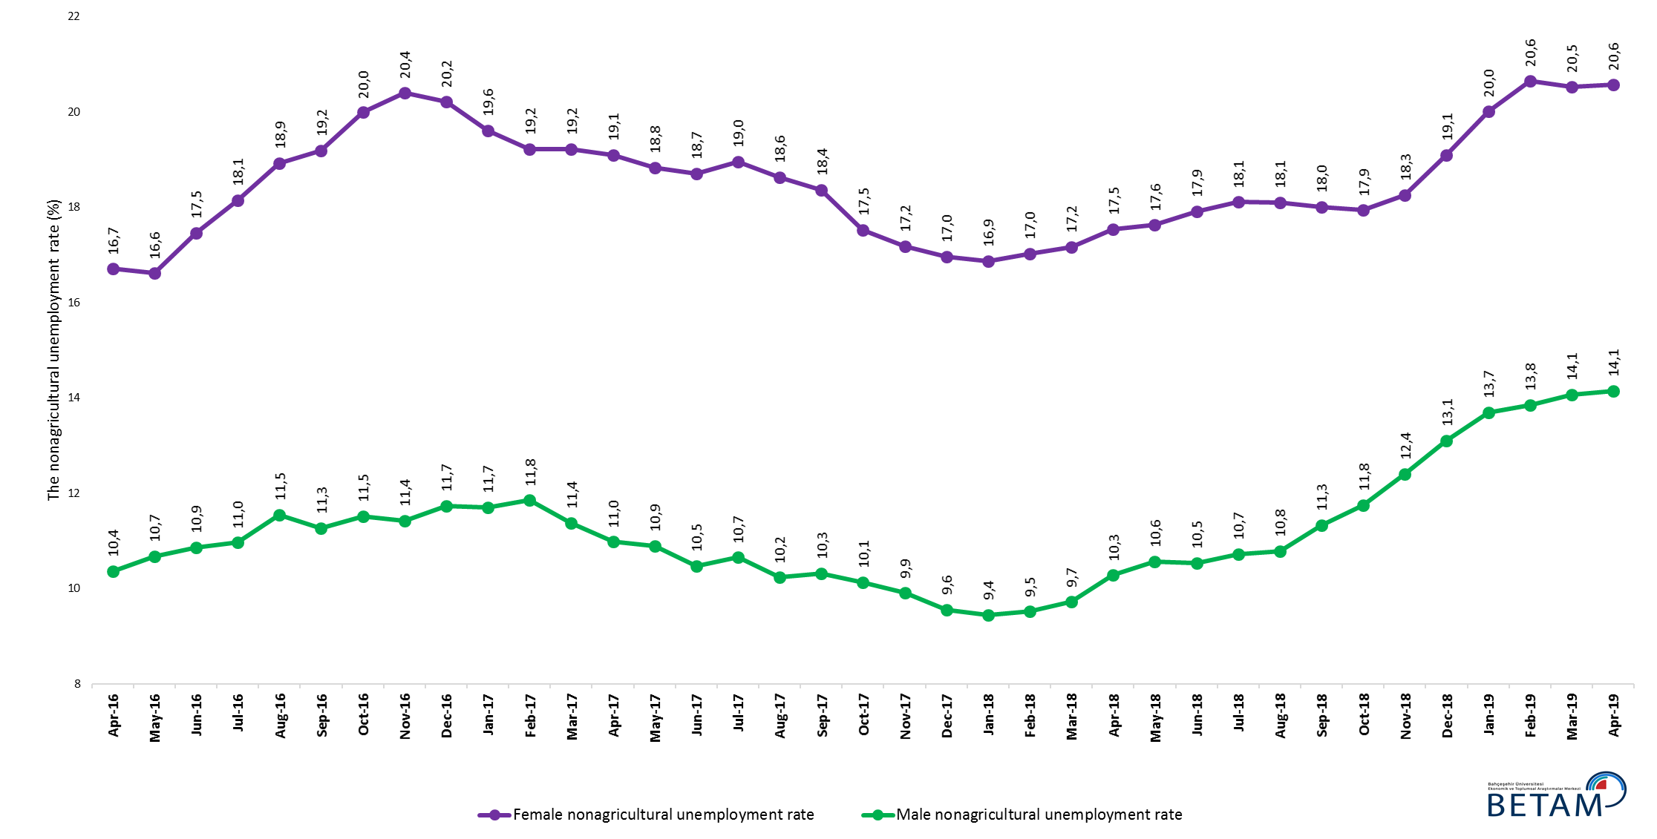

Source: Turkstat, Betam

Table 1: Seasonally adjusted non-agricultural labor market indicators (in thousands) *

 | Labor force | Employment | Unemployment | Unemployment rate | Monthly changes
February-16 | 24844 | 21888 | 2956 | 11,9% | Labor force | Employment | Unemployment
March-16 | 24867 | 21958 | 2909 | 11,7% | 23 | 70 | -47
April-16 | 25019 | 22067 | 2952 | 11,8% | 152 | 109 | 43
May-16 | 25130 | 22039 | 3091 | 12,3% | 111 | -28 | 139
June-16 | 25109 | 21845 | 3264 | 13,0% | -21 | -194 | 173
July-16 | 25185 | 21835 | 3350 | 13,3% | 75 | -10 | 85
August-16 | 25153 | 21707 | 3446 | 13,7% | -32 | -128 | 96
September-16 | 25352 | 21904 | 3448 | 13,6% | 199 | 197 | 2
October-16 | 25529 | 21929 | 3600 | 14,1% | 177 | 25 | 152
November-16 | 25643 | 22027 | 3616 | 14,1% | 114 | 98 | 16
December-16 | 25613 | 21950 | 3663 | 14,3% | -30 | -77 | 47
January-17 | 25702 | 22104 | 3598 | 14,0% | 90 | 154 | -64
February-17 | 25808 | 22221 | 3587 | 13,9% | 106 | 117 | -11
March-17 | 25984 | 22450 | 3534 | 13,6% | 175 | 229 | -54
April-17 | 26039 | 22602 | 3437 | 13,2% | 55 | 152 | -97
May-17 | 26071 | 22630 | 3441 | 13,2% | 32 | 28 | 4
June-17 | 26113 | 22718 | 3395 | 13,0% | 41 | 88 | -47
July-17 | 26118 | 22670 | 3448 | 13,2% | 5 | -48 | 53
August-17 | 26204 | 22850 | 3354 | 12,8% | 87 | 180 | -93
September-17 | 26273 | 22936 | 3337 | 12,7% | 68 | 86 | -18
October-17 | 26307 | 23071 | 3236 | 12,3% | 34 | 135 | -101
November-17 | 26421 | 23224 | 3197 | 12,1% | 114 | 153 | -39
December-17 | 26451 | 23330 | 3121 | 11,8% | 30 | 106 | -76
January-18 | 26524 | 23421 | 3103 | 11,7% | 73 | 91 | -18
February-18 | 26577 | 23494 | 3083 | 11,6% | 53 | 73 | -20
March-18 | 26625 | 23483 | 3142 | 11,8% | 48 | -11 | 59
April-18 | 26731 | 23470 | 3261 | 12,2% | 106 | -13 | 119
May-18 | 26756 | 23385 | 3371 | 12,6% | 25 | -85 | 110
June-18 | 26945 | 23469 | 3476 | 12,9% | 189 | 84 | 105
July-18 | 26972 | 23439 | 3533 | 13,1% | 27 | -30 | 57
August-18 | 27192 | 23603 | 3589 | 13,2% | 220 | 164 | 56
September-18 | 27105 | 23473 | 3632 | 13,4% | -87 | -130 | 43
October-18 | 27210 | 23482 | 3728 | 13,7% | 105 | 9 | 96
November-18 | 27152 | 23296 | 3856 | 14,2% | -58 | -186 | 128
December-18 | 27081 | 23046 | 4035 | 14,9% | -70 | -250 | 180
January-19 | 27031 | 22841 | 4190 | 15,5% | -50 | -205 | 155
February-19 | 27228 | 22926 | 4302 | 15,8% | 197 | 85 | 112
March-19 | 27382 | 23001 | 4381 | 16,0% | 154 | 75 | 79
April-19 | 27394 | 23011 | 4383 | 16,0% | 12 | 10 | 2

Source: Turkstat, Betam

Table 2: Seasonally adjusted employment by sectors (in thousands) *

 | Agriculture | Manufacturing | Construction | Service | Monthly changes
February-16 | 5327 | 5276 | 1994 | 14617 | Agriculture | Manufacturing | Construction | Service
March-16 | 5385 | 5295 | 2023 | 14641 | 58 | 19 | 29 | 24
April-16 | 5375 | 5381 | 2036 | 14649 | -10 | 86 | 13 | 8
May-16 | 5334 | 5386 | 2059 | 14595 | -41 | 5 | 23 | -54
June-16 | 5190 | 5330 | 1956 | 14559 | -144 | -56 | -103 | -36
July-16 | 5217 | 5254 | 1955 | 14626 | 27 | -76 | -1 | 67
August-16 | 5281 | 5224 | 1918 | 14565 | 64 | -30 | -37 | -61
September-16 | 5334 | 5260 | 2026 | 14618 | 53 | 36 | 108 | 53
October-16 | 5266 | 5282 | 1991 | 14656 | -68 | 22 | -35 | 38
November-16 | 5277 | 5316 | 1991 | 14720 | 11 | 34 | 0 | 64
December-16 | 5308 | 5265 | 1963 | 14723 | 31 | -51 | -28 | 3
January-17 | 5434 | 5274 | 1970 | 14861 | 126 | 9 | 7 | 138
February-17 | 5475 | 5251 | 2019 | 14951 | 41 | -23 | 49 | 90
March-17 | 5381 | 5346 | 2095 | 15009 | -94 | 95 | 76 | 58
April-17 | 5359 | 5372 | 2128 | 15102 | -22 | 26 | 33 | 93
May-17 | 5390 | 5386 | 2083 | 15161 | 31 | 14 | -45 | 59
June-17 | 5390 | 5383 | 2066 | 15268 | 0 | -3 | -17 | 107
July-17 | 5511 | 5363 | 2100 | 15207 | 121 | -20 | 34 | -61
August-17 | 5478 | 5437 | 2140 | 15273 | -33 | 74 | 40 | 66
September-17 | 5522 | 5421 | 2116 | 15398 | 44 | -16 | -24 | 125
October-17 | 5483 | 5470 | 2103 | 15498 | -39 | 49 | -13 | 100
November-17 | 5508 | 5470 | 2139 | 15615 | 25 | 0 | 36 | 117
December-17 | 5549 | 5514 | 2196 | 15620 | 41 | 44 | 57 | 5
January-18 | 5493 | 5567 | 2219 | 15635 | -56 | 53 | 23 | 15
February-18 | 5418 | 5627 | 2200 | 15667 | -75 | 60 | -19 | 32
March-18 | 5356 | 5618 | 2158 | 15708 | -62 | -9 | -42 | 41
April-18 | 5354 | 5650 | 2100 | 15720 | -2 | 32 | -58 | 12
May-18 | 5305 | 5669 | 2035 | 15682 | -49 | 19 | -65 | -38
June-18 | 5270 | 5737 | 2013 | 15718 | -35 | 68 | -22 | 36
July-18 | 5270 | 5703 | 1948 | 15788 | 0 | -34 | -65 | 70
August-18 | 5230 | 5730 | 1940 | 15934 | -40 | 27 | -8 | 146
September-18 | 5256 | 5698 | 1899 | 15876 | 26 | -32 | -41 | -58
October-18 | 5287 | 5696 | 1862 | 15924 | 31 | -2 | -37 | 48
November-18 | 5228 | 5656 | 1808 | 15832 | -59 | -40 | -54 | -92
December-18 | 5170 | 5474 | 1727 | 15846 | -58 | -182 | -81 | 14
January-19 | 5145 | 5392 | 1680 | 15770 | -25 | -82 | -47 | -76
February-19 | 5120 | 5388 | 1663 | 15875 | -25 | -4 | -17 | 105
March-19 | 5113 | 5482 | 1610 | 15910 | -7 | 94 | -53 | 35
April-19 | 5029 | 5553 | 1578 | 15880 | -84 | 71 | -32 | -30

Source: Turkstat, Betam

Table 3: Seasonally adjusted non-agricultural labor force by gender (thousands)

 | Female Labor Force | Female Employment | Female Unemployed | Male Labor Force | Male Employment | Male Unemployed
April-16 | 7153 | 5958 | 1195 | 17846 | 15996 | 1850
May-16 | 7180 | 5987 | 1193 | 17916 | 16005 | 1912
June-16 | 7262 | 5994 | 1268 | 17825 | 15890 | 1935
July-16 | 7276 | 5956 | 1320 | 17908 | 15946 | 1963
August-16 | 7318 | 5934 | 1385 | 17945 | 15874 | 2071
September-16 | 7382 | 5965 | 1417 | 18016 | 15987 | 2030
October-16 | 7435 | 5949 | 1486 | 18087 | 16005 | 2082
November-16 | 7465 | 5941 | 1523 | 18154 | 16081 | 2074
December-16 | 7452 | 5945 | 1507 | 18185 | 16051 | 2134
January-17 | 7449 | 5989 | 1461 | 18269 | 16131 | 2137
February-17 | 7503 | 6061 | 1442 | 18286 | 16120 | 2167
March-17 | 7605 | 6143 | 1462 | 18333 | 16247 | 2086
April-17 | 7613 | 6160 | 1454 | 18370 | 16353 | 2016
May-17 | 7657 | 6215 | 1442 | 18389 | 16386 | 2003
June-17 | 7671 | 6236 | 1434 | 18414 | 16486 | 1928
July-17 | 7692 | 6234 | 1458 | 18440 | 16476 | 1964
August-17 | 7721 | 6284 | 1438 | 18486 | 16595 | 1891
September-17 | 7775 | 6347 | 1428 | 18513 | 16603 | 1910
October-17 | 7783 | 6419 | 1364 | 18529 | 16653 | 1877
November-17 | 7836 | 6490 | 1346 | 18570 | 16730 | 1839
December-17 | 7879 | 6543 | 1336 | 18612 | 16833 | 1779
January-18 | 7921 | 6584 | 1337 | 18625 | 16866 | 1759
February-18 | 7942 | 6589 | 1352 | 18651 | 16877 | 1774
March-18 | 7936 | 6574 | 1362 | 18682 | 16867 | 1815
April-18 | 8002 | 6599 | 1403 | 18731 | 16807 | 1925
May-18 | 8029 | 6614 | 1415 | 18750 | 16770 | 1980
June-18 | 8076 | 6629 | 1447 | 18794 | 16815 | 1979
July-18 | 8101 | 6634 | 1467 | 18815 | 16799 | 2017
August-18 | 8198 | 6715 | 1483 | 18856 | 16822 | 2034
September-18 | 8177 | 6705 | 1473 | 18861 | 16723 | 2137
October-18 | 8263 | 6781 | 1482 | 18881 | 16662 | 2219
November-18 | 8254 | 6747 | 1507 | 18886 | 16544 | 2343
December-18 | 8331 | 6740 | 1591 | 18892 | 16418 | 2474
January-19 | 8363 | 6690 | 1673 | 18900 | 16311 | 2588
February-19 | 8433 | 6692 | 1741 | 18927 | 16307 | 2620
March-19 | 8480 | 6739 | 1741 | 18931 | 16269 | 2662
April-19 | 8436 | 6701 | 1735 | 18921 | 16244 | 2677

Source: Turkstat, Betam

* Prof. Seyfettin Gürsel, Betam, Director, seyfettin.gursel@eas.bau.edu.tr
** Assoc. Prof. Gökçe Uysal, Betam, Deputy Director, gokce.uysal@eas.bau.edu.tr ***Mehmet Cem Sahin, Betam, Research Assistant, mehmetcem.sahin@eas.bau.edu.tr
For detailed information on Betam's forecasting model, please see Betam Research Brief 168 titled as "Kariyer.net Verisiyle Kısa Vadeli Tarım Dışı İşsizlik Tahmini" . For the innovations in the model please see Betam Research Brief 14 titled as "Mevsim Etkilerinden Arındırılmış İşsizlik Tahmini" Soybilgen, B., "Kariyer.net Verisiyle Kısa Vadeli Tarım Dışı İşsizlik Tahmini", Betam Research Brief 168. http://betam.bahcesehir.edu.tr/tr/2014/06/kariyer-net-verisiyle-kisa-vadeli-tarim-disi-issizlik-tahmini/ Soybilgen, B., "Mevsim Etkilerinden Arındırılmış İşsizlik Tahmini", Betam Research Brief 14 http://betam.bahcesehir.edu.tr/2015/08/mevsim-etkilerinden-arindirilmis-tarim-disi-issizlik-tahmini/
Betam has been calculating application per vacancy using series released by Kariyer.net for a while. Seasonal and calendar adjustment procedure is applied to application per vacancy series. A decrease in applications per vacancy may be caused by an increase in vacancies or by a decrease in the number of applications. An increase in vacancies signals economic growth while decreasing number of applications indicates a decrease in number of people looking for a job. Monthly labor market series released by TurkStat is the average of three months. Therefore, application per vacancy statistics calculated using Kariyer.net series is the average of three months as well.
Employment in each sector is seasonally adjusted separately. Hence the sum of these series may differ from the seasonally adjusted series of total employment. The difference stems from the non-linearity of the seasonal adjustment process.
Turkstat revised the labor market statistics drastically in February 2014. Within this framework, they back casted various labor market indicators and they also continued to announce seasonally adjusted series. However, Turkstat is not providing back-casted series by gender. Therefore, female and male labor market statistics are not sufficiently long for the seasonal adjustment procedures (There should be minimum 36 observations). With the announcement of the period of February 2017 data, the number of observations required for the seasonal decontamination process was provided. From this period Betam generated seasonal adjustment series in terms of gender. Nevertheless, it should not be forgotten that seasonal adjustment may cause extra volatility in the series for at least a while.

