Labor Market Outlook:
June 2019

17 June 2019

NUMBER OF UNEMPLOYED IN NON-FARM SECTORS HITS 4.4 MILLION

Seyfettin Gürsel*, Gokce Uysal∗∗ and Furkan Kavuncu***

Executive Summary

Seasonally adjusted labor market data shows that, in the period of March 2019, non-agricultural unemployment rate increased by 0.2 percentage points and reached 16 percent. Increases in labor force and employment observed in the period of February 2019 continued in this period as well. The number of unemployed in non-agricultural sectors reached 4.4 million. The employment losses in manufacturing came to a halt in March 2019, and employment increased by 94 thousand, in line with the rise in industrial production index. While employment increased by 37 thousand in services, it declined in agriculture and construction by 5 thousand and 53 thousand, respectively. Since February 2018, the losses in construction have exceeded 600 thousand. In this period, female employment increased by 53 thousand, whereas male employment decreased by 40 thousand. The gender gap in non-agricultural unemployment shrank by 0.3 percentage points.

The rise in non-agricultural unemployment slowed down

According to seasonally adjusted labor market data, in the period of March 2019 compared to February 2019, the non-agricultural labor force increased by 157 thousand to 27 million 401 thousand, and the number of employed in non-agricultural sectors increased by 77 thousand to 23 million 17 thousand. Thereby, the number of unemployed in non-agricultural sectors rose by 80 thousand and reached 4 million 384 thousand and thus the non-agricultural unemployment rate went up to 16 percent (Figure 1, Table 1). As in the previous period, change in total employment level is positive again in this period; however, the increase in labor force continues and thus, the number of unemployed rises. The non-agricultural unemployment rate had reached 16.9 percent in April 2009 during the Global Recession. Nevertheless, a slight slowdown is observed in the rate of increase of non-agricultural unemployment rate in the last two periods.

Figure 1. Seasonally adjusted non-agricultural labor force, employment, and unemployment
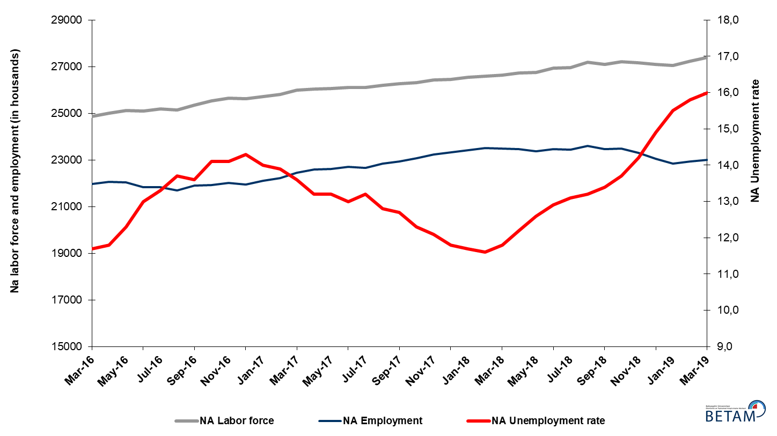
Source: Turkstat, Betam

Unemployment rate is expected to be a constant in April 2019

Betam's forecasting model had predicted that the seasonally adjusted non-agricultural unemployment rate would stay constant at 15.8 percent in March 2019. In fact, non-agricultural unemployment increased by 0.2 percentage points and reached 16.0 percent. Betam’s forecasting model predicts that the seasonally adjusted non-agricultural unemployment rate will stay constant at 16.0 percent in the period of April 2019. Forecasting model details are available on Betam's website. Kariyer.net application per vacancy series used in the Betam forecasting model is depicted in Figure 3. Kariyer.net series is only one of the inputs of Betam forecast model. Indeed, several variables such as employment agency (İŞKUR) data, reel sector confidence index, capacity utilization rate are used in forecasting.

Figure 2 Seasonally adjusted non-agricultural unemployment rate and application per vacancy
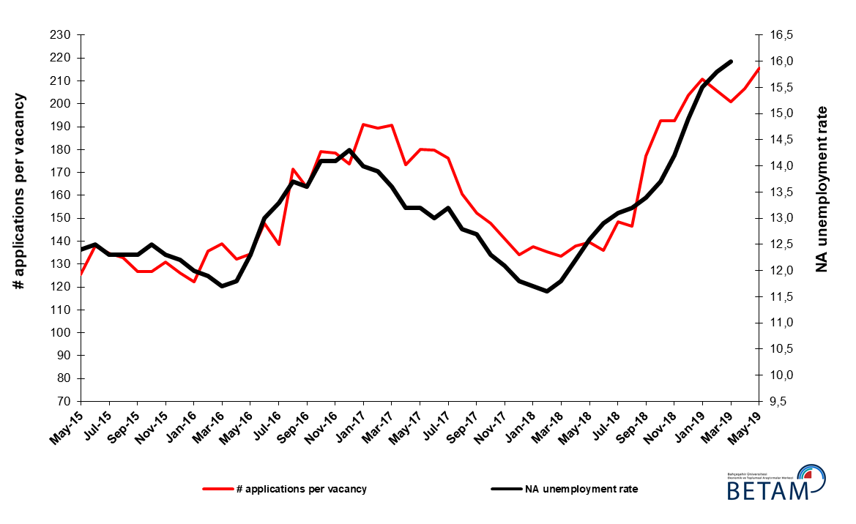
Source: Kariyer.net, Turkstat, Betam

Substantial employment increase in manufacturing

According to seasonally adjusted sectoral labor market data, employment increased in services and manufacturing, while it decreased in construction and agriculture in the period of March 2019 compared to February 2019 (Figure 3, Table 2). In construction, employment losses that started to slowdown in the period of February 2019 ended in March 2019. In fact, an increase of 94 thousand people observed in manufacturing employment level in this period coincide with the increases observed in the industrial production index since the beginning of 2019. In services, employment rose by 37 thousand. As for agriculture, a 5-thousand loss in employment is detected. Employment losses in construction continue. As employment has been declining regularly for a year (since February 2018) in this sector, the total loss in employment reached 608 thousand in March 2019.

Figure 3: Employment by sectors (in thousand)

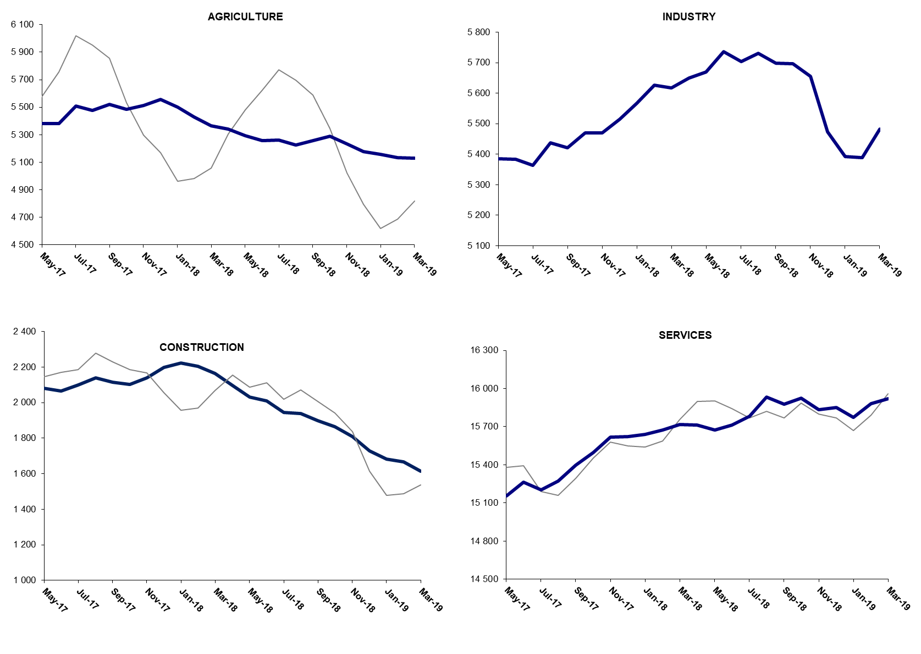
Source: TURKSTAT, Betam

The number of non-agricultural employed within a year decreased

From March 2018 to March 2019 non-agricultural labor force increased by 779 thousand (2.9 percent) and non-agricultural employment decreased by 464 thousand (-2 percent) (Figure 4). Year on year increase in labor force continues its usual trend. On the other hand, non-agricultural employment decreased within the past year. Thus, non-agricultural unemployed increased by 1 million 243 thousand and reached 4 million 409 thousand.

Figure 4 Year-on-year changes in non-agricultural labor force, employment, and unemployment
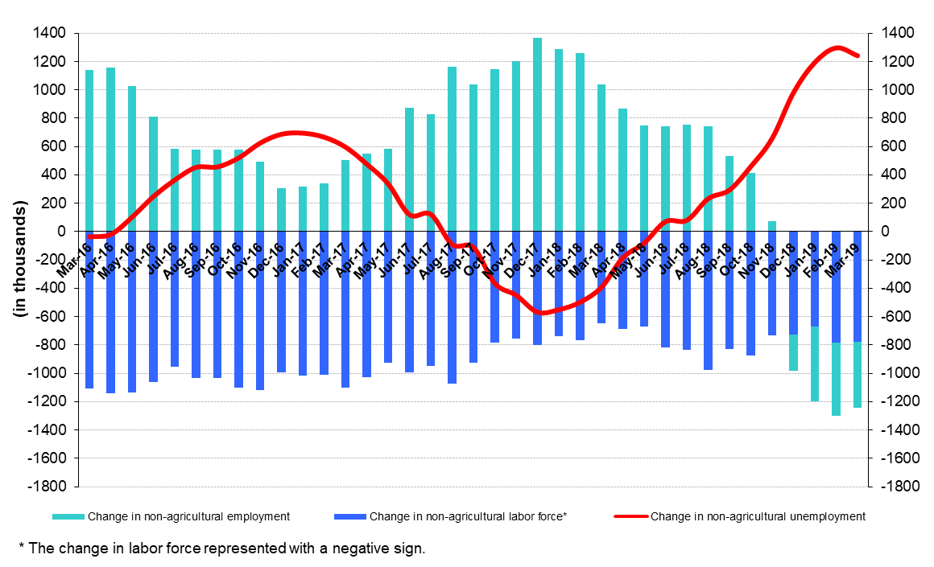
Source: Turkstat, Betam

Non-agricultural unemployment rate for females exceeded 20 percent

Figure 5 shows seasonally adjusted non-agricultural unemployment rate for males (green) and for females (purple). In the period of March 2019, the non-agricultural female unemployment rate decreased by 0.1 percentage points and reached 20.7 percent while the non-agricultural male unemployment rate increased by 0.3 percentage points to 14.3 percent. From February to March 2019, female labor force increased by 48 thousand, male labor force rose slightly by 8 thousand (Table 3). As to employment levels, in this period female employment increased by 53 thousand, whereas male employment decreased by 40 thousand. Thus, the gender gap in non-agricultural unemployment rates shrank from 6.7 to 6.3 percentage points.

Figure 5: Seasonally adjusted non-agricultural unemployment rate by gender
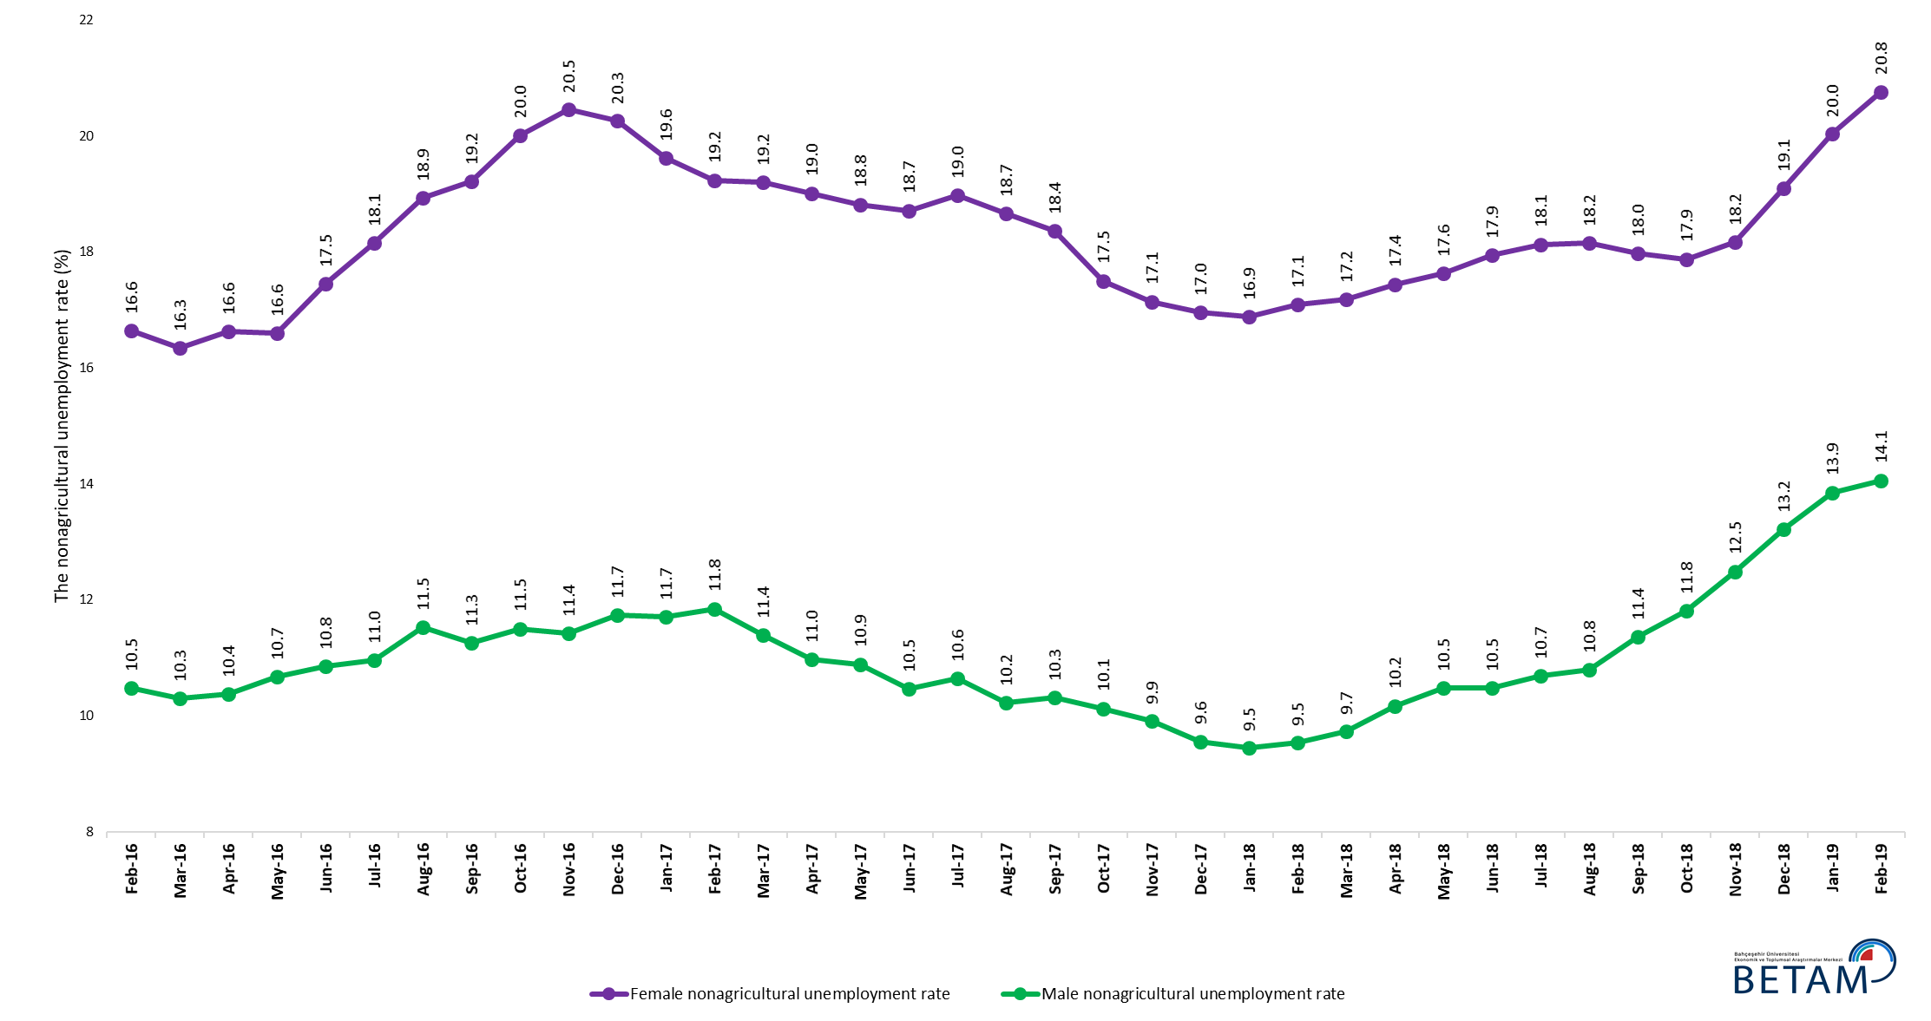
Source: Turkstat, Betam

Table 1 Seasonally adjusted non-agricultural labor market indicators (in thousands) *

 | Labor force | Employment | Unemployment | Unemployment rate | Monthly changes
March-16 | 24875 | 21965 | 2910 | 11,7% | Labor force | Employment | Unemployment
April-16 | 25014 | 22062 | 2952 | 11,8% | 138 | 97 | 41
May-16 | 25124 | 22034 | 3090 | 12,3% | 111 | -28 | 139
June-16 | 25105 | 21841 | 3264 | 13,0% | -20 | -193 | 173
July-16 | 25181 | 21832 | 3349 | 13,3% | 76 | -9 | 85
August-16 | 25149 | 21704 | 3445 | 13,7% | -32 | -128 | 96
September-16 | 25351 | 21903 | 3448 | 13,6% | 201 | 199 | 2
October-16 | 25527 | 21928 | 3599 | 14,1% | 177 | 25 | 152
November-16 | 25645 | 22029 | 3616 | 14,1% | 118 | 101 | 17
December-16 | 25617 | 21954 | 3663 | 14,3% | -28 | -75 | 47
January-17 | 25709 | 22110 | 3599 | 14,0% | 92 | 156 | -64
February-17 | 25818 | 22229 | 3589 | 13,9% | 108 | 119 | -11
March-17 | 25995 | 22460 | 3535 | 13,6% | 178 | 231 | -53
April-17 | 26030 | 22594 | 3436 | 13,2% | 35 | 134 | -99
May-17 | 26062 | 22622 | 3440 | 13,2% | 32 | 28 | 4
June-17 | 26105 | 22711 | 3394 | 13,0% | 42 | 89 | -47
July-17 | 26111 | 22664 | 3447 | 13,2% | 6 | -47 | 53
August-17 | 26201 | 22847 | 3354 | 12,8% | 90 | 183 | -93
September-17 | 26270 | 22934 | 3336 | 12,7% | 70 | 87 | -17
October-17 | 26307 | 23071 | 3236 | 12,3% | 36 | 137 | -101
November-17 | 26425 | 23228 | 3197 | 12,1% | 119 | 157 | -38
December-17 | 26457 | 23335 | 3122 | 11,8% | 31 | 107 | -76
January-18 | 26533 | 23429 | 3104 | 11,7% | 76 | 94 | -18
February-18 | 26590 | 23506 | 3084 | 11,6% | 57 | 77 | -20
March-18 | 26641 | 23497 | 3144 | 11,8% | 50 | -9 | 59
April-18 | 26718 | 23458 | 3260 | 12,2% | 77 | -39 | 116
May-18 | 26744 | 23374 | 3370 | 12,6% | 26 | -84 | 110
June-18 | 26935 | 23460 | 3475 | 12,9% | 191 | 86 | 105
July-18 | 26964 | 23432 | 3532 | 13,1% | 30 | -28 | 58
August-18 | 27190 | 23601 | 3589 | 13,2% | 226 | 169 | 57
September-18 | 27104 | 23472 | 3632 | 13,4% | -86 | -129 | 43
October-18 | 27212 | 23484 | 3728 | 13,7% | 108 | 12 | 96
November-18 | 27156 | 23300 | 3856 | 14,2% | -56 | -184 | 128
December-18 | 27089 | 23053 | 4036 | 14,9% | -67 | -247 | 180
January-19 | 27043 | 22851 | 4192 | 15,5% | -47 | -202 | 155
February-19 | 27245 | 22940 | 4305 | 15,8% | 202 | 89 | 113
March-19 | 27401 | 23017 | 4384 | 16,0% | 157 | 77 | 80

Source: Turkstat, Betam

Table 2 Seasonally adjusted employment by sectors (in thousands) *

 | Agriculture | Manufacturing | Construction | Service | Monthly changes
March-16 | 5391 | 5295 | 2025 | 14646 | Agriculture | Manufacturing | Construction | Service
April-16 | 5371 | 5381 | 2035 | 14646 | -20 | 86 | 10 | 0
May-16 | 5329 | 5386 | 2058 | 14591 | -42 | 5 | 23 | -55
June-16 | 5185 | 5330 | 1954 | 14556 | -144 | -56 | -104 | -35
July-16 | 5214 | 5254 | 1954 | 14624 | 29 | -76 | 0 | 68
August-16 | 5280 | 5224 | 1917 | 14563 | 66 | -30 | -37 | -61
September-16 | 5334 | 5260 | 2026 | 14617 | 54 | 36 | 109 | 54
October-16 | 5267 | 5282 | 1991 | 14656 | -67 | 22 | -35 | 39
November-16 | 5278 | 5316 | 1992 | 14721 | 11 | 34 | 1 | 65
December-16 | 5311 | 5265 | 1964 | 14725 | 33 | -51 | -28 | 4
January-17 | 5439 | 5274 | 1971 | 14865 | 128 | 9 | 7 | 140
February-17 | 5482 | 5251 | 2021 | 14957 | 43 | -23 | 50 | 92
March-17 | 5389 | 5346 | 2098 | 15016 | -93 | 95 | 77 | 59
April-17 | 5352 | 5372 | 2126 | 15097 | -37 | 26 | 28 | 81
May-17 | 5381 | 5386 | 2080 | 15156 | 29 | 14 | -46 | 59
June-17 | 5383 | 5383 | 2064 | 15264 | 2 | -3 | -16 | 108
July-17 | 5507 | 5363 | 2098 | 15204 | 124 | -20 | 34 | -60
August-17 | 5476 | 5437 | 2139 | 15271 | -31 | 74 | 41 | 67
September-17 | 5522 | 5421 | 2116 | 15397 | 46 | -16 | -23 | 126
October-17 | 5484 | 5470 | 2103 | 15498 | -38 | 49 | -13 | 101
November-17 | 5511 | 5470 | 2140 | 15618 | 27 | 0 | 37 | 120
December-17 | 5555 | 5514 | 2198 | 15624 | 44 | 44 | 58 | 6
January-18 | 5501 | 5567 | 2223 | 15639 | -54 | 53 | 25 | 15
February-18 | 5428 | 5627 | 2204 | 15674 | -73 | 60 | -19 | 35
March-18 | 5367 | 5618 | 2163 | 15716 | -61 | -9 | -41 | 42
April-18 | 5343 | 5650 | 2096 | 15713 | -24 | 32 | -67 | -3
May-18 | 5292 | 5669 | 2030 | 15675 | -51 | 19 | -66 | -38
June-18 | 5259 | 5737 | 2009 | 15713 | -33 | 68 | -21 | 38
July-18 | 5263 | 5703 | 1946 | 15784 | 4 | -34 | -63 | 71
August-18 | 5225 | 5730 | 1939 | 15931 | -38 | 27 | -7 | 147
September-18 | 5256 | 5698 | 1899 | 15875 | 31 | -32 | -40 | -56
October-18 | 5289 | 5696 | 1863 | 15925 | 33 | -2 | -36 | 50
November-18 | 5233 | 5656 | 1810 | 15835 | -56 | -40 | -53 | -90
December-18 | 5178 | 5474 | 1729 | 15850 | -55 | -182 | -81 | 15
January-19 | 5156 | 5392 | 1683 | 15775 | -22 | -82 | -46 | -75
February-19 | 5134 | 5388 | 1668 | 15883 | -22 | -4 | -15 | 108
March-19 | 5129 | 5482 | 1615 | 15920 | -5 | 94 | -53 | 37

Source: Turkstat, Betam

Table 3: Seasonally adjusted non-agricultural labor force by gender (thousands)
 | Female Labor Force | Female Employment | Female Unemployed | Male Labor Force | Male Employment | Male Unemployed | Change in female labor force | Change in female employment | Change in male labor force | Change in male employment
February-16 | 7039 | 5868 | 1171 | 17766 | 15905 | 1861
March-16 | 7060 | 5906 | 1154 | 17809 | 15974 | 1835 | 20 | 38 | 43 | 69
April-16 | 7146 | 5957 | 1188 | 17846 | 15995 | 1851 | 86 | 51 | 36 | 21
May-16 | 7179 | 5988 | 1191 | 17916 | 16004 | 1912 | 33 | 30 | 70 | 9
June-16 | 7262 | 5995 | 1267 | 17825 | 15891 | 1934 | 83 | 7 | -91 | -112
July-16 | 7277 | 5956 | 1321 | 17909 | 15947 | 1962 | 15 | -39 | 83 | 55
August-16 | 7316 | 5932 | 1385 | 17945 | 15876 | 2069 | 40 | -24 | 37 | -70
September-16 | 7383 | 5965 | 1418 | 18016 | 15988 | 2028 | 67 | 33 | 71 | 112
October-16 | 7435 | 5947 | 1488 | 18087 | 16006 | 2081 | 52 | -18 | 71 | 18
November-16 | 7467 | 5940 | 1527 | 18154 | 16080 | 2074 | 32 | -7 | 67 | 74
December-16 | 7453 | 5943 | 1510 | 18185 | 16051 | 2133 | -14 | 4 | 30 | -29
January-17 | 7449 | 5988 | 1461 | 18269 | 16131 | 2138 | -3 | 45 | 84 | 79
February-17 | 7505 | 6061 | 1444 | 18286 | 16120 | 2166 | 55 | 73 | 18 | -11
March-17 | 7615 | 6153 | 1462 | 18333 | 16245 | 2088 | 110 | 92 | 47 | 125
April-17 | 7603 | 6158 | 1446 | 18370 | 16354 | 2016 | -12 | 5 | 37 | 109
May-17 | 7655 | 6215 | 1440 | 18389 | 16387 | 2002 | 52 | 57 | 19 | 33
June-17 | 7670 | 6235 | 1436 | 18414 | 16487 | 1928 | 15 | 20 | 25 | 100
July-17 | 7687 | 6229 | 1459 | 18440 | 16477 | 1963 | 17 | -6 | 26 | -10
August-17 | 7722 | 6281 | 1441 | 18486 | 16594 | 1891 | 35 | 52 | 45 | 117
September-17 | 7773 | 6346 | 1427 | 18513 | 16603 | 1910 | 51 | 65 | 27 | 9
October-17 | 7785 | 6422 | 1363 | 18529 | 16653 | 1876 | 12 | 77 | 16 | 50
November-17 | 7835 | 6492 | 1343 | 18570 | 16730 | 1840 | 50 | 70 | 40 | 76
December-17 | 7883 | 6546 | 1337 | 18612 | 16832 | 1780 | 48 | 54 | 42 | 103
January-18 | 7922 | 6585 | 1337 | 18626 | 16865 | 1761 | 39 | 39 | 14 | 33
February-18 | 7948 | 6589 | 1359 | 18653 | 16875 | 1778 | 26 | 4 | 27 | 10
March-18 | 7950 | 6584 | 1366 | 18682 | 16863 | 1820 | 2 | -5 | 29 | -12
April-18 | 7988 | 6595 | 1393 | 18715 | 16811 | 1904 | 38 | 11 | 32 | -52
May-18 | 8025 | 6611 | 1414 | 18739 | 16774 | 1964 | 37 | 16 | 24 | -36
June-18 | 8074 | 6625 | 1449 | 18785 | 16816 | 1969 | 49 | 14 | 46 | 42
July-18 | 8093 | 6626 | 1467 | 18810 | 16799 | 2011 | 19 | 1 | 25 | -17
August-18 | 8201 | 6713 | 1489 | 18854 | 16818 | 2036 | 108 | 87 | 45 | 19
September-18 | 8172 | 6703 | 1469 | 18864 | 16721 | 2143 | -29 | -9 | 10 | -97
October-18 | 8265 | 6788 | 1478 | 18891 | 16660 | 2231 | 93 | 84 | 26 | -61
November-18 | 8250 | 6752 | 1499 | 18904 | 16542 | 2361 | -15 | -36 | 13 | -118
December-18 | 8336 | 6744 | 1591 | 18918 | 16418 | 2500 | 85 | -7 | 14 | -125
January-19 | 8365 | 6689 | 1676 | 18935 | 16311 | 2623 | 29 | -55 | 17 | -106
February-19 | 8443 | 6690 | 1753 | 18971 | 16303 | 2667 | 78 | 1 | 36 | -8

Source: Turkstat, Betam

* Prof. Seyfettin Gürsel, Betam, Director, seyfettin.gursel@eas.bau.edu.tr
** Assoc. Prof. Gökçe Uysal, Betam, Deputy Director, gokce.uysal@eas.bau.edu.tr ***Furkan Kavuncu, Betam, Research Assistant, furkan.kavuncu@eas.bau.edu.tr
For detailed information on Betam's forecasting model, please see Betam Research Brief 168 titled as "Kariyer.net Verisiyle Kısa Vadeli Tarım Dışı İşsizlik Tahmini" . For the innovations in the model please see Betam Research Brief 14 titled as "Mevsim Etkilerinden Arındırılmış İşsizlik Tahmini" Soybilgen, B., "Kariyer.net Verisiyle Kısa Vadeli Tarım Dışı İşsizlik Tahmini", Betam Research Brief 168. http://betam.bahcesehir.edu.tr/tr/2014/06/kariyer-net-verisiyle-kisa-vadeli-tarim-disi-issizlik-tahmini/ Soybilgen, B., "Mevsim Etkilerinden Arındırılmış İşsizlik Tahmini", Betam Research Brief 14 http://betam.bahcesehir.edu.tr/2015/08/mevsim-etkilerinden-arindirilmis-tarim-disi-issizlik-tahmini/
Betam has been calculating application per vacancy using series released by Kariyer.net for a while. Seasonal and calendar adjustment procedure is applied to application per vacancy series. A decrease in applications per vacancy may be caused by an increase in vacancies or by a decrease in the number of applications. An increase in vacancies signals economic growth while decreasing number of applications indicates a decrease in number of people looking for a job. Monthly labor market series released by TurkStat is the average of three months. Therefore, application per vacancy statistics calculated using Kariyer.net series is the average of three months as well.
Employment in each sector is seasonally adjusted separately. Hence the sum of these series may differ from the seasonally adjusted series of total employment. The difference stems from the non-linearity of the seasonal adjustment process.
Turkstat revised the labor market statistics drastically in February 2014. Within this framework, they back casted various labor market indicators and they also continued to announce seasonally adjusted series. However, Turkstat is not providing back-casted series by gender. Therefore, female and male labor market statistics are not sufficiently long for the seasonal adjustment procedures (There should be minimum 36 observations). With the announcement of the period of February 2017 data, the number of observations required for the seasonal decontamination process was provided. From this period Betam generated seasonal adjustment series in terms of gender. Nevertheless, it should not be forgotten that seasonal adjustment may cause extra volatility in the series for at least a while.

