Labor Market Outlook:
May 2019

15 May 2019

UNEMPLOYMENT RISES FOLLOWING A REMARKABLE INCREASE IN LABOR FORCE

Seyfettin Gürsel*, Gokce Uysal∗∗ and Yazgı Genç***

Executive Summary

Seasonally adjusted labor market data shows that, in the period of February 2019, non-agricultural unemployment rate increased by 0.3 percentage points and reached 15.8 percent. In this period, losses in non-agricultural employment stopped and employment increased. However, the non-agricultural labor force which had decreased in the last three periods, increased as well. As such, the number of unemployed reached 4.3 million. In manufacturing, employment losses were limited to 4 thousand, losses continued in construction, and employment increased in services. Parallel to the acceleration in female labor force participation, the gender gap in non-agricultural unemployment widened.

Number of unemployed reaches 4 million 307 thousand

According to seasonally adjusted labor market data, in the period of February 2019 compared to January 2019, the non-agricultural labor force increased by 204 thousand to 27 million 259 thousand, and the number of employed in non-agricultural sectors increased by 91 thousand to 22 million 952 thousand. Thereby, the number of unemployed in non-agricultural sectors increased by 113 thousand and reached 4 million 307 thousand and thus the non-agricultural unemployment rate rose to 15.8 percent (Figure 1, Table 1). Note that February 2019 is the average of January, February and March; thus, it represents to the first quarter of 2019. In the period of February 2019, the employment losses stopped and the decreasing labor force started to increase again. The substantial increase in labor force is behind the increase in unemployment.

Figure 1. Seasonally adjusted non-agricultural labor force, employment, and unemployment
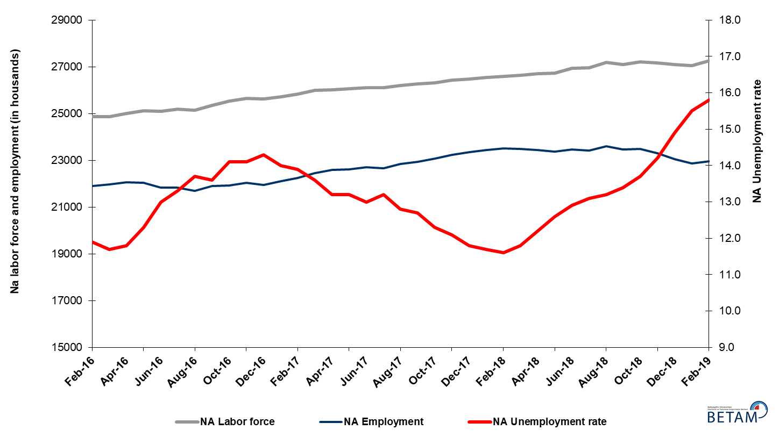

Source: Turkstat, Betam

Unemployment rate is expected to be a constant in March 2019

Betam's forecasting model had predicted that the seasonally adjusted non-agricultural unemployment rate would increase by 0.2 percentage points to reach 15.7 percent in February 2019. In fact, non-agricultural unemployment increased by 0.3 percentage points and reached 15.8 percent. Betam’s forecasting model predicts that the seasonally adjusted non-agricultural unemployment rate will stay constant at 15.8 percent in the period of March 2019. Forecasting model details are available on Betam's website. Kariyer.net application per vacancy series used in the Betam forecasting model is depicted in Figure 3. Kariyer.net series is only one of the inputs of Betam forecast model. Indeed, several variables such as employment agency (İŞKUR) data, reel sector confidence index, capacity utilization rate are used in forecasting.

Figure 2 Seasonally adjusted non-agricultural unemployment rate and application per vacancy
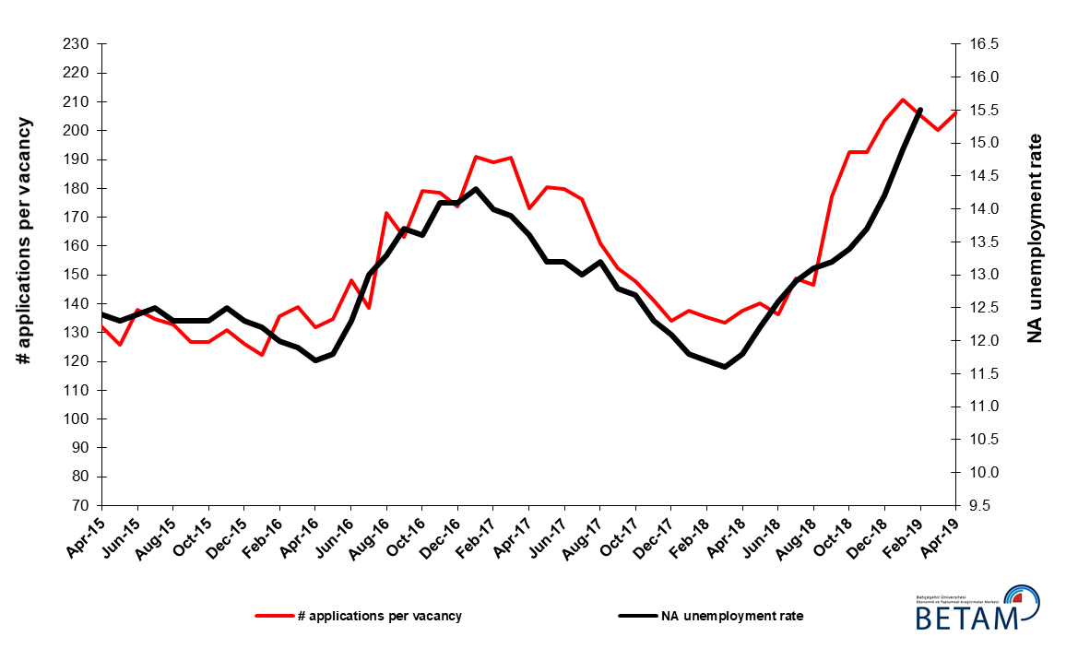
Source: Kariyer.net, Turkstat, Betam

Substantial employment increase in services

According to seasonally adjusted sectoral labor market data, employment decreased significantly in the period of February 2019 compared to January 2019 in all sectors except services (Figure 3, Table 2). While employment in construction decreased by 14 thousand, employment losses in agriculture and industry amounted to 23 thousand, and 4 thousand, respectively. On the other hand the employment in services increased by 108 thousand. The employment losses in manufacturing observed in last three periods (from November 2018 to January 2019) slowed down in February 2019 (Table 2). Employment in construction has been continuously decreasing for a year (since the period of February 2018). Total employment loss has reached 551 thousand. In the service sector, employment had increased by 108 thousand following losses in recent periods.

Figure 3: Employment by sectors (in thousand)

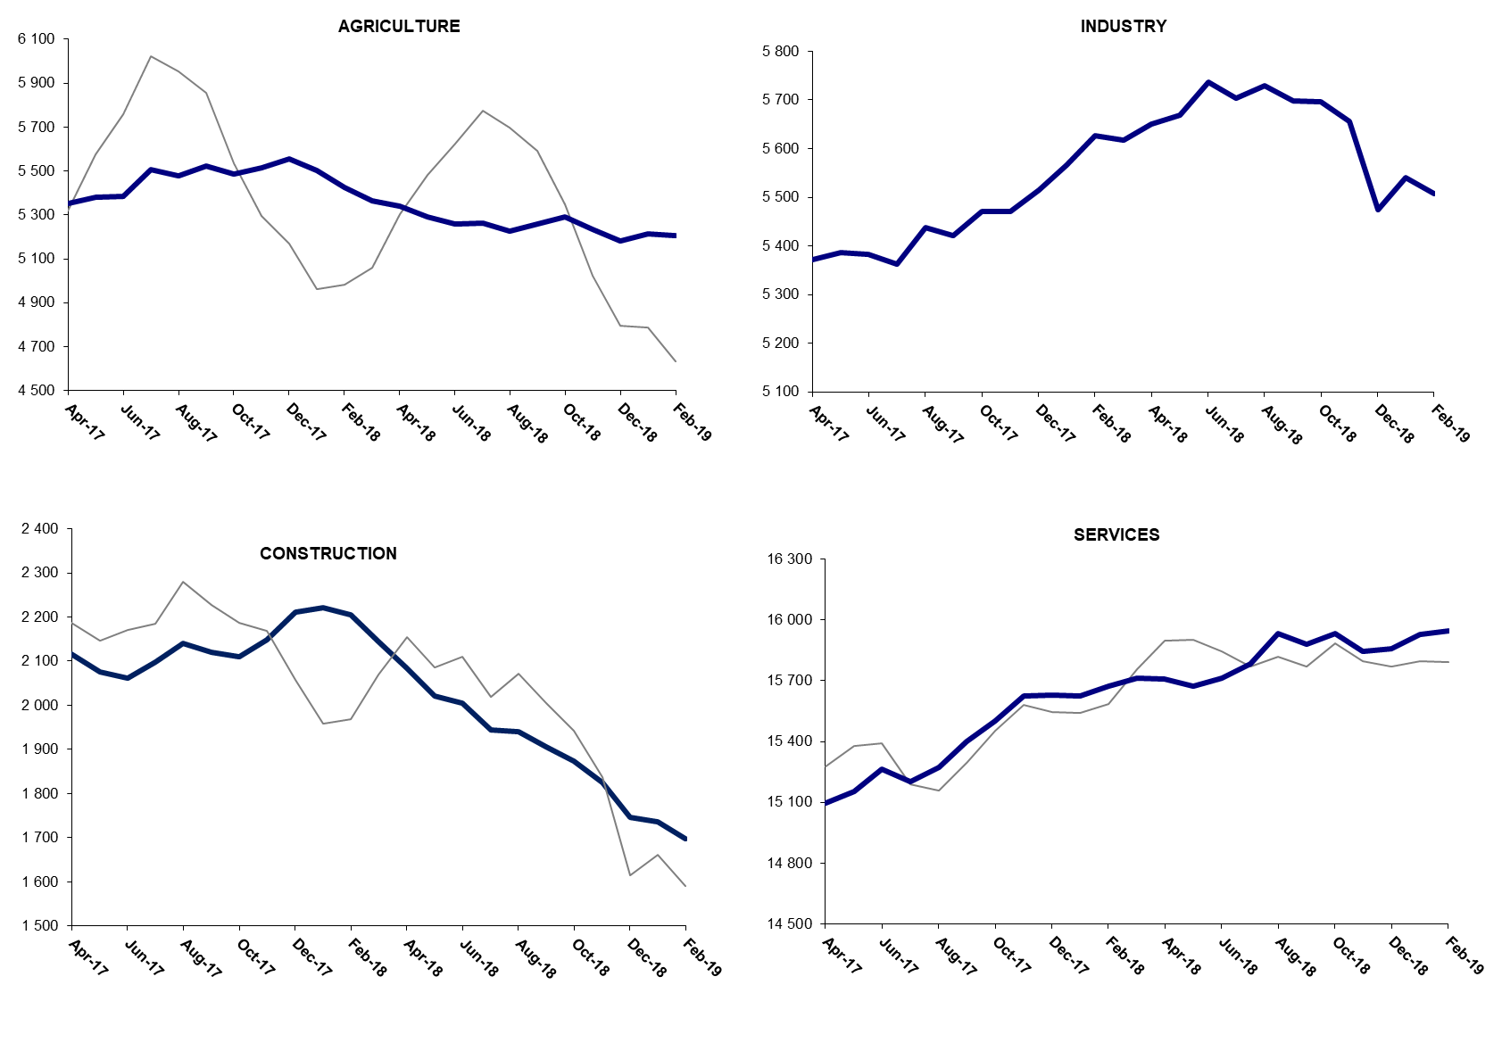
Source: TURKSTAT, Betam

The number of non-agricultural employed within a year decreased

From February 2018 to February 2019 non-agricultural labor force increased by 784 thousand (3 percent) and non-agricultural employment decreased by 514 thousand (-2.2 percent) (Figure 4). Year on year increase in labor force continues its usual trend. On the other hand, non-agricultural employment decreased within the past year. Thus, non-agricultural unemployed increased by 1 million 298 thousand and reached 4 million 610 thousand.

Figure 4 Year-on-year changes in non-agricultural labor force, employment, and unemployment
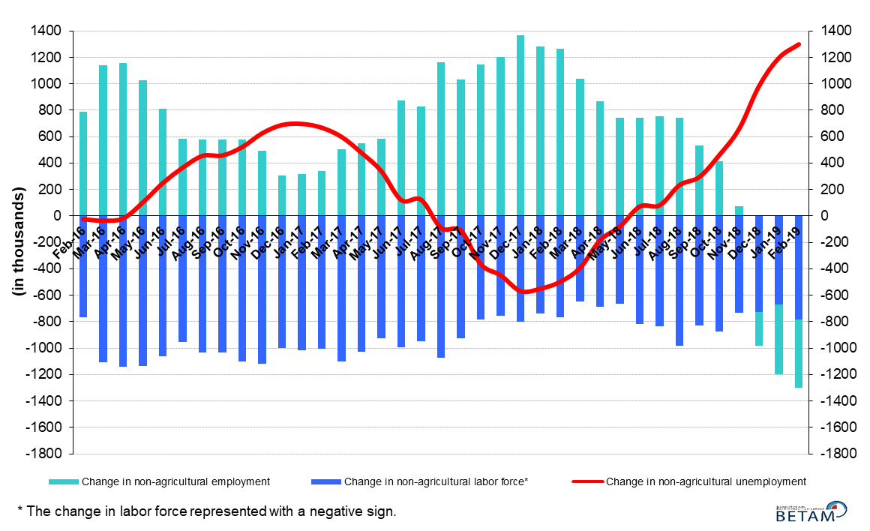
Source: Turkstat, Betam

Non-agricultural unemployment rate for females exceeded 20 percent

Figure 5 shows seasonally adjusted non-agricultural unemployment rate for males (green) and for females (purple). In the period of February 2019, the non-agricultural female unemployment rate increased by 0.8 percentage points and reached 20.8 percent while the non-agricultural male unemployment rate increased by 0.2 percentage points to 14.1 percent. Male employment decreased by 8 thousand in February 2019 compared to January 2019 (Table 3). On the other hand, the increase in female non-agricultural employment was limited to one thousand. Female labor force increased by 78 thousand and male labor force increased by 36 thousand. The gender gap in non-agricultural unemployment rates increased from 6.2 to 6.7 percentage points in the period of February.

Figure 5: Seasonally adjusted non-agricultural unemployment rate by gender
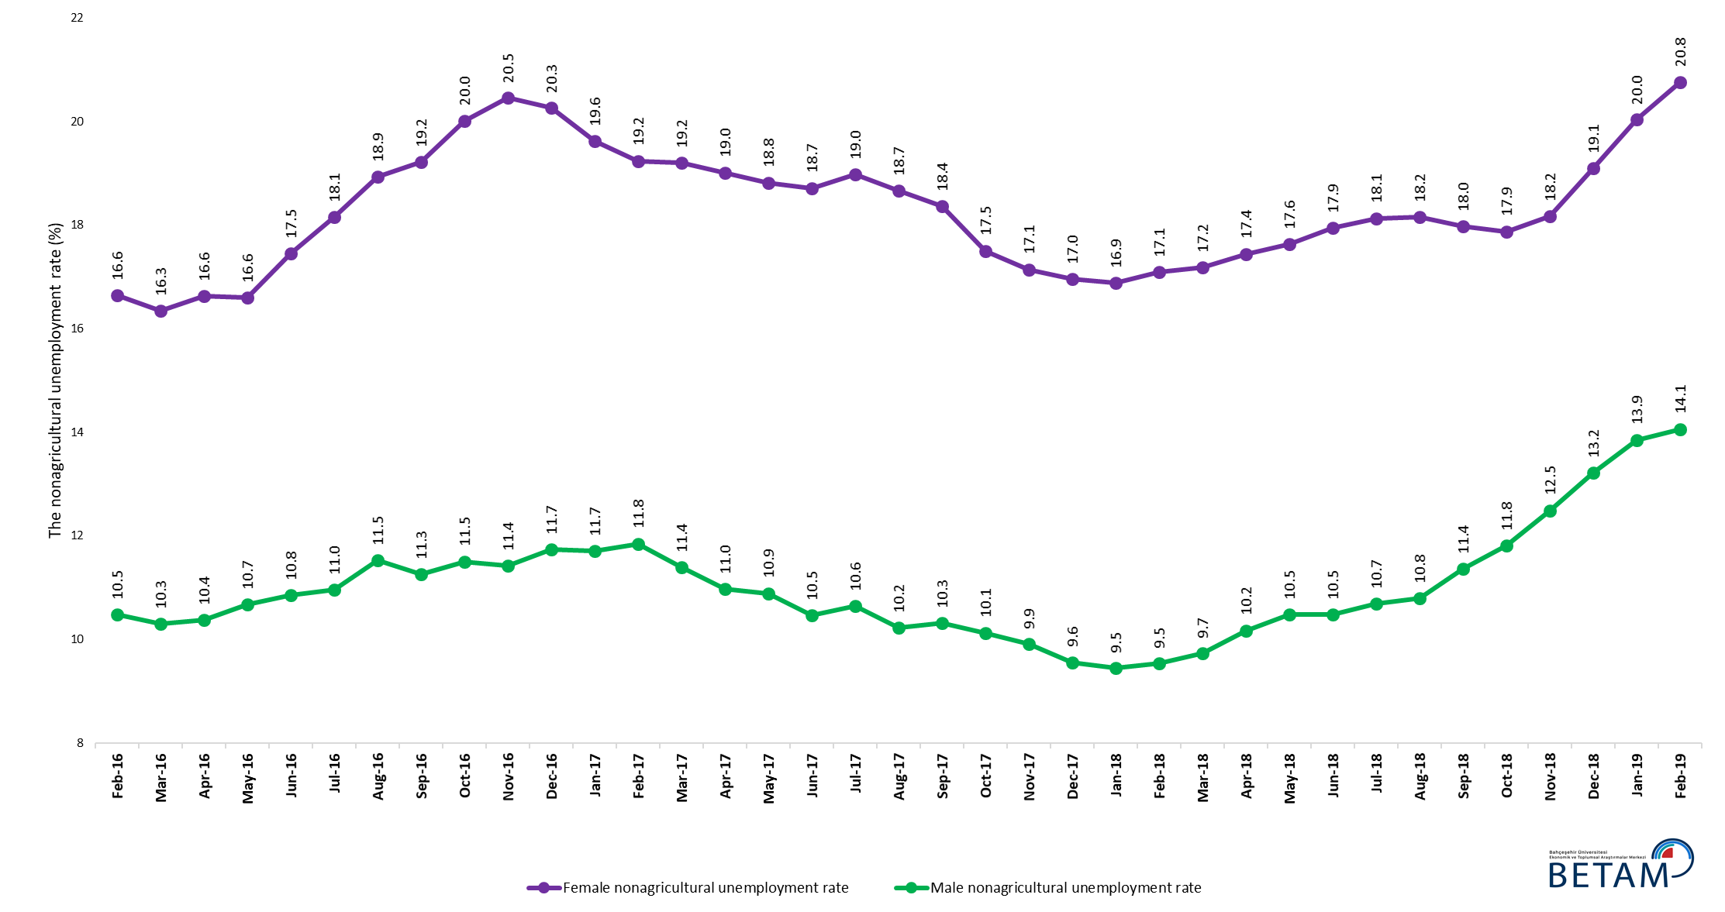
Source: Turkstat, Betam

Table 1 Seasonally adjusted non-agricultural labor market indicators (in thousands) *

 | Labor force | Employment | Unemployment | Unemployment rate | Monthly changes
February-16 | 24856 | 21898 | 2958 | 11.9% | Labor force | Employment | Unemployment
March-16 | 24871 | 21961 | 2910 | 11.7% | 15 | 63 | -48
April-16 | 25010 | 22059 | 2951 | 11.8% | 139 | 98 | 41
May-16 | 25121 | 22031 | 3090 | 12.3% | 111 | -28 | 139
June-16 | 25101 | 21838 | 3263 | 13.0% | -20 | -193 | 173
July-16 | 25180 | 21831 | 3349 | 13.3% | 79 | -7 | 86
August-16 | 25148 | 21703 | 3445 | 13.7% | -32 | -128 | 96
September-16 | 25351 | 21903 | 3448 | 13.6% | 202 | 200 | 2
October-16 | 25529 | 21929 | 3600 | 14.1% | 178 | 26 | 152
November-16 | 25647 | 22031 | 3616 | 14.1% | 119 | 102 | 17
December-16 | 25621 | 21957 | 3664 | 14.3% | -26 | -74 | 48
January-17 | 25714 | 22114 | 3600 | 14.0% | 93 | 157 | -64
February-17 | 25826 | 22236 | 3590 | 13.9% | 112 | 122 | -10
March-17 | 25987 | 22453 | 3534 | 13.6% | 161 | 217 | -56
April-17 | 26023 | 22588 | 3435 | 13.2% | 36 | 135 | -99
May-17 | 26058 | 22618 | 3440 | 13.2% | 35 | 30 | 5
June-17 | 26101 | 22708 | 3393 | 13.0% | 44 | 90 | -46
July-17 | 26109 | 22663 | 3446 | 13.2% | 8 | -45 | 53
August-17 | 26200 | 22846 | 3354 | 12.8% | 90 | 183 | -93
September-17 | 26271 | 22935 | 3336 | 12.7% | 72 | 89 | -17
October-17 | 26310 | 23074 | 3236 | 12.3% | 39 | 139 | -100
November-17 | 26430 | 23232 | 3198 | 12.1% | 120 | 158 | -38
December-17 | 26465 | 23342 | 3123 | 11.8% | 35 | 110 | -75
January-18 | 26542 | 23437 | 3105 | 11.7% | 78 | 95 | -17
February-18 | 26602 | 23516 | 3086 | 11.6% | 59 | 79 | -20
March-18 | 26626 | 23484 | 3142 | 11.8% | 24 | -32 | 56
April-18 | 26706 | 23448 | 3258 | 12.2% | 80 | -36 | 116
May-18 | 26735 | 23366 | 3369 | 12.6% | 28 | -82 | 110
June-18 | 26928 | 23454 | 3474 | 12.9% | 193 | 88 | 105
July-18 | 26961 | 23429 | 3532 | 13.1% | 33 | -25 | 58
August-18 | 27188 | 23599 | 3589 | 13.2% | 227 | 170 | 57
September-18 | 27105 | 23473 | 3632 | 13.4% | -83 | -126 | 43
October-18 | 27217 | 23488 | 3729 | 13.7% | 112 | 15 | 97
November-18 | 27164 | 23307 | 3857 | 14.2% | -52 | -181 | 129
December-18 | 27099 | 23061 | 4038 | 14.9% | -66 | -246 | 180
January-19 | 27054 | 22861 | 4193 | 15.5% | -44 | -200 | 156
February-19 | 27259 | 22952 | 4307 | 15.8% | 204 | 91 | 113

Source: Turkstat, Betam

Table 2 Seasonally adjusted employment by sectors (in thousands) *

 | Agriculture | Manufacturing | Construction | Service | Monthly changes
February-16 | 5330 | 5276 | 1996 | 14621 | Agriculture | Manufacturing | Construction | Service
March-16 | 5389 | 5295 | 2019 | 14643 | 59 | 19 | 23 | 22
April-16 | 5370 | 5381 | 2031 | 14644 | -19 | 86 | 12 | 1
May-16 | 5328 | 5386 | 2054 | 14589 | -42 | 5 | 23 | -55
June-16 | 5185 | 5330 | 1952 | 14556 | -143 | -56 | -102 | -33
July-16 | 5214 | 5254 | 1954 | 14624 | 29 | -76 | 2 | 68
August-16 | 5280 | 5224 | 1918 | 14564 | 66 | -30 | -36 | -60
September-16 | 5335 | 5260 | 2028 | 14619 | 55 | 36 | 110 | 55
October-16 | 5268 | 5282 | 1994 | 14659 | -67 | 22 | -34 | 40
November-16 | 5279 | 5316 | 1997 | 14726 | 11 | 34 | 3 | 67
December-16 | 5313 | 5265 | 1971 | 14731 | 34 | -51 | -26 | 5
January-17 | 5439 | 5274 | 1970 | 14852 | 126 | 9 | -1 | 121
February-17 | 5479 | 5251 | 2022 | 14956 | 40 | -23 | 52 | 104
March-17 | 5387 | 5346 | 2088 | 15013 | -92 | 95 | 66 | 57
April-17 | 5351 | 5372 | 2117 | 15095 | -36 | 26 | 29 | 82
May-17 | 5380 | 5386 | 2075 | 15154 | 29 | 14 | -42 | 59
June-17 | 5383 | 5383 | 2061 | 15263 | 3 | -3 | -14 | 109
July-17 | 5507 | 5363 | 2097 | 15204 | 124 | -20 | 36 | -59
August-17 | 5476 | 5437 | 2141 | 15273 | -31 | 74 | 44 | 69
September-17 | 5523 | 5421 | 2120 | 15400 | 47 | -16 | -21 | 127
October-17 | 5486 | 5470 | 2110 | 15503 | -37 | 49 | -10 | 103
November-17 | 5513 | 5470 | 2149 | 15624 | 27 | 0 | 39 | 121
December-17 | 5557 | 5514 | 2211 | 15631 | 44 | 44 | 62 | 7
January-18 | 5501 | 5567 | 2221 | 15623 | -56 | 53 | 10 | -8
February-18 | 5424 | 5627 | 2205 | 15672 | -77 | 60 | -16 | 49
March-18 | 5365 | 5618 | 2145 | 15711 | -59 | -9 | -60 | 39
April-18 | 5341 | 5650 | 2083 | 15710 | -24 | 32 | -62 | -1
May-18 | 5291 | 5669 | 2021 | 15673 | -50 | 19 | -62 | -37
June-18 | 5259 | 5737 | 2004 | 15713 | -32 | 68 | -17 | 40
July-18 | 5263 | 5703 | 1944 | 15785 | 4 | -34 | -60 | 72
August-18 | 5226 | 5730 | 1941 | 15934 | -37 | 27 | -3 | 149
September-18 | 5257 | 5698 | 1905 | 15879 | 31 | -32 | -36 | -55
October-18 | 5291 | 5696 | 1873 | 15931 | 34 | -2 | -32 | 52
November-18 | 5236 | 5656 | 1824 | 15843 | -55 | -40 | -49 | -88
December-18 | 5182 | 5474 | 1747 | 15859 | -54 | -182 | -77 | 16
January-19 | 5213 | 5540 | 1737 | 15928 | 31 | 66 | -10 | 69
February-19 | 5206 | 5507 | 1698 | 15948 | -8 | -33 | -39 | 20

Source: Turkstat, Betam

Table 3: Seasonally adjusted non-agricultural labor force by gender (thousands)
 | Female Labor Force | Female Employment | Female Unemployed | Male Labor Force | Male Employment | Male Unemployed | Change in female labor force | Change in female employment | Change in male labor force | Change in male employment
February-16 | 7039 | 5868 | 1171 | 17766 | 15905 | 1861
March-16 | 7060 | 5906 | 1154 | 17809 | 15974 | 1835 | 20 | 38 | 43 | 69
April-16 | 7146 | 5957 | 1188 | 17846 | 15995 | 1851 | 86 | 51 | 36 | 21
May-16 | 7179 | 5988 | 1191 | 17916 | 16004 | 1912 | 33 | 30 | 70 | 9
June-16 | 7262 | 5995 | 1267 | 17825 | 15891 | 1934 | 83 | 7 | -91 | -112
July-16 | 7277 | 5956 | 1321 | 17909 | 15947 | 1962 | 15 | -39 | 83 | 55
August-16 | 7316 | 5932 | 1385 | 17945 | 15876 | 2069 | 40 | -24 | 37 | -70
September-16 | 7383 | 5965 | 1418 | 18016 | 15988 | 2028 | 67 | 33 | 71 | 112
October-16 | 7435 | 5947 | 1488 | 18087 | 16006 | 2081 | 52 | -18 | 71 | 18
November-16 | 7467 | 5940 | 1527 | 18154 | 16080 | 2074 | 32 | -7 | 67 | 74
December-16 | 7453 | 5943 | 1510 | 18185 | 16051 | 2133 | -14 | 4 | 30 | -29
January-17 | 7449 | 5988 | 1461 | 18269 | 16131 | 2138 | -3 | 45 | 84 | 79
February-17 | 7505 | 6061 | 1444 | 18286 | 16120 | 2166 | 55 | 73 | 18 | -11
March-17 | 7615 | 6153 | 1462 | 18333 | 16245 | 2088 | 110 | 92 | 47 | 125
April-17 | 7603 | 6158 | 1446 | 18370 | 16354 | 2016 | -12 | 5 | 37 | 109
May-17 | 7655 | 6215 | 1440 | 18389 | 16387 | 2002 | 52 | 57 | 19 | 33
June-17 | 7670 | 6235 | 1436 | 18414 | 16487 | 1928 | 15 | 20 | 25 | 100
July-17 | 7687 | 6229 | 1459 | 18440 | 16477 | 1963 | 17 | -6 | 26 | -10
August-17 | 7722 | 6281 | 1441 | 18486 | 16594 | 1891 | 35 | 52 | 45 | 117
September-17 | 7773 | 6346 | 1427 | 18513 | 16603 | 1910 | 51 | 65 | 27 | 9
October-17 | 7785 | 6422 | 1363 | 18529 | 16653 | 1876 | 12 | 77 | 16 | 50
November-17 | 7835 | 6492 | 1343 | 18570 | 16730 | 1840 | 50 | 70 | 40 | 76
December-17 | 7883 | 6546 | 1337 | 18612 | 16832 | 1780 | 48 | 54 | 42 | 103
January-18 | 7922 | 6585 | 1337 | 18626 | 16865 | 1761 | 39 | 39 | 14 | 33
February-18 | 7948 | 6589 | 1359 | 18653 | 16875 | 1778 | 26 | 4 | 27 | 10
March-18 | 7950 | 6584 | 1366 | 18682 | 16863 | 1820 | 2 | -5 | 29 | -12
April-18 | 7988 | 6595 | 1393 | 18715 | 16811 | 1904 | 38 | 11 | 32 | -52
May-18 | 8025 | 6611 | 1414 | 18739 | 16774 | 1964 | 37 | 16 | 24 | -36
June-18 | 8074 | 6625 | 1449 | 18785 | 16816 | 1969 | 49 | 14 | 46 | 42
July-18 | 8093 | 6626 | 1467 | 18810 | 16799 | 2011 | 19 | 1 | 25 | -17
August-18 | 8201 | 6713 | 1489 | 18854 | 16818 | 2036 | 108 | 87 | 45 | 19
September-18 | 8172 | 6703 | 1469 | 18864 | 16721 | 2143 | -29 | -9 | 10 | -97
October-18 | 8265 | 6788 | 1478 | 18891 | 16660 | 2231 | 93 | 84 | 26 | -61
November-18 | 8250 | 6752 | 1499 | 18904 | 16542 | 2361 | -15 | -36 | 13 | -118
December-18 | 8336 | 6744 | 1591 | 18918 | 16418 | 2500 | 85 | -7 | 14 | -125
January-19 | 8365 | 6689 | 1676 | 18935 | 16311 | 2623 | 29 | -55 | 17 | -106
February-19 | 8443 | 6690 | 1753 | 18971 | 16303 | 2667 | 78 | 1 | 36 | -8

Source: Turkstat, Betam

* Prof. Seyfettin Gürsel, Betam, Director, seyfettin.gursel@eas.bau.edu.tr
** Assoc. Prof. Gökçe Uysal, Betam, Deputy Director, gokce.uysal@eas.bau.edu.tr ***Yazgı Genç, Betam, Research Assistant, yazgi.genc@eas.bau.edu.tr
For detailed information on Betam's forecasting model, please see Betam Research Brief 168 titled as "Kariyer.net Verisiyle Kısa Vadeli Tarım Dışı İşsizlik Tahmini" . For the innovations in the model please see Betam Research Brief 14 titled as "Mevsim Etkilerinden Arındırılmış İşsizlik Tahmini" Soybilgen, B., "Kariyer.net Verisiyle Kısa Vadeli Tarım Dışı İşsizlik Tahmini", Betam Research Brief 168. http://betam.bahcesehir.edu.tr/tr/2014/06/kariyer-net-verisiyle-kisa-vadeli-tarim-disi-issizlik-tahmini/ Soybilgen, B., "Mevsim Etkilerinden Arındırılmış İşsizlik Tahmini", Betam Research Brief 14 http://betam.bahcesehir.edu.tr/2015/08/mevsim-etkilerinden-arindirilmis-tarim-disi-issizlik-tahmini/
Betam has been calculating application per vacancy using series released by Kariyer.net for a while. Seasonal and calendar adjustment procedure is applied to application per vacancy series. A decrease in applications per vacancy may be caused by an increase in vacancies or by a decrease in the number of applications. An increase in vacancies signals economic growth while decreasing number of applications indicates a decrease in number of people looking for a job. Monthly labor market series released by TurkStat is the average of three months. Therefore, application per vacancy statistics calculated using Kariyer.net series is the average of three months as well.
Employment in each sector is seasonally adjusted separately. Hence the sum of these series may differ from the seasonally adjusted series of total employment. The difference stems from the non-linearity of the seasonal adjustment process.
Turkstat revised the labor market statistics drastically in February 2014. Within this framework, they back casted various labor market indicators and they also continued to announce seasonally adjusted series. However, Turkstat is not providing back-casted series by gender. Therefore, female and male labor market statistics are not sufficiently long for the seasonal adjustment procedures (There should be minimum 36 observations). With the announcement of the period of February 2017 data, the number of observations required for the seasonal decontamination process was provided. From this period Betam generated seasonal adjustment series in terms of gender. Nevertheless, it should not be forgotten that seasonal adjustment may cause extra volatility in the series for at least a while.

