Labor Market Outlook:
April 2019

15 April 2019

WORRYING RISE IN UNEMPLOYMENT

Seyfettin Gürsel*, Gokce Uysal∗∗ and Furkan Kavuncu***

Executive Summary

Seasonally adjusted labor market data shows that in the period of January 2019, non-agricultural unemployment rate increased by 0.6 percentage points and reached 15.5 percent. The increase since the period of November 2018 in non-agricultural unemployment rate amounts to 1.9 percentage points. Such an increase is worrisome as it exceeds even the 1.5 percentage points rise in the period of July 15, 2016. In the period of January 2019, employment decreased in all sectors. From November 2018 to January 2019, that is, in the last three periods, employment losses reached 300 thousand in manufacturing and 150 thousand in services. As for construction, employment has decreased by 520 thousand since February 2018. Although non-agricultural labor force decreased, as it did in the past two periods, the number of unemployed in non-agricultural sectors rose to 4 million 193 thousand.

The number of unemployed is 4 million 193 thousand

According to seasonally adjusted labor market data, in the period of January 2018 compared to December 2018, the non-agricultural labor force decreased by 45 thousand to 27 million 49 thousand, and the number of employed in non-agricultural sectors dropped by 201 thousand to 22 million 856 thousand. Thereby, the number of unemployed in non-agricultural sectors increased by 156 thousand and the non-agricultural unemployment rate rose to 15.5 percent (Figure 1, Table 1). Note that, similar to the period of November and December 2018, we observe a decline in non-agricultural labor force in this period as well. An increase of 0.6 percentage points in non-agricultural unemployment despite the decline in non-agricultural labor force underlines the severity of the labor market outlook. During the last three consecutive periods, i.e. from November 2018 to January 2019, the increase in unemployment reached 1.3 percentage points. This rapid rise in non-agricultural unemployment rate is higher than that of 1.5 percentage points observed during the three consecutive periods covering July 15, 2016 (the periods of June, July and August 2016).

Figure 1. Seasonally adjusted non-agricultural labor force, employment, and unemployment
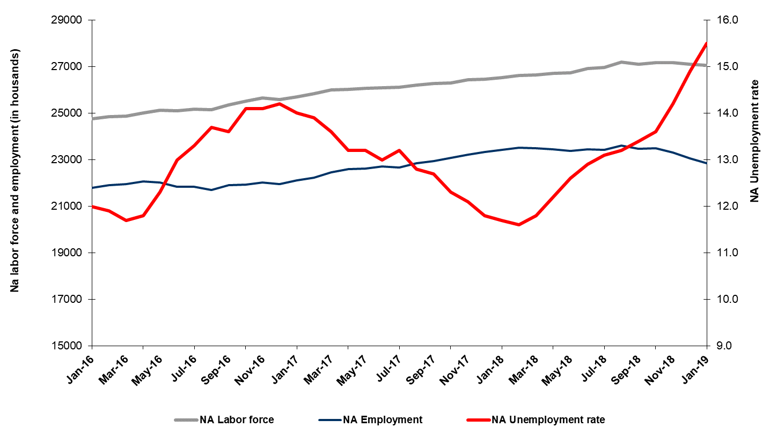

Source: Turkstat, Betam

Unemployment rate is expected to increase in February 2019

Betam's forecasting model had predicted that the seasonally adjusted non-agricultural unemployment rate would increase by 0.4 percentage points to reach 15.3 percent in January 2019. In fact, non-agricultural unemployment increased by 0.6 percentage points and reached 15.5 percent. Betam’s forecasting model predicts that the seasonally adjusted non-agricultural unemployment rate will reach 15.7 percent in the period of January 2019. Forecasting model details are available on Betam's website. Kariyer.net application per vacancy series used in the Betam forecasting model is depicted in Figure 3. Kariyer.net series is only one of the inputs of Betam forecast model. Indeed, several variables such as employment agency (İŞKUR) data, reel sector confidence index, capacity utilization rate are used in forecasting.

Figure 2 Seasonally adjusted non-agricultural unemployment rate and application per vacancy
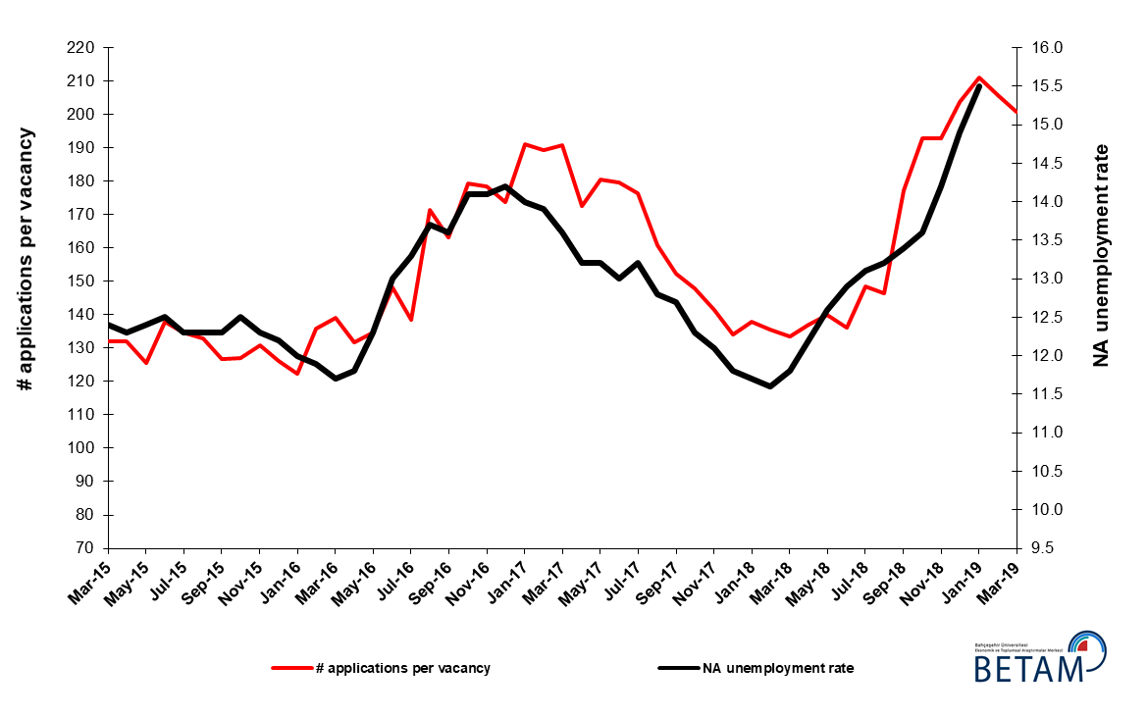
Source: Kariyer.net, Turkstat, Betam

Employment losses in all sectors

According to seasonally adjusted sectoral labor market data, employment decreased significantly in the period of December 2018 compared to January 2019 (Figure 3, Table 2) in all sectors. While employment in industry decreased by 82 thousand, employment losses in agriculture, construction and services amounted to 22 thousand, 44 thousand and 76 thousand, respectively. The losses in manufacturing employment observed in last three periods (from November 2018 to January 2019) are over 300 thousand (Table 2). Employment level in construction is decreasing continuously for almost a year (since the period of February 2018). Total employment loss has reached 250 thousand, implying that the sector has lost one fourth of its total employment. In the service sector, after a loss of 90 thousand in November 2018, employment had recovered by 14 thousand. However, 76 thousand more lost their jobs in this sector, amounting to a total loss in services over 150 thousand people.

Figure 3: Employment by sectors (in thousand)

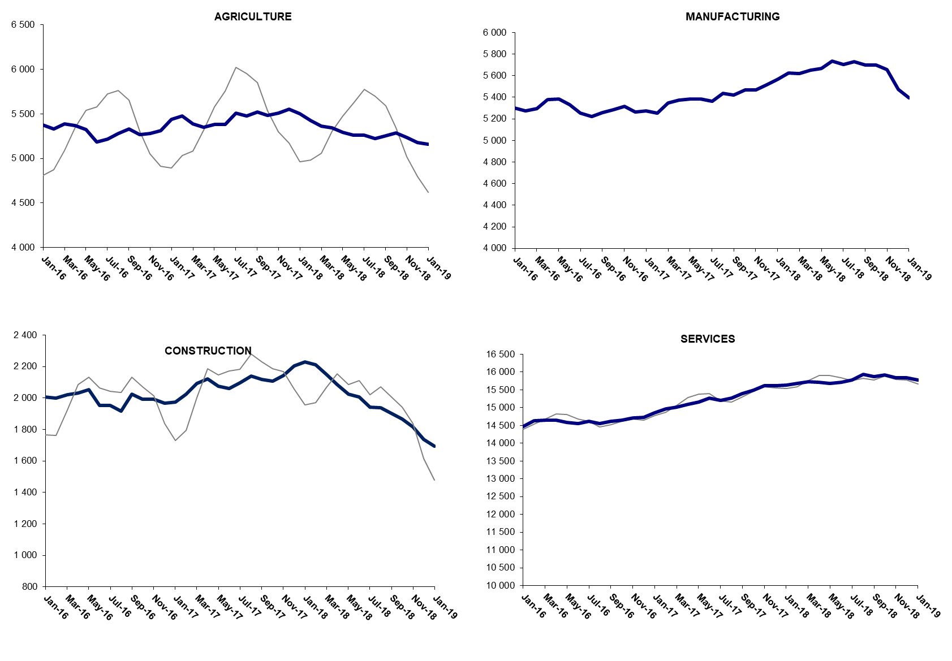
Source: TURKSTAT, Betam

The number of non-agricultural employed within a year decreased

From January 2018 to January 2019 non-agricultural labor force increased by 670 thousand (2.5 percent) and non-agricultural employment decreased by 526 thousand (-2.3 percent) (Figure 4). Year on year increase in labor force continues its usual trend. On the other hand, non-agricultural employment decreased within the past year. Thus, non-agricultural unemployed increased by 1 million 196 thousand and reached 4 million 551 thousand.

Figure 4 Year-on-year changes in non-agricultural labor force, employment, and unemployment

Source: Turkstat, Betam

Non-agricultural unemployment rate for females has reached to 20 percent

Figure 5 shows seasonally adjusted non-agricultural unemployment rate for males (green) and for females (purple). In the period of January 2019, the non-agricultural female unemployment rate increased by 0.9 percentage points and reached 20 percent while the non-agricultural male unemployment rate increased by 0.6 percentage points to 13.8 percent. Male employment decreased by 109 thousand in January 2019 compared to December 2018 (Table 3). On the other hand, the decrease by 54 in female non-agricultural employment is remarkable. The female labor force which decreased by 35 thousand in November 2018, had declined by 38 thousand in the period of July 15, 2016.The gender gap in non-agricultural unemployment rates increased from 5.9 to 6.2 percentage points in the period of January 2019.

Figure 5: Seasonally adjusted non-agricultural unemployment rate by gender
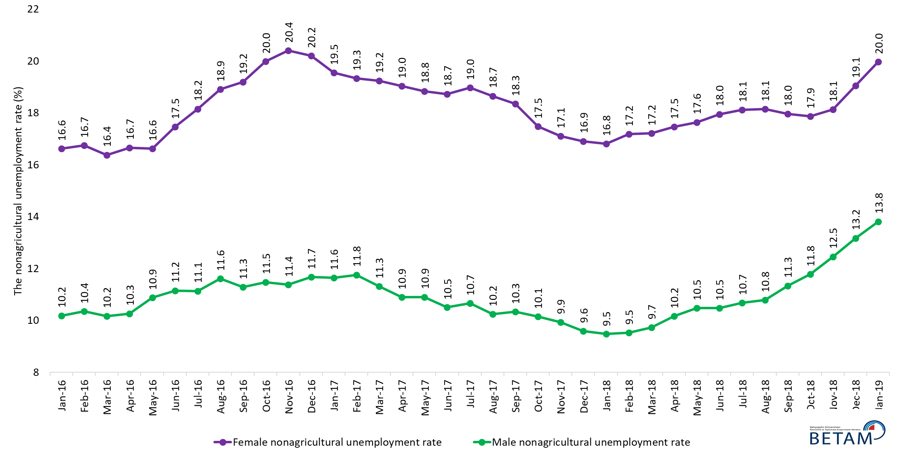
Source: Turkstat, Betam

Table 1 Seasonally adjusted non-agricultural labor market indicators (in thousands) *

 | Labor force | Employment | Unemployment | Unemployment rate | Monthly changes
December-15 | 24647 | 21640 | 3007 | 12.2% | Labor force | Employment | Unemployment
January-16 | 24753 | 21783 | 2970 | 12.0% | 106 | 143 | -37
February-16 | 24862 | 21903 | 2959 | 11.9% | 108 | 120 | -12
March-16 | 24877 | 21966 | 2911 | 11.7% | 15 | 63 | -48
April-16 | 25014 | 22062 | 2952 | 11.8% | 137 | 96 | 41
May-16 | 25123 | 22033 | 3090 | 12.3% | 110 | -29 | 139
June-16 | 25102 | 21839 | 3263 | 13.0% | -21 | -194 | 173
July-16 | 25179 | 21830 | 3349 | 13.3% | 76 | -9 | 85
August-16 | 25146 | 21701 | 3445 | 13.7% | -33 | -129 | 96
September-16 | 25348 | 21901 | 3447 | 13.6% | 202 | 200 | 2
October-16 | 25526 | 21927 | 3599 | 14.1% | 178 | 26 | 152
November-16 | 25646 | 22030 | 3616 | 14.1% | 120 | 103 | 17
December-16 | 25587 | 21954 | 3633 | 14.2% | -59 | -76 | 17
January-17 | 25710 | 22111 | 3599 | 14.0% | 123 | 157 | -34
February-17 | 25833 | 22242 | 3591 | 13.9% | 122 | 131 | -9
March-17 | 25992 | 22457 | 3535 | 13.6% | 159 | 215 | -56
April-17 | 26029 | 22593 | 3436 | 13.2% | 37 | 136 | -99
May-17 | 26058 | 22618 | 3440 | 13.2% | 29 | 25 | 4
June-17 | 26101 | 22708 | 3393 | 13.0% | 44 | 90 | -46
July-17 | 26108 | 22662 | 3446 | 13.2% | 7 | -46 | 53
August-17 | 26198 | 22845 | 3353 | 12.8% | 90 | 183 | -93
September-17 | 26268 | 22932 | 3336 | 12.7% | 70 | 87 | -17
October-17 | 26307 | 23071 | 3236 | 12.3% | 39 | 139 | -100
November-17 | 26428 | 23230 | 3198 | 12.1% | 121 | 159 | -38
December-17 | 26460 | 23338 | 3122 | 11.8% | 33 | 108 | -75
January-18 | 26538 | 23433 | 3105 | 11.7% | 78 | 95 | -17
February-18 | 26610 | 23523 | 3087 | 11.6% | 72 | 90 | -18
March-18 | 26633 | 23490 | 3143 | 11.8% | 23 | -33 | 56
April-18 | 26712 | 23453 | 3259 | 12.2% | 79 | -37 | 116
May-18 | 26737 | 23368 | 3369 | 12.6% | 25 | -85 | 110
June-18 | 26929 | 23455 | 3474 | 12.9% | 192 | 87 | 105
July-18 | 26961 | 23429 | 3532 | 13.1% | 32 | -26 | 58
August-18 | 27187 | 23598 | 3589 | 13.2% | 226 | 169 | 57
September-18 | 27103 | 23471 | 3632 | 13.4% | -84 | -127 | 43
October-18 | 27182 | 23485 | 3697 | 13.6% | 79 | 14 | 65
November-18 | 27161 | 23304 | 3857 | 14.2% | -21 | -181 | 160
December-18 | 27094 | 23057 | 4037 | 14.9% | -67 | -247 | 180
January-19 | 27049 | 22856 | 4193 | 15.5% | -45 | -201 | 156

Source: Turkstat, Betam

Table 2 Seasonally adjusted employment by sectors (in thousands) *

 | Agriculture | Manufacturing | Construction | Service | Monthly changes
December-15 | 5410 | 5311 | 2001 | 14328 | Agriculture | Manufacturing | Construction | Service
January-16 | 5376 | 5300 | 2006 | 14477
February-16 | 5331 | 5276 | 1998 | 14629 | -45 | -24 | -8 | 152
March-16 | 5390 | 5295 | 2021 | 14650 | 59 | 19 | 23 | 21
April-16 | 5371 | 5381 | 2032 | 14649 | -19 | 86 | 11 | -1
May-16 | 5328 | 5386 | 2055 | 14591 | -43 | 5 | 23 | -58
June-16 | 5185 | 5330 | 1952 | 14556 | -143 | -56 | -103 | -35
July-16 | 5214 | 5254 | 1953 | 14623 | 29 | -76 | 1 | 67
August-16 | 5280 | 5224 | 1917 | 14560 | 66 | -30 | -36 | -63
September-16 | 5334 | 5260 | 2026 | 14615 | 54 | 36 | 109 | 55
October-16 | 5267 | 5282 | 1992 | 14653 | -67 | 22 | -34 | 38
November-16 | 5278 | 5316 | 1994 | 14719 | 11 | 34 | 2 | 66
December-16 | 5312 | 5265 | 1967 | 14723 | 34 | -51 | -27 | 4
January-17 | 5440 | 5274 | 1975 | 14862 | 128 | 9 | 8 | 139
February-17 | 5480 | 5251 | 2026 | 14965 | 40 | -23 | 51 | 103
March-17 | 5388 | 5346 | 2092 | 15020 | -92 | 95 | 66 | 55
April-17 | 5351 | 5372 | 2120 | 15100 | -37 | 26 | 28 | 80
May-17 | 5381 | 5386 | 2076 | 15157 | 30 | 14 | -44 | 57
June-17 | 5383 | 5383 | 2061 | 15264 | 2 | -3 | -15 | 107
July-17 | 5507 | 5363 | 2096 | 15203 | 124 | -20 | 35 | -61
August-17 | 5476 | 5437 | 2139 | 15269 | -31 | 74 | 43 | 66
September-17 | 5523 | 5421 | 2117 | 15394 | 47 | -16 | -22 | 125
October-17 | 5485 | 5470 | 2106 | 15495 | -38 | 49 | -11 | 101
November-17 | 5512 | 5470 | 2144 | 15616 | 27 | 0 | 38 | 121
December-17 | 5556 | 5514 | 2204 | 15621 | 44 | 44 | 60 | 5
January-18 | 5502 | 5567 | 2230 | 15635 | -54 | 53 | 26 | 14
February-18 | 5426 | 5627 | 2213 | 15683 | -76 | 60 | -17 | 48
March-18 | 5366 | 5618 | 2152 | 15721 | -60 | -9 | -61 | 38
April-18 | 5342 | 5650 | 2087 | 15716 | -24 | 32 | -65 | -5
May-18 | 5291 | 5669 | 2023 | 15676 | -51 | 19 | -64 | -40
June-18 | 5259 | 5737 | 2005 | 15713 | -32 | 68 | -18 | 37
July-18 | 5263 | 5703 | 1943 | 15783 | 4 | -34 | -62 | 70
August-18 | 5226 | 5730 | 1938 | 15929 | -37 | 27 | -5 | 146
September-18 | 5256 | 5698 | 1901 | 15872 | 30 | -32 | -37 | -57
October-18 | 5290 | 5696 | 1867 | 15922 | 34 | -2 | -34 | 50
November-18 | 5234 | 5656 | 1816 | 15832 | -56 | -40 | -51 | -90
December-18 | 5180 | 5474 | 1737 | 15846 | -54 | -182 | -79 | 14
January-19 | 5158 | 5392 | 1693 | 15770 | -22 | -82 | -44 | -76

Source: Turkstat, Betam

Table 3: Seasonally adjusted non-agricultural labor force by gender (thousands)
 | Female Labor Force | Female Employment | Female Unemployed | Male Labor Force | Male Employment | Male Unemployed | Change in female labor force | Change in female employment | Change in male labor force | Change in male employment
December-15 | 6960 | 5784 | 1176 | 17670 | 15858 | 1812
January-16 | 7005 | 5841 | 1164 | 17704 | 15900 | 1803 | 45 | 56 | 34 | 42
February-16 | 7047 | 5867 | 1180 | 17744 | 15906 | 1838 | 42 | 26 | 40 | 6
March-16 | 7062 | 5905 | 1157 | 17784 | 15975 | 1809 | 15 | 38 | 40 | 69
April-16 | 7148 | 5957 | 1191 | 17826 | 15996 | 1830 | 86 | 51 | 41 | 21
May-16 | 7180 | 5987 | 1194 | 17960 | 16005 | 1955 | 33 | 30 | 134 | 9
June-16 | 7263 | 5994 | 1269 | 17886 | 15892 | 1995 | 83 | 7 | -73 | -113
July-16 | 7277 | 5956 | 1321 | 17946 | 15947 | 1999 | 14 | -38 | 59 | 55
August-16 | 7316 | 5932 | 1384 | 17962 | 15876 | 2086 | 39 | -24 | 17 | -71
September-16 | 7382 | 5965 | 1417 | 18020 | 15987 | 2033 | 66 | 33 | 58 | 111
October-16 | 7433 | 5948 | 1486 | 18081 | 16005 | 2076 | 51 | -17 | 61 | 18
November-16 | 7464 | 5940 | 1523 | 18143 | 16079 | 2064 | 31 | -7 | 62 | 74
December-16 | 7449 | 5944 | 1505 | 18171 | 16049 | 2122 | -15 | 4 | 28 | -30
January-17 | 7444 | 5989 | 1455 | 18254 | 16128 | 2126 | -5 | 45 | 83 | 79
February-17 | 7512 | 6060 | 1452 | 18272 | 16123 | 2149 | 68 | 71 | 18 | -5
March-17 | 7617 | 6152 | 1465 | 18320 | 16248 | 2072 | 105 | 92 | 48 | 124
April-17 | 7605 | 6157 | 1448 | 18355 | 16356 | 1999 | -12 | 5 | 35 | 108
May-17 | 7657 | 6214 | 1443 | 18394 | 16388 | 2005 | 52 | 57 | 39 | 32
June-17 | 7671 | 6235 | 1437 | 18423 | 16488 | 1935 | 15 | 21 | 29 | 100
July-17 | 7688 | 6229 | 1458 | 18444 | 16477 | 1967 | 16 | -5 | 21 | -10
August-17 | 7722 | 6281 | 1441 | 18488 | 16594 | 1894 | 34 | 52 | 44 | 116
September-17 | 7772 | 6346 | 1426 | 18514 | 16601 | 1913 | 50 | 65 | 27 | 8
October-17 | 7783 | 6422 | 1361 | 18531 | 16650 | 1880 | 11 | 76 | 16 | 49
November-17 | 7832 | 6492 | 1340 | 18570 | 16726 | 1845 | 49 | 70 | 40 | 75
December-17 | 7879 | 6546 | 1333 | 18612 | 16827 | 1785 | 46 | 54 | 41 | 101
January-18 | 7917 | 6586 | 1331 | 18623 | 16858 | 1765 | 38 | 40 | 11 | 31
February-18 | 7956 | 6588 | 1367 | 18663 | 16884 | 1780 | 39 | 2 | 41 | 26
March-18 | 7953 | 6583 | 1369 | 18689 | 16870 | 1819 | -3 | -5 | 26 | -14
April-18 | 7990 | 6595 | 1396 | 18720 | 16817 | 1904 | 38 | 11 | 31 | -53
May-18 | 8027 | 6610 | 1416 | 18743 | 16779 | 1964 | 37 | 16 | 22 | -38
June-18 | 8075 | 6625 | 1450 | 18787 | 16819 | 1968 | 48 | 15 | 44 | 40
July-18 | 8094 | 6627 | 1467 | 18808 | 16800 | 2009 | 19 | 2 | 21 | -19
August-18 | 8201 | 6713 | 1488 | 18849 | 16817 | 2032 | 108 | 86 | 41 | 17
September-18 | 8171 | 6704 | 1468 | 18856 | 16717 | 2138 | -30 | -9 | 6 | -100
October-18 | 8264 | 6787 | 1477 | 18878 | 16653 | 2224 | 92 | 83 | 22 | -64
November-18 | 8248 | 6752 | 1496 | 18886 | 16533 | 2353 | -16 | -35 | 8 | -121
December-18 | 8332 | 6745 | 1587 | 18895 | 16405 | 2490 | 84 | -7 | 9 | -128

Source: Turkstat, Betam

* Prof. Seyfettin Gürsel, Betam, Director, seyfettin.gursel@eas.bau.edu.tr
** Assoc. Prof. Gökçe Uysal, Betam, Deputy Director, gokce.uysal@eas.bau.edu.tr ***Furkan Kavuncu, Betam, Research Assistant, yazgi.genc@eas.bau.edu.tr
The foreign trade volume indexes used in Betam forecasting model do not announced yet. Thus, Betam forecasting model cannot be efficiently operated. We think that lack of data will increase the margin of error.
For detailed information on Betam's forecasting model, please see Betam Research Brief 168 titled as "Kariyer.net Verisiyle Kısa Vadeli Tarım Dışı İşsizlik Tahmini" . For the innovations in the model please see Betam Research Brief 14 titled as "Mevsim Etkilerinden Arındırılmış İşsizlik Tahmini" Soybilgen, B., "Kariyer.net Verisiyle Kısa Vadeli Tarım Dışı İşsizlik Tahmini", Betam Research Brief 168. http://betam.bahcesehir.edu.tr/tr/2014/06/kariyer-net-verisiyle-kisa-vadeli-tarim-disi-issizlik-tahmini/ Soybilgen, B., "Mevsim Etkilerinden Arındırılmış İşsizlik Tahmini", Betam Research Brief 14 http://betam.bahcesehir.edu.tr/2015/08/mevsim-etkilerinden-arindirilmis-tarim-disi-issizlik-tahmini/
Betam has been calculating application per vacancy using series released by Kariyer.net for a while. Seasonal and calendar adjustment procedure is applied to application per vacancy series. A decrease in applications per vacancy may be caused by an increase in vacancies or by a decrease in the number of applications. An increase in vacancies signals economic growth while decreasing number of applications indicates a decrease in number of people looking for a job. Monthly labor market series released by TurkStat is the average of three months. Therefore, application per vacancy statistics calculated using Kariyer.net series is the average of three months as well.
Employment in each sector is seasonally adjusted separately. Hence the sum of these series may differ from the seasonally adjusted series of total employment. The difference stems from the non-linearity of the seasonal adjustment process.
Turkstat revised the labor market statistics drastically in February 2014. Within this framework, they back casted various labor market indicators and they also continued to announce seasonally adjusted series. However, Turkstat is not providing back-casted series by gender. Therefore, female and male labor market statistics are not sufficiently long for the seasonal adjustment procedures (There should be minimum 36 observations). With the announcement of the period of February 2017 data, the number of observations required for the seasonal decontamination process was provided. From this period Betam generated seasonal adjustment series in terms of gender. Nevertheless, it should not be forgotten that seasonal adjustment may cause extra volatility in the series for at least a while.

