Labor Market Outlook:
February 2019

15 February 2019

SHARP INCREASE IN UNEMPLOYMENT

Seyfettin Gürsel*, Gokce Uysal∗∗ and Furkan Kavuncu***

Executive Summary

Seasonally adjusted labor market data shows that in the period of November 2018, non-agricultural unemployment rate increased by 0.6 percentage points and reached 14.1 percent. In this period, employment decreased in all sectors albeit a decrease in labor force. Thus unemployment rate rose significantly. Employment in manufacturing decreased by 78 thousand in the last three periods combined. This decline parallel to the in the industrial production index which has been decreasing since July 2018. The decrease in employment in the construction sector has amounted to 363 thousand since the beginning of 2018. As for services, employment dropped by 87 thousand in the period of November 2018. With reference to Betam’s growth estimate for the last quarter of 2018, which is noted as minus 3.5 percent, we expect the increase in non-agricultural unemployment rate to continue in the period of December 2018.

The number of unemployed is 3.8 million

According to seasonally adjusted labor market data, in the period of November 2018 compared to October 2018, the non-agricultural labor force decreased by 13 thousand to 27 million 179 thousand and also the number of employed in non-agricultural sectors decreased by 174 thousand and dropped to 23 million 347 thousand; and thereby non-agricultural unemployment rate rose to 14.1 percent (Figure 1, Table 1). Note that, in this period, we observe a decline in non-agricultural labor force. An increase of 0.6 percentage points in non-agricultural unemployment despite the decline in non-agricultural labor force is implies that the labor market outlook is bleak. Similar increases over the course of a single period were observed in 2008-2009 Global Recession and in the period of July 2016.

Figure 1 Seasonally adjusted non-agricultural labor force, employment, and unemployment
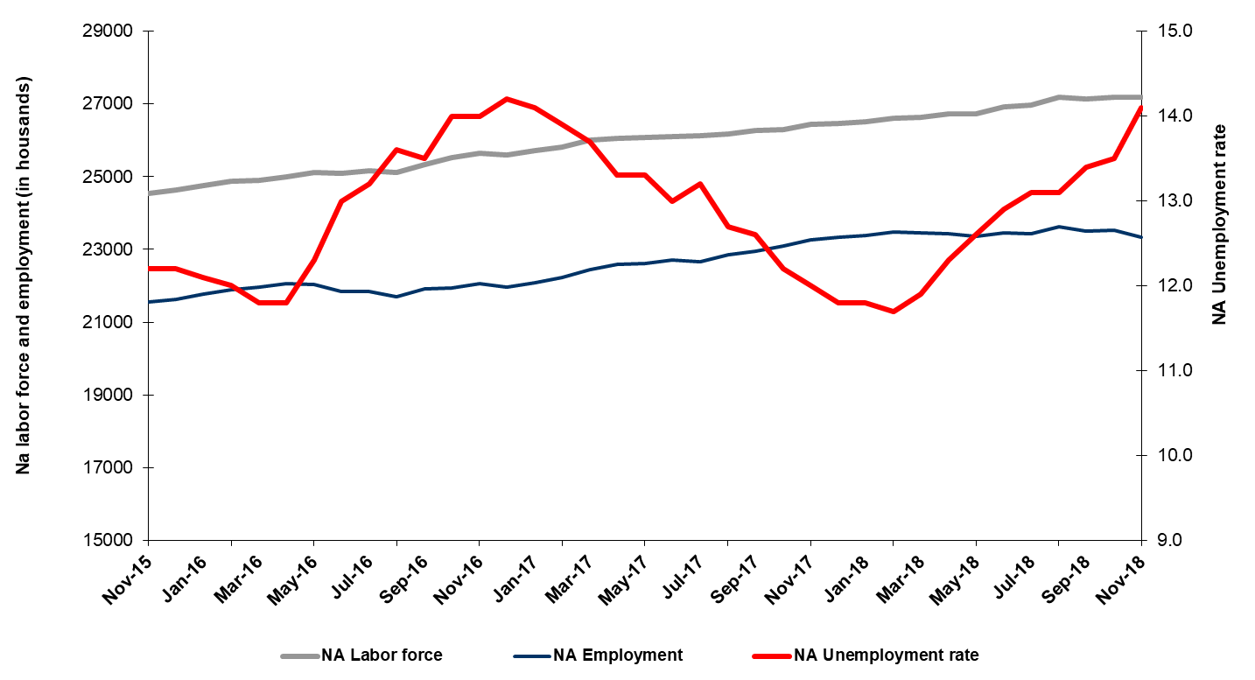

Source: Turkstat, Betam

Note that the period of November 2018 is the average of October, November and December 2018, so it reflects the last quarter of 2018. In addition, Betam’s growth estimate for the last quarter of 2018 is -3.5 percent. The rapid increase in non-agricultural unemployment rate is consistent with this expectation.

Unemployment rate is expected to increase by 0.2 percentage points in December 2018

Betam's forecasting model had predicted that the seasonally adjusted non-agricultural unemployment rate would increase by 0.2 percentage points to reach 13.7 percent in November 2018. In fact, non-agricultural unemployment increased by 0.6 percentage points and reached to 14.1 percent. Betam’s forecasting model predicts that the seasonally adjusted non-agricultural unemployment rate will reach 14.3 percent in the period of December 2018. Forecasting model details are available on Betam's website. Kariyer.net application per vacancy series used in the Betam forecasting model is depicted in Figure 3. Kariyer.net series is only one of the inputs of Betam forecast model. Indeed, several variables such as employment agency (İŞKUR) data, reel sector confidence index, capacity utilization rate are used in forecasting.

Figure 2 Seasonally adjusted non-agricultural unemployment rate and application per vacancy
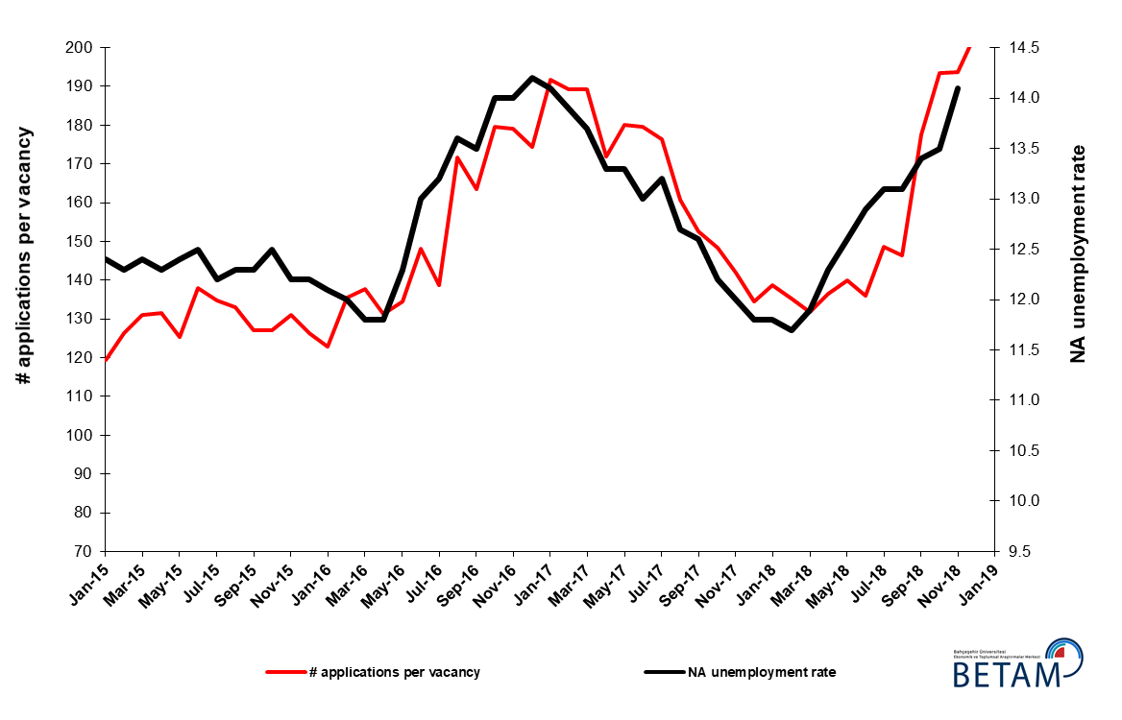
Source: Kariyer.net, Turkstat, Betam

Employment losses in all sectors

According to seasonally adjusted sectoral labor market data, employment decreased significantly in the period of November 2018 compared to September 2018 (Figure 3, Table 2) in all sectors. While the employment in services decreased by 87 thousand in this period, employment losses in manufacturing, construction and agriculture were 40 thousand, 47 thousand and 54 thousand, respectively. The decrease in non-agricultural employment by 174 thousand is the most severe drop since the decrease by 190 thousand in July 2016 (Table 2). In manufacturing, employment decreased for three consecutive periods. As for construction, employment losses which began in the period of February 2018 continued and the total loss recorded since reached 363 thousand.

Figure 3: Employment by sectors (in thousand)

Source: TURKSTAT, Betam

The number of non-agricultural unemployed within a year increased

From October 2017 to October 2018 non-agricultural labor force decreased by 732 thousand (2.8 percent) and non-agricultural employment increased by 72 thousand (0.3 percent) (Figure 4). The slowdown of the increase in employment becomes more evident, while year on year increase in labor force continues its normal trend. Thus, non-agricultural unemployed increased by 660 thousand and reached 3 million 886 thousand.

Figure 4 Year-on-year changes in non-agricultural labor force, employment, and unemployment
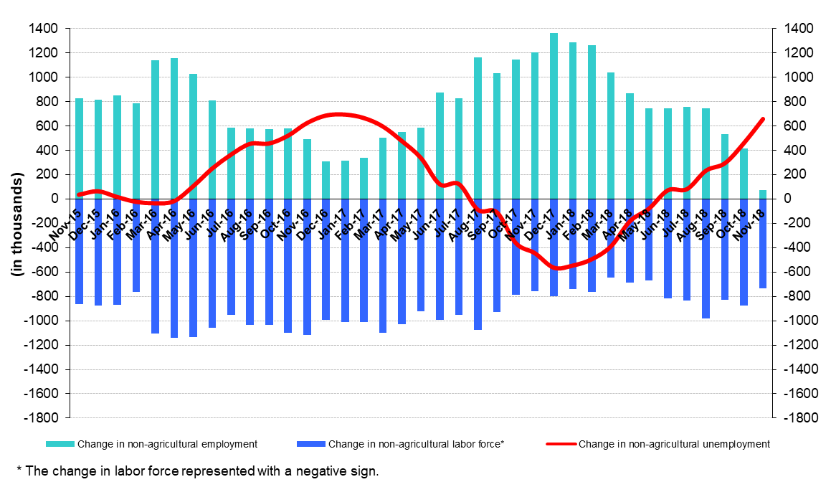
Source: Turkstat, Betam

The increase in non-agricultural male unemployment rate

Figure 5 shows seasonally adjusted non-agricultural unemployment rate for males (green) and for females (purple). In the period of November 2018, the non-agricultural female unemployment rate increased by 0.3 percentage points and reached 18 percent while the non-agricultural male unemployment rate increased by 0.7 percentage points to 12.2 percent. The increase in the male non-agricultural unemployment rate is due to employment losses. Male employment decreased by 113 thousand in November 2018 compared to October 2018 (Table 3). The gender gap in non-agricultural unemployment rates decreased from 6.2 to 5.8 percentage points in the period of November 2018.

Figure 5: Seasonally adjusted non-agricultural unemployment rate by gender
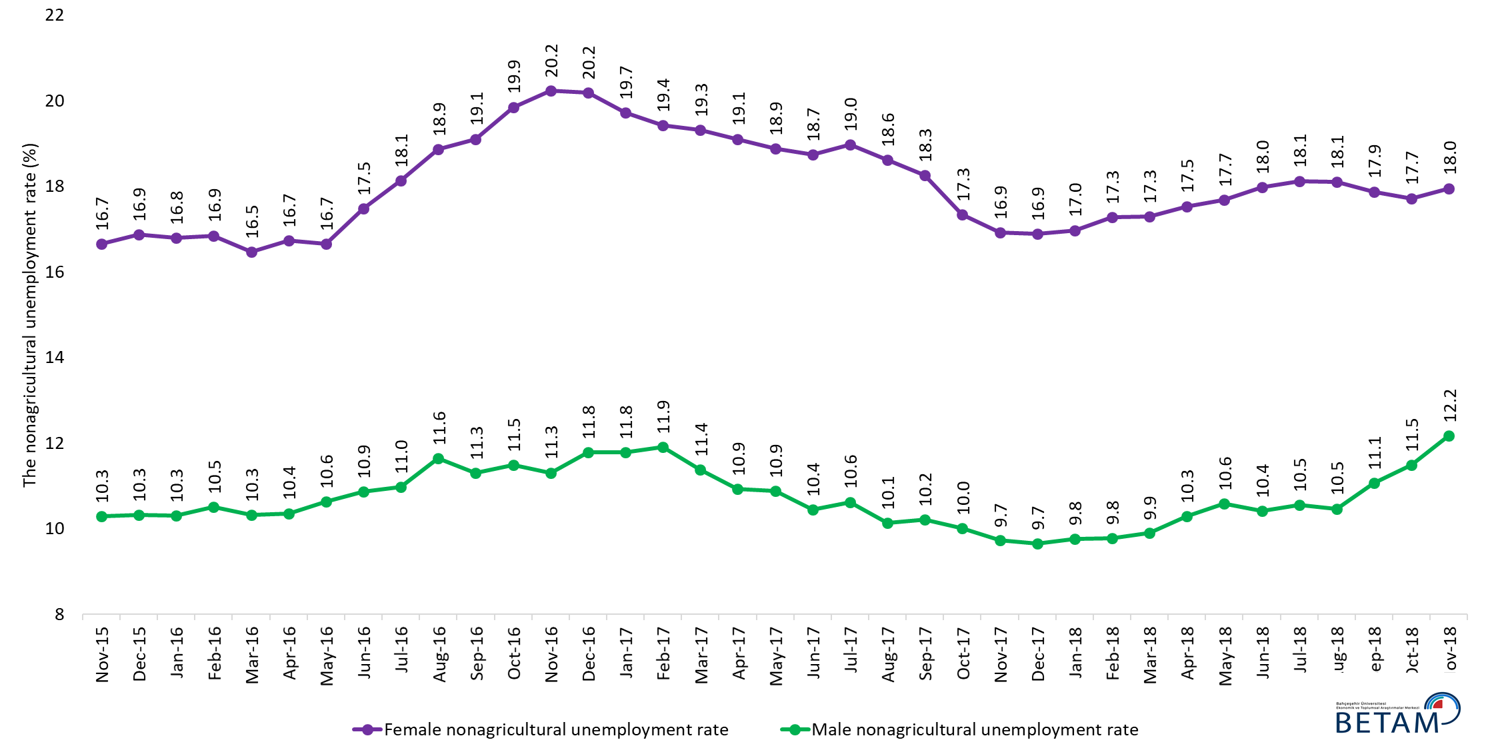
Source: Turkstat, Betam

Table 1 Seasonally adjusted non-agricultural labor market indicators (in thousands) *

 | Labor force | Employment | Unemployment | Unemployment rate | Monthly changes
October-15 | 24397 | 21347 | 3050 | 12.5% | Labor force | Employment | Unemployment
November-15 | 24538 | 21544 | 2994 | 12.2% | 141 | 197 | -56
December-15 | 24639 | 21633 | 3006 | 12.2% | 101 | 89 | 12
January-16 | 24762 | 21766 | 2996 | 12.1% | 123 | 133 | -10
February-16 | 24873 | 21888 | 2985 | 12.0% | 110 | 122 | -12
March-16 | 24891 | 21954 | 2937 | 11.8% | 18 | 66 | -48
April-16 | 25005 | 22054 | 2951 | 11.8% | 113 | 100 | 13
May-16 | 25119 | 22029 | 3090 | 12.3% | 114 | -25 | 139
June-16 | 25102 | 21839 | 3263 | 13.0% | -16 | -190 | 174
July-16 | 25156 | 21835 | 3321 | 13.2% | 53 | -4 | 57
August-16 | 25127 | 21710 | 3417 | 13.6% | -28 | -125 | 97
September-16 | 25333 | 21913 | 3420 | 13.5% | 206 | 203 | 3
October-16 | 25515 | 21943 | 3572 | 14.0% | 182 | 30 | 152
November-16 | 25638 | 22049 | 3589 | 14.0% | 123 | 106 | 17
December-16 | 25589 | 21955 | 3634 | 14.2% | -50 | -94 | 44
January-17 | 25712 | 22087 | 3625 | 14.1% | 124 | 132 | -8
February-17 | 25807 | 22220 | 3587 | 13.9% | 95 | 133 | -38
March-17 | 26003 | 22441 | 3562 | 13.7% | 196 | 221 | -25
April-17 | 26045 | 22581 | 3464 | 13.3% | 42 | 140 | -98
May-17 | 26084 | 22615 | 3469 | 13.3% | 39 | 34 | 5
June-17 | 26103 | 22710 | 3393 | 13.0% | 19 | 95 | -76
July-17 | 26116 | 22669 | 3447 | 13.2% | 13 | -41 | 54
August-17 | 26183 | 22858 | 3325 | 12.7% | 67 | 189 | -122
September-17 | 26261 | 22952 | 3309 | 12.6% | 78 | 94 | -16
October-17 | 26305 | 23096 | 3209 | 12.2% | 44 | 144 | -100
November-17 | 26433 | 23261 | 3172 | 12.0% | 128 | 165 | -37
December-17 | 26457 | 23335 | 3122 | 11.8% | 24 | 74 | -50
January-18 | 26523 | 23393 | 3130 | 11.8% | 66 | 58 | 8
February-18 | 26602 | 23490 | 3112 | 11.7% | 80 | 97 | -17
March-18 | 26635 | 23465 | 3170 | 11.9% | 32 | -25 | 57
April-18 | 26724 | 23437 | 3287 | 12.3% | 90 | -28 | 118
May-18 | 26730 | 23362 | 3368 | 12.6% | 6 | -75 | 81
June-18 | 26931 | 23457 | 3474 | 12.9% | 201 | 95 | 106
July-18 | 26974 | 23440 | 3534 | 13.1% | 42 | -17 | 59
August-18 | 27176 | 23616 | 3560 | 13.1% | 203 | 176 | 27
September-18 | 27134 | 23498 | 3636 | 13.4% | -42 | -118 | 76
October-18 | 27192 | 23521 | 3671 | 13.5% | 58 | 23 | 35
November-18 | 27179 | 23347 | 3832 | 14.1% | -13 | -174 | 161

Source: Turkstat, Betam

Table 2 Seasonally adjusted employment by sectors (in thousands) *

 | Agriculture | Manufacturing | Construction | Service | Monthly changes
October-15 | 5442 | 5363 | 1965 | 14019 | Agriculture | Manufacturing | Construction | Service
November-15 | 5386 | 5353 | 1992 | 14199 | -56 | -10 | 27 | 180
December-15 | 5407 | 5311 | 1996 | 14326 | 21 | -42 | 4 | 127
January-16 | 5372 | 5300 | 1998 | 14468 | -35 | -11 | 2 | 142
February-16 | 5327 | 5276 | 1992 | 14620 | -45 | -24 | -6 | 152
March-16 | 5387 | 5295 | 2016 | 14643 | 60 | 19 | 24 | 23
April-16 | 5369 | 5381 | 2029 | 14644 | -18 | 86 | 13 | 1
May-16 | 5328 | 5386 | 2054 | 14589 | -41 | 5 | 25 | -55
June-16 | 5187 | 5330 | 1954 | 14556 | -141 | -56 | -100 | -33
July-16 | 5215 | 5254 | 1956 | 14625 | 28 | -76 | 2 | 69
August-16 | 5282 | 5224 | 1921 | 14565 | 67 | -30 | -35 | -60
September-16 | 5337 | 5260 | 2033 | 14621 | 55 | 36 | 112 | 56
October-16 | 5272 | 5282 | 2001 | 14661 | -65 | 22 | -32 | 40
November-16 | 5284 | 5316 | 2005 | 14728 | 12 | 34 | 4 | 67
December-16 | 5309 | 5265 | 1961 | 14728 | 25 | -51 | -44 | 0
January-17 | 5434 | 5274 | 1963 | 14850 | 125 | 9 | 2 | 122
February-17 | 5475 | 5251 | 2015 | 14954 | 41 | -23 | 52 | 104
March-17 | 5384 | 5346 | 2083 | 15012 | -91 | 95 | 68 | 58
April-17 | 5350 | 5372 | 2115 | 15094 | -34 | 26 | 32 | 82
May-17 | 5381 | 5386 | 2075 | 15154 | 31 | 14 | -40 | 60
June-17 | 5385 | 5383 | 2063 | 15264 | 4 | -3 | -12 | 110
July-17 | 5509 | 5363 | 2101 | 15205 | 124 | -20 | 38 | -59
August-17 | 5479 | 5437 | 2147 | 15274 | -30 | 74 | 46 | 69
September-17 | 5526 | 5421 | 2129 | 15402 | 47 | -16 | -18 | 128
October-17 | 5491 | 5470 | 2121 | 15505 | -35 | 49 | -8 | 103
November-17 | 5520 | 5470 | 2164 | 15627 | 29 | 0 | 43 | 122
December-17 | 5551 | 5514 | 2193 | 15628 | 31 | 44 | 29 | 1
January-18 | 5494 | 5567 | 2206 | 15620 | -57 | 53 | 13 | -8
February-18 | 5418 | 5627 | 2193 | 15670 | -76 | 60 | -13 | 50
March-18 | 5361 | 5618 | 2137 | 15710 | -57 | -9 | -56 | 40
April-18 | 5340 | 5650 | 2078 | 15709 | -21 | 32 | -59 | -1
May-18 | 5292 | 5669 | 2021 | 15673 | -48 | 19 | -57 | -36
June-18 | 5262 | 5737 | 2007 | 15713 | -30 | 68 | -14 | 40
July-18 | 5266 | 5703 | 1951 | 15786 | 4 | -34 | -56 | 73
August-18 | 5231 | 5730 | 1951 | 15935 | -35 | 27 | 0 | 149
September-18 | 5262 | 5698 | 1918 | 15882 | 31 | -32 | -33 | -53
October-18 | 5298 | 5696 | 1890 | 15934 | 36 | -2 | -28 | 52
November-18 | 5244 | 5656 | 1843 | 15847 | -54 | -40 | -47 | -87

Source: Turkstat, Betam

Table 3: Seasonally adjusted non-agricultural labor force by gender (thousands)
 | Female Labor Force | Female Employment | Female Unemployed | Male Labor Force | Male Employment | Male Unemployed | Change in female labor force | Change in female employment | Change in male labor force | Change in male employment
November-15 | 6876 | 5730 | 1145 | 17632 | 15819 | 1813
December-15 | 6966 | 5790 | 1176 | 17684 | 15859 | 1825 | 91 | 60 | 52 | 40
January-16 | 7010 | 5832 | 1178 | 17723 | 15896 | 1827 | 44 | 42 | 39 | 38
February-16 | 7048 | 5861 | 1188 | 17771 | 15905 | 1866 | 38 | 28 | 48 | 8
March-16 | 7063 | 5900 | 1163 | 17815 | 15976 | 1839 | 15 | 39 | 44 | 71
April-16 | 7148 | 5952 | 1196 | 17851 | 16001 | 1849 | 85 | 53 | 35 | 25
May-16 | 7180 | 5984 | 1196 | 17914 | 16009 | 1905 | 32 | 32 | 64 | 8
June-16 | 7262 | 5993 | 1270 | 17826 | 15888 | 1938 | 82 | 9 | -89 | -121
July-16 | 7276 | 5956 | 1320 | 17912 | 15946 | 1966 | 13 | -37 | 87 | 58
August-16 | 7314 | 5934 | 1380 | 17962 | 15871 | 2091 | 38 | -22 | 50 | -75
September-16 | 7379 | 5969 | 1410 | 18029 | 15993 | 2037 | 65 | 35 | 67 | 122
October-16 | 7430 | 5955 | 1475 | 18093 | 16014 | 2079 | 51 | -15 | 64 | 22
November-16 | 7460 | 5950 | 1509 | 18151 | 16099 | 2052 | 30 | -4 | 58 | 84
December-16 | 7455 | 5950 | 1505 | 18180 | 16038 | 2142 | -4 | 0 | 29 | -60
January-17 | 7449 | 5980 | 1469 | 18253 | 16102 | 2151 | -6 | 30 | 73 | 64
February-17 | 7514 | 6054 | 1460 | 18274 | 16098 | 2176 | 64 | 73 | 21 | -4
March-17 | 7618 | 6146 | 1472 | 18320 | 16236 | 2084 | 105 | 93 | 46 | 138
April-17 | 7606 | 6152 | 1453 | 18360 | 16353 | 2007 | -13 | 6 | 40 | 117
May-17 | 7657 | 6211 | 1446 | 18386 | 16385 | 2000 | 51 | 59 | 26 | 32
June-17 | 7671 | 6233 | 1438 | 18417 | 16493 | 1924 | 14 | 22 | 31 | 107
July-17 | 7686 | 6228 | 1458 | 18446 | 16486 | 1960 | 16 | -5 | 29 | -7
August-17 | 7720 | 6283 | 1437 | 18488 | 16615 | 1873 | 34 | 55 | 42 | 129
September-17 | 7769 | 6350 | 1419 | 18516 | 16626 | 1890 | 49 | 67 | 29 | 11
October-17 | 7780 | 6430 | 1349 | 18535 | 16680 | 1855 | 10 | 80 | 19 | 54
November-17 | 7828 | 6503 | 1325 | 18575 | 16769 | 1806 | 48 | 73 | 40 | 89
December-17 | 7885 | 6553 | 1332 | 18606 | 16809 | 1797 | 57 | 50 | 31 | 40
January-18 | 7922 | 6577 | 1345 | 18621 | 16803 | 1819 | 37 | 24 | 15 | -6
February-18 | 7957 | 6581 | 1375 | 18663 | 16837 | 1825 | 35 | 4 | 41 | 35
March-18 | 7953 | 6577 | 1376 | 18690 | 16840 | 1849 | -3 | -4 | 27 | 3
April-18 | 7991 | 6589 | 1401 | 18721 | 16794 | 1926 | 37 | 12 | 31 | -46
May-18 | 8027 | 6607 | 1420 | 18747 | 16762 | 1985 | 36 | 18 | 26 | -33
June-18 | 8075 | 6623 | 1452 | 18786 | 16831 | 1955 | 48 | 16 | 39 | 69
July-18 | 8092 | 6625 | 1467 | 18810 | 16826 | 1984 | 18 | 2 | 25 | -4
August-18 | 8199 | 6715 | 1484 | 18848 | 16875 | 1973 | 107 | 90 | 38 | 49
September-18 | 8169 | 6708 | 1460 | 18868 | 16780 | 2087 | -31 | -7 | 19 | -95
October-18 | 8260 | 6796 | 1464 | 18900 | 16730 | 2170 | 91 | 88 | 32 | -51
November-18 | 8243 | 6763 | 1480 | 18919 | 16617 | 2303 | -17 | -33 | 19 | -113

Source: Turkstat, Betam

* Prof. Seyfettin Gürsel, Betam, Director, seyfettin.gursel@eas.bau.edu.tr
** Assoc. Prof. Gökçe Uysal, Betam, Deputy Director, gokce.uysal@eas.bau.edu.tr ***Furkan Kavuncu, Betam, Research Assistant, furkan.kavuncu@eas.bau.edu.tr
Labor force statistics are published as the mean values of three months. Therefore, the first impact of the period of July 2016 is observed in the statistics of June 2016 which represents the mean of May, June and July 2016.
For detailed information on Betam's forecasting model, please see Betam Research Brief 168 titled as "Kariyer.net Verisiyle Kısa Vadeli Tarım Dışı İşsizlik Tahmini" . For the innovations in the model please see Betam Research Brief 14 titled as "Mevsim Etkilerinden Arındırılmış İşsizlik Tahmini" Soybilgen, B., "Kariyer.net Verisiyle Kısa Vadeli Tarım Dışı İşsizlik Tahmini", Betam Research Brief 168. http://betam.bahcesehir.edu.tr/tr/2014/06/kariyer-net-verisiyle-kisa-vadeli-tarim-disi-issizlik-tahmini/ Soybilgen, B., "Mevsim Etkilerinden Arındırılmış İşsizlik Tahmini", Betam Research Brief 14 http://betam.bahcesehir.edu.tr/2015/08/mevsim-etkilerinden-arindirilmis-tarim-disi-issizlik-tahmini/
Betam has been calculating application per vacancy using series released by Kariyer.net for a while. Seasonal and calendar adjustment procedure is applied to application per vacancy series. A decrease in applications per vacancy may be caused by an increase in vacancies or by a decrease in the number of applications. An increase in vacancies signals economic growth while decreasing number of applications indicates a decrease in number of people looking for a job. Monthly labor market series released by TurkStat is the average of three months. Therefore, application per vacancy statistics calculated using Kariyer.net series is the average of three months as well.
Employment in each sector is seasonally adjusted separately. Hence the sum of these series may differ from the seasonally adjusted series of total employment. The difference stems from the non-linearity of the seasonal adjustment process.
Turkstat revised the labor market statistics drastically in February 2014. Within this framework, they back casted various labor market indicators and they also continued to announce seasonally adjusted series. However, Turkstat is not providing back-casted series by gender. Therefore, female and male labor market statistics are not sufficiently long for the seasonal adjustment procedures (There should be minimum 36 observations). With the announcement of the period of February 2017 data, the number of observations required for the seasonal decontamination process was provided. From this period Betam generated seasonal adjustment series in terms of gender. Nevertheless, it should not be forgotten that seasonal adjustment may cause extra volatility in the series for at least a while.

