Labor Market Outlook:
January 2018

15 January 2018

INCREASE IN UNEMPLOYMENT CONTINUES

Seyfettin Gürsel*, Gokce Uysal∗∗ and Yazgı Genç***

Executive Summary

Seasonally adjusted labor market data shows that in the period of October 2018, non-agricultural unemployment rate increased by 0.2 percentage points and reached 13.5 percent. In this period, the higher increase in non-agricultural labor force compared to the increase in non-agricultural employment caused a sizable increase in the non-agricultural unemployment. In the period of October 2018, employment losses were recorded in manufacturing and construction while employment increased in agriculture and services. Employment decreased by 2 thousand in manufacturing, 26 thousand in construction and increased by 53 thousand in services. While non-agricultural male unemployment rate rose by 0.4 percentage points, non-agricultural female unemployment rate decreased by 0.1 percentage points in October 2018. Betam’s forecasting model predicts that the non-agricultural unemployment will increase to 13.7 percent in the period of November 2018.

The increase in non-agricultural labor force

According to seasonally adjusted labor market data, in the period of October 2018 compared to September 2018, the non-agricultural labor force increased by 93 thousand and reached 27 million 229 thousand and also the number of employed in non-agricultural sectors increased by 26 thousand and reached 23 million 553 thousand (Figure 1, Table 1). As a result, the number of unemployed in non-agricultural sectors increased by 67 thousand and was recorded as 3 million 676 thousand. Thus, the non-agricultural unemployment rate increased to 13.5 percent.

Figure 1 Seasonally adjusted non-agricultural labor force, employment, and unemployment

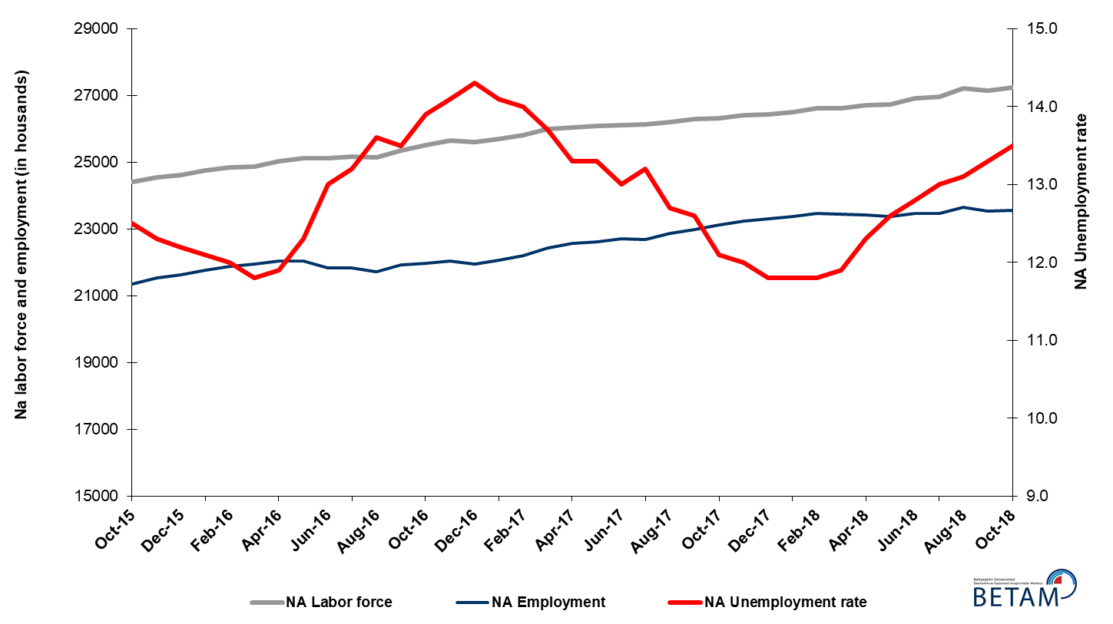
Source: Turkstat, Betam

Unemployment rate is expected to increase by 0.2 percentage points in the period of November 2018

Betam's forecasting model had predicted that the seasonally adjusted non-agricultural unemployment rate would increase by 0.1 percentage points to 13.4 percent in October 2018. In fact, the non-agricultural unemployment increased by 0.2 percentage points and reached to 13.5 percent. Betam’s forecasting model predicts that the non-agricultural unemployment rate will reach 13.7 percent in the period of November 2018. Forecasting model details are available on Betam's website. Kariyer.net application per vacancy series used in the Betam forecasting model is depicted in Figure 3. Kariyer.net series is only one of the inputs of Betam forecast model. Indeed, several variables such as employment agency (İŞKUR) data, reel sector confidence index, capacity utilization rate are used in forecasting.

Figure 2 Seasonally adjusted non-agricultural unemployment rate and application per vacancy
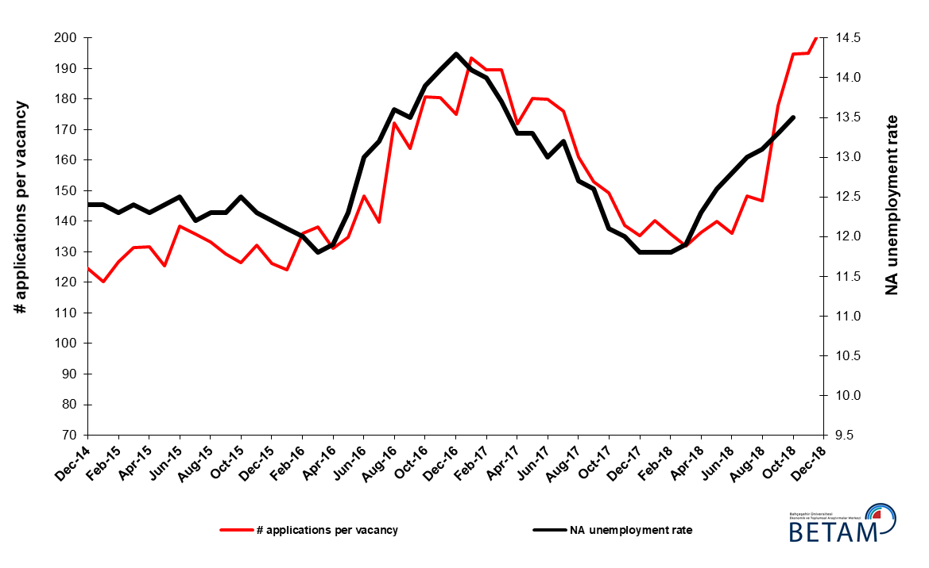
Source: Kariyer.net, Turkstat, Betam

Employment losses in construction continues

According to seasonally adjusted sectorial labor market data, employment decreased in manufacturing and construction while it increased in agriculture and services in October 2018 compared to September 2018 (Figure 3, Table 2). The employment increased by 53 thousand in services and decreased by 2 thousand in manufacturing, 26 thousand in construction. Note that employment losses in construction recorded since the period of February 2018 reached almost 300 thousand (Table 2). It is remarkable that employment losses in services in the period of September 2018 (50 thousand) made way to an increase in the period of October 2018 (Table 2).

Figure 3: Employment by sectors (in thousand)

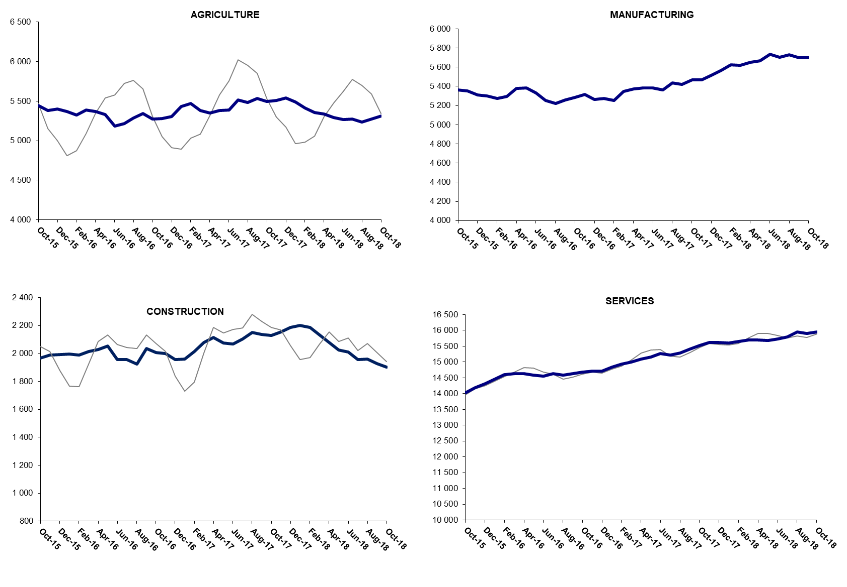

Source: TURKSTAT, Betam

The number of non-agricultural unemployed within a year increased

From October 2017 to October 2018 non-agricultural labor force increased by 876 thousand (3.3 percent) and non-agricultural employment increased by 414 thousand (1.8 percent) (Figure 4). The slowdown of the increase in employment becomes more evident, while year on year increase in labor force continues its normal trend. Thus, non-agricultural unemployed increased by 462 thousand and reached 3 million 703 thousand.

Figure 4 Year-on-year changes in non-agricultural labor force, employment, and unemployment
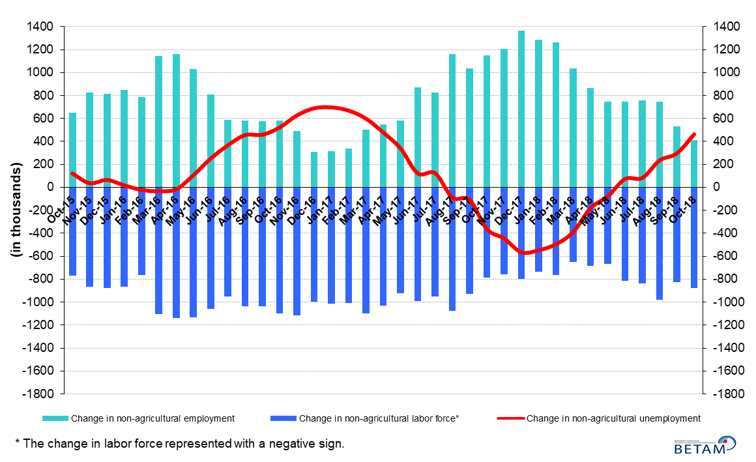
Source: Turkstat, Betam

The increase in non-agricultural male unemployment rate

Figure 5 shows seasonally adjusted non-agricultural unemployment rate for males (green) and for females (purple). In the period of October 2018, the non-agricultural female unemployment rate increasing by 0.4 percentage points reached 11.5 percent while non-agricultural female unemployment rate decreased by 0.1 percentage points to 17.7 percent. The male employment decreased by 45 thousand in October 2018 compared to September 2018. In the same period, an increase in female employment was recorded (Table 3). As female and male unemployment rates moved in opposite directions the gender gap in non-agricultural unemployment rates decreased from 6.7 to 6.2 percentage points in the period of October 2018.

Figure 5: Seasonally adjusted non-agricultural unemployment rate by gender
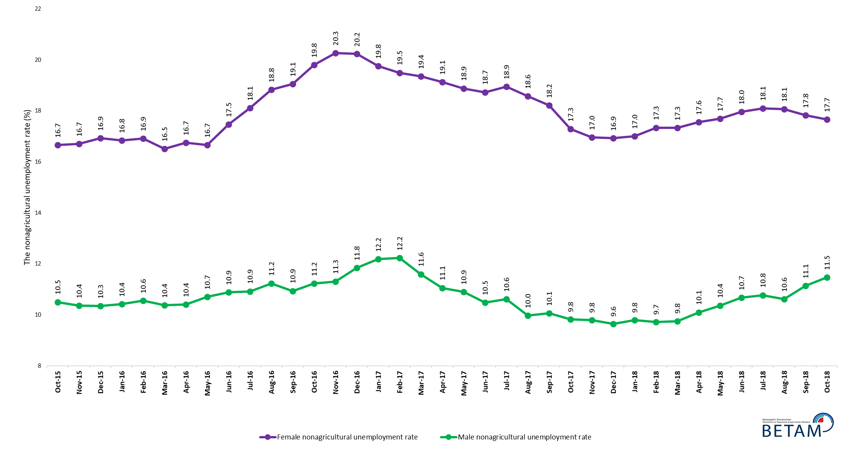
Source: Turkstat, Betam

Table 1 Seasonally adjusted non-agricultural labor market indicators (in thousands) *

 | Labor force | Employment | Unemployment | Unemployment rate | Monthly changes
September-15 | 24341 | 21347 | 2994 | 12.3% | Labor force | Employment | Unemployment
October-15 | 24413 | 21361 | 3052 | 12.5% | 72 | 14 | 58
November-15 | 24552 | 21532 | 3020 | 12.3% | 139 | 171 | -32
December-15 | 24626 | 21622 | 3004 | 12.2% | 75 | 90 | -15
January-16 | 24750 | 21755 | 2995 | 12.1% | 123 | 133 | -10
February-16 | 24857 | 21874 | 2983 | 12.0% | 107 | 119 | -12
March-16 | 24879 | 21943 | 2936 | 11.8% | 22 | 69 | -47
April-16 | 25026 | 22048 | 2978 | 11.9% | 147 | 105 | 42
May-16 | 25122 | 22032 | 3090 | 12.3% | 96 | -16 | 112
June-16 | 25110 | 21846 | 3264 | 13.0% | -12 | -186 | 174
July-16 | 25165 | 21843 | 3322 | 13.2% | 54 | -3 | 57
August-16 | 25145 | 21725 | 3420 | 13.6% | -20 | -118 | 98
September-16 | 25354 | 21931 | 3423 | 13.5% | 209 | 206 | 3
October-16 | 25509 | 21963 | 3546 | 13.9% | 155 | 32 | 123
November-16 | 25650 | 22033 | 3617 | 14.1% | 141 | 70 | 71
December-16 | 25603 | 21942 | 3661 | 14.3% | -46 | -91 | 45
January-17 | 25697 | 22074 | 3623 | 14.1% | 94 | 132 | -38
February-17 | 25820 | 22205 | 3615 | 14.0% | 122 | 131 | -9
March-17 | 25988 | 22428 | 3560 | 13.7% | 169 | 223 | -54
April-17 | 26036 | 22573 | 3463 | 13.3% | 47 | 145 | -98
May-17 | 26089 | 22619 | 3470 | 13.3% | 53 | 46 | 7
June-17 | 26114 | 22719 | 3395 | 13.0% | 25 | 100 | -75
July-17 | 26131 | 22682 | 3449 | 13.2% | 18 | -37 | 55
August-17 | 26205 | 22877 | 3328 | 12.7% | 74 | 195 | -121
September-17 | 26286 | 22974 | 3312 | 12.6% | 81 | 97 | -16
October-17 | 26305 | 23122 | 3183 | 12.1% | 19 | 148 | -129
November-17 | 26403 | 23235 | 3168 | 12.0% | 99 | 113 | -14
December-17 | 26433 | 23314 | 3119 | 11.8% | 30 | 79 | -49
January-18 | 26501 | 23374 | 3127 | 11.8% | 68 | 60 | 8
February-18 | 26610 | 23470 | 3140 | 11.8% | 109 | 96 | 13
March-18 | 26617 | 23450 | 3167 | 11.9% | 8 | -20 | 28
April-18 | 26716 | 23430 | 3286 | 12.3% | 99 | -20 | 119
May-18 | 26738 | 23369 | 3369 | 12.6% | 22 | -61 | 83
June-18 | 26914 | 23469 | 3445 | 12.8% | 176 | 100 | 76
July-18 | 26962 | 23457 | 3505 | 13.0% | 48 | -12 | 60
August-18 | 27204 | 23640 | 3564 | 13.1% | 242 | 183 | 59
September-18 | 27136 | 23527 | 3609 | 13.3% | -68 | -113 | 45
October-18 | 27229 | 23553 | 3676 | 13.5% | 93 | 26 | 67

Table 2 Seasonally adjusted employment by sectors (in thousands) *

 | Agriculture | Manufacturing | Construction | Service | Monthly changes
September-15 | 5518 | 5327 | 1946 | 14074 | Agriculture | Manufacturing | Construction | Service
October-15 | 5446 | 5363 | 1967 | 14031 | -72 | 36 | 21 | -43
November-15 | 5383 | 5353 | 1989 | 14190 | -63 | -10 | 22 | 159
December-15 | 5404 | 5311 | 1993 | 14318 | 21 | -42 | 4 | 128
January-16 | 5369 | 5300 | 1996 | 14459 | -35 | -11 | 3 | 141
February-16 | 5325 | 5276 | 1990 | 14608 | -44 | -24 | -6 | 149
March-16 | 5386 | 5295 | 2014 | 14634 | 61 | 19 | 24 | 26
April-16 | 5368 | 5381 | 2028 | 14638 | -18 | 86 | 14 | 4
May-16 | 5329 | 5386 | 2055 | 14591 | -39 | 5 | 27 | -47
June-16 | 5188 | 5330 | 1955 | 14561 | -141 | -56 | -100 | -30
July-16 | 5218 | 5254 | 1958 | 14631 | 30 | -76 | 3 | 70
August-16 | 5285 | 5224 | 1924 | 14577 | 67 | -30 | -34 | -54
September-16 | 5341 | 5260 | 2036 | 14634 | 56 | 36 | 112 | 57
October-16 | 5277 | 5282 | 2005 | 14675 | -64 | 22 | -31 | 41
November-16 | 5279 | 5316 | 2000 | 14717 | 2 | 34 | -5 | 42
December-16 | 5303 | 5265 | 1957 | 14719 | 24 | -51 | -43 | 2
January-17 | 5430 | 5274 | 1959 | 14840 | 127 | 9 | 2 | 121
February-17 | 5471 | 5251 | 2013 | 14941 | 41 | -23 | 54 | 101
March-17 | 5383 | 5346 | 2080 | 15002 | -88 | 95 | 67 | 61
April-17 | 5350 | 5372 | 2114 | 15088 | -33 | 26 | 34 | 86
May-17 | 5382 | 5386 | 2076 | 15157 | 32 | 14 | -38 | 69
June-17 | 5387 | 5383 | 2066 | 15269 | 5 | -3 | -10 | 112
July-17 | 5513 | 5363 | 2105 | 15214 | 126 | -20 | 39 | -55
August-17 | 5484 | 5437 | 2152 | 15288 | -29 | 74 | 47 | 74
September-17 | 5533 | 5421 | 2135 | 15418 | 49 | -16 | -17 | 130
October-17 | 5499 | 5470 | 2130 | 15522 | -34 | 49 | -5 | 104
November-17 | 5512 | 5470 | 2154 | 15611 | 13 | 0 | 24 | 89
December-17 | 5542 | 5514 | 2185 | 15615 | 30 | 44 | 31 | 4
January-18 | 5487 | 5567 | 2199 | 15608 | -55 | 53 | 14 | -7
February-18 | 5413 | 5627 | 2188 | 15655 | -74 | 60 | -11 | 47
March-18 | 5359 | 5618 | 2133 | 15699 | -54 | -9 | -55 | 44
April-18 | 5339 | 5650 | 2077 | 15703 | -20 | 32 | -56 | 4
May-18 | 5293 | 5669 | 2023 | 15678 | -46 | 19 | -54 | -25
June-18 | 5266 | 5737 | 2012 | 15721 | -27 | 68 | -11 | 43
July-18 | 5272 | 5703 | 1957 | 15797 | 6 | -34 | -55 | 76
August-18 | 5238 | 5730 | 1959 | 15951 | -34 | 27 | 2 | 154
September-18 | 5272 | 5698 | 1929 | 15901 | 34 | -32 | -30 | -50
October-18 | 5310 | 5696 | 1903 | 15954 | 38 | -2 | -26 | 53

Source: Turkstat, Betam

Table 3: Seasonally adjusted non-agricultural labor force by gender (thousands)
 | Female Labor Force | Female Employment | Female Unemployed | Male Labor Force | Male Employment | Male Unemployed | Change in female labor force | Change in female employment | Change in male labor force | Change in male employment
October-15 | 6772 | 5644 | 1128 | 17600 | 15752 | 1848
November-15 | 6871 | 5724 | 1147 | 17636 | 15810 | 1826 | 99 | 80 | 36 | 58
December-15 | 6964 | 5785 | 1179 | 17683 | 15853 | 1829 | 93 | 61 | 47 | 44
January-16 | 7009 | 5829 | 1180 | 17742 | 15893 | 1849 | 44 | 43 | 59 | 39
February-16 | 7050 | 5858 | 1192 | 17781 | 15903 | 1877 | 42 | 29 | 38 | 11
March-16 | 7064 | 5898 | 1166 | 17825 | 15976 | 1849 | 13 | 40 | 44 | 73
April-16 | 7148 | 5951 | 1197 | 17862 | 16004 | 1859 | 85 | 53 | 37 | 28
May-16 | 7180 | 5984 | 1196 | 17932 | 16012 | 1920 | 32 | 33 | 69 | 8
June-16 | 7262 | 5994 | 1268 | 17830 | 15890 | 1940 | 82 | 10 | -102 | -122
July-16 | 7276 | 5958 | 1317 | 17906 | 15950 | 1955 | 14 | -35 | 76 | 60
August-16 | 7315 | 5938 | 1377 | 17885 | 15876 | 2009 | 39 | -21 | -21 | -75
September-16 | 7381 | 5975 | 1406 | 17966 | 16002 | 1965 | 66 | 37 | 81 | 126
October-16 | 7433 | 5962 | 1471 | 18053 | 16027 | 2026 | 52 | -13 | 87 | 25
November-16 | 7455 | 5944 | 1511 | 18132 | 16081 | 2051 | 22 | -18 | 79 | 54
December-16 | 7453 | 5945 | 1508 | 18177 | 16025 | 2152 | -2 | 1 | 45 | -56
January-17 | 7448 | 5977 | 1471 | 18324 | 16091 | 2233 | -5 | 31 | 146 | 66
February-17 | 7516 | 6051 | 1465 | 18331 | 16089 | 2242 | 68 | 74 | 8 | -2
March-17 | 7619 | 6145 | 1475 | 18361 | 16233 | 2129 | 103 | 94 | 30 | 144
April-17 | 7605 | 6151 | 1454 | 18386 | 16354 | 2033 | -14 | 6 | 25 | 121
May-17 | 7656 | 6211 | 1445 | 18392 | 16388 | 2004 | 51 | 60 | 6 | 34
June-17 | 7670 | 6234 | 1436 | 18432 | 16500 | 1932 | 14 | 23 | 39 | 112
July-17 | 7686 | 6230 | 1456 | 18455 | 16497 | 1958 | 16 | -3 | 23 | -3
August-17 | 7721 | 6287 | 1434 | 18474 | 16632 | 1843 | 35 | 56 | 20 | 135
September-17 | 7771 | 6356 | 1415 | 18508 | 16646 | 1861 | 50 | 69 | 33 | 15
October-17 | 7783 | 6438 | 1345 | 18526 | 16706 | 1820 | 12 | 82 | 18 | 60
November-17 | 7824 | 6497 | 1327 | 18549 | 16732 | 1816 | 41 | 59 | 23 | 26
December-17 | 7883 | 6548 | 1335 | 18577 | 16785 | 1792 | 59 | 51 | 28 | 52
January-18 | 7920 | 6574 | 1347 | 18604 | 16783 | 1821 | 37 | 25 | 27 | -2
February-18 | 7959 | 6579 | 1380 | 18633 | 16823 | 1810 | 38 | 5 | 29 | 40
March-18 | 7954 | 6576 | 1379 | 18653 | 16833 | 1820 | -5 | -3 | 20 | 10
April-18 | 7990 | 6588 | 1402 | 18678 | 16792 | 1886 | 36 | 12 | 25 | -41
May-18 | 8026 | 6607 | 1419 | 18703 | 16764 | 1939 | 36 | 19 | 25 | -28
June-18 | 8074 | 6624 | 1450 | 18857 | 16845 | 2012 | 48 | 17 | 154 | 80
July-18 | 8092 | 6627 | 1465 | 18883 | 16849 | 2034 | 18 | 4 | 26 | 4
August-18 | 8200 | 6719 | 1481 | 18920 | 16911 | 2009 | 108 | 91 | 37 | 62
September-18 | 8171 | 6714 | 1457 | 18929 | 16821 | 2108 | -29 | -5 | 10 | -89
October-18 | 8264 | 6804 | 1460 | 18949 | 16776 | 2172 | 93 | 90 | 19 | -45

Source: Turkstat, Betam

* Prof. Seyfettin Gürsel, Betam, Director, seyfettin.gursel@eas.bau.edu.tr
** Assoc. Prof. Gökçe Uysal, Betam, Deputy Director, gokce.uysal@eas.bau.edu.tr ***Yazgı Genç, Betam, Research Assistant, yazgi.genc@eas.bau.edu.tr
For detailed information on Betam's forecasting model, please see Betam Research Brief 168 titled as "Kariyer.net Verisiyle Kısa Vadeli Tarım Dışı İşsizlik Tahmini" . For the innovations in the model please see Betam Research Brief 14 titled as "Mevsim Etkilerinden Arındırılmış İşsizlik Tahmini" Soybilgen, B., "Kariyer.net Verisiyle Kısa Vadeli Tarım Dışı İşsizlik Tahmini", Betam Research Brief 168. http://betam.bahcesehir.edu.tr/tr/2014/06/kariyer-net-verisiyle-kisa-vadeli-tarim-disi-issizlik-tahmini/ Soybilgen, B., "Mevsim Etkilerinden Arındırılmış İşsizlik Tahmini", Betam Research Brief 14 http://betam.bahcesehir.edu.tr/2015/08/mevsim-etkilerinden-arindirilmis-tarim-disi-issizlik-tahmini/
Betam has been calculating application per vacancy using series released by Kariyer.net for a while. Seasonal and calendar adjustment procedure is applied to application per vacancy series. A decrease in applications per vacancy may be caused by an increase in vacancies or by a decrease in the number of applications. An increase in vacancies signals economic growth while decreasing number of applications indicates a decrease in number of people looking for a job. Monthly labor market series released by TurkStat is the average of three months. Therefore, application per vacancy statistics calculated using Kariyer.net series is the average of three months as well.
Employment in each sector is seasonally adjusted separately. Hence the sum of these series may differ from the seasonally adjusted series of total employment. The difference stems from the non-linearity of the seasonal adjustment process.
Turkstat revised the labor market statistics drastically in February 2014. Within this framework, they back casted various labor market indicators and they also continued to announce seasonally adjusted series. However, Turkstat is not providing back-casted series by gender. Therefore, female and male labor market statistics are not sufficiently long for the seasonal adjustment procedures (There should be minimum 36 observations). With the announcement of the period of February 2017 data, the number of observations required for the seasonal decontamination process was provided. From this period Betam generated seasonal adjustment series in terms of gender. Nevertheless, it should not be forgotten that seasonal adjustment may cause extra volatility in the series for at least a while.

