Labor Market Outlook:
December 2018

17 December 2018

EMPLOYMENT LOSSES IN NON-AGRICULTURAL SECTORS

Seyfettin Gürsel*, Gokce Uysal∗∗ and Yazgi Genc ***

Executive Summary

Seasonally adjusted labor market data shows that in the period of September 2018, non-agricultural unemployment rate increased by 0.2 percentage points and reached 13.3 percent. In the period of September 2018, there is a strong decrease in non-agricultural employment, but due to a concurrent decrease in non-agricultural labor force, the increase in the non-agricultural unemployment rate was limited to 0.2 percentage points. In the period of September 2018, employment losses were recorded in all non-agricultural sectors. Employment decreased by 32 thousand in manufacturing, 29 thousand in construction and 50 thousand in services. While non-agricultural male unemployment rate rose by 0.6 percentage points, non-agricultural female unemployment rate decreased by 0.2 percentage points in September 2018. Betam’s forecasting model predicts that the non-agricultural unemployment will increase to 13.4 percent in the period of October 2018.

The strong decrease in non-agricultural employment

According to seasonally adjusted labor market data, in the period of September 2018 compared to August 2018, the number of employed in non-agricultural sectors decreased by 112 thousand down to 23 million 534 thousand (Figure 1, Table 1). Note that the decline in non-agricultural employment is almost is similar in size to the decline in the periods of June-July-August 2016. In the period of September, non-agricultural labor force decreased by 66 thousand to 27 million 144 thousand. In Turkey there is an increasing trend in the labor force given that the population is young. In contrast to this general trend, there is a substantial fall in labor force (66 thousand). As a result, the increase in the number of unemployed in non-agricultural sectors was limited to 46 thousand and the number of unemployed reached 3 million 610 thousand and the non-agricultural unemployment rate increased to 13.3 percent.

Figure 1 Seasonally adjusted non-agricultural labor force, employment, and unemployment

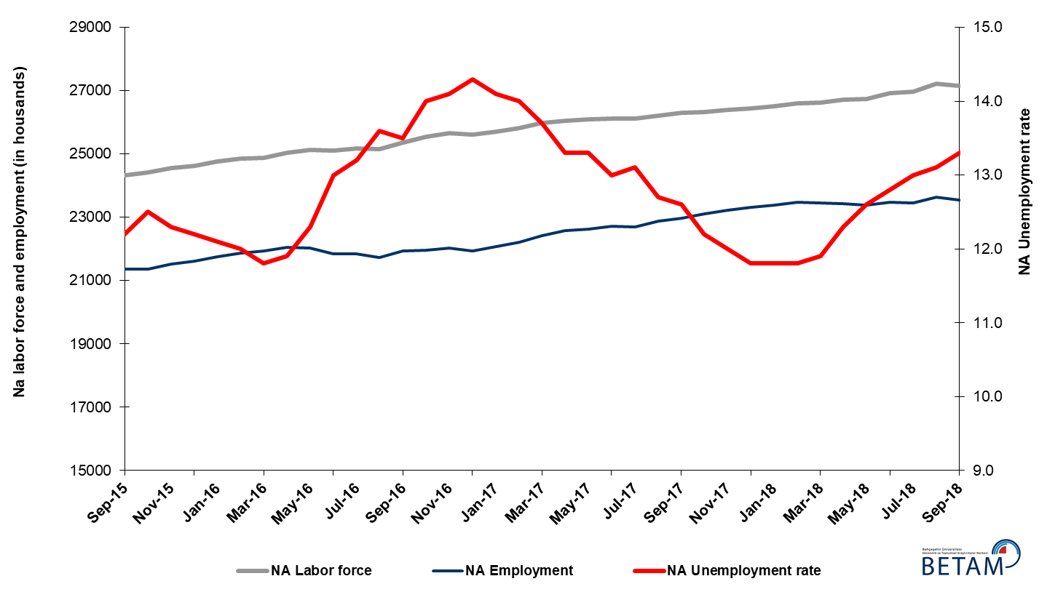
Source: Turkstat, Betam

Unemployment rate is expected to increase by 0.1 percentage points in the period of October 2018

Betam's forecasting model had predicted that the seasonally adjusted non-agricultural unemployment rate would increase by 0.2 percentage points to 13.2 percent in September 2018. TURKSTAT revised the unemployment rate of August 2018 from 13.0 percent to 13.1 percent. The non-agricultural unemployment rate increased by 0.2 percentage points, as forecasted, and reached to 13.3 percent in the period of September 2017. Betam’s forecasting model predicts that the non-agricultural unemployment rate will reach 13.4 percent in the period of October 2018. Forecasting model details are available on Betam's website. Kariyer.net application per vacancy series used in the Betam forecasting model is depicted in Figure 3. Kariyer.net series is only one of the inputs of Betam forecast model. Indeed, several variables such as employment agency (İŞKUR) data, reel sector confidence index, capacity utilization rate are used in forecasting.

Figure 2 Seasonally adjusted non-agricultural unemployment rate and application per vacancy
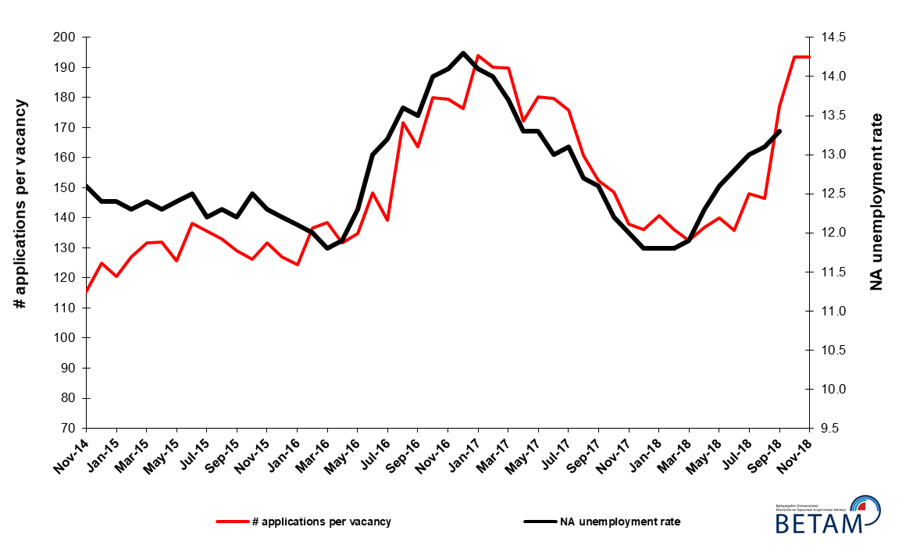
Source: Kariyer.net, Turkstat, Betam

Employment losses in non-agricultural sectors

According to seasonally adjusted sectoral labor market data, employment increased in agriculture while it decreased in all of the non-agricultural sectors in September 2018 compared to August 2018 (Figure 3, Table 2). The employment decreased by 50 thousand in services, 32 thousand in manufacturing and 29 thousand in construction. Note that employment losses in construction recorded since the period of February 2018 reached 200 thousand. It is remarkable that the strong increase in services in the period of August 2018 (154 thousand) was replaced by a decrease in the period of September 2018 (Table 2).

Figure 3: Employment by sectors (in thousand)

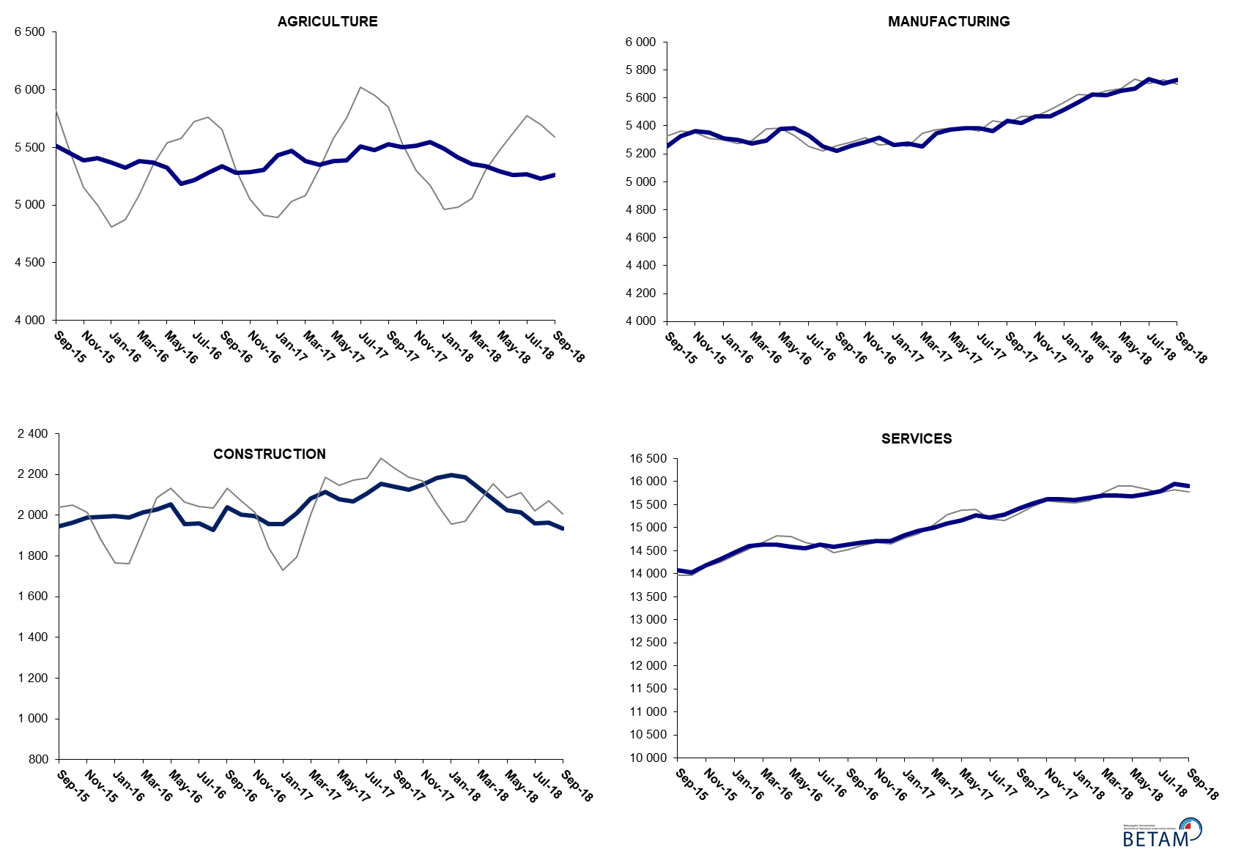

Source: TURKSTAT, Betam

The number of non-agricultural unemployed within a year increased

From September 2017 to September 2018 non-agricultural labor force increased by 827 thousand (3.1 percent) and non-agricultural employment increased by 531 thousand (2.3 percent) (Figure 4). Thus, non-agricultural unemployed decreased by 296 thousand and reached 3 million 664 thousand.

Figure 4 Year-on-year changes in non-agricultural labor force, employment, and unemployment
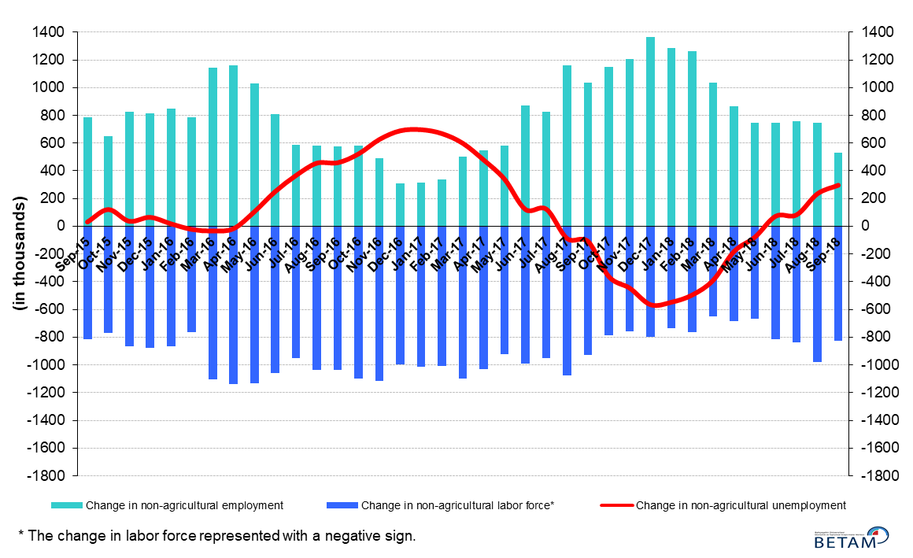
Source: Turkstat, Betam

The strong increase in the male unemployment rate

Figure 5 shows seasonally adjusted non-agricultural unemployment rate for males (green) and for females (purple). In the period of September 2018, non-agricultural female unemployment rate decreased by 0.2 percentage points to 17.9 percent while the non-agricultural male unemployment rate increased by 0.6 percentage points to 11.0 percent. The male employment decreased by 105 thousand in September 2018 compared to August 2018. In the same period, employment losses in females were limited to 6 thousand while female labor force decreased by 31 thousand. Parallel to the increase in male unemployment rate and the decrease in female unemployment rate, the gender gap in non-agricultural unemployment rates decreased from 7.8 to 6.9 percentage points in the period of September 2018.

Figure 5: Seasonally adjusted non-agricultural unemployment rate by gender
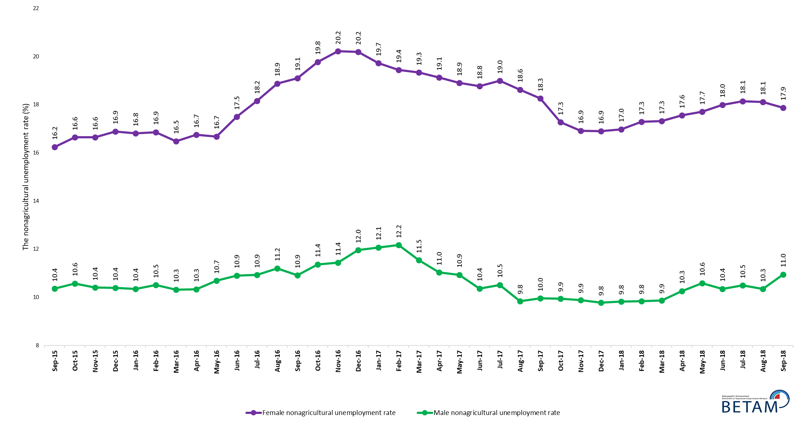
Source: Turkstat, Betam

Table 1 Seasonally adjusted non-agricultural labor market indicators (in thousands) *

 | Labor force | Employment | Unemployment | Unemployment rate | Monthly changes
August-15 | 24107 | 21142 | 2965 | 12.3% | Labor force | Employment | Unemployment
September-15 | 24315 | 21349 | 2966 | 12.2% | 208 | 207 | 1
October-15 | 24411 | 21360 | 3051 | 12.5% | 96 | 11 | 85
November-15 | 24551 | 21531 | 3020 | 12.3% | 139 | 171 | -32
December-15 | 24625 | 21621 | 3004 | 12.2% | 75 | 90 | -15
January-16 | 24750 | 21755 | 2995 | 12.1% | 124 | 134 | -10
February-16 | 24857 | 21874 | 2983 | 12.0% | 107 | 119 | -12
March-16 | 24879 | 21943 | 2936 | 11.8% | 22 | 69 | -47
April-16 | 25025 | 22047 | 2978 | 11.9% | 146 | 104 | 42
May-16 | 25123 | 22033 | 3090 | 12.3% | 98 | -14 | 112
June-16 | 25111 | 21847 | 3264 | 13.0% | -12 | -186 | 174
July-16 | 25167 | 21845 | 3322 | 13.2% | 56 | -2 | 58
August-16 | 25147 | 21727 | 3420 | 13.6% | -20 | -118 | 98
September-16 | 25356 | 21933 | 3423 | 13.5% | 209 | 206 | 3
October-16 | 25535 | 21960 | 3575 | 14.0% | 179 | 27 | 152
November-16 | 25646 | 22030 | 3616 | 14.1% | 111 | 70 | 41
December-16 | 25601 | 21940 | 3661 | 14.3% | -45 | -90 | 45
January-17 | 25695 | 22072 | 3623 | 14.1% | 94 | 132 | -38
February-17 | 25819 | 22204 | 3615 | 14.0% | 124 | 132 | -8
March-17 | 25988 | 22428 | 3560 | 13.7% | 170 | 224 | -54
April-17 | 26038 | 22575 | 3463 | 13.3% | 50 | 147 | -97
May-17 | 26091 | 22621 | 3470 | 13.3% | 53 | 46 | 7
June-17 | 26115 | 22720 | 3395 | 13.0% | 24 | 99 | -75
July-17 | 26105 | 22685 | 3420 | 13.1% | -10 | -35 | 25
August-17 | 26208 | 22880 | 3328 | 12.7% | 104 | 195 | -91
September-17 | 26292 | 22979 | 3313 | 12.6% | 83 | 99 | -16
October-17 | 26328 | 23116 | 3212 | 12.2% | 36 | 137 | -101
November-17 | 26398 | 23230 | 3168 | 12.0% | 70 | 114 | -44
December-17 | 26430 | 23311 | 3119 | 11.8% | 32 | 81 | -49
January-18 | 26499 | 23372 | 3127 | 11.8% | 69 | 61 | 8
February-18 | 26608 | 23468 | 3140 | 11.8% | 109 | 96 | 13
March-18 | 26619 | 23451 | 3168 | 11.9% | 11 | -17 | 28
April-18 | 26717 | 23431 | 3286 | 12.3% | 99 | -20 | 119
May-18 | 26741 | 23372 | 3369 | 12.6% | 24 | -59 | 83
June-18 | 26919 | 23473 | 3446 | 12.8% | 177 | 101 | 76
July-18 | 26967 | 23461 | 3506 | 13.0% | 48 | -12 | 60
August-18 | 27211 | 23646 | 3565 | 13.1% | 244 | 185 | 59
September-18 | 27144 | 23534 | 3610 | 13.3% | -66 | -112 | 46

Source: Turkstat, Betam

Table 2 Seasonally adjusted employment by sectors (in thousands) *

 | Agriculture | Manufacturing | Construction | Service | Monthly changes
August-15 | 5541 | 5252 | 1922 | 13968 | Agriculture | Manufacturing | Construction | Service
September-15 | 5515 | 5327 | 1947 | 14075 | -26 | 75 | 25 | 107
October-15 | 5449 | 5363 | 1965 | 14031 | -66 | 36 | 18 | -44
November-15 | 5386 | 5353 | 1988 | 14190 | -63 | -10 | 23 | 159
December-15 | 5406 | 5311 | 1992 | 14318 | 20 | -42 | 4 | 128
January-16 | 5370 | 5300 | 1995 | 14459 | -36 | -11 | 3 | 141
February-16 | 5325 | 5276 | 1990 | 14608 | -45 | -24 | -5 | 149
March-16 | 5385 | 5295 | 2015 | 14634 | 60 | 19 | 25 | 26
April-16 | 5368 | 5381 | 2029 | 14638 | -17 | 86 | 14 | 4
May-16 | 5328 | 5386 | 2055 | 14592 | -40 | 5 | 26 | -46
June-16 | 5188 | 5330 | 1956 | 14561 | -140 | -56 | -99 | -31
July-16 | 5216 | 5254 | 1960 | 14631 | 28 | -76 | 4 | 70
August-16 | 5282 | 5224 | 1926 | 14578 | 66 | -30 | -34 | -53
September-16 | 5337 | 5260 | 2039 | 14635 | 55 | 36 | 113 | 57
October-16 | 5281 | 5282 | 2002 | 14675 | -56 | 22 | -37 | 40
November-16 | 5284 | 5316 | 1997 | 14716 | 3 | 34 | -5 | 41
December-16 | 5306 | 5265 | 1956 | 14719 | 22 | -51 | -41 | 3
January-17 | 5431 | 5274 | 1958 | 14840 | 125 | 9 | 2 | 121
February-17 | 5471 | 5251 | 2012 | 14941 | 40 | -23 | 54 | 101
March-17 | 5383 | 5346 | 2081 | 15002 | -88 | 95 | 69 | 61
April-17 | 5349 | 5372 | 2114 | 15088 | -34 | 26 | 33 | 86
May-17 | 5381 | 5386 | 2077 | 15158 | 32 | 14 | -37 | 70
June-17 | 5387 | 5383 | 2067 | 15270 | 6 | -3 | -10 | 112
July-17 | 5509 | 5363 | 2108 | 15214 | 122 | -20 | 41 | -56
August-17 | 5480 | 5437 | 2155 | 15288 | -29 | 74 | 47 | 74
September-17 | 5526 | 5421 | 2140 | 15418 | 46 | -16 | -15 | 130
October-17 | 5504 | 5470 | 2124 | 15522 | -22 | 49 | -16 | 104
November-17 | 5518 | 5470 | 2150 | 15610 | 14 | 0 | 26 | 88
December-17 | 5545 | 5514 | 2182 | 15615 | 27 | 44 | 32 | 5
January-18 | 5488 | 5567 | 2197 | 15608 | -57 | 53 | 15 | -7
February-18 | 5414 | 5627 | 2187 | 15655 | -74 | 60 | -10 | 47
March-18 | 5359 | 5618 | 2134 | 15699 | -55 | -9 | -53 | 44
April-18 | 5339 | 5650 | 2078 | 15703 | -20 | 32 | -56 | 4
May-18 | 5292 | 5669 | 2024 | 15678 | -47 | 19 | -54 | -25
June-18 | 5264 | 5737 | 2014 | 15721 | -28 | 68 | -10 | 43
July-18 | 5267 | 5703 | 1961 | 15797 | 3 | -34 | -53 | 76
August-18 | 5232 | 5730 | 1964 | 15951 | -35 | 27 | 3 | 154
September-18 | 5263 | 5698 | 1935 | 15901 | 31 | -32 | -29 | -50

Source: Turkstat, Betam

Table 3: Seasonally adjusted non-agricultural labor force by gender (thousands)

 | Female Labor Force | Female Employment | Female Unemployed | Male Labor Force | Male Employment | Male Unemployed | Change in female labor force | Change in female employment | Change in male labor force | Change in male employment
September-15 | 6760 | 5662 | 1098 | 17561 | 15742 | 1819
October-15 | 6779 | 5651 | 1128 | 17607 | 15745 | 1862 | 20 | -10 | 46 | 2
November-15 | 6875 | 5731 | 1144 | 17642 | 15806 | 1836 | 95 | 79 | 34 | 61
December-15 | 6967 | 5791 | 1177 | 17689 | 15852 | 1838 | 93 | 60 | 48 | 46
January-16 | 7011 | 5832 | 1178 | 17729 | 15894 | 1835 | 43 | 42 | 40 | 42
February-16 | 7048 | 5860 | 1188 | 17773 | 15906 | 1867 | 37 | 27 | 43 | 12
March-16 | 7062 | 5898 | 1164 | 17819 | 15980 | 1839 | 15 | 38 | 46 | 74
April-16 | 7147 | 5950 | 1197 | 17858 | 16012 | 1846 | 85 | 52 | 39 | 32
May-16 | 7179 | 5982 | 1197 | 17937 | 16020 | 1917 | 32 | 31 | 78 | 8
June-16 | 7261 | 5990 | 1271 | 17835 | 15890 | 1945 | 82 | 9 | -101 | -129
July-16 | 7274 | 5954 | 1320 | 17912 | 15954 | 1958 | 13 | -37 | 77 | 64
August-16 | 7312 | 5932 | 1380 | 17878 | 15875 | 2003 | 38 | -22 | -34 | -79
September-16 | 7377 | 5968 | 1409 | 17971 | 16011 | 1961 | 65 | 36 | 93 | 136
October-16 | 7440 | 5969 | 1471 | 18065 | 16011 | 2054 | 64 | 2 | 94 | 1
November-16 | 7458 | 5951 | 1508 | 18151 | 16074 | 2077 | 18 | -19 | 86 | 63
December-16 | 7456 | 5951 | 1506 | 18189 | 16013 | 2176 | -2 | 0 | 38 | -61
January-17 | 7450 | 5980 | 1469 | 18288 | 16080 | 2208 | -6 | 30 | 98 | 67
February-17 | 7513 | 6053 | 1460 | 18305 | 16077 | 2228 | 63 | 72 | 17 | -3
March-17 | 7618 | 6145 | 1473 | 18354 | 16235 | 2119 | 105 | 92 | 48 | 158
April-17 | 7605 | 6150 | 1454 | 18390 | 16362 | 2028 | -13 | 5 | 36 | 127
May-17 | 7656 | 6209 | 1447 | 18404 | 16391 | 2013 | 51 | 58 | 14 | 29
June-17 | 7670 | 6230 | 1439 | 18420 | 16511 | 1910 | 14 | 22 | 16 | 119
July-17 | 7685 | 6226 | 1459 | 18448 | 16507 | 1940 | 15 | -5 | 27 | -3
August-17 | 7718 | 6281 | 1437 | 18471 | 16654 | 1818 | 33 | 55 | 24 | 146
September-17 | 7767 | 6349 | 1418 | 18508 | 16665 | 1843 | 49 | 68 | 37 | 12
October-17 | 7790 | 6445 | 1345 | 18521 | 16680 | 1841 | 23 | 97 | 12 | 15
November-17 | 7827 | 6504 | 1323 | 18556 | 16722 | 1834 | 37 | 58 | 35 | 42
December-17 | 7886 | 6554 | 1332 | 18590 | 16772 | 1818 | 59 | 50 | 35 | 50
January-18 | 7922 | 6577 | 1345 | 18598 | 16771 | 1827 | 37 | 24 | 8 | -1
February-18 | 7956 | 6581 | 1376 | 18646 | 16812 | 1834 | 34 | 3 | 48 | 41
March-18 | 7953 | 6576 | 1377 | 18679 | 16837 | 1842 | -4 | -5 | 33 | 25
April-18 | 7990 | 6587 | 1402 | 18718 | 16797 | 1921 | 37 | 11 | 39 | -40
May-18 | 8026 | 6605 | 1421 | 18747 | 16761 | 1986 | 36 | 17 | 29 | -36
June-18 | 8073 | 6620 | 1453 | 18810 | 16862 | 1947 | 47 | 16 | 63 | 101
July-18 | 8091 | 6623 | 1468 | 18846 | 16867 | 1979 | 18 | 2 | 36 | 5
August-18 | 8197 | 6713 | 1484 | 18907 | 16951 | 1956 | 106 | 90 | 61 | 84
September-18 | 8166 | 6707 | 1460 | 18918 | 16846 | 2072 | -31 | -6 | 11 | -105

Source: Turkstat, Betam

* Prof. Seyfettin Gürsel, Betam, Director, seyfettin.gursel@eas.bau.edu.tr
** Assoc. Prof. Gökçe Uysal, Betam, Deputy Director, gokce.uysal@eas.bau.edu.tr ***Yazgı Genç, Betam, Research Assistant, yazgi.genc@eas.bau.edu.tr
For detailed information on Betam's forecasting model, please see Betam Research Brief 168 titled as "Kariyer.net Verisiyle Kısa Vadeli Tarım Dışı İşsizlik Tahmini" . For the innovations in the model please see Betam Research Brief 14 titled as "Mevsim Etkilerinden Arındırılmış İşsizlik Tahmini" Soybilgen, B., "Kariyer.net Verisiyle Kısa Vadeli Tarım Dışı İşsizlik Tahmini", Betam Research Brief 168. http://betam.bahcesehir.edu.tr/tr/2014/06/kariyer-net-verisiyle-kisa-vadeli-tarim-disi-issizlik-tahmini/ Soybilgen, B., "Mevsim Etkilerinden Arındırılmış İşsizlik Tahmini", Betam Research Brief 14 http://betam.bahcesehir.edu.tr/2015/08/mevsim-etkilerinden-arindirilmis-tarim-disi-issizlik-tahmini/
Betam has been calculating application per vacancy using series released by Kariyer.net for a while. Seasonal and calendar adjustment procedure is applied to application per vacancy series. A decrease in applications per vacancy may be caused by an increase in vacancies or by a decrease in the number of applications. An increase in vacancies signals economic growth while decreasing number of applications indicates a decrease in number of people looking for a job. Monthly labor market series released by TurkStat is the average of three months. Therefore, application per vacancy statistics calculated using Kariyer.net series is the average of three months as well.
Employment in each sector is seasonally adjusted separately. Hence the sum of these series may differ from the seasonally adjusted series of total employment. The difference stems from the non-linearity of the seasonal adjustment process.
Turkstat revised the labor market statistics drastically in February 2014. Within this framework, they back casted various labor market indicators and they also continued to announce seasonally adjusted series. However, Turkstat is not providing back-casted series by gender. Therefore, female and male labor market statistics are not sufficiently long for the seasonal adjustment procedures (There should be minimum 36 observations). With the announcement of the period of February 2017 data, the number of observations required for the seasonal decontamination process was provided. From this period Betam generated seasonal adjustment series in terms of gender. Nevertheless, it should not be forgotten that seasonal adjustment may cause extra volatility in the series for at least a while.

