Labor Market Outlook:
November 2018

15 November 2018

NO INCREASES IN UNEMPLOYMENT

Seyfettin Gürsel*, Gokce Uysal∗∗ and Furkan Kavuncu ***

Executive Summary

Seasonally adjusted labor market data shows that in the period of August 2018, non-agricultural unemployment rate remained constant at 13.0 percent. Even though there is a strong increase in non-agricultural labor force, due to a parallel increase in non-agricultural employment, non-agricultural unemployment rate remained constant. In the period of August 2018, the increase in non-agricultural employment stems from an increase in the service sector. Employment increased by 27 thousand in manufacturing, 4 thousand in construction where employment losses were recorded since February 2018, and 156 thousand in services. Even though the non-agricultural unemployment rate did not raise, the gender gap in non-agricultural unemployment has widened in this period. While non-agricultural male unemployment rate decreased by 0.1 percentage points, non-agricultural female unemployment rate rose by 0.6 percentage points. Betam’s forecasting model predicts that the non-agricultural unemployment will increase to 13.2 percent in the period of September 2018.

The strong increase in non-agricultural employment

According to seasonally adjusted labor market data, in the period of August 2018 compared to July 2018, the non-agricultural labor force increased by 215 thousand and reached 27 million 206 thousand and also the number of employed in non-agricultural sectors decreased by 187 thousand and reached 23 million 669 thousand (Figure 1, Table 1). As a result, the number of unemployed in non-agricultural sectors increased by 28 thousand and was recorded as 3 million 537 thousand. Thus, the non-agricultural unemployment remained constant at 13.0 percent. The increase in non-agricultural labor force which had slowed down in July 2018, re-accelerated in August 2018 and is accompanied by an increase in non-agricultural employment.

Figure 1 Seasonally adjusted non-agricultural labor force, employment, and unemployment

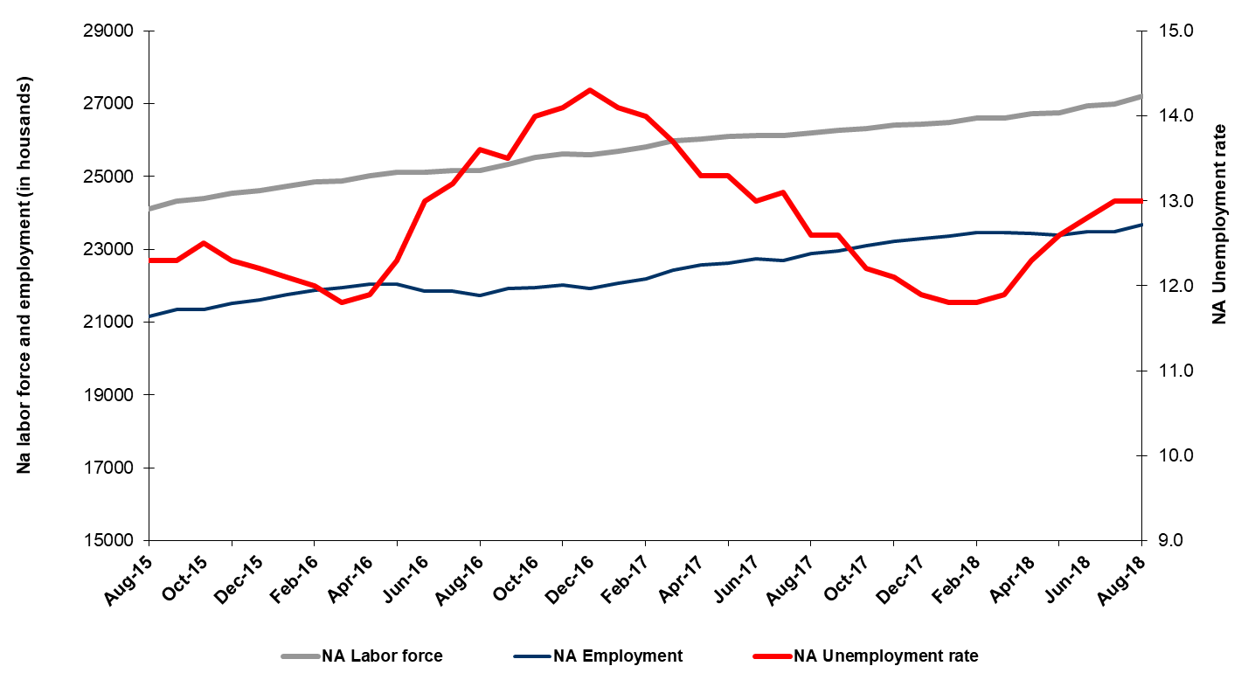
Source: Turkstat, Betam

Unemployment rate is expected to increase by 0.2 percentage points in the period of September 2018

Betam's forecasting model had predicted that the seasonally adjusted non-agricultural unemployment rate would increase by 0.2 percentage points to 13.2 percent in August 2018. The non-agricultural unemployment remained constant at 13.0 in the period of August 2018. Betam’s forecasting model predicts that the non-agricultural unemployment rate will reach 13.2 percent in the period of September 2018. Forecasting model details are available on Betam's website. Kariyer.net application per vacancy series used in the Betam forecasting model is depicted in Figure 3. Kariyer.net series is only one of the inputs of Betam forecast model. Indeed, several variables such as employment agency (İŞKUR) data, reel sector confidence index, capacity utilization rate are used in forecasting.

Figure 2 Seasonally adjusted non-agricultural unemployment rate and application per vacancy
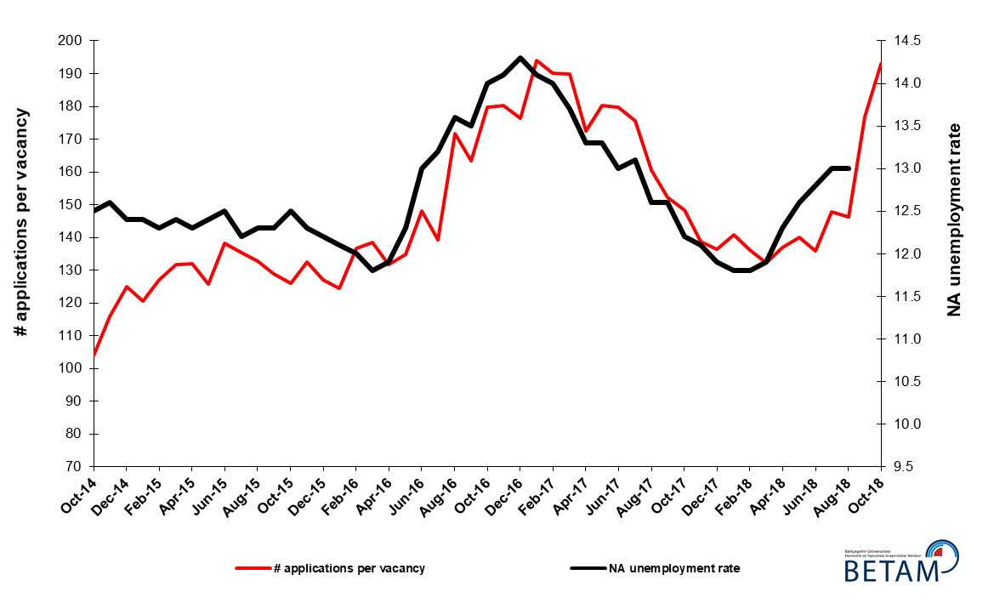
Source: Kariyer.net, Turkstat, Betam

Strong increase in services employment

According to seasonally adjusted sectoral labor market data, employment decreased in agriculture while it increased in all the non-agricultural sectors in August 2018 compared to July 2018 (Figure 3, Table 2). The employment decreased by 36 thousand in agriculture and increased by 156 thousand in services, 27 thousand in manufacturing and 4 thousand in construction. Note that the losses in construction recorded since the period of February 2018 are replaced by an increase for the first time (Table 2). The most substantial contribution to the increase in employment comes from services.

Figure 3: Employment by sectors (in thousand)

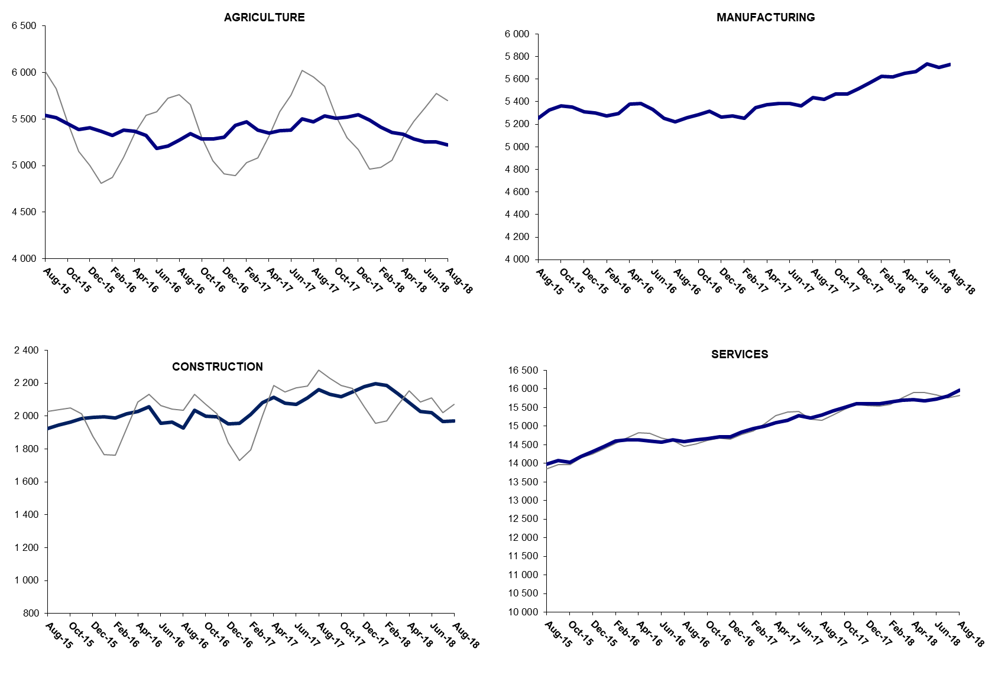

Source: TURKSTAT, Betam

The number of non-agricultural unemployed within a year increased

From August 2017 to August 2018 non-agricultural labor force increased by 979 thousand (3.7 percent) and non-agricultural employment increased by 745 thousand (3.3 percent) (Figure 4). Thus, non-agricultural unemployed decreased by 234 thousand and reached 3 million 592 thousand.

Figure 4 Year-on-year changes in non-agricultural labor force, employment, and unemployment
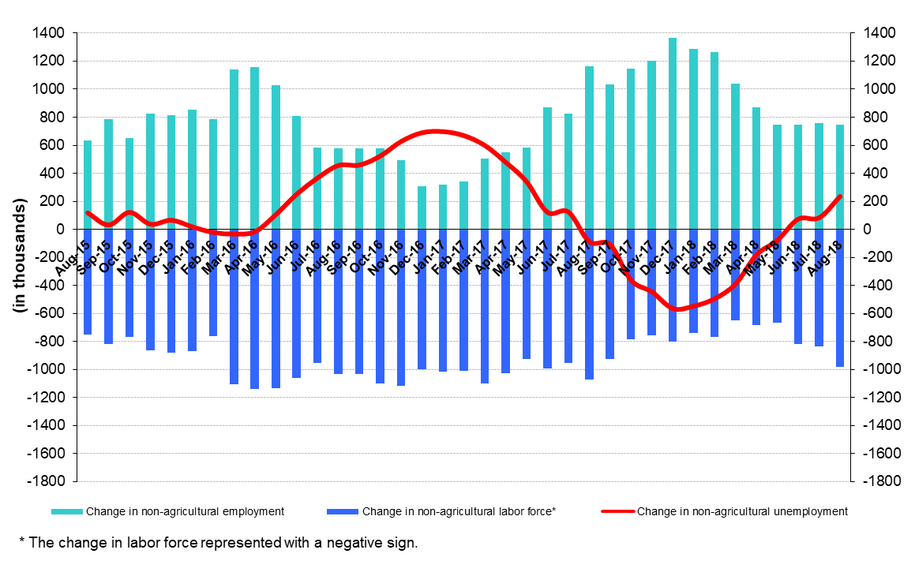
Source: Turkstat, Betam

The gender gap in non-agricultural unemployment rate increased

Figure 5 shows seasonally adjusted non-agricultural unemployment rate for males (green) and for females (purple). In the period of August 2018, the non-agricultural female unemployment rate increased by 0.6 percentage points to 18.5 percent while non-agricultural male unemployment rate decreased by 0.1 percentage points to 10.4 percent. In other words, even though the non-agricultural unemployment rate remained unchanged; male unemployment decreased whereas female unemployment substantially increased. The gender gap in non-agricultural unemployment rates rose from 7.4 to 8.1 percentage points in the period of August 2018.

Figure 5: Seasonally adjusted non-agricultural unemployment rate by gender
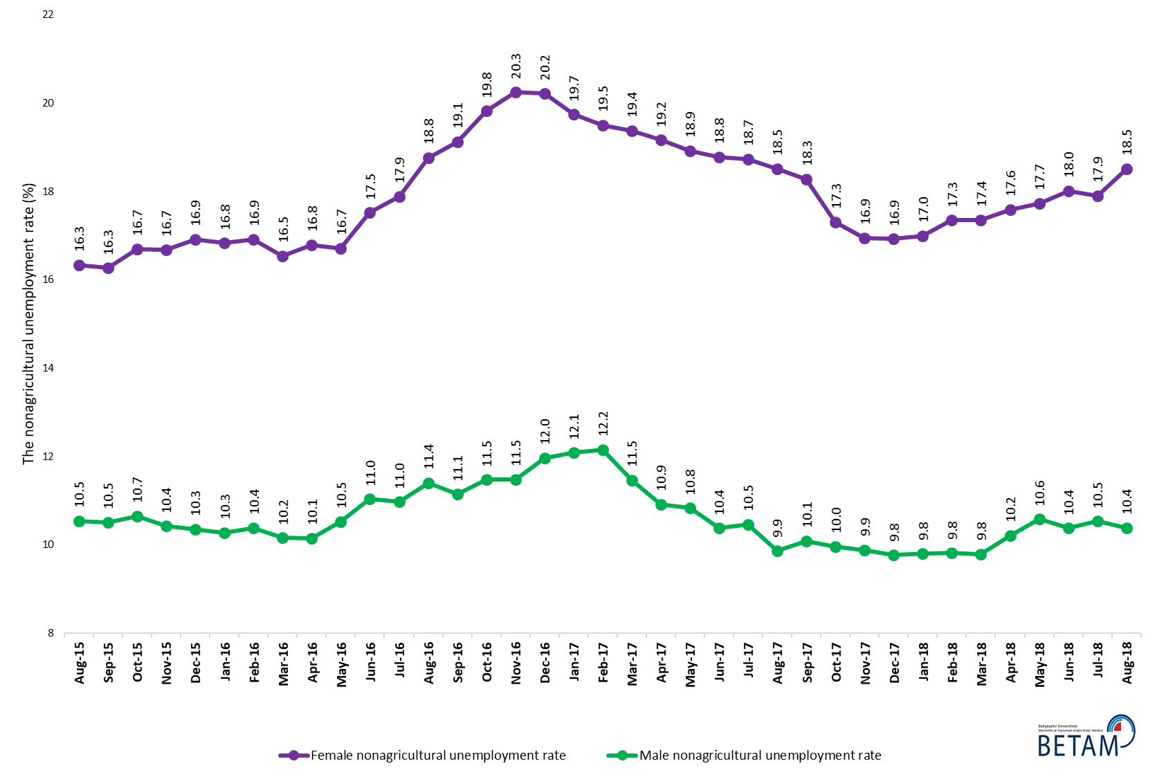
Source: Turkstat, Betam

Table 1 Seasonally adjusted non-agricultural labor market indicators (in thousands) *

 | Labor force | Employment | Unemployment | Unemployment rate (%) | Monthly changes
July-15 | 24211 | 21257 | 2954 | 12.2 | Labor force | Employment | Unemployment
August-15 | 24117 | 21151 | 2966 | 12.3 | -93 | -106 | 13
September-15 | 24335 | 21342 | 2993 | 12.3 | 218 | 191 | 27
October-15 | 24405 | 21354 | 3051 | 12.5 | 69 | 12 | 57
November-15 | 24544 | 21525 | 3019 | 12.3 | 139 | 171 | -32
December-15 | 24621 | 21617 | 3004 | 12.2 | 77 | 92 | -15
January-16 | 24745 | 21751 | 2994 | 12.1 | 124 | 134 | -10
February-16 | 24853 | 21871 | 2982 | 12.0 | 108 | 120 | -12
March-16 | 24879 | 21943 | 2936 | 11.8 | 25 | 72 | -47
April-16 | 25027 | 22049 | 2978 | 11.9 | 149 | 106 | 43
May-16 | 25129 | 22038 | 3091 | 12.3 | 102 | -11 | 113
June-16 | 25120 | 21854 | 3266 | 13.0 | -9 | -184 | 175
July-16 | 25179 | 21855 | 3324 | 13.2 | 59 | 1 | 58
August-16 | 25162 | 21740 | 3422 | 13.6 | -17 | -115 | 98
September-16 | 25345 | 21923 | 3422 | 13.5 | 182 | 183 | -1
October-16 | 25524 | 21951 | 3573 | 14.0 | 180 | 28 | 152
November-16 | 25636 | 22021 | 3615 | 14.1 | 111 | 70 | 41
December-16 | 25594 | 21934 | 3660 | 14.3 | -42 | -87 | 45
January-17 | 25690 | 22068 | 3622 | 14.1 | 96 | 134 | -38
February-17 | 25815 | 22201 | 3614 | 14.0 | 125 | 133 | -8
March-17 | 25990 | 22429 | 3561 | 13.7 | 174 | 228 | -54
April-17 | 26040 | 22577 | 3463 | 13.3 | 51 | 148 | -97
May-17 | 26099 | 22628 | 3471 | 13.3 | 59 | 51 | 8
June-17 | 26128 | 22731 | 3397 | 13.0 | 28 | 103 | -75
July-17 | 26121 | 22699 | 3422 | 13.1 | -7 | -32 | 25
August-17 | 26199 | 22898 | 3301 | 12.6 | 78 | 199 | -121
September-17 | 26272 | 22962 | 3310 | 12.6 | 73 | 64 | 9
October-17 | 26311 | 23101 | 3210 | 12.2 | 39 | 139 | -100
November-17 | 26413 | 23217 | 3196 | 12.1 | 102 | 116 | -14
December-17 | 26449 | 23302 | 3147 | 11.9 | 37 | 85 | -48
January-18 | 26492 | 23366 | 3126 | 11.8 | 43 | 64 | -21
February-18 | 26605 | 23466 | 3139 | 11.8 | 113 | 100 | 13
March-18 | 26620 | 23452 | 3168 | 11.9 | 14 | -14 | 28
April-18 | 26723 | 23436 | 3287 | 12.3 | 103 | -16 | 119
May-18 | 26754 | 23383 | 3371 | 12.6 | 31 | -53 | 84
June-18 | 26936 | 23488 | 3448 | 12.8 | 182 | 105 | 77
July-18 | 26991 | 23482 | 3509 | 13.0 | 55 | -6 | 61
August-18 | 27206 | 23669 | 3537 | 13.0 | 215 | 187 | 28

Source: Turkstat, Betam

Table 2 Seasonally adjusted employment by sectors (in thousands) *

 | Agriculture | Manufacturing | Construction | Service | Monthly changes
July-15 | 5504 | 5336 | 1929 | 13992 | Agriculture | Manufacturing | Construction | Service
August-15 | 5538 | 5252 | 1924 | 13976 | 34 | -84 | -5 | -16
September-15 | 5518 | 5327 | 1945 | 14070 | -20 | 75 | 21 | 94
October-15 | 5452 | 5363 | 1964 | 14028 | -66 | 36 | 19 | -42
November-15 | 5388 | 5353 | 1986 | 14186 | -64 | -10 | 22 | 158
December-15 | 5408 | 5311 | 1991 | 14315 | 20 | -42 | 5 | 129
January-16 | 5372 | 5300 | 1995 | 14456 | -36 | -11 | 4 | 141
February-16 | 5326 | 5276 | 1990 | 14605 | -46 | -24 | -5 | 149
March-16 | 5385 | 5295 | 2015 | 14633 | 59 | 19 | 25 | 28
April-16 | 5367 | 5381 | 2029 | 14638 | -18 | 86 | 14 | 5
May-16 | 5326 | 5386 | 2056 | 14595 | -41 | 5 | 27 | -43
June-16 | 5184 | 5330 | 1958 | 14567 | -142 | -56 | -98 | -28
July-16 | 5211 | 5254 | 1963 | 14638 | 27 | -76 | 5 | 71
August-16 | 5277 | 5224 | 1929 | 14587 | 66 | -30 | -34 | -51
September-16 | 5341 | 5260 | 2035 | 14628 | 64 | 36 | 106 | 41
October-16 | 5285 | 5282 | 1999 | 14669 | -56 | 22 | -36 | 41
November-16 | 5287 | 5316 | 1995 | 14710 | 2 | 34 | -4 | 41
December-16 | 5309 | 5265 | 1954 | 14715 | 22 | -51 | -41 | 5
January-17 | 5433 | 5274 | 1957 | 14837 | 124 | 9 | 3 | 122
February-17 | 5473 | 5251 | 2012 | 14938 | 40 | -23 | 55 | 101
March-17 | 5382 | 5346 | 2081 | 15001 | -91 | 95 | 69 | 63
April-17 | 5348 | 5372 | 2116 | 15089 | -34 | 26 | 35 | 88
May-17 | 5378 | 5386 | 2079 | 15163 | 30 | 14 | -37 | 74
June-17 | 5381 | 5383 | 2071 | 15277 | 3 | -3 | -8 | 114
July-17 | 5503 | 5363 | 2112 | 15224 | 122 | -20 | 41 | -53
August-17 | 5473 | 5437 | 2161 | 15300 | -30 | 74 | 49 | 76
September-17 | 5533 | 5421 | 2133 | 15408 | 60 | -16 | -28 | 108
October-17 | 5511 | 5470 | 2119 | 15513 | -22 | 49 | -14 | 105
November-17 | 5523 | 5470 | 2145 | 15602 | 12 | 0 | 26 | 89
December-17 | 5550 | 5514 | 2179 | 15609 | 27 | 44 | 34 | 7
January-18 | 5492 | 5567 | 2196 | 15604 | -58 | 53 | 17 | -5
February-18 | 5415 | 5627 | 2187 | 15652 | -77 | 60 | -9 | 48
March-18 | 5358 | 5618 | 2135 | 15699 | -57 | -9 | -52 | 47
April-18 | 5336 | 5650 | 2081 | 15705 | -22 | 32 | -54 | 6
May-18 | 5287 | 5669 | 2028 | 15685 | -49 | 19 | -53 | -20
June-18 | 5256 | 5737 | 2020 | 15731 | -31 | 68 | -8 | 46
July-18 | 5258 | 5703 | 1968 | 15811 | 2 | -34 | -52 | 80
August-18 | 5222 | 5730 | 1972 | 15967 | -36 | 27 | 4 | 156

Source: Turkstat, Betam

Table 3: Seasonally adjusted non-agricultural labor force by gender (thousands)

 | Female Labor Force | Female Employment | Female Unemployed | Male Labor Force | Male Employment | Male Unemployed
August-15 | 6695 | 5601 | 1094 | 17489 | 15647 | 1843
September-15 | 6754 | 5655 | 1099 | 17575 | 15728 | 1847
October-15 | 6776 | 5645 | 1131 | 17614 | 15738 | 1876
November-15 | 6872 | 5726 | 1147 | 17638 | 15800 | 1838
December-15 | 6966 | 5787 | 1179 | 17679 | 15849 | 1829
January-16 | 7010 | 5830 | 1180 | 17714 | 15894 | 1820
February-16 | 7049 | 5856 | 1193 | 17751 | 15908 | 1843
March-16 | 7064 | 5896 | 1168 | 17791 | 15984 | 1807
April-16 | 7150 | 5949 | 1201 | 17828 | 16020 | 1808
May-16 | 7182 | 5982 | 1200 | 17913 | 16028 | 1885
June-16 | 7265 | 5992 | 1273 | 17867 | 15896 | 1971
July-16 | 7279 | 5977 | 1302 | 17930 | 15963 | 1967
August-16 | 7308 | 5936 | 1372 | 17926 | 15883 | 2044
September-16 | 7371 | 5961 | 1410 | 17998 | 15993 | 2005
October-16 | 7437 | 5963 | 1474 | 18075 | 16001 | 2074
November-16 | 7456 | 5946 | 1510 | 18153 | 16068 | 2085
December-16 | 7455 | 5947 | 1508 | 18180 | 16004 | 2175
January-17 | 7449 | 5978 | 1471 | 18282 | 16073 | 2209
February-17 | 7515 | 6049 | 1465 | 18293 | 16070 | 2223
March-17 | 7619 | 6143 | 1477 | 18342 | 16239 | 2103
April-17 | 7607 | 6149 | 1458 | 18378 | 16371 | 2007
May-17 | 7658 | 6209 | 1450 | 18388 | 16396 | 1991
June-17 | 7673 | 6232 | 1441 | 18436 | 16523 | 1913
July-17 | 7690 | 6249 | 1440 | 18451 | 16521 | 1930
August-17 | 7714 | 6286 | 1429 | 18503 | 16678 | 1825
September-17 | 7761 | 6342 | 1419 | 18507 | 16641 | 1866
October-17 | 7787 | 6439 | 1348 | 18512 | 16668 | 1844
November-17 | 7824 | 6499 | 1326 | 18548 | 16715 | 1833
December-17 | 7884 | 6550 | 1334 | 18578 | 16763 | 1814
January-18 | 7922 | 6575 | 1347 | 18584 | 16763 | 1821
February-18 | 7958 | 6577 | 1380 | 18634 | 16805 | 1829
March-18 | 7955 | 6574 | 1381 | 18672 | 16844 | 1828
April-18 | 7992 | 6586 | 1406 | 18717 | 16805 | 1912
May-18 | 8029 | 6605 | 1424 | 18744 | 16761 | 1983
June-18 | 8077 | 6622 | 1455 | 18833 | 16879 | 1954
July-18 | 8096 | 6646 | 1449 | 18872 | 16884 | 1987
August-18 | 8244 | 6718 | 1527 | 18955 | 16986 | 1969

Source: Turkstat, Betam

* Prof. Seyfettin Gürsel, Betam, Director, seyfettin.gursel@eas.bau.edu.tr
** Assoc. Prof. Gökçe Uysal, Betam, Deputy Director, gokce.uysal@eas.bau.edu.tr ***Furkan Kavuncu, Betam, Research Assistant, furkan.kavuncu@eas.bau.edu.tr
For detailed information on Betam's forecasting model, please see Betam Research Brief 168 titled as "Kariyer.net Verisiyle Kısa Vadeli Tarım Dışı İşsizlik Tahmini" . For the innovations in the model please see Betam Research Brief 14 titled as "Mevsim Etkilerinden Arındırılmış İşsizlik Tahmini" Soybilgen, B., "Kariyer.net Verisiyle Kısa Vadeli Tarım Dışı İşsizlik Tahmini", Betam Research Brief 168. http://betam.bahcesehir.edu.tr/tr/2014/06/kariyer-net-verisiyle-kisa-vadeli-tarim-disi-issizlik-tahmini/ Soybilgen, B., "Mevsim Etkilerinden Arındırılmış İşsizlik Tahmini", Betam Research Brief 14 http://betam.bahcesehir.edu.tr/2015/08/mevsim-etkilerinden-arindirilmis-tarim-disi-issizlik-tahmini/
Betam has been calculating application per vacancy using series released by Kariyer.net for a while. Seasonal and calendar adjustment procedure is applied to application per vacancy series. A decrease in applications per vacancy may be caused by an increase in vacancies or by a decrease in the number of applications. An increase in vacancies signals economic growth while decreasing number of applications indicates a decrease in number of people looking for a job. Monthly labor market series released by TurkStat is the average of three months. Therefore, application per vacancy statistics calculated using Kariyer.net series is the average of three months as well.
Employment in each sector is seasonally adjusted separately. Hence the sum of these series may differ from the seasonally adjusted series of total employment. The difference stems from the non-linearity of the seasonal adjustment process.
Turkstat revised the labor market statistics drastically in February 2014. Within this framework, they back casted various labor market indicators and they also continued to announce seasonally adjusted series. However, Turkstat is not providing back-casted series by gender. Therefore, female and male labor market statistics are not sufficiently long for the seasonal adjustment procedures (There should be minimum 36 observations). With the announcement of the period of February 2017 data, the number of observations required for the seasonal decontamination process was provided. From this period Betam generated seasonal adjustment series in terms of gender. Nevertheless, it should not be forgotten that seasonal adjustment may cause extra volatility in the series for at least a while.

