Labor Market Outlook:
October 2018

15 October 2018

EMPLOYMENT DECREASED IN MANUFACTURING AND CONSTRUCTION

Seyfettin Gürsel*, Gökçe Uysal Kolaşın∗∗ and Yazgı Genç ***

Executive Summary

Seasonally adjusted labor market data shows that in the period of July 2018 compared to June 2018, non-agricultural unemployment rate increased by 0.2 percentage points and reached 13.0 percent. Even though the increase in non-agricultural labor force slowed down in this period, losses in non-agricultural employment translated into an increase in the number of unemployed and the non-agricultural unemployment rate. Even though the employment increased in services by 77 thousand in July 2018, there are significant employment loses in manufacturing and construction. The cumulative loss in construction reached 230 thousand from February to July. The fact that there were losses in manufacturing of 34 thousand despite an increased in the industrial production index in July 2018, is worrisome. Betam’s forecasting model predicts that the non-agricultural unemployment will rise to 13.1 percent in the period of August 2018. In the period of July 2018, the non-agricultural female and male unemployment rate increased in a parallel manner, and thus the gender gap in non-agricultural unemployment rates remained constant.

The decrease in non-agricultural employment

According to seasonally adjusted labor market data, in the period of July 2018 compared to June 2018, the non-agricultural labor force increased by 52 thousand and reached 26 million 975 thousand while the number of employed in non-agricultural sectors decreased by 9 thousand and reached 23 million 468 thousand (Figure 1, Table 1). As result, the number of unemployed in non-agricultural sectors increased by 61 thousand and was recorded as 3 million 507 thousand. Thus, the non-agricultural unemployment rate rose to 13.0 percent. The increases in the non-agricultural labor force which had accelerated in June 2018, slowed down in July 2018. On the other hand, the employment loses in non-agricultural sectors are significant. As result, the non-agricultural unemployment rate increased in July 2018.

Figure 1 Seasonally adjusted non-agricultural labor force, employment, and unemployment

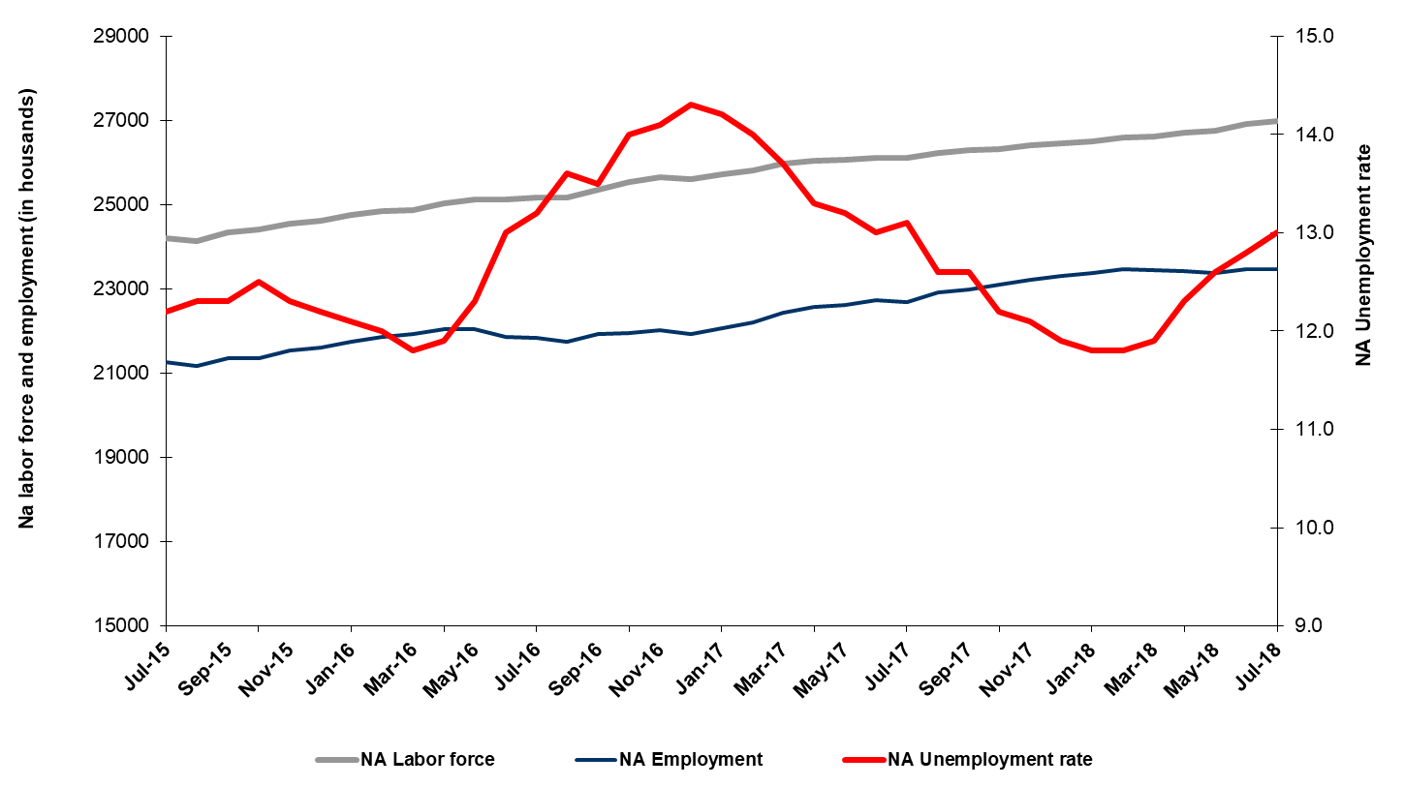
Source: Turkstat, Betam

Unemployment rate is expected to increase by 0.1 percentage points in the period of August 2018

Betam's forecasting model had predicted that the seasonally adjusted non-agricultural unemployment rate would increase by 0.1 percentage points to 12.9 percent in the July 2018. The non-agricultural unemployment rate rose by 0.2 percentage points to 13.0 percent in the period of July 2018. Betam’s forecasting model predicts that the non-agricultural unemployment rate will reach 13.1 percent in the period of August 2018. Forecasting model details are available on Betam's website. Kariyer.net application per vacancy series used in the Betam forecasting model is depicted in Figure 3. Kariyer.net series is only one of the inputs of Betam forecast model. Indeed, several variables such as employment agency (İŞKUR) data, reel sector confidence index, capacity utilization rate are used in forecasting.

Figure 2 Seasonally adjusted non-agricultural unemployment rate and application per vacancy
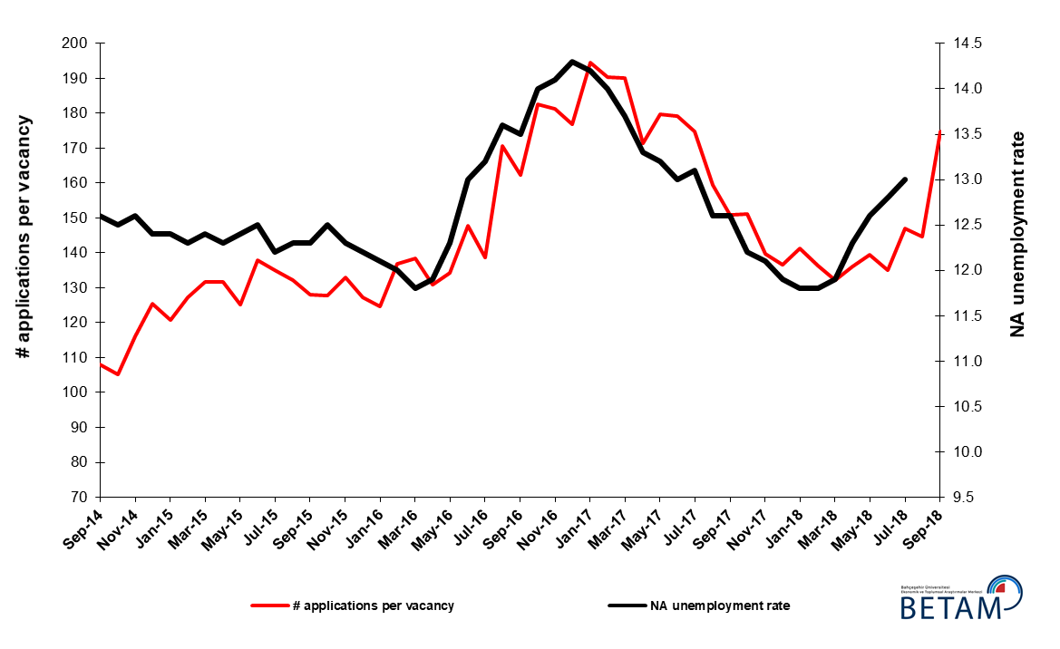
Source: Kariyer.net, Turkstat, Betam

Employment losses in manufacturing and construction

According to seasonally adjusted sectoral labor market data, employment decreased in manufacturing and construction while it increased in agriculture and services in July 2018 compared to June 2018 (Figure 3, Table 2). The employment increased by 3 thousand in agriculture and 77 thousand in services while employment in manufacture and construction decreased by 34 and 52 thousand respectively. Note that employment loses in construction accelerated again and reached 230 thousand from February to July (Table 2). Furthermore, the employment losses in manufacturing despite an increase in the industrial production index are worrying.

Figure 3: Employment by sectors (in thousand)

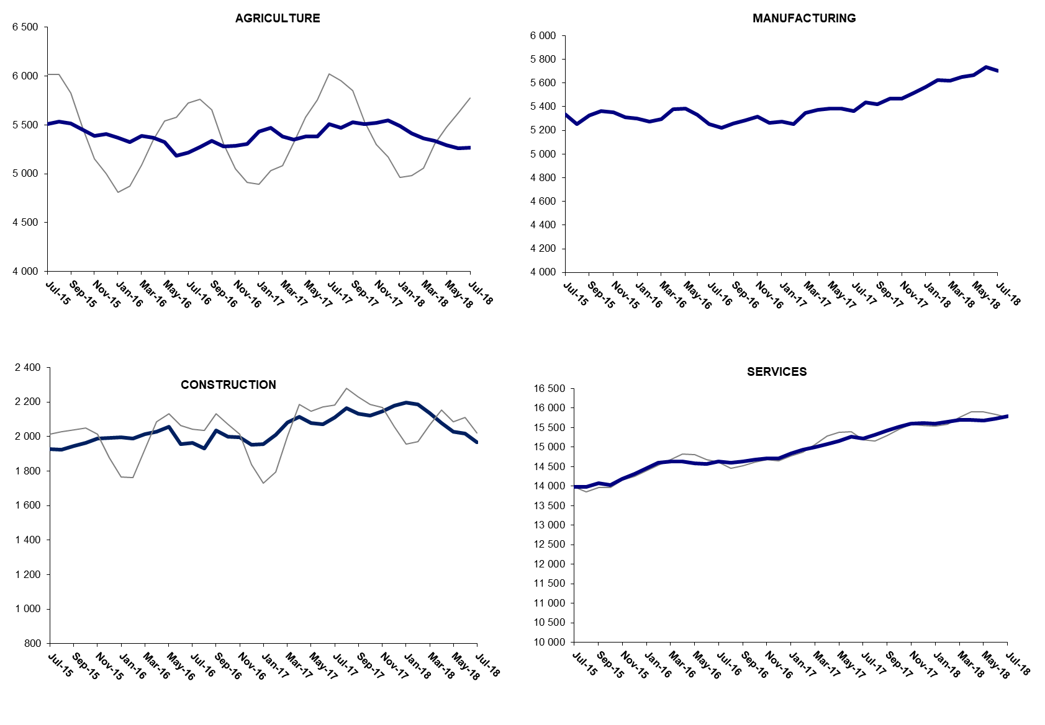

Source: TURKSTAT, Betam

The number of non-agricutural unemployed within a year increased

From July 2017 to July 2018 non-agricultural labor force increased by 837 thousand (3.2 percent) and non-agricultural employment increased by 755 thousand (3.3 percent) (Figure 4). Thus, non-agricultural unemployed decreased by 82 thousand and reached 3 million 479 thousand.

Figure 4 Year-on-year changes in non-agricultural labor force, employment, and unemployment
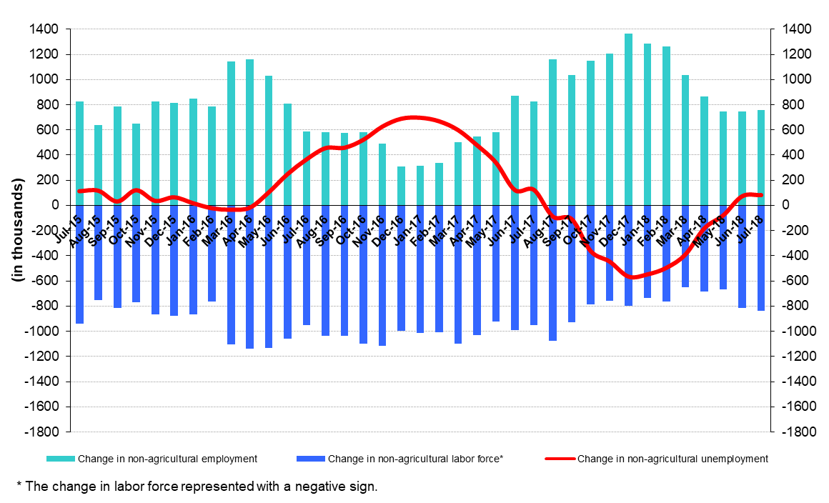
Source: Turkstat, Betam

Increase in female and male unemployment rates

Figure 5 shows seasonally adjusted non-agricultural unemployment rate for males (green) and for females (purple). In the period of July 2018, the non-agricultural female unemployment rate increased by 0.1 percentage points to 18.1 percent while non-agricultural male unemployment rate increased by 0.2 percentage points to 10.6 percent. Parallel to increases in unemployment rates, the gender gap in non-agricultural unemployment rates remained constant at around 7.6 percentage points in July 2018.

Figure 5: Seasonally adjusted non-agricultural unemployment rate by gender
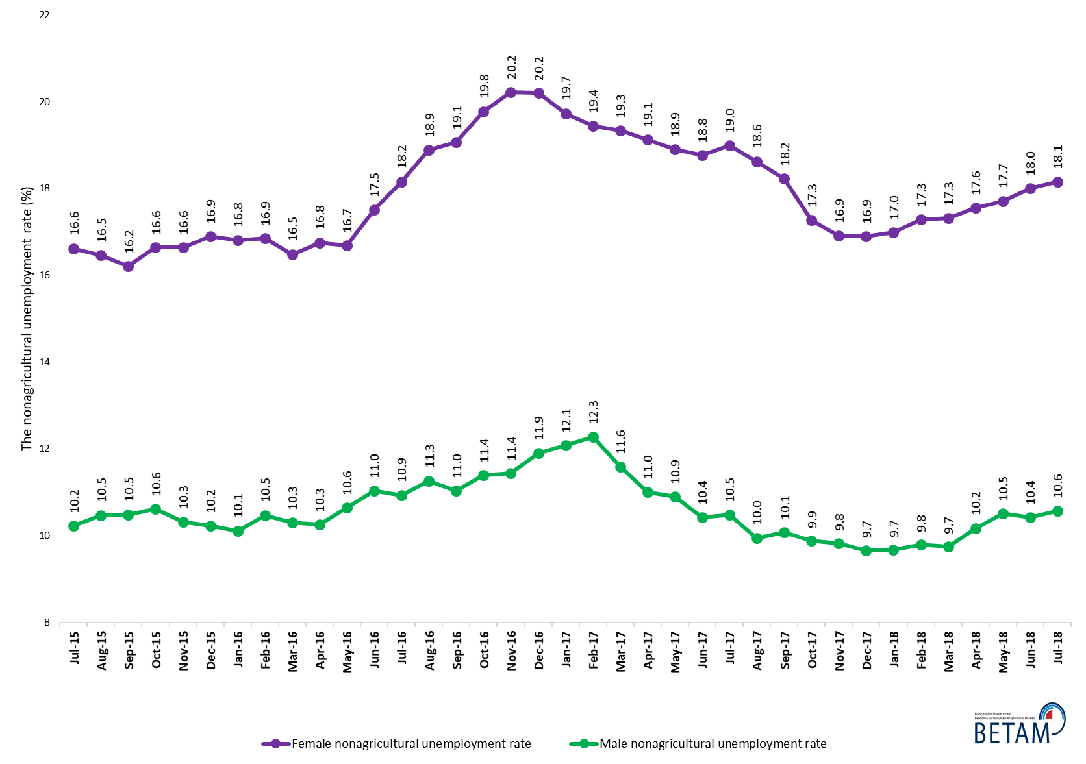
Source: Turkstat, Betam

Table 1 Seasonally adjusted non-agricultural labor market indicators (in thousands) *
 | Labor force | Employment | Unemployment | Unemployment rate | Monthly changes
June-15 | 24048 | 21042 | 3006 | 12.5% | Labor force | Employment | Unemployment
July-15 | 24205 | 21252 | 2953 | 12.2% | 157 | 210 | -53
August-15 | 24128 | 21160 | 2968 | 12.3% | -77 | -92 | 15
September-15 | 24343 | 21349 | 2994 | 12.3% | 216 | 189 | 27
October-15 | 24411 | 21360 | 3051 | 12.5% | 68 | 11 | 57
November-15 | 24546 | 21527 | 3019 | 12.3% | 135 | 167 | -32
December-15 | 24622 | 21618 | 3004 | 12.2% | 76 | 91 | -15
January-16 | 24744 | 21750 | 2994 | 12.1% | 122 | 132 | -10
February-16 | 24849 | 21867 | 2982 | 12.0% | 105 | 117 | -12
March-16 | 24874 | 21939 | 2935 | 11.8% | 25 | 72 | -47
April-16 | 25020 | 22043 | 2977 | 11.9% | 146 | 104 | 42
May-16 | 25123 | 22033 | 3090 | 12.3% | 103 | -10 | 113
June-16 | 25115 | 21850 | 3265 | 13.0% | -8 | -183 | 175
July-16 | 25169 | 21847 | 3322 | 13.2% | 54 | -3 | 57
August-16 | 25176 | 21752 | 3424 | 13.6% | 7 | -95 | 102
September-16 | 25355 | 21932 | 3423 | 13.5% | 179 | 180 | -1
October-16 | 25533 | 21958 | 3575 | 14.0% | 178 | 26 | 152
November-16 | 25640 | 22025 | 3615 | 14.1% | 108 | 67 | 41
December-16 | 25596 | 21936 | 3660 | 14.3% | -44 | -89 | 45
January-17 | 25720 | 22068 | 3652 | 14.2% | 124 | 132 | -8
February-17 | 25810 | 22197 | 3613 | 14.0% | 90 | 129 | -39
March-17 | 25983 | 22423 | 3560 | 13.7% | 172 | 226 | -54
April-17 | 26032 | 22570 | 3462 | 13.3% | 50 | 147 | -97
May-17 | 26062 | 22622 | 3440 | 13.2% | 30 | 52 | -22
June-17 | 26118 | 22723 | 3395 | 13.0% | 56 | 101 | -45
July-17 | 26109 | 22689 | 3420 | 13.1% | -9 | -34 | 25
August-17 | 26217 | 22914 | 3303 | 12.6% | 108 | 225 | -117
September-17 | 26286 | 22974 | 3312 | 12.6% | 69 | 60 | 9
October-17 | 26321 | 23110 | 3211 | 12.2% | 35 | 136 | -101
November-17 | 26418 | 23221 | 3197 | 12.1% | 96 | 111 | -15
December-17 | 26453 | 23305 | 3148 | 11.9% | 35 | 84 | -49
January-18 | 26492 | 23366 | 3126 | 11.8% | 39 | 61 | -22
February-18 | 26600 | 23461 | 3139 | 11.8% | 108 | 95 | 13
March-18 | 26613 | 23446 | 3167 | 11.9% | 13 | -15 | 28
April-18 | 26713 | 23427 | 3286 | 12.3% | 100 | -19 | 119
May-18 | 26744 | 23374 | 3370 | 12.6% | 31 | -53 | 84
June-18 | 26923 | 23477 | 3446 | 12.8% | 179 | 103 | 76
July-18 | 26975 | 23468 | 3507 | 13.0% | 52 | -9 | 61
Source: Turkstat, Betam

Table 2 Seasonally adjusted employment by sectors (in thousands) *
 | Agriculture | Manufacturing | Construction | Service | Monthly changes
June-15 | 5583 | 5380 | 1871 | 13791 | Agriculture | Manufacturing | Construction | Service
July-15 | 5506 | 5336 | 1929 | 13987 | -77 | -44 | 58 | 196
August-15 | 5536 | 5252 | 1924 | 13984 | 30 | -84 | -5 | -3
September-15 | 5516 | 5327 | 1945 | 14076 | -20 | 75 | 21 | 92
October-15 | 5450 | 5363 | 1964 | 14033 | -66 | 36 | 19 | -43
November-15 | 5387 | 5353 | 1987 | 14188 | -63 | -10 | 23 | 155
December-15 | 5407 | 5311 | 1991 | 14316 | 20 | -42 | 4 | 128
January-16 | 5371 | 5300 | 1995 | 14455 | -36 | -11 | 4 | 139
February-16 | 5326 | 5276 | 1990 | 14601 | -45 | -24 | -5 | 146
March-16 | 5386 | 5295 | 2015 | 14629 | 60 | 19 | 25 | 28
April-16 | 5369 | 5381 | 2029 | 14633 | -17 | 86 | 14 | 4
May-16 | 5328 | 5386 | 2056 | 14591 | -41 | 5 | 27 | -42
June-16 | 5186 | 5330 | 1958 | 14562 | -142 | -56 | -98 | -29
July-16 | 5215 | 5254 | 1962 | 14632 | 29 | -76 | 4 | 70
August-16 | 5274 | 5224 | 1930 | 14598 | 59 | -30 | -32 | -34
September-16 | 5338 | 5260 | 2036 | 14636 | 64 | 36 | 106 | 38
October-16 | 5283 | 5282 | 2000 | 14676 | -55 | 22 | -36 | 40
November-16 | 5285 | 5316 | 1995 | 14714 | 2 | 34 | -5 | 38
December-16 | 5308 | 5265 | 1954 | 14717 | 23 | -51 | -41 | 3
January-17 | 5433 | 5274 | 1957 | 14837 | 125 | 9 | 3 | 120
February-17 | 5473 | 5251 | 2012 | 14934 | 40 | -23 | 55 | 97
March-17 | 5384 | 5346 | 2081 | 14996 | -89 | 95 | 69 | 62
April-17 | 5350 | 5372 | 2115 | 15083 | -34 | 26 | 34 | 87
May-17 | 5381 | 5386 | 2078 | 15157 | 31 | 14 | -37 | 74
June-17 | 5385 | 5383 | 2070 | 15270 | 4 | -3 | -8 | 113
July-17 | 5508 | 5363 | 2111 | 15215 | 123 | -20 | 41 | -55
August-17 | 5468 | 5437 | 2163 | 15314 | -40 | 74 | 52 | 99
September-17 | 5528 | 5421 | 2134 | 15419 | 60 | -16 | -29 | 105
October-17 | 5507 | 5470 | 2120 | 15521 | -21 | 49 | -14 | 102
November-17 | 5520 | 5470 | 2146 | 15605 | 13 | 0 | 26 | 84
December-17 | 5548 | 5514 | 2179 | 15612 | 28 | 44 | 33 | 7
January-18 | 5491 | 5567 | 2196 | 15603 | -57 | 53 | 17 | -9
February-18 | 5416 | 5627 | 2187 | 15647 | -75 | 60 | -9 | 44
March-18 | 5360 | 5618 | 2135 | 15693 | -56 | -9 | -52 | 46
April-18 | 5340 | 5650 | 2080 | 15698 | -20 | 32 | -55 | 5
May-18 | 5292 | 5669 | 2027 | 15678 | -48 | 19 | -53 | -20
June-18 | 5262 | 5737 | 2018 | 15722 | -30 | 68 | -9 | 44
July-18 | 5265 | 5703 | 1966 | 15799 | 3 | -34 | -52 | 77
Source: Turkstat, Betam

Table 3: Seasonally adjusted non-agricultural labor force by gender (thousands)

 | Female Labor Force | Female Employment | Female Unemployed | Male Labor Force | Male Employment | Male Unemployed
July-15 | 6750 | 5628 | 1122 | 17481 | 15693 | 1788
August-15 | 6714 | 5609 | 1105 | 17481 | 15651 | 1830
September-15 | 6759 | 5664 | 1095 | 17572 | 15730 | 1843
October-15 | 6781 | 5652 | 1129 | 17610 | 15740 | 1869
November-15 | 6876 | 5731 | 1145 | 17618 | 15800 | 1818
December-15 | 6968 | 5791 | 1177 | 17655 | 15851 | 1805
January-16 | 7011 | 5832 | 1179 | 17685 | 15896 | 1789
February-16 | 7046 | 5858 | 1187 | 17770 | 15909 | 1861
March-16 | 7060 | 5896 | 1164 | 17821 | 15984 | 1836
April-16 | 7145 | 5948 | 1197 | 17851 | 16021 | 1830
May-16 | 7176 | 5979 | 1197 | 17937 | 16028 | 1909
June-16 | 7257 | 5987 | 1270 | 17859 | 15889 | 1970
July-16 | 7270 | 5950 | 1320 | 17917 | 15957 | 1960
August-16 | 7327 | 5944 | 1383 | 17911 | 15894 | 2017
September-16 | 7376 | 5970 | 1406 | 17981 | 15998 | 1983
October-16 | 7442 | 5970 | 1472 | 18059 | 16002 | 2057
November-16 | 7460 | 5951 | 1508 | 18146 | 16070 | 2076
December-16 | 7457 | 5951 | 1506 | 18163 | 16001 | 2162
January-17 | 7450 | 5980 | 1470 | 18276 | 16068 | 2208
February-17 | 7511 | 6051 | 1460 | 18308 | 16060 | 2248
March-17 | 7615 | 6143 | 1472 | 18366 | 16239 | 2127
April-17 | 7602 | 6148 | 1454 | 18396 | 16372 | 2024
May-17 | 7652 | 6206 | 1447 | 18391 | 16387 | 2004
June-17 | 7666 | 6227 | 1439 | 18440 | 16519 | 1921
July-17 | 7681 | 6222 | 1459 | 18446 | 16513 | 1933
August-17 | 7733 | 6293 | 1440 | 18548 | 16702 | 1846
September-17 | 7766 | 6351 | 1415 | 18517 | 16652 | 1865
October-17 | 7792 | 6446 | 1345 | 18501 | 16672 | 1828
November-17 | 7828 | 6504 | 1324 | 18544 | 16722 | 1823
December-17 | 7887 | 6554 | 1333 | 18553 | 16762 | 1791
January-18 | 7923 | 6577 | 1345 | 18553 | 16758 | 1795
February-18 | 7954 | 6579 | 1375 | 18618 | 16795 | 1823
March-18 | 7950 | 6574 | 1376 | 18663 | 16845 | 1818
April-18 | 7987 | 6585 | 1402 | 18706 | 16803 | 1903
May-18 | 8022 | 6602 | 1421 | 18708 | 16742 | 1966
June-18 | 8069 | 6617 | 1452 | 18835 | 16873 | 1962
July-18 | 8087 | 6619 | 1468 | 18865 | 16871 | 1994
Source: Turkstat, Betam

* Prof. Seyfettin Gürsel, Betam, Director, seyfettin.gursel@eas.bau.edu.tr
** Assoc. Prof. Gökçe Uysal, Betam, Deputy Director, gokce.uysal@eas.bau.edu.tr *** Yazgı Genç, Betam, Research Assistant, yazgi.genc@eas.bau.edu.tr
For detailed information on Betam's forecasting model, please see Betam Research Brief 168 titled as "Kariyer.net Verisiyle Kısa Vadeli Tarım Dışı İşsizlik Tahmini" . For the innovations in the model please see Betam Research Brief 14 titled as "Mevsim Etkilerinden Arındırılmış İşsizlik Tahmini" Soybilgen, B., "Kariyer.net Verisiyle Kısa Vadeli Tarım Dışı İşsizlik Tahmini", Betam Research Brief 168. http://betam.bahcesehir.edu.tr/tr/2014/06/kariyer-net-verisiyle-kisa-vadeli-tarim-disi-issizlik-tahmini/ Soybilgen, B., "Mevsim Etkilerinden Arındırılmış İşsizlik Tahmini", Betam Research Brief 14 http://betam.bahcesehir.edu.tr/2015/08/mevsim-etkilerinden-arindirilmis-tarim-disi-issizlik-tahmini/
Betam has been calculating application per vacancy using series released by Kariyer.net for a while. Seasonal and calendar adjustment procedure is applied to application per vacancy series. A decrease in applications per vacancy may be caused by an increase in vacancies or by a decrease in the number of applications. An increase in vacancies signals economic growth while decreasing number of applications indicates a decrease in number of people looking for a job. Monthly labor market series released by TurkStat is the average of three months. Therefore, application per vacancy statistics calculated using Kariyer.net series is the average of three months as well.
Employment in each sector is seasonally adjusted separately. Hence the sum of these series may differ from the seasonally adjusted series of total employment. The difference stems from the non-linearity of the seasonal adjustment process.
Turkstat revised the labor market statistics drastically in February 2014. Within this framework, they back casted various labor market indicators and they also continued to announce seasonally adjusted series. However, Turkstat is not providing back-casted series by gender. Therefore, female and male labor market statistics are not sufficiently long for the seasonal adjustment procedures (There should be minimum 36 observations). With the announcement of the period of February 2017 data, the number of observations required for the seasonal decontamination process was provided. From this period Betam generated seasonal adjustment series in terms of gender. Nevertheless, it should not be forgotten that seasonal adjustment may cause extra volatility in the series for at least a while.

