Labor Market Outlook:
September 2018

17 September 2018

INCREASE IN NON-AGRICULTURAL UNEMPLOYMENT CONTINUES

Seyfettin Gürsel*, Gökçe Uysal Kolaşın∗∗ and Yazgı Genç ***

Executive Summary

Seasonally adjusted labor market data shows that in the period of June 2018 compared to May 2018, non-agricultural unemployment rate increased by 0.2 percentage points and reached 12.8 percent. The employment loses since March 2018 stopped in June 2018 and non-agricultural employment increased by 105 thousand. Sectoral data indicates that employment decreased in construction while it increased in manufacturing and services. The increase in non-agricultural labor force accelerated and non-agricultural labor force reached to 182 thousand. Thus, increase in non-agricultural unemployment continues. Betam’s forecasting model predicts that the non-agricultural unemployment will rise to 12.9 percent in the period of July 2018. In the period of June 2018, the non-agricultural female unemployment rate increased by 0.3 percentage points to 18 percent while non-agricultural male unemployment rate decreased by 0.1 percentage points to 10.4 percent. Thus, the gender gap in non-agricultural unemployment rates have increased.

The strong increase in the non-agricultural labor force

According to seasonally adjusted labor market data, in the period of June 2018 compared to May 2018, the non-agricultural labor force increased by 182 thousand and reached 26 million 937 thousand while the number of employed in non-agricultural sectors decreased by 105 thousand and reached 23 million 489 thousand (Figure 1, Table 1). As result, the number of unemployed in non-agricultural sectors increased by 77 thousand and recorded as 3 million 448 thousand and the non-agricultural unemployment rate rose to 12.8 percent. The employment loses in the non-agricultural employment since March 2018 stopped in June 2018 whereas the increases in the non-agricultural labor force accelerated. The non-agricultural unemployment increased since the increase in employment is higher than the increase in the labor force. As result, the non-agricultural unemployment rate which was 11.8 percent in January 2018 increased steadily by 1 percentage points in a period of 6 months and reached 12.8 in June 2018.

Figure 1 Seasonally adjusted non-agricultural labor force, employment, and unemployment

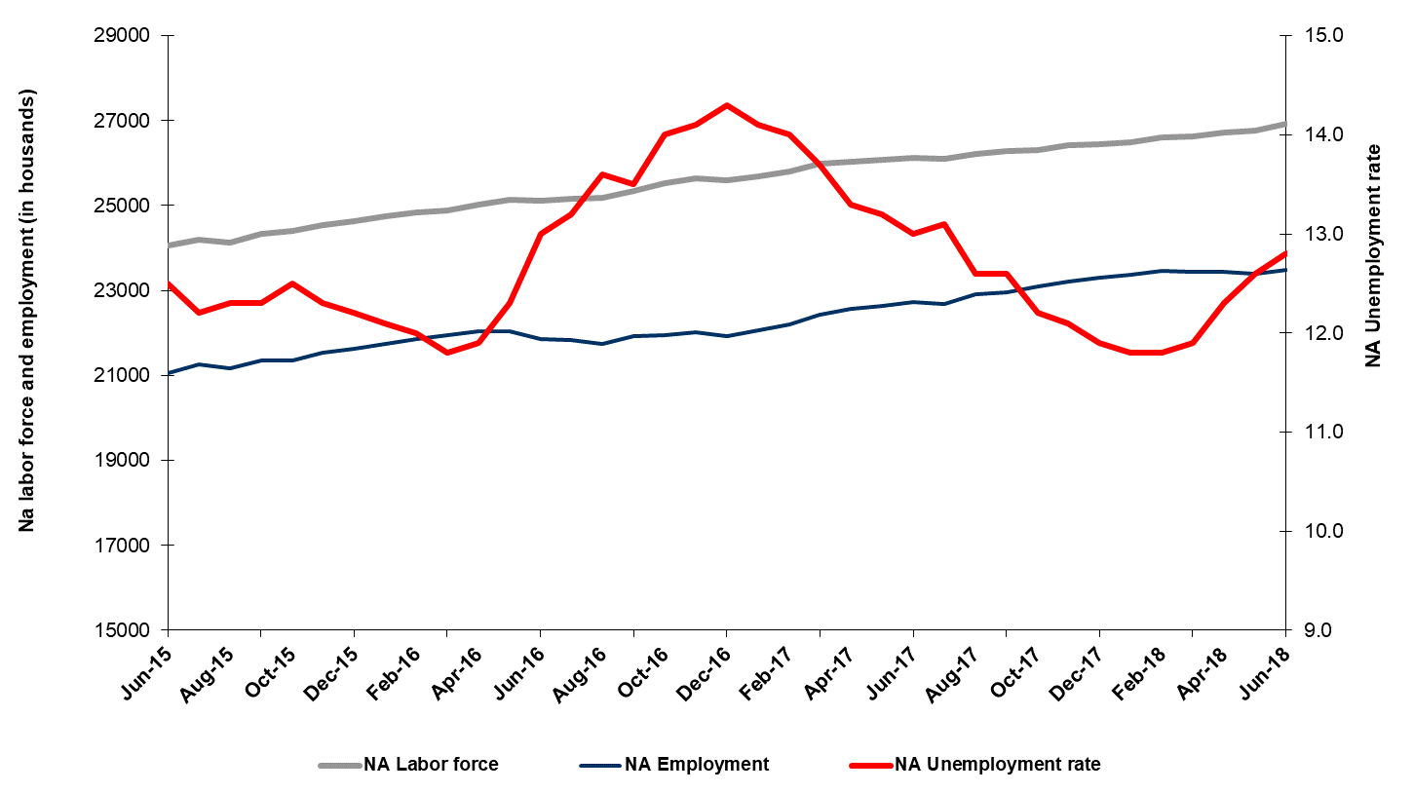
Source: Turkstat, Betam

Unemployment rate is expected to increase by 0.1 percentage points in the period of July 2018

Betam's forecasting model had predicted that the seasonally adjusted non-agricultural unemployment rate would increase by 0.2 percentage points to 12.7 percent in the June 2018. TURKSTAT revised the non-agricultural unemployment rate in May 2018 from 12.5 percent to 12.6 percent. The non-agricultural unemployment rate rose by 0.2 percentage points –as predicted- to 12.8 percent in the period of June 2018. Betam’s forecasting model predicts that the non-agricultural unemployment rate will reach to 12.9 percent in the period of July 2018. Forecasting model details are available on Betam's website. Kariyer.net application per vacancy series used in the Betam forecasting model is depicted in Figure 3. Kariyer.net series is only one of the inputs of Betam forecast model. Indeed, several variables such as employment agency (İŞKUR) data, reel sector confidence index, capacity utilization rate are used in forecasting.

Figure 2 Seasonally adjusted non-agricultural unemployment rate and application per vacancy
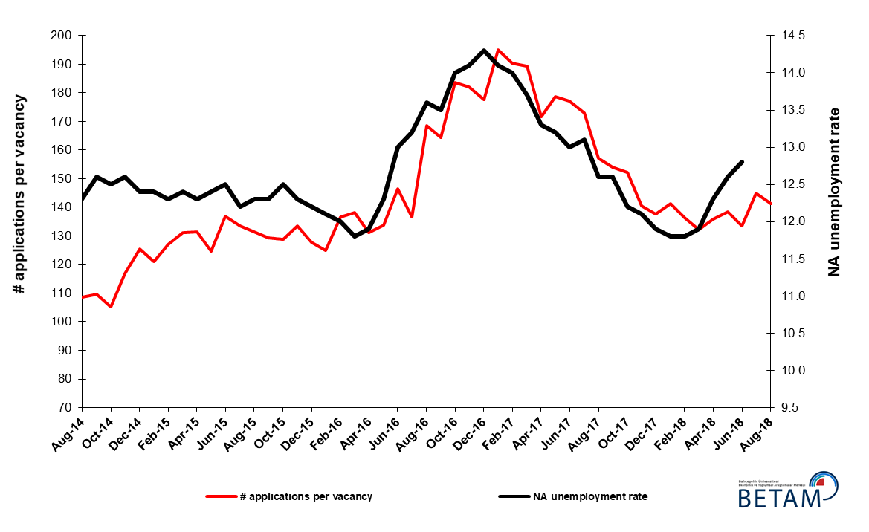
Source: Kariyer.net, Turkstat, Betam

Employment increases in manufacturing and services

According to seasonally adjusted sectoral labor market data, employment decreased in agriculture and construction while it increased in manufacturing and services in June 2018 compared to May 2018 (Figure 3, Table 2). The employment increased by 68 thousand in manufacturing and 43 thousand in services while employment in agriculture and construction decreased by 30 and 6 thousand respectively. Industry production index increased in July while it decreased in the May and June. We would like recall that labor force statistics in the period of June 2018 is the average of the May, June and July. In this case, the increase in industrial production index in July is consistent with the increases in employment in manufacturing. The slowdown in the increase of employment in services since December 2017 is remarkable (Table 2). It has to be noted that employment loses in construction reached to 164 thousand from February to June. The construction sector lost the 7.5 percent of its employment in 5 months compared to January (Table 2).

Figure 3: Employment by sectors (in thousand)

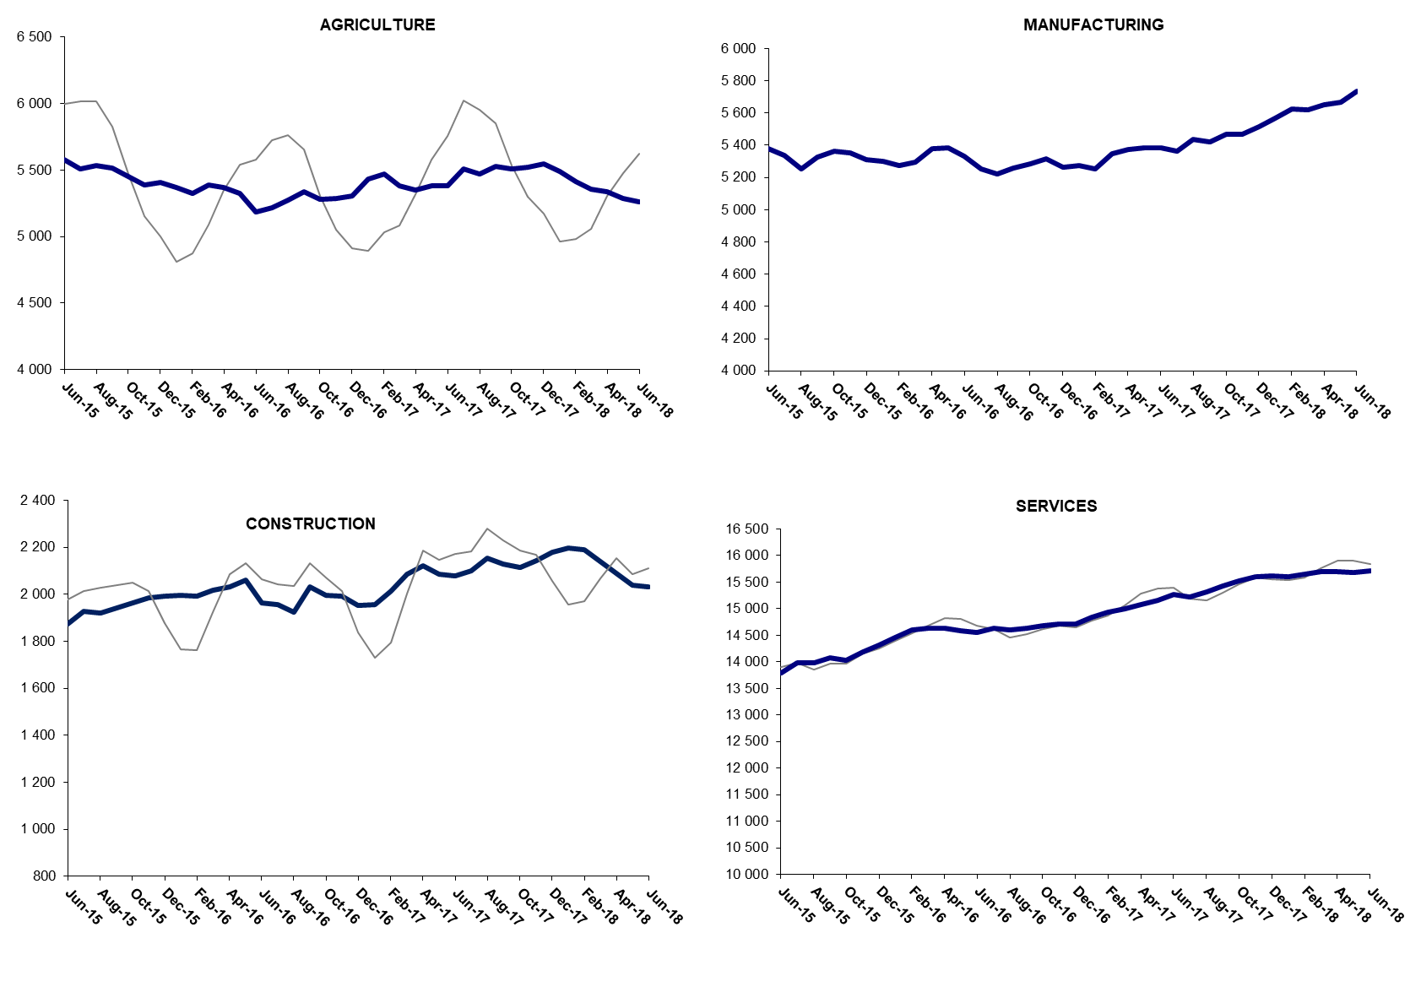

Source: TURKSTAT, Betam

The number of non-agricutural unemployed within a year increased

From June 2017 to June 2018 non-agricultural labor force increased by 817 thousand (3.1 percent) and non-agricultural employment increased by 744 thousand (3.2 percent) (Figure 4). Thus, non-agricultural unemployed decreased by 73 thousand and reached 3 million 261 thousand. Looking at annual changes, a slowdown in unemployed decrease ended in June 2018 and unemployment rate increased to 12.1 percent and closed to the unemployment in June 2017 (12.2 percent).

Figure 4 Year-on-year changes in non-agricultural labor force, employment, and unemployment
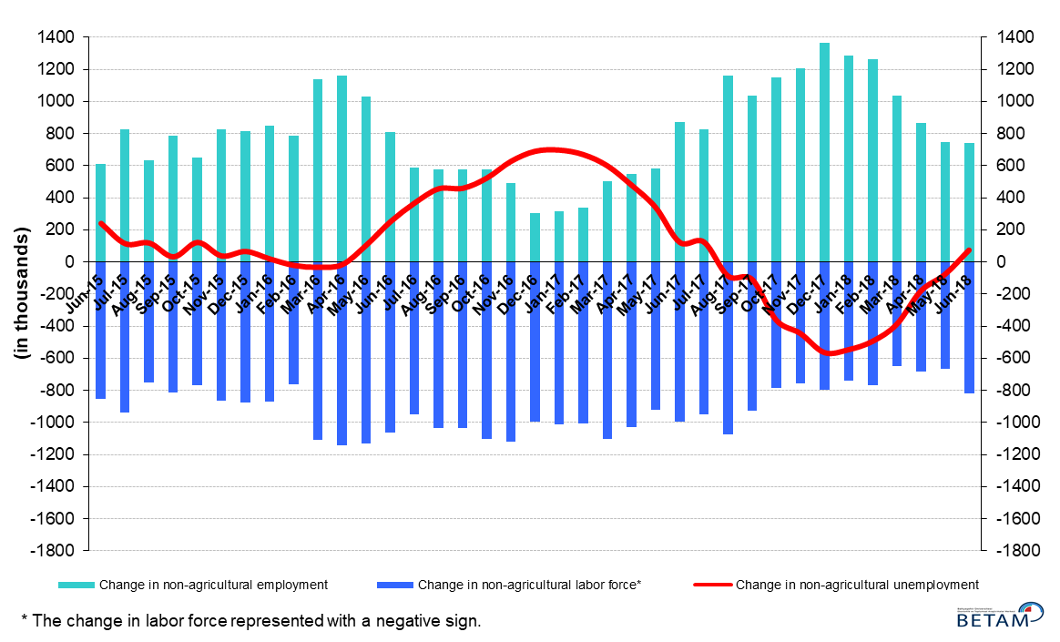
Source: Turkstat, Betam

Unemployment rate difference between female and male increased

Figure 5 shows seasonally adjusted non-agricultural unemployment rate for males (green) and for females (purple). In the period of June 2018, the non-agricultural female unemployment rate increased by 0.3 percentage points to 18.0 percent while non-agricultural male unemployment rate increased by 0.1 percentage points to 10.4 percent. In a period when the non-agricultural unemployment rate increases, a decrease in male unemployment rate while female unemployment rate increases should be underlined. As a result, the gender gap in non-agricultural unemployment rates increased from 7.2 percent in May 2018 to 7.6 percent in June 2018.

Figure 5: Seasonally adjusted non-agricultural unemployment rate by gender
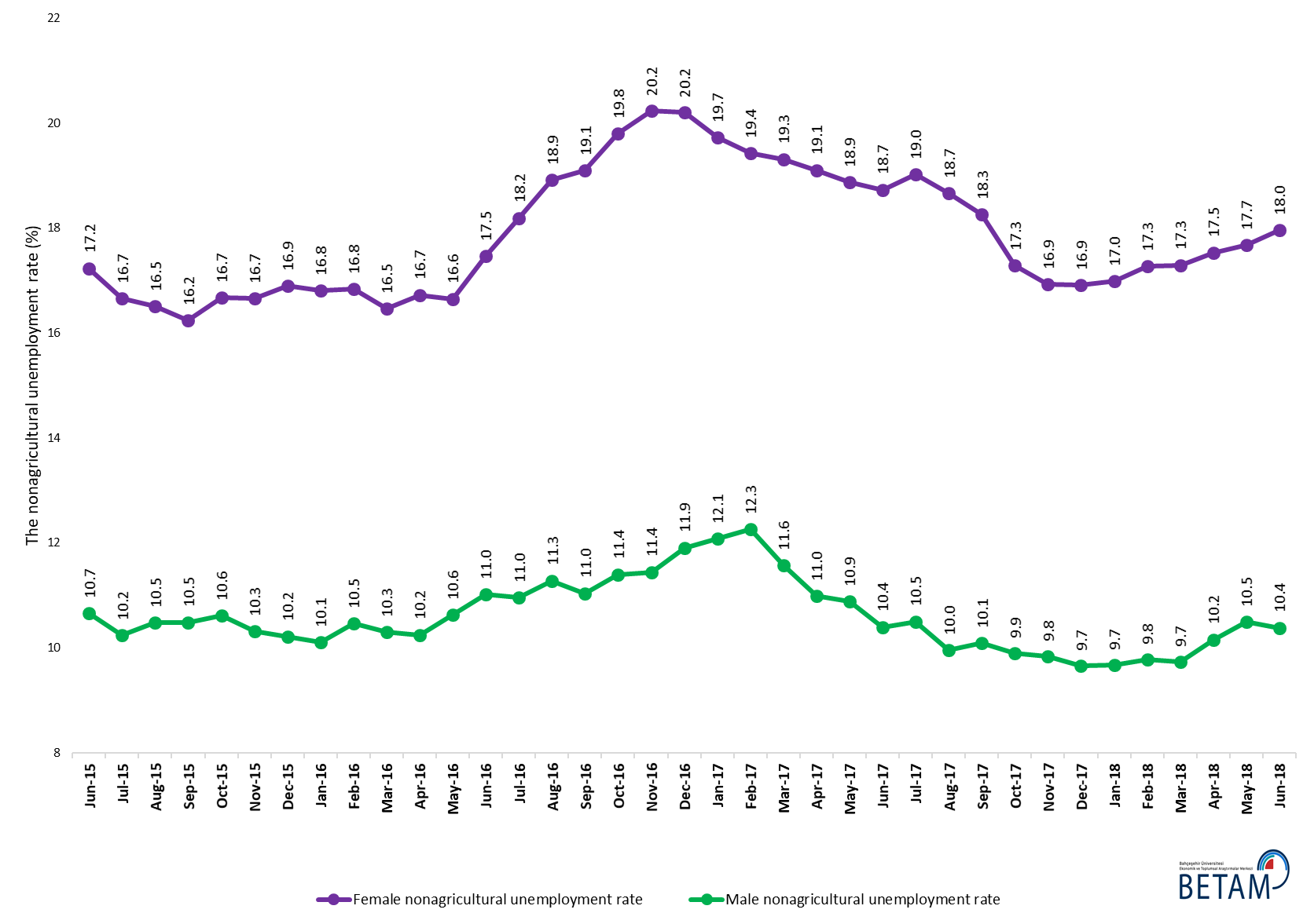
Source: Turkstat, Betam

Table 1 Seasonally adjusted non-agricultural labor market indicators (in thousands) *
 | Labor force | Employment | Unemployment | Unemployment rate | Monthly changes
May-15 | 24000 | 21024 | 2976 | 12.4% | Labor force | Employment | Unemployment
June-15 | 24051 | 21045 | 3006 | 12.5% | 51 | 21 | 30
July-15 | 24204 | 21251 | 2953 | 12.2% | 152 | 206 | -54
August-15 | 24125 | 21158 | 2967 | 12.3% | -78 | -93 | 15
September-15 | 24341 | 21347 | 2994 | 12.3% | 216 | 189 | 27
October-15 | 24410 | 21359 | 3051 | 12.5% | 69 | 12 | 57
November-15 | 24545 | 21526 | 3019 | 12.3% | 135 | 167 | -32
December-15 | 24622 | 21618 | 3004 | 12.2% | 77 | 92 | -15
January-16 | 24744 | 21750 | 2994 | 12.1% | 122 | 132 | -10
February-16 | 24850 | 21868 | 2982 | 12.0% | 106 | 118 | -12
March-16 | 24874 | 21939 | 2935 | 11.8% | 24 | 71 | -47
April-16 | 25023 | 22045 | 2978 | 11.9% | 149 | 106 | 43
May-16 | 25127 | 22036 | 3091 | 12.3% | 104 | -9 | 113
June-16 | 25118 | 21853 | 3265 | 13.0% | -8 | -183 | 175
July-16 | 25165 | 21843 | 3322 | 13.2% | 46 | -10 | 56
August-16 | 25172 | 21749 | 3423 | 13.6% | 8 | -94 | 102
September-16 | 25353 | 21930 | 3423 | 13.5% | 180 | 181 | -1
October-16 | 25531 | 21957 | 3574 | 14.0% | 179 | 27 | 152
November-16 | 25639 | 22024 | 3615 | 14.1% | 108 | 67 | 41
December-16 | 25596 | 21936 | 3660 | 14.3% | -43 | -88 | 45
January-17 | 25692 | 22069 | 3623 | 14.1% | 95 | 133 | -38
February-17 | 25813 | 22199 | 3614 | 14.0% | 121 | 130 | -9
March-17 | 25986 | 22426 | 3560 | 13.7% | 173 | 227 | -54
April-17 | 26037 | 22574 | 3463 | 13.3% | 51 | 148 | -97
May-17 | 26069 | 22628 | 3441 | 13.2% | 32 | 54 | -22
June-17 | 26128 | 22731 | 3397 | 13.0% | 58 | 103 | -45
July-17 | 26100 | 22681 | 3419 | 13.1% | -27 | -50 | 23
August-17 | 26209 | 22907 | 3302 | 12.6% | 109 | 226 | -117
September-17 | 26280 | 22969 | 3311 | 12.6% | 71 | 62 | 9
October-17 | 26318 | 23107 | 3211 | 12.2% | 37 | 138 | -101
November-17 | 26415 | 23219 | 3196 | 12.1% | 97 | 112 | -15
December-17 | 26452 | 23304 | 3148 | 11.9% | 37 | 85 | -48
January-18 | 26493 | 23367 | 3126 | 11.8% | 41 | 63 | -22
February-18 | 26603 | 23464 | 3139 | 11.8% | 110 | 97 | 13
March-18 | 26617 | 23450 | 3167 | 11.9% | 14 | -14 | 28
April-18 | 26721 | 23434 | 3287 | 12.3% | 103 | -16 | 119
May-18 | 26755 | 23384 | 3371 | 12.6% | 35 | -50 | 85
June-18 | 26937 | 23489 | 3448 | 12.8% | 182 | 105 | 77
Source: Turkstat, Betam

Table 2 Seasonally adjusted employment by sectors (in thousands) *
 | Agriculture | Manufacturing | Construction | Service | Monthly changes
May-15 | 5543 | 5404 | 1879 | 13741 | Agriculture | Manufacturing | Construction | Service
June-15 | 5582 | 5380 | 1875 | 13790 | 39 | -24 | -4 | 49
July-15 | 5506 | 5336 | 1926 | 13989 | -76 | -44 | 51 | 199
August-15 | 5537 | 5252 | 1922 | 13985 | 31 | -84 | -4 | -4
September-15 | 5517 | 5327 | 1943 | 14078 | -20 | 75 | 21 | 93
October-15 | 5450 | 5363 | 1963 | 14034 | -67 | 36 | 20 | -44
November-15 | 5387 | 5353 | 1986 | 14188 | -63 | -10 | 23 | 154
December-15 | 5407 | 5311 | 1991 | 14316 | 20 | -42 | 5 | 128
January-16 | 5371 | 5300 | 1995 | 14455 | -36 | -11 | 4 | 139
February-16 | 5326 | 5276 | 1991 | 14601 | -45 | -24 | -4 | 146
March-16 | 5386 | 5295 | 2017 | 14627 | 60 | 19 | 26 | 26
April-16 | 5368 | 5381 | 2032 | 14632 | -18 | 86 | 15 | 5
May-16 | 5327 | 5386 | 2060 | 14590 | -41 | 5 | 28 | -42
June-16 | 5185 | 5330 | 1963 | 14560 | -142 | -56 | -97 | -30
July-16 | 5216 | 5254 | 1956 | 14634 | 31 | -76 | -7 | 74
August-16 | 5275 | 5224 | 1925 | 14600 | 59 | -30 | -31 | -34
September-16 | 5339 | 5260 | 2032 | 14638 | 64 | 36 | 107 | 38
October-16 | 5283 | 5282 | 1997 | 14677 | -56 | 22 | -35 | 39
November-16 | 5285 | 5316 | 1994 | 14714 | 2 | 34 | -3 | 37
December-16 | 5308 | 5265 | 1954 | 14717 | 23 | -51 | -40 | 3
January-17 | 5433 | 5274 | 1958 | 14836 | 125 | 9 | 4 | 119
February-17 | 5473 | 5251 | 2014 | 14933 | 40 | -23 | 56 | 97
March-17 | 5383 | 5346 | 2085 | 14995 | -90 | 95 | 71 | 62
April-17 | 5349 | 5372 | 2121 | 15081 | -34 | 26 | 36 | 86
May-17 | 5379 | 5386 | 2086 | 15156 | 30 | 14 | -35 | 75
June-17 | 5382 | 5383 | 2080 | 15268 | 3 | -3 | -6 | 112
July-17 | 5510 | 5363 | 2100 | 15218 | 128 | -20 | 20 | -50
August-17 | 5470 | 5437 | 2153 | 15317 | -40 | 74 | 53 | 99
September-17 | 5530 | 5421 | 2127 | 15421 | 60 | -16 | -26 | 104
October-17 | 5508 | 5470 | 2115 | 15522 | -22 | 49 | -12 | 101
November-17 | 5521 | 5470 | 2143 | 15606 | 13 | 0 | 28 | 84
December-17 | 5549 | 5514 | 2178 | 15612 | 28 | 44 | 35 | 6
January-18 | 5492 | 5567 | 2197 | 15603 | -57 | 53 | 19 | -9
February-18 | 5416 | 5627 | 2191 | 15646 | -76 | 60 | -6 | 43
March-18 | 5359 | 5618 | 2141 | 15691 | -57 | -9 | -50 | 45
April-18 | 5338 | 5650 | 2089 | 15695 | -21 | 32 | -52 | 4
May-18 | 5289 | 5669 | 2039 | 15676 | -49 | 19 | -50 | -19
June-18 | 5259 | 5737 | 2033 | 15719 | -30 | 68 | -6 | 43
Source: Turkstat, Betam

Table 3: Seasonally adjusted non-agricultural labor force by gender (thousands)

 | Female Labor Force | Female Employment | Female Unemployed | Male Labor Force | Male Employment | Male Unemployed
June-15 | 6654 | 5507 | 1147 | 17422 | 15565 | 1858
July-15 | 6749 | 5625 | 1124 | 17482 | 15691 | 1791
August-15 | 6714 | 5606 | 1108 | 17483 | 15651 | 1832
September-15 | 6759 | 5662 | 1097 | 17573 | 15730 | 1843
October-15 | 6781 | 5651 | 1130 | 17609 | 15740 | 1869
November-15 | 6876 | 5730 | 1146 | 17618 | 15800 | 1818
December-15 | 6968 | 5790 | 1178 | 17655 | 15851 | 1804
January-16 | 7011 | 5832 | 1179 | 17684 | 15896 | 1788
February-16 | 7046 | 5859 | 1186 | 17769 | 15909 | 1860
March-16 | 7060 | 5898 | 1162 | 17820 | 15985 | 1835
April-16 | 7145 | 5950 | 1195 | 17850 | 16021 | 1829
May-16 | 7176 | 5981 | 1195 | 17935 | 16028 | 1907
June-16 | 7258 | 5990 | 1267 | 17859 | 15890 | 1968
July-16 | 7270 | 5947 | 1322 | 17919 | 15956 | 1964
August-16 | 7327 | 5941 | 1386 | 17913 | 15893 | 2020
September-16 | 7376 | 5968 | 1409 | 17983 | 15997 | 1986
October-16 | 7442 | 5969 | 1473 | 18061 | 16002 | 2058
November-16 | 7460 | 5950 | 1509 | 18147 | 16070 | 2077
December-16 | 7457 | 5950 | 1507 | 18164 | 16002 | 2163
January-17 | 7450 | 5980 | 1470 | 18275 | 16069 | 2207
February-17 | 7511 | 6052 | 1459 | 18306 | 16062 | 2245
March-17 | 7615 | 6145 | 1471 | 18364 | 16240 | 2124
April-17 | 7602 | 6150 | 1452 | 18393 | 16372 | 2021
May-17 | 7652 | 6208 | 1444 | 18390 | 16388 | 2001
June-17 | 7666 | 6230 | 1436 | 18437 | 16520 | 1917
July-17 | 7680 | 6219 | 1461 | 18449 | 16511 | 1938
August-17 | 7733 | 6290 | 1443 | 18548 | 16700 | 1847
September-17 | 7766 | 6349 | 1418 | 18519 | 16651 | 1868
October-17 | 7792 | 6445 | 1347 | 18503 | 16672 | 1831
November-17 | 7828 | 6503 | 1325 | 18545 | 16721 | 1824
December-17 | 7887 | 6553 | 1333 | 18555 | 16763 | 1793
January-18 | 7923 | 6577 | 1345 | 18555 | 16759 | 1796
February-18 | 7954 | 6580 | 1374 | 18618 | 16796 | 1822
March-18 | 7950 | 6576 | 1375 | 18661 | 16845 | 1816
April-18 | 7987 | 6587 | 1400 | 18703 | 16803 | 1900
May-18 | 8023 | 6604 | 1418 | 18707 | 16744 | 1962
June-18 | 8070 | 6620 | 1449 | 18829 | 16874 | 1955
Source: Turkstat, Betam

*Prof. Dr. Seyfettin Gürsel, Betam, Direktör, seyfettin.gursel@eas.bau.edu.tr
∗∗Doç. Dr. Gökçe Uysal Kolaşın, Betam, Direktör Yardımcısı, gokce.uysal@eas.bau.edu.tr *** Yazgı Genç, Betam, Araştırma Görevlisi, yazgi.genc@eas.bau.edu.tr
For detailed information on Betam's forecasting model, please see Betam Research Brief 168 titled as "Kariyer.net Verisiyle Kısa Vadeli Tarım Dışı İşsizlik Tahmini" . For the innovations in the model please see Betam Research Brief 14 titled as "Mevsim Etkilerinden Arındırılmış İşsizlik Tahmini" Soybilgen, B., "Kariyer.net Verisiyle Kısa Vadeli Tarım Dışı İşsizlik Tahmini", Betam Research Brief 168. http://betam.bahcesehir.edu.tr/tr/2014/06/kariyer-net-verisiyle-kisa-vadeli-tarim-disi-issizlik-tahmini/ Soybilgen, B., "Mevsim Etkilerinden Arındırılmış İşsizlik Tahmini", Betam Research Brief 14 http://betam.bahcesehir.edu.tr/2015/08/mevsim-etkilerinden-arindirilmis-tarim-disi-issizlik-tahmini/
Betam has been calculating application per vacancy using series released by Kariyer.net for a while. Seasonal and calendar adjustment procedure is applied to application per vacancy series. A decrease in applications per vacancy may be caused by an increase in vacancies or by a decrease in the number of applications. An increase in vacancies signals economic growth while decreasing number of applications indicates a decrease in number of people looking for a job. Monthly labor market series released by TurkStat is the average of three months. Therefore, application per vacancy statistics calculated using Kariyer.net series is the average of three months as well.
Employment in each sector is seasonally adjusted separately. Hence the sum of these series may differ from the seasonally adjusted series of total employment. The difference stems from the non-linearity of the seasonal adjustment process.
Turkstat revised the labor market statistics drastically in February 2014. Within this framework, they back casted various labor market indicators and they also continued to announce seasonally adjusted series. However, Turkstat is not providing back-casted series by gender. Therefore, female and male labor market statistics are not sufficiently long for the seasonal adjustment procedures (There should be minimum 36 observations). With the announcement of the period of February 2017 data, the number of observations required for the seasonal decontamination process was provided. From this period Betam generated seasonal adjustment series in terms of gender. Nevertheless, it should not be forgotten that seasonal adjustment may cause extra volatility in the series for at least a while.

