Labor Market Outlook:
August 2018

16 August 2018

SHARP INCREASE IN NON-AGRICULTURAL UNEMPLOYMENT CONTINUES
Seyfettin Gürsel* and Uğurcan Acar ∗∗

Executive Summary

Seasonally adjusted labor market data shows that, in the period of May 2018 compared to April 2018, non-agricultural unemployment rate increased by 0.3 percentage points and reached 12.5 percent. Thus, non-agricultural unemployment rate increased from 11.9 to 12.5 percent in the last two months. Consecutive decreases in employment are the reasons behind the increase in non-agricultural unemployment. Sectoral data indicates that employment decreased in all sectors except manufacturing. There have been strong employment losses in construction in the last three periods. Since employment losses occurred mostly in construction where men are more likely to be employed, the gender gap in non-agricultural unemployment rates have decreased in favor of women. Betam’s forecasting model predicts that the non-agricultural unemployment will increase to 12.7 percent in the period of June 2018.

The non-agricultural labor force increased while employment decreased

According to seasonally adjusted labor market data, in the period of May 2018 compared to April 2018, the non-agricultural labor force increased by 34 thousand and reached 26 million 729 thousand while the number of employed in non-agricultural sectors decreased by 50 thousand and reached 23 million 388 thousand (Figure 1, Table 1). As result, the number of unemployed in non-agricultural sectors increased by 84 thousand and recorded as 3 million 241 thousand and the non-agricultural unemployment rate rose to 12.5 percent.

Figure 1 Seasonally adjusted non-agricultural labor force, employment, and unemployment

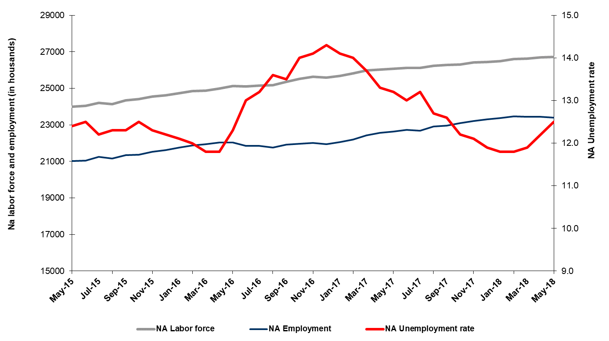
Source: Turkstat, Betam
Unemployment rate is expected to increase by 0.2 percentage point in the period of May 2018

Betam's forecasting model had predicted that the seasonally adjusted non-agricultural unemployment rate would increase to 12.3 percent in the May 2018. The non-agricultural unemployment rate rose to 12.5 percent in the period of May 2018. Betam’s forecasting model predicts that the non-agricultural unemployment rate will reach to 12.7 percent in the period of June 2018. Forecasting model details are available on Betam's website. Kariyer.net application per vacancy series used in the Betam forecasting model is depicted in Figure 3. Kariyer.net series is only one of the inputs of Betam forecast model. Indeed, several variables such as employment agency (İŞKUR) data, reel sector confidence index, capacity utilization rate are used in forecasting.

Figure 2 Seasonally adjusted non-agricultural unemployment rate and application per vacancy
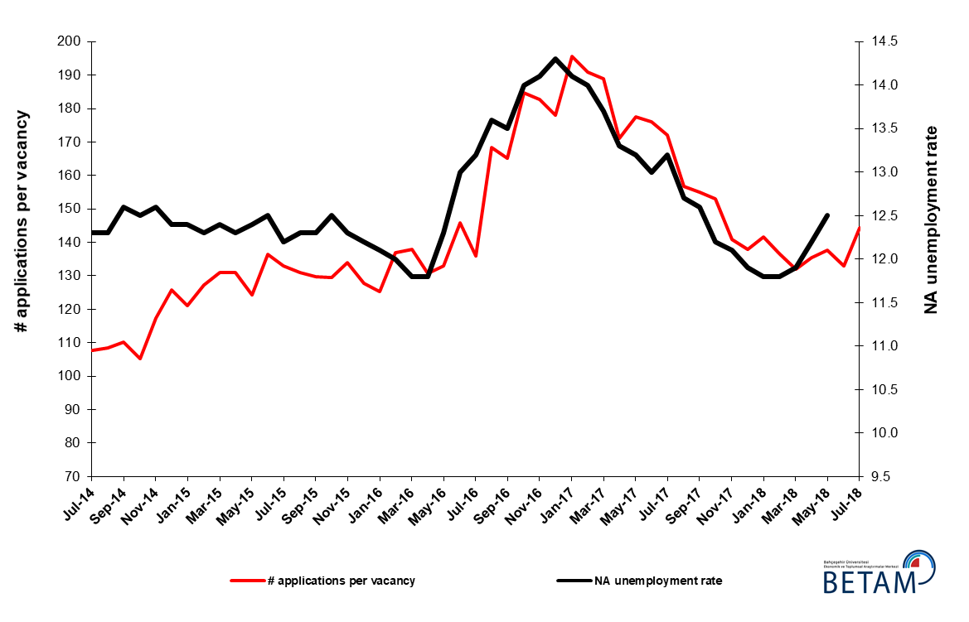
Source: Kariyer.net, Turkstat, Betam

Employment decreases in construction continues

According to seasonally adjusted sectoral labor market data, employment decreased in all sectors except manufacturing in May 2018 compared to April 2018 (Figure 3, Table 2). Employment increased by 19 thousand in manufacturing while employment in agriculture, construction and services decreased by 48, 49 and 19 thousand respectively. Employment losses in construction in the last three periods have exceeded 150 thousand. It has to be noted that the total increase in employment in the service sector, which shoulders about half of the total employment, from December to May period was limited to 62 thousand.
Figure 3: Employment by sectors (in thousands)
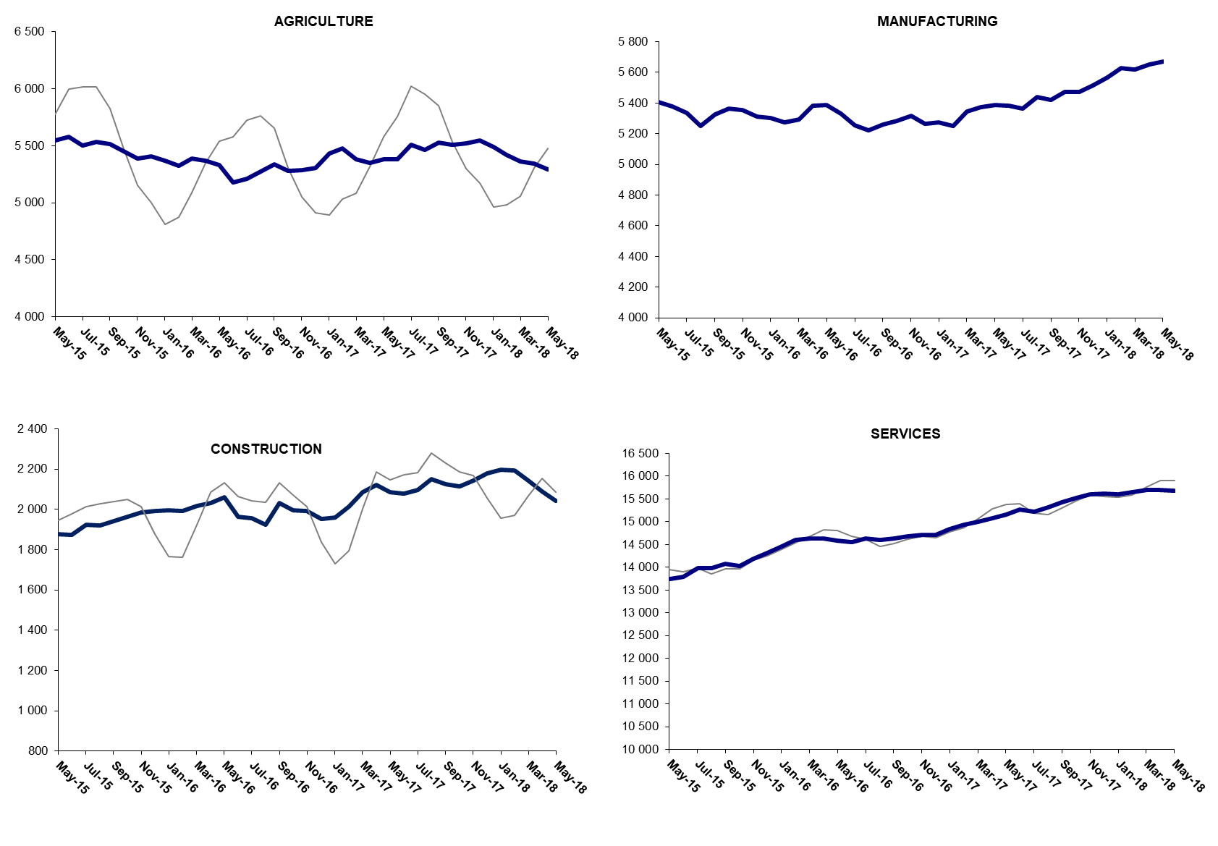

Source: TURKSTAT, Betam

Decline in the number of non-agricultural unemployed within a year continues due to base effect

From May 2017 to May 2018 non-agricultural labor force increased by 668 thousand (2.6 percent) and non-agricultural employment increased by 747 thousand (3.3 percent) (Figure 4). Thus, non-agricultural unemployed decreased by 79 thousand and attained 3 million 104 thousand. Looking at annual changes, a slowdown in labor force increase and a sharp slowdown in employment increase became obvious. (Figure 4).

Figure 4 Year-on-year changes in non-agricultural labor force, employment, and unemployment
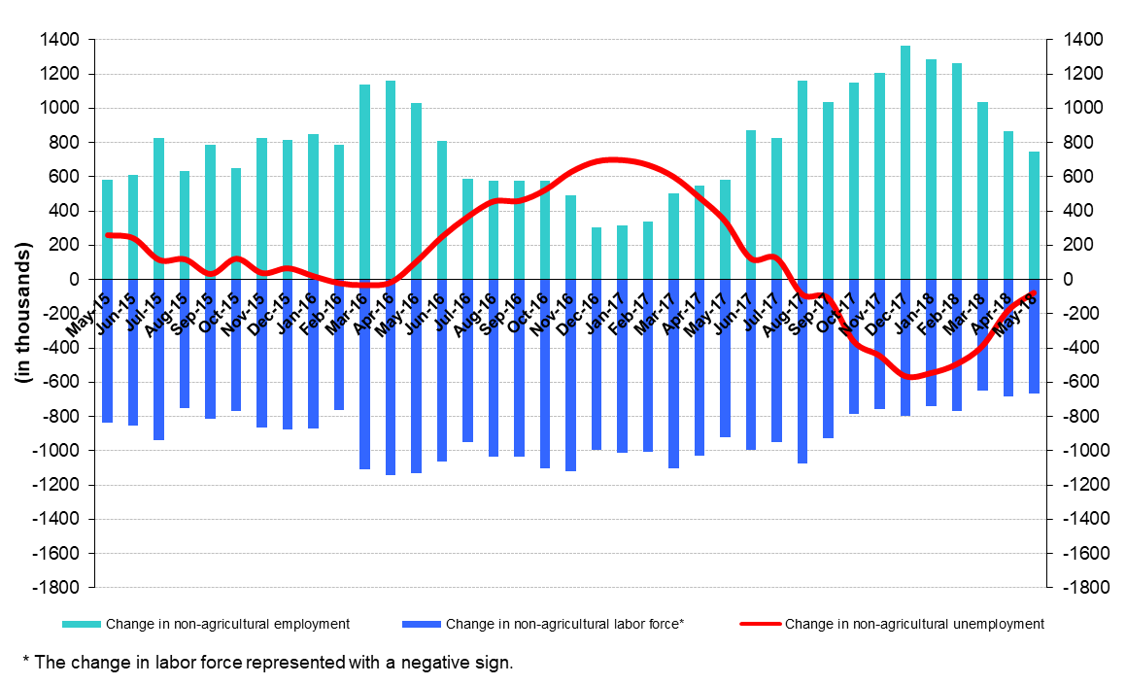
Source: Turkstat, Betam

Unemployment ratio difference between female and male decreased

Figure 5 shows seasonally adjusted non-agricultural unemployment rate for males (green) and for females (purple). In the period of May 2018, the non-agricultural female unemployment rate increased by 0.1 percentage points to 17.6 percent while non-agricultural male unemployment rate increased by 0.2 percentage points to 10.5 percent. In other words non-agricultural unemployment increases were larger for males. Thus, the gender gap in non-agricultural unemployment rates dropped from 7.2 percent in April 2018 to 7.1 percent in May 2018. This may be due to the fact that men are more likely to be employed more in construction where employment losses were stronger.

Figure 5: Seasonally adjusted non-agricultural unemployment rate by gender
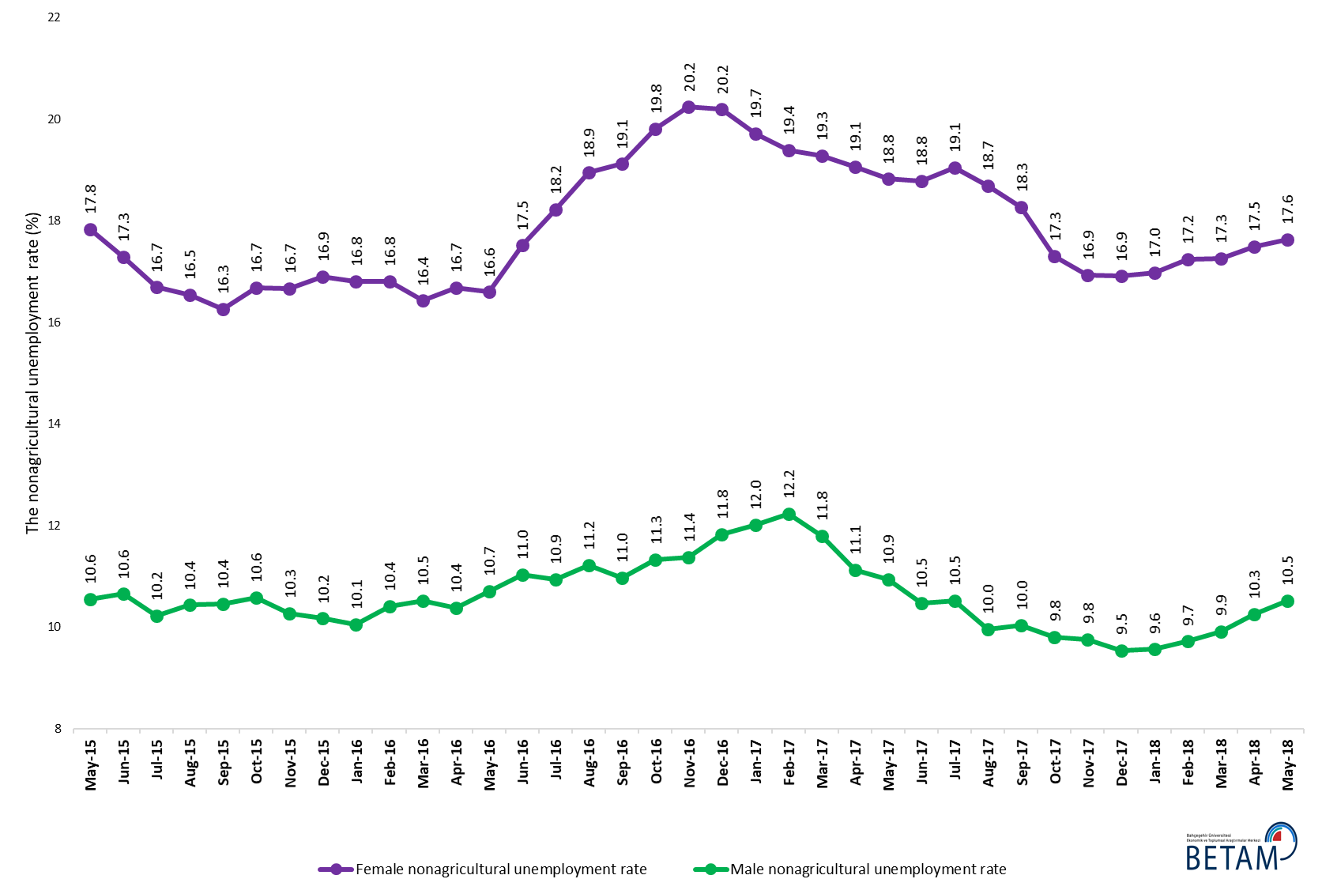
Source: Turkstat, Betam

Table 1 Seasonally adjusted non-agricultural labor market indicators (in thousands) *
 | Labor force | Employment | Unemployment | Unemployment rate | Monthly changes
April-15 | 23863 | 20928 | 2935 | 12.3% | Labor force | Employment | Unemployment
May-15 | 24001 | 21025 | 2976 | 12.4% | 138 | 97 | 41
June-15 | 24049 | 21043 | 3006 | 12.5% | 48 | 18 | 30
July-15 | 24203 | 21250 | 2953 | 12.2% | 154 | 207 | -53
August-15 | 24125 | 21158 | 2967 | 12.3% | -77 | -92 | 15
September-15 | 24342 | 21348 | 2994 | 12.3% | 217 | 190 | 27
October-15 | 24411 | 21360 | 3051 | 12.5% | 69 | 12 | 57
November-15 | 24546 | 21527 | 3019 | 12.3% | 135 | 167 | -32
December-15 | 24622 | 21618 | 3004 | 12.2% | 76 | 91 | -15
January-16 | 24745 | 21751 | 2994 | 12.1% | 123 | 133 | -10
February-16 | 24851 | 21869 | 2982 | 12.0% | 106 | 118 | -12
March-16 | 24875 | 21940 | 2935 | 11.8% | 24 | 71 | -47
April-16 | 24995 | 22046 | 2949 | 11.8% | 120 | 106 | 14
May-16 | 25129 | 22038 | 3091 | 12.3% | 133 | -8 | 141
June-16 | 25116 | 21851 | 3265 | 13.0% | -13 | -187 | 174
July-16 | 25164 | 21842 | 3322 | 13.2% | 48 | -9 | 57
August-16 | 25171 | 21748 | 3423 | 13.6% | 8 | -94 | 102
September-16 | 25351 | 21929 | 3422 | 13.5% | 180 | 181 | -1
October-16 | 25530 | 21956 | 3574 | 14.0% | 179 | 27 | 152
November-16 | 25639 | 22024 | 3615 | 14.1% | 109 | 68 | 41
December-16 | 25596 | 21936 | 3660 | 14.3% | -43 | -88 | 45
January-17 | 25693 | 22070 | 3623 | 14.1% | 96 | 134 | -38
February-17 | 25814 | 22200 | 3614 | 14.0% | 121 | 130 | -9
March-17 | 25988 | 22428 | 3560 | 13.7% | 174 | 228 | -54
April-17 | 26039 | 22576 | 3463 | 13.3% | 51 | 148 | -97
May-17 | 26071 | 22630 | 3441 | 13.2% | 32 | 54 | -22
June-17 | 26123 | 22727 | 3396 | 13.0% | 52 | 97 | -45
July-17 | 26127 | 22678 | 3449 | 13.2% | 4 | -49 | 53
August-17 | 26237 | 22905 | 3332 | 12.7% | 110 | 227 | -117
September-17 | 26278 | 22967 | 3311 | 12.6% | 41 | 62 | -21
October-17 | 26317 | 23106 | 3211 | 12.2% | 39 | 139 | -100
November-17 | 26415 | 23219 | 3196 | 12.1% | 99 | 113 | -14
December-17 | 26452 | 23304 | 3148 | 11.9% | 37 | 85 | -48
January-18 | 26495 | 23369 | 3126 | 11.8% | 44 | 65 | -21
February-18 | 26604 | 23465 | 3139 | 11.8% | 109 | 96 | 13
March-18 | 26621 | 23453 | 3168 | 11.9% | 17 | -12 | 29
April-18 | 26695 | 23438 | 3257 | 12.2% | 74 | -15 | 89
May-18 | 26729 | 23388 | 3341 | 12.5% | 34 | -50 | 84
Source: Turkstat, Betam

Table 2 Seasonally adjusted employment by sectors (in thousands) *
 | Agriculture | Manufacturing | Construction | Service | Monthly changes
April-15 | 5517 | 5326 | 1884 | 13718 | Agriculture | Manufacturing | Construction | Service
May-15 | 5545 | 5404 | 1879 | 13742 | 28 | 78 | -5 | 24
June-15 | 5581 | 5380 | 1874 | 13789 | 36 | -24 | -5 | 47
July-15 | 5504 | 5336 | 1925 | 13988 | -77 | -44 | 51 | 199
August-15 | 5535 | 5252 | 1921 | 13985 | 31 | -84 | -4 | -3
September-15 | 5516 | 5327 | 1943 | 14077 | -19 | 75 | 22 | 92
October-15 | 5449 | 5363 | 1962 | 14034 | -67 | 36 | 19 | -43
November-15 | 5386 | 5353 | 1986 | 14188 | -63 | -10 | 24 | 154
December-15 | 5407 | 5311 | 1991 | 14316 | 21 | -42 | 5 | 128
January-16 | 5372 | 5300 | 1996 | 14455 | -35 | -11 | 5 | 139
February-16 | 5327 | 5276 | 1992 | 14601 | -45 | -24 | -4 | 146
March-16 | 5388 | 5295 | 2018 | 14628 | 61 | 19 | 26 | 27
April-16 | 5370 | 5381 | 2033 | 14632 | -18 | 86 | 15 | 4
May-16 | 5329 | 5386 | 2061 | 14591 | -41 | 5 | 28 | -41
June-16 | 5182 | 5330 | 1962 | 14559 | -147 | -56 | -99 | -32
July-16 | 5213 | 5254 | 1955 | 14633 | 31 | -76 | -7 | 74
August-16 | 5273 | 5224 | 1924 | 14599 | 60 | -30 | -31 | -34
September-16 | 5338 | 5260 | 2031 | 14638 | 65 | 36 | 107 | 39
October-16 | 5283 | 5282 | 1997 | 14677 | -55 | 22 | -34 | 39
November-16 | 5285 | 5316 | 1994 | 14714 | 2 | 34 | -3 | 37
December-16 | 5309 | 5265 | 1954 | 14717 | 24 | -51 | -40 | 3
January-17 | 5434 | 5274 | 1959 | 14837 | 125 | 9 | 5 | 120
February-17 | 5475 | 5251 | 2015 | 14934 | 41 | -23 | 56 | 97
March-17 | 5385 | 5346 | 2086 | 14996 | -90 | 95 | 71 | 62
April-17 | 5351 | 5372 | 2122 | 15082 | -34 | 26 | 36 | 86
May-17 | 5382 | 5386 | 2087 | 15157 | 31 | 14 | -35 | 75
June-17 | 5379 | 5383 | 2078 | 15266 | -3 | -3 | -9 | 109
July-17 | 5506 | 5363 | 2098 | 15217 | 127 | -20 | 20 | -49
August-17 | 5467 | 5437 | 2152 | 15316 | -39 | 74 | 54 | 99
September-17 | 5529 | 5421 | 2126 | 15420 | 62 | -16 | -26 | 104
October-17 | 5507 | 5470 | 2115 | 15522 | -22 | 49 | -11 | 102
November-17 | 5520 | 5470 | 2143 | 15606 | 13 | 0 | 28 | 84
December-17 | 5550 | 5514 | 2179 | 15612 | 30 | 44 | 36 | 6
January-18 | 5493 | 5567 | 2198 | 15603 | -57 | 53 | 19 | -9
February-18 | 5419 | 5627 | 2192 | 15647 | -74 | 60 | -6 | 44
March-18 | 5362 | 5618 | 2143 | 15692 | -57 | -9 | -49 | 45
April-18 | 5341 | 5650 | 2091 | 15697 | -21 | 32 | -52 | 5
May-18 | 5293 | 5669 | 2042 | 15678 | -48 | 19 | -49 | -19
Source: Turkstat, Betam

Table 3: Seasonally adjusted non-agricultural labor force by gender (thousands)

 | Female Labor Force | Female Employment | Female Unemployed | Male Labor Force | Male Employment | Male Unemployed
May-15 | 6624 | 5442 | 1182 | 17352 | 15521 | 1831
June-15 | 6657 | 5506 | 1151 | 17427 | 15571 | 1856
July-15 | 6751 | 5624 | 1127 | 17487 | 15699 | 1787
August-15 | 6715 | 5605 | 1110 | 17483 | 15659 | 1824
September-15 | 6760 | 5661 | 1099 | 17577 | 15741 | 1837
October-15 | 6782 | 5650 | 1132 | 17616 | 15753 | 1864
November-15 | 6876 | 5730 | 1146 | 17620 | 15812 | 1808
December-15 | 6968 | 5790 | 1178 | 17658 | 15863 | 1795
January-16 | 7011 | 5833 | 1178 | 17686 | 15908 | 1778
February-16 | 7044 | 5860 | 1184 | 17765 | 15917 | 1848
March-16 | 7058 | 5899 | 1159 | 17815 | 15942 | 1873
April-16 | 7143 | 5951 | 1191 | 17844 | 15993 | 1851
May-16 | 7174 | 5983 | 1191 | 17929 | 16009 | 1920
June-16 | 7261 | 5989 | 1272 | 17869 | 15898 | 1971
July-16 | 7271 | 5946 | 1325 | 17923 | 15963 | 1960
August-16 | 7328 | 5940 | 1388 | 17915 | 15904 | 2011
September-16 | 7377 | 5967 | 1410 | 17982 | 16010 | 1973
October-16 | 7443 | 5968 | 1475 | 18058 | 16014 | 2044
November-16 | 7460 | 5950 | 1510 | 18147 | 16083 | 2064
December-16 | 7457 | 5950 | 1507 | 18158 | 16011 | 2147
January-17 | 7450 | 5981 | 1469 | 18271 | 16077 | 2194
February-17 | 7509 | 6053 | 1456 | 18303 | 16064 | 2239
March-17 | 7613 | 6146 | 1468 | 18364 | 16198 | 2166
April-17 | 7600 | 6151 | 1449 | 18390 | 16345 | 2045
May-17 | 7650 | 6210 | 1440 | 18375 | 16365 | 2011
June-17 | 7669 | 6229 | 1440 | 18463 | 16530 | 1933
July-17 | 7681 | 6218 | 1463 | 18460 | 16519 | 1941
August-17 | 7734 | 6289 | 1445 | 18565 | 16716 | 1849
September-17 | 7768 | 6348 | 1420 | 18524 | 16666 | 1859
October-17 | 7793 | 6444 | 1348 | 18498 | 16685 | 1814
November-17 | 7829 | 6503 | 1326 | 18545 | 16736 | 1809
December-17 | 7887 | 6553 | 1334 | 18542 | 16773 | 1769
January-18 | 7923 | 6578 | 1345 | 18539 | 16767 | 1772
February-18 | 7952 | 6581 | 1371 | 18606 | 16798 | 1808
March-18 | 7948 | 6577 | 1372 | 18654 | 16805 | 1849
April-18 | 7985 | 6588 | 1397 | 18692 | 16775 | 1917
May-18 | 8020 | 6606 | 1414 | 18679 | 16716 | 1964
Source: Turkstat, Betam

* Seyfettin Gürsel, Betam, Direktör, seyfettin.gursel@eas.bau.edu.tr
∗∗ Uğurcan Acar, Betam, Araştırma Görevlisi, ugurcan.acar@eas.bau.edu.tr
For detailed information on Betam's forecasting model, please see Betam Research Brief 168 titled as "Kariyer.net Verisiyle Kısa Vadeli Tarım Dışı İşsizlik Tahmini" . For the innovations in the model please see Betam Research Brief 14 titled as "Mevsim Etkilerinden Arındırılmış İşsizlik Tahmini" Soybilgen, B., "Kariyer.net Verisiyle Kısa Vadeli Tarım Dışı İşsizlik Tahmini", Betam Research Brief 168. http://betam.bahcesehir.edu.tr/tr/2014/06/kariyer-net-verisiyle-kisa-vadeli-tarim-disi-issizlik-tahmini/ Soybilgen, B., "Mevsim Etkilerinden Arındırılmış İşsizlik Tahmini", Betam Research Brief 14 http://betam.bahcesehir.edu.tr/2015/08/mevsim-etkilerinden-arindirilmis-tarim-disi-issizlik-tahmini/
Betam has been calculating application per vacancy using series released by Kariyer.net for a while. Seasonal and calendar adjustment procedure is applied to application per vacancy series. A decrease in applications per vacancy may be caused by an increase in vacancies or by a decrease in the number of applications. An increase in vacancies signals economic growth while decreasing number of applications indicates a decrease in number of people looking for a job. Monthly labor market series released by TurkStat is the average of three months. Therefore, application per vacancy statistics calculated using Kariyer.net series is the average of three months as well.
Employment in each sector is seasonally adjusted separately. Hence the sum of these series may differ from the seasonally adjusted series of total employment. The difference stems from the non-linearity of the seasonal adjustment process.
Turkstat revised the labor market statistics drastically in February 2014. Within this framework, they back casted various labor market indicators and they also continued to announce seasonally adjusted series. However, Turkstat is not providing back-casted series by gender. Therefore, female and male labor market statistics are not sufficiently long for the seasonal adjustment procedures (There should be minimum 36 observations). With the announcement of the period of February 2017 data, the number of observations required for the seasonal decontamination process was provided. From this period Betam get seasonal adjustment series in terms of gender. Nevertheless, it should not be forgotten that seasonal adjustment may cause extra volatility in the series for at least a while.

