Labor Market Outlook:
July 2018

16 July 2018

SHARP INCREASE IN NON-AGRICULTURAL UNEMPLOYMENT
Gökçe Uysal* and Uğurcan Acar ∗∗

Executive Summary

Seasonally adjusted labor market data shows that, in the period of April 2018 compared to March 2018, non-agricultural unemployment rate increased by 0.4 percentage points and reached 12.2 percent. An increase in the labor force and a decrease in employment concurrently are the reasons behind the increase in non-agricultural unemployment. Sectoral data indicates that employment in manufacturing increased while employment in services remained almost unchanged. On the other hand, there have been strong employment losses in construction in the last two periods. Thus the non-agricultural unemployment rate has increased to 12.2 percent. Since employment losses occurred mostly in construction where men are more likely to be employed, the gender gap in non-agricultural unemployment rates have decreased in favor of women. Betam’s forecasting model predicts that the non-agricultural unemployment will increase to 12.3 percent in the period of May 2018.

The non-agricultural labor force increased while employment decreased

According to seasonally adjusted labor market data, in the period of April 2018 compared to March 2018, the non-agricultural labor force increased by 105 thousand and reached 26 million 729 thousand while the number of employed in non-agricultural sectors decreased by 14 thousand and reached 23 million 468 thousand (Figure 1, Table 1). As result, the number of unemployed in non-agricultural sectors increased by 119 thousand and recorded as 3 million 261 thousand and the non-agricultural unemployment rate rose to 12.2 percent.

Figure 1 Seasonally adjusted non-agricultural labor force, employment, and unemployment

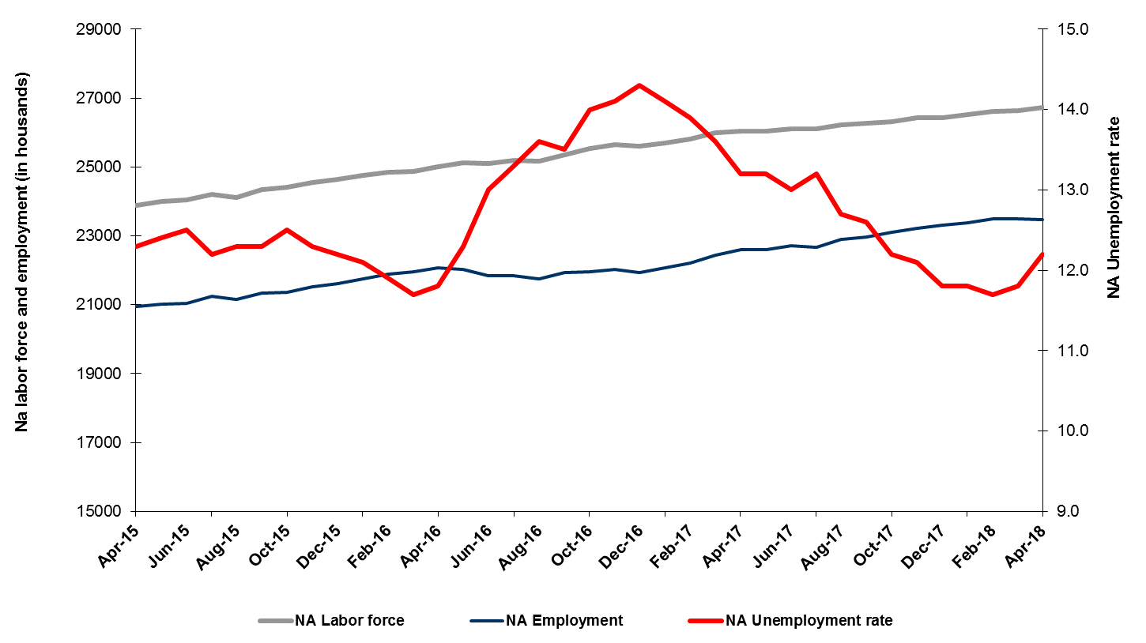
Source: Turkstat, Betam
Unemployment rate is expected to increase by 0.1 percentage point in the period of May 2018

Betam's forecasting model had predicted that the seasonally adjusted non-agricultural unemployment rate would remain constant at 11.7 percent in the April 2018. TURKSTAT revised the unemployment rate of March from 11.7 percent to 11.8. The non-agricultural unemployment rate rose to 12.2 percent in the period of April 2018. Betam’s forecasting model predicts that the non-agricultural unemployment rate will reach to 12.3 percent in the period of May 2018. Forecasting model details are available on Betam's website. Kariyer.net application per vacancy series used in the Betam forecasting model is depicted in Figure 3. Kariyer.net series is only one of the inputs of Betam forecast model. Indeed, several variables such as employment agency (İŞKUR) data, reel sector confidence index, capacity utilization rate are used in forecasting.

Figure 2 Seasonally adjusted non-agricultural unemployment rate and application per vacancy
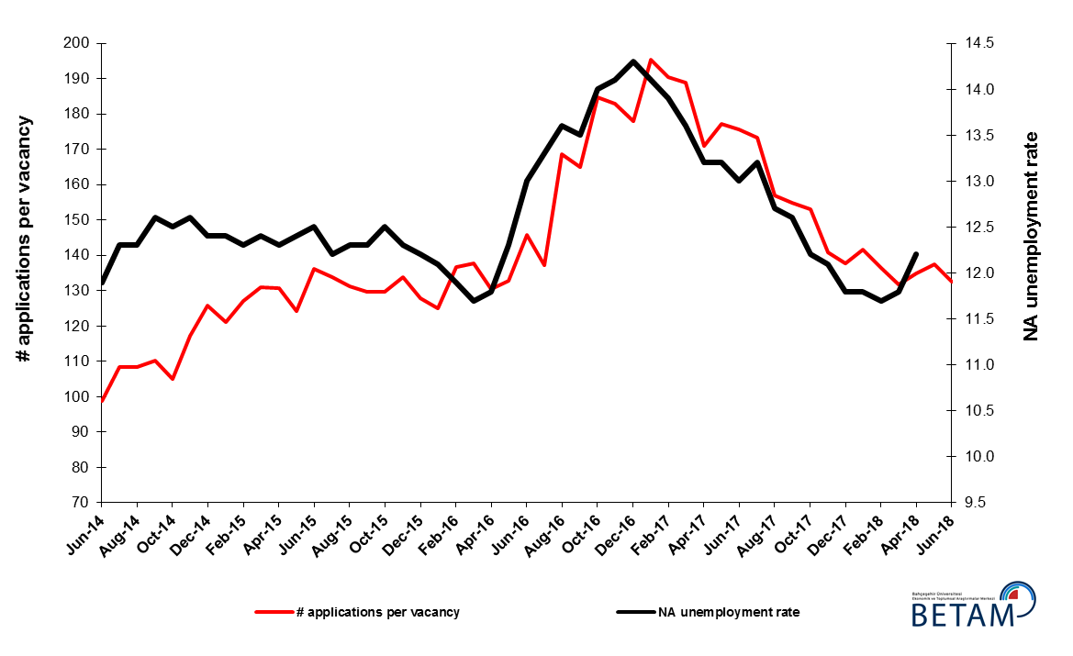
Source: Kariyer.net, Turkstat, Betam

Employment decreases in construction continues

According to seasonally adjusted sectoral labor market data, employment decreased in agriculture and construction while employment increased in manufacturing and services in April 2018 compared to March 2018 (Figure 3, Table 2). Employment increased by 32 thousand in manufacturing and 6 thousand in services. On the other hand, employment in agriculture and construction decreased by 20 and 52 thousand respectively. Employment losses in construction in the last two periods have reached 100 thousand. The increase in employment in the service sector, which shoulders about half of the total employment, stalled in this period, whereas the employment losses in construction have continued, resulting in a sizeable increase in non-agricultural unemployment.
Figure 3: Employment by sectors (in thousands)
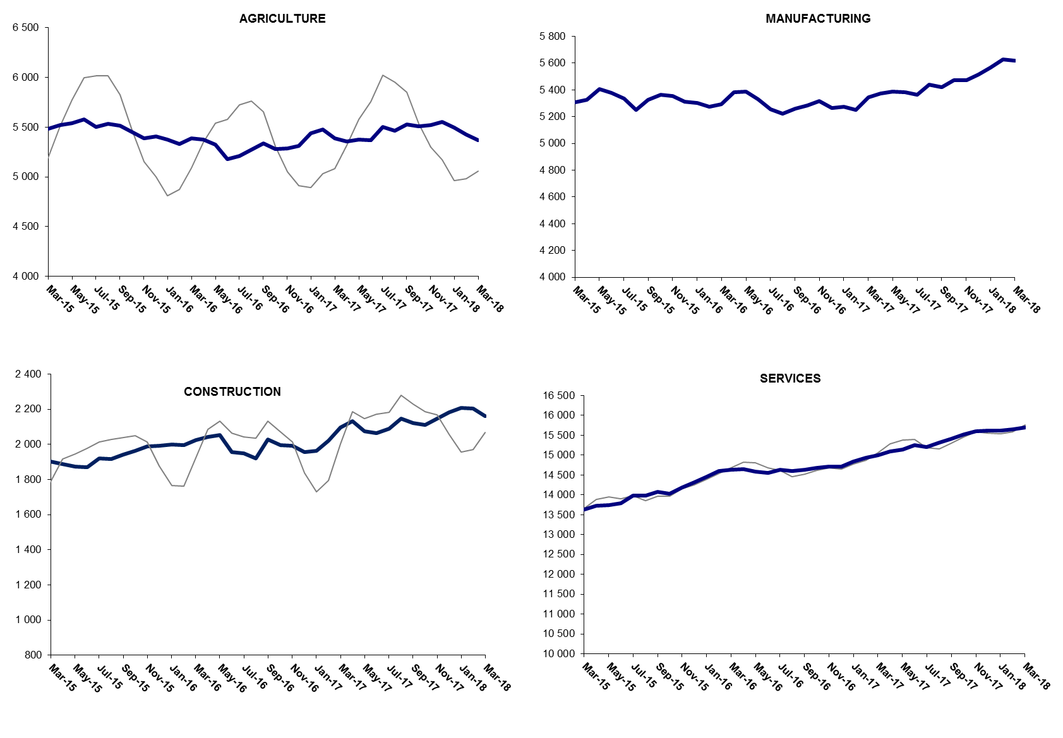

Source: TURKSTAT, Betam

The number of non-agricultural unemployed decreased within a year

From April 2017 to April 2018 non-agricultural labor force increased by 685 thousand (2.6 percent) and non-agricultural employment increased by 868 thousand (3.8 percent) (Figure 4). Thus, non-agricultural unemployed decreased by 183 thousand and attained 3 million 50 thousand (Figure 4).

Figure 4 Year-on-year changes in non-agricultural labor force, employment, and unemployment
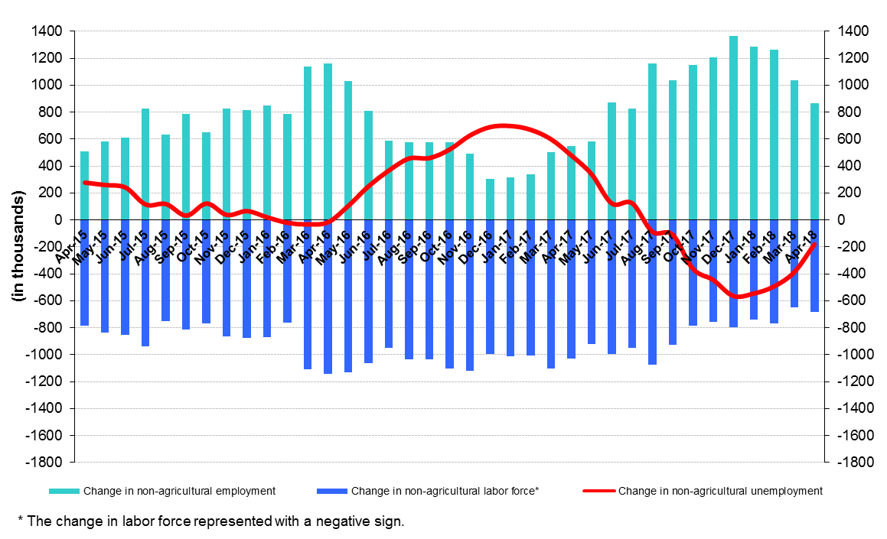
Source: Turkstat, Betam

Unemployment ratio difference between female and male decreased

Figure 5 shows seasonally adjusted non-agricultural unemployment rate for males (green) and for females (purple). In the period of April 2018, the non-agricultural female unemployment rate increased by 0.3 percentage points to 17.5 percent while non-agricultural male unemployment rate increased by 0.4 percentage points to 10 percent. In other words non-agricultural unemployment increases were larger for males. Thus, the gender gap in non-agricultural unemployment rates dropped from 7.7 percent in March 2018 to 7.4 percent in April 2018. This may be due to the fact that men are more likely to be employed more in construction where employment losses were stronger.

Figure 5: Seasonally adjusted non-agricultural unemployment rate by gender
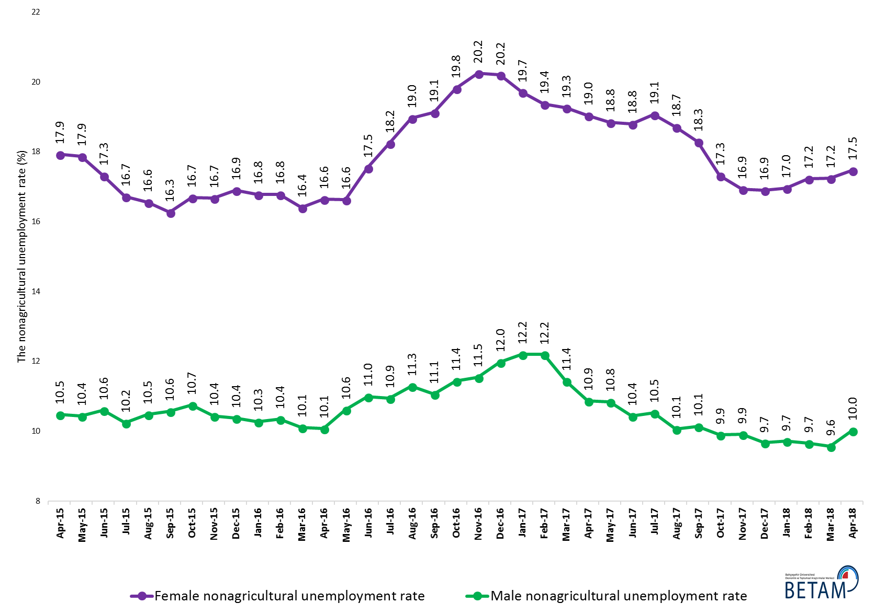
Source: Turkstat, Betam

Table 1 Seasonally adjusted non-agricultural labor market indicators (in thousands) *

 | Labor force | Employment | Unemployment | Unemployment rate | Monthly changes
March-15 | 23788 | 20838 | 2950 | 12.4% | Labor force | Employment | Unemployment
April-15 | 23873 | 20937 | 2936 | 12.3% | 86 | 99 | -13
May-15 | 23990 | 21015 | 2975 | 12.4% | 116 | 78 | 38
June-15 | 24038 | 21033 | 3005 | 12.5% | 48 | 18 | 30
July-15 | 24192 | 21241 | 2951 | 12.2% | 155 | 208 | -53
August-15 | 24115 | 21149 | 2966 | 12.3% | -77 | -92 | 15
September-15 | 24335 | 21342 | 2993 | 12.3% | 220 | 193 | 27
October-15 | 24407 | 21356 | 3051 | 12.5% | 72 | 14 | 58
November-15 | 24548 | 21529 | 3019 | 12.3% | 142 | 173 | -31
December-15 | 24628 | 21623 | 3005 | 12.2% | 79 | 94 | -15
January-16 | 24754 | 21759 | 2995 | 12.1% | 127 | 136 | -9
February-16 | 24837 | 21881 | 2956 | 11.9% | 82 | 122 | -40
March-16 | 24864 | 21955 | 2909 | 11.7% | 28 | 74 | -46
April-16 | 25015 | 22063 | 2952 | 11.8% | 151 | 108 | 43
May-16 | 25113 | 22024 | 3089 | 12.3% | 98 | -39 | 137
June-16 | 25101 | 21838 | 3263 | 13.0% | -12 | -186 | 174
July-16 | 25180 | 21831 | 3349 | 13.3% | 79 | -7 | 86
August-16 | 25160 | 21738 | 3422 | 13.6% | -20 | -93 | 73
September-16 | 25345 | 21923 | 3422 | 13.5% | 185 | 185 | 0
October-16 | 25526 | 21952 | 3574 | 14.0% | 181 | 29 | 152
November-16 | 25641 | 22026 | 3615 | 14.1% | 116 | 74 | 42
December-16 | 25602 | 21941 | 3661 | 14.3% | -39 | -85 | 46
January-17 | 25703 | 22079 | 3624 | 14.1% | 101 | 138 | -37
February-17 | 25803 | 22216 | 3587 | 13.9% | 99 | 137 | -38
March-17 | 25981 | 22448 | 3533 | 13.6% | 179 | 232 | -53
April-17 | 26036 | 22599 | 3437 | 13.2% | 54 | 151 | -97
May-17 | 26046 | 22608 | 3438 | 13.2% | 10 | 9 | 1
June-17 | 26100 | 22707 | 3393 | 13.0% | 54 | 99 | -45
July-17 | 26108 | 22662 | 3446 | 13.2% | 8 | -45 | 53
August-17 | 26222 | 22892 | 3330 | 12.7% | 114 | 230 | -116
September-17 | 26269 | 22959 | 3310 | 12.6% | 47 | 67 | -20
October-17 | 26312 | 23102 | 3210 | 12.2% | 43 | 143 | -100
November-17 | 26421 | 23224 | 3197 | 12.1% | 109 | 122 | -13
December-17 | 26433 | 23314 | 3119 | 11.8% | 12 | 90 | -78
January-18 | 26514 | 23385 | 3129 | 11.8% | 80 | 71 | 9
February-18 | 26602 | 23490 | 3112 | 11.7% | 89 | 105 | -16
March-18 | 26624 | 23482 | 3142 | 11.8% | 21 | -8 | 29
April-18 | 26729 | 23468 | 3261 | 12.2% | 105 | -14 | 119
Source: Turkstat, Betam

Table 2 Seasonally adjusted employment by sectors (in thousands) *
 | Agriculture | Manufacturing | Construction | Service | Monthly changes
March-15 | 5244 | 5351 | 1862 | 13879 | Agriculture | Manufacturing | Construction | Service
April-15 | 5486 | 5308 | 1901 | 13629 | 242 | -43 | 39 | -250
May-15 | 5520 | 5326 | 1888 | 13724 | 34 | 18 | -13 | 95
June-15 | 5543 | 5404 | 1875 | 13737 | 23 | 78 | -13 | 13
July-15 | 5578 | 5380 | 1869 | 13785 | 35 | -24 | -6 | 48
August-15 | 5502 | 5336 | 1920 | 13985 | -76 | -44 | 51 | 200
September-15 | 5534 | 5252 | 1918 | 13980 | 32 | -84 | -2 | -5
October-15 | 5515 | 5327 | 1941 | 14074 | -19 | 75 | 23 | 94
November-15 | 5449 | 5363 | 1962 | 14031 | -66 | 36 | 21 | -43
December-15 | 5386 | 5353 | 1987 | 14189 | -63 | -10 | 25 | 158
January-16 | 5408 | 5311 | 1993 | 14318 | 22 | -42 | 6 | 129
February-16 | 5374 | 5300 | 1999 | 14459 | -34 | -11 | 6 | 141
March-16 | 5330 | 5276 | 1996 | 14608 | -44 | -24 | -3 | 149
April-16 | 5391 | 5295 | 2025 | 14635 | 61 | 19 | 29 | 27
May-16 | 5374 | 5381 | 2041 | 14641 | -17 | 86 | 16 | 6
June-16 | 5325 | 5386 | 2054 | 14584 | -49 | 5 | 13 | -57
July-16 | 5177 | 5330 | 1955 | 14553 | -148 | -56 | -99 | -31
August-16 | 5210 | 5254 | 1950 | 14628 | 33 | -76 | -5 | 75
September-16 | 5271 | 5224 | 1921 | 14593 | 61 | -30 | -29 | -35
October-16 | 5337 | 5260 | 2029 | 14633 | 66 | 36 | 108 | 40
November-16 | 5282 | 5282 | 1995 | 14675 | -55 | 22 | -34 | 42
December-16 | 5285 | 5316 | 1994 | 14715 | 3 | 34 | -1 | 40
January-17 | 5310 | 5265 | 1956 | 14719 | 25 | -51 | -38 | 4
February-17 | 5437 | 5274 | 1963 | 14841 | 127 | 9 | 7 | 122
March-17 | 5479 | 5251 | 2022 | 14942 | 42 | -23 | 59 | 101
April-17 | 5390 | 5346 | 2097 | 15005 | -89 | 95 | 75 | 63
May-17 | 5357 | 5372 | 2134 | 15093 | -33 | 26 | 37 | 88
June-17 | 5376 | 5386 | 2074 | 15147 | 19 | 14 | -60 | 54
July-17 | 5372 | 5383 | 2065 | 15258 | -4 | -3 | -9 | 111
August-17 | 5501 | 5363 | 2089 | 15210 | 129 | -20 | 24 | -48
September-17 | 5464 | 5437 | 2147 | 15308 | -37 | 74 | 58 | 98
October-17 | 5527 | 5421 | 2123 | 15415 | 63 | -16 | -24 | 107
November-17 | 5506 | 5470 | 2112 | 15520 | -21 | 49 | -11 | 105
December-17 | 5521 | 5470 | 2145 | 15608 | 15 | 0 | 33 | 88
January-18 | 5552 | 5514 | 2184 | 15616 | 31 | 44 | 39 | 8
February-18 | 5498 | 5567 | 2208 | 15610 | -54 | 53 | 24 | -6
March-18 | 5425 | 5627 | 2206 | 15657 | -73 | 60 | -2 | 47
April-18 | 5370 | 5618 | 2160 | 15704 | -55 | -9 | -46 | 47
Source: Turkstat, Betam

Table 3: Seasonally adjusted non-agricultural labor force by gender (thousands)

 | Female Labor Force | Female Employment | Female Unemployed | Male Labor Force | Male Employment | Male Unemployed
April-15 | 6541 | 5368 | 1173 | 17268 | 15457 | 1811
May-15 | 6625 | 5441 | 1184 | 17328 | 15518 | 1809
June-15 | 6658 | 5505 | 1153 | 17412 | 15567 | 1845
July-15 | 6751 | 5623 | 1128 | 17481 | 15690 | 1791
August-15 | 6715 | 5603 | 1112 | 17481 | 15648 | 1833
September-15 | 6760 | 5660 | 1100 | 17587 | 15728 | 1859
October-15 | 6782 | 5650 | 1132 | 17635 | 15740 | 1895
November-15 | 6876 | 5730 | 1146 | 17642 | 15800 | 1841
December-15 | 6968 | 5791 | 1177 | 17688 | 15853 | 1835
January-16 | 7010 | 5834 | 1177 | 17720 | 15900 | 1820
February-16 | 7044 | 5862 | 1182 | 17752 | 15914 | 1838
March-16 | 7058 | 5900 | 1157 | 17790 | 15991 | 1799
April-16 | 7142 | 5953 | 1189 | 17824 | 16029 | 1795
May-16 | 7175 | 5982 | 1193 | 17907 | 16006 | 1901
June-16 | 7261 | 5988 | 1273 | 17855 | 15893 | 1961
July-16 | 7271 | 5945 | 1327 | 17915 | 15954 | 1960
August-16 | 7328 | 5938 | 1390 | 17914 | 15892 | 2021
September-16 | 7377 | 5966 | 1411 | 17987 | 15997 | 1990
October-16 | 7443 | 5968 | 1475 | 18068 | 16001 | 2067
November-16 | 7460 | 5950 | 1510 | 18167 | 16071 | 2096
December-16 | 7457 | 5951 | 1506 | 18180 | 16001 | 2178
January-17 | 7449 | 5982 | 1468 | 18301 | 16070 | 2232
February-17 | 7509 | 6055 | 1455 | 18293 | 16062 | 2231
March-17 | 7613 | 6147 | 1466 | 18346 | 16247 | 2100
April-17 | 7599 | 6153 | 1446 | 18379 | 16381 | 1998
May-17 | 7651 | 6209 | 1442 | 18352 | 16362 | 1990
June-17 | 7670 | 6228 | 1442 | 18451 | 16525 | 1926
July-17 | 7682 | 6217 | 1465 | 18453 | 16510 | 1943
August-17 | 7734 | 6287 | 1447 | 18572 | 16704 | 1869
September-17 | 7767 | 6347 | 1420 | 18530 | 16653 | 1878
October-17 | 7792 | 6444 | 1349 | 18504 | 16672 | 1832
November-17 | 7828 | 6503 | 1326 | 18564 | 16724 | 1840
December-17 | 7886 | 6554 | 1333 | 18558 | 16763 | 1794
January-18 | 7922 | 6579 | 1343 | 18562 | 16760 | 1803
February-18 | 7952 | 6583 | 1370 | 18593 | 16796 | 1797
March-18 | 7948 | 6578 | 1370 | 18638 | 16853 | 1785
April-18 | 7984 | 6590 | 1394 | 18684 | 16811 | 1873
Source: Turkstat, Betam

* Gökçe Uysal, Betam, Direktör Yardımcısı, gokce.uysal@eas.bau.edu.tr
∗∗ Uğurcan Acar, Betam, Araştırma Görevlisi, ugurcan.acar@eas.bau.edu.tr
For detailed information on Betam's forecasting model, please see Betam Research Brief 168 titled as "Kariyer.net Verisiyle Kısa Vadeli Tarım Dışı İşsizlik Tahmini" . For the innovations in the model please see Betam Research Brief 14 titled as "Mevsim Etkilerinden Arındırılmış İşsizlik Tahmini" Soybilgen, B., "Kariyer.net Verisiyle Kısa Vadeli Tarım Dışı İşsizlik Tahmini", Betam Research Brief 168. http://betam.bahcesehir.edu.tr/tr/2014/06/kariyer-net-verisiyle-kisa-vadeli-tarim-disi-issizlik-tahmini/ Soybilgen, B., "Mevsim Etkilerinden Arındırılmış İşsizlik Tahmini", Betam Research Brief 14 http://betam.bahcesehir.edu.tr/2015/08/mevsim-etkilerinden-arindirilmis-tarim-disi-issizlik-tahmini/
Betam has been calculating application per vacancy using series released by Kariyer.net for a while. Seasonal and calendar adjustment procedure is applied to application per vacancy series. A decrease in applications per vacancy may be caused by an increase in vacancies or by a decrease in the number of applications. An increase in vacancies signals economic growth while decreasing number of applications indicates a decrease in number of people looking for a job. Monthly labor market series released by TurkStat is the average of three months. Therefore, application per vacancy statistics calculated using Kariyer.net series is the average of three months as well.
Employment in each sector is seasonally adjusted separately. Hence the sum of these series may differ from the seasonally adjusted series of total employment. The difference stems from the non-linearity of the seasonal adjustment process.
Turkstat revised the labor market statistics drastically in February 2014. Within this framework, they back casted various labor market indicators and they also continued to announce seasonally adjusted series. However, Turkstat is not providing back-casted series by gender. Therefore, female and male labor market statistics are not sufficiently long for the seasonal adjustment procedures (There should be minimum 36 observations). With the announcement of the period of February 2017 data, the number of observations required for the seasonal decontamination process was provided. From this period Betam get seasonal adjustment series in terms of gender. Nevertheless, it should not be forgotten that seasonal adjustment may cause extra volatility in the series for at least a while.

