Labor Market Outlook:
June 2018

18 June 2018

THE DECREASE IN UNEMPLOYMENT STOPPED IN MARCH
Seyfettin Gürsel* and Yazgı Genç ∗∗

Executive Summary

Seasonally adjusted labor market data shows that non-agricultural unemployment rate remained at 11.7 percent in the period of March. The non-agricultural unemployment rate decreased from 13.6 to 11.7 in the last year as a consequence of high GDP growth in 2017. As result, the non-agricultural unemployment rate has decreased by 1.9 percentage points in the recent year. The reason behind this decrease has been the strong increase in non-agricultural employment. This increase continues along with GDP growth; from March 2017 to March 2018, employment increased by 272 thousand in manufacture, 701 thousand in the services and 69 thousand in construction, 1 million 42 thousand in total. Betam’s forecasting model predicts that the non-agricultural unemployment will remain at 11.7 percent in the period of April 2018.

The non-agricultural unemployment remained constant compared with the previous period

According to seasonally adjusted labor market data, in the period of March 2018 compared to February 2018, the non-agricultural labor force decreased by 5 thousand and reached 26 million 619 thousand while the number of employed in non-agricultural sectors decreased by 4 thousand and reached 23 million 505 thousand (Figure 1, Table 1). As result, the number of unemployed in non-agricultural sectors decreased by a thousand and recorded as 3 million 114 thousand and the non-agricultural unemployment rate remained at 11.7 percent. In the last year, the seasonally adjusted non-agricultural unemployment rate decreased from 13.6 to 11.7 as a consequence of high GDP growth in 2017.

Figure 1 Seasonally adjusted non-agricultural labor force, employment, and unemployment

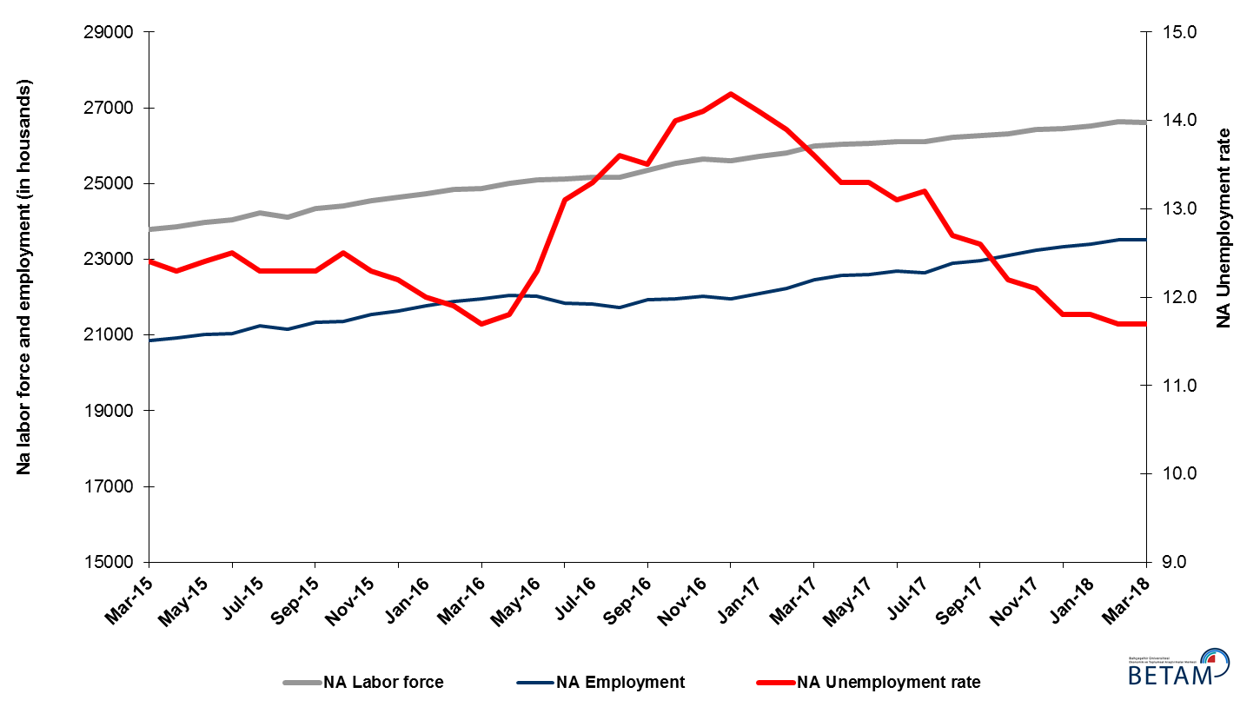
Source: Turkstat, Betam
Unemployment rate is expected to remain constant in the period of April 2018

Betam's forecasting model had predicted that the seasonally adjusted non-agricultural unemployment rate would decrease from 11.6 percent to 11.5 percent in the March 2018. TURKSTAT revised the unemployment rate of February from 11.6 percent to 11.7 and the non-agricultural unemployment rate remained constant at 11.7 percent in the period of March 2018. Betam’s forecasting model predicts that the non-agricultural unemployment rate will remain constant at 11.7 percent in April 2018. Forecasting model details are available on Betam's website. Kariyer.net application per vacancy series used in the Betam forecasting model is depicted in Figure 3. Kariyer.net series is only one of the inputs of Betam forecast model. Indeed, several variables such as employment agency (İŞKUR) data, reel sector confidence index, capacity utilization rate are used in forecasting.

Figure 2 Seasonally adjusted non-agricultural unemployment rate and application per vacancy
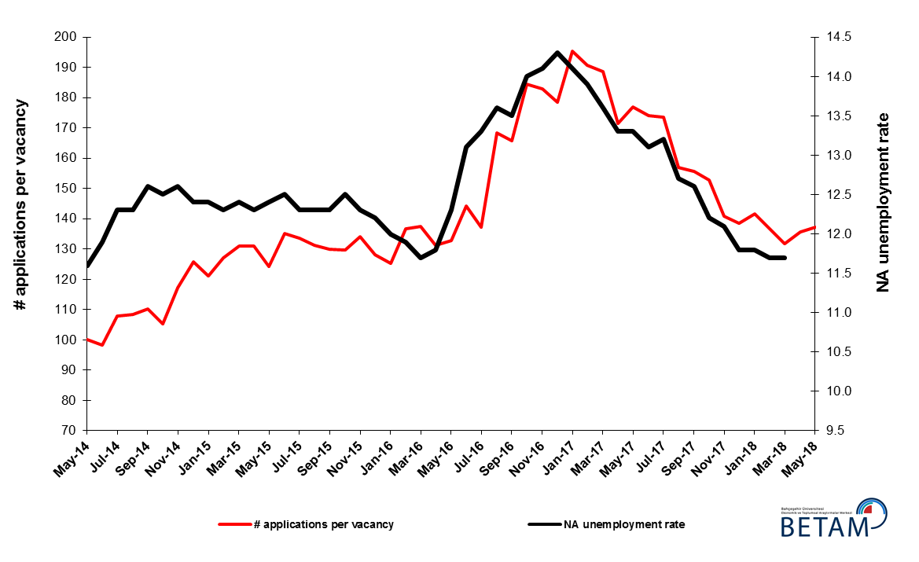
Source: Kariyer.net, Turkstat, Betam

Employment decreases in all sectors except services

According to seasonally adjusted sectorial labor market data in March 2018 compared to February 2018, employment decreased in agriculture, manufacturing and construction sectors while employment increased in services (Figure 3, Table 2). Employment decreased by 55, 9 and 44 thousand in agriculture, manufacturing and construction sectors respectively. On the other hand, employment in services increased by 48 thousand. It has to be noted that employment decrease in agriculture accelerates. On the other hand, increase of employment in construction and manufacturing sectors in the previous period has been replaced by a decrease. Non-agricultural unemployment rates which have fallen sharply in the past year have been realized thanks to the employment increases in all sectors. These yearly increases attained 272 thousand in manufacturing, 69 thousand in construction, 701 thousand in services and 1 million 42 thousand in total. Given that the GDP growth rate reached 7.4 percent in 2017, this increase in employment is reasonable.

Figure 3: Employment by sectors (in thousands)
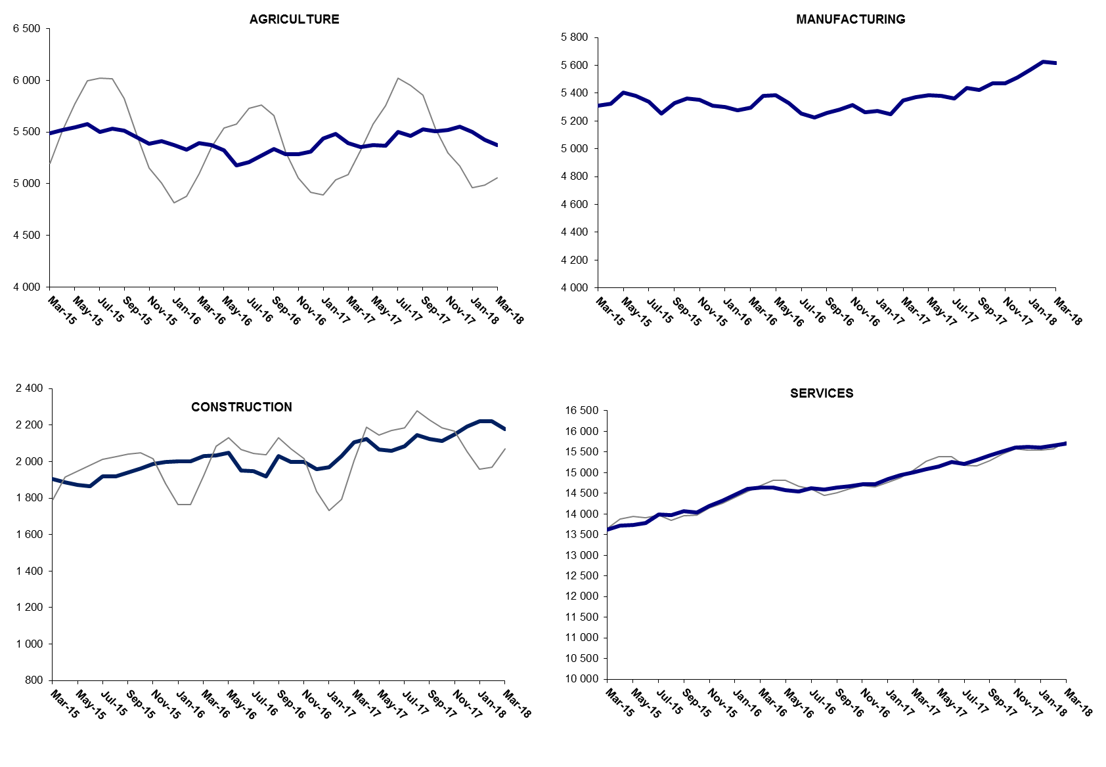

Source: TURKSTAT, Betam

The number of non-agricultural unemployed decreased by 390 thousand within a year

From March 2017 to March 2018 non-agricultural labor force increased by 648 thousand (2.5 percent) and non-agricultural employment increased by 1 million 38 thousand (4.6 percent) (Figure 4). Thus, non-agricultural unemployed decreased by 390 thousand and attained 3 million 166 thousand (Figure 4). Annual increases in non-agricultural employment exceed one million people since the period of August 2017. Since September 2017, the number of non-agricultural unemployed has decreased sharply as the non-agricultural labor force increases have been relatively weak.

Figure 4 Year-on-year changes in non-agricultural labor force, employment, and unemployment
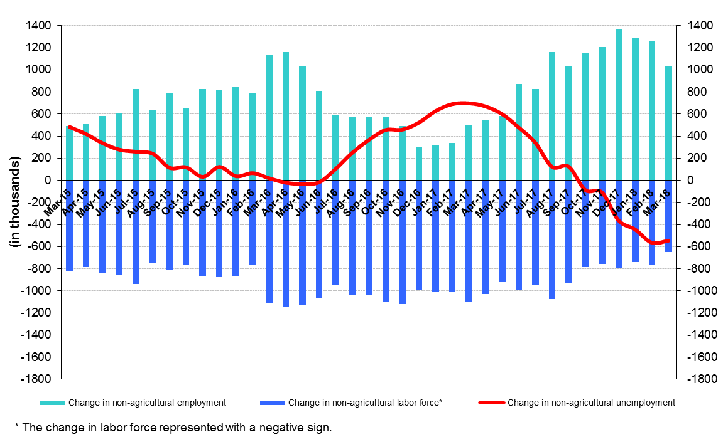
Source: Turkstat, Betam

Unemployment ratio difference between female and male did not decrease

Figure 5 shows seasonally adjusted non-agricultural unemployment rate for males (green) and for females (purple). In the period of March 2018, the non-agricultural female and male unemployment rate remained constant at 17.2 and 9.7 percent, respectively. Therefore, the gender gap in non-agricultural unemployment rate remained at 7.5 percentage points. The gender gap in non-agricultural unemployment rate which was 7.7 percentage points in the period of January 2017 (19.7 percent against 12.0 percent) had reached its peak of 8.6 percentage points in the period of August 2017 (18.7 percent against 10.1 percent), but then decreased to 7.1 percentage points in the period of November 2017. It can be said that the gender gap has entered an upward trend again in the last 4 periods. The fact that the gender gap in non-agricultural unemployment rate evolved at high level during a year where unemployment had a strong decrease indicates the insufficiency of policies which aims to gender equality in the labor market.

Figure 5: Seasonally adjusted non-agricultural unemployment rate by gender
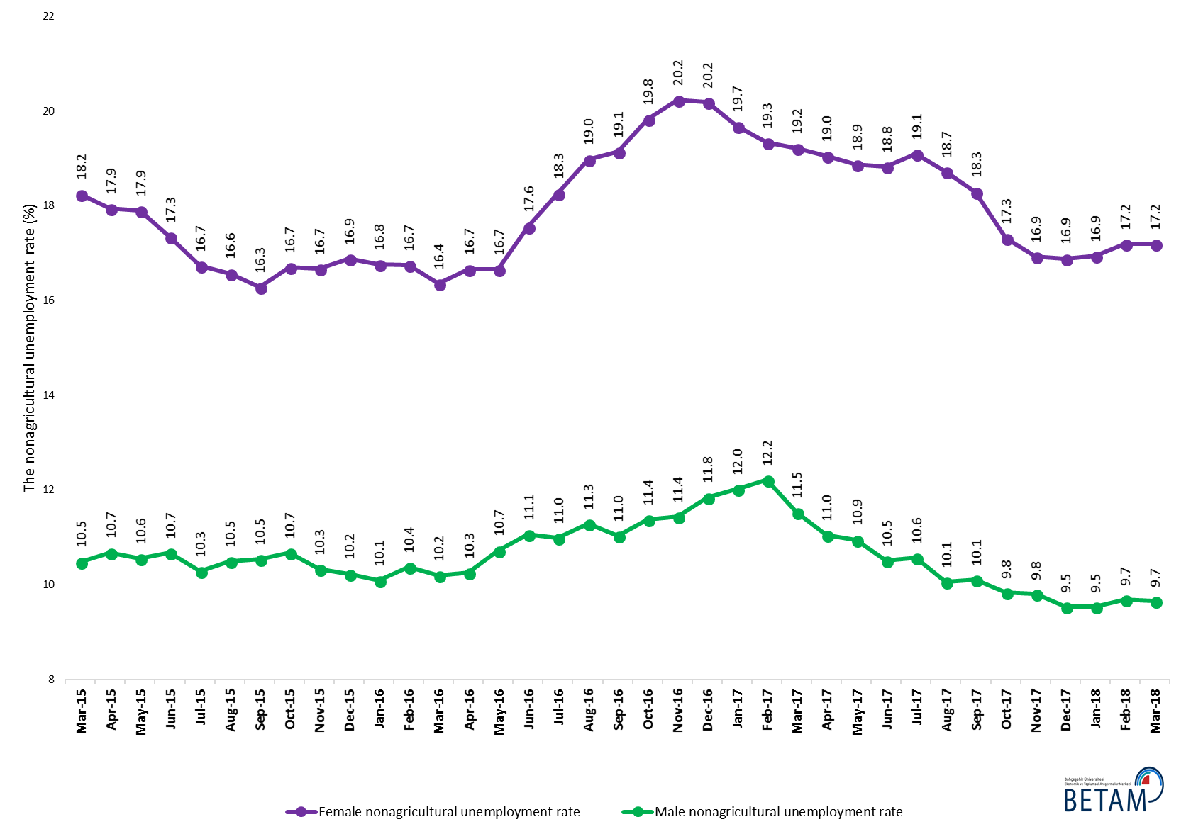
Source: Turkstat, Betam

Table 1 Seasonally adjusted non-agricultural labor market indicators (in thousands) *

 | Labor force | Employment | Unemployment | Unemployment rate | Monthly changes
February-15 | 24056 | 21097 | 2959 | 12.3% | Labor force | Employment | Unemployment
March-15 | 23795 | 20844 | 2951 | 12.4% | -261 | -253 | -8
April-15 | 23867 | 20931 | 2936 | 12.3% | 72 | 87 | -15
May-15 | 23983 | 21009 | 2974 | 12.4% | 116 | 78 | 38
June-15 | 24033 | 21029 | 3004 | 12.5% | 50 | 20 | 30
July-15 | 24216 | 21237 | 2979 | 12.3% | 182 | 208 | -26
August-15 | 24114 | 21148 | 2966 | 12.3% | -101 | -89 | -12
September-15 | 24335 | 21342 | 2993 | 12.3% | 221 | 194 | 27
October-15 | 24409 | 21358 | 3051 | 12.5% | 74 | 16 | 58
November-15 | 24551 | 21531 | 3020 | 12.3% | 142 | 173 | -31
December-15 | 24632 | 21627 | 3005 | 12.2% | 81 | 96 | -15
January-16 | 24732 | 21764 | 2968 | 12.0% | 100 | 137 | -37
February-16 | 24844 | 21888 | 2956 | 11.9% | 113 | 124 | -11
March-16 | 24875 | 21965 | 2910 | 11.7% | 31 | 77 | -46
April-16 | 25002 | 22052 | 2950 | 11.8% | 127 | 87 | 40
May-16 | 25103 | 22015 | 3088 | 12.3% | 100 | -37 | 137
June-16 | 25122 | 21831 | 3291 | 13.1% | 19 | -184 | 203
July-16 | 25174 | 21826 | 3348 | 13.3% | 52 | -5 | 57
August-16 | 25156 | 21735 | 3421 | 13.6% | -18 | -91 | 73
September-16 | 25343 | 21922 | 3421 | 13.5% | 187 | 187 | 0
October-16 | 25528 | 21954 | 3574 | 14.0% | 185 | 32 | 153
November-16 | 25645 | 22029 | 3616 | 14.1% | 117 | 75 | 42
December-16 | 25609 | 21947 | 3662 | 14.3% | -36 | -82 | 46
January-17 | 25712 | 22087 | 3625 | 14.1% | 103 | 140 | -37
February-17 | 25815 | 22227 | 3588 | 13.9% | 103 | 140 | -37
March-17 | 25999 | 22463 | 3536 | 13.6% | 184 | 236 | -52
April-17 | 26046 | 22582 | 3464 | 13.3% | 47 | 119 | -72
May-17 | 26060 | 22594 | 3466 | 13.3% | 14 | 12 | 2
June-17 | 26117 | 22696 | 3421 | 13.1% | 57 | 102 | -45
July-17 | 26099 | 22654 | 3445 | 13.2% | -18 | -42 | 24
August-17 | 26218 | 22888 | 3330 | 12.7% | 119 | 234 | -115
September-17 | 26268 | 22958 | 3310 | 12.6% | 50 | 70 | -20
October-17 | 26315 | 23105 | 3210 | 12.2% | 48 | 147 | -99
November-17 | 26428 | 23230 | 3198 | 12.1% | 112 | 125 | -13
December-17 | 26444 | 23324 | 3120 | 11.8% | 17 | 94 | -77
January-18 | 26529 | 23399 | 3130 | 11.8% | 85 | 75 | 10
February-18 | 26624 | 23509 | 3115 | 11.7% | 95 | 110 | -15
March-18 | 26619 | 23505 | 3114 | 11.7% | -5 | -4 | -1
Source: Turkstat, Betam

Table 2 Seasonally adjusted employment by sectors (in thousands) *

 | Agriculture | Manufacturing | Construction | Service | Monthly changes
February-15 | 5244 | 5351 | 1865 | 13882 | Agriculture | Manufacturing | Construction | Service
March-15 | 5487 | 5308 | 1904 | 13632 | 243 | -43 | 39 | -250
April-15 | 5519 | 5326 | 1885 | 13720 | 32 | 18 | -19 | 88
May-15 | 5542 | 5404 | 1871 | 13734 | 23 | 78 | -14 | 14
June-15 | 5577 | 5380 | 1866 | 13783 | 35 | -24 | -5 | 49
July-15 | 5502 | 5336 | 1918 | 13983 | -75 | -44 | 52 | 200
August-15 | 5533 | 5252 | 1917 | 13979 | 31 | -84 | -1 | -4
September-15 | 5515 | 5327 | 1941 | 14074 | -18 | 75 | 24 | 95
October-15 | 5449 | 5363 | 1963 | 14032 | -66 | 36 | 22 | -42
November-15 | 5387 | 5353 | 1988 | 14190 | -62 | -10 | 25 | 158
December-15 | 5409 | 5311 | 1996 | 14320 | 22 | -42 | 8 | 130
January-16 | 5375 | 5300 | 2003 | 14462 | -34 | -11 | 7 | 142
February-16 | 5331 | 5276 | 2001 | 14611 | -44 | -24 | -2 | 149
March-16 | 5393 | 5295 | 2031 | 14639 | 62 | 19 | 30 | 28
April-16 | 5373 | 5381 | 2035 | 14636 | -20 | 86 | 4 | -3
May-16 | 5324 | 5386 | 2049 | 14581 | -49 | 5 | 14 | -55
June-16 | 5176 | 5330 | 1951 | 14550 | -148 | -56 | -98 | -31
July-16 | 5209 | 5254 | 1946 | 14626 | 33 | -76 | -5 | 76
August-16 | 5271 | 5224 | 1919 | 14592 | 62 | -30 | -27 | -34
September-16 | 5337 | 5260 | 2029 | 14633 | 66 | 36 | 110 | 41
October-16 | 5282 | 5282 | 1996 | 14675 | -55 | 22 | -33 | 42
November-16 | 5286 | 5316 | 1997 | 14717 | 4 | 34 | 1 | 42
December-16 | 5311 | 5265 | 1960 | 14722 | 25 | -51 | -37 | 5
January-17 | 5439 | 5274 | 1968 | 14845 | 128 | 9 | 8 | 123
February-17 | 5481 | 5251 | 2030 | 14946 | 42 | -23 | 62 | 101
March-17 | 5392 | 5346 | 2107 | 15010 | -89 | 95 | 77 | 64
April-17 | 5356 | 5372 | 2124 | 15086 | -36 | 26 | 17 | 76
May-17 | 5374 | 5386 | 2065 | 15143 | 18 | 14 | -59 | 57
June-17 | 5370 | 5383 | 2058 | 15255 | -4 | -3 | -7 | 112
July-17 | 5500 | 5363 | 2084 | 15207 | 130 | -20 | 26 | -48
August-17 | 5463 | 5437 | 2144 | 15307 | -37 | 74 | 60 | 100
September-17 | 5527 | 5421 | 2122 | 15415 | 64 | -16 | -22 | 108
October-17 | 5506 | 5470 | 2114 | 15521 | -21 | 49 | -8 | 106
November-17 | 5522 | 5470 | 2149 | 15610 | 16 | 0 | 35 | 89
December-17 | 5554 | 5514 | 2192 | 15619 | 32 | 44 | 43 | 9
January-18 | 5500 | 5567 | 2219 | 15614 | -54 | 53 | 27 | -5
February-18 | 5427 | 5627 | 2220 | 15663 | -73 | 60 | 1 | 49
March-18 | 5372 | 5618 | 2176 | 15711 | -55 | -9 | -44 | 48
Source: Turkstat, Betam

Table 3: Seasonally adjusted non-agricultural labor force by gender (thousands)

 | Female Labor Force | Female Employment | Female Unemployed | Male Labor Force | Male Employment | Male Unemployed
March-15 | 6520 | 5330 | 1190 | 17239 | 15431 | 1808
April-15 | 6540 | 5366 | 1174 | 17295 | 15448 | 1847
May-15 | 6625 | 5439 | 1186 | 17345 | 15514 | 1831
June-15 | 6658 | 5503 | 1155 | 17422 | 15562 | 1860
July-15 | 6751 | 5622 | 1130 | 17485 | 15686 | 1799
August-15 | 6716 | 5603 | 1113 | 17478 | 15644 | 1834
September-15 | 6761 | 5660 | 1101 | 17578 | 15726 | 1852
October-15 | 6782 | 5650 | 1133 | 17620 | 15739 | 1881
November-15 | 6876 | 5730 | 1146 | 17622 | 15801 | 1821
December-15 | 6968 | 5792 | 1176 | 17663 | 15856 | 1807
January-16 | 7010 | 5835 | 1175 | 17691 | 15906 | 1785
February-16 | 7043 | 5863 | 1179 | 17767 | 15923 | 1844
March-16 | 7057 | 5902 | 1154 | 17818 | 16001 | 1817
April-16 | 7142 | 5951 | 1190 | 17851 | 16020 | 1831
May-16 | 7175 | 5980 | 1195 | 17924 | 16002 | 1922
June-16 | 7262 | 5986 | 1275 | 17865 | 15889 | 1976
July-16 | 7272 | 5944 | 1328 | 17918 | 15950 | 1968
August-16 | 7329 | 5938 | 1391 | 17911 | 15889 | 2022
September-16 | 7378 | 5966 | 1412 | 17978 | 15994 | 1984
October-16 | 7443 | 5968 | 1476 | 18054 | 16000 | 2054
November-16 | 7460 | 5950 | 1510 | 18147 | 16072 | 2076
December-16 | 7457 | 5952 | 1505 | 18155 | 16004 | 2151
January-17 | 7449 | 5983 | 1466 | 18272 | 16075 | 2197
February-17 | 7508 | 6056 | 1452 | 18308 | 16071 | 2237
March-17 | 7612 | 6149 | 1462 | 18374 | 16257 | 2117
April-17 | 7599 | 6151 | 1447 | 18405 | 16372 | 2033
May-17 | 7651 | 6207 | 1444 | 18369 | 16358 | 2011
June-17 | 7670 | 6226 | 1444 | 18461 | 16521 | 1941
July-17 | 7682 | 6216 | 1467 | 18457 | 16506 | 1951
August-17 | 7735 | 6287 | 1448 | 18569 | 16700 | 1869
September-17 | 7768 | 6347 | 1421 | 18521 | 16650 | 1871
October-17 | 7793 | 6444 | 1349 | 18490 | 16671 | 1819
November-17 | 7829 | 6503 | 1325 | 18544 | 16725 | 1819
December-17 | 7886 | 6555 | 1332 | 18534 | 16766 | 1767
January-18 | 7921 | 6580 | 1342 | 18533 | 16765 | 1768
February-18 | 7951 | 6584 | 1367 | 18608 | 16805 | 1803
March-18 | 7947 | 6580 | 1367 | 18666 | 16864 | 1802
Source: Turkstat, Betam

*Prof. Dr. Seyfettin Gürsel, Betam, Director, seyfettin.gursel@eas.bau.edu.tr
∗∗ Yazgı Genç, Betam, Research Assistant, yazgi.genc@eas.bau.edu.tr
For detailed information on Betam's forecasting model, please see Betam Research Brief 168 titled as "Kariyer.net Verisiyle Kısa Vadeli Tarım Dışı İşsizlik Tahmini" . For the innovations in the model please see Betam Research Brief 14 titled as "Mevsim Etkilerinden Arındırılmış İşsizlik Tahmini" Soybilgen, B., "Kariyer.net Verisiyle Kısa Vadeli Tarım Dışı İşsizlik Tahmini", Betam Research Brief 168. http://betam.bahcesehir.edu.tr/tr/2014/06/kariyer-net-verisiyle-kisa-vadeli-tarim-disi-issizlik-tahmini/ Soybilgen, B., "Mevsim Etkilerinden Arındırılmış İşsizlik Tahmini", Betam Research Brief 14 http://betam.bahcesehir.edu.tr/2015/08/mevsim-etkilerinden-arindirilmis-tarim-disi-issizlik-tahmini/
Betam has been calculating application per vacancy using series released by Kariyer.net for a while. Seasonal and calendar adjustment procedure is applied to application per vacancy series. A decrease in applications per vacancy may be caused by an increase in vacancies or by a decrease in the number of applications. An increase in vacancies signals economic growth while decreasing number of applications indicates a decrease in number of people looking for a job. Monthly labor market series released by TurkStat is the average of three months. Therefore, application per vacancy statistics calculated using Kariyer.net series is the average of three months as well.
Employment in each sector is seasonally adjusted separately. Hence the sum of these series may differ from the seasonally adjusted series of total employment. The difference stems from the non-linearity of the seasonal adjustment process.
Turkstat revised the labor market statistics drastically in February 2014. Within this framework, they back casted various labor market indicators and they also continued to announce seasonally adjusted series. However, Turkstat is not providing back-casted series by gender. Therefore, female and male labor market statistics are not sufficiently long for the seasonal adjustment procedures (There should be minimum 36 observations). With the announcement of the period of February 2017 data, the number of observations required for the seasonal decontamination process was provided. From this period Betam get seasonal adjustment series in terms of gender. Nevertheless, it should not be forgotten that seasonal adjustment may cause extra volatility in the series for at least a while.

