Labor Market Outlook:
May 2018

15 May 2018

THE DECREASE IN UNEMPLOYMENT SLOWS DOWN
Seyfettin Gürsel*, Yazgı Genç ∗∗ and Uğurcan Acar***

Executive Summary

Seasonally adjusted labor market data show that non-agricultural unemployment rate decreased by 0.1 percentage points in the period of February reaching 11.6 percent. The non-agricultural unemployment rate decreased from 13.9 to 11.6 in the last year as a consequence of high GDP growth in 2017. As result, the non-agricultural unemployment rate has decreased by 2.3 percentage points in the recent year. The reason behind this decrease has been the strong increase in non-agricultural employment. This increase continues along with GDP growth; from January 2018 to February 2018, employment increased by 60 thousand in manufacture, 49 thousand in the services and 3 thousand in construction. Betam’s forecasting model predicts that the non-agricultural unemployment will decrease by 0.1 percentage point to 11.5 percent in the period of March 2018.

Decrease in non-agricultural unemployment continues

According to seasonally adjusted labor market data, in the period of February 2018 compared to January 2018, the non-agricultural labor force increased by 96 thousand and reached 26 million 610 thousand while the number of employed in non-agricultural sectors increased by 111 thousand and reached 23 million 523 thousand (Figure 1, Table 1). As result, the number of unemployed in non-agricultural sectors decreased by 15 thousand and recorded as 3 million 87 thousand and the non-agricultural unemployment rate decreased from 11.7 percent to 11.6 percent. In the last year, the non-agricultural unemployment rate decreased from 13.9 to 11.6 as a consequence of high GDP growth in 2017.

Figure 1 Seasonally adjusted non-agricultural labor force, employment, and unemployment

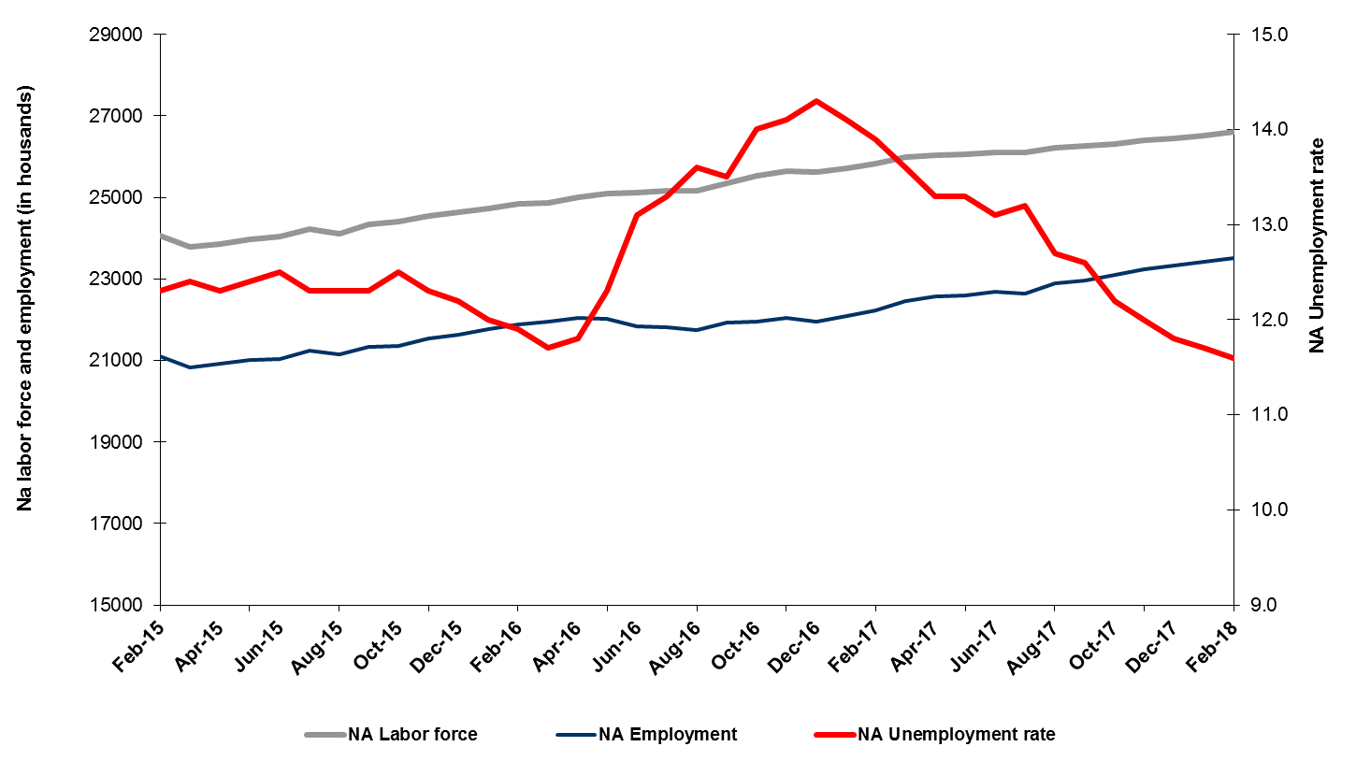
Source: Turkstat, Betam
Unemployment rate is expected to decrease in the period of March 2018

Betam's forecasting model had predicted that the seasonally adjusted non-agricultural unemployment rate would remain constant at 11.7 in the February 2018. However, the non-agricultural unemployment rate decreased by 0.1 percentage points in the period of February reaching 11.6 percent. Betam’s forecasting model predicts that the non-agricultural unemployment rate will decrease to 11.5 percent in March 2018. Forecasting model details are available on Betam's website. Kariyer.net application per vacancy series used in the Betam forecasting model is depicted in Figure 3. Kariyer.net series is only one of the inputs of Betam forecast model. Indeed, several variables such as employment agency (İŞKUR) data, reel sector confidence index, capacity utilization rate are used in forecasting.

Figure 2 Seasonally adjusted non-agricultural unemployment rate and application per vacancy
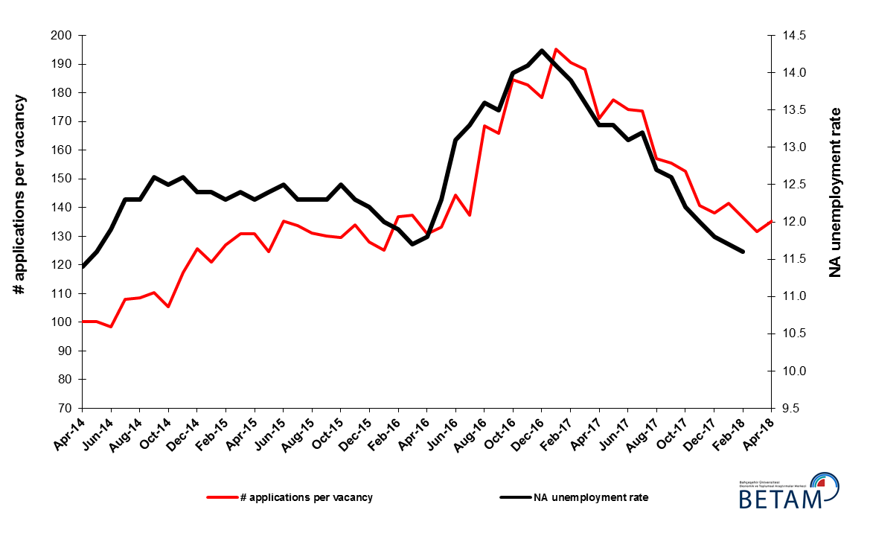
Source: Kariyer.net, Turkstat, Betam

Employment increases in all sectors except agriculture
According to seasonally adjusted sectorial labor market data in February 2018 compared to January 2017, employment increased in manufacturing, construction and services sectors while employment decreased in agriculture (Figure 3, Table 2). Employment increased by 60, 49 and 3 thousand in manufacture, services and construction, respectively. On the other hand, employment in agriculture sector decreased by 71 thousand. It has to be noted that while employment decrease in agriculture accelerates, increase in construction decelerates. On the other hand, exceptional decrease of employment in services sector in the previous period has been replaced by an usual increase.
Non-agricultural unemployment rates which have fallen sharply in the past year have been realized thanks to the employment increases in all sectors. These yearly increases attained 376 thousand in industry, 195 thousand in construction, 717 thousand in services and 1 million 288 thousand in total. Given that the GDP growth rate reached 7.4 percent in 2017, this increase in employment is reasonable.

Figure 3: Employment by sectors (in thousands)
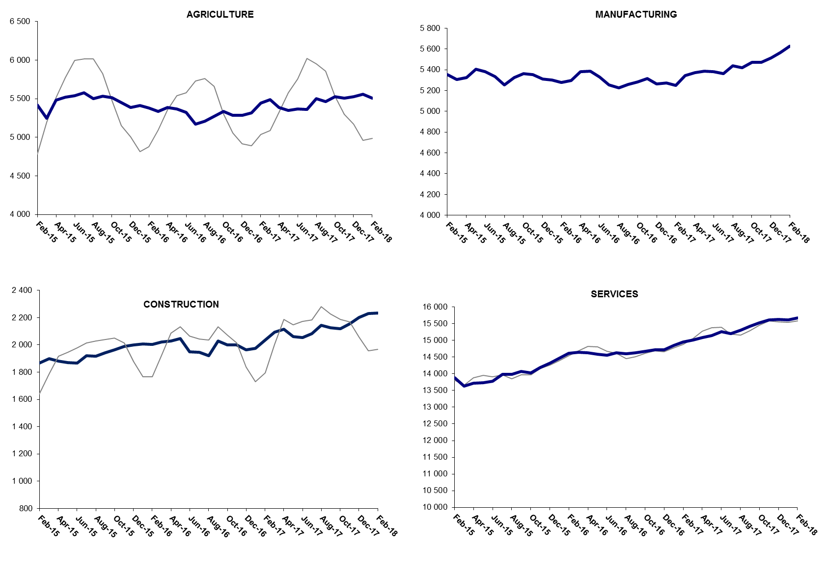

Source: TURKSTAT, Betam

The number of non-agricultural unemployed decreased by 496 thousand within a year

From February 2017 to February 2018 non-agricultural labor force increased by 766 thousand (3 percent) and non-agricultural employment by 1 million 262 thousand (5.8 percent) (Figure 4). Thus, non-agricultural unemployed decreased by 496 thousand and attained 3 million 312 thousand (Figure 4). Annual increases in non-agricultural employment exceed one million people since the period of August 2017. Since September 2017, the number of non-agricultural unemployed has decreased sharply as the non-agricultural labor force increases have been relatively weak.

Figure 4 Year-on-year changes in non-agricultural labor force, employment, and unemployment
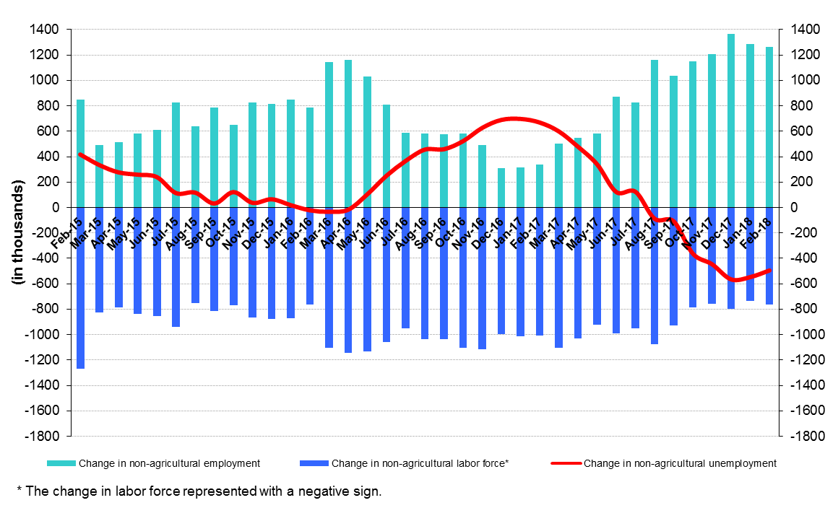
Source: Turkstat, Betam

Unemployment ratio difference between female and male increased

Figure 5 shows seasonally adjusted non-agricultural unemployment rate for males (green) and for females (purple). In the period of February 2018, the non-agricultural female unemployment rate increased from 16.9 to 17.2 percent, while the non-agricultural male unemployment rate decreased by 0.1 percent to 9.6 percent. The gender gap in non-agricultural unemployment rate increased sharply by 0.4 percentage points and reached 7.6 percentage points. The gender gap in non-agricultural unemployment rate which was 7.5 percentage points in the period of January 2017 (19.6 percent against 12.1 percent) had reached its peak of 8.6 percentage points in the period of August 2017 (18.7 percent against 10.1 percent), but then decreased to 7 percentage points. It can be said that the gender gap has entered an upward trend again in the last 3 periods. The fact that the gender gap in non-agricultural unemployment rate evolved at high level during a year where unemployment had a strong decrease indicates the insufficiency of policies which aims to gender equality in the labor market.

Figure 5: Seasonally adjusted non-agricultural unemployment rate by gender
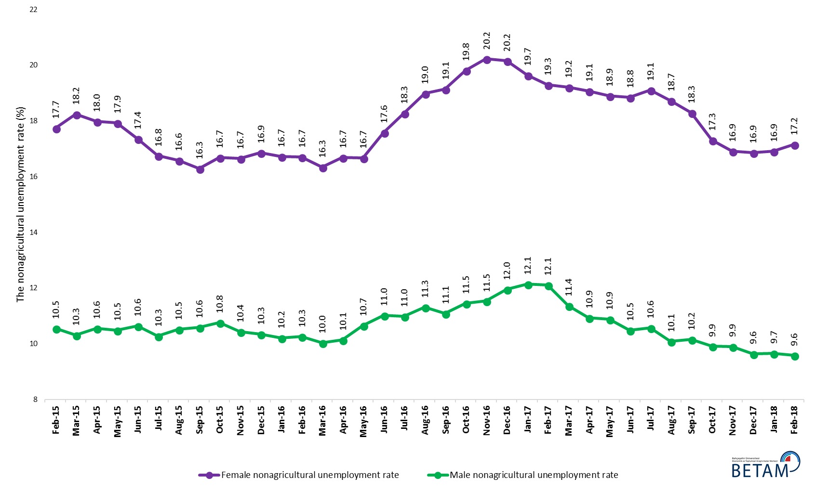
Source: Turkstat, Betam

Table 1 Seasonally adjusted non-agricultural labor market indicators (in thousands) *
 | Labor force | Employment | Unemployment | Unemployment rate | Monthly changes
January-15 | 23862 | 20903 | 2959 | 12.4% | Labor force | Employment | Unemployment
February-15 | 24058 | 21099 | 2959 | 12.3% | 196 | 196 | 0
March-15 | 23789 | 20839 | 2950 | 12.4% | -269 | -260 | -9
April-15 | 23862 | 20927 | 2935 | 12.3% | 73 | 88 | -15
May-15 | 23982 | 21008 | 2974 | 12.4% | 120 | 81 | 39
June-15 | 24033 | 21029 | 3004 | 12.5% | 51 | 21 | 30
July-15 | 24217 | 21238 | 2979 | 12.3% | 184 | 209 | -25
August-15 | 24115 | 21149 | 2966 | 12.3% | -101 | -89 | -12
September-15 | 24336 | 21343 | 2993 | 12.3% | 221 | 194 | 27
October-15 | 24411 | 21360 | 3051 | 12.5% | 75 | 17 | 58
November-15 | 24554 | 21534 | 3020 | 12.3% | 143 | 174 | -31
December-15 | 24636 | 21630 | 3006 | 12.2% | 81 | 96 | -15
January-16 | 24736 | 21768 | 2968 | 12.0% | 101 | 138 | -37
February-16 | 24850 | 21893 | 2957 | 11.9% | 114 | 125 | -11
March-16 | 24865 | 21956 | 2909 | 11.7% | 15 | 63 | -48
April-16 | 24994 | 22045 | 2949 | 11.8% | 129 | 89 | 40
May-16 | 25098 | 22011 | 3087 | 12.3% | 104 | -34 | 138
June-16 | 25121 | 21830 | 3291 | 13.1% | 23 | -181 | 204
July-16 | 25174 | 21826 | 3348 | 13.3% | 53 | -4 | 57
August-16 | 25157 | 21736 | 3421 | 13.6% | -17 | -90 | 73
September-16 | 25346 | 21924 | 3422 | 13.5% | 188 | 188 | 0
October-16 | 25531 | 21957 | 3574 | 14.0% | 186 | 33 | 153
November-16 | 25651 | 22034 | 3617 | 14.1% | 119 | 77 | 42
December-16 | 25616 | 21953 | 3663 | 14.3% | -35 | -81 | 46
January-17 | 25721 | 22094 | 3627 | 14.1% | 105 | 141 | -36
February-17 | 25825 | 22235 | 3590 | 13.9% | 104 | 141 | -37
March-17 | 25983 | 22449 | 3534 | 13.6% | 158 | 214 | -56
April-17 | 26033 | 22571 | 3462 | 13.3% | 51 | 122 | -71
May-17 | 26053 | 22588 | 3465 | 13.3% | 20 | 17 | 3
June-17 | 26114 | 22693 | 3421 | 13.1% | 61 | 105 | -44
July-17 | 26097 | 22652 | 3445 | 13.2% | -17 | -41 | 24
August-17 | 26216 | 22887 | 3329 | 12.7% | 120 | 235 | -115
September-17 | 26270 | 22960 | 3310 | 12.6% | 54 | 73 | -19
October-17 | 26321 | 23110 | 3211 | 12.2% | 51 | 150 | -99
November-17 | 26406 | 23237 | 3169 | 12.0% | 84 | 127 | -43
December-17 | 26456 | 23334 | 3122 | 11.8% | 50 | 97 | -47
January-18 | 26514 | 23412 | 3102 | 11.7% | 58 | 78 | -20
February-18 | 26610 | 23523 | 3087 | 11.6% | 96 | 111 | -15
Source: Turkstat, Betam

Table 2 Seasonally adjusted employment by sectors (in thousands) *
 | Agriculture | Manufacturing | Construction | Service | Monthly changes
January-15 | 5421 | 5349 | 1924 | 13630 | Agriculture | Manufacturing | Construction | Service
February-15 | 5249 | 5351 | 1866 | 13882 | -172 | 2 | -58 | 252
March-15 | 5485 | 5308 | 1900 | 13631 | 236 | -43 | 34 | -251
April-15 | 5517 | 5326 | 1882 | 13720 | 32 | 18 | -18 | 89
May-15 | 5540 | 5404 | 1870 | 13734 | 23 | 78 | -12 | 14
June-15 | 5575 | 5380 | 1866 | 13782 | 35 | -24 | -4 | 48
July-15 | 5500 | 5336 | 1919 | 13983 | -75 | -44 | 53 | 201
August-15 | 5533 | 5252 | 1918 | 13979 | 33 | -84 | -1 | -4
September-15 | 5516 | 5327 | 1942 | 14074 | -17 | 75 | 24 | 95
October-15 | 5449 | 5363 | 1964 | 14032 | -67 | 36 | 22 | -42
November-15 | 5387 | 5353 | 1990 | 14190 | -62 | -10 | 26 | 158
December-15 | 5411 | 5311 | 1998 | 14320 | 24 | -42 | 8 | 130
January-16 | 5379 | 5300 | 2006 | 14462 | -32 | -11 | 8 | 142
February-16 | 5337 | 5276 | 2005 | 14612 | -42 | -24 | -1 | 150
March-16 | 5389 | 5295 | 2023 | 14638 | 52 | 19 | 18 | 26
April-16 | 5369 | 5381 | 2028 | 14635 | -20 | 86 | 5 | -3
May-16 | 5320 | 5386 | 2045 | 14580 | -49 | 5 | 17 | -55
June-16 | 5172 | 5330 | 1950 | 14550 | -148 | -56 | -95 | -30
July-16 | 5207 | 5254 | 1946 | 14626 | 35 | -76 | -4 | 76
August-16 | 5270 | 5224 | 1919 | 14592 | 63 | -30 | -27 | -34
September-16 | 5338 | 5260 | 2030 | 14633 | 68 | 36 | 111 | 41
October-16 | 5283 | 5282 | 1999 | 14676 | -55 | 22 | -31 | 43
November-16 | 5288 | 5316 | 2001 | 14717 | 5 | 34 | 2 | 41
December-16 | 5315 | 5265 | 1965 | 14722 | 27 | -51 | -36 | 5
January-17 | 5445 | 5274 | 1974 | 14846 | 130 | 9 | 9 | 124
February-17 | 5490 | 5251 | 2037 | 14947 | 45 | -23 | 63 | 101
March-17 | 5386 | 5346 | 2094 | 15009 | -104 | 95 | 57 | 62
April-17 | 5348 | 5372 | 2113 | 15085 | -38 | 26 | 19 | 76
May-17 | 5368 | 5386 | 2060 | 15142 | 20 | 14 | -53 | 57
June-17 | 5364 | 5383 | 2055 | 15254 | -4 | -3 | -5 | 112
July-17 | 5498 | 5363 | 2082 | 15207 | 134 | -20 | 27 | -47
August-17 | 5463 | 5437 | 2143 | 15307 | -35 | 74 | 61 | 100
September-17 | 5529 | 5421 | 2124 | 15415 | 66 | -16 | -19 | 108
October-17 | 5509 | 5470 | 2119 | 15521 | -20 | 49 | -5 | 106
November-17 | 5526 | 5470 | 2156 | 15611 | 17 | 0 | 37 | 90
December-17 | 5561 | 5514 | 2200 | 15620 | 35 | 44 | 44 | 9
January-18 | 5509 | 5567 | 2229 | 15615 | -52 | 53 | 29 | -5
February-18 | 5438 | 5627 | 2232 | 15664 | -71 | 60 | 3 | 49
Source: Turkstat, Betam

Table 3: Seasonally adjusted non-agricultural labor force by gender (thousands)
 | Female Labor Force | Female Employment | Female Unemployed | Male Labor Force | Male Employment | Male Unemployed
February-15 | 6559 | 5395 | 1164 | 17456 | 15615 | 1841
March-15 | 6518 | 5329 | 1189 | 17211 | 15435 | 1776
April-15 | 6539 | 5363 | 1176 | 17273 | 15449 | 1824
May-15 | 6624 | 5436 | 1187 | 17330 | 15514 | 1816
June-15 | 6656 | 5500 | 1156 | 17414 | 15561 | 1852
July-15 | 6750 | 5619 | 1131 | 17483 | 15684 | 1798
August-15 | 6715 | 5601 | 1114 | 17482 | 15642 | 1839
September-15 | 6760 | 5659 | 1101 | 17587 | 15724 | 1863
October-15 | 6782 | 5650 | 1132 | 17634 | 15738 | 1897
November-15 | 6877 | 5732 | 1145 | 17640 | 15800 | 1840
December-15 | 6970 | 5795 | 1175 | 17686 | 15856 | 1830
January-16 | 7013 | 5840 | 1173 | 17717 | 15907 | 1810
February-16 | 7047 | 5870 | 1177 | 17748 | 15927 | 1822
March-16 | 7054 | 5901 | 1153 | 17790 | 16004 | 1786
April-16 | 7141 | 5948 | 1192 | 17830 | 16021 | 1809
May-16 | 7174 | 5977 | 1196 | 17910 | 16002 | 1908
June-16 | 7260 | 5983 | 1277 | 17857 | 15888 | 1969
July-16 | 7270 | 5941 | 1329 | 17916 | 15948 | 1967
August-16 | 7328 | 5936 | 1392 | 17914 | 15887 | 2027
September-16 | 7377 | 5965 | 1412 | 17987 | 15993 | 1994
October-16 | 7443 | 5968 | 1475 | 18067 | 15999 | 2069
November-16 | 7461 | 5952 | 1509 | 18166 | 16071 | 2095
December-16 | 7459 | 5955 | 1504 | 18177 | 16004 | 2173
January-17 | 7452 | 5988 | 1464 | 18298 | 16076 | 2222
February-17 | 7513 | 6063 | 1449 | 18289 | 16075 | 2214
March-17 | 7609 | 6148 | 1462 | 18347 | 16260 | 2087
April-17 | 7598 | 6148 | 1449 | 18384 | 16373 | 2011
May-17 | 7650 | 6204 | 1446 | 18355 | 16358 | 1997
June-17 | 7668 | 6223 | 1445 | 18453 | 16520 | 1934
July-17 | 7681 | 6213 | 1468 | 18455 | 16504 | 1950
August-17 | 7733 | 6285 | 1448 | 18573 | 16698 | 1875
September-17 | 7767 | 6346 | 1421 | 18530 | 16648 | 1882
October-17 | 7793 | 6444 | 1349 | 18503 | 16670 | 1834
November-17 | 7829 | 6505 | 1325 | 18562 | 16724 | 1838
December-17 | 7888 | 6558 | 1331 | 18555 | 16766 | 1789
January-18 | 7925 | 6585 | 1340 | 18559 | 16766 | 1793
February-18 | 7956 | 6591 | 1365 | 18590 | 16809 | 1781
Source: Turkstat, Betam

*Prof. Dr. Seyfettin Gürsel, Betam, Director, seyfettin.gursel@eas.bau.edu.tr
∗∗ Yazgı Genç, Betam, Research Assistant, yazgi.genc@eas.bau.edu.tr *** Uğurcan Acar, Betam, Research Assistant, ugurcan.acar@eas.bau.edu.tr
For detailed information on Betam's forecasting model, please see Betam Research Brief 168 titled as "Kariyer.net Verisiyle Kısa Vadeli Tarım Dışı İşsizlik Tahmini" . For the innovations in the model please see Betam Research Brief 14 titled as "Mevsim Etkilerinden Arındırılmış İşsizlik Tahmini" Soybilgen, B., "Kariyer.net Verisiyle Kısa Vadeli Tarım Dışı İşsizlik Tahmini", Betam Research Brief 168. http://betam.bahcesehir.edu.tr/tr/2014/06/kariyer-net-verisiyle-kisa-vadeli-tarim-disi-issizlik-tahmini/ Soybilgen, B., "Mevsim Etkilerinden Arındırılmış İşsizlik Tahmini", Betam Research Brief 14 http://betam.bahcesehir.edu.tr/2015/08/mevsim-etkilerinden-arindirilmis-tarim-disi-issizlik-tahmini/
Betam has been calculating application per vacancy using series released by Kariyer.net for a while. Seasonal and calendar adjustment procedure is applied to application per vacancy series. A decrease in applications per vacancy may be caused by an increase in vacancies or by a decrease in the number of applications. An increase in vacancies signals economic growth while decreasing number of applications indicates a decrease in number of people looking for a job. Monthly labor market series released by TurkStat is the average of three months. Therefore, application per vacancy statistics calculated using Kariyer.net series is the average of three months as well.
Employment in each sector is seasonally adjusted separately. Hence the sum of these series may differ from the seasonally adjusted series of total employment. The difference stems from the non-linearity of the seasonal adjustment process.
Turkstat revised the labor market statistics drastically in February 2014. Within this framework, they back casted various labor market indicators and they also continued to announce seasonally adjusted series. However, Turkstat is not providing back-casted series by gender. Therefore, female and male labor market statistics are not sufficiently long for the seasonal adjustment procedures (There should be minimum 36 observations). With the announcement of the period of February 2017 data, the number of observations required for the seasonal decontamination process was provided. From this period Betam get seasonal adjustment series in terms of gender. Nevertheless, it should not be forgotten that seasonal adjustment may cause extra volatility in the series for at least a while.

