Labor Market Outlook:
April 2018

16 April 2018

DECREASE IN UNEMPLOYMENT CONTINUES
Seyfettin Gürsel*, Gökçe Uysal ∗∗ and Uğurcan Acar***

Executive Summary

Seasonally adjusted labor market data show that non-agricultural unemployment rate decreased by 0.1 percentage points in the period of January reaching 11.7 percent. The non-agricultural unemployment rate decreased from 14,1 to 11,7 in the last year as a consequence of high GDP growth in 2017. As result, the non-agricultural unemployment rate has decreased by 2.4 percentage points in the recent year. The reason behind this decrease is the strong increases in non-agricultural employment. From December 2017 to January 2018, employment increased by 29 and 53 thousand in the construction and manufacture sectors while employment decreased by 4 thousand in the services. Betam’s forecasting model predicts that the non-agricultural unemployment will remain constant at 11.7 percent in the period of February 2018.

Decrease in non-agricultural unemployment continues

According to seasonally adjusted labor market data, in the period of January 2018 compared to December 2017, the non-agricultural labor force increased by 58 thousand and reached 26 million 518 thousand while the number of employed in non-agricultural sectors increased by 78 thousand and reached 23 million 415 thousand (Figure 1, Table 1). As result, the number of unemployed in non-agricultural sectors decreased by 20 thousand and recorded as 3 million 103 thousand and the non-agricultural unemployment rate decreased from 11.8 percent to 11.7 percent. In the last year, the non-agricultural unemployment rate decreased from 14,1 to 11,7 as a consequence of high GDP growth in 2017.

Figure 1 Seasonally adjusted non-agricultural labor force, employment, and unemployment

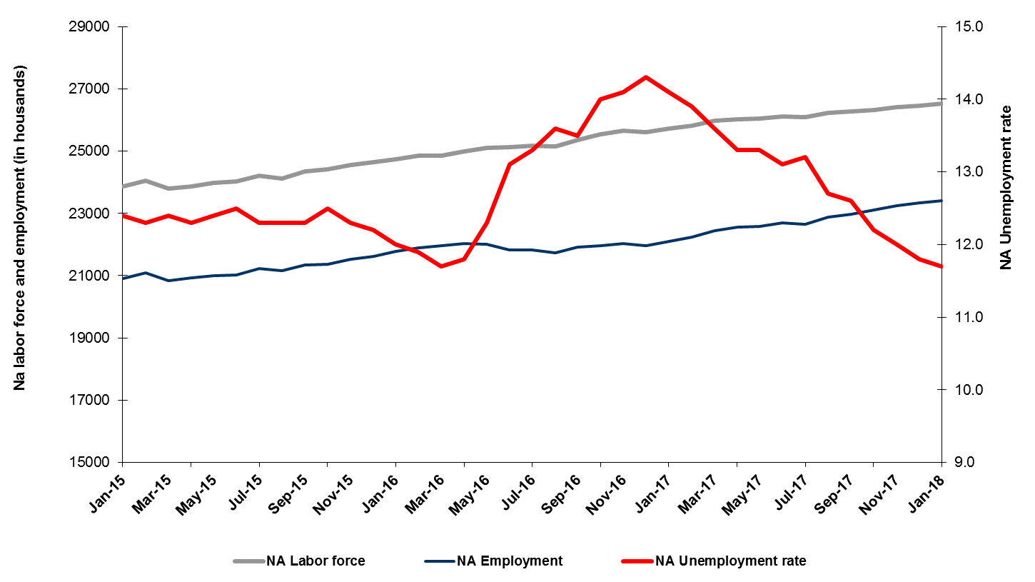
Source: Turkstat, Betam
Unemployment rate is expected to remain stable in the period of February 2018

Betam's forecasting model had predicted that the seasonally adjusted non-agricultural unemployment rate would decrease from 11.8 in the December 2017 to 11.7 in the period of January 2018. Betam’s forecasting has revealed to be accurate. Betam’s forecasting model predicts that the non-agricultural unemployment rate will remain stable at 11,7 percent in February 2018. Forecasting model details are available on Betam's website. Kariyer.net application per vacancy series used in the Betam forecasting model is depicted in Figure 3. Kariyer.net series is only one of the inputs of Betam forecast model. Indeed, several variables such as employment agency (İŞKUR) data, reel sector confidence index, capacity utilization rate are used in forecasting.

Figure 2 Seasonally adjusted non-agricultural unemployment rate and application per vacancy
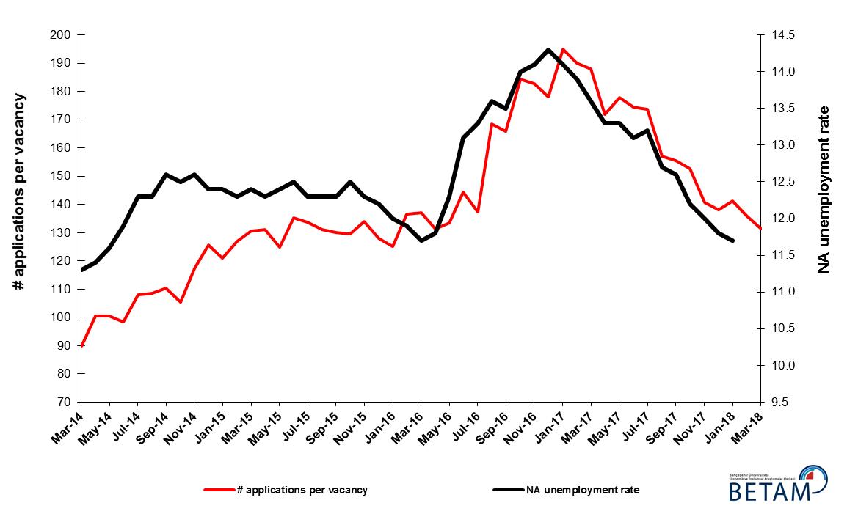
Source: Kariyer.net, Turkstat, Betam

Employment increases in manufacturing and construction sectors but decreases in services

According to seasonally adjusted sectoral labor market data in January 2018 compared to December 2017, employment increased in manufacturing and construction sectors while employment decreased in services and agriculture sectors (Figure 3, Table 2). Employment increased by 53 and 29 thousand in manufacture and construction sectors, respectively. On the other hand, strong monthly increases of around 100 thousand in the services employment from August 2017 to November 2017 had decelerated in December 2017 (increase of 9 thousand) and gave way to a limited decrease of 4 thousand in January 2018. Non-agricultural unemployment rates which have fallen sharply in the past year have been realized thanks to the employment increases in all sectors. These yearly increases attained 293 thousand in industry, 255 thousand in construction and 771 thousand in services.

Figure 3: Employment by sectors (in thousands)
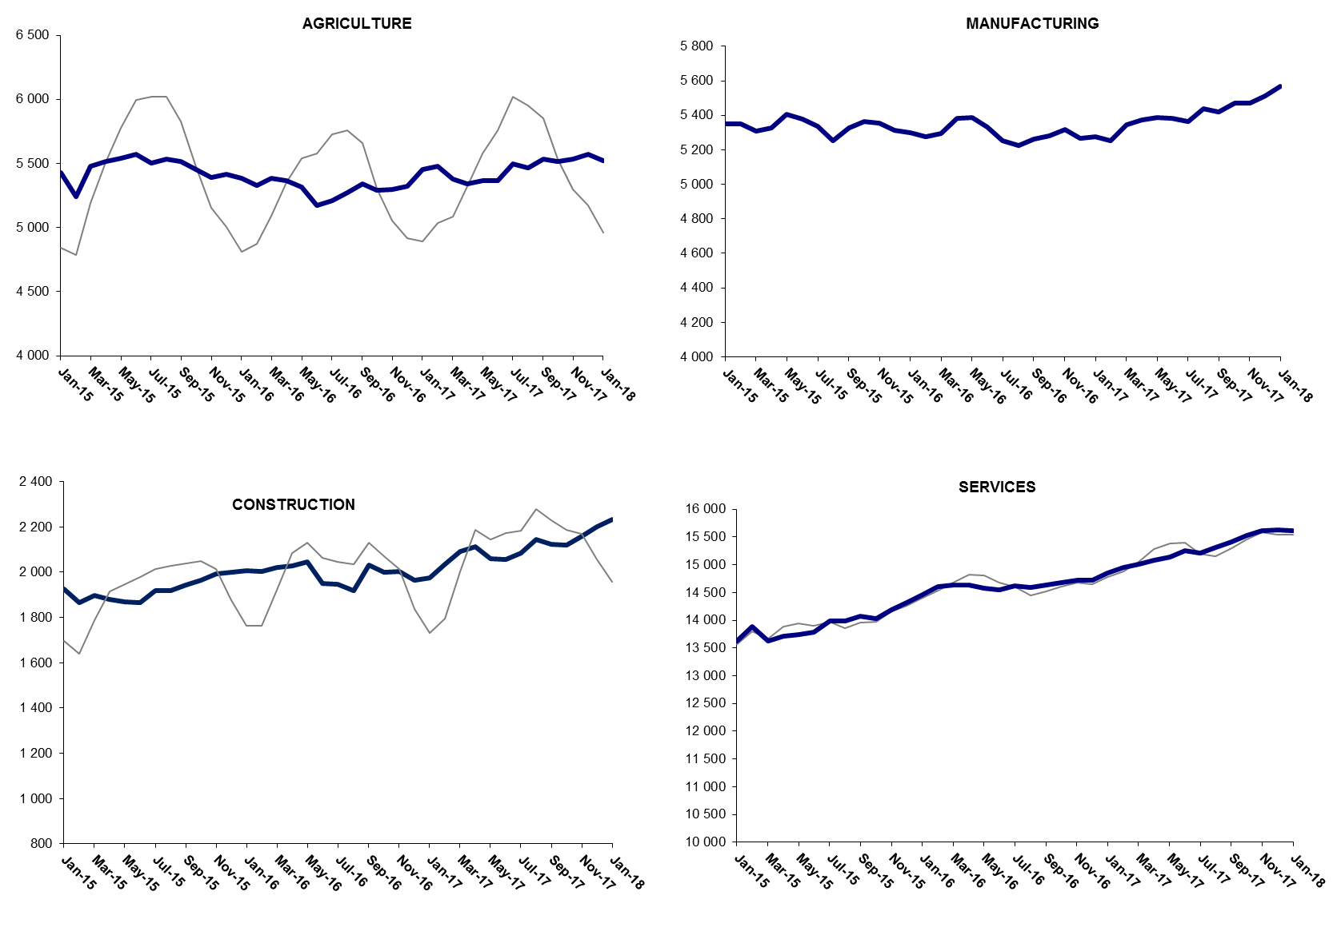

Source: TURKSTAT, Betam

The number of non-agricultural unemployed decreased by 548 thousand within a year

From January 2017 to January 2018 non-agricultural labor force increased by 738 thousand (2.9 percent) and non-agricultural employment by 1 million 286 thousand (5.9 percent) (Figure 4). Thus, non-agricultural unemployed decreased by 548 thousand and attained 3 million 356 thousand (Figure 4). Annual increases in non-agricultural employment exceed one million people since the period of August 2017.

Figure 4 Year-on-year changes in non-agricultural labor force, employment, and unemployment
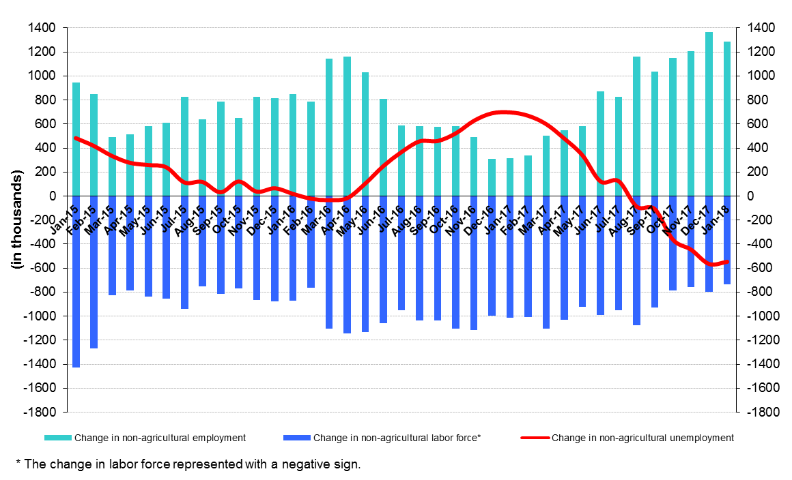
Source: Turkstat, Betam

Limited increase in female and male unemployment difference

Figure 5 shows seasonally adjusted non-agricultural unemployment rate for males (green) and for females (purple). In the period of January 2018, the non-agricultural female unemployment rate is at 16.9 percent while the non-agricultural male employment rate is at 9.6 percent. The gender gap in non-agricultural unemployment rate increased slightly by 0.1 percentage point and reached 7.3 percentage points. The gender gap in non-agricultural unemployment rate which was 7.5 percentage points in the period of January 2017 (19.6 percent and 12.1 percent) and was 8.6 percentage points in the period of August 2017 (18.7 percent and 10.1 percent), had decreased to 7.2 percentage points. The fact that the gender gap in non-agricultural unemployment rate evolved at high level during a year where unemployment had a strong decrease indicates the insufficiency of policies which aims to gender equality in the labor market.

Figure 5: Seasonally adjusted non-agricultural unemployment rate by gender
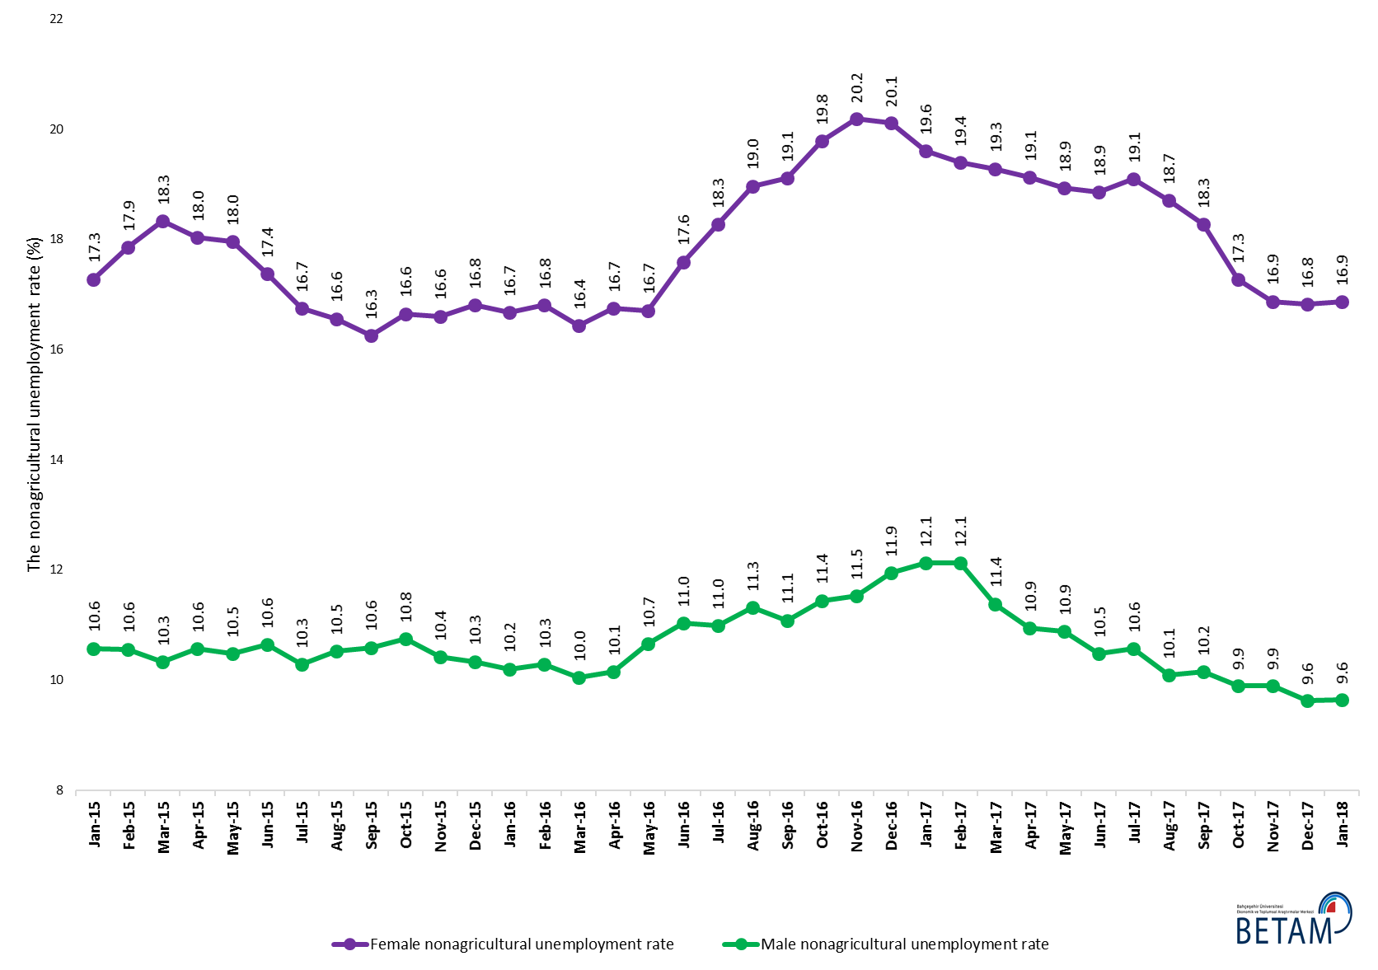
Source: Turkstat, Betam

Table 1 Seasonally adjusted non-agricultural labor market indicators (in thousands) *
 | Labor force | Employment | Unemployment | Unemployment rate | Monthly changes
December-14 | 23745 | 20801 | 2944 | 12.4% | Labor force | Employment | Unemployment
January-15 | 23863 | 20904 | 2959 | 12.4% | 118 | 103 | 15
February-15 | 24056 | 21097 | 2959 | 12.3% | 193 | 193 | 0
March-15 | 23787 | 20837 | 2950 | 12.4% | -269 | -260 | -9
April-15 | 23861 | 20926 | 2935 | 12.3% | 74 | 89 | -15
May-15 | 23982 | 21008 | 2974 | 12.4% | 121 | 82 | 39
June-15 | 24033 | 21029 | 3004 | 12.5% | 51 | 21 | 30
July-15 | 24218 | 21239 | 2979 | 12.3% | 185 | 210 | -25
August-15 | 24115 | 21149 | 2966 | 12.3% | -103 | -90 | -13
September-15 | 24338 | 21344 | 2994 | 12.3% | 222 | 195 | 27
October-15 | 24411 | 21360 | 3051 | 12.5% | 74 | 16 | 58
November-15 | 24555 | 21535 | 3020 | 12.3% | 144 | 175 | -31
December-15 | 24636 | 21630 | 3006 | 12.2% | 80 | 95 | -15
January-16 | 24738 | 21769 | 2969 | 12.0% | 102 | 139 | -37
February-16 | 24846 | 21889 | 2957 | 11.9% | 108 | 120 | -12
March-16 | 24863 | 21954 | 2909 | 11.7% | 17 | 65 | -48
April-16 | 24991 | 22042 | 2949 | 11.8% | 128 | 88 | 40
May-16 | 25097 | 22010 | 3087 | 12.3% | 106 | -32 | 138
June-16 | 25120 | 21829 | 3291 | 13.1% | 23 | -181 | 204
July-16 | 25174 | 21826 | 3348 | 13.3% | 54 | -3 | 57
August-16 | 25159 | 21737 | 3422 | 13.6% | -16 | -89 | 73
September-16 | 25347 | 21925 | 3422 | 13.5% | 188 | 188 | 0
October-16 | 25534 | 21959 | 3575 | 14.0% | 187 | 34 | 153
November-16 | 25653 | 22036 | 3617 | 14.1% | 119 | 77 | 42
December-16 | 25617 | 21954 | 3663 | 14.3% | -36 | -82 | 46
January-17 | 25723 | 22096 | 3627 | 14.1% | 106 | 142 | -36
February-17 | 25820 | 22231 | 3589 | 13.9% | 97 | 135 | -38
March-17 | 25978 | 22445 | 3533 | 13.6% | 158 | 214 | -56
April-17 | 26030 | 22568 | 3462 | 13.3% | 52 | 123 | -71
May-17 | 26052 | 22587 | 3465 | 13.3% | 22 | 19 | 3
June-17 | 26113 | 22692 | 3421 | 13.1% | 61 | 105 | -44
July-17 | 26098 | 22653 | 3445 | 13.2% | -15 | -39 | 24
August-17 | 26218 | 22888 | 3330 | 12.7% | 120 | 235 | -115
September-17 | 26272 | 22962 | 3310 | 12.6% | 55 | 74 | -19
October-17 | 26323 | 23112 | 3211 | 12.2% | 51 | 150 | -99
November-17 | 26408 | 23239 | 3169 | 12.0% | 84 | 127 | -43
December-17 | 26459 | 23337 | 3122 | 11.8% | 51 | 98 | -47
January-18 | 26518 | 23415 | 3103 | 11.7% | 58 | 78 | -20
Source: Turkstat, Betam

Table 2 Seasonally adjusted employment by sectors (in thousands) *
 | Agriculture | Manufacturing | Construction | Service | Monthly changes
December-14 | 5432 | 5266 | 1937 | 13598 | Agriculture | Manufacturing | Construction | Service
January-15 | 5426 | 5349 | 1924 | 13630 | -6 | 83 | -13 | 32
February-15 | 5243 | 5351 | 1865 | 13881 | -183 | 2 | -59 | 251
March-15 | 5480 | 5308 | 1899 | 13630 | 237 | -43 | 34 | -251
April-15 | 5513 | 5326 | 1881 | 13719 | 33 | 18 | -18 | 89
May-15 | 5537 | 5404 | 1870 | 13734 | 24 | 78 | -11 | 15
June-15 | 5574 | 5380 | 1866 | 13782 | 37 | -24 | -4 | 48
July-15 | 5500 | 5336 | 1919 | 13983 | -74 | -44 | 53 | 201
August-15 | 5534 | 5252 | 1918 | 13980 | 34 | -84 | -1 | -3
September-15 | 5517 | 5327 | 1942 | 14075 | -17 | 75 | 24 | 95
October-15 | 5453 | 5363 | 1965 | 14033 | -64 | 36 | 23 | -42
November-15 | 5392 | 5353 | 1991 | 14191 | -61 | -10 | 26 | 158
December-15 | 5417 | 5311 | 1999 | 14321 | 25 | -42 | 8 | 130
January-16 | 5385 | 5300 | 2006 | 14463 | -32 | -11 | 7 | 142
February-16 | 5330 | 5276 | 2004 | 14610 | -55 | -24 | -2 | 147
March-16 | 5382 | 5295 | 2022 | 14637 | 52 | 19 | 18 | 27
April-16 | 5364 | 5381 | 2028 | 14634 | -18 | 86 | 6 | -3
May-16 | 5317 | 5386 | 2045 | 14580 | -47 | 5 | 17 | -54
June-16 | 5171 | 5330 | 1950 | 14550 | -146 | -56 | -95 | -30
July-16 | 5207 | 5254 | 1946 | 14626 | 36 | -76 | -4 | 76
August-16 | 5271 | 5224 | 1920 | 14593 | 64 | -30 | -26 | -33
September-16 | 5340 | 5260 | 2031 | 14634 | 69 | 36 | 111 | 41
October-16 | 5288 | 5282 | 2000 | 14677 | -52 | 22 | -31 | 43
November-16 | 5294 | 5316 | 2002 | 14718 | 6 | 34 | 2 | 41
December-16 | 5323 | 5265 | 1966 | 14723 | 29 | -51 | -36 | 5
January-17 | 5454 | 5274 | 1976 | 14846 | 131 | 9 | 10 | 123
February-17 | 5479 | 5251 | 2035 | 14945 | 25 | -23 | 59 | 99
March-17 | 5377 | 5346 | 2093 | 15007 | -102 | 95 | 58 | 62
April-17 | 5341 | 5372 | 2112 | 15084 | -36 | 26 | 19 | 77
May-17 | 5363 | 5386 | 2059 | 15141 | 22 | 14 | -53 | 57
June-17 | 5363 | 5383 | 2055 | 15254 | 0 | -3 | -4 | 113
July-17 | 5497 | 5363 | 2083 | 15207 | 134 | -20 | 28 | -47
August-17 | 5464 | 5437 | 2144 | 15308 | -33 | 74 | 61 | 101
September-17 | 5532 | 5421 | 2125 | 15416 | 68 | -16 | -19 | 108
October-17 | 5515 | 5470 | 2120 | 15522 | -17 | 49 | -5 | 106
November-17 | 5535 | 5470 | 2158 | 15612 | 20 | 0 | 38 | 90
December-17 | 5572 | 5514 | 2202 | 15621 | 37 | 44 | 44 | 9
January-18 | 5522 | 5567 | 2231 | 15617 | -50 | 53 | 29 | -4
Source: Turkstat, Betam

Table 3: Seasonally adjusted non-agricultural labor force by gender (thousands)
 | Female Labor Force | Female Employment | Female Unemployed | Male Labor Force | Male Employment | Male Unemployed
January-15 | 6504 | 5380 | 1124 | 17361 | 15525 | 1836
February-15 | 6564 | 5393 | 1172 | 17454 | 15610 | 1844
March-15 | 6520 | 5325 | 1195 | 17210 | 15432 | 1778
April-15 | 6540 | 5360 | 1180 | 17273 | 15447 | 1825
May-15 | 6623 | 5433 | 1189 | 17330 | 15513 | 1817
June-15 | 6654 | 5498 | 1156 | 17414 | 15561 | 1853
July-15 | 6747 | 5618 | 1130 | 17483 | 15685 | 1799
August-15 | 6712 | 5600 | 1111 | 17482 | 15643 | 1839
September-15 | 6758 | 5659 | 1098 | 17588 | 15725 | 1863
October-15 | 6780 | 5652 | 1129 | 17635 | 15739 | 1896
November-15 | 6877 | 5735 | 1142 | 17640 | 15802 | 1839
December-15 | 6971 | 5799 | 1172 | 17686 | 15858 | 1828
January-16 | 7016 | 5846 | 1170 | 17717 | 15909 | 1808
February-16 | 7053 | 5868 | 1185 | 17746 | 15922 | 1824
March-16 | 7056 | 5897 | 1159 | 17789 | 16002 | 1787
April-16 | 7141 | 5945 | 1196 | 17829 | 16020 | 1810
May-16 | 7173 | 5974 | 1198 | 17910 | 16001 | 1909
June-16 | 7258 | 5981 | 1277 | 17857 | 15888 | 1969
July-16 | 7268 | 5940 | 1328 | 17916 | 15949 | 1968
August-16 | 7325 | 5935 | 1389 | 17915 | 15888 | 2027
September-16 | 7375 | 5965 | 1409 | 17988 | 15994 | 1994
October-16 | 7441 | 5970 | 1472 | 18068 | 16000 | 2068
November-16 | 7461 | 5955 | 1506 | 18166 | 16073 | 2093
December-16 | 7460 | 5959 | 1500 | 18178 | 16006 | 2171
January-17 | 7456 | 5994 | 1461 | 18298 | 16078 | 2219
February-17 | 7518 | 6061 | 1458 | 18286 | 16069 | 2217
March-17 | 7612 | 6144 | 1468 | 18346 | 16258 | 2088
April-17 | 7598 | 6145 | 1453 | 18383 | 16371 | 2012
May-17 | 7649 | 6201 | 1448 | 18355 | 16357 | 1998
June-17 | 7666 | 6221 | 1445 | 18454 | 16520 | 1934
July-17 | 7678 | 6212 | 1466 | 18455 | 16505 | 1951
August-17 | 7731 | 6284 | 1446 | 18574 | 16699 | 1875
September-17 | 7765 | 6346 | 1418 | 18531 | 16650 | 1881
October-17 | 7791 | 6446 | 1346 | 18504 | 16671 | 1833
November-17 | 7829 | 6508 | 1321 | 18563 | 16726 | 1837
December-17 | 7890 | 6562 | 1327 | 18556 | 16768 | 1787
January-18 | 7928 | 6591 | 1337 | 18559 | 16768 | 1790
Source: Turkstat, Betam

*Prof. Dr. Seyfettin Gürsel, Betam, Director, seyfettin.gursel@eas.bau.edu.tr
∗∗ Gökçe Uysal Betam, Deputy Director, gokce.uysal @eas.bau.edu.tr *** Uğurcan Acar, Betam, Research Assistant, ugurcan.acar@eas.bau.edu.tr
For detailed information on Betam's forecasting model, please see Betam Research Brief 168 titled as "Kariyer.net Verisiyle Kısa Vadeli Tarım Dışı İşsizlik Tahmini" . For the innovations in the model please see Betam Research Brief 14 titled as "Mevsim Etkilerinden Arındırılmış İşsizlik Tahmini" Soybilgen, B., "Kariyer.net Verisiyle Kısa Vadeli Tarım Dışı İşsizlik Tahmini", Betam Research Brief 168. http://betam.bahcesehir.edu.tr/tr/2014/06/kariyer-net-verisiyle-kisa-vadeli-tarim-disi-issizlik-tahmini/ Soybilgen, B., "Mevsim Etkilerinden Arındırılmış İşsizlik Tahmini", Betam Research Brief 14 http://betam.bahcesehir.edu.tr/2015/08/mevsim-etkilerinden-arindirilmis-tarim-disi-issizlik-tahmini/
Betam has been calculating application per vacancy using series released by Kariyer.net for a while. Seasonal and calendar adjustment procedure is applied to application per vacancy series. A decrease in applications per vacancy may be caused by an increase in vacancies or by a decrease in the number of applications. An increase in vacancies signals economic growth while decreasing number of applications indicates a decrease in number of people looking for a job. Monthly labor market series released by TurkStat is the average of three months. Therefore, application per vacancy statistics calculated using Kariyer.net series is the average of three months as well.
Sektörel istihdam serileri teker teker mevsim etkilerinden arındırılmaktadır. Dolayısıyla sektörel istihdam rakamlarının toplamı, mevsim etkilerinden arındırılmış toplam istihdam rakamından farklı olabilmektedir. Aradaki fark mevsim etkilerinden arındırma prosedürünün lineer olmamasından kaynaklanmaktadır.
Turkstat revised the labor market statistics drastically in February 2014. Within this framework, they back casted various labor market indicators and they also continued to announce seasonally adjusted series. However, Turkstat is not providing back-casted series by gender. Therefore, female and male labor market statistics are not sufficiently long for the seasonal adjustment procedures (There should be minimum 36 observations). With the announcement of the period of February 2017 data, the number of observations required for the seasonal decontamination process was provided. From this period Betam get seasonal adjustment series in terms of gender. Nevertheless, it should not be forgotten that seasonal adjustment may cause extra volatility in the series for at least a while.

