Labor Market Outlook:
March 2018

15 March 2018

DECREASE IN UNEMPLOYMENT CONTINUES
Seyfettin Gürsel*, Gökçe Uysal ∗∗ and Yazgı Genç***

Executive Summary

Seasonally adjusted labor market data show that non-agricultural unemployment rate decreased by 0.2 percentage points in the period of December reaching 11.8 percent. It is worthy to note that in recent past the highest level in unemployment has been attained in December 2016 at 14.2 percent. The reason behind this decrease is the high GDP growth (expected over 7 percent) which leaded strong increases in non-agricultural employment. From November to December employment increased in the services by 13 thousand while employment increase reached 44 thousand in both manufacture and construction sectors. Betam’s forecasting model predicts that the non-agricultural unemployment will decrease to 11.7 percent in the period of January 2018. On the other hand, according to seasonally adjusted labour data, the unemployment rate for females remained unchanged at 16,8 and for males it decreased from 9.9 percent to 9.6 percent. Thus, difference in non-agricultural unemployment rate by gender increased.

Decrease in non-agricultural unemployment continues

According to seasonally adjusted labor market data, in the period of December 2017 compared to November 2017, the non-agricultural labor force increased by 55 thousand and reached 26 million 465 thousand while the number of employed in non-agricultural sectors increased by 101 thousand and reached 23 million 342 thousand (Figure 1, Table 1). As result, the number of unemployed in non-agricultural sectors decreased by 46 thousand and recorded as 3 million 123 thousand and the non-agricultural unemployment rate decreased from 12.0 percent to 11.8 percent. From the period of January 2017 to December 2017, the non-agricultural unemployment rate decreased from 14,2 to 11,8 as a consequence of high GDP growth in 2017.

Figure 1 Seasonally adjusted non-agricultural labor force, employment, and unemployment

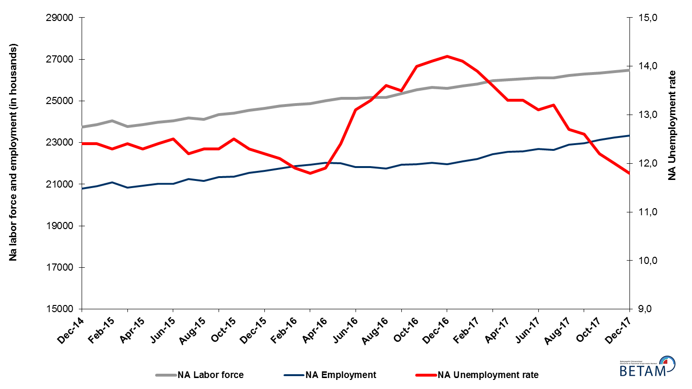

Source: Turkstat, Betam
Decrease in unemployment rate is expected in the period of January 2018

Betam's forecasting model had predicted that the seasonally adjusted non-agricultural unemployment rate would decrease from 12.1 in the October 2017 to 11.8 in the period of December 2017. TUİK revised the unemployment rate of November from 12.1 to 12.0 and the non-agricultural unemployment rate decreased to 11.8 in the period of December 2017. In other words, Betam’s forecasting revealed to be accurate. Betam’s forecasting model predicts that the non-agricultural unemployment rate will decrease to 11,7 percent in January 2018. Forecasting model details are available on Betam's website. Kariyer.net application per vacancy series used in the Betam forecasting model is depicted in Figure 3. Kariyer.net series is only one of the inputs of Betam forecast model. Indeed, several variables such as employment agency (İŞKUR) data, reel sector confidence index, capacity utilization rate are used in forecasting.

Figure 2 Seasonally adjusted non-agricultural unemployment rate and application per vacancy
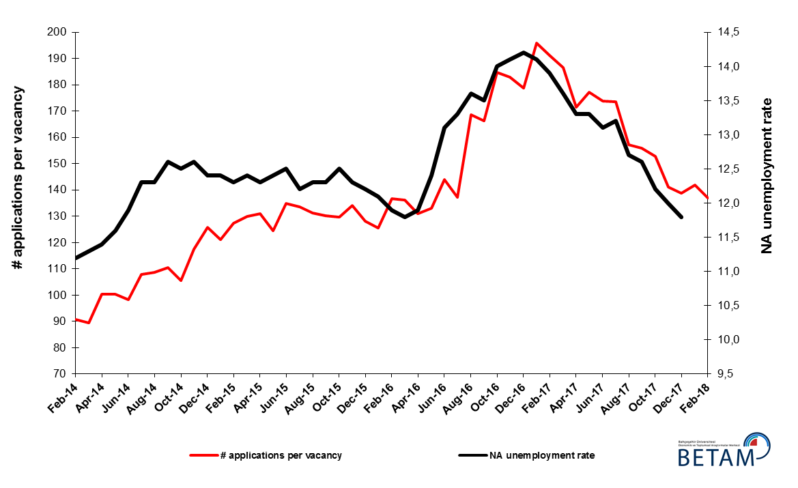
Source: Kariyer.net, Turkstat, Betam

Employment increases in all sectors
According to seasonally adjusted sectoral labor market data, in December 2017 compared to November 2017 employment increased in all sectors (Figure 3, Table 2). Employment increased by 44 thousand in manufacture sector in the period of December 2017 while an unchanged employment has been observed in manufacture sectors in the period of November 2017. In the construction sector employment increase continued (44 thousand) in December 2017 following a modest increase of 7 thousand in November 2017. Employment in services had strong increases since the period of August 2017 but in December we observe a slow down as employment increase has been limited to 2017 13 thousand. It is worthy to note that 900 thousand additional employment has been created in services sector since the beginning of 2017.
Figure 3: Employment by sectors (in thousands)

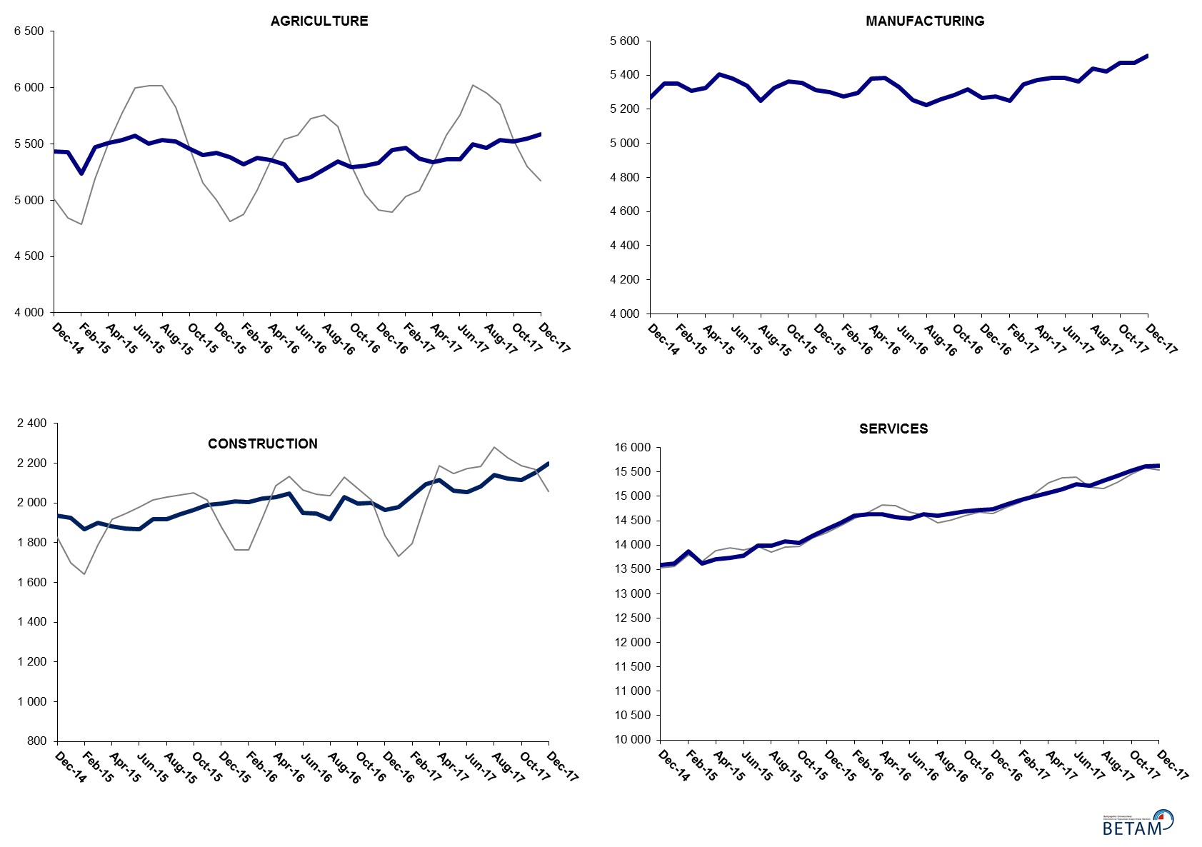

Source: TURKSTAT, Betam

The number of non-agricultural unemployed decreased by 566 thousand within a year

From December 2016 to December 2017 non-agricultural labor force increased by 799 thousand (3.1 percent) and non-agricultural employment by 1 million 365 thousand (6.3 percent) (Figure 4). Thus, non-agricultural unemployed decreased by 566 thousand and attained 3 million 242 thousand (Figure 4). Annual increases in non-agricultural employment exceed one million people since the period of August 2017. In the last three periods, increases in non-agricultural labor force are relatively weak; thus, the non-agricultural unemployed decreased rapidly.

Figure 4 Year-on-year changes in non-agricultural labor force, employment, and unemployment
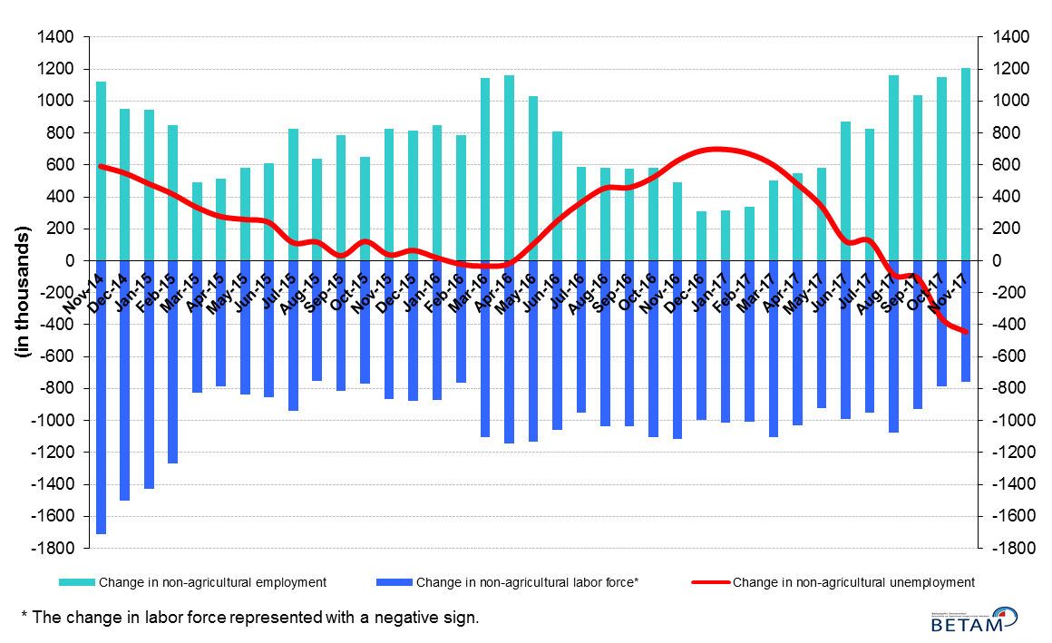
Source: Turkstat, Betam

Increase in female and male unemployment difference

Figure 5 shows seasonally adjusted non-agricultural unemployment rate for males (green) and for females (purple). From the period of November 2017 to the period of December 2017, the non-agricultural female unemployment rate remained at 16.8 percent while the non-agricultural male employment rate decreased by 0.3 percentage points and recorded as 9.6 percent. In the context of a rapid unemployment decrease at the aggregate the gender gap in unemployment has been widened since female unemployment remained constant while male unemployment decreased sizably.

Figure 5: Seasonally adjusted non-agricultural unemployment rate by gender
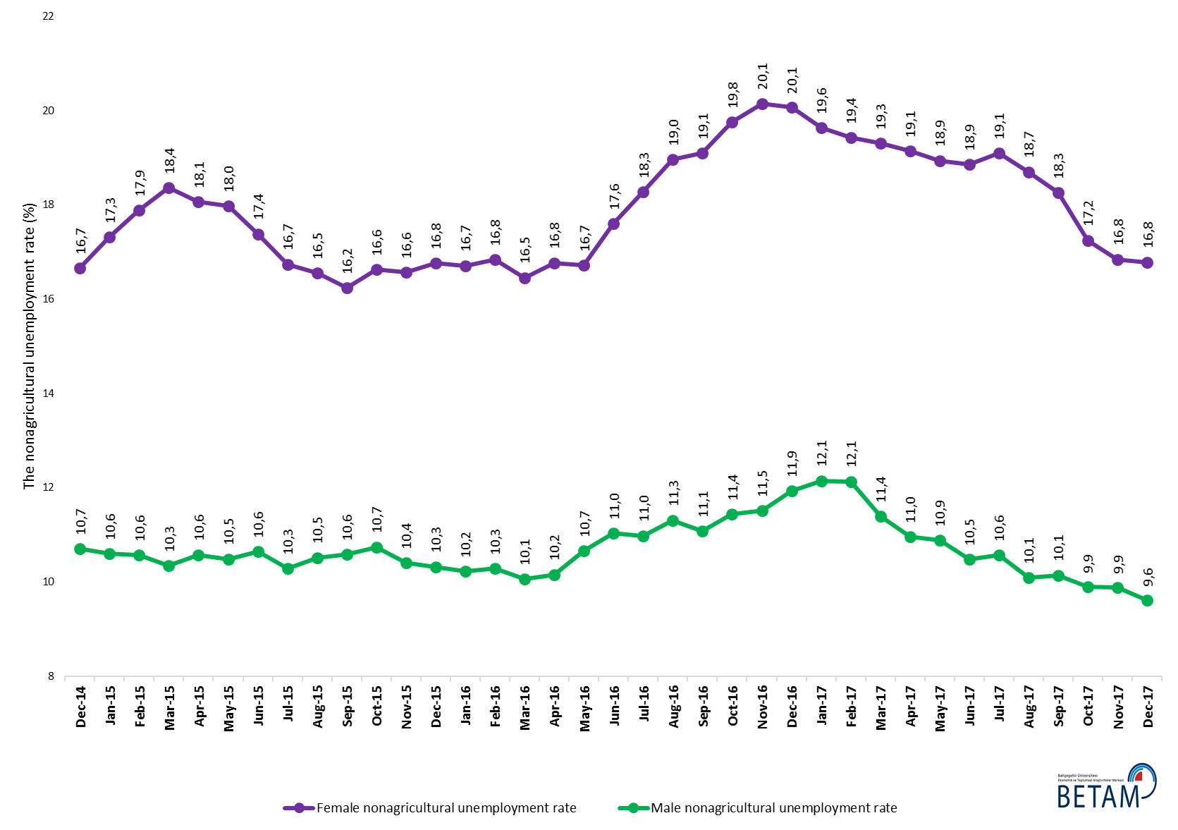
Source: Turkstat, Betam

Table 1 Seasonally adjusted non-agricultural labor market indicators (in thousands) *
 | Labor force | Employment | Unemployment | Unemployment rate | Monthly changes
November-14 | 23684 | 20700 | 2984 | 12,6% | Labor force | Employment | Unemployment
December-14 | 23745 | 20801 | 2944 | 12,4% | 61 | 101 | -40
January-15 | 23856 | 20898 | 2958 | 12,4% | 111 | 97 | 14
February-15 | 24047 | 21089 | 2958 | 12,3% | 191 | 191 | 0
March-15 | 23780 | 20831 | 2949 | 12,4% | -267 | -258 | -9
April-15 | 23855 | 20921 | 2934 | 12,3% | 76 | 90 | -14
May-15 | 23982 | 21008 | 2974 | 12,4% | 127 | 87 | 40
June-15 | 24034 | 21030 | 3004 | 12,5% | 53 | 22 | 31
July-15 | 24191 | 21240 | 2951 | 12,2% | 157 | 210 | -53
August-15 | 24123 | 21156 | 2967 | 12,3% | -68 | -84 | 16
September-15 | 24345 | 21351 | 2994 | 12,3% | 222 | 195 | 27
October-15 | 24421 | 21368 | 3053 | 12,5% | 75 | 17 | 58
November-15 | 24558 | 21537 | 3021 | 12,3% | 137 | 169 | -32
December-15 | 24639 | 21633 | 3006 | 12,2% | 81 | 96 | -15
January-16 | 24758 | 21762 | 2996 | 12,1% | 119 | 129 | -10
February-16 | 24833 | 21878 | 2955 | 11,9% | 75 | 116 | -41
March-16 | 24881 | 21945 | 2936 | 11,8% | 48 | 67 | -19
April-16 | 25012 | 22036 | 2976 | 11,9% | 132 | 91 | 41
May-16 | 25126 | 22010 | 3116 | 12,4% | 113 | -26 | 139
June-16 | 25122 | 21831 | 3291 | 13,1% | -4 | -179 | 175
July-16 | 25176 | 21828 | 3348 | 13,3% | 54 | -3 | 57
August-16 | 25168 | 21745 | 3423 | 13,6% | -9 | -83 | 74
September-16 | 25356 | 21933 | 3423 | 13,5% | 188 | 188 | 0
October-16 | 25543 | 21967 | 3576 | 14,0% | 187 | 34 | 153
November-16 | 25655 | 22038 | 3617 | 14,1% | 112 | 71 | 41
December-16 | 25593 | 21959 | 3634 | 14,2% | -62 | -79 | 17
January-17 | 25715 | 22089 | 3626 | 14,1% | 122 | 130 | -8
February-17 | 25807 | 22220 | 3587 | 13,9% | 92 | 131 | -39
March-17 | 25968 | 22436 | 3532 | 13,6% | 160 | 216 | -56
April-17 | 26021 | 22560 | 3461 | 13,3% | 53 | 124 | -71
May-17 | 26051 | 22586 | 3465 | 13,3% | 30 | 26 | 4
June-17 | 26114 | 22693 | 3421 | 13,1% | 63 | 107 | -44
July-17 | 26101 | 22656 | 3445 | 13,2% | -13 | -37 | 24
August-17 | 26229 | 22898 | 3331 | 12,7% | 128 | 242 | -114
September-17 | 26281 | 22970 | 3311 | 12,6% | 52 | 72 | -20
October-17 | 26333 | 23120 | 3213 | 12,2% | 51 | 150 | -99
November-17 | 26410 | 23241 | 3169 | 12,0% | 78 | 121 | -43
December-17 | 26465 | 23342 | 3123 | 11,8% | 55 | 101 | -46
Source: Turkstat, Betam

Table 2 Seasonally adjusted employment by sectors (in thousands) *
 | Agriculture | Manufacturing | Construction | Service | Monthly changes
November-14 | 5415 | 5273 | 1940 | 13487 | Agriculture | Manufacturing | Construction | Service
December-14 | 5432 | 5266 | 1937 | 13598 | 17 | -7 | -3 | 111
January-15 | 5424 | 5349 | 1926 | 13624 | -8 | 83 | -11 | 26
February-15 | 5237 | 5351 | 1866 | 13872 | -187 | 2 | -60 | 248
March-15 | 5474 | 5308 | 1900 | 13624 | 237 | -43 | 34 | -248
April-15 | 5509 | 5326 | 1882 | 13713 | 35 | 18 | -18 | 89
May-15 | 5535 | 5404 | 1871 | 13734 | 26 | 78 | -11 | 21
June-15 | 5574 | 5380 | 1866 | 13784 | 39 | -24 | -5 | 50
July-15 | 5501 | 5336 | 1919 | 13985 | -73 | -44 | 53 | 201
August-15 | 5535 | 5252 | 1917 | 13987 | 34 | -84 | -2 | 2
September-15 | 5519 | 5327 | 1942 | 14082 | -16 | 75 | 25 | 95
October-15 | 5458 | 5363 | 1964 | 14041 | -61 | 36 | 22 | -41
November-15 | 5399 | 5353 | 1989 | 14195 | -59 | -10 | 25 | 154
December-15 | 5423 | 5311 | 1997 | 14325 | 24 | -42 | 8 | 130
January-16 | 5380 | 5300 | 2009 | 14453 | -43 | -11 | 12 | 128
February-16 | 5321 | 5276 | 2005 | 14597 | -59 | -24 | -4 | 144
March-16 | 5376 | 5295 | 2023 | 14626 | 55 | 19 | 18 | 29
April-16 | 5360 | 5381 | 2029 | 14625 | -16 | 86 | 6 | -1
May-16 | 5316 | 5386 | 2046 | 14579 | -44 | 5 | 17 | -46
June-16 | 5173 | 5330 | 1950 | 14551 | -143 | -56 | -96 | -28
July-16 | 5208 | 5254 | 1946 | 14629 | 35 | -76 | -4 | 78
August-16 | 5272 | 5224 | 1919 | 14602 | 64 | -30 | -27 | -27
September-16 | 5342 | 5260 | 2029 | 14643 | 70 | 36 | 110 | 41
October-16 | 5295 | 5282 | 1998 | 14686 | -47 | 22 | -31 | 43
November-16 | 5304 | 5316 | 1999 | 14723 | 9 | 34 | 1 | 37
December-16 | 5331 | 5265 | 1963 | 14731 | 27 | -51 | -36 | 8
January-17 | 5444 | 5274 | 1979 | 14836 | 113 | 9 | 16 | 105
February-17 | 5466 | 5251 | 2038 | 14930 | 22 | -23 | 59 | 94
March-17 | 5369 | 5346 | 2095 | 14995 | -97 | 95 | 57 | 65
April-17 | 5338 | 5372 | 2114 | 15074 | -31 | 26 | 19 | 79
May-17 | 5363 | 5386 | 2060 | 15139 | 25 | 14 | -54 | 65
June-17 | 5366 | 5383 | 2055 | 15254 | 3 | -3 | -5 | 115
July-17 | 5498 | 5363 | 2082 | 15211 | 132 | -20 | 27 | -43
August-17 | 5466 | 5437 | 2142 | 15318 | -32 | 74 | 60 | 107
September-17 | 5535 | 5421 | 2123 | 15426 | 69 | -16 | -19 | 108
October-17 | 5524 | 5470 | 2117 | 15533 | -11 | 49 | -6 | 107
November-17 | 5547 | 5470 | 2153 | 15618 | 23 | 0 | 36 | 85
December-17 | 5583 | 5514 | 2197 | 15631 | 36 | 44 | 44 | 13

Source: Turkstat, Betam

Table 3: Seasonally adjusted non-agricultural labor force by gender (thousands)
 | Female Labor Force | Female Employment | Female Unemployed | Male Labor Force | Male Employment | Male Unemployed
December-14 | 6416 | 5347 | 1069 | 17365 | 15506 | 1859
January-15 | 6505 | 5378 | 1126 | 17354 | 15515 | 1839
February-15 | 6565 | 5390 | 1174 | 17453 | 15607 | 1846
March-15 | 6520 | 5323 | 1197 | 17210 | 15430 | 1780
April-15 | 6540 | 5359 | 1181 | 17272 | 15445 | 1827
May-15 | 6623 | 5432 | 1190 | 17329 | 15511 | 1817
June-15 | 6654 | 5498 | 1157 | 17413 | 15560 | 1853
July-15 | 6747 | 5618 | 1129 | 17483 | 15685 | 1798
August-15 | 6712 | 5601 | 1111 | 17482 | 15644 | 1838
September-15 | 6758 | 5661 | 1097 | 17589 | 15727 | 1861
October-15 | 6780 | 5653 | 1127 | 17637 | 15743 | 1894
November-15 | 6877 | 5737 | 1139 | 17644 | 15807 | 1837
December-15 | 6971 | 5802 | 1168 | 17691 | 15865 | 1826
January-16 | 7017 | 5844 | 1173 | 17710 | 15900 | 1811
February-16 | 7053 | 5865 | 1188 | 17745 | 15919 | 1826
March-16 | 7056 | 5895 | 1161 | 17789 | 15999 | 1790
April-16 | 7141 | 5944 | 1197 | 17828 | 16017 | 1811
May-16 | 7173 | 5973 | 1199 | 17909 | 15999 | 1909
June-16 | 7258 | 5981 | 1277 | 17856 | 15887 | 1969
July-16 | 7267 | 5940 | 1328 | 17916 | 15949 | 1967
August-16 | 7325 | 5936 | 1389 | 17915 | 15889 | 2026
September-16 | 7375 | 5967 | 1408 | 17989 | 15996 | 1992
October-16 | 7441 | 5971 | 1470 | 18070 | 16004 | 2066
November-16 | 7460 | 5957 | 1503 | 18170 | 16078 | 2091
December-16 | 7460 | 5962 | 1497 | 18183 | 16014 | 2169
January-17 | 7456 | 5992 | 1464 | 18291 | 16069 | 2222
February-17 | 7518 | 6058 | 1460 | 18285 | 16067 | 2219
March-17 | 7612 | 6142 | 1470 | 18346 | 16255 | 2090
April-17 | 7598 | 6144 | 1455 | 18383 | 16369 | 2014
May-17 | 7649 | 6200 | 1449 | 18354 | 16355 | 1998
June-17 | 7666 | 6221 | 1446 | 18453 | 16519 | 1934
July-17 | 7678 | 6212 | 1466 | 18455 | 16505 | 1950
August-17 | 7731 | 6285 | 1446 | 18574 | 16700 | 1874
September-17 | 7765 | 6348 | 1417 | 18532 | 16652 | 1880
October-17 | 7791 | 6447 | 1344 | 18506 | 16675 | 1831
November-17 | 7829 | 6510 | 1319 | 18566 | 16731 | 1835
December-17 | 7889 | 6565 | 1324 | 18561 | 16776 | 1785
Source: Turkstat, Betam

*Prof. Dr. Seyfettin Gürsel, Betam, Director, seyfettin.gursel@eas.bau.edu.tr
∗∗ Gökçe Uysal Betam, Deputy Director, gokce.uysal @eas.bau.edu.tr *** Yazgı Genç, Betam, Research Assistant, yazgi.genc@eas.bau.edu.tr
For detailed information on Betam's forecasting model, please see Betam Research Brief 168 titled as "Kariyer.net Verisiyle Kısa Vadeli Tarım Dışı İşsizlik Tahmini" . For the innovations in the model please see Betam Research Brief 14 titled as "Mevsim Etkilerinden Arındırılmış İşsizlik Tahmini" Soybilgen, B., "Kariyer.net Verisiyle Kısa Vadeli Tarım Dışı İşsizlik Tahmini", Betam Research Brief 168. http://betam.bahcesehir.edu.tr/tr/2014/06/kariyer-net-verisiyle-kisa-vadeli-tarim-disi-issizlik-tahmini/ Soybilgen, B., "Mevsim Etkilerinden Arındırılmış İşsizlik Tahmini", Betam Research Brief 14 http://betam.bahcesehir.edu.tr/2015/08/mevsim-etkilerinden-arindirilmis-tarim-disi-issizlik-tahmini/
Betam has been calculating application per vacancy using series released by Kariyer.net for a while. Seasonal and calendar adjustment procedure is applied to application per vacancy series. A decrease in applications per vacancy may be caused by an increase in vacancies or by a decrease in the number of applications. An increase in vacancies signals economic growth while decreasing number of applications indicates a decrease in number of people looking for a job. Monthly labor market series released by TurkStat is the average of three months. Therefore, application per vacancy statistics calculated using Kariyer.net series is the average of three months as well.
Sektörel istihdam serileri teker teker mevsim etkilerinden arındırılmaktadır. Dolayısıyla sektörel istihdam rakamlarının toplamı, mevsim etkilerinden arındırılmış toplam istihdam rakamından farklı olabilmektedir. Aradaki fark mevsim etkilerinden arındırma prosedürünün lineer olmamasından kaynaklanmaktadır.
Turkstat revised the labor market statistics drastically in February 2014. Within this framework, they back casted various labor market indicators and they also continued to announce seasonally adjusted series. However, Turkstat is not providing back-casted series by gender. Therefore, female and male labor market statistics are not sufficiently long for the seasonal adjustment procedures (There should be minimum 36 observations). With the announcement of the period of February 2017 data, the number of observations required for the seasonal decontamination process was provided. From this period Betam get seasonal adjustment series in terms of gender. Nevertheless, it should not be forgotten that seasonal adjustment may cause extra volatility in the series for at least a while.

