Research Note 18/222

8 February 2018
The effect of minimum wage hike on informality is concentrated on low-wage sectors
Seyfettin Gürsel*, Ozan Bakış∗∗ and Yazgı Genç***

Executive Summary
In the research note we published earlier (see Betam Research Note 18/220, “Minimum wage affects formal employment negatively”), the effect of the increase in minimum wage on informal employment was analysed for both wage and non-wage earners (employer, own account worker and free family worker). We observed that effect of minimum wage increase is positive especially for non-wage earners.
In this research note, we are examining the effect of minimum wage on informal employment at the sector level by using the most up-to-date data. The preliminary results show that the minimum wage increase in 2016 affects the informal employment both in 2016 and 2017. However, there is a difference between the effects in 2016 and 2017. While the effect of informality is more concentrated in the low-wage sectors (sectors where workers earning minimum wage or below) in 2016, in the period of 2017 the effect, while still there, is likely to be independent of sector.

Introduction
In the previous research note, we have examined the effects of high minimum wage increase in 2016 (from 1000 TL to 1300 TL) on informal employment for both wage and non-wage earners using both the all data of 2016 and the first three quarters data of 2017. We noted that effects are positive especially for employers, own account workers and free family workers. In addition, we stated that results of extended studies will be examined in the next two studies. (see Betam Research Note 18/220 “Minimum wage effects formal employment negatively”).
In this research note, we analyse the effects of minimum wage shock at sectoral level. We claim that wage distribution in each sector can be used as a proxy for the effect of minimum wage increase on informal employment. The first step of this assumption is determining the differences of the rate of low-wage workers in each sector. This ratio can be interpreted as reflecting “the effect of minimum wage increase on each sector”. In the second step we verify the above claim. If this proposition is correct, the minimum wage increase will be more effective in low wage sectors; moreover, informal employment will increase compared to other sectors.
In the research note we published in 2016 (see. Betam Research Note 16/196, “The minimum wage increase negatively affects informal employment”), we tested this assumption; moreover, we stated that first findings seemed to verify this claim. This research note expands this finding by using the most up-to-date (quarterly and annual) Households Labor Force Survey (HLFS) data published by TurkStat. We find that effect of increase in minimum wage raises the rate of informal employment more in sectors with low wage earners especially in the first two quarters following the increase. In the fourth quarter of 2016 an in 2017, we observe that effect continues to spread evenly across all sectors.

The increase in informality is clearer in low wage sectors
In the research note we published on the January 10th, 2018 we stated that informality of non-salaried workers decreases almost regularly after the period of 2015. In the same note, we also stated that decreases of informal employment were very low from the period of 2015 to 2016 compared to previous trends (only 0.2 percentage points). On the other hand, in the non-salaried workers informality rates which decrease before the period of 2016, separate from general trend by increasing in the period of 2015-2016. Sectoral differences cannot be determined since the calculations above belong to all economy for both wage earners and total employment. The sectors with the high number of low wage workers and other sectors may be affected differently by minimum wage increase. In addition, these effects may have shadowed each other. In order to check our assumption, detailed sectoral analyses are needed. We will discuss this topic in detail below.

Data and Methodology
Let us, first, summarize the methodology that we use to understand the effect of minimum wage increase on informality: we calculate the ratio of low-paid full-time employees at sectoral level by using the data of 2014, 2015 and 2016. It is expected that effect is higher in the sectors where low paid workers are more intense if the minimum wage increase affects the informal employment. In that case, we can compare the rates of informal employment in sectors by using all data of years 2014-2016 and partial data of 2017 to test whether sectors with high increases in informal employment are also characterized by high fractions of low wage workers.
We think that findings of our previous research note show that minimum wage hike affects not only wage earners but also non-salaried workers. The mechanisms by which this effect is operative need to be investigated further. The first possible reason is higher social security premiums (due to minimum wage increase) that increase the cost of formality. Especially, newly established small family companies may have preferred to work for a while. Another possibility is that wage earners who work at low paid sectors can lose their jobs because of increasing cost and they can start to work informally at small family business.
We use the rate of workers who earn around the minimum wage and below (low-wage ratio) as the effect of minimum wage increase on sectors. We obtain this information from HLFS microdata set. Following Card (1992), to determine how a given sector is expected to be affected by the minimum wage hike in 2016, we use the fraction of workers earning a wage below the new (following year’s) minimum wage. The only difference is inflation adjustment compared to the study of Card (1992). To be more precise, in 2015 average minimum wage was 975 TL and the inflation rate was 7.67 percent. If all wages increased by inflation rate between 2014 and 2015, a wage of 905.5 TL in 2014 would become 975 TL in the period of 2015. Thus, we calculate the share of workers who earn 905.5 TL and below in total wage earners in each sector in 2014 HLFS data. A sector will be affected more by the minimum wage increase when this ratio is higher. Given the minimum wage hike in January 2016, the first thing that comes to mind is to compute the low-wage ratio for year 2015. If our reasoning is correct, we expect that informal working will increase especially in low-paid sectors. At the same time, it is a necessary to show that the same increase in informality does not occur in the same low-wage sectors. The rate of low paid workers and informality of sectors in the period of 2014-2016 were presented in the Table 1. Despite big differences in the levels of low-wage workers between years, the ranking among sectors was almost constant in the period of 2014 and 2015.

We have two main data sources. Firstly, we use 2014-2016 HLFS micro data to compute ratio of low wage workers in each sector. The other data source is online labor force statistics used for measuring the quarterly rates of informality at sectoral level. In order to get this data, we use the link “February 2014 and after” in the “Dynamic Search” section of the “Statistical Tables and Dynamic Interrogation” heading in the “Labor Statistics” section on the TURKSTAT website. Unfortunately, at sectoral level (18 sectors) queries, it is not possible to get informal employment figures for wage and non-wage earners separately. As a result, we are forced to calculate the rate of sectoral informal employment for total employment.
The Household Budget Surveys compiled also by TurkStat considers workers with 35 hours (usual working hours) as full-time workers and the ones who work less as part-time workers. Thus, when we calculate the rate of low-wage workers at sectoral level, we consider wage earners who have positive wage and monthly income as a minimum wage and below and work weekly 35 and more hours (full-time).
We do our analyses by using annual changes since the data of monthly employment has seasonality. Thus, we use the data of February, May, August and November in the period of 2014, 2015 and 2016 and the data of February, May, August in the period of 2017. As known, the monthly data of HLFS are averages of three months. Thus, the data of February, May, August and November correspond to four quarter of a year. If our hypothesis is true we expect a positive correlation between the two variables. On the other hand, we do not expect a positive correlation between the increase of sectoral informal employment and the share of low paid workers in sector compared to same months of 2014 and 2015 since there is not a minimum wage shock in sectors from the period of 2014 to 2015.

The informality and wage distribution of sectors
We see a positive correlation between informality rate and low-wage ratio when considering sectoral data (17 sectors) (see Figure 1 in the appendix). Here, we need to make an important reminder. The rate of informality is high in agriculture; thus, we analyse non-agricultural sectors. This is the reason why we use the information of 17 sectors rather than 18 sectors. At the same time, inclusion of agriculture does not affect our results since sectoral analyses focus on annual changes.
Table 1 shows the rate of informal employment and low paid workers in 17 sectors for the last three years. The differences between sectors are striking. Informal employment is very high in “Other Services” (52.1 percentage in the period of 2016). On the other hand, it is low in the sectors of “Mining and Quarrying”, “Public Administrative and Defence”, “Education” and “Financial and Insurance Activities” (5.0 percentage and below in 2016). In 2016, compared to 2015, the rate of informality increased in many sectors while in 2015, compared to 2014, informality rates decreased in almost all sectors. The sector of “Other Services” which has the high informality rate among non-agricultural sectors shows the most striking change: in 2016, its informality rate increased by 0.3 percentage points (from 51.8 percentage to 52.1 percentage) while it decreased by 4.6 percentage points in the period of 2015. Lastly, in the large sector of manufacturing, the rate of informal employment increased by 1.1 percentage points (from 18.9 percentage to 19.9 percentage) in the period of 2015-2016 while it decreased by 1.3 percentage points in the period of 2014-2015.
Table 1 also shows that share of low paid workers in each sector and the relationship between the rate of informal employment and the rate of low paid workers. The positive correlation between these two rates are striking (see Table 1 in the appendix). Generally, the rate of informal employee is high in low paid sectors. In the period of 2016, the rate of low-paid employees is the highest in the sectors of “Other Services” and “Human Health” (45.0 percentage and 28.9 percentage respectively). On the other hand, in the sectors of “Financial and Insurance Activities” and “Public Administrative and Defence”, the rate of low paid workers is low (in the period of 2016, 1.9 and 2.2 percentage respectively).
In the period of 2014 and 2015, the average rates of low paid workers were 29.4 and 33.6 percentage respectively. In the period of 2016 it decreased to 13.2 percentage. The reason of this decrease is that rate of minimum wage increases in the period of 2017 (7.9 percentage points) is lower than inflation rate in 2017 (11.1 percentage). According to our definition, if many workers who earn below minimum wage raise their wages as the inflation rate in the period of 2016, they are not considered as “low-paid” workers since they will exceed the minimum wage level in the period of 2017.
Table 1: Informal and low paid workers according to sectors (percentage)
 | 2014 |  | 2015 |  | 2016
Sector | Low wage | Informal | Low wage | Informal | Low wage | Informal
Financial and Insurance | 7.6 | 3.4 | 17.3 | 4.0 | 1.9 | 3.3
Education | 11.9 | 3.5 | 18.3 | 3.2 | 4.9 | 3.6
Public Administration and Defence | 6.5 | 4.1 | 9.6 | 4.0 | 2.2 | 3.9
Mining and Quarrying | 19.0 | 6.7 | 30.6 | 6.1 | 4.0 | 4.2
Professional, Scientific and Technical | 20.1 | 11.1 | 30.9 | 9.9 | 6.3 | 9.2
Information and Communication | 13.0 | 13.3 | 27.7 | 13.0 | 5.9 | 12.6
Administrative and Support Services Activities | 36.7 | 15.3 | 60.4 | 14.6 | 6.4 | 13.1
Arts, entertainment and Recreation | 18.9 | 20.4 | 27.7 | 19.0 | 8.2 | 19.9
Manufacturing | 34.8 | 20.2 | 55.6 | 18.9 | 11.3 | 19.9
Transport and Storage | 25.3 | 24.8 | 43.2 | 24.6 | 10.1 | 23.2
Real Estate | 38.3 | 26.3 | 65.6 | 20.9 | 14.5 | 23.7
Wholesale and Retail Trade | 37.2 | 26.5 | 58.7 | 25.9 | 14.5 | 27.1
Human Health | 33.9 | 24.7 | 43.4 | 27.2 | 28.9 | 28.6
Accommodation | 39.1 | 33.0 | 60.9 | 29.4 | 18.2 | 31.6
Electricity and Water | 16.3 | 29.9 | 29.5 | 30.5 | 7.2 | 33.9
Construction | 28.0 | 36.6 | 49.0 | 35.6 | 18.4 | 35.8
Other Services | 57.7 | 56.4 | 74.4 | 51.8 | 45.0 | 52.1
Total | 29.4 | 35.0 | 45.9 | 33.6 | 13.2 | 33.5

Source: TURKSTAT, HLFS 2014, 2015,2016 micro data and Labor Force Statistics (http://www.tuik.gov.tr, Date of Access 06.11.2017) Note: The minimum wage level corrected by inflation for the following year is used as a limit value while the rate of low paid workers is calculated (see. The section of Data and Methodology and Footnote 2).

We calculated the ratio of low-wage workers in each sector in the period of 2014, 2015 and 2016 to examine our claim explained before. We interpret this ratio as the proxy for the effect of the minimum wage increase. Then, we calculate the rate of informal employment for 17 sectors in the period of 2014-2017. Figure 1, Figure 2 and Figure 3 show the yearly changes of informal employment rate from 2014 to 2015, from 2015 to 2016 and from 2016 to 2017 respectively. They also show the relationship between the rate of informality and the rate low-wage workers for same periods.
Figure 1 shows the relationship between the changes of the rate of informal employment and low-wage workers from the period of 2014 to 2015 which is before minimum wage shock. It is obvious that there is negative correlation between these two variables. The informality rate decreases in almost every sector compared to previous year. In addition, decreases in informal employment are high in the sector which has high rate of low paid workers.
The negative correlation between two variables gives place to a positive correlation in the first two quarters of 2016 immediately after the hike in minimum wage as it is clearly distinguishable from Figure 2. In the period of February and May, the increase of informality rate is relatively higher in the sectors which have high rate of low-paid workers. In the second part of the year (subfigures for August and November), the rate of informal employment did not change with the rate of low-paid workers. It seems that the low-wage characteristic of sectors is not determinant anymore starting from the third quarter in 2016. The effect of minimum wage increase on informality is similar across all sectors thereafter. Nevertheless, there is an important difference between the third and fourth quarters. In the last quarter (November), average yearly change in informality is positive while it is nearly zero in the third quarter (August).
Lastly, the change of the rate of informal employment in the period of 2016-2017 is examined in Figure 3. The similarity between each quarter in Figure 3 and the fourth quarter in Figure 2 is striking. The rate of informal working increased on average in the period of 2017 compared to 2016. In some sectors informality rate has increased, in other sectors, it has decreased; however, changes are not systematically associated with the rate of low-paid workers.
Given these findings, to a large extent, our claim seems to be verified. In the low-wage sectors, the effect of minimum wage increase on informal employment is higher initially (immediately after the minimum wage shock). However, in the following periods, the increase in the rate of informal employment is positive but similar for all sector. To sum up, between 2014 and 2015, we see a general decline in informality rates across sectors while the decline in low-wage sectors is clearly more important. We find that high increase of minimum wage in the beginning of 2016 increases initially the informality rate in low-wage sectors. Then, in the following period, this effect is generalised to all sectors independently of the ratio of low-wage earners in the sector.
Our findings in this research note have parallels with the trends of informality for wage earners examined in previous research note (Research Note 220/18). In 2016, compared to 2015, the informal working rate of wage earners increased in the first two quarters, decreased in the third quarter and increased again in the last quarter. Thus, the main trends in the data are, expectedly, shaped by trends of wage earners since they are more than half of total employment.
The effect of minimum wage shock on informal employment will also be examined in detail in the next research note at the gender division. Our next note indicates that total effect mentioned through this note is driven by men. It is known that number of low-wage workers among women is much lower than men since education level is relatively higher for women compared to men. Thus, the above result, comes from the fact that the number of female workers with low education levels that is characterized by high informality rates is much low compared to male workers. Taking all these factors into account, it is not surprising that the minimum wage increase does not affect the informality rate for women.

Conclusions and remarks
Our results in this note confirm the claim that the minimum wage increase which was effective as of January 1, 2016 has affected the informal employment rate. This effect was especially higher in low-wage sectors in the first two quarters of 2016. Then, this effect became independent of the ratio of low-wage workers in the sector. Since the last quarter of 2016 the generalized upward trend in informality seems to continue. One needs to be cautious about findings of this and previous research note relies on aggregate sectoral level data. In our next research note, we will examine the relationship between minimum wage and informality, in more detail using microdata at the gender division and separating wage earners and non-wage earners. As we will see on next research note, the effect of minimum wage increase on informal working is observed especially for male employees.

References
[1] Card, David (1992). Using regional variation in wages to measure the effects of the federal minimum wage, Industrial and Labor Relations Review 46, 22-37.
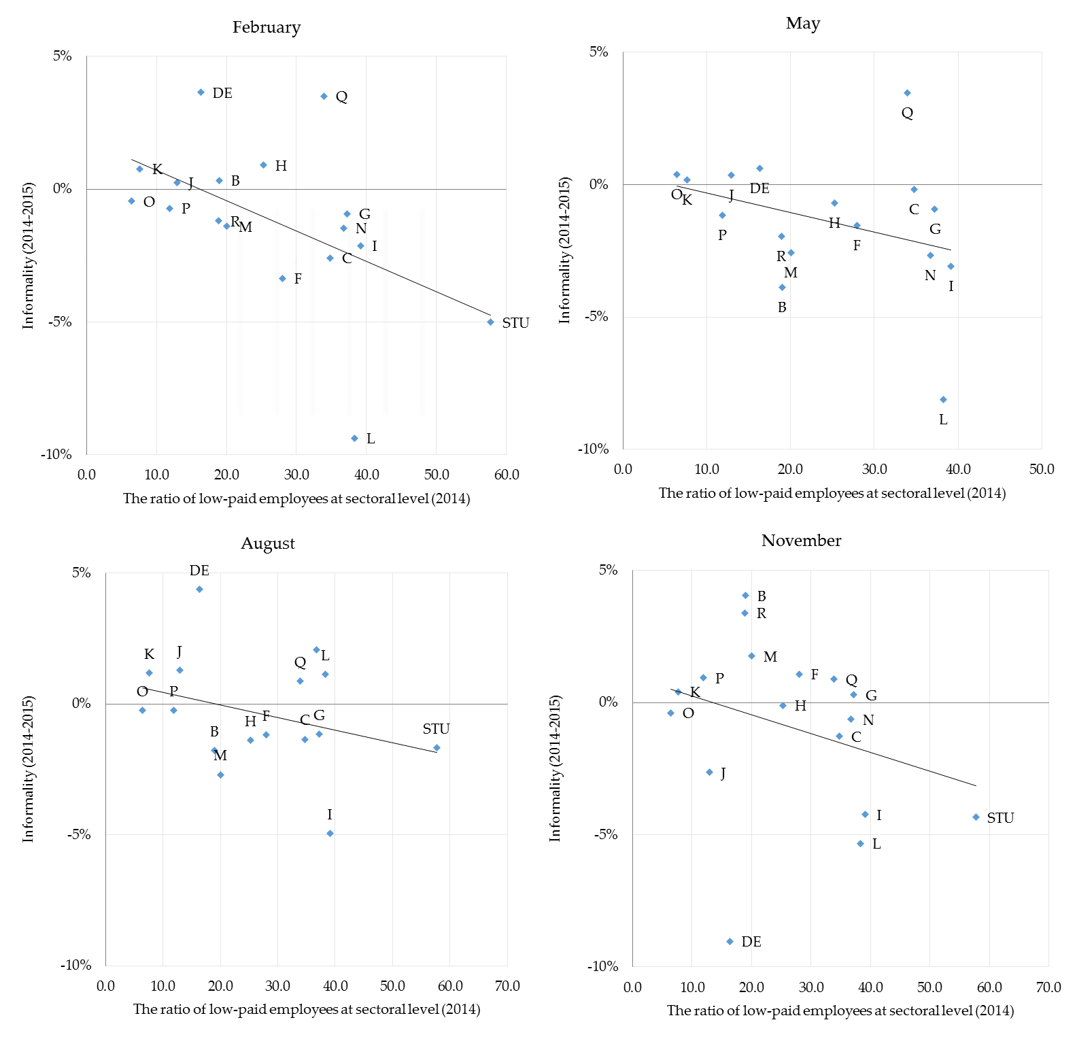
Figure 1: the relationship between the changes of the rate of low paid workers and total informal employment 2014-2015
Source: TURKSTAT HLFS 2016 micro data and Labor Force Statistics (http://www.tuik.gov.tr, Date of access 06.11.2017.) See Table 2 in the Appendix for the sectors where the letters correspond). Note: The minimum wage level corrected by inflation for the following year is used as a limit value while the rate of low paid workers is calculated (see. The section of Data and Methodology and Footnote 2). The vertical axis represents the change in the rate of informal working for each quarter. Note 2: The rate of low-paid workers calculated for wage earners; however, the rate of informal employment calculated for all employees. The reason of this case is that informal employment data of TURKSTAT does not include the wages of non-salaried workers for 18 sectors.

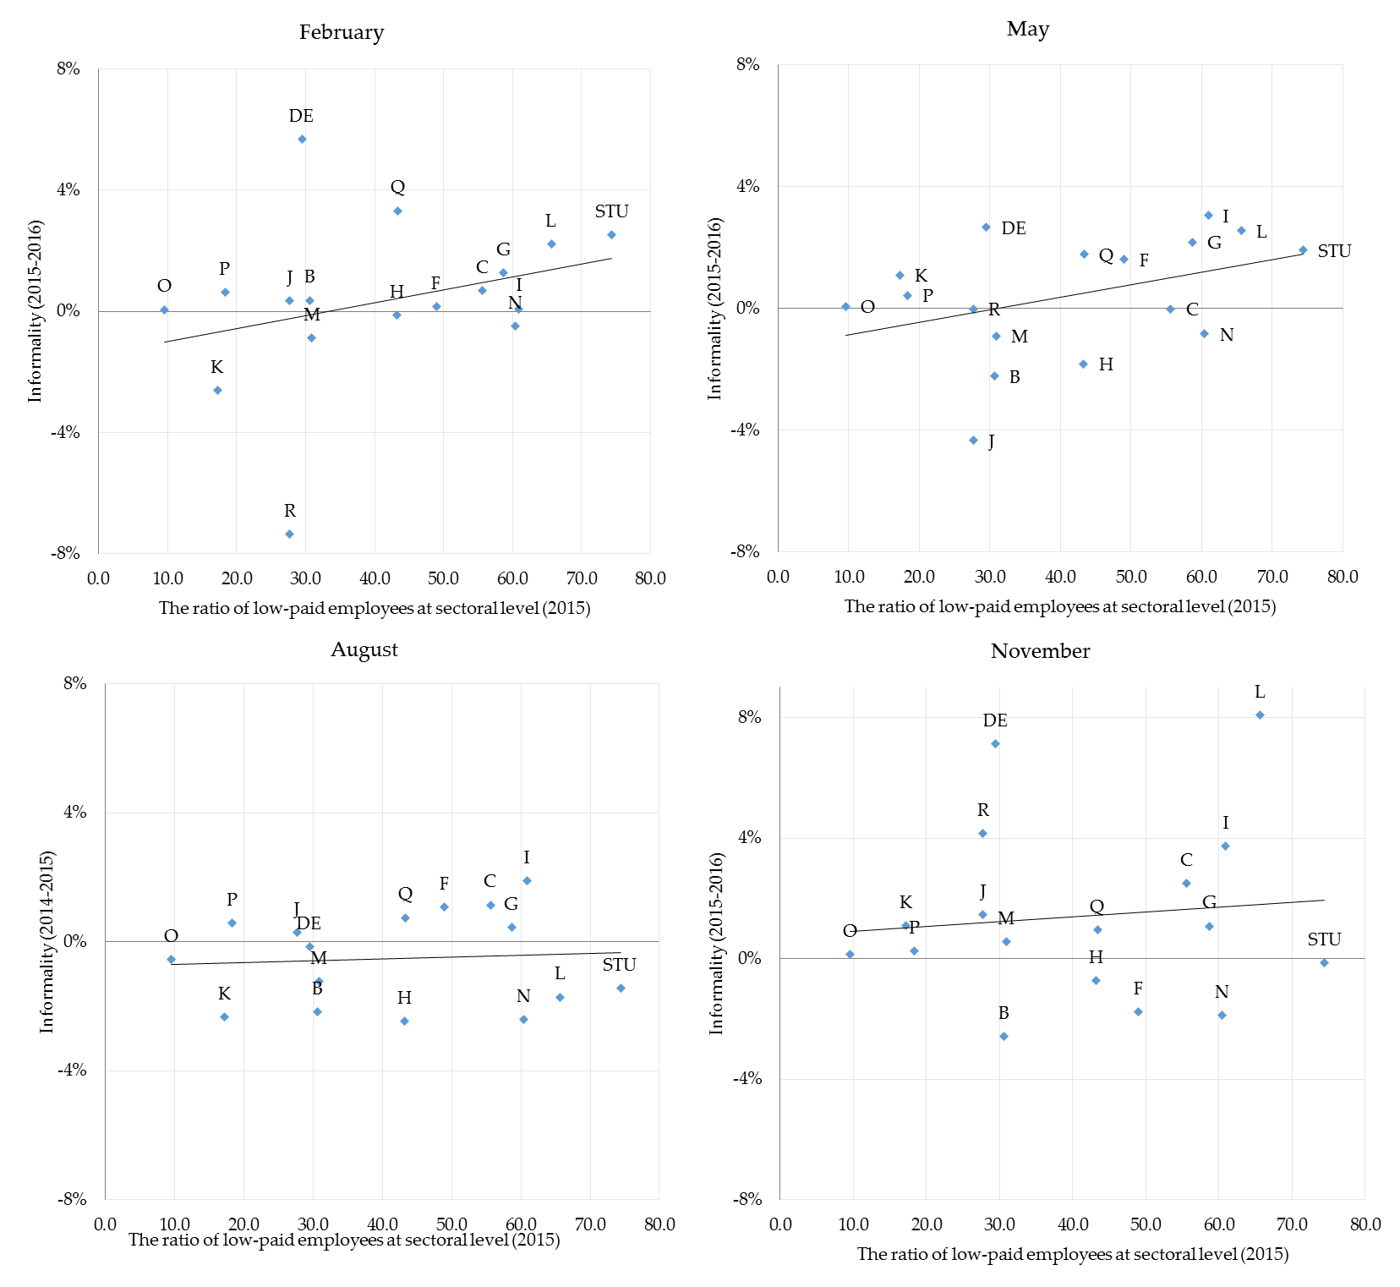
Figure 2: the relationship between the changes of the rate of low paid workers and total informal employment 2015-2016

Source: TURKSTAT HLFS 2016 micro data and Labor Force Statistics (http://www.tuik.gov.tr, Date of access 06.11.2017.) See Table 2 in the Appendix for the sectors where the letters correspond). Note: The minimum wage level corrected by inflation for the following year is used as a limit value while the rate of low paid workers is calculated (see. The section of Data and Methodology and Footnote 2). The vertical axis represents the change in the rate of informal working for each quarter. Note 2: The rate of low-paid workers calculated for wage earners; however, the rate of informal employment calculated for all employees. The reason of this case is that informal employment data of TURKSTAT does not include the wages of non-salaried workers for 18 sectors.

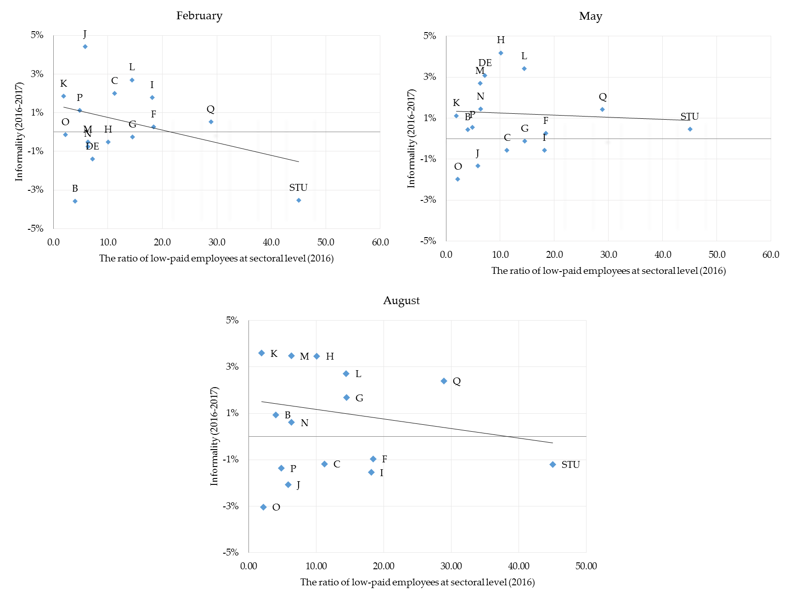
Figure 3: the relationship between the changes of the rate of low paid workers and total informal employment 2016-2017

Source: TURKSTAT HLFS 2016 micro data and Labor Force Statistics (http://www.tuik.gov.tr, Date of access 06.11.2017.) See Table 2 in the Appendix for the sectors where the letters correspond). Note: The minimum wage level corrected by inflation for the following year is used as a limit value while the rate of low paid workers is calculated (see. The section of Data and Methodology and Footnote 2). The vertical axis represents the change in the rate of informal working for each quarter. Note 2: The rate of low-paid workers calculated for wage earners; however, the rate of informal employment calculated for all employees. The reason of this case is that informal employment data of TURKSTAT does not include the wages of non-salaried workers for 18 sectors.

Appendix
Figure 1: The relationship between the rate of low paid employees and informal employment according to sectors (2014)

Source: TURKSTAT HLFS 2014 micro data and Labor Force Statistics (http://www.tuik.gov.tr, Date of access 06.11.2017). Note: The minimum wage level corrected by inflation for the following year is used as a limit value while the rate of low paid workers is calculated (see. The section of Data and Methodology and Footnote 2). Note 2: It created by using Table 1 and Table 1 in Appendix. Note 3: The data of 2015 and 2016 gives the very similar results.

Table 1: Informal and low paid wage earners according to sectors (percentage)
 | 2014 |  | 2015 |  | 2016
Sector | Low wage | Informal | Low wage | Informal | Low wage | Informal
Mining and Quarrying | 19.0 | 6.7 | 30.6 | 5.3 | 4.0 | 3.9
Manufacturing | 34.8 | 15.8 | 55.6 | 14.6 | 11.3 | 15.3
Electricity and Water | 16.3 | 6.0 | 29.5 | 5.6 | 7.2 | 7.8
Construction | 28.0 | 35.6 | 49.0 | 34.1 | 18.4 | 34.3
Wholesale and Retail Trade | 37.2 | 17.6 | 58.7 | 16.6 | 14.5 | 17.0
Transport and Storage | 25.3 | 19.9 | 43.2 | 20.4 | 10.1 | 18.5
Accommodation | 39.1 | 29.5 | 60.9 | 26.6 | 18.2 | 27.1
Information and Communication | 13.0 | 8.6 | 27.7 | 7.8 | 5.9 | 7.0
Financial and Insurance | 7.6 | 2.2 | 17.3 | 2.6 | 1.9 | 1.9
Real Estate | 38.3 | 20.5 | 65.6 | 16.6 | 14.5 | 18.0
Professional, Scientific and Technical | 20.1 | 9.4 | 30.9 | 7.6 | 6.3 | 6.5
Administrative and Support Services Activities | 36.7 | 7.0 | 60.4 | 6.4 | 6.4 | 4.9
Public Administration and Defence | 6.5 | 4.1 | 9.6 | 4.0 | 2.2 | 3.9
Education | 11.9 | 2.8 | 18.3 | 2.6 | 4.9 | 3.0
Human Health | 33.9 | 24.9 | 43.4 | 27.2 | 28.9 | 28.4
Arts, entertainment and Recreation | 18.9 | 15.6 | 27.7 | 13.8 | 8.2 | 13.2
Other Services | 57.7 | 62.0 | 74.4 | 57.3 | 45.0 | 55.9
Total | 29.4 | 19.6 | 45.9 | 18.3 | 13.2 | 18.2
Source: TURKSTAT, HLFS 2014, 2015,2016 micro data and Labor Force Statistics (http://www.tuik.gov.tr, Date of Access 06.11.2017) Note: The minimum wage level corrected by inflation for the following year is used as a limit value while the rate of low paid workers is calculated (see. The section of Data and Methodology and Footnote 2).

Table 2: Letters corresponded to the sectors
Code | Sector
B | Mining and Quarrying
C | Manufacturing
DE | Electricity and Water
F | Construction
G | Wholesale and Retail Trade
H | Transport and Storage
I | Accommodation
J | Information and Communication
K | Financial and Insurance
L | Real Estate
M | Professional, Scientific and Technical
N | Administrative and Support Services Activities
O | Public Administration and Defence
P | Education
Q | Human Health
R | Arts, entertainment and Recreation
STU | Other Services
Source: TURKSTAT Labor Force Statistics (http://www.tuik.gov.tr, Date of Access 30.11.2017)

*Prof. Dr. Seyfettin Gürsel, Betam, Director, seyfettin.gursel@eas.bau.edu.tr
∗∗ Ozan Bakış, Betam, Senior Researcher, ozan.bakis@eas.bau.edu.tr *** Yazgı Genç, Betam, Research Assistant, yazgi.genc@eas.bau.edu.tr
See. http://betam.bahcesehir.edu.tr/en/2018/01/minimum-wage-affects-formal-employment-negatively/
In the period of January and July 2014, net monthly minimum wages were 849 TL and 891 TL respectively. In the period of 2015 these wages were 849 and 1000 TL respectively. We calculated the minimum wages of these years by considering the average minimum wage of January and July (865,5 TL for 2014 and 975 TL for 2015) since there is no periodical information in yearly data. In the period of 2016 and 2017 there is only one minimum wage (1301 TL and 1404 TL respectively).

