Labor Market Outlook:
February 2018

15 February 2018

DECREASE IN UNEMPLOYMENT CONTINUES
Seyfettin Gürsel*, Gökçe Uysal ∗∗ and Yazgı Genç***

Executive Summary

Seasonally adjusted labor market data show that non-agricultural unemployment rate decreased by 0.1 percentage points in the period of November from October reaching 12.1 percent. In this period, employment increased in the construction and services sector by 35 and 87 thousand respectively while employment did not change in the manufacturing sector. Betam’s forecasting model predicts that the non-agricultural unemployment will decrease to 11.8 percent in the period of December 2017. On the other hand, according to seasonally adjusted labour data, difference in non-agricultural unemployment rate by gender decreased. From November 2016 to November 2017, the unemployment rate of female decreased by 2.8 percentage points reaching 17.3 percent and the rate for males decreased by 1.6 percentage points and reached 9.8 percent.

Strong increase in employment and labor force

According to seasonally adjusted labor market data, in the period of November 2017 compared to October 2017, the non-agricultural labor force increased by 109 thousand and reached 26 million 440 thousand while the number of employed in non-agricultural sectors increased by 122 thousand and reached 23 million 241 thousand (Figure 1, Table 1). As result, the number of unemployed in non-agricultural sectors decreased by 13 thousand and recorded as 3 million 169 thousand and the non-agricultural unemployment rate decreased from 12.2 percent to 12.1 percent. Nevertheless, the declining unemployment rate slows down but continues.

Figure 1 Seasonally adjusted non-agricultural labor force, employment, and unemployment

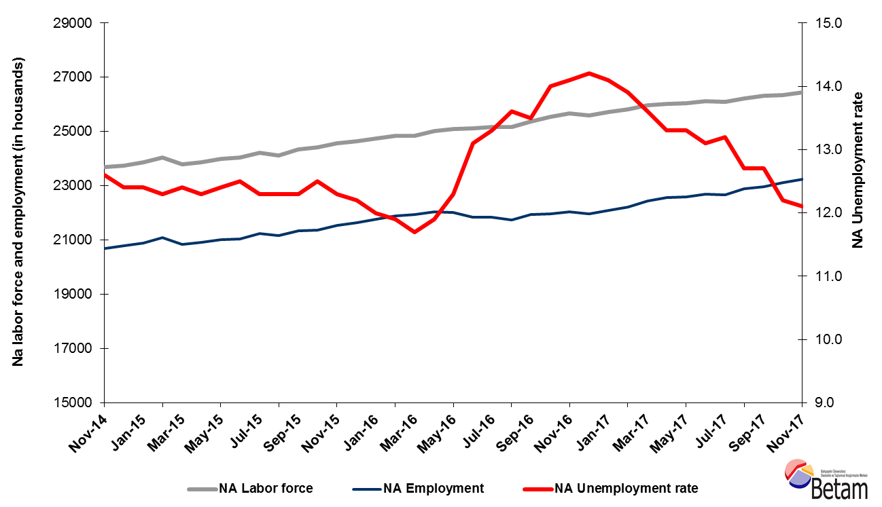

Source: Turkstat, Betam

Decrease in unemployment rate is expected in the period of December 2017

Betam's forecasting model had predicted that the seasonally adjusted non-agricultural unemployment rate would remain at 12.2 in the period of November 2017. However, seasonally adjusted non-agricultural unemployment rate in November 2017 decreased by 0,1 percentage points and reached 12.1 compared to the previous period. Betam’s forecasting model predicts the seasonally adjusted December 2017 non-agricultural unemployment will decrease to 11,8 percent. Forecasting model details are available on Betam's website. Kariyer.net application per vacancy series used in the Betam forecasting model is depicted in Figure 3. Kariyer.net series is only one of the inputs of Betam forecast model. Indeed, several variables such as employment agency (İŞKUR) data, reel sector confidence index, capacity utilization rate are used in forecasting. Taken into account all these factors, Betam's forecasting model predicts that seasonally adjusted non-agricultural unemployment rate will decline to 11.8 in the period of December 2017.

Figure 2 Seasonally adjusted non-agricultural unemployment rate and application per vacancy
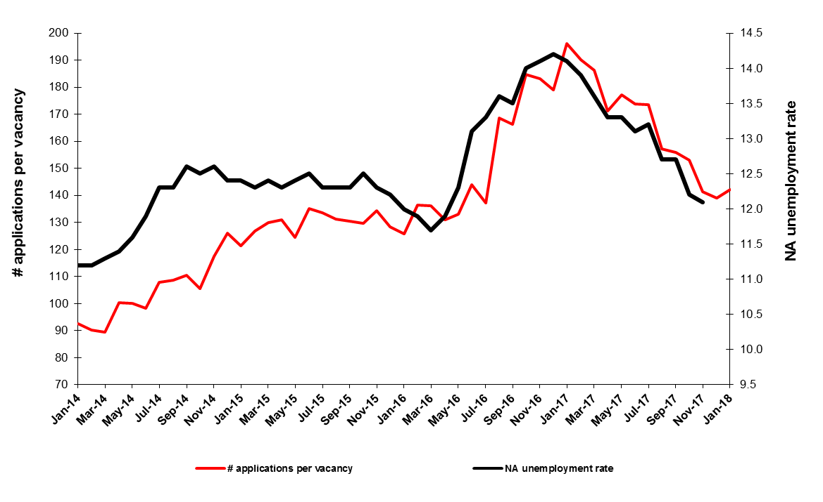
Source: Kariyer.net, Turkstat, Betam

Employment increases in services and construction
According to seasonally adjusted sectoral labor market data, in November 2017 compared to October employment increased in all sectors except in manufacturing (Figure 3, Table 2). An unchanged employment has been observed in manufacture sectors in the period of November 2017, while employment had increased by 49 thousand in this sector in the period of October 2017. In the construction sector 35 thousand employment increase is observed in November 2017 while employment had decreased by 7 thousand in October 2017. Employment in services continued its increase in the period of November 2017 by 87 thousand. 900 thousand additional employment has been created in this sector since the beginning of 2017.
Figure 3: Employment by sectors (in thousands)

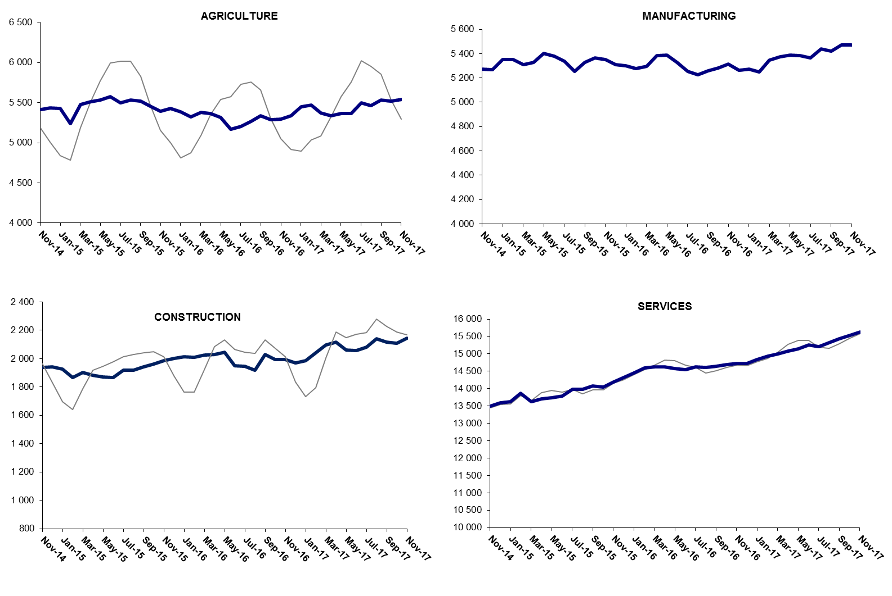

Source: TURKSTAT, Betam

The number of non-agricultural unemployed decreased by 447 thousand within a year

From November 2016 to November 2017 non-agricultural labor force increased by 758 thousand (3.0 percent) and non-agricultural employment by 1 million 205 thousand (5.5 percent) (Figure 4). Thus, the decrease in non-agricultural unemployed decreased by 447 thousand and attained 3 million 226 thousand (Figure 4). Annual increases in non-agricultural employment exceed one million people since the period of August 2017. In the last three periods, increases in non-agricultural labor force are relatively weak; thus, the non-agricultural unemployed decreased rapidly.

Figure 4 Year-on-year changes in non-agricultural labor force, employment, and unemployment
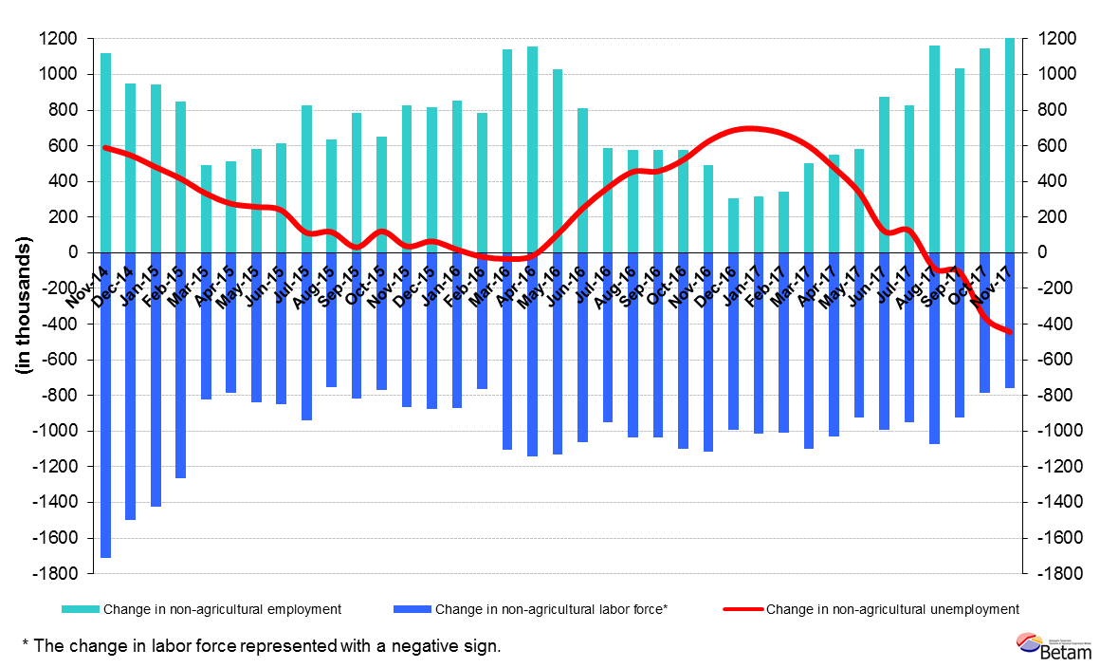
Source: Turkstat, Betam

Limited increase in female and male unemployment difference

Figure 5 shows seasonally adjusted non-agricultural unemployment rate for males (green) and for females (purple). From the period of October 2017 to the period of November 2017, the non-agricultural female unemployment rate remained at 17.3 percent while the non-agricultural male employment rate decreased by 0.1 percentage points and recorded as 9.8 percent. It is worthy to notice that on yearly basis, the non-agricultural female unemployment rate decreased from 20.1 to 17.3 percent (2.8 percentage points) and male unemployment rate by 11.8 percent to 9.8 percent (2.0 percentage points). So, the gender gap in non-agricultural unemployment has been narrowed.

Figure 5: Seasonally adjusted nonagricultural unemployment rate by gender
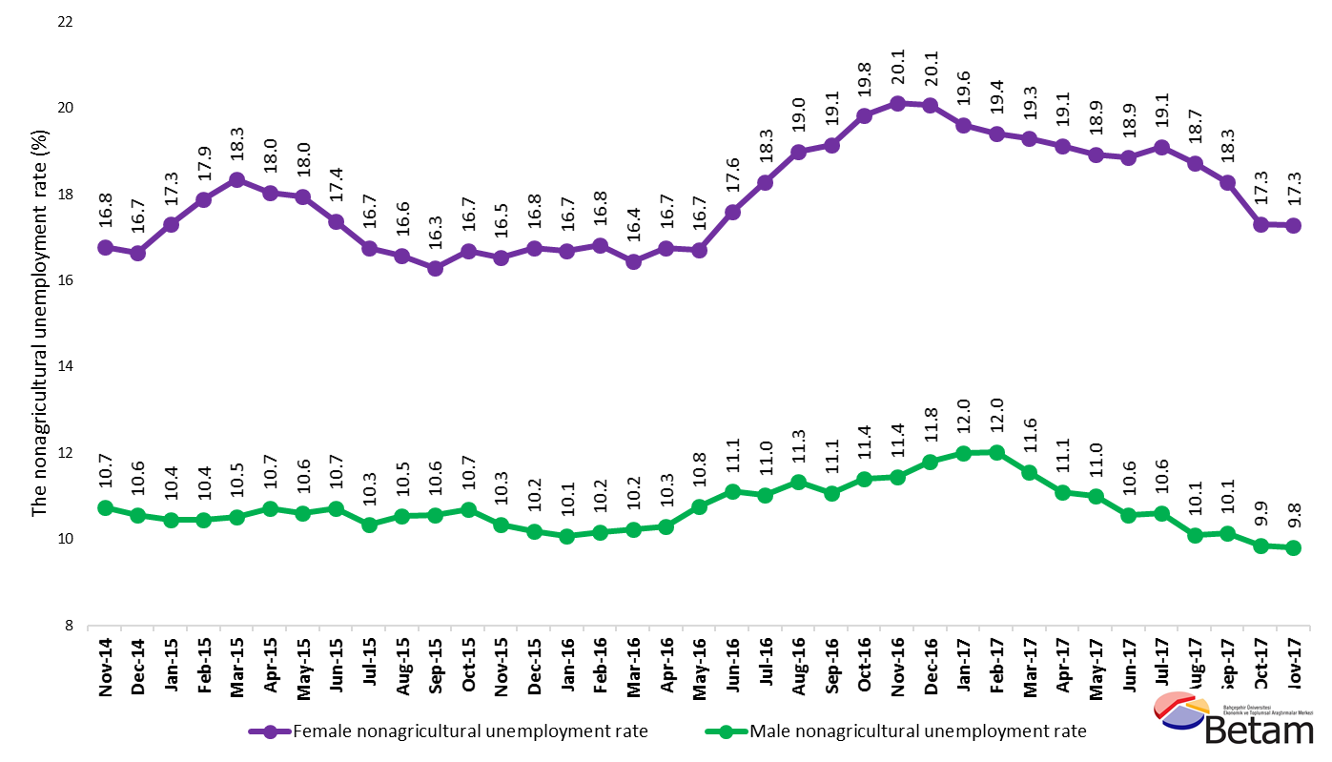
Source: Turkstat, Betam

Table 1 Seasonally adjusted non-agricultural labor market indicators (in thousands) *
 | Labor force | Employment | Unemployment | Unemployment rate | Monthly changes
October-14 | 23653 | 20696 | 2957 | 12.5% | Labor force | Employment | Unemployment
November-14 | 23685 | 20701 | 2984 | 12.6% | 33 | 5 | 28
December-14 | 23744 | 20800 | 2944 | 12.4% | 59 | 99 | -40
January-15 | 23855 | 20897 | 2958 | 12.4% | 111 | 97 | 14
February-15 | 24047 | 21089 | 2958 | 12.3% | 192 | 192 | 0
March-15 | 23780 | 20831 | 2949 | 12.4% | -267 | -258 | -9
April-15 | 23855 | 20921 | 2934 | 12.3% | 76 | 90 | -14
May-15 | 23983 | 21009 | 2974 | 12.4% | 128 | 88 | 40
June-15 | 24035 | 21031 | 3004 | 12.5% | 53 | 22 | 31
July-15 | 24220 | 21241 | 2979 | 12.3% | 185 | 210 | -25
August-15 | 24124 | 21157 | 2967 | 12.3% | -96 | -84 | -12
September-15 | 24345 | 21351 | 2994 | 12.3% | 221 | 194 | 27
October-15 | 24421 | 21368 | 3053 | 12.5% | 75 | 17 | 58
November-15 | 24559 | 21538 | 3021 | 12.3% | 138 | 170 | -32
December-15 | 24639 | 21633 | 3006 | 12.2% | 80 | 95 | -15
January-16 | 24730 | 21762 | 2968 | 12.0% | 91 | 129 | -38
February-16 | 24834 | 21879 | 2955 | 11.9% | 105 | 117 | -12
March-16 | 24853 | 21945 | 2908 | 11.7% | 18 | 66 | -48
April-16 | 25011 | 22035 | 2976 | 11.9% | 159 | 90 | 69
May-16 | 25097 | 22010 | 3087 | 12.3% | 86 | -25 | 111
June-16 | 25122 | 21831 | 3291 | 13.1% | 25 | -179 | 204
July-16 | 25178 | 21829 | 3349 | 13.3% | 56 | -2 | 58
August-16 | 25168 | 21745 | 3423 | 13.6% | -10 | -84 | 74
September-16 | 25356 | 21933 | 3423 | 13.5% | 188 | 188 | 0
October-16 | 25542 | 21966 | 3576 | 14.0% | 186 | 33 | 153
November-16 | 25657 | 22039 | 3618 | 14.1% | 115 | 73 | 42
December-16 | 25594 | 21960 | 3634 | 14.2% | -62 | -79 | 17
January-17 | 25715 | 22089 | 3626 | 14.1% | 120 | 129 | -9
February-17 | 25807 | 22220 | 3587 | 13.9% | 92 | 131 | -39
March-17 | 25968 | 22436 | 3532 | 13.6% | 160 | 216 | -56
April-17 | 26021 | 22560 | 3461 | 13.3% | 53 | 124 | -71
May-17 | 26050 | 22585 | 3465 | 13.3% | 29 | 25 | 4
June-17 | 26114 | 22693 | 3421 | 13.1% | 64 | 108 | -44
July-17 | 26101 | 22656 | 3445 | 13.2% | -13 | -37 | 24
August-17 | 26228 | 22897 | 3331 | 12.7% | 127 | 241 | -114
September-17 | 26310 | 22969 | 3341 | 12.7% | 82 | 72 | 10
October-17 | 26331 | 23119 | 3212 | 12.2% | 21 | 150 | -129
November-17 | 26440 | 23241 | 3199 | 12.1% | 109 | 122 | -13
Source: Turkstat, Betam

Table 2 Seasonally adjusted employment by sectors (in thousands) *
 | Agriculture | Manufacturing | Construction | Service | Monthly changes
October-14 | 5381 | 5353 | 1908 | 13435 | Agriculture | Manufacturing | Construction | Service
November-14 | 5412 | 5273 | 1938 | 13490 | 31 | -80 | 30 | 55
December-14 | 5434 | 5266 | 1940 | 13595 | 22 | -7 | 2 | 105
January-15 | 5426 | 5349 | 1927 | 13621 | -8 | 83 | -13 | 26
February-15 | 5239 | 5351 | 1867 | 13870 | -187 | 2 | -60 | 249
March-15 | 5476 | 5308 | 1901 | 13623 | 237 | -43 | 34 | -247
April-15 | 5510 | 5326 | 1883 | 13712 | 34 | 18 | -18 | 89
May-15 | 5535 | 5404 | 1871 | 13733 | 25 | 78 | -12 | 21
June-15 | 5573 | 5380 | 1867 | 13784 | 38 | -24 | -4 | 51
July-15 | 5500 | 5336 | 1919 | 13985 | -73 | -44 | 52 | 201
August-15 | 5533 | 5252 | 1917 | 13988 | 33 | -84 | -2 | 3
September-15 | 5518 | 5327 | 1940 | 14084 | -15 | 75 | 23 | 96
October-15 | 5455 | 5363 | 1962 | 14044 | -63 | 36 | 22 | -40
November-15 | 5395 | 5353 | 1987 | 14198 | -60 | -10 | 25 | 154
December-15 | 5426 | 5311 | 2001 | 14320 | 31 | -42 | 14 | 122
January-16 | 5383 | 5300 | 2012 | 14450 | -43 | -11 | 11 | 130
February-16 | 5324 | 5276 | 2008 | 14594 | -59 | -24 | -4 | 144
March-16 | 5378 | 5295 | 2025 | 14625 | 54 | 19 | 17 | 31
April-16 | 5362 | 5381 | 2030 | 14624 | -16 | 86 | 5 | -1
May-16 | 5316 | 5386 | 2046 | 14578 | -46 | 5 | 16 | -46
June-16 | 5172 | 5330 | 1950 | 14551 | -144 | -56 | -96 | -27
July-16 | 5206 | 5254 | 1945 | 14630 | 34 | -76 | -5 | 79
August-16 | 5270 | 5224 | 1917 | 14604 | 64 | -30 | -28 | -26
September-16 | 5340 | 5260 | 2027 | 14646 | 70 | 36 | 110 | 42
October-16 | 5291 | 5282 | 1995 | 14690 | -49 | 22 | -32 | 44
November-16 | 5298 | 5316 | 1994 | 14728 | 7 | 34 | -1 | 38
December-16 | 5336 | 5265 | 1970 | 14725 | 38 | -51 | -24 | -3
January-17 | 5450 | 5274 | 1985 | 14831 | 114 | 9 | 15 | 106
February-17 | 5471 | 5251 | 2042 | 14927 | 21 | -23 | 57 | 96
March-17 | 5372 | 5346 | 2098 | 14993 | -99 | 95 | 56 | 66
April-17 | 5339 | 5372 | 2115 | 15073 | -33 | 26 | 17 | 80
May-17 | 5363 | 5386 | 2061 | 15139 | 24 | 14 | -54 | 66
June-17 | 5364 | 5383 | 2055 | 15255 | 1 | -3 | -6 | 116
July-17 | 5496 | 5363 | 2080 | 15213 | 132 | -20 | 25 | -42
August-17 | 5463 | 5437 | 2138 | 15321 | -33 | 74 | 58 | 108
September-17 | 5531 | 5421 | 2117 | 15431 | 68 | -16 | -21 | 110
October-17 | 5518 | 5470 | 2110 | 15539 | -13 | 49 | -7 | 108
November-17 | 5539 | 5470 | 2145 | 15626 | 21 | 0 | 35 | 87

Source: Turkstat, Betam

Table 3: Seasonally adjusted non-agricultural labor force by gender (thousands)
 | Female Labor Force | Female Employment | Female Unemployed | Male Labor Force | Male Employment | Male Unemployed
November-14 | 6399 | 5325 | 1074 | 17241 | 15390 | 1852
December-14 | 6419 | 5350 | 1069 | 17333 | 15503 | 1831
January-15 | 6505 | 5380 | 1125 | 17322 | 15514 | 1808
February-15 | 6565 | 5392 | 1173 | 17425 | 15605 | 1819
March-15 | 6520 | 5325 | 1196 | 17243 | 15429 | 1814
April-15 | 6540 | 5360 | 1180 | 17299 | 15445 | 1854
May-15 | 6623 | 5434 | 1189 | 17351 | 15512 | 1838
June-15 | 6654 | 5498 | 1156 | 17429 | 15561 | 1868
July-15 | 6747 | 5617 | 1130 | 17493 | 15686 | 1807
August-15 | 6712 | 5600 | 1112 | 17487 | 15646 | 1841
September-15 | 6758 | 5658 | 1100 | 17587 | 15729 | 1858
October-15 | 6780 | 5649 | 1132 | 17630 | 15744 | 1886
November-15 | 6873 | 5737 | 1136 | 17630 | 15806 | 1824
December-15 | 6973 | 5805 | 1168 | 17660 | 15862 | 1798
January-16 | 7017 | 5846 | 1171 | 17678 | 15898 | 1780
February-16 | 7053 | 5867 | 1187 | 17717 | 15917 | 1800
March-16 | 7057 | 5897 | 1160 | 17823 | 15999 | 1824
April-16 | 7141 | 5945 | 1196 | 17856 | 16017 | 1839
May-16 | 7173 | 5975 | 1198 | 17930 | 16000 | 1930
June-16 | 7258 | 5981 | 1277 | 17872 | 15888 | 1984
July-16 | 7268 | 5939 | 1328 | 17926 | 15950 | 1976
August-16 | 7325 | 5935 | 1390 | 17919 | 15890 | 2029
September-16 | 7375 | 5964 | 1411 | 17987 | 15998 | 1990
October-16 | 7441 | 5967 | 1475 | 18064 | 16006 | 2058
November-16 | 7457 | 5957 | 1500 | 18156 | 16077 | 2079
December-16 | 7462 | 5965 | 1497 | 18151 | 16011 | 2141
January-17 | 7457 | 5994 | 1463 | 18259 | 16067 | 2192
February-17 | 7519 | 6060 | 1459 | 18257 | 16065 | 2193
March-17 | 7612 | 6144 | 1468 | 18379 | 16255 | 2125
April-17 | 7598 | 6145 | 1453 | 18410 | 16369 | 2041
May-17 | 7649 | 6202 | 1448 | 18375 | 16356 | 2019
June-17 | 7666 | 6221 | 1445 | 18468 | 16520 | 1949
July-17 | 7678 | 6211 | 1467 | 18465 | 16506 | 1959
August-17 | 7731 | 6284 | 1447 | 18578 | 16702 | 1876
September-17 | 7765 | 6345 | 1420 | 18531 | 16654 | 1877
October-17 | 7791 | 6443 | 1348 | 18499 | 16677 | 1823
November-17 | 7840 | 6485 | 1356 | 18559 | 16738 | 1821
Source: Turkstat, Betam

*Prof. Dr. Seyfettin Gürsel, Betam, Director, seyfettin.gursel@eas.bau.edu.tr
∗∗ Gökçe Uysal Betam, Deputy Director, gokce.uysal @eas.bau.edu.tr *** Yazgı Genç, Betam, Research Assistant, yazgi.genc@eas.bau.edu.tr
For detailed information on Betam's forecasting model, please see Betam Research Brief 168 titled as "Kariyer.net Verisiyle Kısa Vadeli Tarım Dışı İşsizlik Tahmini" . For the innovations in the model please see Betam Research Brief 14 titled as "Mevsim Etkilerinden Arındırılmış İşsizlik Tahmini" Soybilgen, B., "Kariyer.net Verisiyle Kısa Vadeli Tarım Dışı İşsizlik Tahmini", Betam Research Brief 168. http://betam.bahcesehir.edu.tr/tr/2014/06/kariyer-net-verisiyle-kisa-vadeli-tarim-disi-issizlik-tahmini/ Soybilgen, B., "Mevsim Etkilerinden Arındırılmış İşsizlik Tahmini", Betam Research Brief 14 http://betam.bahcesehir.edu.tr/2015/08/mevsim-etkilerinden-arindirilmis-tarim-disi-issizlik-tahmini/
Betam has been calculating application per vacancy using series released by Kariyer.net for a while. Seasonal and calendar adjustment procedure is applied to application per vacancy series. A decrease in applications per vacancy may be caused by an increase in vacancies or by a decrease in the number of applications. An increase in vacancies signals economic growth while decreasing number of applications indicates a decrease in number of people looking for a job. Monthly labor market series released by TurkStat is the average of three months. Therefore, application per vacancy statistics calculated using Kariyer.net series is the average of three months as well.
Sektörel istihdam serileri teker teker mevsim etkilerinden arındırılmaktadır. Dolayısıyla sektörel istihdam rakamlarının toplamı, mevsim etkilerinden arındırılmış toplam istihdam rakamından farklı olabilmektedir. Aradaki fark mevsim etkilerinden arındırma prosedürünün lineer olmamasından kaynaklanmaktadır.
Turkstat revised the labor market statistics drastically in February 2014. Within this framework, they back casted various labor market indicators and they also continued to announce seasonally adjusted series. However, Turkstat is not providing back-casted series by gender. Therefore, female and male labor market statistics are not sufficiently long for the seasonal adjustment procedures (There should be minimum 36 observations). With the announcement of the period of February 2017 data, the number of observations required for the seasonal decontamination process was provided. From this period Betam get seasonal adjustment series in terms of gender. Nevertheless, it should not be forgotten that seasonal adjustment may cause extra volatility in the series for at least a while.

